Supplemental Document for

Nematode-resistance loci in Upland cotton genomes are associated with structural differences

Zachary P. Cohen¹, Lindsey C. Perkin¹, Tanya A. Wagner¹, Jinggao Liu¹, Alois A. Bell¹, Mark A. Arick II², Corrinne E. Grover³, John Z. Yu⁴, Joshua A. Udall⁴, and Charles P.-C. Suh¹
¹ USDA Agricultural Research Service, Insect Control and Cotton Disease Research Unit, College Station, TX 77845
² Institute for Genomics, Biocomputing & Biotechnology, Mississippi State University, Mississippi State, MS 39762
³ EEOB Department, Iowa State University, Ames, IA 50011
⁴ USDA Agricultural Research Service, Crop Germplasm Research Unit, College Station, TX 77845

Supplemental Table S1 PSC355 Chromosome Feature Summary
Chromosome | ID | Length | Contig # | Telomeres (L; R) | Alternative Haplotype (MB) | Gene number (AED 0.37) | Repeats (%)
1 | A01 | 119474596 | 1 | -; 9600 | 8.63 | 2716 | 70.2
2 | A02 | 108240954 | 1 | 8,800; 11,800 | 3.23 | 2184 | 71.3
3 | A03 | 113544907 | 1 | 10,700; 10,200 | 6 | 2593 | 69.3
4 | A04 | 90025657 | 1 | 6,900; 9,200 | 9.43 | 1907 | 70.1
5 | A05 | 112537697 | 1 | 9,200; 10,300 | 8.15 | 4438 | 59.4
6 | A06 | 128169327 | 1 | 6,500; 9,700 | 30.57 | 2646 | 71.5
7 | A07 | 98278401 | 2 | 6,800; 5,200 | 3.56 | 2787 | 65.3
8 | A08 | 126651951 | 1 | 2,800; 1,900 | 6.84 | 2996 | 70.2
9 | A09 | 87012727 | 1 | -; 6,800 | 8.62 | 2816 | 60.6
10 | A10 | 118101055 | 1 | -; 11,600 | 8.33 | 2788 | 67.8
11 | A11 | 124146241 | 1 | 10,900; 9,400 | 46.67 | 3947 | 65.7
12 | A12 | 109175953 | 1 | 11,300; - | 6.83 | 3142 | 66.7
13 | A13 | 112117856 | 1 | 10,800; 8,900 | 14.7 | 2841 | 68.7
14 | D01 | 66201905 | 1 | 12,100; 6,300 | 5.57 | 2657 | 54.4
15 | D02 | 73250298 | 1 | 10,800; 11,700 | 49.08 | 2750 | 54.8
16 | D03 | 54720647 | 1 | -; 6,500 | 5.86 | 2147 | 55.3
17 | D04 | 59665483 | 1 | 8,900; 9,300 | 11.28 | 2323 | 53.9
18 | D05 | 65908016 | 1 | 4,600; - | 8.61 | 4022 | 43.5
19 | D06 | 66868618 | 1 | 5,100; 11,800 | 39.95 | 2664 | 54.4
20 | D07 | 61041968 | 1 | 11,700; - | 7.41 | 2799 | 49.8
21 | D08 | 71775203 | 1 | -; 11,700 | 2.62 | 2951 | 51.5
22 | D09 | 56087791 | 1 | -; 2,100 | 12.02 | 2832 | 46.9
23 | D10 | 68597512 | 1 | 8,200; - | 5.53 | 2938 | 51.4
24 | D11 | 74015571 | 1 | 11,300; 11,800 | 6.98 | 3931 | 49.1
25 | D12 | 63565837 | 1 | 9,500; - | 11.7 | 3113 | 50.3
26 | D13 | 65155209 | 1 | 6,500; 6,700 | 2.11 | 2818 | 53.9

Supplemental Table S2. BUSCO analysis of the PSC355 genome sequence.
Num. genes | BUSCO Categories
2291 | Complete BUSCOs (C)
290 | Complete and single-copy BUSCOs (S)
2001 | Complete and duplicated BUSCOs (D)
4 | Fragmented BUSCOs (F)
31 | Missing BUSCOs (M)
2326 | Total BUSCO groups searched

Supplemental Table S3. Repeats in the genome assembly of PSC355
Repeats | Sub-type | Number | MB | %
Retroelements |  | 1370001 | 1124.32 | 49
LINEs (L1/CIN4) |  | 48501 | 29.41 | 1.28
LTR elements |  | 1321500 | 1094.91 | 47.72
 | Ty1/Copia | 296217 | 149.67 | 6.52
 | Gypsy/DIRS1 | 783533 | 864.12 | 37.66
DNA transposons |  | 70804 | 52.43 | 2.29
 | hobo-Activator | 4244 | 2.61 | 0.11
 | Tourist/Harbinger | 22178 | 11.13 | 0.49
Rolling-circles |  | 3202 | 2.41 | 0.11
Unclassified |  | 1492648 | 566.19 | 24.68
Total interspersed repeats |  | - | 1742.94 | 75.97
Small RNA |  | 5839 | 6.65 | 0.29
Satellites |  | 0 | 0 | 0
Simple repeats |  | 256705 | 11.87 | 0.52
Low complexity |  | 71662 | 3.8 | 0.17

Supplemental Table S4. Annotations with SNPs and INDELs Within Resistant Marker Regions

Gene | Annotation
Bar32.A11G287600 | Similar to LOC107962949: probable low-specificity L-threonine aldolase 1 (Gossypium hirsutum);Ontology_term=GO:0006520,GO:0016829;
Bar32.A11G288200 | Similar to LOC108473967: probable ADP-ribosylation factor GTPase-activating protein AGD14 (Gossypium arboreum);Ontology_term=GO:0005096;
Bar32.A11G288300 | Similar to F383_35688: Porphobilinogen deaminase (Gossypium arboreum);
Bar32.A11G288400 | Similar to E1A91_D11G359700v1: ADP-ribosyl cyclase/cyclic ADP-ribose hydrolase (Gossypium mustelinum);Ontology_term=GO:0006952,GO:0007165,GO:0043531
Bar32.A11G288500 | Similar to LOC107962704: ADP-ribosyl cyclase/cyclic ADP-ribose hydrolase (Gossypium hirsutum);Ontology_term=GO:0005515,GO:0006952,GO:0007165,GO:0043531
Bar32.A11G288700 | Similar to LOC107962677: chromo domain-containing protein LHP1-like (Gossypium hirsutum);Ontology_term=GO:0005634,GO:0006325,GO:003150
Bar32.A11G288800 | Similar to Goklo_021687: RNA polymerase sigma factor (Gossypium klotzschianum);Ontology_term=GO:0003700,GO:0006352,GO:0006355;
Bar32.A11G289000 | Similar to LOC107962663: Tubulin-specific chaperone A (Gossypium hirsutum);Ontology_term=GO:0007021,GO:0007023,GO:0048487;
Bar32.A11G289300 | Similar to GOBAR_AA15901: Beta-amylase (Gossypium barbadense);Ontology_term=GO:0000272,GO:0016161;
Bar32.A11G289400 | Similar to LOC107944120: serine/threonine-protein kinase CDL1-like (Gossypium hirsutum);Ontology_term=GO:0004672,GO:0005524,GO:0006468;
Bar32.A11G289500 | Similar to E1A91_A11G340300v1: Beta-glucosidase (Gossypium mustelinum);Ontology_term=GO:0004553,GO:0005975,GO:0008422,GO:0030245;
Bar32.A11G290000 | Similar to E1A91_A11G341300v1: RBR-type E3 ubiquitin transferase (Gossypium mustelinum);Ontology_term=GO:0004842,GO:0016567;
Bar32.A11G290200 | Similar to F383_12726: Aladin (Gossypium arboreum);Ontology_term=GO:0005515;
Bar32.A11G290900 | Similar to ES319_A11G334800v1: TFIIS N-terminal domain-containing protein (Gossypium barbadense);Ontology_term=GO:0005634;
Bar32.A11G291000 | Similar to E1A91_A11G342700v1: Hydroxymethylglutaryl-CoA lyase (Gossypium mustelinum);Ontology_term=GO:0003824,GO:0016833;
Bar32.A11G291100 | Similar to GOBAR_AA09986: BHLH domain-containing protein (Gossypium barbadense);Ontology_term=GO:0003700,GO:0006355,GO:0046983;
Bar32.A11G291200 | Similar to F383_00101: F-box domain-containing protein (Gossypium arboreum);Ontology_term=GO:0005515;
Bar32.A11G291500 | Similar to LOC107942592: nucleolar protein 10-like (Gossypium hirsutum);Ontology_term=GO:0005515,GO:0005634;
Bar32.A11G292700 | Similar to CCACVL1_29339: Zinc finger%2C CCHC-type (Corchorus capsularis);
Bar32.A11G292800 | Similar to F383_13539: Viral IAP-associated factor (Gossypium arboreum);
Bar32.A11G293400 | Similar to E1A91_A11G346700v1: Eukaryotic translation initiation factor 3 subunit E (Gossypium mustelinum);Ontology_term=GO:0003743,GO:0005515,GO:0005737,GO:0005852;
Bar32.A11G293500 | Similar to E1A91_A11G346900v1: AAA domain-containing protein (Gossypium mustelinum);Ontology_term=GO:0043531;
Bar32.A11G295300 | Similar to EPI10_015754: Reverse transcriptase (Gossypium australe);
Bar32.A11G295600 | Similar to E1A91_A11G347400v1: AAA domain-containing protein (Gossypium mustelinum);Ontology_term=GO:0043531;
*Bar32.A11G295800 | Similar to Godav_025810: NB-ARC domain-containing protein (Gossypium davidsonii);
Bar32.A11G295900 | Similar to LOC107940523: Nuclear pore protein (Gossypium hirsutum);Ontology_term=GO:0005643,GO:0017056;
Bar32.A11G296000 | Similar to E1A91_A11G348100v1: RRM domain-containing protein (Gossypium mustelinum);Ontology_term=GO:0003676,GO:0003723;
Bar32.A11G296600 | Similar to LOC107940520: arabinogalactan peptide 23-like (Gossypium hirsutum);
Bar32.A11G296800 | Similar to EPI10_021159: Gag/pol polyprotein (Gossypium australe);Ontology_term=GO:0003676,GO:0004523,GO:0015074;
Bar32.A11G298800 | Similar to ES319_A11G343400v1: 60S ribosomal protein L6 (Gossypium barbadense);Ontology_term=GO:0003735,GO:0005840,GO:0006412;
Bar32.A11G298900 | Similar to F383_07628: Squamosa promoter-binding-like protein 17 (Gossypium arboreum);Ontology_term=GO:0003677,GO:0005634;
Bar32.A11G299500 | Similar to E1A91_A11G353800v1: Dirigent protein (Gossypium mustelinum);
Bar32.A11G299600 | Similar to ES319_A11G344200v1: Dirigent protein (Gossypium barbadense);
Bar32.A11G299700 | Similar to LOC107924168: RNA helicase (Gossypium hirsutum);Ontology_term=GO:0003676,GO:0003724,GO:0005524;
Bar32.A11G299800 | Similar to LOC107924167: RING-type E3 ubiquitin transferase (Gossypium hirsutum);
Bar32.A11G300200 | Similar to ES319_A11G345100v1: RING-type domain-containing protein (Gossypium barbadense);
Bar32.A11G300400 | Similar to LOC107923492: MADS-box transcription factor PHERES 2-like (Gossypium hirsutum);
Bar32.A11G300500 | Similar to E1A91_A11G354600v1: Nuclear transcription factor Y subunit (Gossypium mustelinum);Ontology_term=GO:0003700,GO:0006355;
Bar32.D02G005200 | Similar to E1A91_D02G014800v1: ULP_PROTEASE domain-containing protein (Gossypium mustelinum);Ontology_term=GO:0003677,GO:0005515,GO:0006508,GO:0008234,GO:0046983;
Bar32.D02G005300 | Similar to E1A91_D02G014900v1: DYW_deaminase domain-containing protein (Gossypium mustelinum);Ontology_term=GO:0003723,GO:0005515,GO:0008270,GO:0009451;
Bar32.D02G005400 | Similar to E1A91_D02G014800v1: ULP_PROTEASE domain-containing protein (Gossypium mustelinum);Ontology_term=GO:0003677,GO:0006508,GO:0008234,GO:0046983;
Bar32.D02G005600 | Similar to E1A91_D02G014800v1: ULP_PROTEASE domain-containing protein (Gossypium mustelinum);Ontology_term=GO:0003677,GO:0003735,GO:0005840,GO:0006412,GO:0006508,GO:0008234,GO:0046983;
Bar32.D02G005800 | Similar to LOC107938721: F-box protein SKIP16-like (Gossypium hirsutum);Ontology_term=GO:0003700,GO:0005515,GO:0006355;
Bar32.D02G005900 | Similar to B456_005G016000: NAC domain-containing protein (Gossypium raimondii);Ontology_term=GO:0000398,GO:0003677,GO:0006355;
Bar32.D02G006000 | Similar to Godav_012899: Rhomboid domain-containing protein (Gossypium davidsonii);Ontology_term=GO:0004252,GO:0016021;
Bar32.D02G006200 | Similar to LOC107938696: RNA polymerase II C-terminal domain phosphatase-like (Gossypium hirsutum);Ontology_term=GO:0004721,GO:0005634,GO:0008420,GO:0070940;
Bar32.D02G006300 | Similar to Gogos_022196: Acetolactate synthase (Gossypium gossypioides);Ontology_term=GO:0000287

Bar32.D02G006400 | Similar to GCP2: Probable tRNA N6-adenosine threonylcarbamoyltransferase (Populus alba);Ontology_term=GO:0000408  GO:0002949;
Bar32.D02G006600 | Similar to LOC107938714: importin beta-like SAD2 (Gossypium hirsutum);Ontology_term=GO:0006886  GO:0031267;
Bar32.D02G006700 | Similar to B456_005G017500: Peptidase A1 domain-containing protein (Gossypium raimondii);Ontology_term=GO:0004190  GO:0006508;
Bar32.D02G013400 | Similar to B456_005G028000: Epimerase domain-containing protein (Gossypium raimondii);
Bar32.D02G013500 | Similar to B456_005G028100: RRM domain-containing protein (Gossypium raimondii);Ontology_term=GO:0003676  GO:0003723;
Bar32.D02G013700 | Similar to B456_005G028300: J domain-containing protein (Gossypium raimondii);
Bar32.D02G015400 | Similar to LOC107934486: Isoform of A0A1U8M6H7%2C UV radiation resistance-associated gene protein-like isoform X2 (Gossypium hirsutum);
Bar32.D02G016900 | Similar to E1A91_D02G032800v1: ER lumen protein-retaining receptor (Gossypium mustelinum);Ontology_term=GO:0006621  GO:0016021
Bar32.D02G017000 | Similar to Godav_012976: Purple acid phosphatase (Gossypium davidsonii);Ontology_term=GO:0003993  GO:0016787
Bar32.D02G017100 | Similar to B456_005G032500: X8 domain-containing protein (Gossypium raimondii);
*Bar32.D11G231300 | Similar to B456_007G3277001: LRRNT_2 domain-containing protein (Fragment) (Gossypium raimondii);Ontology_term=GO:0005515;
*Bar32.D11G233200 | Similar to LOC107963816: probable leucine-rich repeat receptor-like serine/threonine-protein kinase At3g14840 (Gossypium hirsutum);Ontology_term=GO:0004672  GO:0005515
*Bar32.D11G233400 | Similar to E1A91_D11G342100v1: Protein kinase domain-containing protein (Gossypium mustelinum);Ontology_term=GO:0004672  GO:0005515
Bar32.D11G233500 | Similar to E1A91_D11G342500v1: PMR5N domain-containing protein (Gossypium mustelinum);Ontology_term=GO:0016413  GO:0016740;
Bar32.D11G233700 | Similar to LOC107963883: putative disease resistance protein RGA3 isoform X1 (Gossypium hirsutum);Ontology_term=GO:0006952  GO:0043531;
Bar32.D11G233800 | Similar to B456_007G331400: AAA domain-containing protein (Gossypium raimondii);Ontology_term=GO:0006952  GO:0043531;
Bar32.D11G234000 | Similar to EPI10_022782: E3 ubiquitin-protein ligase CCNB1IP1-like protein isoform X5 (Gossypium australe);
Bar32.D11G234100 | Similar to E1A91_D11G342900v1: BED-type domain-containing protein (Gossypium mustelinum);Ontology_term=GO:0003677  GO:0046983;
Bar32.D11G234300 | Similar to B456_007G332100: Bidirectional sugar transporter SWEET (Gossypium raimondii);Ontology_term=GO:0016021;
*Bar32.D11G234400 | Similar to E1A91_D11G343300v1: Mitogen-activated protein kinase (Gossypium mustelinum);Ontology_term=GO:0004672  GO:0004707
*Bar32.D11G234500 | Similar to B456_007G332400: SH2 domain-containing protein (Gossypium raimondii);Ontology_term=GO:0003700  GO:0006355
Bar32.D11G236500 | Similar to LOC107886173: ubiquitin carboxyl-terminal hydrolase 15-like isoform X1 (Gossypium hirsutum);Ontology_term=GO:0004843  GO:0006511
Bar32.D11G236600 | Similar to LOC107886191: polyadenylate-binding protein-interacting protein 9-like (Gossypium hirsutum);Ontology_term=GO:0003676  GO:0003723;
Bar32.D11G236700 | Similar to Goshw_009526: Fe2OG dioxygenase domain-containing protein (Gossypium schwendimanii);
Bar32.D11G237400 | Similar to E1A91_D11G347000v1: Histone domain-containing protein (Gossypium mustelinum);Ontology_term=GO:0003677  GO:0046982;
Bar32.D13G098700 | Similar to EPI10_031110: Branched-chain-amino-acid aminotransferase-like protein 1 isoform X1 (Gossypium australe);Ontology_term=GO:0003824;
Bar32.D13G104700 | Similar to Gogos_000885: RNase H type-1 domain-containing protein (Gossypium gossypioides);Ontology_term=GO:0003676  GO:0004523;
Bar32.D13G106800 | Similar to LOC107963597: beta-amyrin 28-oxidase-like (Gossypium hirsutum);Ontology_term=GO:0004497  GO:0005506
Bar32.D13G132700 | Similar to LOC107919484: COBRA-like protein 10 (Gossypium hirsutum);Ontology_term=GO:0009055  GO:0010215
Bar32.D13G147600 | Similar to E1A91_D13G185200v1: Isoform of A0A5D2S594%2C J domain-containing protein (Gossypium mustelinum);

Supplemental Table S5. Blastn hits of the two Gorai.007G333200.1 paralogues by Bar resistant lines with copy number differences between them.
qseqid | sseqid | pident | length | mismatch | gapopen | qstart | qend | sstart | send | evalue | bitscore
Gorai.007G333200.1-JGI_221_v2.1 | D11_B713 | 99.745 | 7852 | 16 | 3 | 1 | 7851 | 141026 | 148874 | 0 | 14386
Gorai.007G333200.1-JGI_221_v2.1 | D11_B713 | 99.745 | 7852 | 16 | 3 | 1 | 7851 | 206782 | 214630 | 0 | 14386
Gorai.007G333200.1-JGI_221_v2.1 | D11_B713 | 99.771 | 7852 | 14 | 3 | 1 | 7851 | 272538 | 280386 | 0 | 14397
Gorai.007G333200.1-JGI_221_v2.1 | D11_BAR3230 | 99.745 | 7852 | 16 | 3 | 1 | 7851 | 141026 | 148874 | 0 | 14386
Gorai.007G333200.1-JGI_221_v2.1 | D11_BAR3230 | 99.771 | 7852 | 14 | 3 | 1 | 7851 | 206782 | 214630 | 0 | 14397

Supplemental Figure S1.

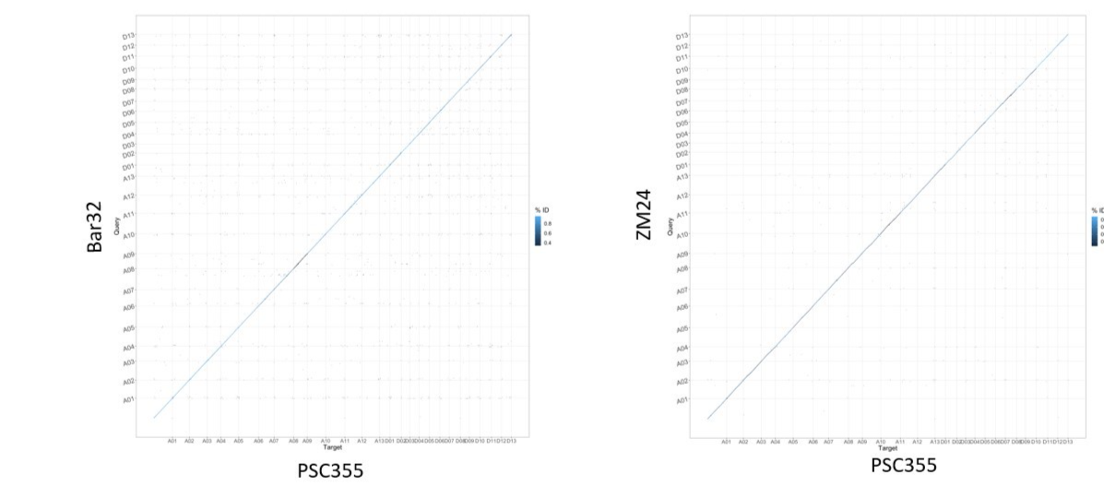

A genome-wide alignment of the newly assembled PSC355 to Bar32 (left) and ZM24 (Perkin et al., 2021; Yang et al. 2019).

Supplemental Figure S2.
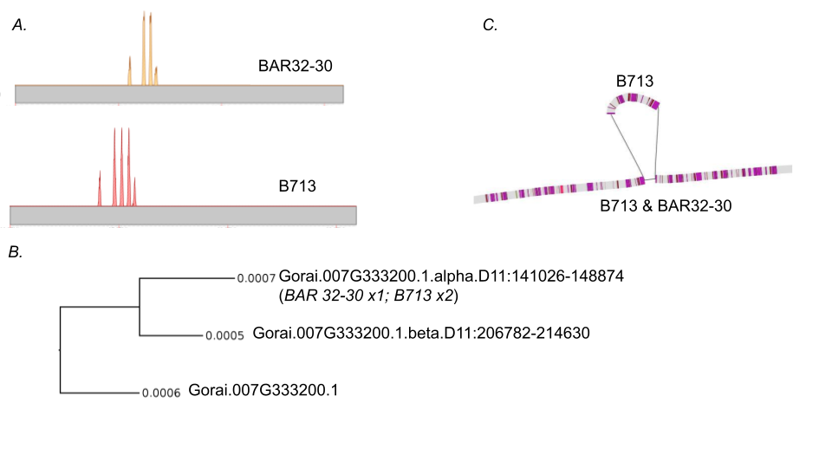

Copy number variation in resistant lines (B713 & BAR32-30) demonstrated by read coverage histogram (A), cladogram of two paralogues (B), and structural differences between B713 and BAR32-30, with Gorai.007G333200.1.alpha sequence highlighted in purple (C). The alpha variant was present twice in B713 and once in BAR 32-30, whereas beta was present once in both Barbren derived strains. Furthermore, neither of these genes were present in PSC355 within the marker region or on Chromosome D11.

