O-GlcNAcylation of MITF regulates its activity and CDK4/6 inhibitor resistance
in breast cancer

Yi Zhang, Shuyan Zhou, Yan Kai, YaQin Zhang, Changmin Peng, Zhuqing Li, Muhammad Jameel, Junfeng Ma, Shunqiang Li, Cynthia X Ma, Min Shen, Matthew D Hall, Wenge Zhu

This file includes:
Supplementary Figure 1. qHTCS identifies MITF inhibitor ML329 that overcomes palbociclib
resistance
Supplementary Figure 2. Inhibition of MITF overcomes palbociclib resistance by activating the senescence pathway in breast cancer cells
Supplementary Figure 3. OGT interacts with MITF and promotes its nuclear translocation Supplementary Figure 4. O-GlcNAcylation of MITF at S49 is required for nuclear accumulation and resistance
Supplementary Figure 5. O-GlcNAcylation within the nuclear localization signal (NLS) promotes the interaction of MITF with importin α/β
Supplementary Figure 6. MITF-mediated pathway is activated in response to palbociclib and elevated in tumors from palbociclib-resistant breast cancer patients

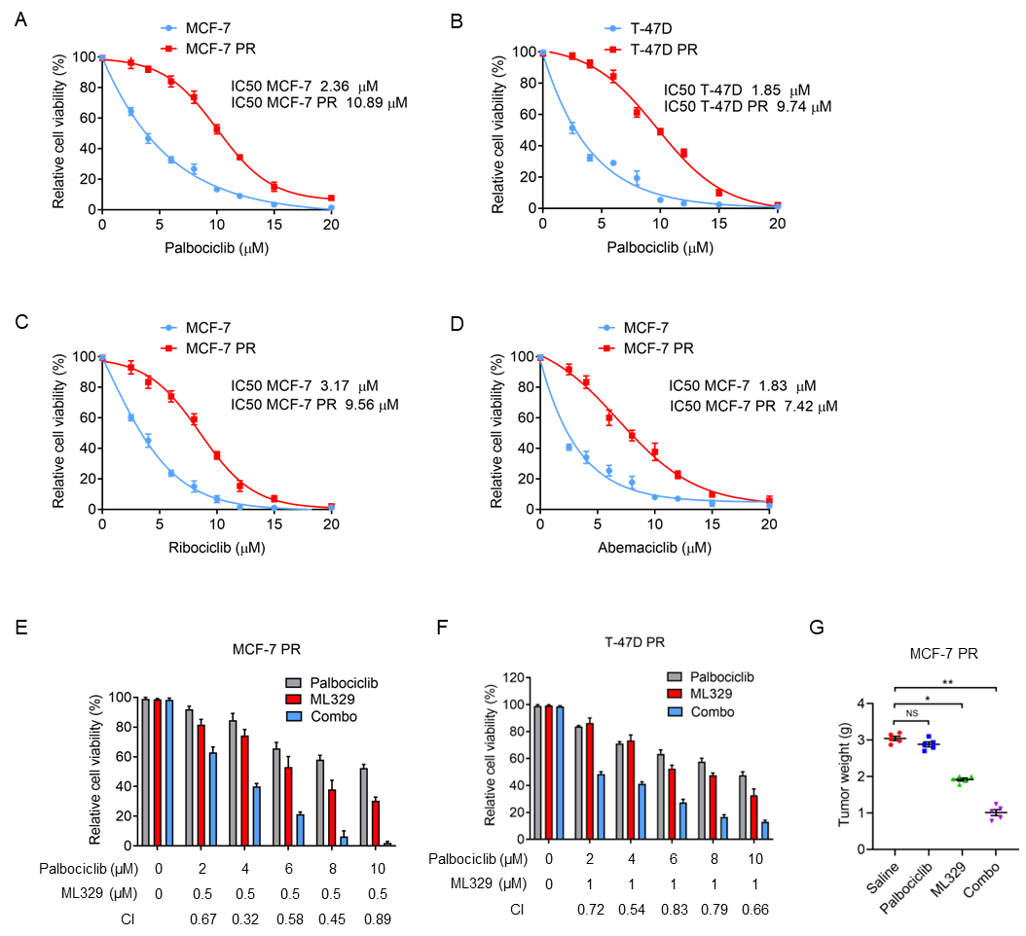
Supplementary Figure 1. qHTS identifies MITF inhibitor ML329 that overcomes palbociclib
resistance
(A-B) Viability of MCF-7 and MCF-7 PR cells (A), T-47D and T-47D PR cells (B) treated with increasing concentrations of palbociclib for 3 days. The IC₅₀ was indicated. (C-D) Viability of MCF-7 PR cells treated with increasing concentrations of ribociclib (C) and abemaciclib (D) for 3 days. The IC₅₀ was indicated. (E-F) The synergistic effects of ML329 and palbociclib on MCF-7 PR cells (E) and T-47D PR cells (F). CI values are presented below the bars. (G) Tumor weight of MCF-7 PR xenografts was assessed after treatments with the following compounds: saline, palbociclib (25mg/kg), ML329 (10mg/kg), and a combination of palbociclib with ML329 for 2 weeks. Data are represented as means ± SEM, n = 6 mice/group. **, p≤0.01.

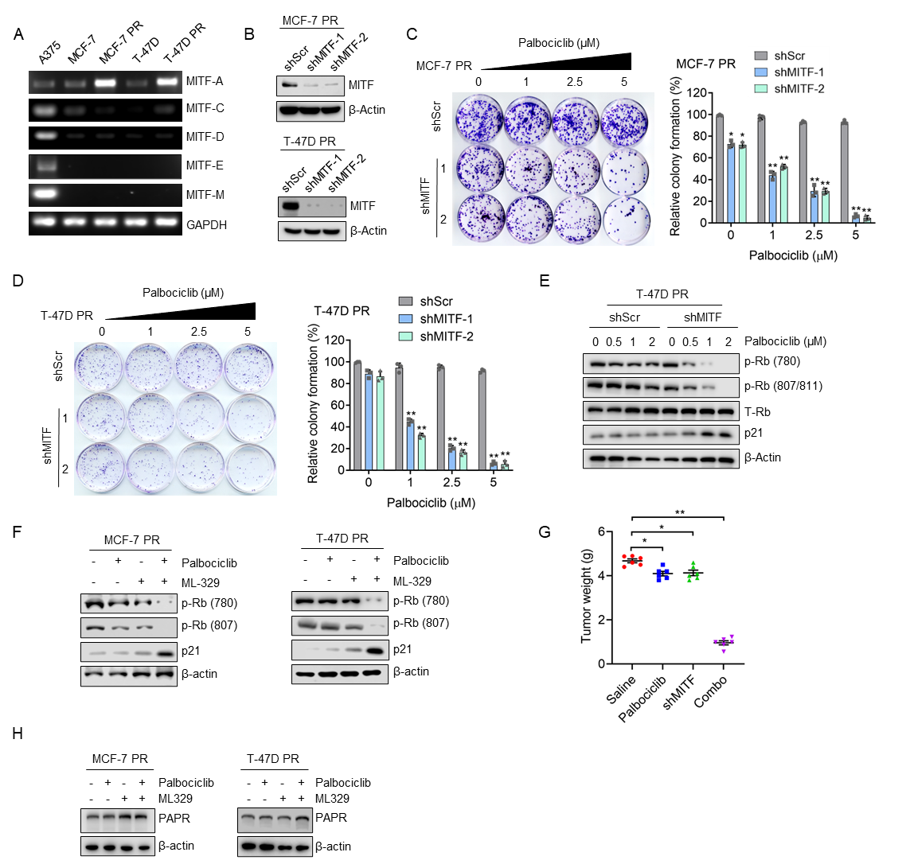
Supplementary Figure 2. Inhibition of MITF overcomes palbociclib resistance by activating the senescence pathway in breast cancer cells
(A) RT–PCR analysis to examine the expression levels of MITF isoforms in cells as indicated. Note, MITF-M was detected in A375 melanoma cells but not in breast cancer cells. (B) MCF-7 PR and T-47D PR cells treated as indicated were collected and then followed by immunoblotting for the indicated proteins. (C-D) Representative images of colony formation and quantification results in MCF-7 PR cells (C) and T-47D PR cells (D) with indicated treatments. (E) T-47D PR cells treated as indicated were collected and then followed by immunoblotting for the indicated proteins. (F) MCF-7 PR and T-47D PR cells treated as indicated were collected and then followed by immunoblotting for the indicated proteins. (G) Tumor weight of MCF-7 PR xenograft treated with saline, palbociclib (25mg/kg), ML329(5mg/kg), or a combination of both for 3 weeks. Data were represented as means ± SEM, n = 6 mice/group. **, p≤0.01. (H) MCF-7 PR and T-47D PR cells treated as indicated were collected and then immunoblotted for indicated proteins.

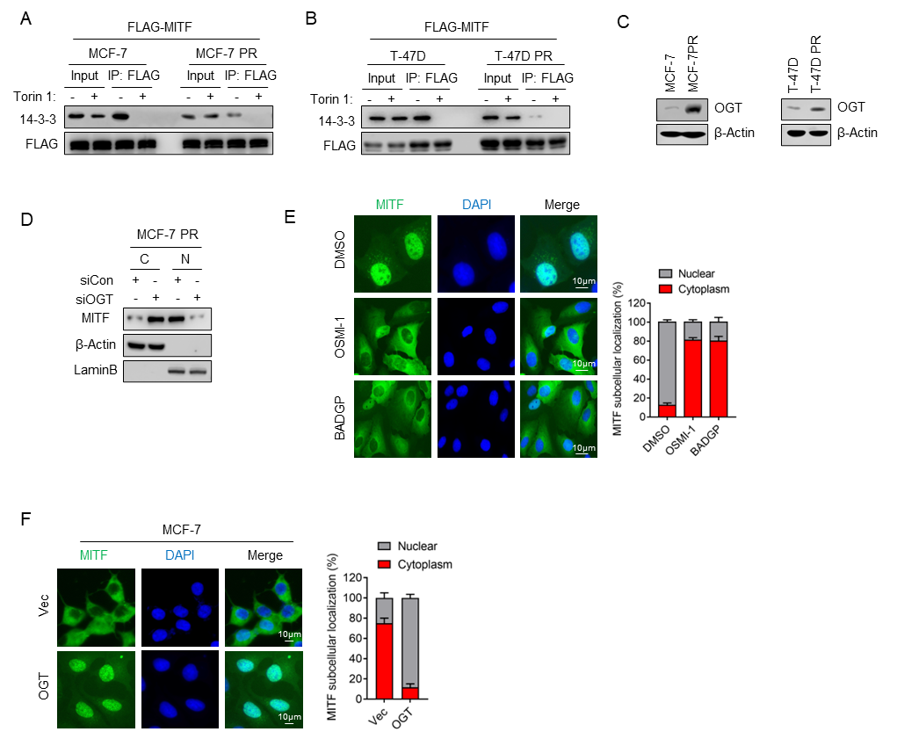
Supplementary Figure 3. OGT interacts with MITF and promotes its nuclear translocation
(A) MCF-7 and MCF-7 PR cells were transfected with the indicated plasmids for 48 hr before being harvested. FLAG-IPs were immunoblotted for the indicated proteins. (B) T-47D and T-47D PR cells were transfected with the indicated plasmids for 48 hr before being harvested. FLAG-IPs were immunoblotted for the indicated proteins. (C) MCF-7 & MCF-7 PR cells and T-47D & T-47D PR cells were collected and followed by immunoblotting for the indicated proteins. (D) MCF-7 PR cells were collected after indicated treatments, and then cytoplasmic and nuclear fractions were separated and cell lysates were subjected to immunoblotting for indicated proteins. (E) MCF-7 PR cells were treated as indicated, followed by immunostaining to examine the localization of MITF. Right panel, quantification results. (F) MCF-7 cells were treated as indicated, and then followed by immunostaining to examine the localization of MITF. Right panel, quantification results.
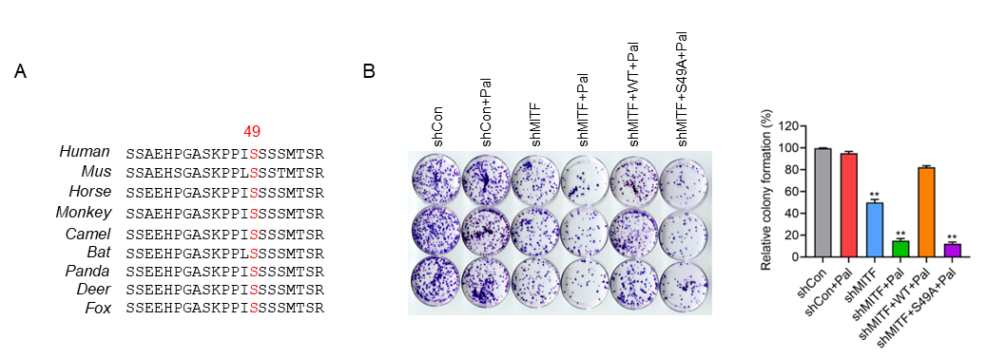
Supplementary Figure 4. O-GlcNAcylation of MITF at S49 is required for its nuclear accumulation and resistance
(A) MITF S49 site is conserved across various species. (B) Left panel, representative images of colony formation in MCF-7 PR cells with indicated treatments. Right panel, quantification results.

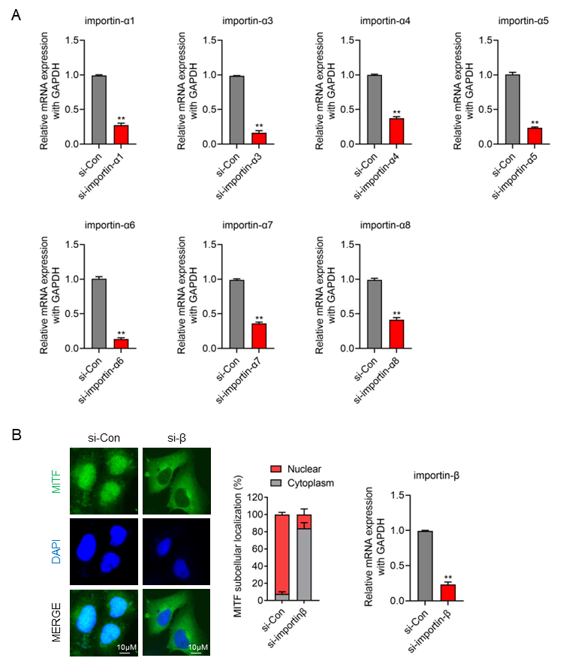

Supplementary Figure 5. O-GlcNAcylation within the nuclear localization signal (NLS) promotes the interaction of MITF with importin α/β and nuclear translocation
(A) MCF-7 PR cells were collected after the indicated treatment and subjected to qPCR to examine the expression of indicated genes. (B) MCF-7 PR cells were transfected with the indicated siRNAs, and then followed by immunostaining to detect MITF cellular localization. Right panel, quantification results are shown on the left.

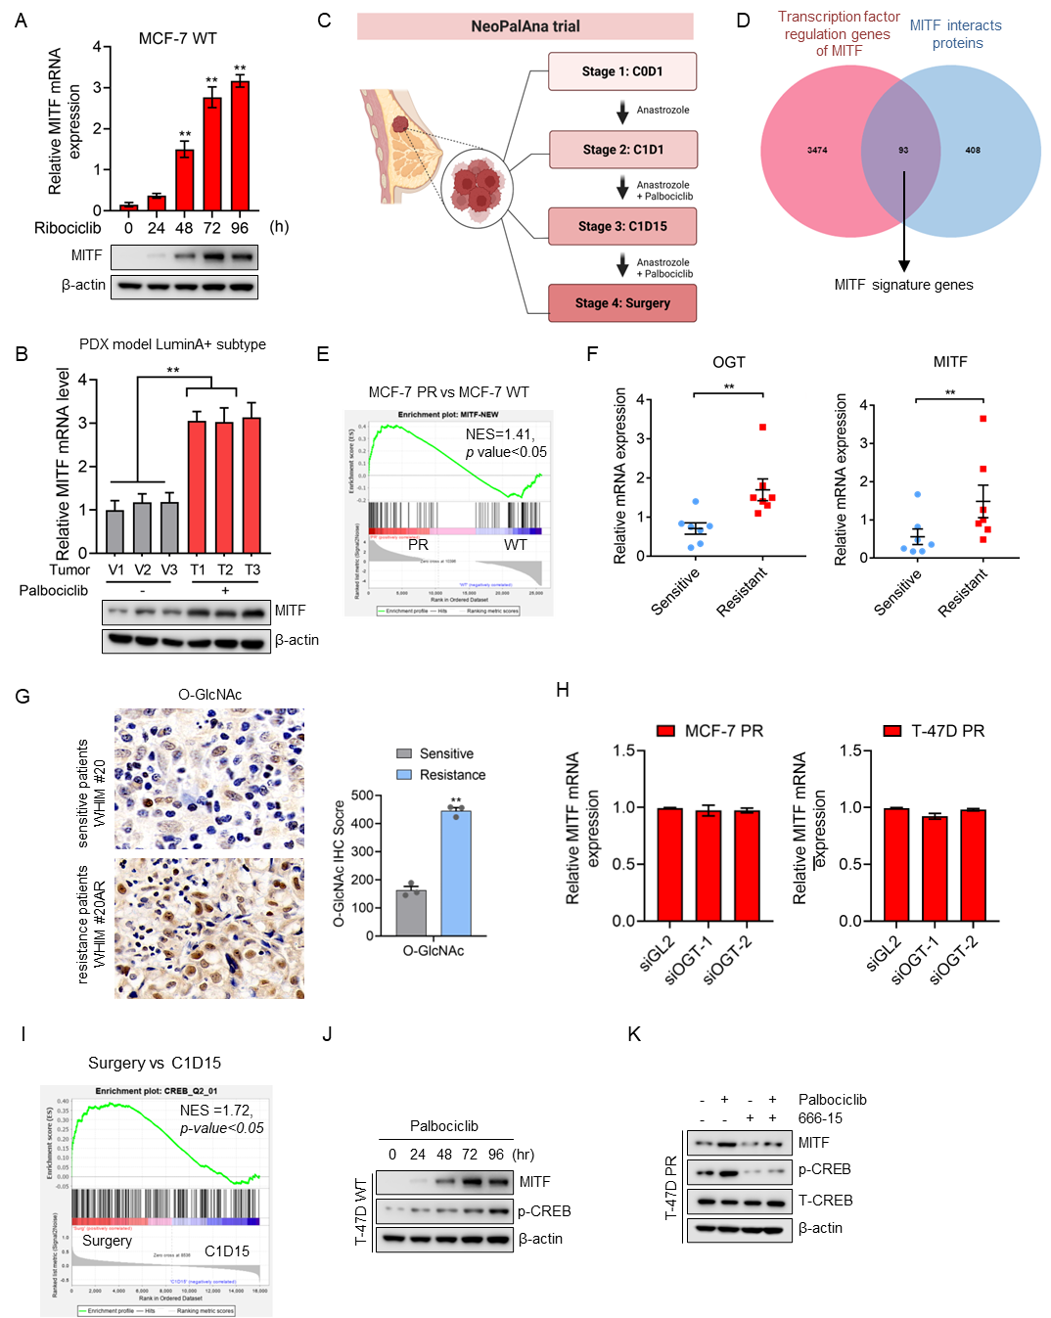

Supplementary Figure 6. MITF-mediated pathway is activated in response to palbociclib and elevated in tumors from palbociclib-resistant breast cancer patients
(A) MCF-7 cells were collected after indicated treatments and then subjected to qPCR or immunoblotting to examine the expression of indicated genes and proteins. (B) PDX model LuminA+ tumors from mice were collected after indicated treatments and then subjected to qPCR and immunoblotting to examine the expression of indicated genes and proteins. (C) Schematic of the stages of the NeoPalAna trial. (D) Venn diagram to show the overlapping of proteins that interact with MITF (by mass-spec analysis) and genes that are functionally associated with MITF (by PahtwayNet analysis). Totally 93 genes were identified and these genes were defined as MITF signature geneset. (E) GSEA profiling to show enrichment of the MITF signature geneset in the MCF-7 PR cells vs. MCF-7 cells. (F) Palbociclib-resistant and sensitive breast cancer PDX cells were collected and followed by qPCR to examine the expression of indicated genes. (G) Representative images of IHC staining for O-GlcNAc in PDX lines WHIM 20AR and WHIM 20. (H) MCF-7 PR and T-47D PR cells were collected after treatments as indicated and then subjected to qPCR to examine the expression of genes as indicated. (I) GSEA profiling to show enrichment of the CREB geneset in the Surgery group vs. C1D15 group. (J-K) T-47D cell (J) and T-47D PR cells (K) were collected after indicated treatments and then followed by immunoblotting for the indicated proteins.

