Supplementary material

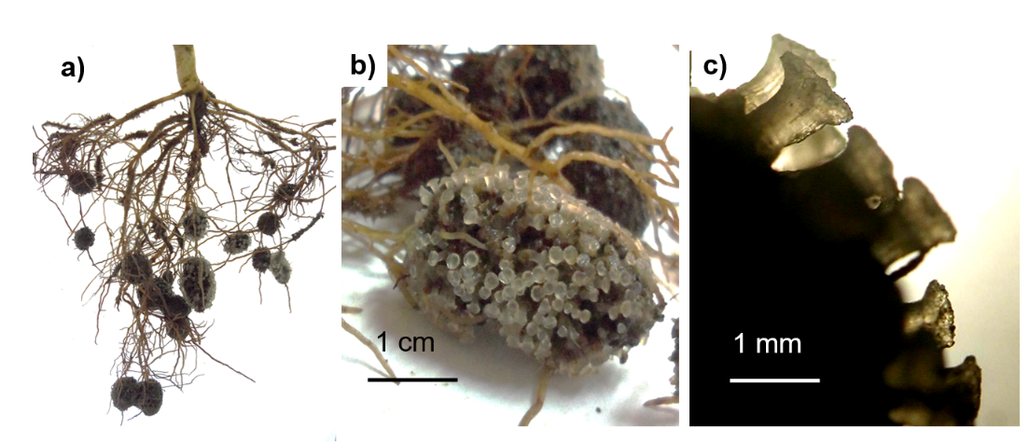
Figure supplementary 1 a) Root system of Gevuina avellana, b) cluster roots and c) magnified rootlets with “claviform” tips of a mature cluster root.

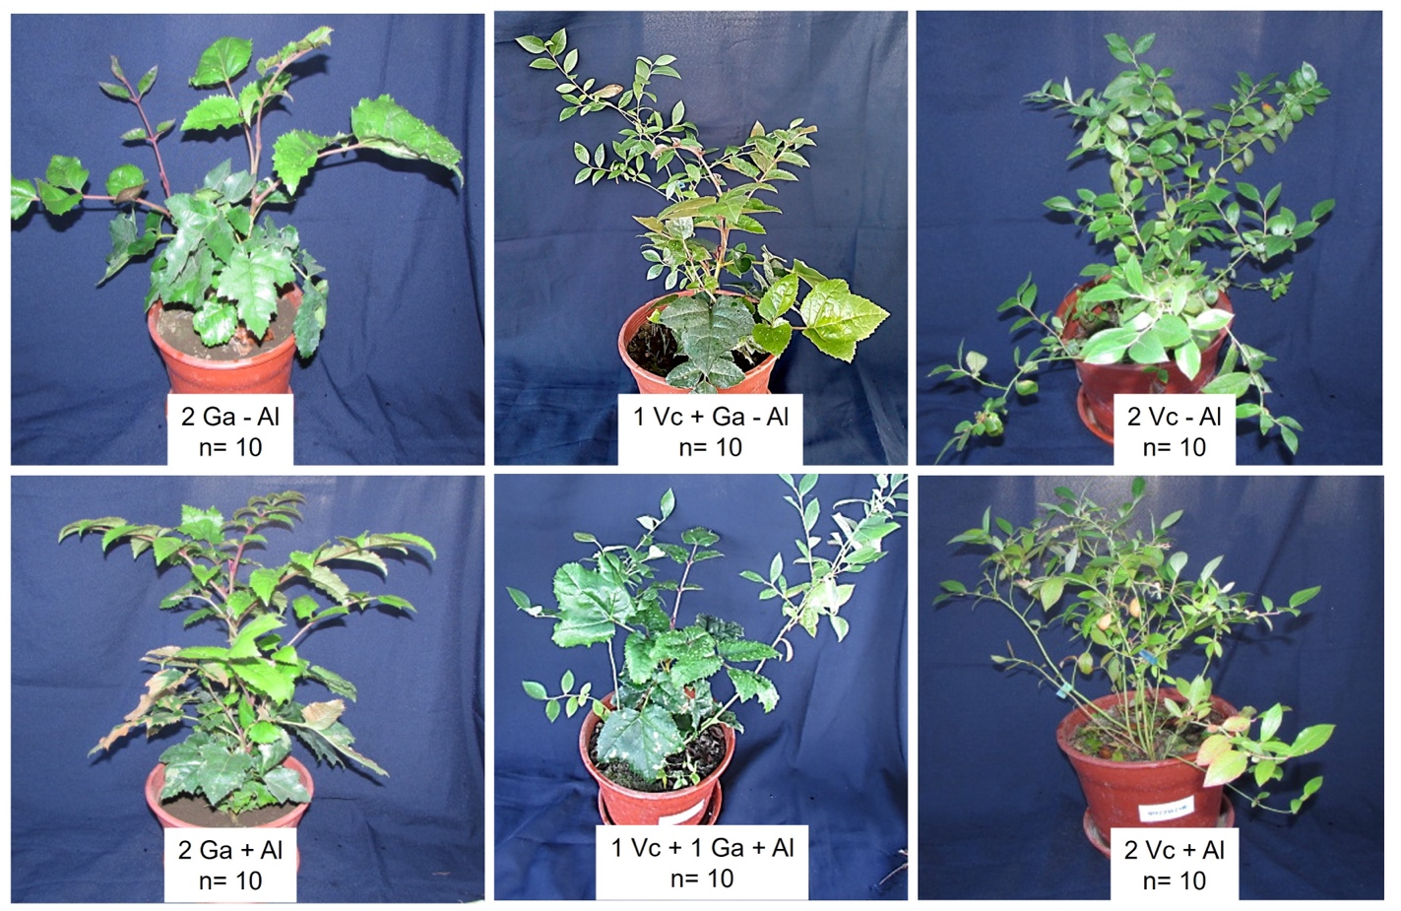 Figure supplementary 2. Plants of Gevuina avellana and Vaccinium corymbosum growing alone or in combination with or without aluminum (Al) supplementation (as Al₂(SO₄)₃)) at the end of the experiment.

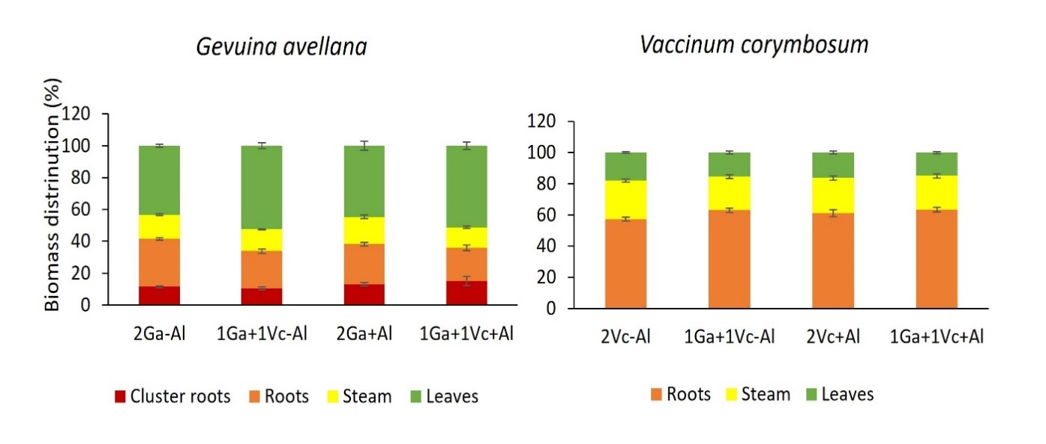 Figure supplementary 3. Biomass distribution of Gevuina avellana and Vaccinium corymbosum growing alone or in combination with or without aluminum sulfate (Al₂(SO₄)₃) supplementation.

