Theoretical investigations on the antioxidant potential of a non-phenolic compound thymoquinone: a DFT Approach

Jewel Hossen, Md. Abbas Ali

Department of Chemistry, Rajshahi University of Engineering & Technology, Rajshahi, Rajshahi-6204, Bangladesh

Corresponding author:
Jewel Hossen, Department of Chemistry, Rajshahi University of Engineering & Technology, Rajshahi, Rajshahi-6204, Bangladesh, E-mail: jewelhossenruet@gmail.com, Orchid ID: 0000-0003-4365-6272

Figure 1. Total energy changes of TQ along the optimization process in gas phase and water medium

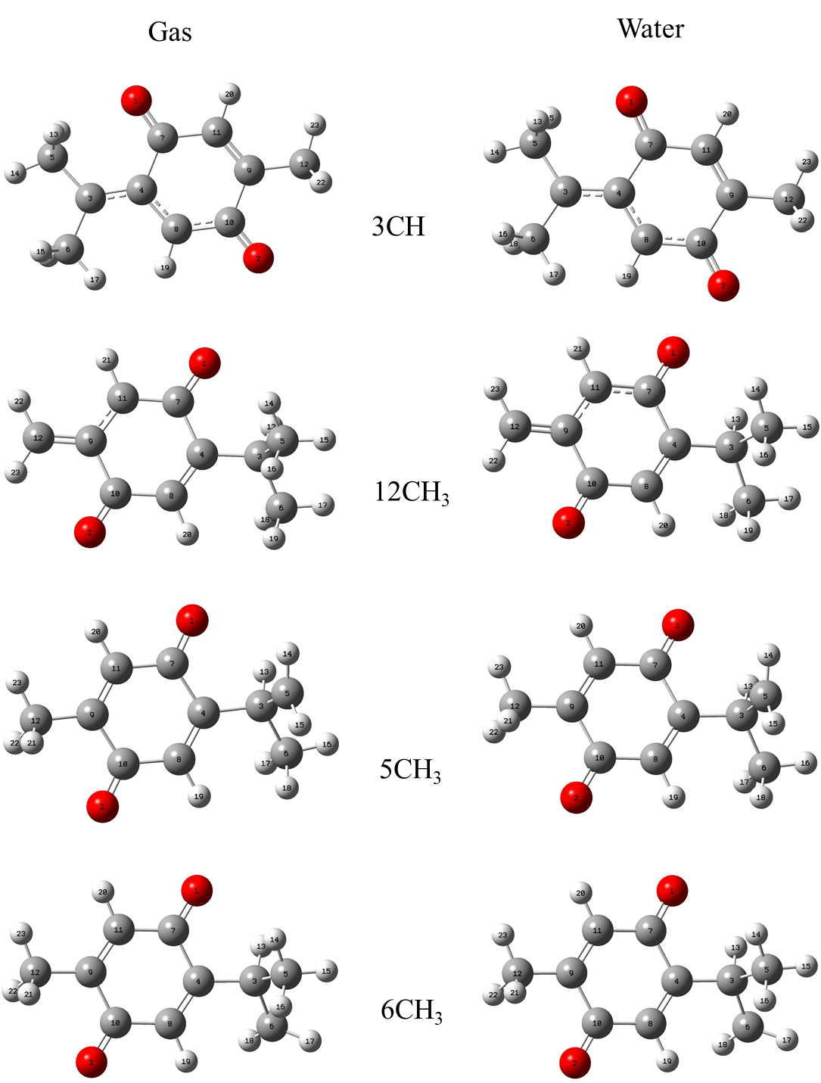
Figure 2. Structures of radicals after abstraction of hydrogen atom from 3CH, 12CH₃, 5CH₃ and 6CH₃ groups of thymoquinone molecule in gas and water optimized at B3LYP/6-311+G(d,p) level of theory
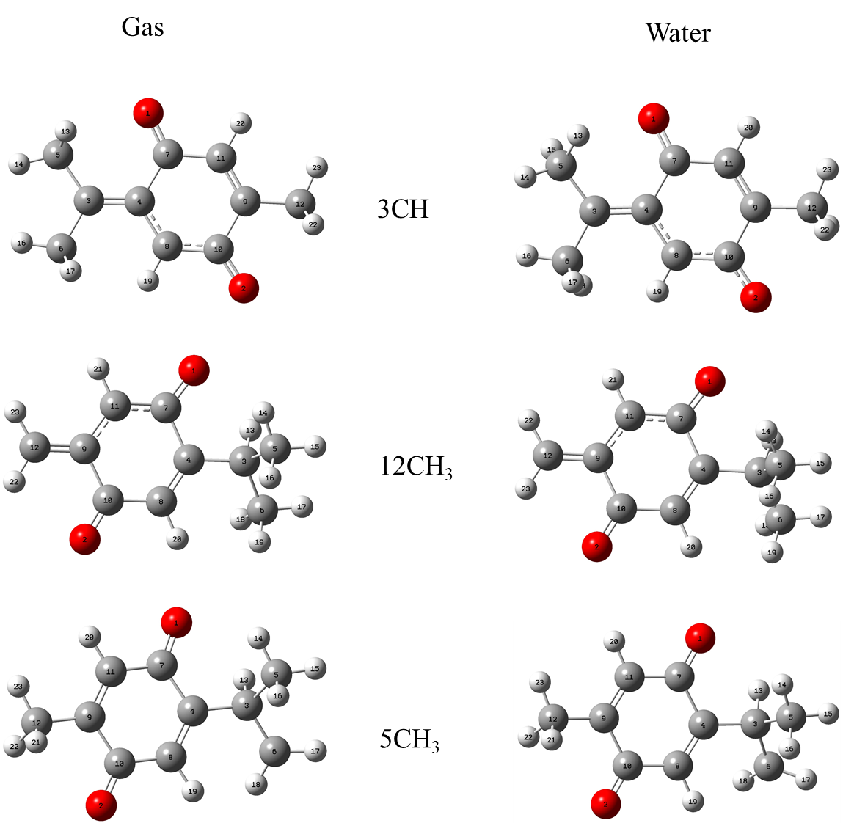
Figure 3. Structures of anions after removal of proton from 3CH, 12CH₃, 5CH₃ and 6CH₃ groups of thymoquinone molecule in gas and water optimized at B3LYP/6-311+G(d,p) level of theory

