Supporting Information
Copper oxide nanoparticles suppress retinal angiogenesis via inducing endothelial cell cuproptosis
Haorui Zhang^{1†}, Chang Cai^{1,2†}, Qing Li^{1†}, Zheng Nie, Mengzhu Wang, Yongxuan Liu, Wei Shen^{1*}, Hongyuan Song^{1*}
¹Department of Ophthalmology, Shanghai Changhai Hospital, No. 168 Changhai Road, Shanghai, 200433, China.
²Department of Spine Surgery, Changzheng Hospital, No. 415 Fengyang Road, Shanghai, 200040, China.
*Correspondence should be addressed to Wei Shen: shenwei@smmu.edu.cn, Hongyuan Song: hongyuansong@hotmail.com (H. Song).
†These authors contributed equally to this work.

The Supporting Information includes:
A complete description of supplementary results (Supplemental Figure1-4).

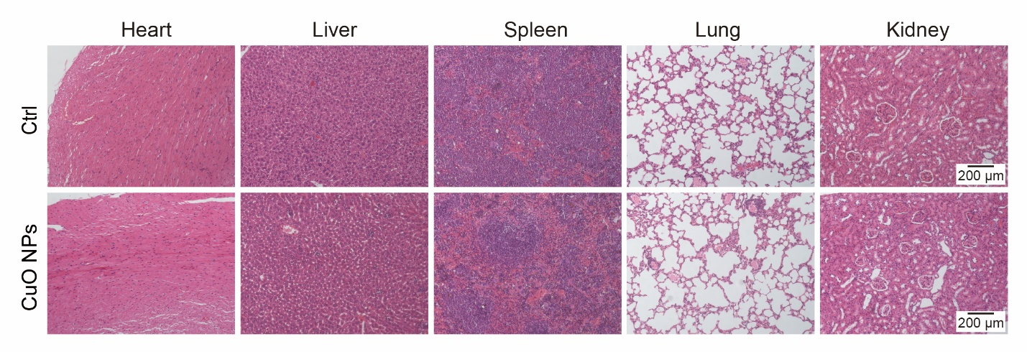
Supplemental Figure 1. Histological data of the heart, liver, spleen, lung, liver and kidney using HE staining. Scale bar: 200 μm.
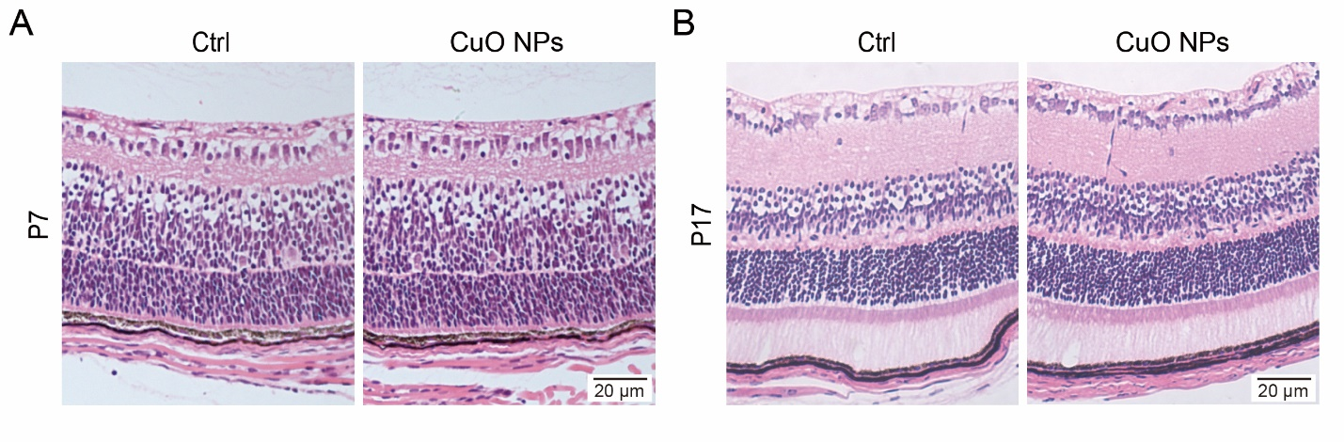
Supplemental Figure 2. Representative images of HE staining of mouse retina of P7 (A) and P17 (B) with different treatments. Scale bar: 20 μm.
Supplemental Figure 3. Hepatic and renal function of mice after treatment with CuO NPs. None of the indicators were changed by CuO NPs, including aspartate aminotransferase (AST) (A), alanine aminotransferase (ALT) (B), blood urea nitrogen (BUN) (C), creatinine (CR) (D)and uric acid (UA) (E). The data are presented as the means ± SD. n = 3, two-tailed t test.
Supplemental Figure 4. Blood biochemistry of mice after treatment with CuO NPs. None of the indicators were changed by CuO NPs, including white blood cell (WBC) (A), red blood cell (RBC) (B), platelet (PLT) (C), hemoglobin (HGB) (D) and mean corpuscular volume (MCV) (E). The data are presented as the means ± SD. n = 3, two-tailed t test.

