Supporting Information

Cellular dynamics in the maize leaf growth zone during recovery from chilling depends on the leaf developmental stage
Cindy M.S. Lainé¹, Hamada AbdElgawad^{1,2}, Gerrit T.S. Beemster¹
¹Laboratory for Integrated Molecular Plant Physiology Research (IMPRES), Department of Biology, Antwerp University, Groenenborgerlaan 171, 2020 Antwerp, Belgium
²Botany and Microbiology Department, Faculty of Science, Beni-Suef University, Beni-Suef 62511, Egypt
Supplemental Method

Method S1: Explanation for correction of the kinematic parameters when leaf growth is in non steady-state
- Steady-state assumption
See kinematic calculation under steady-state assumption in the papers of Sprangers et al. 2016 and Bertels and Beemster 2020. The calculated kinematic parameters under steady-state assumption are illustrated by dotted lines in Figure 8.
- Correction for the l_{mat}: Use mature cell length from the cell length profile to recalculate the kinematic parameters for the 1st (D1 and D4) and 2nd day of recovery (D2 and D5)
Based on the cell length profile, we realized that the mature cell length after 2-days cold recovery (d_{n}) corresponds to the cells that were still elongating at 1-day cold recovery (d_{n-1}) (See the dotted vertical line in Fig. 6b, e). Following this, it is possible to re-calculate cell production (P’) (1) by replacing the length of the mature cell at d_{n} with the length of the mature cell at d_{n+1}:
$P^{'}(dn) = \frac{LER (dn)}{ l mat' dn+1}$ (eqt 1)
Where P’ is the cell production rate per unit leaf length with corrected l_{mat}, LER is the Leaf Elongation Rate, l mat is the length of the mature cells and dn and dn+1 correspond to the day at which the kinematic parameters are measured. From this new equation, it is possible to recalculate cell division rate (D’), cell cycle duration (Tc’), time in the elongation zone (Tel’), Relative cell elongation rate (Rel’), and time cells spend in the division zone (Tdiv’).
$D^{'}= \frac{P'}{ N mer }$ (eqt 2) $Tc'= \frac{ln⁡(2)}{ D'}$ (eqt 3) $Tel’ = \frac{Nel}{P'}$ (eqt 4)
$Rel’ = \frac{(\ln{lmat'-\ln{ldiv)}}}{Tel'}$ (eqt 5) $Tdiv' = log2 \left(Nmer\right)*Tc'$ (eqt 6)
Where N_{mer} is the number of cells in the meristem, N_{el} is the number of cells in the elongation zone and l_{div} is the length of the cells leaving the meristem. The effect of this transformation is illustrated by dashed lines in Figure 8.
- Non steady-state assumption
Under non steady-state conditions, density changes in the division zone need to be taken into account to calculate the cell division rate (D’’) and cell production rate (P’’) (Silk, 1992; Fiorani and Beemster, 2006). They represent additional cells that are produced but don’t leave the meristem zone when cell density increases, or excess cells that leave the meristem when cell density decreases in the meristem, respectively.
To calculate the rate of density change, we considered a meristem zone of 2 cm for which we determined the number of cells from the cell length profile in function of time (a).
Number of cells in the meristem by kinematic analysis (performed with a stable meristem size of 2cm) of the direct effect of cold and its recovery on cell division and expansion. Plants in control condition (green line) were harvested from D0 before leaf emergence to D5 after leaf emergence. Cold-treated plants (blue line) were either placed in the cold at D0 before leaf emergence (light blue) or D3 after leaf emergence (dark blue). Those plants were harvested directly after cold (D0 and D3), 1 day after cold recovery (D1 and D4), and 2 days after cold recovery (D2 and D5). Data are represented as mean ± SE (n=6-7).
To determine, rate of density change (∆Density) in the meristem we used calculated the derivative of a 3 or 5 points polynomial fitted to the data of cold treated and control plants, respectively:
$∆n = \frac{y' }{24h}$ (eqt 7)
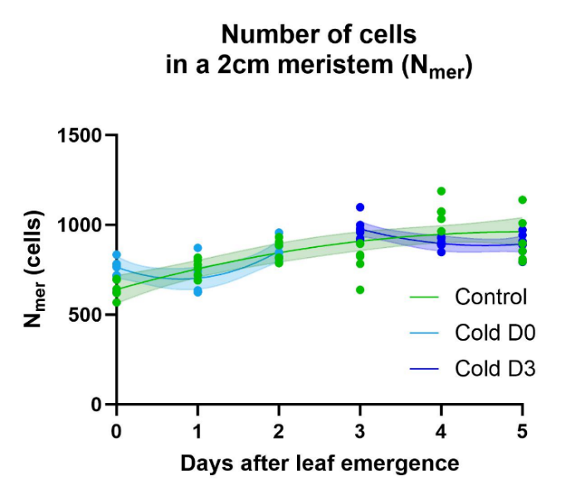
Where y’ (y’=2ax+b) is the derivative of the polynomial equation (y=ax²+ bx +c). (b)
(b)
Number of cells in the meristem by kinematic analysis (performed with a stable meristem size of 2cm) with 3 or 5 points second order polynomial fitted to the data of cold treated and control plants, respectively. Detailed calculation of ∆n can be found in the table below.
y _{Control} = -12,846x² + 128,42x+640,28
y _{Cold D0} = 106x²-168,92x+765,49
y _{Cold D3} =38,984x²-354,18x+640,28

 |  | D0 | D1 | D2 | D3 | D4 | D5
Calculation ∆n from the derivative | Control | ∆0 = (2*-12,846x0 + 128,42)/24 | ∆1 = (2*-12,846x1 + 128,43)/24 | ∆2 = (2*-12,846x2 + 128,44)/24 | ∆3 = (2*-12,846x3 + 128,45)/24 | ∆4 = (2*-12,846x4 + 128,46)/24 | ∆5 = (2*-12,846x5 + 128,47)/24
Calculation ∆n from the derivative | Cold D0 | ∆0 = (2*106x0-168,92)/24 | ∆1 = (2*106x1-168,93)/24 | ∆2 = (2*106x2-168,94)24
Calculation ∆n from the derivative | Cold D3 |  |  |  | ∆3 = (2*38,984x3-354,18)/24 | ∆4 = (2*38,984x4-354,19)/24 | ∆5 = (2*38,984x5-354,20)/24
∆n obtained | Control | 5,35 | 4,28 | 3,21 | 2,14 | 1,07 | 0,00
∆n obtained | Cold D0 | -7,04 | 1,80 | 10,63
∆n obtained | Cold D3 |  |  |  | -5,01 | -1,76 | 1,49

Once the delta number of extra cells produced each day is obtained, we used it to re-calculate the cell production rate (P’’) and cell division rate (D’’) under non steady-state conditions (Erickson, 1976; Beemster and Baskin, 1998).
$P^{''}=P' + ∆n$ (eqt 8) $D''= \frac{P' + ∆n }{N}$ (eqt 9)
Where P’ is the cell production rate between 2 successive days, ∆_{n} is the number of cells produced in the meristem per hour and D” is the cell division rate at a non steady-state. This method was tested by comparing its output with the classical method during steady growth. The effect of this transformation is illustrated by full lines in Figure 8b & d.

