Appendix

A1. Distribution of Robot Density
Figure A1. Distribution of the variation in robot density between 1997 and 2017
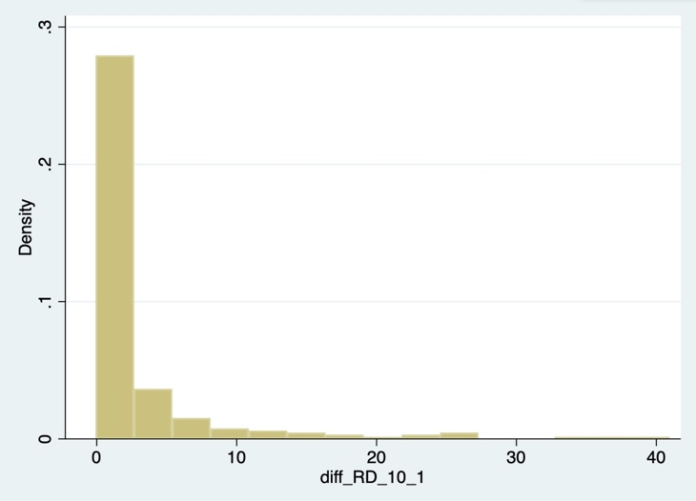 | 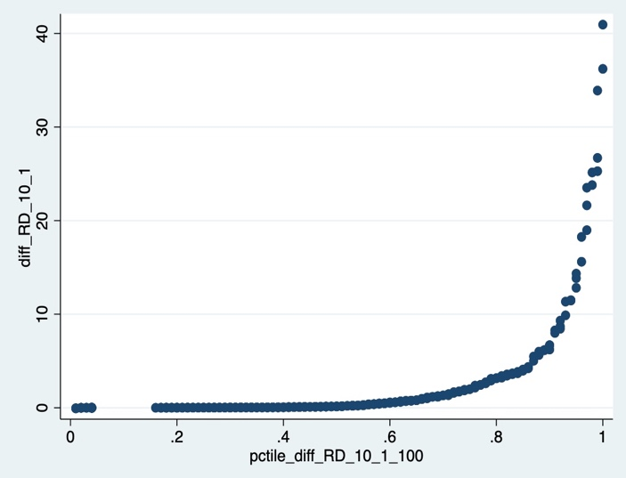

A2. Replication of the GM main results

Table A2.1. Changes in Robots Input and Growth on Productivity, Value Added and Hours Worked (1993-2007): OLS and IV Estimates – without country trend – comparison with GM
 |  |  | $$△ln⁡(VA/H)$$ |  | $$△ln⁡(VA)$$ |  | $$△ln⁡(H)$$
 |  |  | Current work | GM | Current work | GM | Current work | GM
A. OLS
Percentile of $△(\#\frac{robots}{hours})/100$ |  |  | 0.330*** | 0.359*** | 0.385*** | 0.336*** | 0.055 | -0.023
 |  |  | (0.125) | (0.106) | (0.135) | (0.117) | (0.116) | (0.114)
B. Instrumental Variable
Percentile of $△(\#\frac{robots}{hours})/100$ |  |  | 0.877*** | 0.833*** | 0.619*** | 0.545*** | -0.258 | -0.289
 |  |  | (0.198) | (0.188) | (0.159) | (0.155) | (0.175) | (0.169)
First-stage F-statistic |  |  | 124.3 | 93.7 | 124.3 | 93.7 | 124.3 | 93.7
Observations |  |  | 238 | 238 | 238 | 238 | 238 | 238
Country Trend |  |  | No | No | No | No | No | No
Robust standard errors in parenthesis. Regressions weighted by each industry’s 1993 share of hours within a country.

Table A2.2. Changes in Robots Input and Growth on Productivity, Value Added and Hours Worked (1993-2007): OLS and IV Estimates – with country trend – comparison with GM
 |  |  | $$△ln⁡(VA/H)$$ |  | $$△ln⁡(VA)$$ |  | $$△ln⁡(H)$$
 |  |  | Current work | GM | Current work | GM | Current work | GM
A. OLS
Percentile of $△(\#\frac{robots}{hours})/100$ |  |  | 0.567*** | 0.572*** | 0.647*** | 0.602*** | 0.079 | 0.03
 |  |  | (0.131) | (0.118) | (0.138) | (0.121) | (0.104) | (0.099)
B. Instrumental Variable
Percentile of $△(\#\frac{robots}{hours})/100$ |  |  | 0.918*** | 0.873*** | 0.688*** | 0.607*** | -0.230 | -0.266
 |  |  | (0.161) | (0.157) | (0.142) | (0.143) | (0.160) | (0.155)
First-stage F-statistic |  |  | 161.9 | 152.6 | 161.9 | 152.6 | 161.9 | 152.6
Observations |  |  | 238 | 238 | 238 | 238 | 238 | 238
Country Trend |  |  | Yes | Yes | Yes | Yes | Yes | Yes
Robust standard errors in parenthesis. Regressions weighted by each industry’s 1993 share of hours within a country.
TableA2.3. Changes in Robots Input and Growth on Productivity, Value Added and Hours Worked (1993-2007): OLS and IV Estimates – without country trend
 |  |  | $$△ln⁡(VA/H)$$ |  | $$△ln⁡(VA)$$ |  | $$△ln⁡(H)$$
 |  |  | Current work | GM | Current work | GM | Current work | GM
A. OLS
Percentile of $△(\#\frac{robots}{hours})/100$ |  |  | 0.330 | 0.359 | 0.385* | 0.336* | 0.055 | -0.023
 |  |  | (0.253) | (0.230) | (0.190) | (0.180) | (0.230) | (0.230)
B. Instrumental Variable
Percentile of $△(\#\frac{robots}{hours})/100$ |  |  | 0.877* | 0.880* | 0.619** | 0.570** | -0.258 | -0.300
 |  |  | (0.504) | (0.500) | (0.286) | (0.370) | (0.542) | (0.530)
First-stage F-statistic |  |  | 124.3 | 93.7 | 124.3 | 93.7 | 124.3 | 93.7
Observations |  |  | 238 | 238 | 238 | 238 | 238 | 238
Country Trend |  |  | No | No | No | No | No | No
Two-way cluster (Country and Industry) standard errors in parenthesis. Regressions weighted by each industry’s 1993 share of hours within a country.

Table A2.4. Changes in Robots Input and Growth on Productivity, Value Added and Hours Worked (1993-2007): OLS and IV Estimates – with country trend
 |  |  | $$△ln⁡(VA/H)$$ |  | $$△ln⁡(VA)$$ |  | $$△ln⁡(H)$$
 |  |  | Current work | GM | Current work | GM | Current work | GM
A. OLS
Percentile of $△(\#\frac{robots}{hours})/100$ |  |  | 0.567* | 0.572* | 0.647** | 0.602** | 0.079 | 0.03
 |  |  | (0.288) | (0.27) | (0.253) | (0.230) | (0.260) | (0.250)
B. Instrumental Variable
Percentile of $△(\#\frac{robots}{hours})/100$ |  |  | 0.918* | 0.910* | 0.688** | 0.640** | -0.230 | -0.280
 |  |  | (0.487) | (0.490) | (0.322) | (0.400) | (0.530) | (0.520)
First-stage F-statistic |  |  | 161.9 | 152.6 | 161.9 | 152.6 | 161.9 | 152.6
Observations |  |  | 238 | 238 | 238 | 238 | 238 | 238
Country Trend |  |  | Yes | Yes | Yes | Yes | Yes | Yes
Two-way cluster (Country and Industry) standard errors in parenthesis. Regressions weighted by each industry’s 1993 share of hours within a country.

A3. Estimations with two-way clustered standard-errors

Table A3.1 Changes in Robots Input and Growth on Productivity, Value Added and Hours Worked: First period (1997-2007): OLS and IV Estimates
 |  |  | $$△ln⁡(VA/H)$$ |  | $$△ln⁡(VA)$$ |  | $$△ln⁡(H)$$
 |  |  | (1) | (2) | (3) | (4) | (5) | (6)
A. OLS
Percentile of $△(\#\frac{robots}{hours})/100$ |  |  | 0.555*** | 0.546** | 0.451*** | 0.545*** | -0.104 |  | -0.002
 |  |  | (0.194) | (0.214) | (0.159) | (0.183) | (0.202) |  | (0.249)
B. Instrumental Variable
Percentile of $△(\#\frac{robots}{hours})/100$ |  |  | 0.965*** | 0.804*** | 0.565** | 0.717*** | -0.400 |  | -0.087
 |  |  | (0.280) | (0.320) | (0.234) | (0.250) | (0.296) |  | (0.393)
First-stage F-statistic |  |  | 220.6 | 239.7 | 220.6 | 239.7 | 220.6 |  | 239.7
Observations |  |  | 269 | 256 | 269 | 256 | 269 |  | 256
Country Trend |  |  | Yes | Yes | Yes | Yes | Yes |  | Yes
Two-way clustered standard errors in parenthesis. Regressions weighted by each industry’s available initial share of hours within a country. Models 1,3 and 5 normalize variables by total hours worked by employees whereas models 2, 4 and 6 normalize variables by total hours worked by persons engaged.

Table A3.2. Changes in Robots Input and Growth on Productivity, Value Added and Hours Worked: Full sample (1997-2017): OLS and IV Estimates
 |  |  | $$△ln⁡(VA/H)$$ |  | $$△ln⁡(VA)$$ |  | $$△ln⁡(H)$$
 |  |  | (1) | (2) | (3) | (4) | (5) | (6)
A. OLS
Percentile of $△(\#\frac{robots}{hours})/100$ |  |  | 0.740*** | 0.503 | 0.631** | 0.591** | -0.109 | 0.088
 |  |  | (0.195) | (0.346) | (0.246) | (0.245) | (0.263) | (0.292)
B. Instrumental Variable
Percentile of $△(\#\frac{robots}{hours})/100$ |  |  | 1.070*** | 0.697 | 0.532** | 0.535** | -0.538 | -0.161
 |  |  | (0.302) | (0.442) | (0.231) | (0.252) | (0.368) | (0.419)
First-stage F-statistic |  |  | 361.9 | 397.1 | 361.9 | 397.1 | 361.9 | 397.1
Observations |  |  | 252 | 241 | 252 | 241 | 252 | 241
Country Trend |  |  | Yes | Yes | Yes | Yes | Yes | Yes
Two-way clustered standard errors in parenthesis. Regressions weighted by each industry’s available initial share of hours within a country. Models 1,3 and 5 normalize variables by total hours worked by employees whereas models 2, 4 and 6 normalize variables by total hours worked by persons engaged.

Table A3.3 Changes in Robots Input and Growth on Productivity, Value Added and Hours Worked Second Period (2008-2017): OLS and IV Estimates
 |  |  | $$△ln⁡(VA/H)$$ |  | $$△ln⁡(VA)$$ |  | $$△ln⁡(H)$$
 |  |  | (1) | (2) | (3) | (4) | (5) | (6)
A. OLS
Percentile of $△(\#\frac{robots}{hours})/100$ |  |  | 0.269*** | 0.133 | 0.127 | 0.055 | -0.143 |  | -0.077
 |  |  | (0.080) | (0.127) | (0.128) | (0.138) | (0.097) |  | (0.086)
B. Instrumental Variable
Percentile of $△(\#\frac{robots}{hours})/100$ |  |  | 0.472*** | 0.280 | 0.229 | 0.098 | -0.243 |  | -0.182
 |  |  | (0.167) | (0.207) | (0.199) | (0.197) | (0.268) |  | (0.194)
First-stage F-statistic |  |  | 176.9 | 223.0 | 176.9 | 223.0 | 176.9 |  | 223.0
Observations |  |  | 270 | 283 | 270 | 283 | 270 |  | 283
Country Trend |  |  | Yes | Yes | Yes | Yes | Yes |  | Yes
Two-way clustered standard errors in parenthesis. Regressions weighted by each industry’s available initial share of hours within a country. Models 1,3 and 5 normalize variables by total hours worked by employees whereas models 2, 4 and 6 normalize variables by total hours worked by persons engaged.
A4. Regressions with observations until 2016

TableA4.1. Changes in Robots Input and Growth on Productivity, Value Added and Hours Worked Full Sample (1997-2016): OLS and IV Estimates
 |  |  | $$△ln⁡(VA/H)$$ |  | $$△ln⁡(VA)$$ |  | $$△ln⁡(H)$$
 |  |  | (1) | (2) | (3) | (4) | (5) | (6)
A. OLS
Percentile of $△(\#\frac{robots}{hours})/100$ |  |  | 0.710*** | 0.498*** | 0.589*** | 0.535*** | -0.134 |  | 0.013
 |  |  | (0.105) | (0.122) | (0.103) | (0.101) | (0.098) |  | (0.094)
B. Instrumental Variable
Percentile of $△(\#\frac{robots}{hours})/100$ |  |  | 1.056*** | 0.696*** | 0.443*** | 0.435*** | -0.612*** |  | -0.271**
 |  |  | (0.128) | (0.132) | (0.115) | (0.112) | (0.130) |  | (0.124)
First-stage F-statistic |  |  | 363.1 | 405.1 | 391.3 | 397.2 | 383.7 |  | 387.9
Observations |  |  | 267 | 254 | 267 | 254 | 267 |  | 254
Country Trend |  |  | Yes | Yes | Yes | Yes | Yes |  | Yes
Robust standard errors in parenthesis. Regressions weighted by each industry’s 1997 share of hours within a country. Models 1,3 and 5 normalize variables by total hours worked by employees whereas models 2, 4 and 6 normalize variables by total hours worked by persons engaged.
Table A4.2. Changes in Robots Input and Growth on Productivity, Value Added and Hours Worked Second Period (2008-2016): OLS and IV Estimates
 |  |  | $$△ln⁡(VA/H)$$ |  | $$△ln⁡(VA)$$ |  | $$△ln⁡(H)$$
 |  |  | (1) | (2) | (3) | (4) | (5) | (6)
A. OLS
Percentile of $△(\#\frac{robots}{hours})/100$ |  |  | 0.260*** | 0.141*** | 0.124** | 0.055 | -0.141*** |  | -0.092**
 |  |  | (0.054) | (0.051) | (0.062) | (0.060) | (0.051) |  | (0.045)
B. Instrumental Variable
Percentile of $△(\#\frac{robots}{hours})/100$ |  |  | 0.420*** | 0.237*** | 0.152* | 0.047 | -0.265*** |  | -0.189***
 |  |  | (0.080) | (0.146) | (0.089) | (0.082) | (0.084) |  | (0.068)
First-stage F-statistic |  |  | 208.5 | 266.4 | 208.5 | 266.4 | 208.5 |  | 266.4
Observations |  |  | 308 | 309 | 308 | 309 | 311 |  | 312
Country Trend |  |  | Yes | Yes | Yes | Yes | Yes |  | Yes
Two-way cluster (Country and Industry) standard errors in parenthesis. Regressions weighted by each industry’s 1997 share of hours within a country. Models 1,3 and 5 normalize variables by total hours worked by employees whereas models 2, 4 and 6 normalize variables by total hours worked by persons engaged.

A5. Regressions with controls and two-way clustered SE
Table A5.1. Changes in Robots Input and Growth on Productivity: First period (1997-2007): OLS and IV Estimates
 |  |  | $$△ln⁡(VA/H)$$ |  | $$△ln⁡(VA)$$ |  | $$△ln⁡(H)$$
 |  |  | (1) | (2) | (3) | (4) | (5) | (6)
A. OLS
Percentile of $△(\#\frac{robots}{hours})/100$ |  |  | 0.465** | 0.496** | 0.364** | 0.313** | -0.101 | -0.183
 |  |  | (0.161) | (0.174) | (0.141) | (0.145) | (0.145) | (0.185)
B. Instrumental Variable
Percentile of $△(\#\frac{robots}{hours})/100$ |  |  | 0.592*** | 0.666*** | 0.421*** | 0.333* | -0.172 | -0.334
 |  |  | (0.164) | (0.208) | (0.149) | (0.195) | (0.162) | (0.207)
First-stage F-statistic |  |  | 181.4 | 144.3 | 181.4 | 144.3 | 181.4 | 144.3
Controls |  |  | Yes | Yes | Yes | Yes | Yes | Yes
Country Trend |  |  | Yes | Yes | Yes | Yes | Yes | Yes
Observations |  |  | 156 | 156 | 156 | 156 | 156 | 156
Two-way clustered standard errors in parenthesis. Regressions weighted by each industry’s available initial share of hours within a country.

Table A5.2. Changes in Robots Input and Growth on Productivity: Full period (1997-2017): OLS and IV Estimates
 |  |  | $$△ln⁡(VA/H)$$ |  | $$△ln⁡(VA)$$ |  | $$△ln⁡(H)$$
 |  |  | (1) | (2) | (3) | (4) | (5) | (6)
A. OLS
Percentile of $△(\#\frac{robots}{hours})/100$ |  |  | 0.802*** | 0.857*** | 0.802*** | 0.857*** | -0.124 |  | -0.236
 |  |  | (0.254) | (0.247) | (0.254) | (0.247) | (0.220) |  | (0.192)
B. Instrumental Variable
Percentile of $△(\#\frac{robots}{hours})/100$ |  |  | 0.874*** | 0.887*** | 0.874*** | 0.887*** | -0.333 |  | -0.469*
 |  |  | (0.195) | (0.245) | (0.195) | (0.245) | (0.293) |  | (0.259)
First-stage F-statistic |  |  | 268.2 | 212.4 | 268.2 | 212.4 | 268.2 |  | 212.4
Controls |  |  | Yes | Yes | Yes | Yes | Yes |  | Yes
Country Trend |  |  | Yes | Yes | Yes | Yes | Yes |  | Yes
Observations |  |  | 117 | 117 | 117 | 117 | 117 |  | 117
Two-way clustered standard errors in parenthesis. Regressions weighted by each industry’s available initial share of hours within a country.

Table A5.3. Changes in Robots Input and Growth on Productivity: Second period (2008-2017): OLS and IV Estimates
 |  |  | $$△ln⁡(VA/H)$$ |  | $$△ln⁡(VA)$$ |  | $$△ln⁡(H)$$
 |  |  | (1) | (2) | (3) | (4) | (5) | (6)
A. OLS
Percentile of $△(\#\frac{robots}{hours})/100$ |  |  | 0.246*** | 0.284** | 0.157 | 0.186 | -0.089 |  | -0.097
 |  |  | (0.089) | (0.111) | (0.131) | (0.144) | (0.075) |  | (0.144)
B. Instrumental Variable
Percentile of $△(\#\frac{robots}{hours})/100$ |  |  | 0.390*** | 0.426*** | 0.152 | 0.117 | -0.237 |  | -0.309*
 |  |  | (0.102) | (0.093) | (0.142) | (0.156) | (0.168) |  | (0.170)
First-stage F-statistic |  |  | 136.4 | 103.0 | 136.4 | 103.0 | 136.4 |  | 103.0
Controls |  |  | Yes | Yes | Yes | Yes | Yes |  | Yes
Country Trend |  |  | Yes | Yes | Yes | Yes | Yes |  | Yes
Observations |  |  | 156 | 130 | 156 | 130 | 156 |  | 130
Two-way clustered standard errors in parenthesis. Regressions weighted by each industry’s available initial share of hours within a country.

