Extended data
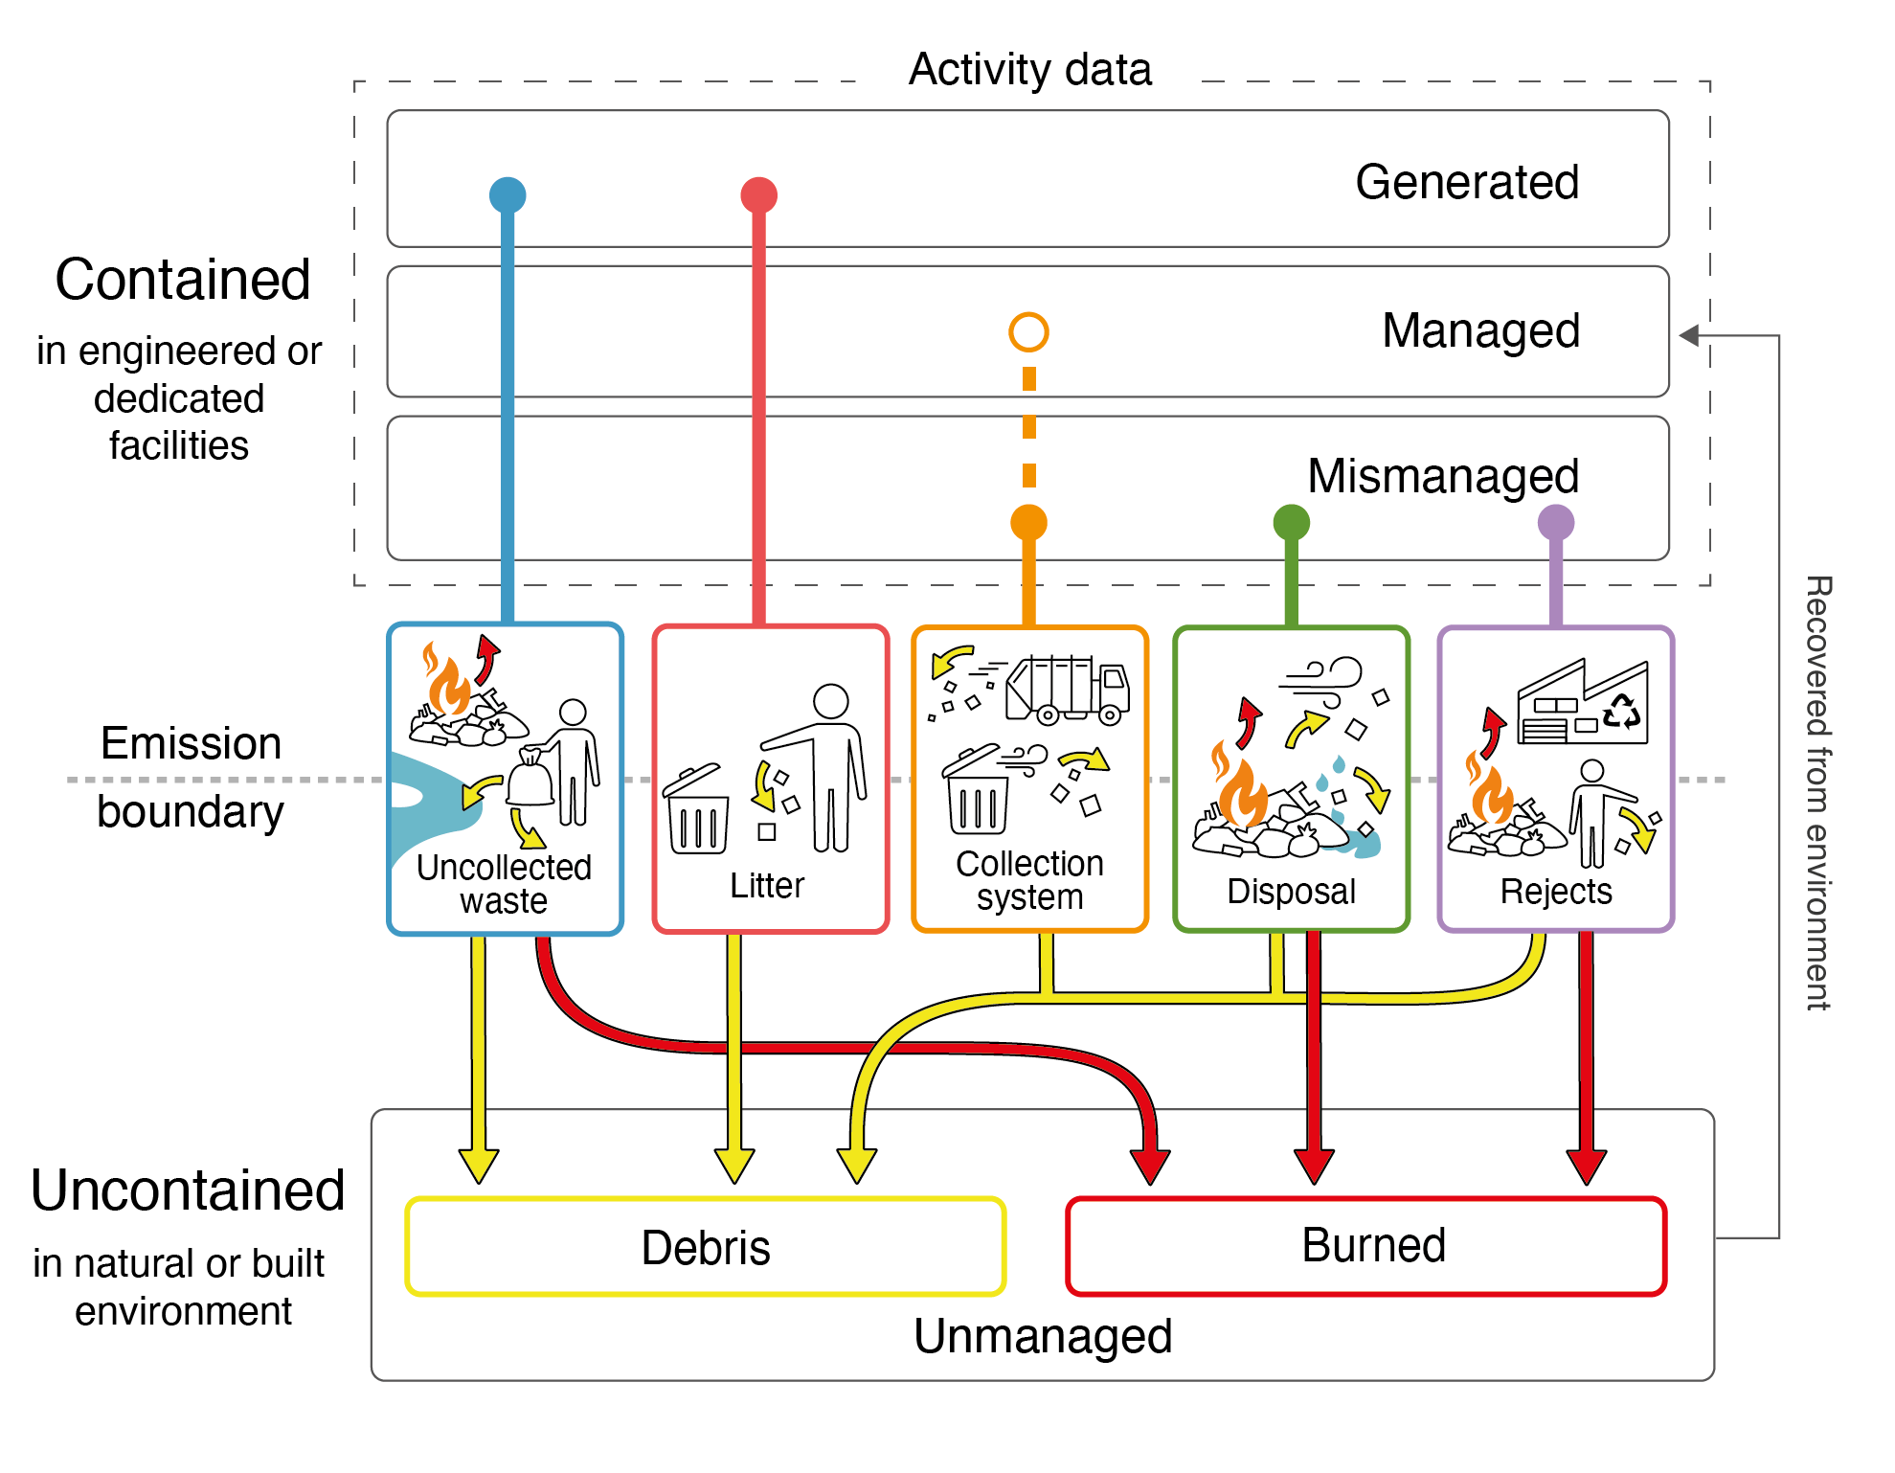
Extended data Fig. 1. The point at which material passes from the contained to an uncontained state is described here as the emission boundary. Material from five core emission sources originate from three system parts, each of which exhibit different containment characteristics.

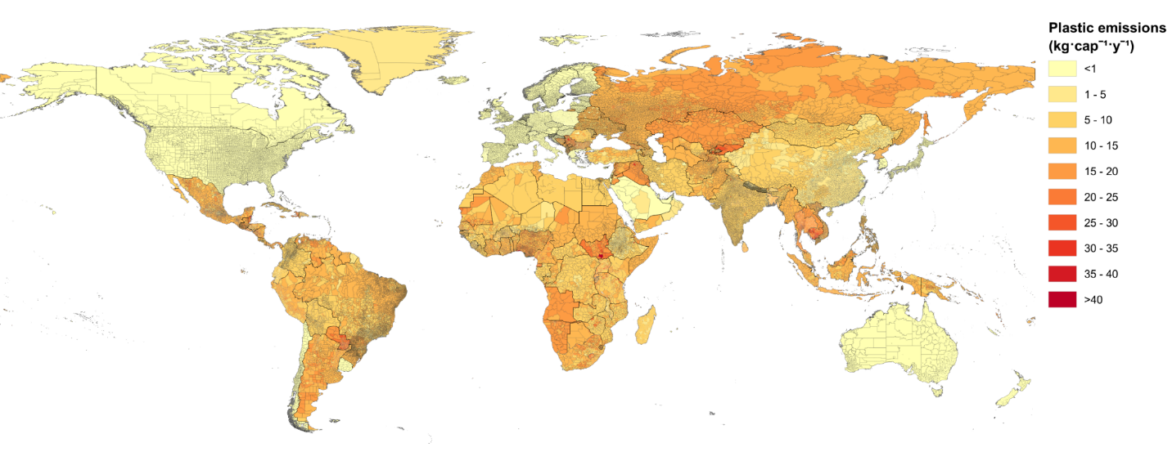
Extended data Fig. 2. Macroplastic emissions into the environment (debris and open burned) by municipality. Countries in the Global South have high per capita emissions compared to those in the Global North.
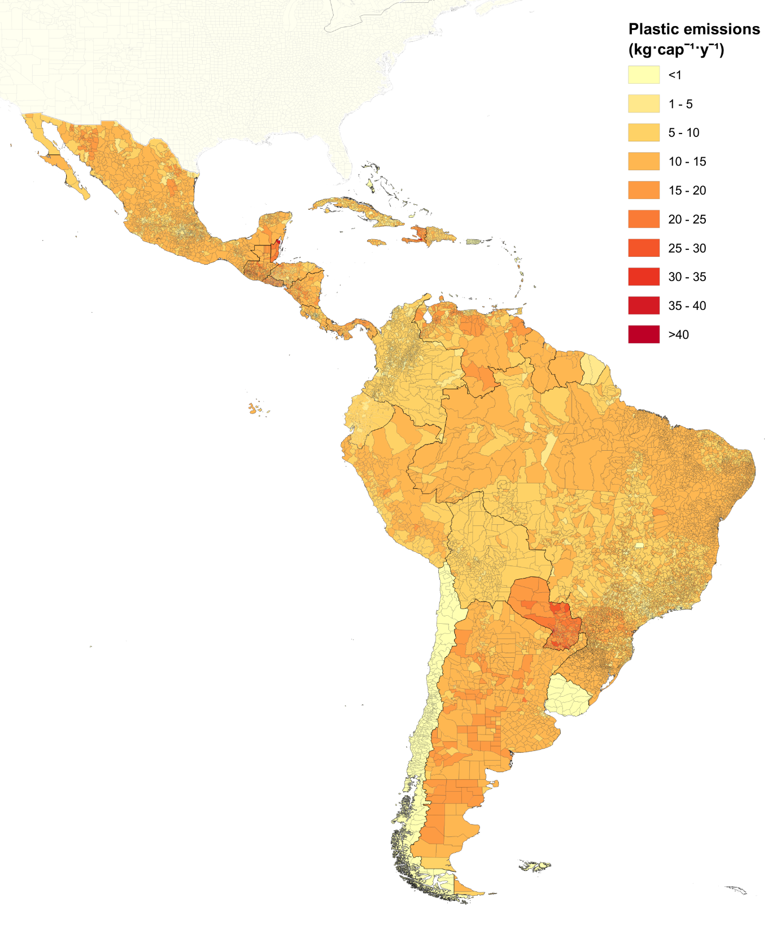
Extended data Fig. 3. Macroplastic emissions into the environment (debris and open burned) by municipality for Latin America and the Caribbean. Hotspots for per capita emissions include municipalities in Paraguay, Belize and Haiti, whereas municipalities in Uruguay and Chile have comparably lower emissions.

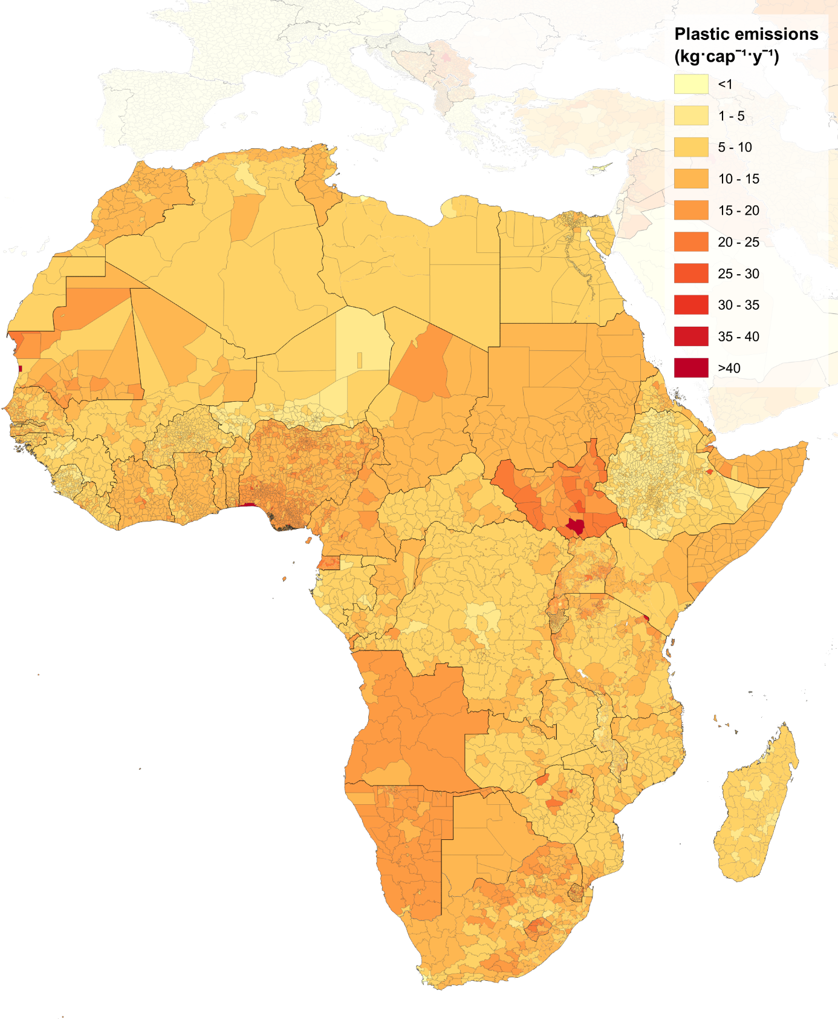
Extended data Fig. 4. Macroplastic emissions into the environment (debris and open burned) by municipality for Africa. Per capita emissions are high throughout the continent, with notable hotspots including municipalities in South Sudan, Angola, and Namibia. Several megacities standout as key hotspots including Lagos (Nigeria), Juba (South Sudan) and Nouakchott (Mauritania).

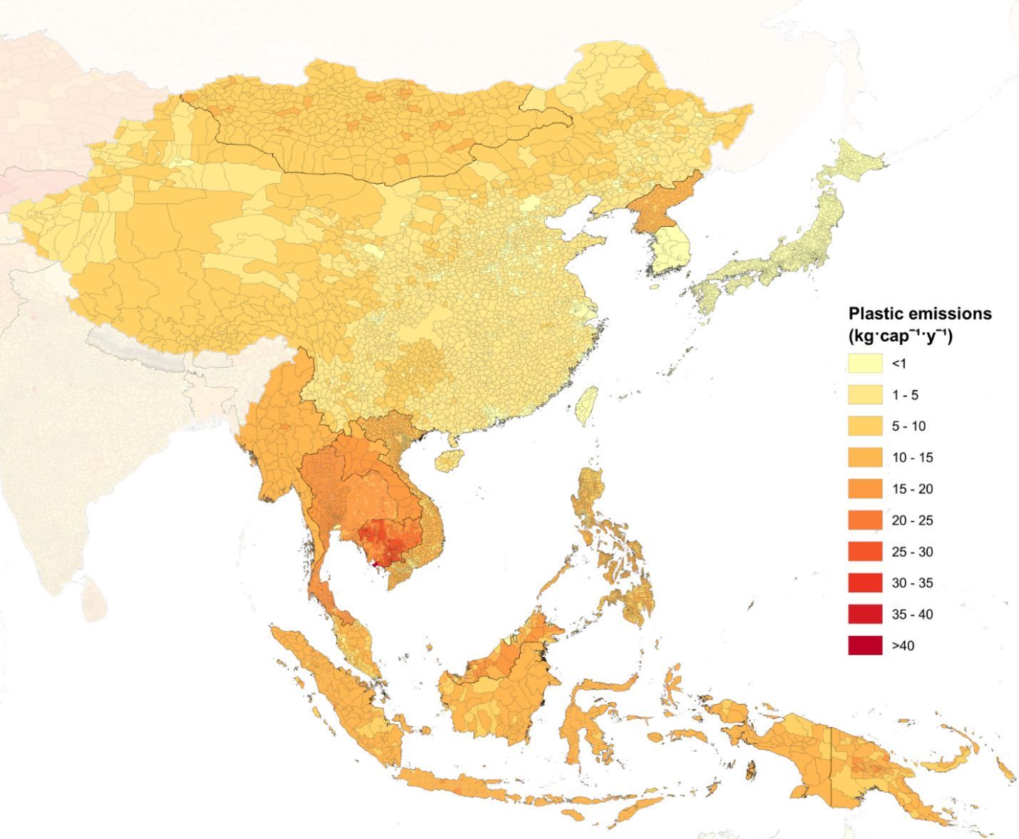
Extended data Fig. 4. Macroplastic emissions into the environment (debris and open burned) by municipality for Eastern Asia and South-Eastern Asia. Emissions on a per capita basis are low for municipalities in High income counties such as Japan and South Korea, but high throughout much of Southeast Asia, particularly Cambodia. Eastern China has low per capita emissions due to recent progress in solid waste management, however, emissions are marginally higher in Western China.

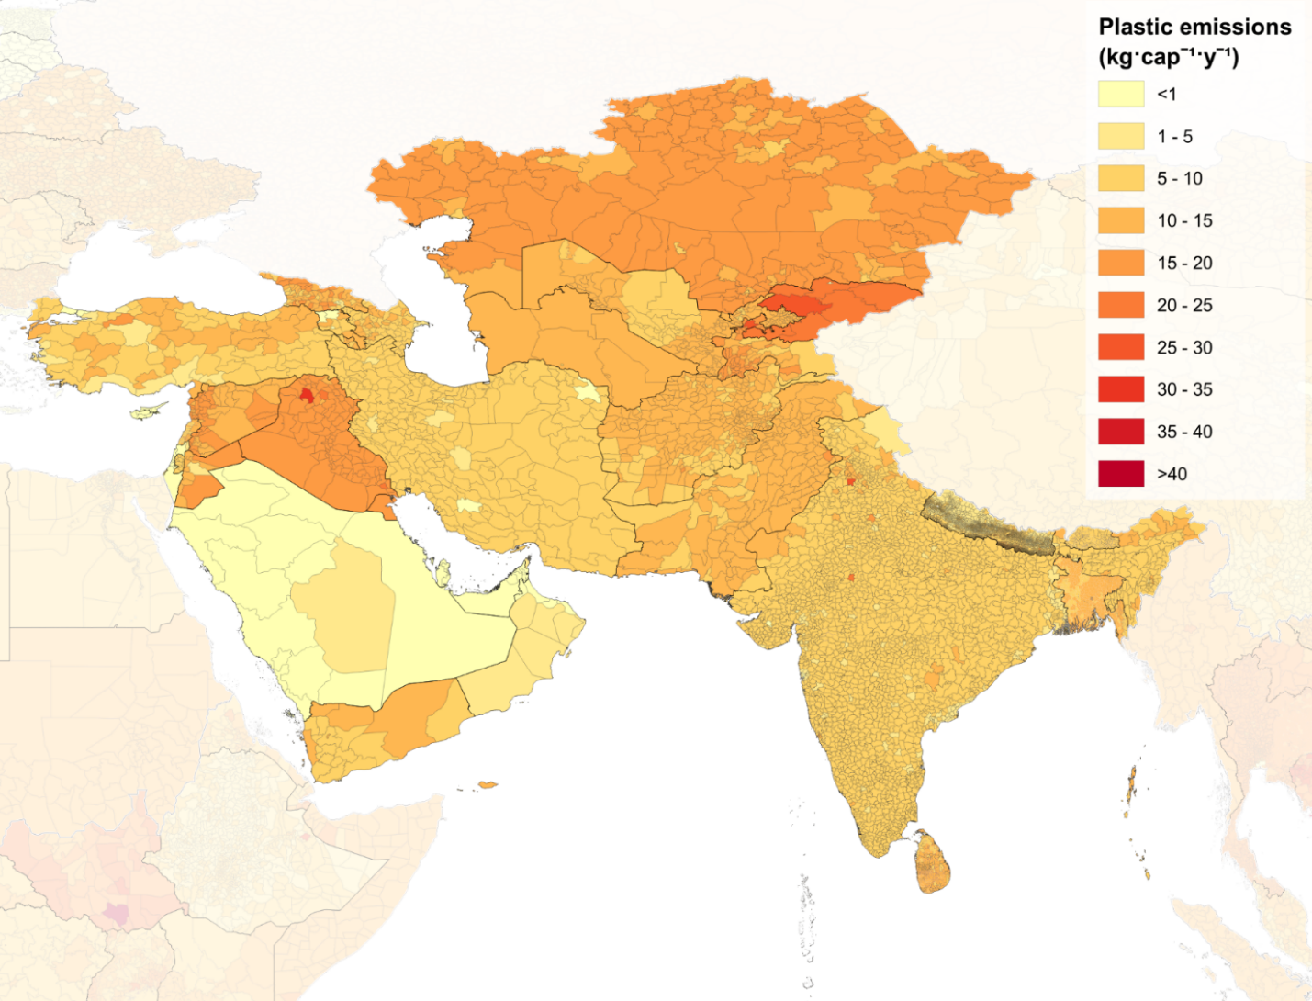
Extended data Fig. 5. Macroplastic emissions into the environment (debris and open burned) by municipality for Central Asia, Western Asia, and Southern Asia. Per capita emissions are high throughout the region, with the exception of municipalities in high income countries on the Arabian Peninsula such as Saudi Arabia, Qatar, and United Arab Emirates. Municipalities in Kyrgyzstan, Kazakhstan, Iraq, Jordan, and Syria have relatively high per capita emissions. Although India has the highest absolute emissions of all countries, on a per-capita basis the majority of its municipalities have between 5 and 10 kg·cap⁻¹·y⁻¹.

