(a) |  | (b) |  | (c)
(d) |  | (e) |  | (f)
(g) |  | (h) |  | (i)
(j) |  | 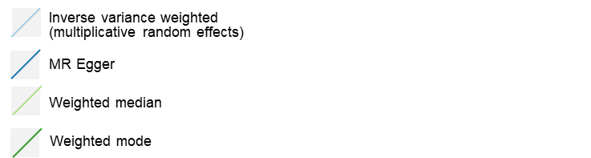
Supplementary figures 1. Scatter plots for effect sizes of SNPs for women’s reproductive traits and Postpartum depression. (a) Funnel plots for age at first sexual intercourse; (b) Funnel plots for age at menarche; (c) Funnel plots for age at first birth; (d) Funnel plots for age at menopause; (e) Funnel plots for lifetime number of sexual partners; (f) Funnel plots for age at last live birth; (g) Funnel plots for number of live births; (h) Funnel plots for spontaneous abortion; (i) Funnel plots for number of stillbirths; (j) Funnel plots for Number of spontaneous miscarriages. The x-axis represents the MR estimate of individual variants; the y-axis represents the inverse of their standard error. Colors indicate for approaches used in univariable MR analyses.
(a) |  | (b) |  | (c)
(d) |  | (e) |  | (f)
(g) |  | (h) |  | (i)
(j) |  | MR Egger  Inverse variance weighted
Supplementary figures 2. Funnel plots to show symmetrical distribution of individual variant estimates around the point estimate. (a) Funnel plots for age at first sexual intercourse; (b) Funnel plots for age at menarche; (c) Funnel plots for age at first birth; (d) Funnel plots for age at menopause; (e) Funnel plots for lifetime number of sexual partners; (f) Funnel plots for age at last live birth; (g) Funnel plots for number of live births; (h) Funnel plots for spontaneous abortion; (i) Funnel plots for number of stillbirths; (j) Funnel plots for Number of spontaneous miscarriages. The x-axis represents the MR estimate of individual variants; the y-axis represents the inverse of their standard error. Colors indicate for approaches used in univariable MR analyses.

