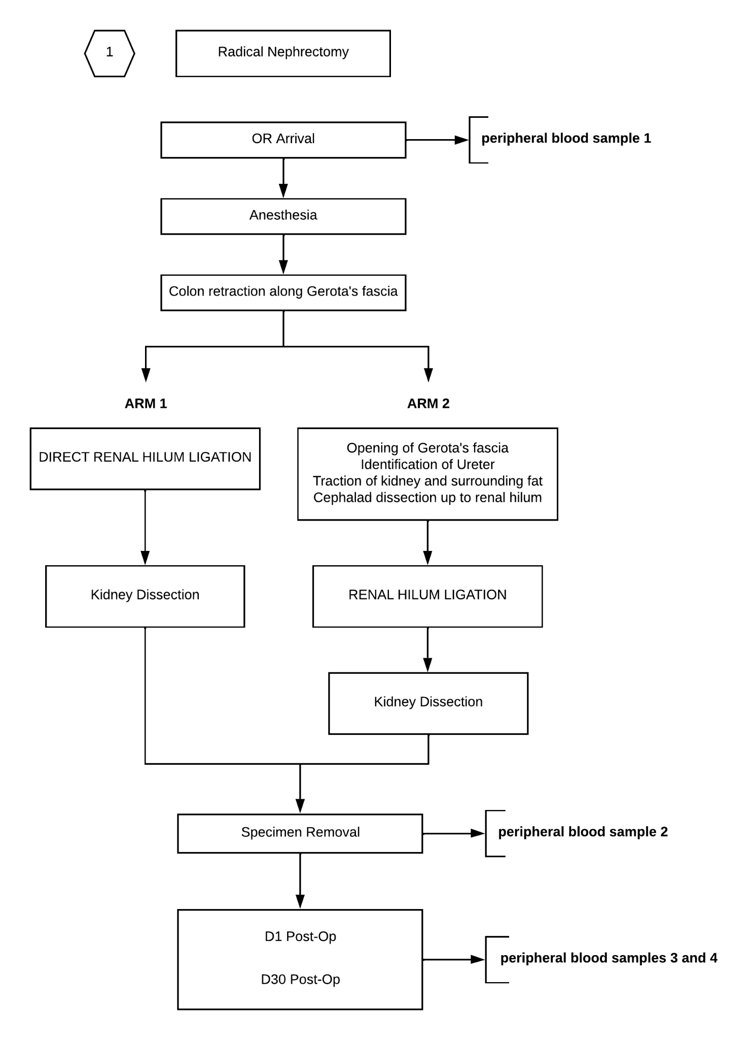
Figure S1. Study protocol flow chart.

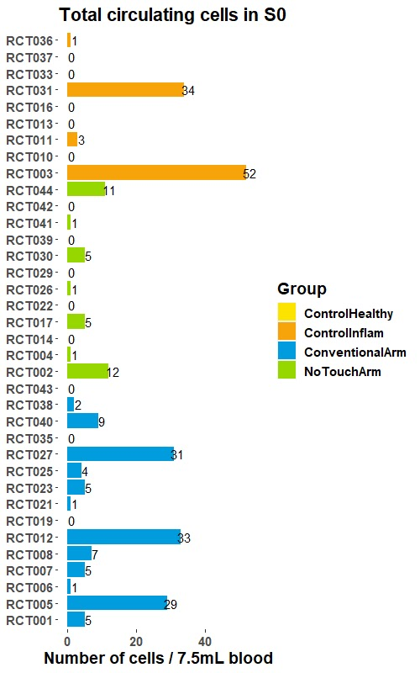
Figure S2. CMC counts per patient and time points.

S3. Survival (Kaplan-Meyer) Analysis
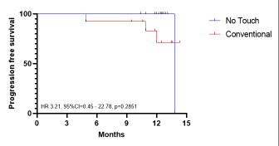

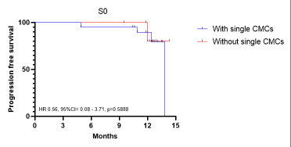

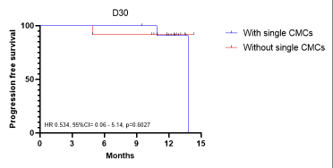

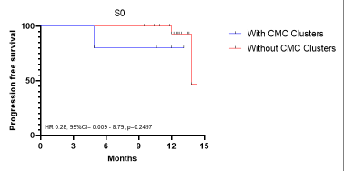
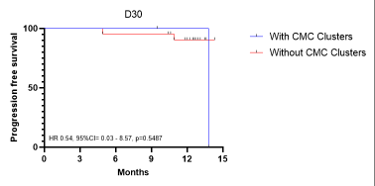

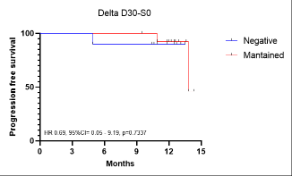

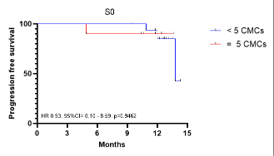

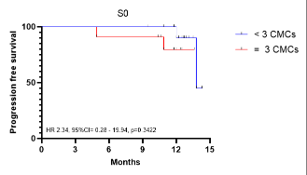
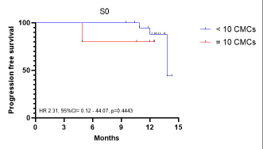

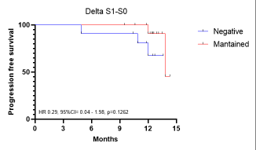


CONSORT 2010 checklist of information to include when reporting a randomised trial*

Section/Topic | Item nº | Checklist item | Reported on page nº
Title and abstract
 | 1a | Identification as a randomised trial in the title | Page 1
 | 1b | Structured summary of trial design, methods, results, and conclusions (for specific guidance see CONSORT for abstracts) | Page 3
Introduction
Background and objectives | 2a | Scientific background and explanation of rationale | Page 4-5
Background and objectives | 2b | Specific objectives or hypotheses | Page 5, paragraph 3
Methods
Trial design | 3a | Description of trial design (such as parallel, factorial) including allocation ratio | Page 28, paragraph 3
Trial design | 3b | Important changes to methods after trial commencement (such as eligibility criteria), with reasons | None
Participants | 4a | Eligibility criteria for participants | Page 27, paragraph 1  Page 28, paragraph 4
Participants | 4b | Settings and locations where the data were collected | Page 27, paragraph 1
Interventions | 5 | The interventions for each group with sufficient details to allow replication, including how and when they were actually administered | Page 28, paragraph 1-3  Page 29, paragraph 1-2  Page 30, paragraph 1
Outcomes | 6a | Completely defined pre-specified primary and secondary outcome measures, including how and when they were assessed | Page 30, paragraph 2
Outcomes | 6b | Any changes to trial outcomes after the trial commenced, with reasons | None
Sample size | 7a | How sample size was determined | Page 30, paragraph 2
Sample size | 7b | When applicable, explanation of any interim analyses and stopping guidelines | None
Randomisation:
Sequence generation | 8a | Method used to generate the random allocation sequence | Page 29, paragraph 2
Sequence generation | 8b | Type of randomisation; details of any restriction (such as blocking and block size) | Page 29, paragraph 2
Allocation concealment mechanism | 9 | Mechanism used to implement the random allocation sequence (such as sequentially numbered containers), describing any steps taken to conceal the sequence until interventions were assigned | Page 29, paragraph 2
Implementation | 10 | Who generated the random allocation sequence, who enrolled participants, and who assigned participants to interventions | Page 29, paragraph 2
Blinding | 11a | If done, who was blinded after assignment to interventions (for example, participants, care providers, those assessing outcomes) and how | Page 29, paragraph 2
Blinding | 11b | If relevant, description of the similarity of interventions | Page 28, paragraph 1-3
Statistical methods | 12a | Statistical methods used to compare groups for primary and secondary outcomes | Page 30, paragraph 2
Statistical methods | 12b | Methods for additional analyses, such as subgroup analyses and adjusted analyses | Page 30, paragraph 2
Results
Participant flow (a diagram is strongly recommended) | 13a | For each group, the numbers of participants who were randomly assigned, received intended treatment, and were analysed for the primary outcome | Page 5, paragraph 4  Page 6, figure 1
Participant flow (a diagram is strongly recommended) | 13b | For each group, losses and exclusions after randomisation, together with reasons | Page 6, figure 1
Recruitment | 14a | Dates defining the periods of recruitment and follow-up | Page 25, paragraph 1  Page 28, paragraph 3
Recruitment | 14b | Why the trial ended or was stopped | None
Baseline data | 15 | A table showing baseline demographic and clinical characteristics for each group | Page 6, table 1
Numbers analysed | 16 | For each group, number of participants (denominator) included in each analysis and whether the analysis was by original assigned groups | Page 6, figure 1
Outcomes and estimation | 17a | For each primary and secondary outcome, results for each group, and the estimated effect size and its precision (such as 95% confidence interval) | Pages 24, paragraph 1
Outcomes and estimation | 17b | For binary outcomes, presentation of both absolute and relative effect sizes is recommended | Page 24, paragraph 1
Ancillary analyses | 18 | Results of any other analyses performed, including subgroup analyses and adjusted analyses, distinguishing pre-specified from exploratory | Page 18, paragraph 1-6  Page 24, paragraph 2-4  Page 25, paragraph 1
Harms | 19 | All important harms or unintended effects in each group (for specific guidance see CONSORT for harms) | —
Discussion
Limitations | 20 | Trial limitations, addressing sources of potential bias, imprecision, and, if relevant, multiplicity of analyses | Page 27, paragraph 1
Generalisability | 21 | Generalisability (external validity, applicability) of the trial findings | Page 27, paragraph 2
Interpretation | 22 | Interpretation consistent with results, balancing benefits and harms, and considering other relevant evidence | Page 25, paragraph 1-3  Page 25, paragraph 1-3
Other information
Registration | 23 | Registration number and name of trial registry | Page 29, paragraph 1
Protocol | 24 | Where the full trial protocol can be accessed, if available | Page 29, paragraph 1
Funding | 25 | Sources of funding and other support (such as supply of drugs), role of funders | Page 35, Funding section

*We strongly recommend reading this statement in conjunction with the CONSORT 2010 Explanation and Elaboration for important clarifications on all the items. If relevant, we also recommend reading CONSORT extensions for cluster randomised trials, non-inferiority and equivalence trials, non-pharmacological treatments, herbal interventions, and pragmatic trials. Additional extensions are forthcoming: for those and for up to date references relevant to this checklist, see www.consort-statement.org.



Analyzed (n=16)
Excluded from analysis (n=0)
Enrollment

Analysis

Lost to follow-up (n=0)
Allocated to conventional RN (n=16)
- Received allocated intervention (n=16)
- Did not receive allocated intervention (n=0)
Lost to follow-up (n=0)
Allocation

Randomized (n=34)
Follow-Up

Allocated to no-touch RN (n=18)
- Received allocated intervention (n=16)
- Did not receive allocated intervention (n=2): patient anatomical distortion preventing early access to pedicle
Enrolled (n=34)
Analyzed (n=16)
Excluded from analysis (n=0)
Excluded (n=0)
CONSORT 2010 Flow Diagram

