Supplementary Materials for
Seeded growth of three-dimensional block heterojunctions featuring heterogeneous long-rang exciton migration

Yanjun Gong^{1,2,} , Yangyang Ren^{1,2 #}, Yanxue Che³, Chenglong Liao^{1,2}, Hongwei Ji^{1,2}, Linfeng Cui^{4*}, Ling Zang⁵, Yanke Che^{1,2*}, and Jincai Zhao^{1,2}

¹ Key Laboratory of Photochemistry, CAS Research/Education Center for Excellence in Molecular Sciences, Institute of Chemistry, Chinese Academy of Sciences, Beijing 100190, China
² University of Chinese Academy of Sciences, Beijing 100049, China
³ HT-NOVA Co., Ltd., Zhuyuan Road, Shunyi District, Beijing 101312, China
⁴ Hebei Key Laboratory of Organic Functional Molecules, College of Chemistry and Material Science, Hebei Normal University, Shijiazhuang 050023, P. R. China
⁵ Department of Materials Science and Engineering, University of Utah, Salt Lake City, UT 84112, USA
*Correspondence to: cuilinfeng@hebtu.edu.cn; ykche@iccas.ac.cn
#These authors contributed equally to this work.

Table of Contents

1. Synthesis of molecules 1 and 2
2. Supporting Figures S3 to S15
3. Supporting tables
4. References

- Synthesis of molecules 1 and 2
1.1. Synthesis of molecule 1.
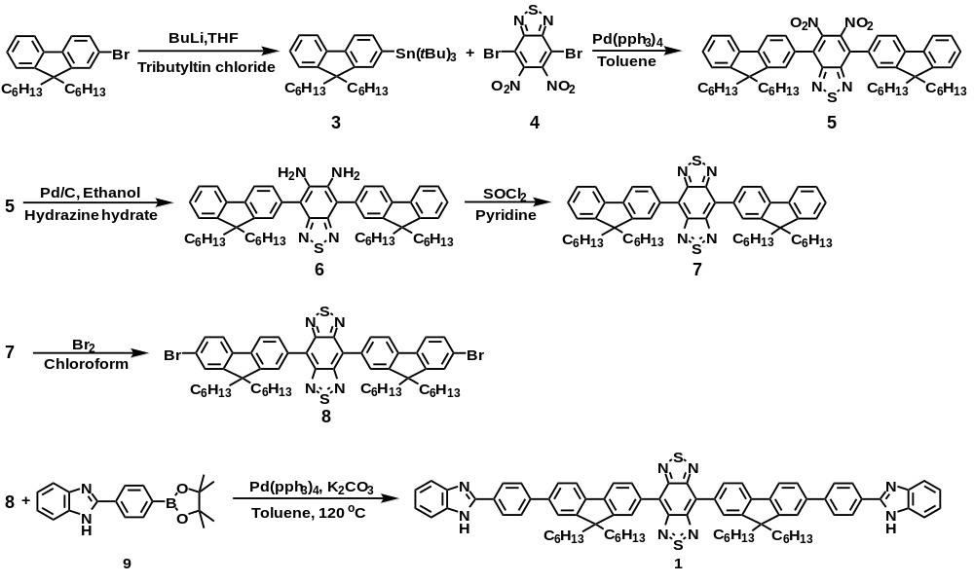

Scheme S1. Synthesis route of molecule 1
tri-tert-butyl(9,9-dihexyl-9H-fluoren-2-yl)stannane (3). 2-bromo-9,9-dihexyl fluorene (1.00 g, 2.42 mmol) was dissolved in 20 ml of anhydrous tetrahydrofuran and cooled to -78 ºC under argon. 1.5 ml of a hexane solution of n-butyllithium (2.5 M) was dropwise added into the mixture and stirred for 1 h and then tributyltin chloride (1.28 g, 3.63 mmol) was added and stirred for 10 min. The mixture was warmed to room temperature and stirred overnight. The reaction solution was concentrated under vacuum and the residue was washed with brine (80 mL) and extracted with dichloromethane (3 × 30 mL). The organic layer was dried over anhydrous Na₂SO₄ and concentrated under vacuum. The resulting crude product was purified by column chromatography on silica gel (petroleum ether as the eluent) to afford compound 3 (1.08 g, 1.74 mmol, 72 % yield).
Compound 3. ¹H NMR (400 MHz, CDCl₃, ppm): δ 7.81-6.67 (m, 2 H), 7.48 (m, 1 H), 7.41-7.27 (m, 4 H), 1.96 (td, J = 7.3, 3.4 Hz, 4 H), 1.58 (q, J = 7.3 Hz, 4 H), 1.20-0.98 (m, 12 H), 0.77 (t, J = 7.0 Hz, 6 H).
4,7-bis(9,9-dihexyl-9H-fluoren-2-yl)-5,6-dinitrobenzo[c][1,2,5]thiadiazole (5). To a stirred solution of compound 3 (1.08 g, 1.74 mmol) and 4,7-dibromo-5,6-dinitrobenzo[c][1,2,5]thiadiazole 4 (0.27 g, 0.69 mmol) in anhydrous toluene (30 mL), Pd(PPh₃)₄ (22 mg, 0.02 mmol) was added under argon. Then the mixture was heated to 100 °C and stirred for 48 h. After removing the solvent under vacuum, the residue was extracted with dichloromethane (3 × 30 mL) and water (80 mL), respectively. The organic layer was dried over anhydrous Na₂SO₄ and concentrated under vacuum. The yellow compound 5 (0.45 g, 0.51 mmol, 30 % yield) was obtained upon purification by silica gel chromatographic column (petroleum ether: dichloromethane =1:1)
Compound 5: ¹H NMR (400 MHz, Chloroform-d) δ 7.90 (d, J = 7.8 Hz, 2 H), 7.81-7.75 (m,2 H), 7.62 (dd, J = 7.8, 1.6 Hz, 2 H), 7.52 (d, J = 1.6 Hz, 2 H), 7.38 (d, J = 3.1 Hz, 6 H), 1.98 (t, J = 8.3 Hz, 8 H), 1.21-1.00 (m, 24 H), 0.78 (t, J = 7.0 Hz, 12 H), 0.69 (q, J = 8.2 Hz, 8 H).
4,7-bis(9,9-dihexyl-9H-fluoren-2-yl)benzo[c][1,2,5]thiadiazole-5,6-diamine (6). To a stirred solution of compound 5 (0.45 g, 0.51 mmol), palladium carbon, (10% Pd, 0.20 g) in ethanol (20 mL), 5 mL of hydrazine hydrate was dropwise added under argon. Then the mixture was refluxed for 6 h and concentrated under vacuum. The residue was extracted with dichloromethane (3 × 30 mL) and water (80 mL), respectively. The organic layer was dried over anhydrous Na₂SO₄ and concentrated under vacuum. The crude product was purified by chromatographic column on silica gel (petroleum ether: ethyl acetate =5:1) to afford compound 6 (348 mg, 0.42 mmol, 82 % yield).
Compound 6. ¹H NMR (400 MHz, Chloroform-d) δ 7.96 (d, J = 7.7 Hz, 2 H), 7.86-7.77 (m, 2 H), 7.65 (d, J = 7.4 Hz, 4 H), 7.42 (ddt, J = 14.0, 7.6, 3.8 Hz, 6 H), 4.18 (s, 4 H), 2.05 (dp, J = 11.8, 6.8 Hz, 8 H), 1.25-1.04 (m, 24 H), 0.86-0.81 (m, 20 H).
4,7-bis(9,9-dihexyl-9H-fluoren-2-yl)benzo[1,2-c:4,5-c']bis([1,2,5]thiadiazole) (7). To a stirred solution of 6 (348 mg, 0.42 mmol) in 5 mL of pyridine, sulfoxide chloride (0.39 g, 2.5 mmol) was dropwise added. The mixture was stirred at room temperature for 12 h. After removal of the solvent under vacuum, the residue was extracted with dichloromethane (3 × 20 mL) and water (20 mL), respectively. The combined organic layer was dried over anhydrous Na₂SO₄ and concentrated under vacuum. Compound 7 (312 mg, 0.36 mmol, 85 % yield) was obtained by column chromatography on silica gel (petroleum ethe: dichloromethane = 2: 1 as the eluent).
Compound 7. ¹H NMR (400 MHz, Chloroform-d) δ 8.28 (d, J = 7.6 Hz, 4 H), 7.97 (dd, J = 7.7, 1.0 Hz, 2 H), 7.86-7.77 (m, 2 H), 7.45-7.32 (m, 6 H), 2.06 (dtd, J = 41.5, 12.9, 4.8 Hz, 8 H), 1.15 (d, J = 17.7 Hz, 24 H), 1.00 – 0.82 (m, 8 H), 0.78 (t, J = 6.8 Hz, 12H).
4,7-bis(7-bromo-9,9-dihexyl-9H-fluoren-2-yl)-benzo[1,2-c:4,5-c']bis([1,2,5]thiadiazole) (8). To a stirred solution of 7 (312 mg, 0.36 mmol) in dichloromethane (20 mL), bromine (0.8 g, 5 mmol) was dropwise added. The mixture was stirred at room temperature for 1 h. After removing the solvent under vacuum, saturated sodium thiosulfate was added and the mixture was extracted with dichloromethane (3 × 20 mL). The combined organic layer was dried over anhydrous Na₂SO₄ and concentrated under vacuum. Compound 8 (204 mg, 0.20 mmol, 55 % yield) was obtained by purification through column chromatography on silica gel (petroleum ether: dichloromethane = 5: 1 as the eluent).
Compound 8. ¹H NMR (400 MHz, Chloroform-d) δ 8.35-8.27 (m, 4 H), 7.97 (d, J = 8.3 Hz, 2H), 7.71 (d, J = 8.0 Hz, 2 H), 7.60-7.52 (m, 4 H), 2.08 (m, J = 52.7, 12.8, 5.9 Hz, 8 H), 1.20 (m, J = 16.3, 6.0 Hz, 24 H), 1.09 – 0.70 (m, 20 H).
4,7-bis(7-(4-(1H-benzo[d]imidazol-2-yl)phenyl)-9,9-dihexyl-9H-fluoren-2-yl) benzo[1,2-c:4,5-c']bis([1,2,5]thiadiazole) (1)
To a solution of compound 8 (204 mg, 0.20 mmol), 2-(4-(4,4,5,5-tetramethyl-1,3,2-dioxaborolan-2-yl)phenyl)-1H-benzo[d]imidazole 9 (150 mg, 0.47 mmol), and K₂CO₃ (165 mg, 1.2 mmol) in mixed solvent (toluene: water = 7: 1, 20 mL), Pd(PPh₃)₄ (0.02 g, 0.02 mmol) was added under argon. Then the mixture was heated to 120 °C and stirred for 20 h. After removing the solvent under vacuum, the residue was washed with brine (50 mL) and extracted with dichloromethane (3 × 30 mL). The organic layer was dried over anhydrous Na₂SO₄ and concentrated under vacuum. The orange compound 1 (98 mg, 0.08 mmol, 40% yield) was obtained upon purification by chromatographic column on silica gel (dichloromethane: acetone = 10: 1).
Molecule 1: ¹H NMR (400 MHz, Chloroform-d) δ 11.8 (s, 2 H), 8.33 (d, J = 8.0 Hz, 4 H), 8.16 (d, J = 8.0 Hz, 2 H), 8.08 (s, 2 H), 8.02-7.94 (m, 8 H), 7.89 (s, 2 H), 7.83 (d, J = 8.0 Hz, 2 H), 7.73 (d, J = 8.0 Hz, 2 H), 7.51 (d, J = 8.0 Hz, 2 H), 7.22 (d, J = 8.0 Hz, 2 H), 2.51-2.24 (m, 8 H), 1.35-1.14 (m, 24 H), 0.96-0.93 (m, 8 H), 0.84 (t, J = 8.0 Hz, 12 H). MALDI-MS: (m/z) =1243.4.
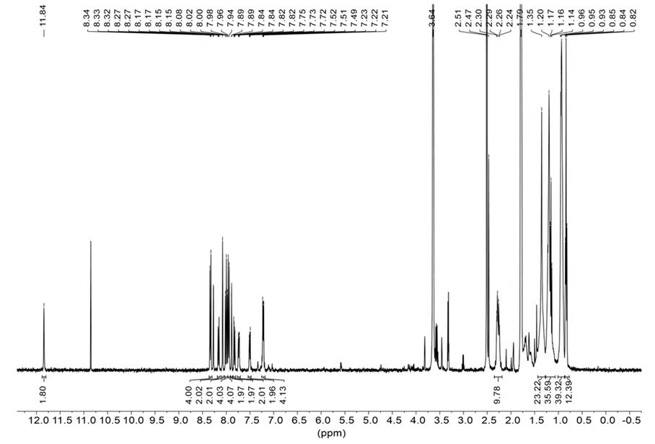
Fig. S1. ¹H NMR of molecule 1.
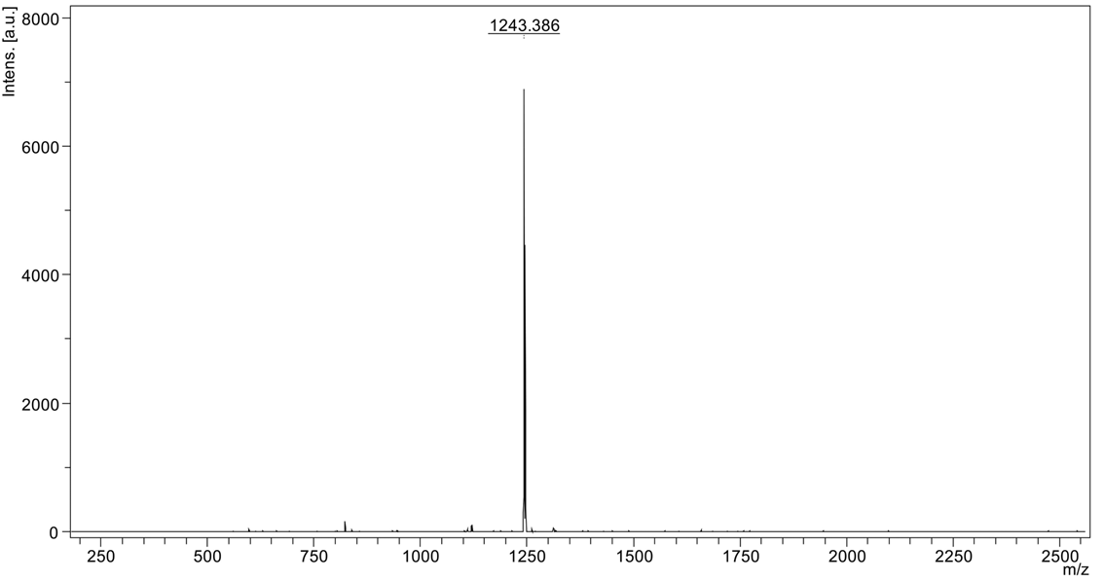
Fig. S2. MALDI-MS of molecule 1.
1.2. Synthesis of molecule 2.
Molecule 2 was synthesized by following the previously reported method.¹
¹H NMR (400 MHz, THF-d8): δ: 11.83 (s, 2 H), 8.31 (d, J = 8.0 Hz, 4 H), 8.25 (s, 2 H), 8.14 (d, J = 8.0 Hz, 2 H), 8.06 (s, 2 H), 8.00-7.92 (m, 8 H), 7.87 (s, 2 H), 7.81 (d, J = 8.0 Hz, 2 H), 7.73-7.70 (m, J = 4.0 Hz, 2 H), 7.50-7.47 (m, J = 4.0 Hz, 2 H), 7.21-7.19 (m, J = 4.0 Hz, 4 H), 2.25 (q, J = 2.0 Hz, 8 H), 1.20-1.17 (m, 24 H), 0.91-0.89 (m, 8 H), 0.83-0.81 (m, J = 4.0 Hz, 12 H). MALDI-MS: (m/z) =1185.7.

2. Supporting Figures S3 to S15.

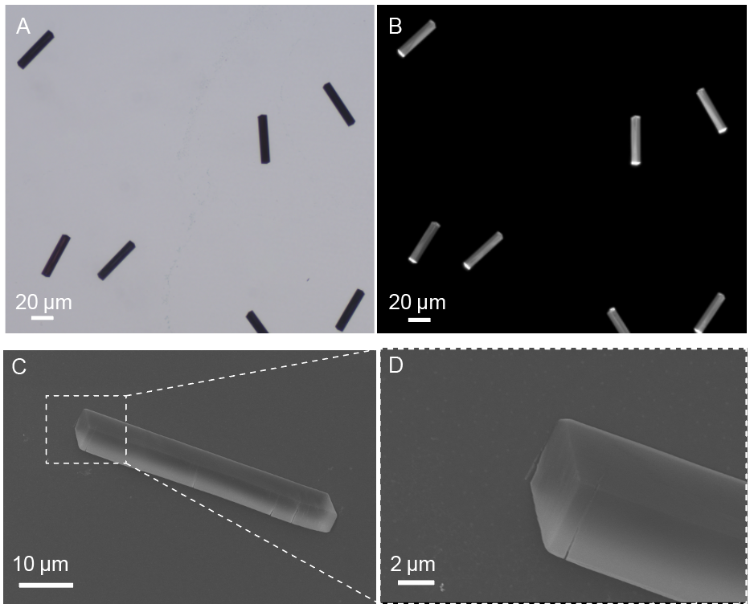
Fig. S3. (A) Bright-field and (B) fluorescence-mode optical microscopic images of the cuboid crystals assembled from 1. (C) SEM image of a cuboid crystal from 1. (D) Magnified SEM image of the cuboid crystal shown in (C).

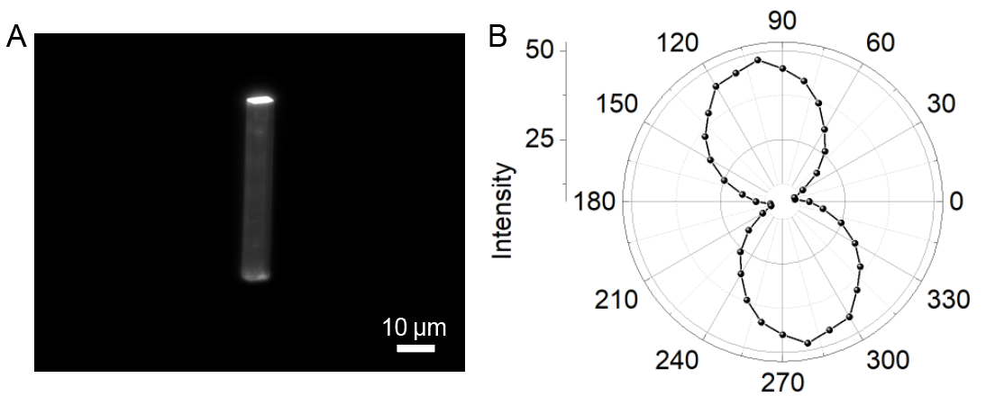

Fig. S4. (A) Fluorescence-mode optical microscopic image and (B) polarized emission of a typical cuboid crystal grown from 1.

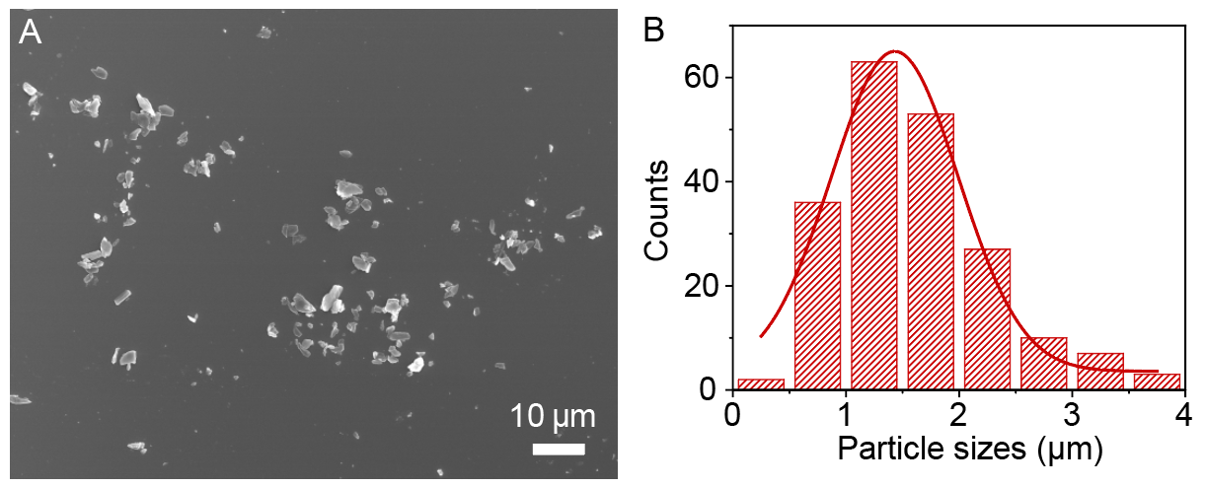
Fig. S5. (A) SEM image and (B) statistic histogram of the particle size distribution of the irregular seeds prepared by sonicating the 3D cuboid crystals from 1 at −30 °C for 1 min, showing particle size ranging from 400 nm to 3.8 µm.

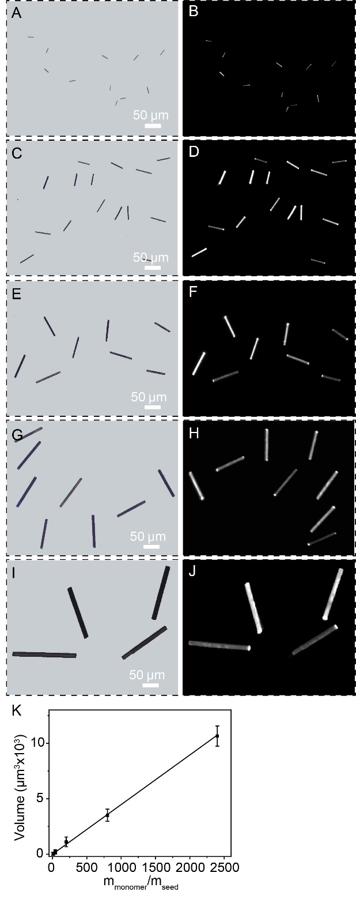
Fig. S6. (A, C, E, G, I) Bright-field and (B, D, F, H, J) fluorescence-mode optical microscopic images of the 3D cuboid crystals assembled upon the sequential addition of varying volumes (i.e., 1, 0.25, 0.05, 0.0125, and 0.004 mL) of irregular seeds (0.005 mg/mL) in acetonitrile to a supersaturated solutions of 1 (1 mL, 0.05 mg/mL) in a acetonitrile/propanol (v/v, 1:10) mixture, corresponding to monomer-to-seed mass ratios (m_{monomer}/m_{seed}) of (A, B) 10:1, (C, D) 40:1, (E, F) 200:1, (G, H) 800:1, and (I, J) 2400:1. (K) Volume of the 3D cuboid crystals plotted as a function of the monomer-to-seed mass ratio.

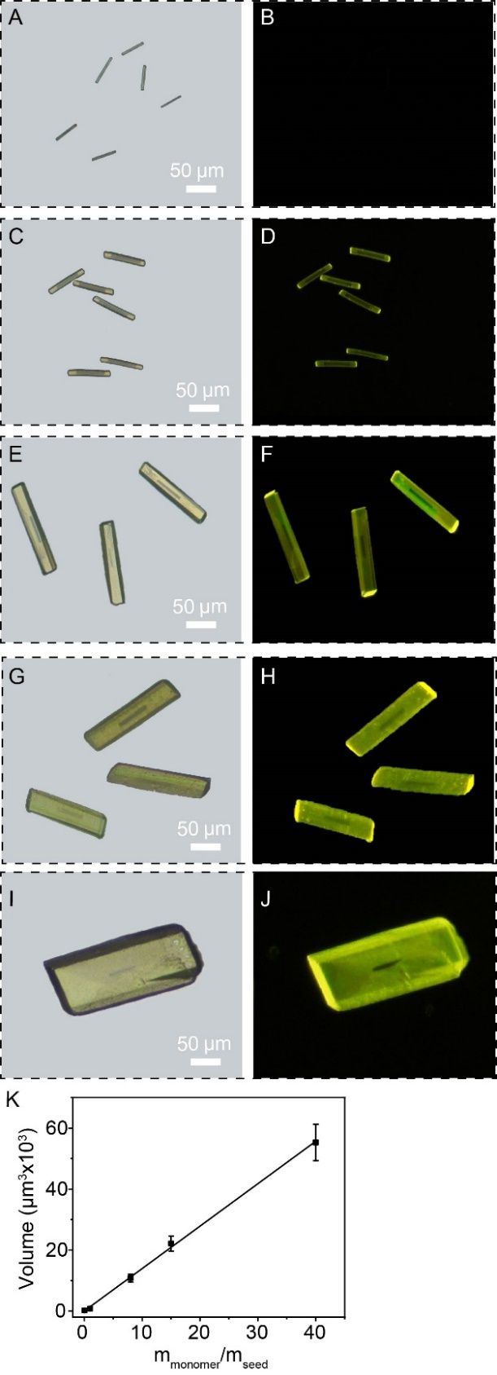
Fig. S7. (A, C, E, G, I) Bright-field and (B, D, F, H, J) fluorescence-mode optical microscopic images of the 3D block heterojunctions with the outer blocks of different thicknesses, which were assembled upon the sequential addition of 0.1 mL of an acetonitrile solution of 3D cuboid crystals from 1 (0.05 mg/mL) into a supersaturated solution of 2 (1 mL, 0.1 mg/mL) in acetonitrile/propanol (v/v, 1:5) mixture with varying volumes (0.01, 0.2, 1.6, 4, and 8 mL) and aging at 25 °C for 30 min. This leads to the mass ratios of molecules 2 to molecules 1 at (A, B) 1:20, (C, D) 1:1, (E, F) 8:1, (G, H) 20:1, and (I, J) 40:1. (K) Volume of the 3D block heterojunctions plotted as a function of the mass ratio of molecule 2 to 1.
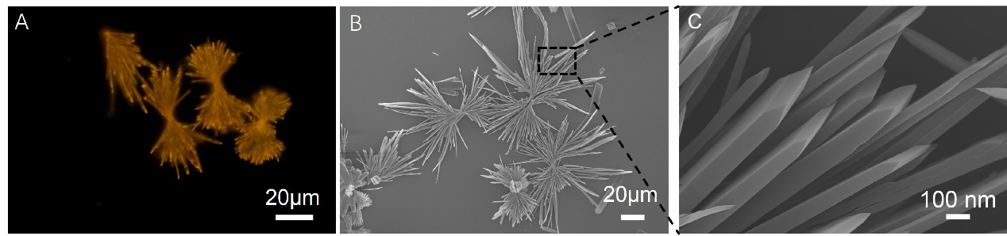
Fig. S8. (A) Fluorescence-mode optical microscopic image and (B, C) SEM images of 1D structures assembled from 2.

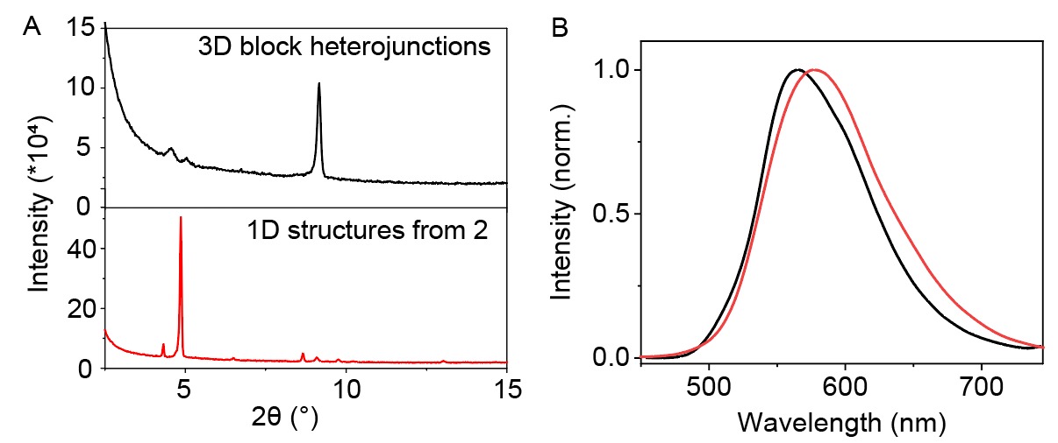
Fig. S9. (A) PXRD pattern of the 3D block heterojunctions (black) assembled from 1 and 2 in comparison to that of the 1D structures assembled from 2 alone (red). (B) Fluorescence spectra measured over the same 3D block heterojunctions (black) and 1D structures (red) shown in (A).

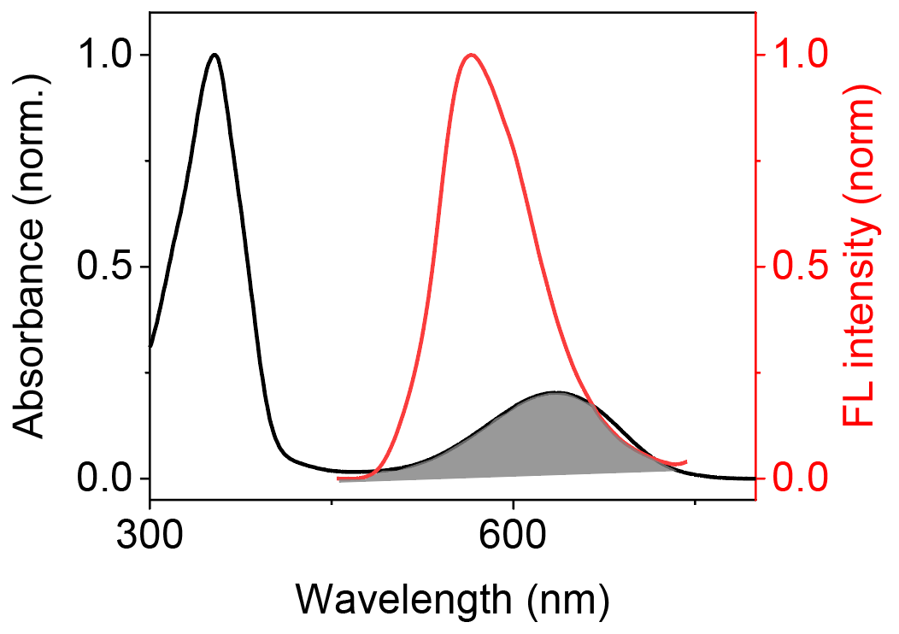
Fig. S10. UV-vis absorption spectrum (black) of molecule 1 in a propanol/chloroform (v/v, 3:1) solution and fluorescence spectrum (red) of the outer block of the bulk 3D block heterojunctions. Note: the fluorescence spectrum was recorded at the terminal of the bulk 3D block heterojunction, which was prepared by adding 0.1 mL of an acetonitrile solution of the hetero-seeds of 1 (0.05 mg/mL) into a supersaturated solution of 2 (8 mL, 0.1 mg/mL) in acetonitrile/ propanol (v/v, 1:5) mixture and subsequently aging at 25 °C for 30 min.

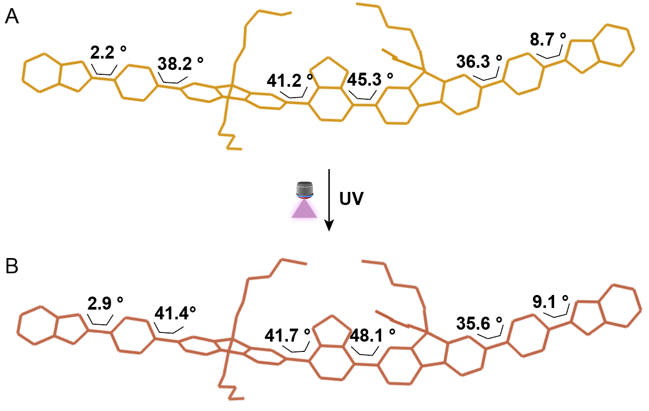
Fig. S11. Structural change of molecule 2 in the 3D block heterojunction before (A) and after (B) UV irradiation (330-390 nm, 3 mW/cm²).

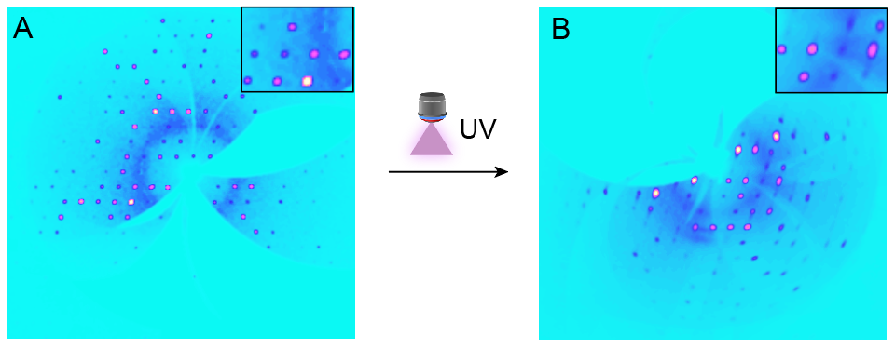
Fig. S12. Precession X-ray diffraction spots observed through the (100) plane of a 3D block heterojunction before (A) and after (B) UV irradiation (330-390 nm, 3 mW/cm²).

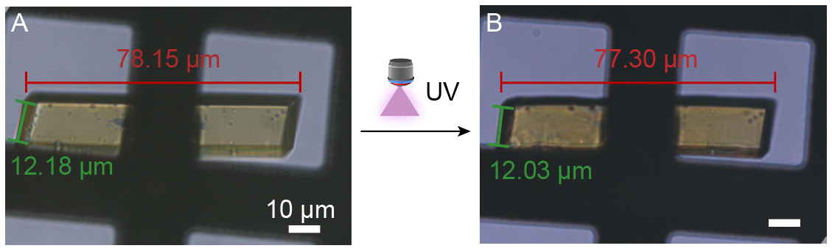
Fig. S13. Bright-field optical microscopic images of a 3D block heterojunction before (A) and after (B) UV irradiation (330-390 nm, 3 mW/cm²), showing a photoinduced macroscopic deformation. Note: The black frame is the copper grid used as the supporting substrate.

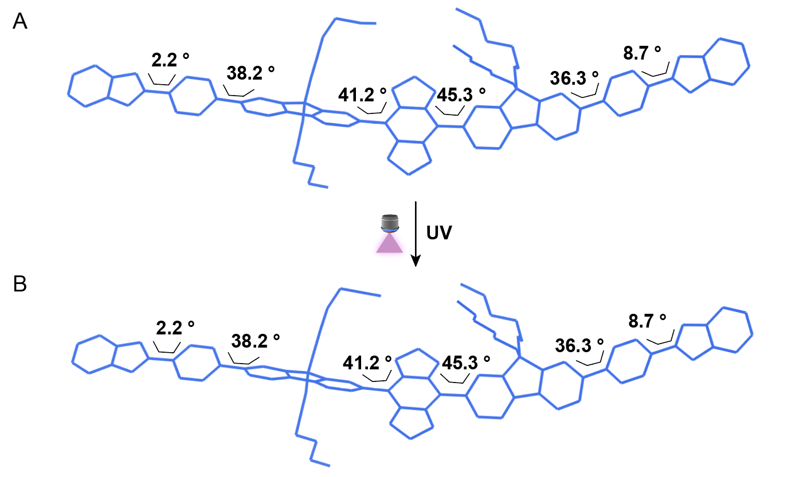
Fig. S14. Structural change of molecule 1 in the 3D cuboid crystal before (A) and after (B) UV irradiation (330-390 nm, 3 mW/cm²).

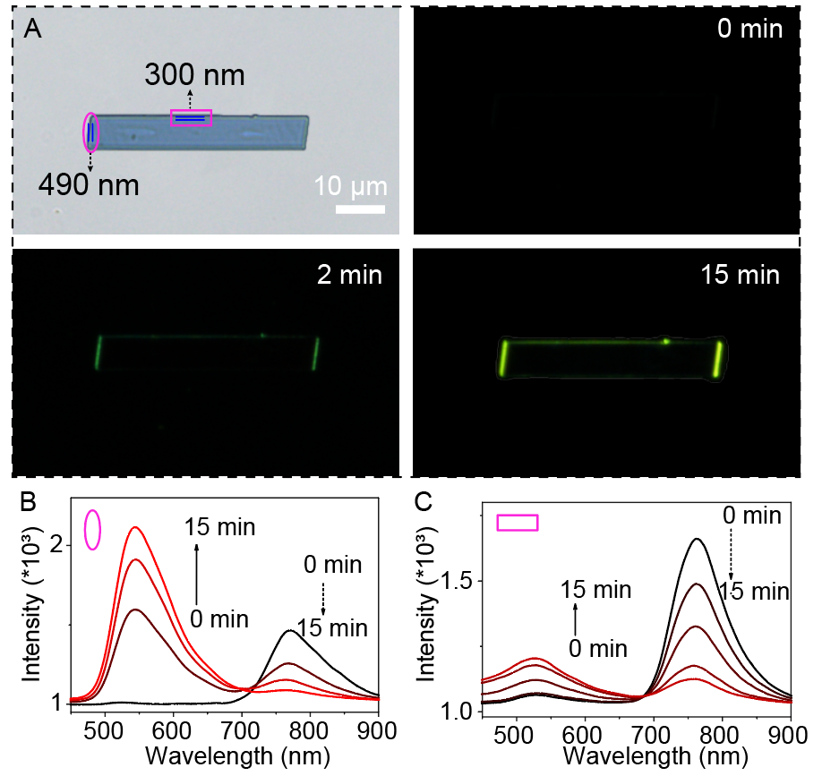
Fig. S15. (A) Bright-field and fluorescence-mode optical microscopic images of a typical 3D block heterojunction with a thin outer block before and after UV irradiation (330-390 nm, 3 mW/cm²). (B, C) Fluorescence spectra recorded at the terminal (B) and the side (C) of the 3D block heterojunction after varying times of UV irradiation.

3. Supporting tables
Table S1. Lattice parameters of the 3D cuboid crystal from 1 and 3D block heterojunction from 1 and 2.
Single Crystal | 3D cuboid crystal  from 1 | 3D block  heterojunction
Empirical formula | C₉₄H₁₀₇N₁₁O₂S₂ | C₉₄H₁₀₉N₉O₂S
Formula weight | 1487.02 | 1428.96
Crystal system | Triclinic | Triclinic
Space group | P -1 | P -1
a/Å | 12.17889(9) | 12.3480(5)
b/Å | 18.37255(17) | 17.9869(7)
c/Å | 19.89915(15) | 19.9424(5)
α/º | 101.4170(7) | 74.093(3)
β/º | 106.5335(7) | 72.311(3)
γ/º | 95.1273(7) | 84.161(3)
V/Å³ | 4133.41(6) | 4057.4(3)

Table S2. Lattice parameters of the 3D cuboid crystal from 1 and 3D block heterojunction from 1 and 2 after UV irradiation (330-390 nm, 3 mW/cm²).
Single Crystal | 3D cuboid crystals from 1 after UV irradiation | 3D block heterojunction after UV irradiation
Empirical formula | C₉₄H₁₀₇N₁₁O₂S₂ | C₉₄H₁₀₉N₉O₂S
Formula weight | 1487.02 | 1247.59
Crystal system | Triclinic | Triclinic
Space group | P -1 | P -1
a/Å | 12.17889(9) | 12.4210(9)
b/Å | 18.37255(17) | 17.8992(14)
c/Å | 19.89915(15) | 19.577(2)
α/º | 101.4170(7) | 72.294(8)
β/º | 106.5335(7) | 72.039(8)
γ/º | 95.1273(7) | 83.377(6)
V/Å³ | 4133.41(6) | 3943.2(7)

4. References
1. Gong, Y. et al., Unprecedented Small Molecule-Based Uniform Two-Dimensional Platelets with Tailorable Shapes and Sizes. J. Am. Chem. Soc. 144, 15403-15410 (2022).

