Supplementary Material

The influence of the precuneus on the hippocampus determines the subjective quality of memory during the retrieval of naturalistic episodes
Samy-Adrien Foudil & Emiliano Macaluso

Supplementary Figures
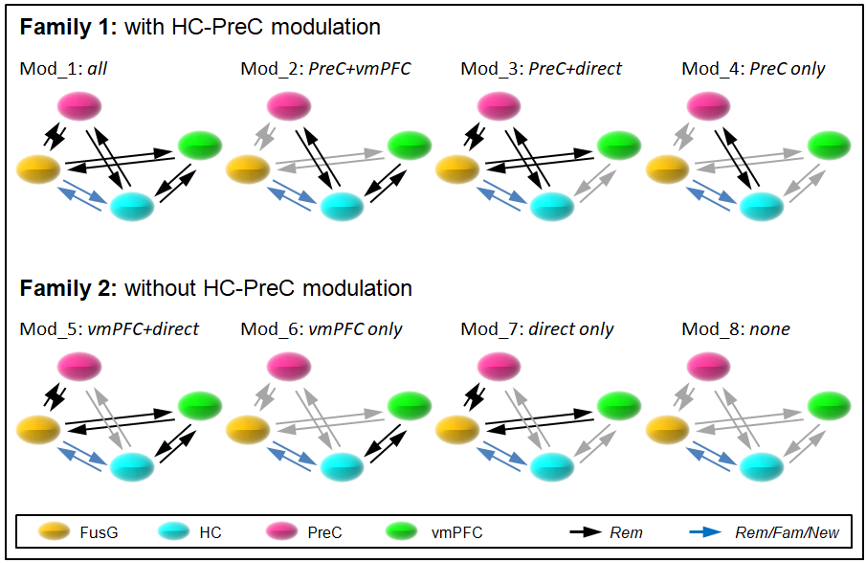
Supplementary Figure S1. DCM model space. The model space included 8 models, partitioned in two families. All models received external input at the FusG node (C-parameters, not shown; see Methods for details). The intrinsic connectivity (A-parameters) was the same in all models and it is represented by the arrows, irrespective of color. The models differed in terms of the modulatory influence that the Rem condition could exert on specific connections (B-parameters, black arrows). These modulations entailed the connectivity between HC-PreC, HC-vmPFC and the direct connections between FusG and PreC/vmPFC. The two families included the models with/without modulation of the HC-PreC connections. In addition, in all models the three retrieval conditions (Rem/Fam/New) could modulate the FusG-HC connections (blue arrows). FusG: left fusiform gyrus; HC: left hippocampus, PreC: precuneus, vmPFC: ventro-medial prefrontal cortex. Rem/Fam: correctly recognized old-objects with “Remember/Familiar” responses, New: correctly recognized new-objects.

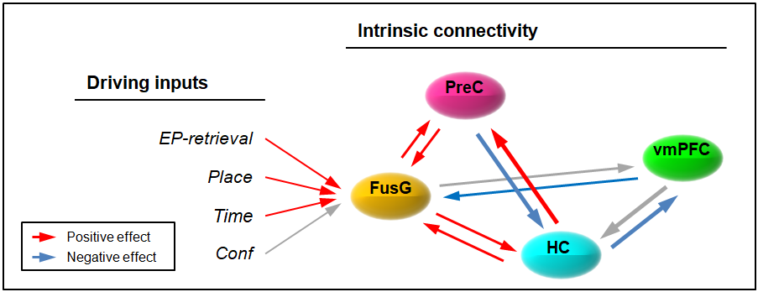
Supplementary Figure S2. Intrinsic connectivity and driving inputs for the winning model. Bayesian Parameter Averaging showed significant couplings between the different regions of the network (A-parameters of the DCM, see also Methods section). Notably, the condition-independent connectivity between the precuneus and the hippocampus indicated a “driving” effect of the HC to the PreC, while the PreC connection exhibited a negative influence on the HC. This pattern was opposite to the modulatory effect specific for the “Rem” responses (cf. Fig. 4A, and note that the HC-vmPFC connectivity showed a related pattern), see also Discussion in the main text. Concerning the driving input (C-parameters), the presentation of the object-image during the episode retrieval phase of the trial, as well as the two source discrimination tasks elicited significant activation of the network at the level of the fusiform gurus, while the presentation of the confidence judgments did not. FusG: left fusiform gyrus; HC: left hippocampus, PreC: precuneus, vmPFC: ventro-medial prefrontal cortex. EP-retrieval: the episode retrieval phase of the trial, Place: place-discrimination phase, Time: Time-discrimination phase, Conf: confidence judgment (see also Fig. 1B). Red/blue arrows: posterior probability > 99%.

