Supplementary Information S5:
EHB-IMR Joinpoint Trends for 12 select nations.
1. Bangladesh- 3 Joinpoints
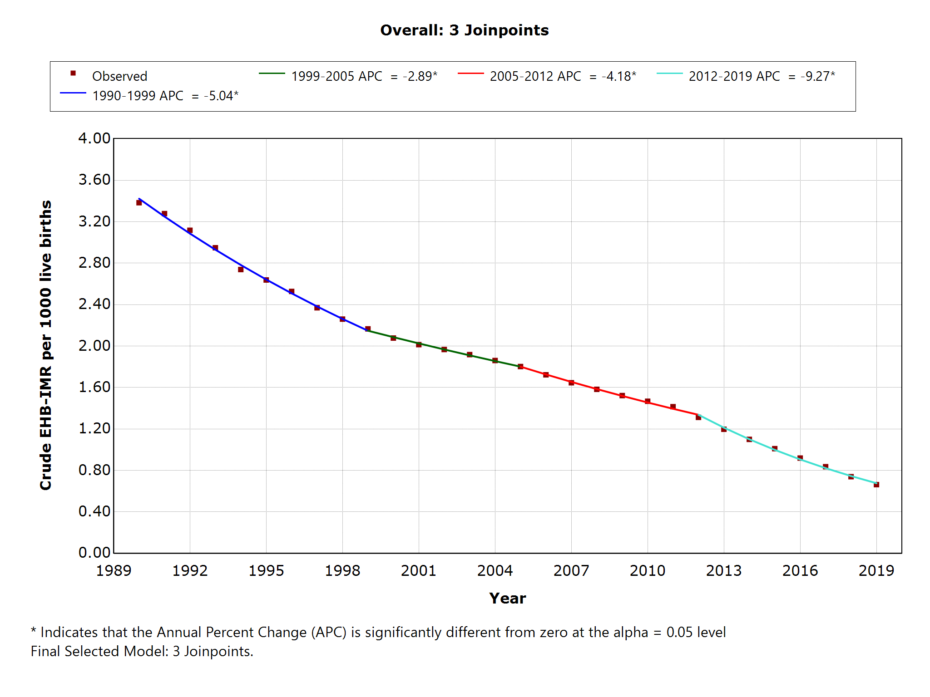

2. Brazil- 4 Joinpoints
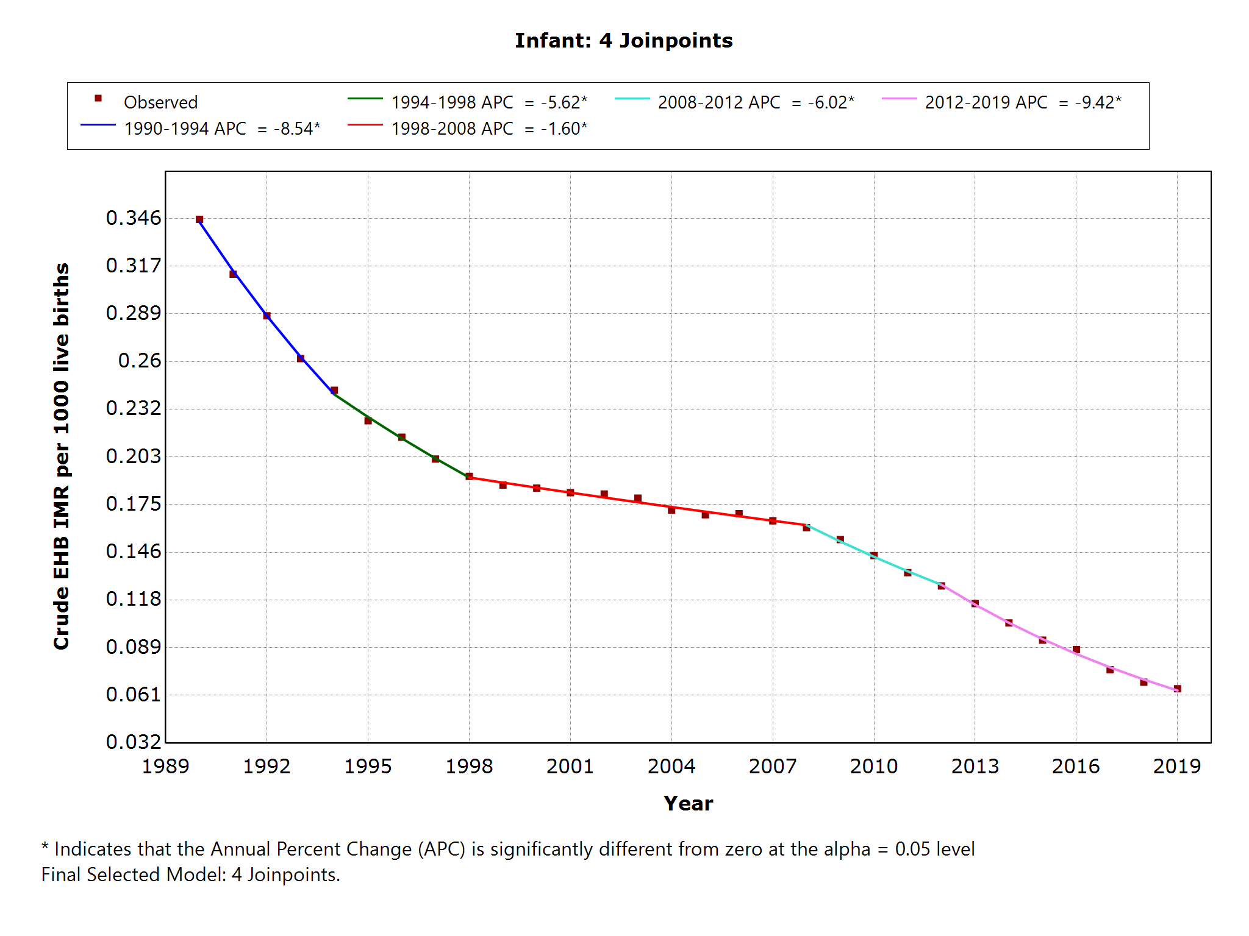

3. China- 1 Joinpoint
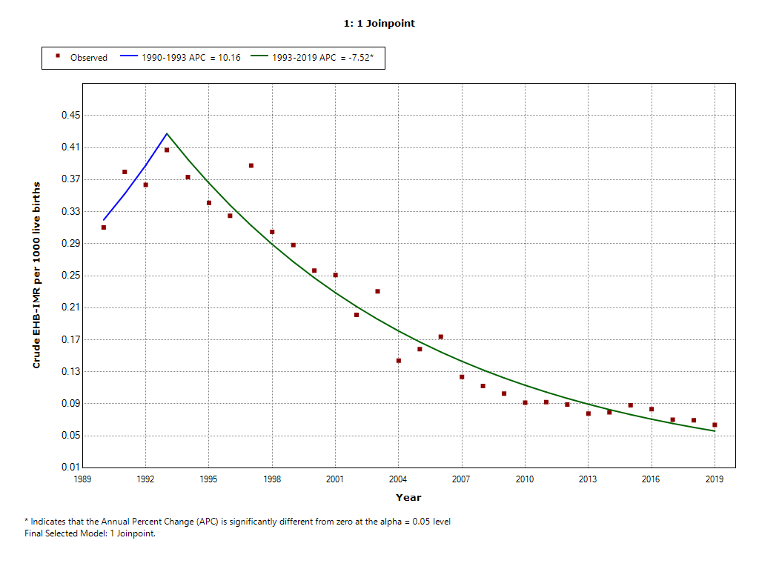

4. Egypt- 5 Joinpoints

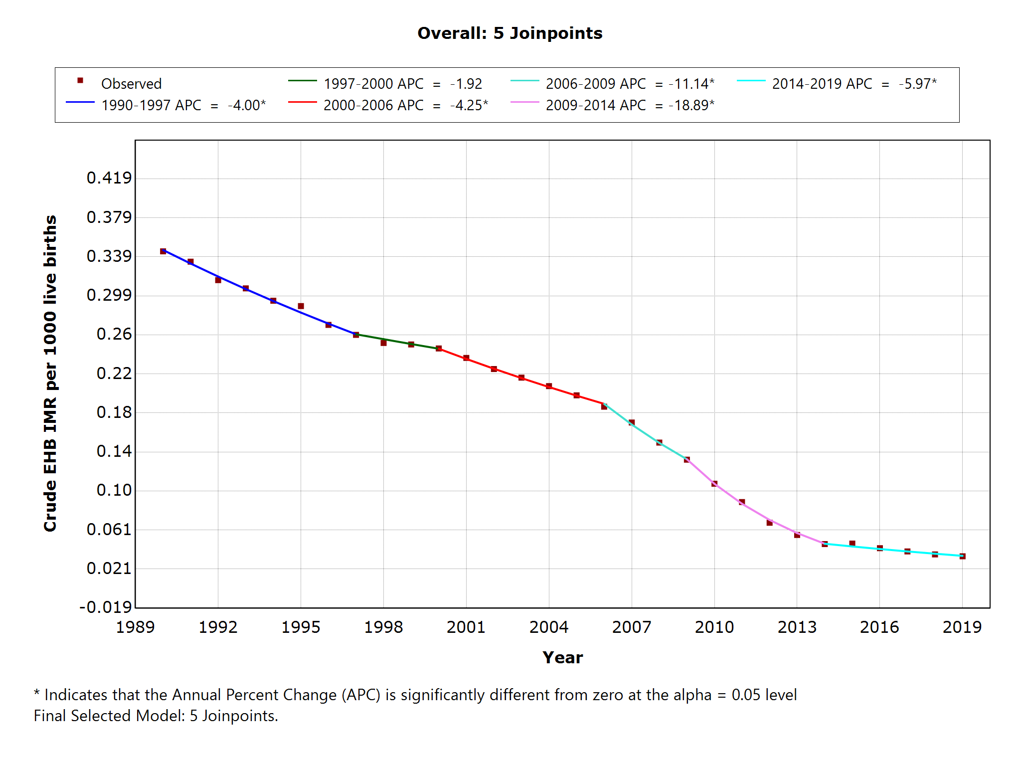

5. India- 5 Joinpoints
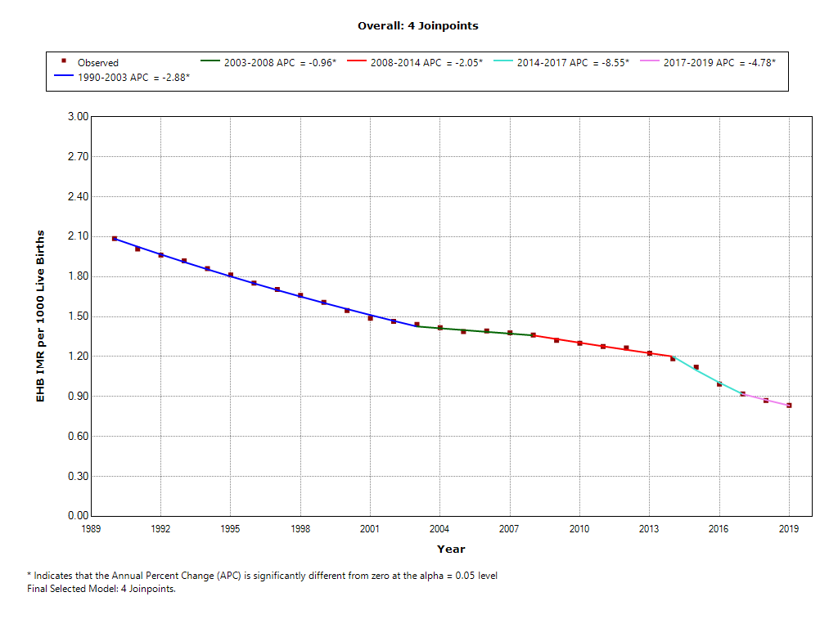

6. Iraq- 5 Joinpoints
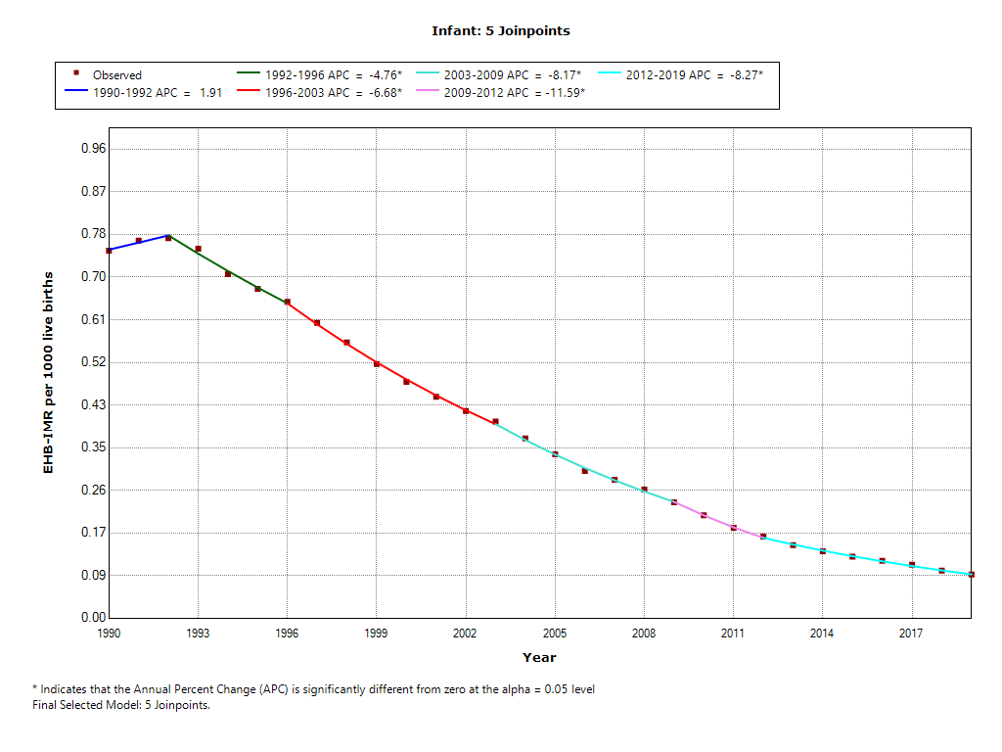

7. Italy- 4 Joinpoints
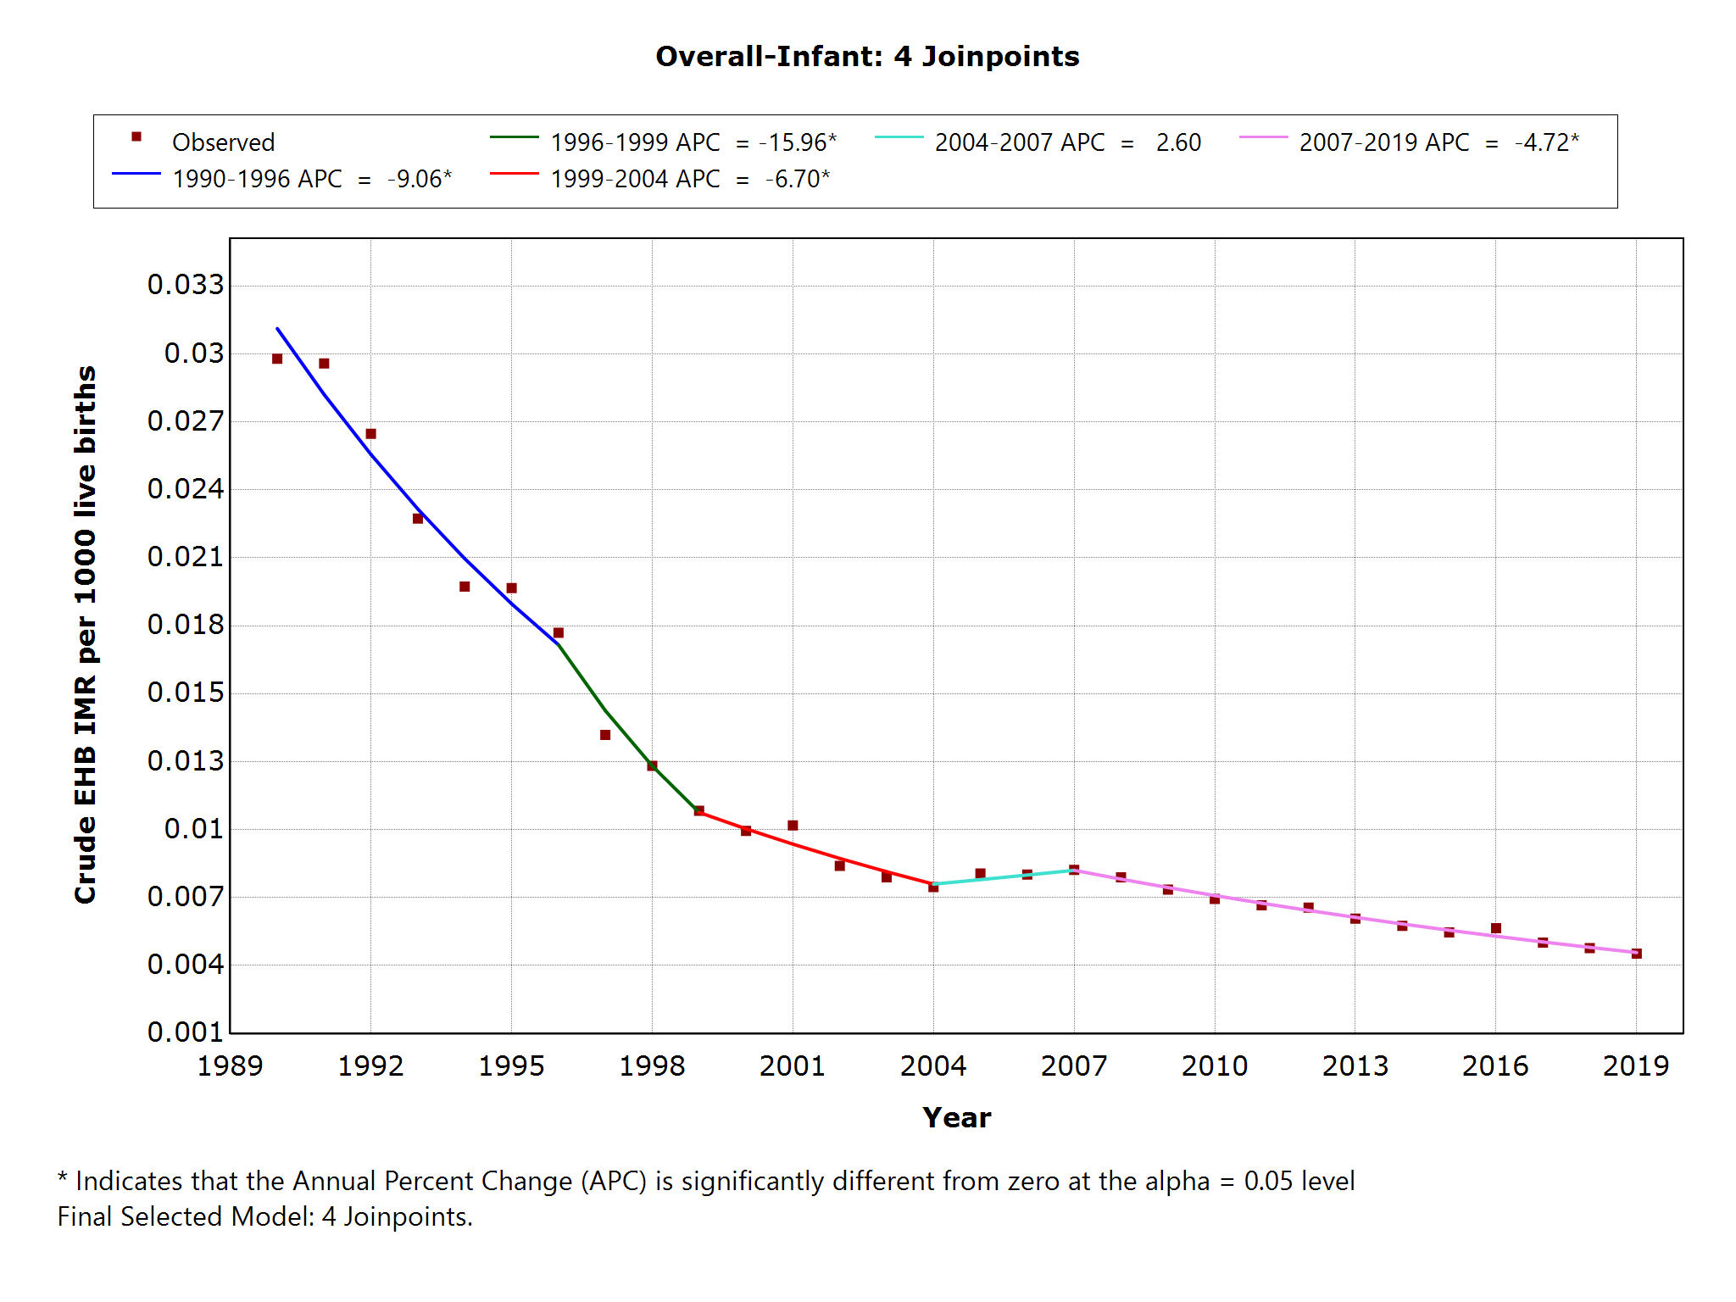

8. Mexico- 4 Joinpoints
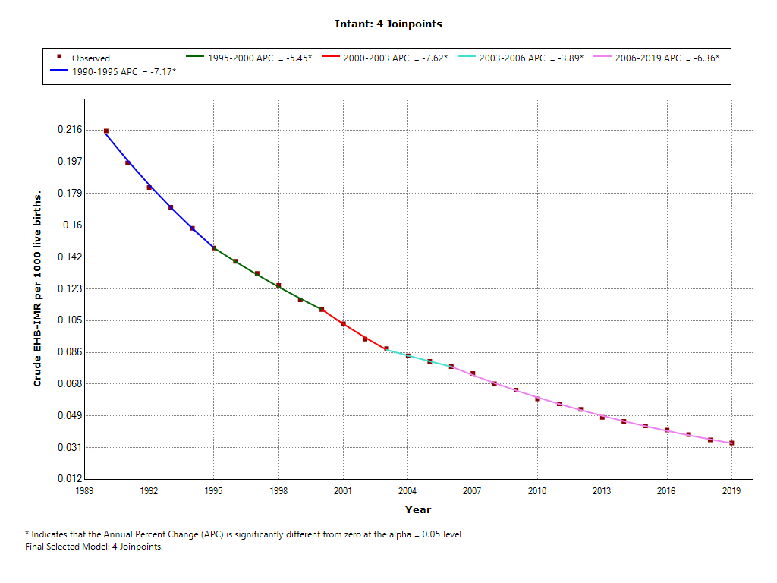

9. Netherlands-2 Joinpoints
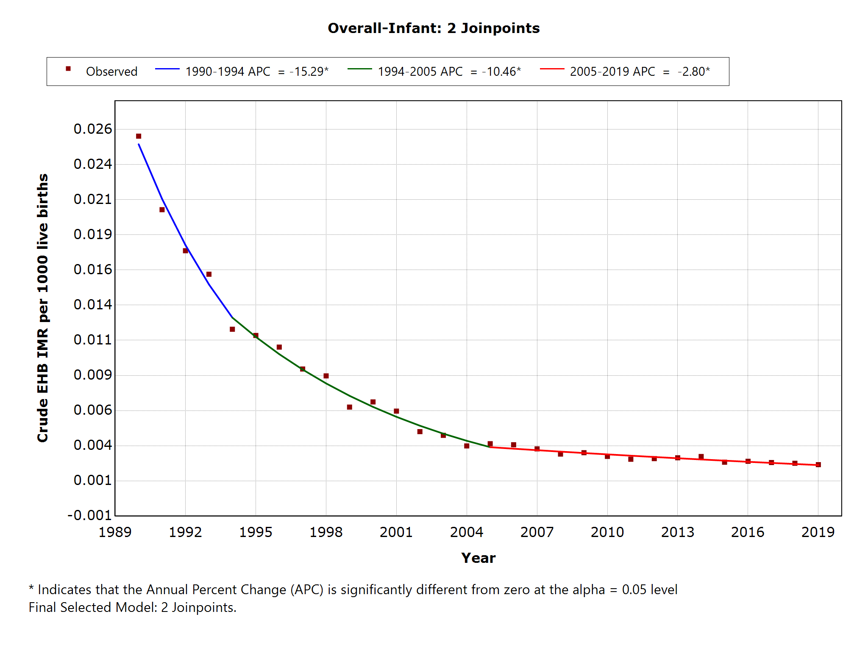

10. Nigeria- 4 Joinpoints
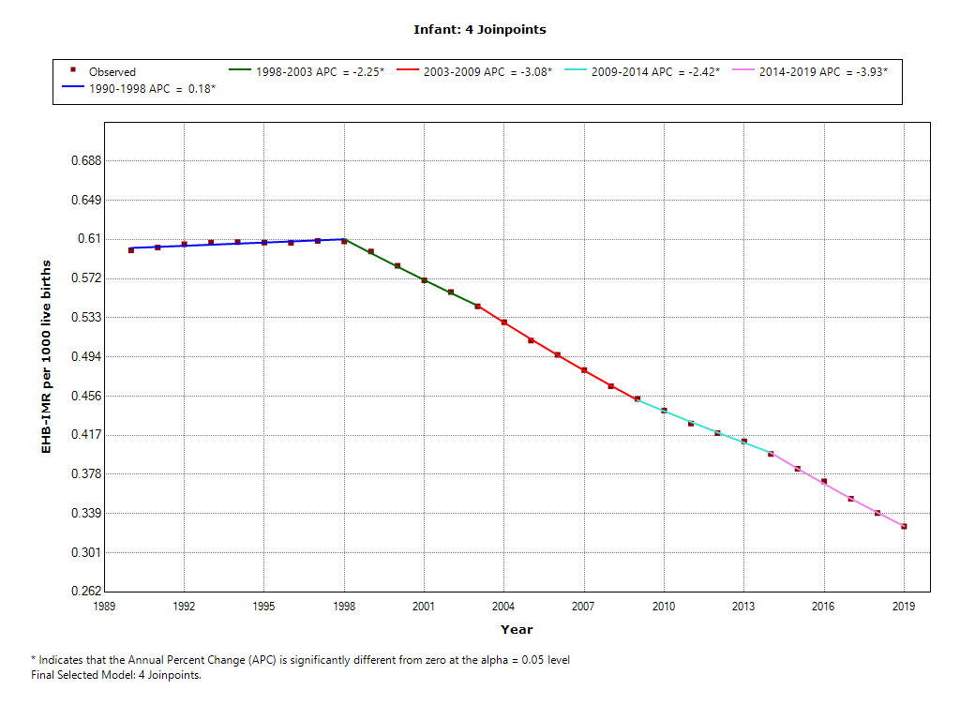

11. Philippines- 4 Joinpoints
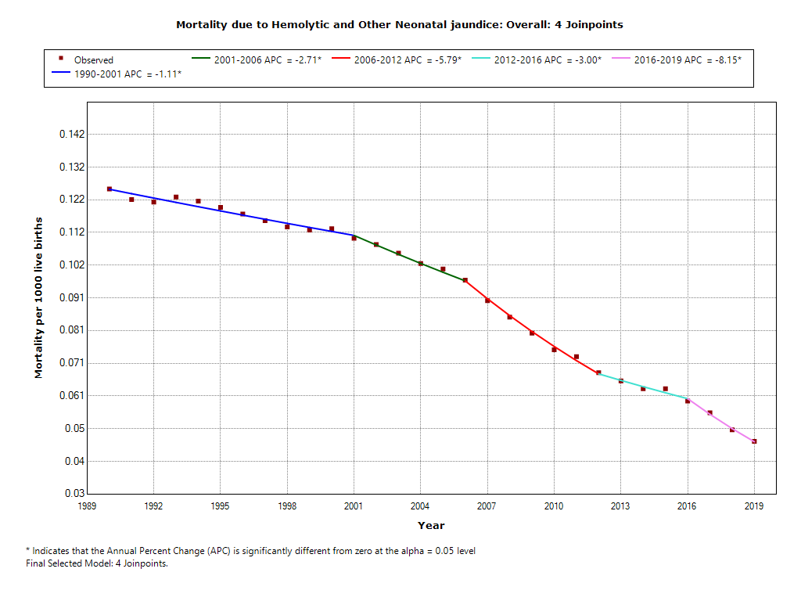

12. USA- 1 joinpoint

