Enhanced lipid biosynthesis in OSCC cancer associated fibroblasts contributes to tumor progression: role of IL8/AKT/p-ACLY axis

Pan Liu¹, Yue Wang¹, Xiang Li¹, Zhenan Liu¹, Yunqing Sun¹, Hanzhe Liu¹, Zhe Shao^{1,2}, Erhui Jiang^{1,2}, Xiaocheng Zhou^{1, 3}*, Zhengjun Shang^{1, 2}*

¹State Key Laboratory of Oral & Maxillofacial Reconstruction and Regeneration, Key Laboratory of Oral Biomedicine Ministry of Education, Hubei Key Laboratory of Stomatology, School & Hospital of Stomatology, Wuhan University, Wuhan 430079, P. R. China
²Department of oral and Maxillofacial Head and Neck Oncology, School & Hospital of Stomatology, Wuhan University, Wuhan 430079, P. R. China
³Department of oral and Maxillofacial Surgery, School & Hospital of Stomatology, Wuhan University, Wuhan 430079, P. R. China

*Corresponding authors. E-mail addresses: zhouxiaocheng@whu.edu.cn (X. C. Zhou); shangzhengjun@whu.edu.cn (Z. Shang).

Fig. S1 IHC scores of p-ACLY and ACLY expression in epithelial region of normal mucosa and OSCC tissues. A IHC score of p-ACLY. B IHC score of ACLY. Data are presented as means ± SD. *p <0 .05, **p < 0.01, and ***p <0 .001.

Fig. S2 Lipid synthesis blockade in CAFs reduced CAF tumor-promoting effect on OSCC cell migration. A and C Cell migration abilities of OSCC cells were analyzed by Wound healing assay. The cells were treated with indicated CM. B and D Quantitative analysis for the migration area of A and C. Data are presented as means ± SD. *p <0 .05, **p < 0.01, and ***p <0 .001.

Fig. S3 CD36 inhibition in OSCC cells reduced CAF tumor-promoting effect on OSCC cell migration. A and C Cell migration abilities of OSCC cells were analyzed by Wound healing assay. The cells were treated with indicated CM. B and D Quantitative analysis for the migration area of A and C. Data are presented as means ± SD. *p <0 .05, **p < 0.01, and ***p <0 .001.

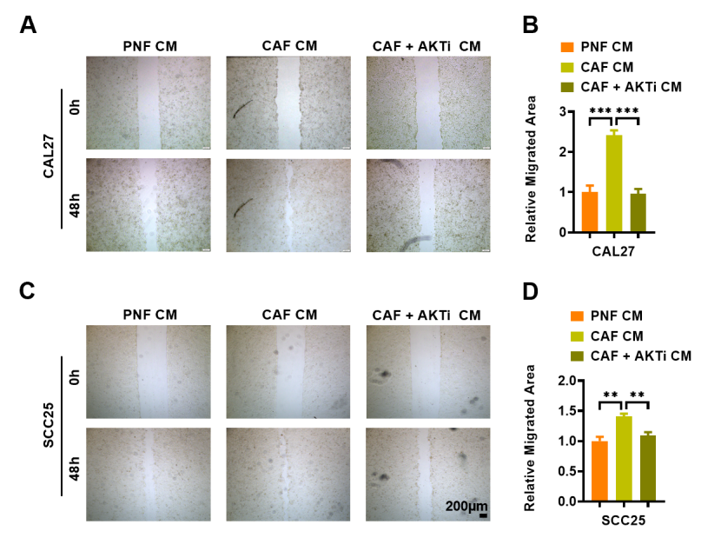

Fig. S4 AKT signaling blockade in CAFs reduced CAF tumor-promoting effect on OSCC cell migration. A and C Cell migration abilities of OSCC cells were analyzed by Wound healing assay. The cells were treated with indicated CM. B and D Quantitative analysis for the migration area of A and C. Data are presented as means ± SD. *p <0 .05, **p < 0.01, and ***p <0 .001.

Fig. S5 IHC scores of p-ACLY, ACLY, p-AKT and AKT in stromal region of xenograft tumors. A IHC score of p-ACLY. B IHC score of ACLY. C IHC score of p-AKT. D IHC score of AKT. Data are presented as means ± SD. *p <0 .05, **p < 0.01, and ***p <0 .001.

