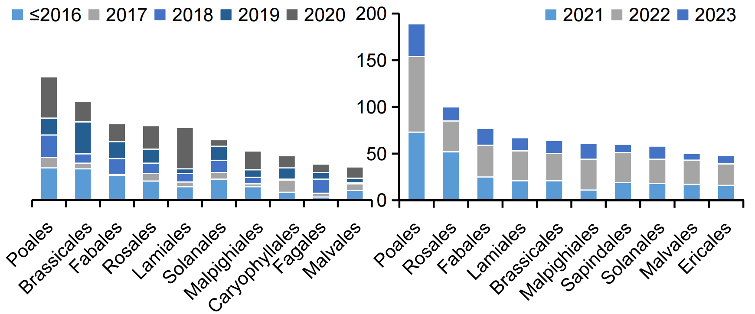
Supplemantry Figure 1 The top ten orders among the published plant genomes from 2000 to 2020, and the recent two years.

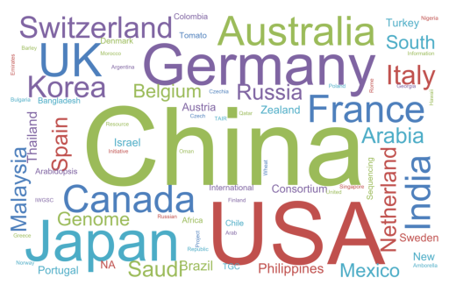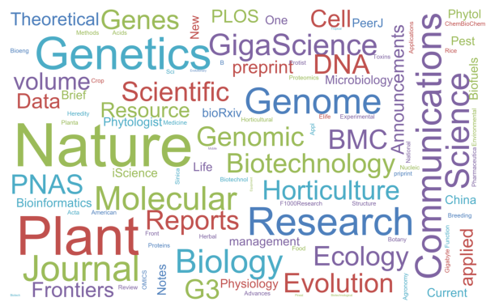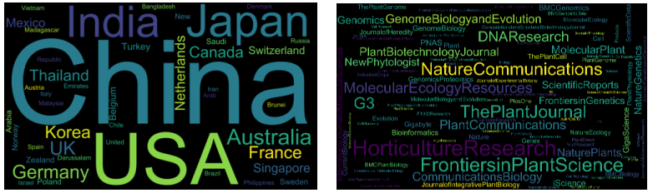
Supplemantry Figure 2 The contribution of different countries and journals for the published plant genomes in the first twenty years (top) and in the last two years (bottom) (the country of the first author or the international institutions were collected).

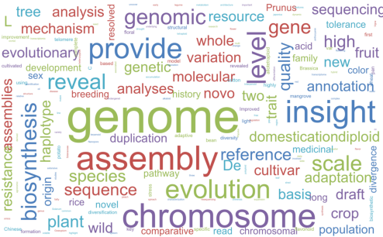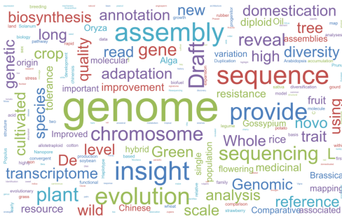
Supplemantry Figure 3 The word cloud analysis of the publications using their title in the last two years(left) and in the first twenty years(right).

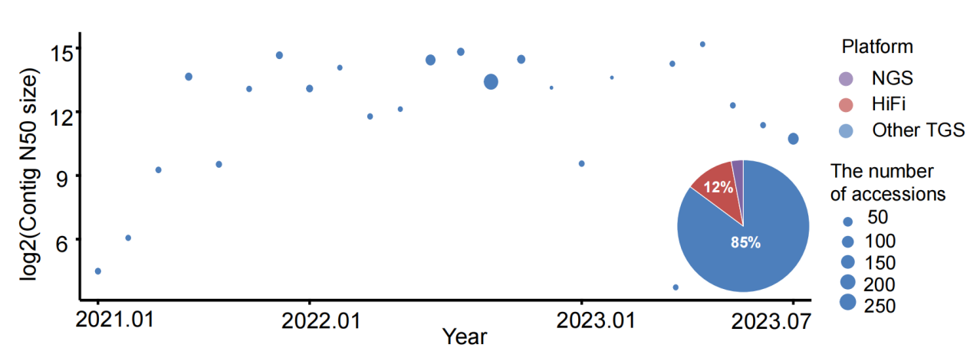
Supplemantry Figure 4 The numbers and continuity of de novo assembly of the pan-genomes. The larger the circle, the greater the number of de novo genomes are used into pan-genomes construction. The pie chart shows the proportion of different sequencing platforms. “NGS” refers to the use of only second-generation sequencing platforms; “HiFi” means HiFi reads generating by PacBio sequencing platforms; “Other TGS” refers to sequencing technologies that incorporate third-generations sequencing platforms (not including HiFi and ONT ultra-long reads) sequencing platforms. The pie chart shows the proportion of three sequencing platforms type.

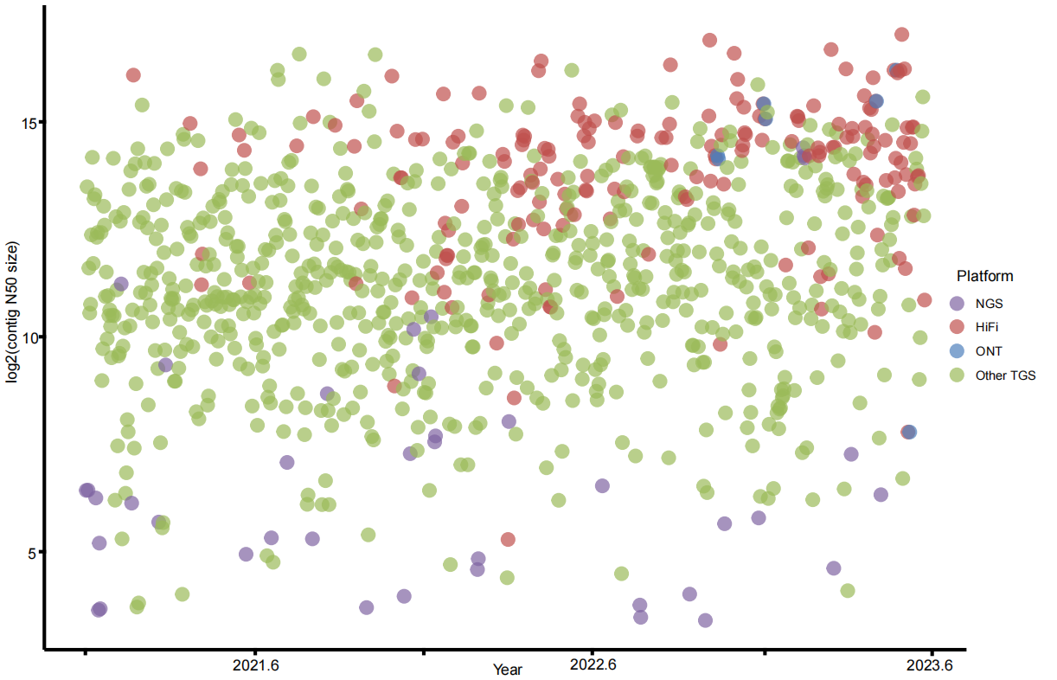
Supplemantry Figure 5 The sequencing platforms used in the assembly of plant genomes released and during the last two years. “NGS” refers to the use of only second-generation sequencing platforms; “HiFi” means HiFi reads generating by PacBio sequencing platforms; “ONT” refers to ONT ultra-long reads (reads N50 size ≥100kb); “Other TGS” refers to sequencing technologies that incorporate third-generations sequencing platforms (not including HiFi and ONT ultra-long reads).

