Longitudinal adaptive immune profiling of vaccinated children reveals correlates of protection against symptomatic SARS-CoV-2

Extended Data

Extended Data Figure 1: Isotypes and binding activity of Spike-specific memory B cells (S+ MBC) in children with immunity against SARS-CoV-2. A S+ MBC isotypes in children with vaccine-only immunity, at pre-vaccination baseline, and 3- and 6-months post vaccination. B. Binding activity against Spike proteins from three SARS-CoV-2 variants in B cell ELISPOT. Spike-specific memory B cells (S+ MBCs) were extracted from paediatric subject 3 months after 2 doses of mRNA BNT162b2, and then cultured and differentiated ex vivo into antibody secreting cells.

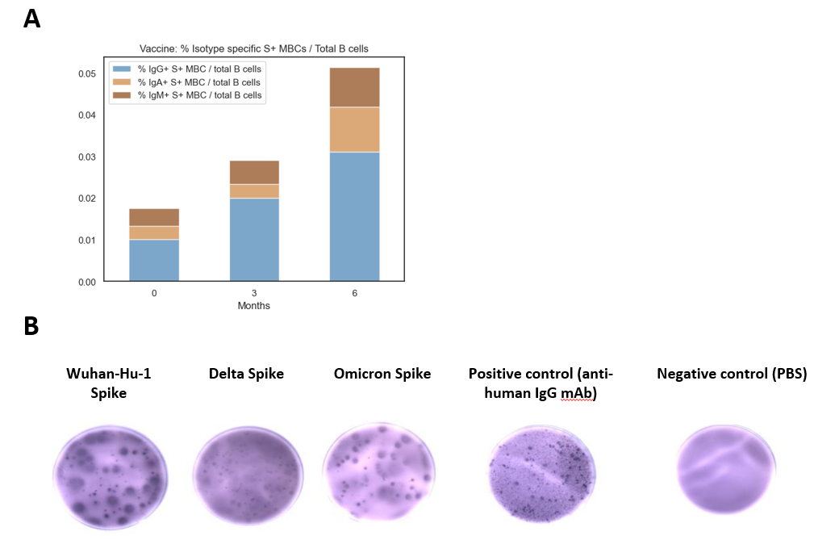

Extended Data Figure 2: Children vaccinated with 2 doses of mRNA SARS-CoV-2 vaccine have low levels of Th2 cytokines. A, B, C. Spike-reactive Th2 responses, measured by interleukin-4, interleukin-5 and interleukin-13 for children with vaccine-only immunity, and adults. For box-whisker graphs, upper and lower boundaries of boxes indicate upper and lower quartile respectively, line indicates median, and whiskers represent the range.

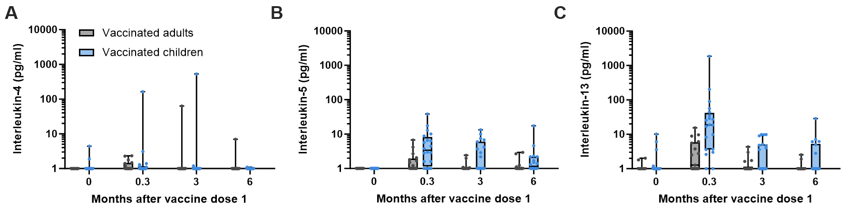
Extended Data Figure 3: Side effects post vaccination, and symptoms of SARS-CoV-2 infection reported by MARVELS children A. Percentages and severity of parent and / or subject – reported side effects for 10 days after vaccination. Blue = side effects of doses 1 and 2, with colour gradient representing spectrum of severity; Red = side effects of booster (dose 3), with colour gradient representing spectrum of severity. B. Clinical features of COVID-19 for all episodes of symptomatic SARS-CoV-2 infection among vaccinated children. Two-tailed Fisher’s exact test was used for comparison between groups; ns: not significant, *: p < 0.05, **: p < 0.01, ***: p < 0.001, ****: p < 0.0001.

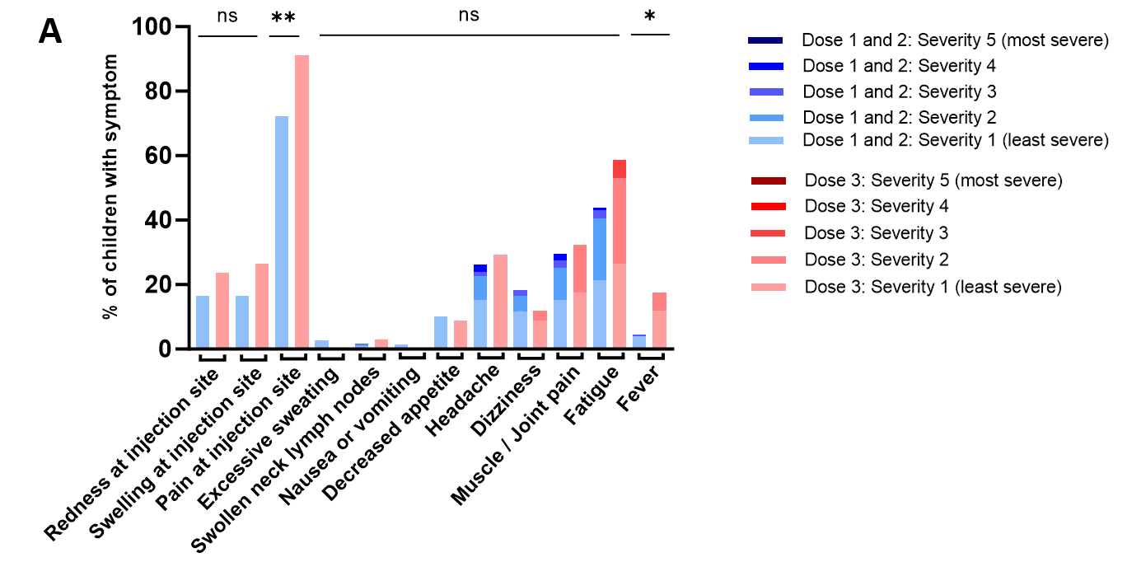

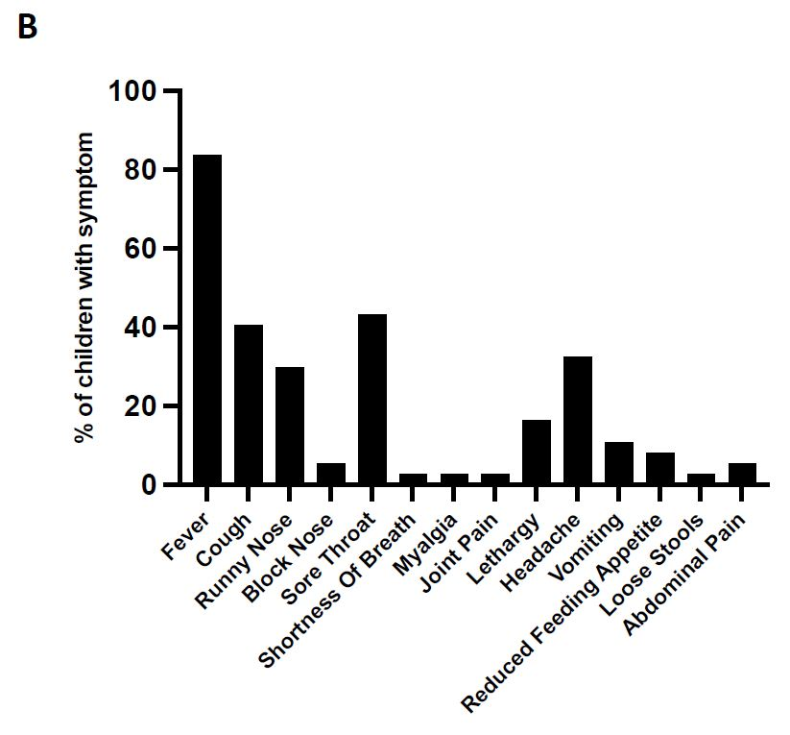
Extended Data Figure 4: Nucleocapsid (N)-specific adaptive immune responses of children with asymptomatic SARS-CoV-2 infections. A. Venn diagram showing all episodes of asymptomatic COVID-19 identified in this study (n = 30), separated into whether they were identified via serological evidence, T cell evidence, or both. B, C. N-reactive T cell responses measured by post-stimulation interferon-𝛾 and interleukin-2 levels, at pre-vaccination baseline, 3- and 6-months post vaccination, of children who remained uninfected (VV), children with symptomatic infection after 2 doses of vaccine (VVI(S)), and children with asymptomatic infection after 2 doses of vaccine (VVI(A)). D, E. N-reactive T cell responses measured by post-stimulation interferon-𝛾 and interleukin-2 levels, at 6- and 12-months post vaccination, for children with vaccine-only immunity (VV) at 6 months, and who either 1) did not develop SARS-CoV-2 infection between 6 and 12 months, 2) developed symptomatic SARS-CoV-2 infection (S), or 3) developed asymptomatic infection. F, G. N-reactive T cell responses measured by post-stimulation interferon-𝛾 and interleukin-2 levels, at 6- and 12-months post vaccination, for children with hybrid immunity at 6 months, and who either 1) did not develop SARS-CoV-2 infection between 6 and 12 months, 2) developed symptomatic SARS-CoV-2 re-infection (S), or 3) developed asymptomatic re-infection. In all graphs, subjects with serological evidence of asymptomatic SARS-CoV-2 are coloured in blue.

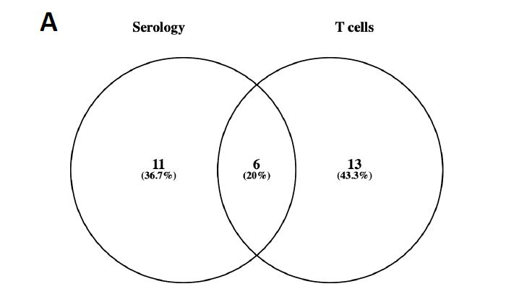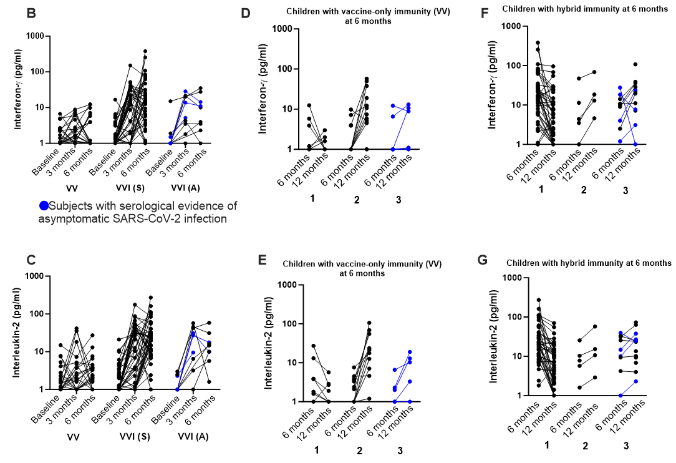
Extended Data Figure 5: The proximity of last immunity-boosting event is similar for children who had symptomatic SARS-CoV-2 infection between doses 1 and 2 (VIV), and children who had symptomatic SARS-CoV-2 infection after 2 doses (VVI(S)) A. Schematic of the time period that “proximity of last immunity-boosting event” refers to, for VIV and VVI(S) children. Created with BioRender.com. B. Comparison of proximity of immunity-boosting event for VIV and VVI(S) children. For box-whisker graphs, upper and lower boundaries of boxes indicate upper and lower quartile respectively, line indicates median, and whiskers represent the range. Two-tailed Mann-Whitney U test was used for comparison between groups; ns: not significant, *: p < 0.05, **: p < 0.01, ***: p < 0.001, ****: p < 0.0001.

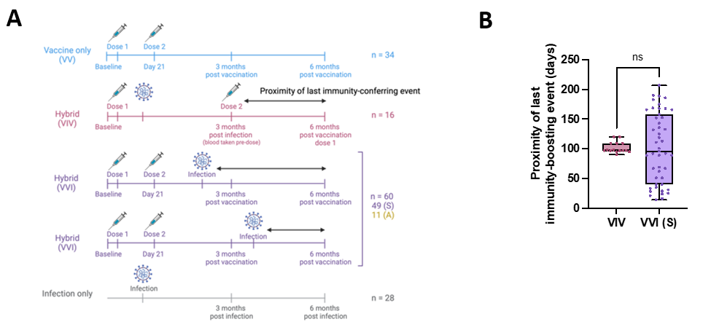
Extended Data Figure 6: Neutralising capacity across variants of concern (VOC) for paediatric subjects with immunity against SARS-CoV-2. Neutralising capacity using % inhibition at single dilution for Spike (S) proteins from VOC, for A. children who had symptomatic SARS-CoV-2 infection after 2 doses of vaccine (VVI(S)), B. symptomatic infection after 2 primary doses (VVI (S)), C. asymptomatic infection after 2 primary doses (VVI (A)), D. immunity from 2 doses of vaccine alone, E. immunity from natural infection without vaccination. Statistical testing for each variant used VVI (S) as a reference, and results of statistical testing are shown above respective VOC. Two-tailed Mann-Whitney U test was used for comparison between groups; ns: not significant, *: p < 0.05, **: p < 0.01, ***: p < 0.001, ****: p < 0.0001.

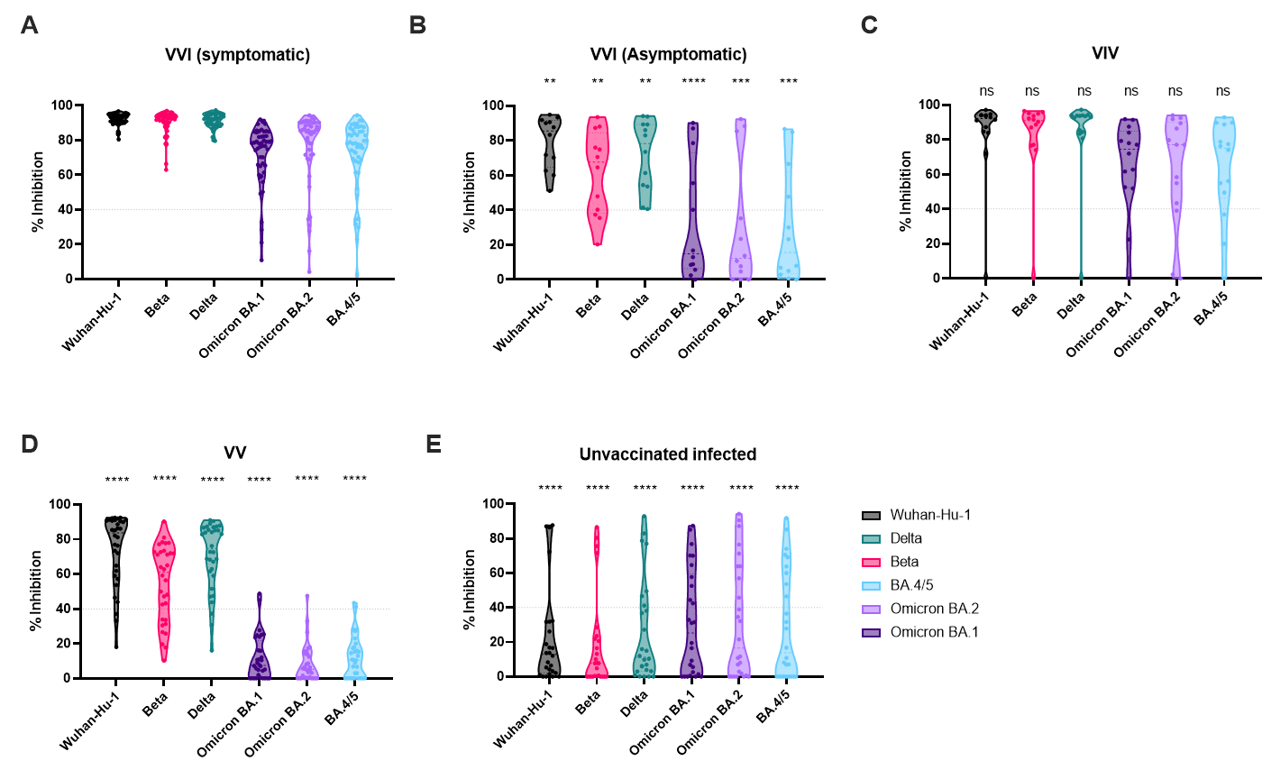
Extended Data Figure 7: Eight-cytokine release assay for Spike-reactive T cell responses among children with hybrid immunity. A. Schematic of whole-blood stimulation with SARS-CoV-2 Spike (S) peptide pools overnight and analysis of the cytokine secretion profile (after DMSO control subtraction) using unsupervised clustering algorithm (UMAP). The cytokines quantified were interferon-𝛾 (IFN-𝛾), interleukin-2 (IL-2), tumour necrosis factor-α (TNF-α), Granzyme B, interleukin-10 (IL-10), interleukin-4 (IL-4), interleukin-5 (IL-5), and interleukin-13 (IL-13). B. UMAP plots generated with all analysed blood culture supernatants (n = 391, consisting of adults, infected children and vaccinated children at all time points) with indicated cytokine secretion heatmaps. C. Concatenated cytokine secretion profiles of S peptide-pool stimulated whole blood from children with 3 types of hybrid immunity: VIV – children who had 1 dose of vaccine, followed by natural infection, followed by dose 2 3 months later, VVI (S) – children who had 2 doses of vaccine followed by symptomatic natural infection, VVI (A) – children who had 2 doses of vaccine followed by asymptomatic natural infection. Cytokine secretion profiles are overlaid on the global UMAP plot of all analysed samples (black dots; each dot corresponds to one culture supernatant). D. The amount of indicated cytokines secreted, compared between the children with 3 types of hybrid immunity. Two-tailed Mann Whitney-U test was used to compare between groups. ns: not significant, *: p < 0.05, **: p < 0.01, ***: p < 0.001, ****: p < 0.0001

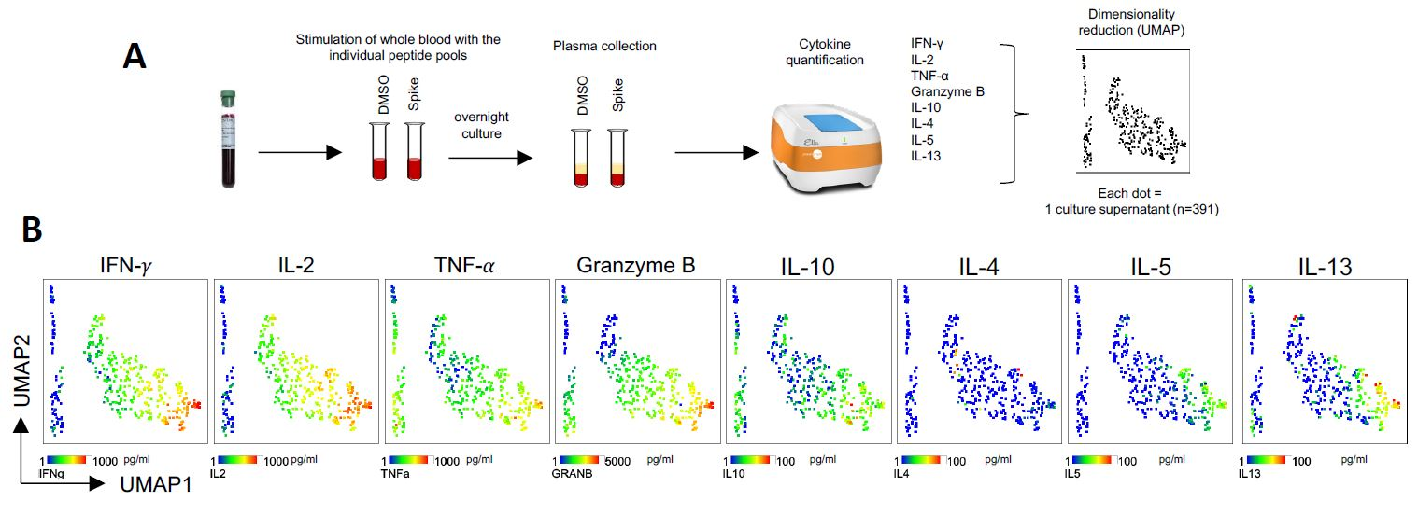

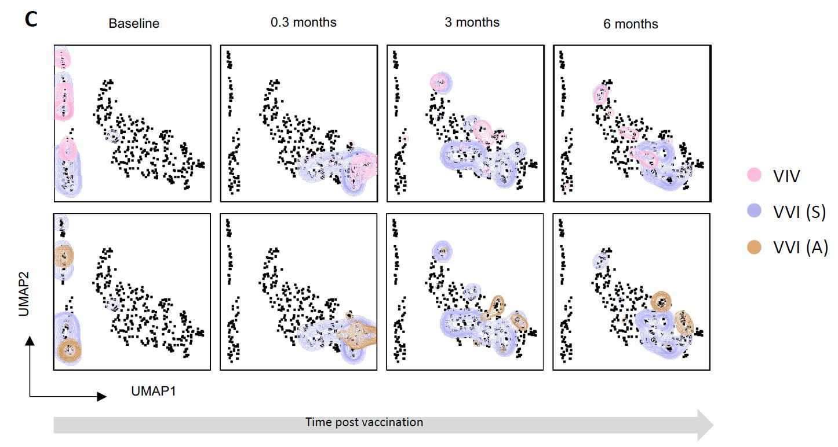
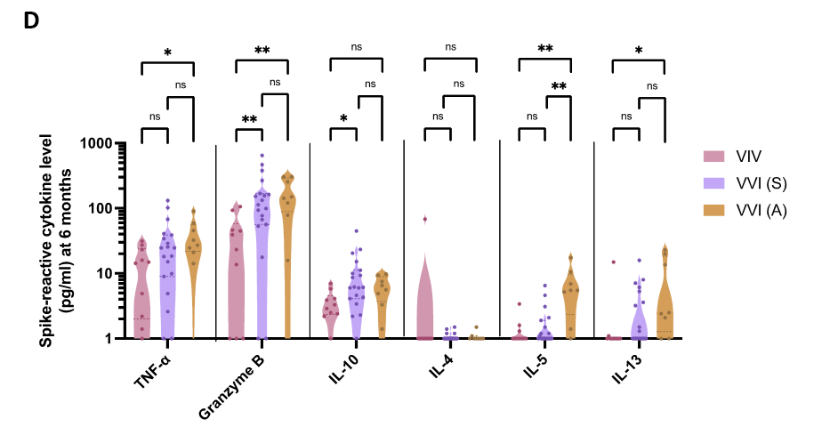
Extended Data Figure 8: Immune correlates of protection against symptomatic SARS-CoV-2 infection in 2 time-periods post vaccination. A. 3-month Spike (S)-reactive T cell responses, quantified using interferon- 𝛾 (IFN-𝛾) and interleukin-2 (IL-2), for children with no infection, symptomatic SARS-CoV-2 infection, and asymptomatic infection between 3 and 6 months. B. Receiver operating characteristics curve combining S-specific memory B cell (MBC) counts and S-reactive T cell responses measured by IFN-𝛾 (obtained by adding individual Z-scores for MBC to Z-scores of IFN-𝛾).C. S-reactive T cell responses measured by IFN-𝛾 and IL-2, for children with no symptomatic SARS-CoV-2 infection between 6 and 12 months who were VVI(A) at 6 months, the rest of the children who had no symptomatic SARS-CoV-2 infection, and the children with symptomatic SARS-CoV-2 infection. D. 3-month anti-S IgG titres for children with no infection, symptomatic SARS-CoV-2 infection, and asymptomatic infection between 3 and 6 months. For box-whisker graphs, upper and lower boundaries of boxes indicate upper and lower quartile respectively, line indicates median, and whiskers represent the range. Two-tailed Mann Whitney-U test was used to compare between groups. ns: not significant, *: p < 0.05, **: p < 0.01, ***: p < 0.001, ****: p < 0.0001. Timeline was created with BioRender.com.

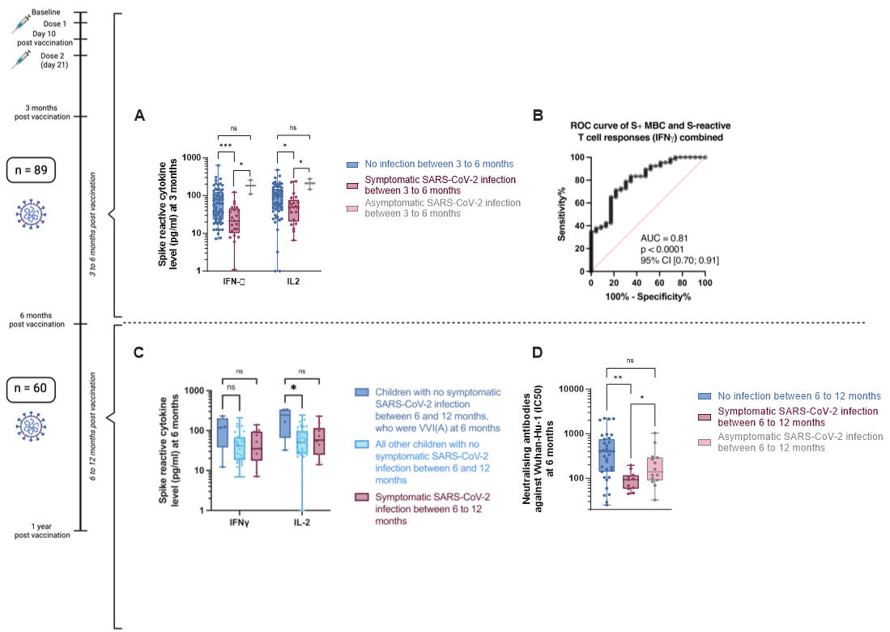

Extended Data Figure 9: Effect of a booster (third) dose of vaccine on adaptive immune responses in children who had hybrid immunity by 6 months. A. Anti-Spike (S) IgG titres at pre-vaccination baseline, 10 days, 3 months, 6 months and 12 months. B. Neutralising antibody titres against Wuhan-Hu-1 receptor binding domain, using half-maximal inhibitory concentration (IC50). C, D. Neutralising capacity using % inhibition at single dilution for S proteins for variants of concern (VOC), for children who had neither booster nor infection between 6 and 12 months, and those with booster but no infection. E. Percentage of S-specific memory B cells (S+ MBC) out of total B cells. F, G. S-reactive T cell responses measured by post-stimulation interferon-𝛾 and interleukin-2 levels. H. Anti-S IgG titres at 12 months. I. Neutralising antibody titres at 12 months. J. S+ MBC at 12 months. K. S-reactive T cell responses at 12 months. L, M. Neutralising capacity for VOC of children who had SARS-CoV-2 re-infections but no booster, and those with both re-infection and booster. Two-tailed Mann Whitney-U test was used to compare between different groups. Wilcoxon Rank test was used to compare parameters of the same subjects between different time points. ns: not significant, *: p < 0.05, **: p < 0.01, ***: p < 0.001, ****: p < 0.0001

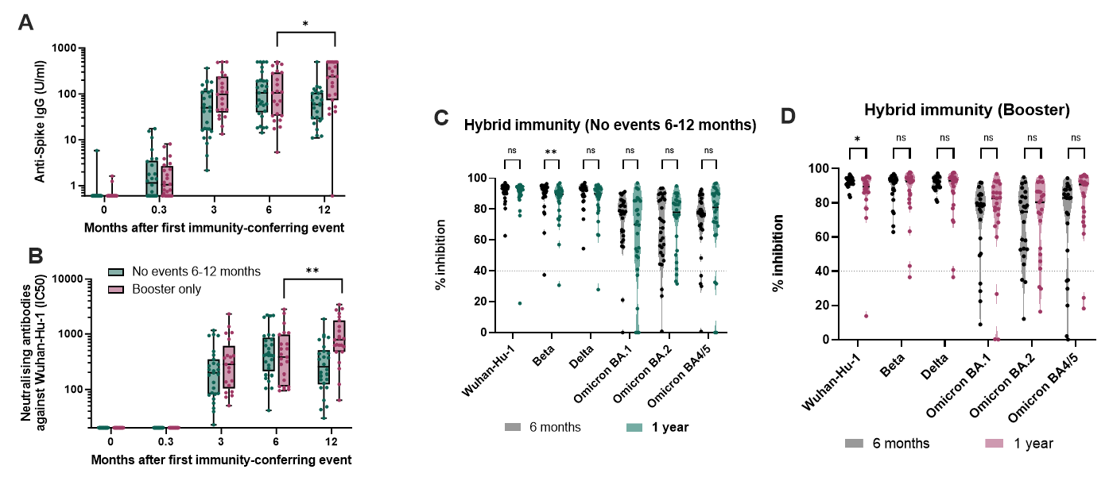
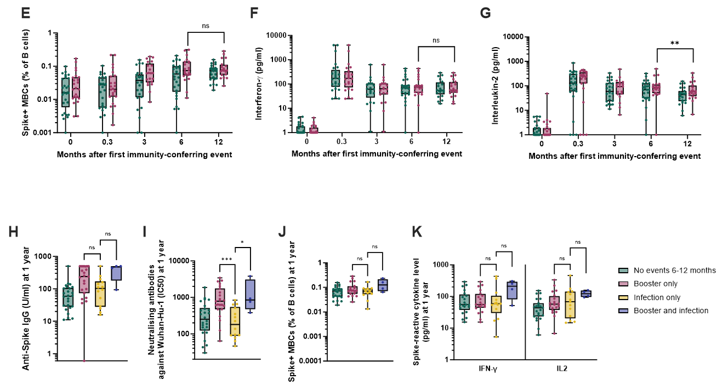
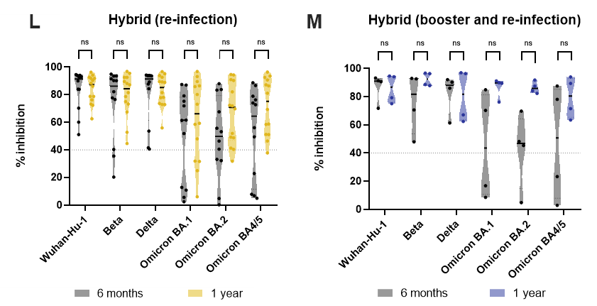
Extended Data Figure 10: Superior protective capacity of hybrid immunity, demonstrated by the different in percentages of children who developed symptomatic SARS-CoV-2 infection between 6 and 12 months, among children with vaccine-only (VV) immunity at 6 months, compared to children with hybrid immunity at 6 months. Two-tailed Fisher’s exact test was used for comparison between groups; ns: not significant, *: p < 0.05, **: p < 0.01, ***: p < 0.001, ****: p < 0.0001.

