Supplementary Information for
A new strategy in developing antifouling membranes: pulling out carrots and mud coming with
Hongwei Piao^{*, 1}, Jian Zhao^{*, 1}, Xupin Zhuang¹, Shujie Zhang¹, Qinglin Huang¹, Changfa Xiao¹, Shaomin Liu²
¹State Key Laboratory of Separation Membranes and Membrane Processes, School of Textile Science and Engineering, Tiangong University, Tianjin 300387, China
²WA School of Mines: Minerals, Energy and Chemical Engineering, Curtin University, WA 6102, Australia

Tables of contents
- Conventional photocatalytic membrane system
- Materials and reagents
- Catalyst fabrication
- Membrane preparation
  - Preparation of magnetic PET braided tube
  - Preparation of "membrane fouling-detachable" PVDF nanofiber membrane reinforced by magnetic PET braided tube
- Characterizations and methods
5.1 General characterizations
5.2 Methods
5.2.1 Preparation of foulant solutions
5.2.2 HPLC and HPLC-MS methods
5.2.3 Anti-protein adsorption tests (Anti-BSA fouling test)
5.2.4 Membrane fouling resistance calculations
- Computational mythologies
  - DFT calculations
  - MD simulations
  - CFD simulations
  - FDTD simulations
- Results

- Conventional photocatalytic membrane system
In recent decades, environmentalists have focused on the hybrid photocatalytic membrane process and its characteristics such as hydrophilicity/hydrophobicity, permeability, photocatalytic efficiency and antifouling properties ¹⁻⁵. The integration of membranes and photocatalysts can be roughly classified into two categories: photocatalysts-slurry membrane system and photocatalysts-immobilized membrane system, and the latter also can be divided into membrane surface immobilized type and membrane matrix mixed type as shown in Fig. S1.
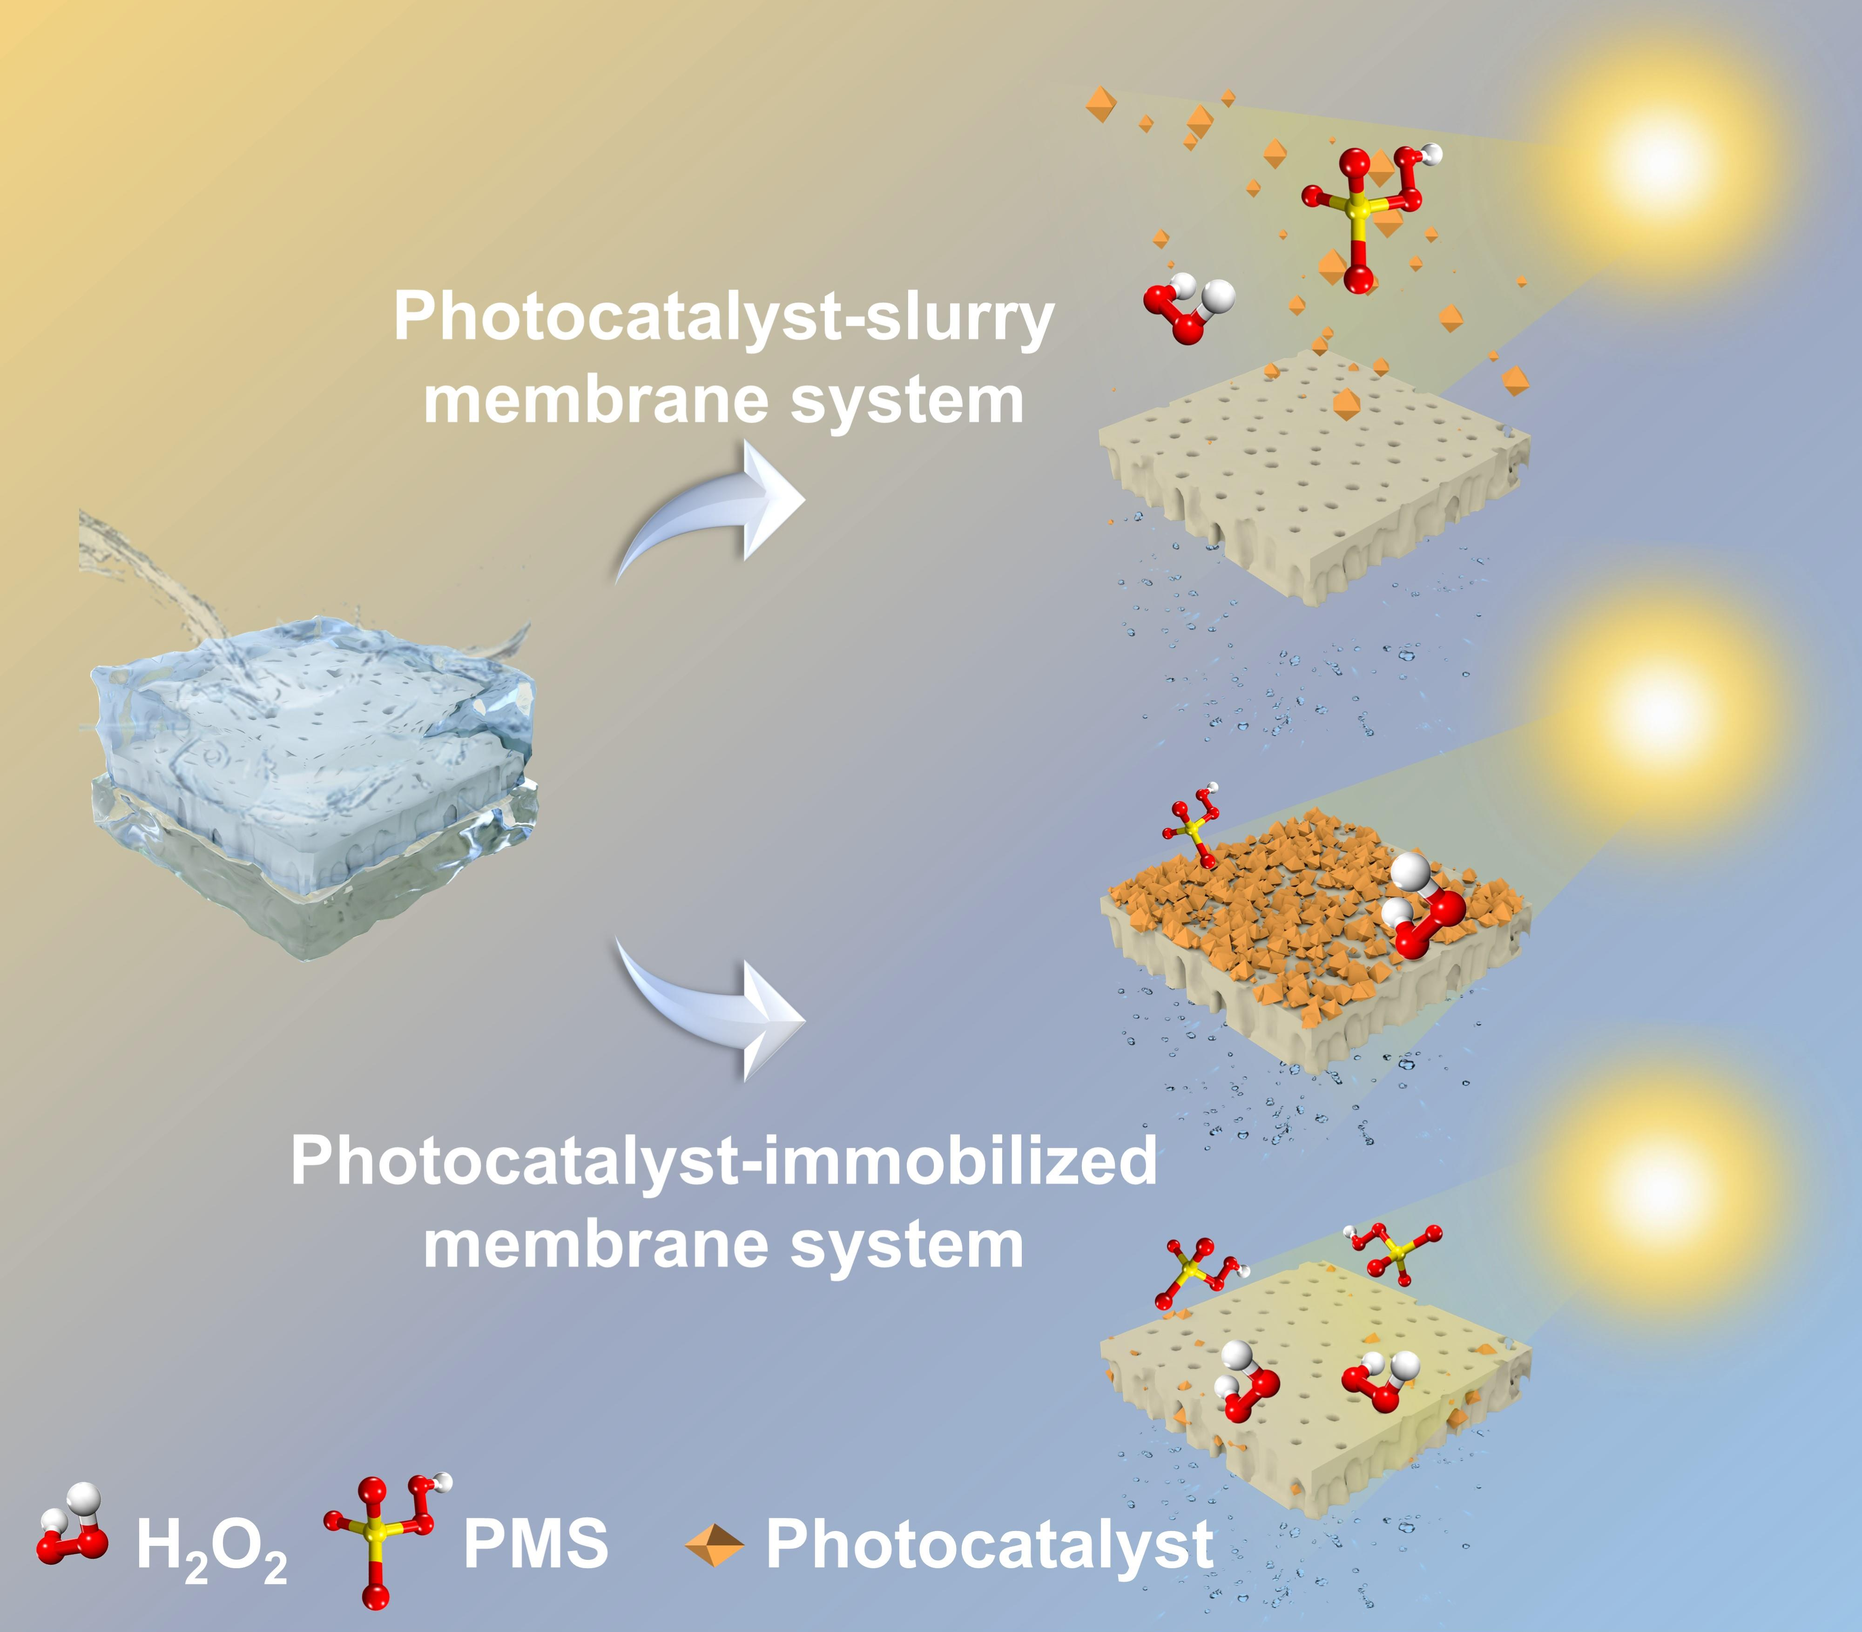
Fig. S1. Schematic diagram of conventional photocatalytic membrane systems: catalyst-slurry membrane system and catalyst-immobilized membrane.
Generally, the practical applications of photocatalytic membrane is associated with the combined action of membrane filtration and selected photocatalysts. Different combinations of membrane materials (polymer or ceramic based membranes) and photocatalysts (TiO₂, ZnO, CdS and so on) have been adopted to develop photocatalytic membranes with above strategies. Although the working mechanisms and structural compositions of the two conventional configurations differ considerably, each has its own merits, as summarized in Table S1. Here, a revolutionary method against membrane fouling was proposed based on magnetic particle attaching/detaching cycle as well as photocatalysis.
Table S1. Advantages and disadvantages of two conventional photocatalytic membrane configurations
Type | Catalyst-slurry system | Catalyst-immobilized system
Advantages | - Increasing the contact area between photocatalysts and pollutants;  - Less membrane damage by light irradiation in aqueous environment or ·OH indirect contact;  - Only need to refresh photocatalysts. | - The tunable photocatalyst loading amount;  - Low replacement frequency;  - Pollutants filtration and degradation can be performed simultaneously;  - Enhanced anti-fouling performance can be achieved by in-situ degradation.
Disadvantages | - Poor filtration efficiency induced by catalysts blockage and membrane fouling;  - Inevitable photocatalysts loss;  - Pre-treatments need be applied before separation. | - Photocatalytic efficiency may be constrained by operated conditions (photocatalyst's activity, turbidity, filtration method, operation pressure and etc.);  - The adhesion between photocatalyst and membrane matrix is vital during a long-term filtration;  - The deactivation of photocatalyst needs the replacement of membrane units;  - Long-term irradiation and ·OH direct contact resulting in membrane matrix damage (especially to polymer-based membranes).

- Materials and reagents
Ferric chloride hexahydrate (FeCl₃·6H₂O, > 99%), potassium peroxymonosulfate salt (KHSO₅·0.5KHSO₄·0.5K₂SO₄, PMS, 42~46%), humic acid (HA, ≥90.0%), thioacetamide (TAA, 99.9%), bisphenol A (BPA, > 99.8%), ofloxacin (OFL, 98.0%), tetracycline (TC, AR), 5,5-Dimethyl-1-pyrroline-N-oxide (DMPO, ≥99.0%), 2,2,6,6-Tetramethyl-1-piperidine (TEMP, ≥99.0%), sodium carbonate (Na₂CO₃, AR), p-benzoquinone (p-BQ, >99%), L-histidine (L-HIS, 99%), sodium alginate (SA, ≥90.0%), bovine serum albumin (BSA, 98.0%) and sulfamethoxazole (SMX, 98.0%) were purchased from Shanghai Macklin Co., Ltd., China. Dimethylacetamide (DMAc), phenol, dimethyl sulfoxide (DMSO), fluorescein isothiocyanate (FITC, 90.0%), dibasic sodium phosphate (Na₂HPO₄, AR), potassium dihydrogen phosphate (KH₂PO₄, AR), sodium carbonate (Na₂CO₃, AR), sodium bicarbonate (NaHCO₃, AR), sodium chloride (NaCl, 99.0%) and potassium chloride (KCl, 99.0%) were provided by Tianjin Kermel Chemical Reagent Co., Ltd., China. Isopropyl alcohol (IPA, 99.5%), sodium dodecyl sulfate (SDS, ≥98.0 %) and methanol (MeOH, 99.5%) were supplied by Tianjin Wind-ship Chemical Technology Co., Ltd., China. Methyl orange (MO, IND), crystal violet (CV, AR), methylene blue (MB, AR) and rhodamine B (Rh B, AR) were acquired from Tianjin Municipality Tianxin Superfine Chemical Industry Development Center, China. Sodium hydroxide (NaOH, 95%), acetone and hydrochloric acid (HCl, 36~38%) were provided by Tianjin Wind-ship Chemical Technology Co., Ltd., China. Fumaric acid (≥99.5%), acetonitrile (LC-MS, 99%), formic acid (LC-MS, 99%), methanol (LC-MS, ≥99.9%), ammonium acetate (AR, ≥99.0%) was obtained from Aladdin Reagent Co., Ltd., China. All of above chemical reagents were used directly without further purification.
Neodymium magnet tube electroplated copper-nickel layer (NdFeB magnet tube, outer diameter × inner diameter × length = 2.7 × 1.55 × 7.4 mm, magnetic field intensity: 1.29 kGs) was supplied by Jiuci Technology Co., Ltd., Beijing, China. Polyester (PET) monofilament (d=0.2 mm) was provided by Nantong NTEC monofilament technology Co. Ltd., China. PVDF powder (Solef 761A, Mw≈ 800,000) was purchased from Solvay Industries Ltd., Belgium. Phosphor powder (fluorescent blue) was supplied by Jiucaigu Coating Co. Ltd., Shenzhen, China. Fe₃O₄ and iron particles were provided by Metal-Metallurgy Co., Ltd., Guangzhou, China.

- Catalyst synthetization

3.1 Fabrication of MIL-88 (A)
Rod-like MIL-88 (A) nanoparticles were prepared according to previous method with slight modification ⁶⁻⁸. Briefly, 3.2436 g (12 mmol) of FeCl₃·6H₂O and 1.3929 g (12 mmol) of fumaric acid were dissolved in 30 mL of DI water, respectively. Subsequently, two solutions were mixed and stirred for 10 min, and the homogenous solution was transferred into a Teflon-lined autoclave at 100℃ for 6 h. After cooling down to room temperature, the red-brown precipitates were extracted by centrifugation and washed by DI water and ethanol sequentially for several times, and then the rinsed precipitates were dried in a vacuum oven at 60℃ for 12 h.

3.2 Fabrication of magnetic Fe₃S₄
Magnetic Fe₃S₄ particles was fabricated via a facile sulfation strategy using the resulting MIL-88 (A) as precursor ^{9, 10}. Firstly, 0.1 g of MIL-88 (A) powder was intimately dispersed in 20 mL of absolute ethanol and stirred for 30 minutes. Subsequently, 0.5 g of TAA was added in the suspension under vigorous stirring and sonicated for 30 min. The resulting homogenous suspension was sealed in a Teflon-lined autoclave and heated at 120℃ for 12 h. After cooling down to ambient temperature, the black product was extracted from the residual solution by centrifuging with a speed of 7000 rpm for 10 min, and washed with DI water and ethanol for several times respectively. Finally, the collected product was dried at 40℃ in a vacuum oven overnight, and the Fe₃S₄ particles were yielded.

- Membrane preparation

4.1 Preparation of magnetic PET braided tube composite
PET braided tube was fabricated via a two-dimensional braiding machine with PET monofilaments in our laboratory as shown in Fig. S2. Briefly, the braided tubes were prepared according to the pre-set braiding parameters illustrated in Table S2, and the obtained braided tube was rinsed by acetone/ethanol to remove the stains and oiling agents, followed by drying to a constant weight. As for magnetic PET braided tube, 16 NdFeB magnet tubes were firstly stacked into a long magnet tube (assembly), and then the braided PET tube was sheathed on it. Ultimately, the magnetic PTE braided tube composites were placed in a 60℃ oven for 24 h for heat-setting.
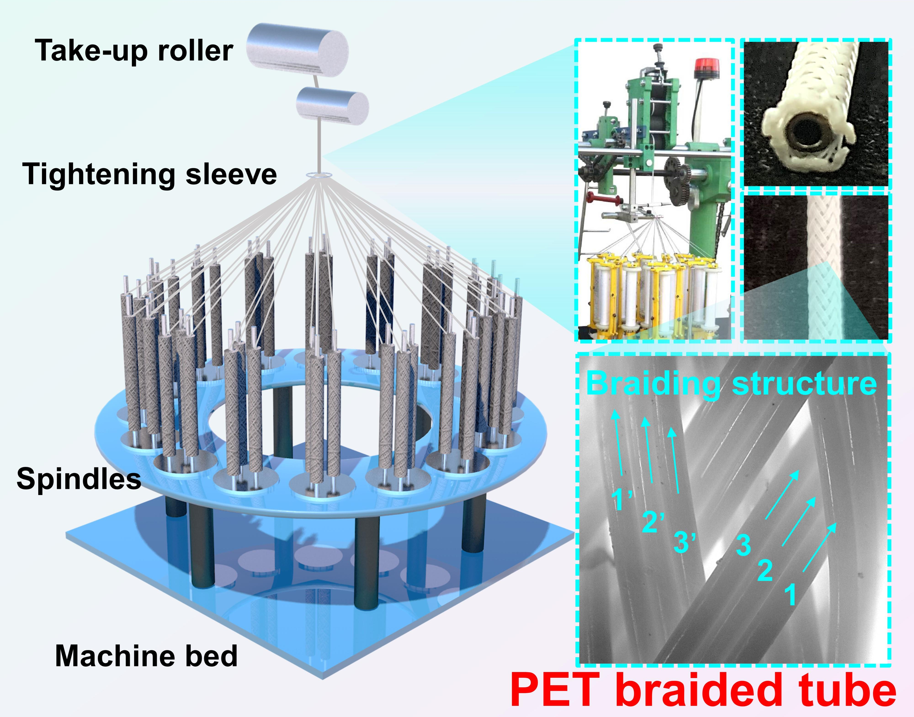
Fig. S2. Digital images of the PET braided tube and photograph & schematic diagram of the braiding machine.

Table S2. Braided parameters of PET braided tube
Parameter | PET braided tube
Outer diameter (mm) | 3.00
Monofilament diameter (mm) | 0.20
Linear density (D) | 400
Number of spindles | 16
Total filament counts | 48
Weaving angle (°) | 65.58
Weaving pitch (mm) | 0.64

4.2 Preparation of PVDF nanofiber membrane reinforced by magnetic PET braided tube (MTNFM) with detachable Fe₃S₄ for membrane fouling resistance
A defined amount of PVDF powder (14 wt%) was dissolved in a mix solution (acetone to DMAc of 2.5:7.5 in mass ratio) and followed by stirring for 12 h at 50 ℃ to get a homogeneous doping solution. A commercial electrospinning apparatus (TL-Pro, TONGLI, China) was adopted to prepare PVDF nanofiber onto magnetic PET braided tube. Specifically, the electrospinning process was carried out with a high voltage of 15 kV, -5 kV voltage of collector, a feed rate of 0.6 mL·h⁻¹, and the distance from spinneret to collector of 12.5 cm. Particularly, as-prepared magnetic PET braided tube (outer diameter ~ 3.2 mm) was used as a targeted collector with a rotating speed of 800 rpm. The ambient temperature and relative humidity of spinning environment were controlled at 25 ± 2℃ and 65 ± 5%, respectively. After electrospinning, the resulting composite membranes were placed in a vacuum oven at 60 ℃ for 12 h to remove the excessive solvent.
As for magnetic detachable Fe₃S₄ loading on PVDF nanofiber membrane reinforced by magnetic PET braided tube (MTNFM), the desired amount of Fe₃S₄ particles were uniformly attached on PVDF membrane surface via magnetic force. Correspondingly, the composite membranes were respectively denoted as M0, M1, M2, M3, M4 and M5 according to the different loading amount of Fe₃S₄ on membrane surface (0, 0.1, 0.2, 0.3, 0.4 and 0.5 g, respectively).

- Characterizations and methods

5.1 General characterizations
The morphologies and structures of as-prepared catalysts and membranes were observed through desktop scanning electron microscopy (SEM, Phenom XL, Netherlands) and field emission scanning electron microscopy (FESEM, Hitachi S4800, Japan). Transmission electron microscope (TEM) and selected area electron diffraction (SAED) were conducted on a high-resolution transmission electron microscope (HRTEM, JEM-F200, Japan). The elemental composition of as-prepared catalysts was detected via an energy dispersive spectrometer (EDS, Edax Apollo XL, USA). The magnetic properties of as-prepared catalysts were determined via a vibrating sample magnetometer (VSM-7300, Quantum Design, San Diego, CA, USA) at 298 K. True color confocal microscope (CCM, ZEISS, Germany) was employed to detect the roughness of composite membranes. Surface functional groups and crystalline behavior of as-prepared catalysts and membranes were characterized by Fourier transform infrared spectrum (FTIR, Nicolet iS50, USA) under ATR mode and powder X-ray diffraction (PXRD, D8 Discover, Bruker, Germany), respectively. X-ray photoelectron spectrometer (XPS, Thermo Fisher, USA) was used to determine the surface chemical composition and binding energies of as-prepared samples. The specific surface area and pore size distribution were detected with a fully automated surface area and porosity analyzer (Anton Paar, NOVA4200e, USA) by the Brunauer-Emmett-Teller (BET) equation and Barrett-Joyner-Halenda (BJH) method. Water contact angle (WCA) of as-prepared samples was measured by an optical contact angle analyzer (KRUSS, JYSP-180, Germany) with ~0.5 μL of water drop. UV-Vis diffuse reflectance spectra (UV-Vis DRS) were obtained by an UV-Vis NIR spectrometer (UH 4150, HITACHI, Japan) in the range of from 200 to 1500 nm. ζ-potentials of as-prepared membranes and catalysts were measured by a solid surface ζ-potential analyzer (Surpass-3, AntonParr, Austria) with pH values of 3 ~ 10 and a ζ-potentiometer (Zetasizer Nano-ZS, Malvern Instruments, UK). Leachability of catalysts was determined by the Varian Vista MPX inductively coupled plasma optical emission spectrometer (ICP-OES, CCD, USA).
The electrochemical tests were conducted by a commercial electrochemical workstation (CHI 650E, Shanghai Chenhua Instrument Co., China) with a standard three-electrode system including a photocatalyst electrode (working electrode), a Pt wire electrode (counter electrode) and an Ag/AgCl electrode (reference electrode). As-prepared photocatalysts were coated on a clean 1×1 cm² fluorine-doped tin oxide glass (FTO) for testing. 0.5 M Na₂SO₄ solution (pH ~ 6.98) was served as the electrolyte. The pore size distributions of as-prepared membranes were measured via a capillary flow pore size analyzer (Porolux 1000, Porometer, Belgium), and the reported results are the average values of 3 replicates. The porosity (ε, %) of membranes was calculated by the equation S1:
$$\begin{aligned}ε=\frac{W_{w}-W_{d}}{\left(D_{o}^{2}-D_{i}^{2}\right)\left(\frac{π}{4}\right)lρ}×100\%\#\left(S1\right)\end{aligned}$$
where W_{w} and W_{d} represent the weight of wet membrane and dry membrane, respectively. D_{o}, D_{i}, l and ρ are the outer diameter (cm), inner diameter (cm), membrane length (cm) and the density of n-butanol (0.81 g·cm⁻³), respectively.

5.2 Methods

5.2.1 Preparation of foulant solutions
To evaluate the anti-fouling performance of as-prepared membranes, various foulant solutions were used here including BSA solution (1 g·L⁻¹), HA solution (1 g·L⁻¹), SA solution (1 g·L⁻¹) and kerosene-in-water emulsion (surfactant stabilized).
Preparation of BSA solutions: phosphate buffered saline (PBS) solution was prepared by dissolving 8.0 g NaCl, 0.2 g KCl, 1.44 g Na₂HPO₄ and 0.24 g of KH₂PO₄ in 800 mL of double distilled (DD) water and adjusted by HCl to pH=7.4, and then fixed volume to 1 L with DD water. The mixture was sterilized for 1 h in an autoclave and then stored in a 4℃ refrigerator. The BSA solution (1 g·L⁻¹) was prepared by dissolving certain amount of BSA particles into PBS, which was stored for no longer than 1 h before any test.
Preparation of HA solutions: HA batching solution (10 g·L⁻¹) was obtained by dissolving 10 g HA powder in 1 L of 0.1M NaOH solution with magnetic stirring for 72 h. The standard HA solution (1 g·L⁻¹) was diluted by the mother liquor and then adjusted the pH value to ~ 7.5 with 0.1 M HCl solution. Subsequently, the mixture was filtered through a 0.45 μm filter paper to remove the insoluble ingredients and fixed the volume to 1 L. Finally, the resultant HA solution was stored in a 4℃ refrigerator for use.
Preparation of SA solutions: 1 g SA powder were dissolved in 10 g of DI water at 60℃ to get a transparent and homogeneous SA solution, and stored in a 4℃ refrigerator (no more than one week before use).
Preparation of kerosene-in-water emulsion: 495 mg SDS powder was pre-dissolved in 495 mL of DI water, then 5 mL of kerosene was added in it. And the mixture was sonicated for 30 min at 40 kHz and then mechanically stirred (1000 rpm) for 12 h to obtain the stable milky surfactant stabilized emulsions.

5.2.2 HPLC and HPLC-MS methods
TC concentration in permeate and feeding solution was detected by a high-performance liquid chromatography (HPLC, Agilent 1260, USA) equipped with an Agilent Zorbax Eclipse XDB-C18 column (4.6 mm×150 mm×5 μm). The mobile phase was consisted of acetonitrile and 0.01 M NaH₂PO₄ with the volume ratio of 35/65, and the flow rate and column temperature were controlled at 1 mL·min⁻¹ and 30℃. Additionally, the detection wavelength and sample size were set as λ= 360 nm and 10 μL. The standard curve of TC is shown in Fig. S3, and the regression relationship between TC concentration and detection peak area is calculated by: C=0.02784A+0.36349 (C: TC concentration, ppm; A: detection peak area; R²=0.9999). Additionally, the concentration of various organic compounds was also analyzed by HPLC, and the brief detection conditions were listed in Table S3.
Fig. S3. Standard curve of TC concentration detected by HPLC.
TC degradation intermediates were detected by a triple quadrupole ultrahigh performance liquid chromatograph-mass spectrometer (HPLC-MS, Agilent 1100 LC/MSD, USA). The mobile phase was consisted of acetonitrile and 0.1% (v/v) of formic acid aqueous solution according to the volume ratio of 10/90. And the flow rate of mobile phase, sample volume and column temperature were set as 0.2 mL·min⁻¹, 10 μL and 40℃, respectively. Mass spectra with an electrospray ionization (ESI) source were recorded across the range of 50-500 m/z with the positive (& negative) scan mode and further analyzed with the multiple reaction monitoring (MRM) mode (positive & negative). All of permeate samples were filtered through a 0.22 μm Millipore filter paper before testing.

Table S3. HPLC detection parameters of various organic compounds
Targeted compounds | HPLC methods*
Sulfamethoxazole (SMX) | Sample volume: 20 μL; the mobile phase contained 0.1% acetic acid solution/acetonitrile (50/50, v/v) at a flow rate of 1.0 mL·min⁻¹; column temperature: 40℃.
Bisphenol A (BPA) | Sample volume: 50 μL; the mobile phase was ultrapure water/acetonitrile (35/65, v/v) at a flow rate of 0.8 mL·min⁻¹; column temperature: 40℃.
Ofloxacin (OFL) | Sample volume: 20 μL; the mobile phase was 0.2% acetic acid solution/acetonitrile (87/13, v/v) at a flow rate of 1.5 mL·min⁻¹; column temperature: 40℃.
Humic acid (HA) | Sample volume: 10 μL; the mobile phase was 20.0% acetic acid solution (v/v) at a flow rate of 1.0 mL·min⁻¹; column temperature: 40℃.
Methyl orange (MO) | Sample volume: 10 μL; the mobile phase was ultrapure water/80.0% methanol solution (30/70, v/v) at a flow rate of 0.5 mL·min⁻¹; column temperature: 30℃.
Phenol | Sample volume: 20 μL; the mobile phase was ultrapure water/80.0% methanol solution (35/65, v/v) at a flow rate of 0.8 mL·min⁻¹; column temperature: 30℃.
Crystal violet (CV) | Sample volume: 10 μL; the mobile phase contained ultrapure water/80.0% methanol solution (50/50, v/v) at a flow rate of 1.0 mL·min⁻¹; column temperature: 30℃.
Rhodamine B (Rh B) | Sample volume: 10 μL; the mobile phase contained ultrapure water/80.0% methanol solution (50/50, v/v) at a flow rate of 1.0 mL·min⁻¹; column temperature: 30℃.
Methylene blue (MB) | Sample volume: 20 μL; the mobile phase was methanol contained 10 mM ammonium acetate at a flow rate of 0.8 mL·min-1; column temperature: 35℃.
*In Table S3, different concentration ratios here are among volume ratio when not given any special instructions.

5.2.3 Anti-protein adsorption tests (Anti-BSA fouling test)
Carbonate buffer solution (CBS, pH≈9.0) was prepared by dissolving 6.36 g Na₂CO₃, 3.36 g NaHCO₃ in 100 mL of DD water. Simultaneously, 10 mg FITC was dissolved in 10 mL DMSO, and then fixed volume to 10 mL with the CBS above, and finally 1 mg·mL⁻¹ FITC solution was yielded. After pre-wetted by the CBS, the membranes were immersed in FITC solution and kept in the dark at ambient temperature for 0.5 h to check BSA fouling, and then cleaned with PBS solution several times for observation. Ultimately, the confocal scanning microscopy (CSM, Leica SP8, Germany) was adopted to characterize the anti-protein properties of as-prepared membranes.

5.2.4 Membrane fouling resistance calculations
The resistance-in-series model was adopted to further evaluate the antifouling capacities of as-prepared membranes. Based on it, the extent of the membrane fouling can be quantitatively calculated as follows ¹¹:
$$\begin{aligned}R_{TOT}=\frac{∆P}{ηJ_{F}}=R_{M}+R_{C}+R_{F}\#\left(S2\right)\end{aligned}$$
here, R_{TOT}, ∆P, η and J_{F} stand for the total filtration resistance (m⁻¹), transmembrane pressure (0.02 MPa), the viscosity of permeate (8.937 × 10⁻⁴ Pa∙s⁻¹) and the flux of foulant solution.
The accurate resistance values of membranes can be calculated by the following equations:
$$\begin{aligned}R_{M}=\frac{∆P}{ηJ_{0}}\#\left(S3\right)\end{aligned}$$
$$\begin{aligned}R_{F}=\frac{∆P}{ηJ_{F}}-R_{M}\#\left(S4\right)\end{aligned}$$
$$\begin{aligned}R_{C}=\frac{∆P}{ηJ_{R}}-R_{M}-R_{F}\#\left(S5\right)\end{aligned}$$
where R_{M} (m⁻¹) is the intrinsic resistance of the membrane; R_{F} (m⁻¹) represents the fouling resistance caused by adsorption stain of foulants on membrane or pore wall; R_{C} (m⁻¹) stands for the fouling resistance caused by the removable gel/cake layer on membrane surface. Thus, the total filtration resistance (R_{TOT}) is obtained by simple summation of R_{M}, R_{F} and R_{C}.

- Computational methodologies

6.1 Density function theory (DFT) calculations
DFT calculations were carried out by Material Studio packages and Gaussian 09W program. Firstly, the interactions between PMS and Fe₃S₄ were calculated by CASTEP model in Materials Studio using the periodic supercell approach. Generalized gradient approximation with Perdew-Burke-Ernzerhof (GGA-PBE) method was adopted to treat the exchange–correlation functions ^{9, 12-14}. For the plane-wave basis set, the energy cutoff was setup to 571.40 eV, and the Brillouin zone integration was generated according to Monkhorst-Pack method using Gamma centered 1×2×1 k-point mesh. All of structures were rearranged until the energy change less than 0.0001 eV with the forces on each atom below 0.01 eV/Å (and the maximum stress ˂0.03 GPa). The electrostatic potential (ESP) and Mulliken charge of β-PVDF, SA and HA were also analyzed to reveal the adsorption mechanism via DMol³ model. The adsorption energy (E_{ads}) can be defined as Eq. S6 ¹⁵:
$$\begin{aligned}E_{ads}=E_{total}-E_{substrate}-E_{molecule}\#(S6)\end{aligned}$$
where $E_{total}$, $E_{substrate}$and $E_{molecule}$ stand for the total energy of the total structure of the adsorption system, substrate energy and free molecule energy, respectively.
In addition, the molecular structure of TC was optimized by B3LYP/6-31G (d) basic set level via Gaussian 09W program. The highest occupied molecular orbital (HOMO), the lowest unoccupied molecular orbital (LUMO) and Fukui function were performed by Multiwfn 3.8 before being drawn and further rendered by VMD 1.4 ¹⁶⁻¹⁸. Specifically, the condensed Fukui function could be defined by Eq. S7:
$$\begin{aligned}f\left(r\right)={{\left(\frac{∂^{2}E}{∂N. ∂v\left(r\right)}\right)=\left[\frac{∂μ}{∂v\left(r\right)}\right]}_{N}=\left[\frac{∂ρ\left(r\right)}{∂N}\right]}_{V\left(r\right)}\#(S7)\end{aligned}$$
here, ρ(r), N and the constant term ν in the partial derivatives represents the electron density at the point r, electron number and external potential, respectively. Specifically, the condensed Fukui function can be expressed for three types as followed equations.
Nucleophilic attack: $f_{k}^{+}=q_{N}^{k}-q_{N+1}^{k}$
Electrophilic attack: $f_{k}^{-}=q_{N-1}^{k}-q_{N}^{k}$
Radical attack: $f_{k}^{0}={(q}_{N-1}^{k}-q_{N+1}^{k})/2$
here, $q_{N}^{k}$ is the atom electric density of atom k at the corresponding state.

6.2 Molecular dynamic (MD) simulations
MD simulations were carried out to illustrate the transport properties of water molecules within as-prepared membranes via Materials Studio package. Briefly, two models including pristine membrane system (water/PVDF) and Fe₃S₄ attached membrane system (water/Fe₃S₄/PVDF) were taken account here. The current work assumes that the water box, Fe₃S₄ box and PVDF box were composed of 1700 water molecules, 50 Fe₃S₄ molecules (amorphous) and 50 PVDF molecular chains (each box size was controlled at ~ 35±1.75 Å). The boundary conditions were applied in x- and y-direction, whereas z-direction was regarded as non-periodic ¹⁹. Geometry optimization was performed in advance to get the stable structure of the molecule unit and boxes. Each sample was respectively equilibrated under NPT and NVT ensemble at a constant temperature of 298 K with zero pressure for 1000 ps to achieve the equilibrium ¹⁵. Here, Andersen thermostat and Berendsen barostat were applied in the system regarding to temperature and pressure conversion, and the universal force field was selected to represent the interaction between microscopic atoms. Finally, the properties of modules were obtained in the last 1000 ps. Mean Square Displacement (MSD) curves and diffusion coefficient (D) were adopted to evaluate the water mobility in system, and MSD and D can be calculated as Eq. S8 and S9:
$$\begin{aligned}\lim_{n→∞}{MSD}=\lim_{t→∞}{\frac{d}{dt}\sum_{i=1}^{N_{α}}{<{\left[r_{i}\left(t\right)-r_{i}\left(0\right)\right]}^{2}>}} \#(S8)\end{aligned}$$
here, r_{i}(t) and r_{i}(0) represent the distance of i^{th} atom at time t and initial time (t=0), respectively.
$$\begin{aligned}D=\frac{1}{6T}MSD \#(S9)\end{aligned}$$
where T is total simulation time of the system, and D is the one-sixth slope of MSD, which can reflect the intensity of the molecule’s mobility.

6.3 Computational fluid dynamic (CFD) simulations
Two-dimensional simulation domains for smooth membrane surface (M0) and rough membrane surface (M3) were generated in commercial software (COMSOL Multiphysics)²⁰. The overall simulation domain was set as 10 cm (length) × 1 cm (height). A steady-state model was used to study the velocity and pressure distribution of water flow on the membrane surface. The physical models were displayed in Fig. S4 & S5, in which the part A, B and C was the quartz, water and PVDF (substrate), respectively. Navier-Stokes and fluid continuity equations were solved by finite element method, and the fluid was assumed as Newtonian fluid ²¹. Specifically, the inlet velocity was set as 0.1804 m∙s⁻¹, which was consistent with the actual test conditions.
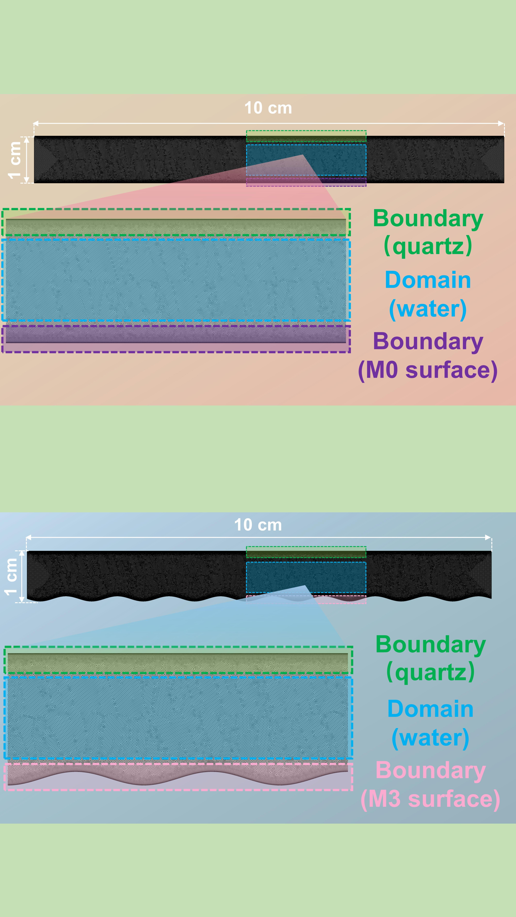
Fig. S4. The physical model of M0 surface with mesh situations.
Fig. S5. The physical model of M3 surface with mesh situations.

6.4 Computational magnetism simulations
The three-dimensional simulation domain for NdFeB magnetic tube was simulated by COMSOL Multiphysics (AC/DC model) ^{22, 23}. Magnetic field was studied in the air medium. The overall simulation domain was a sphere with radius of 10 mm contained a magnetic tube as depicted in Fig. S6 (outer diameter × inner diameter × length = 2.7 mm × 1.55 mm × 7.4 mm). Axisymmetric boundary condition and magnetic boundary condition (air medium) were adopted to center the model plane and apply the outer borders of the whole simulation domain (assuming no magnetic flux leakage occurs beyond the work domain). To approach realistic results, the magnetic field strength of 102684 A∙m⁻¹ was applied to the Z-axis.
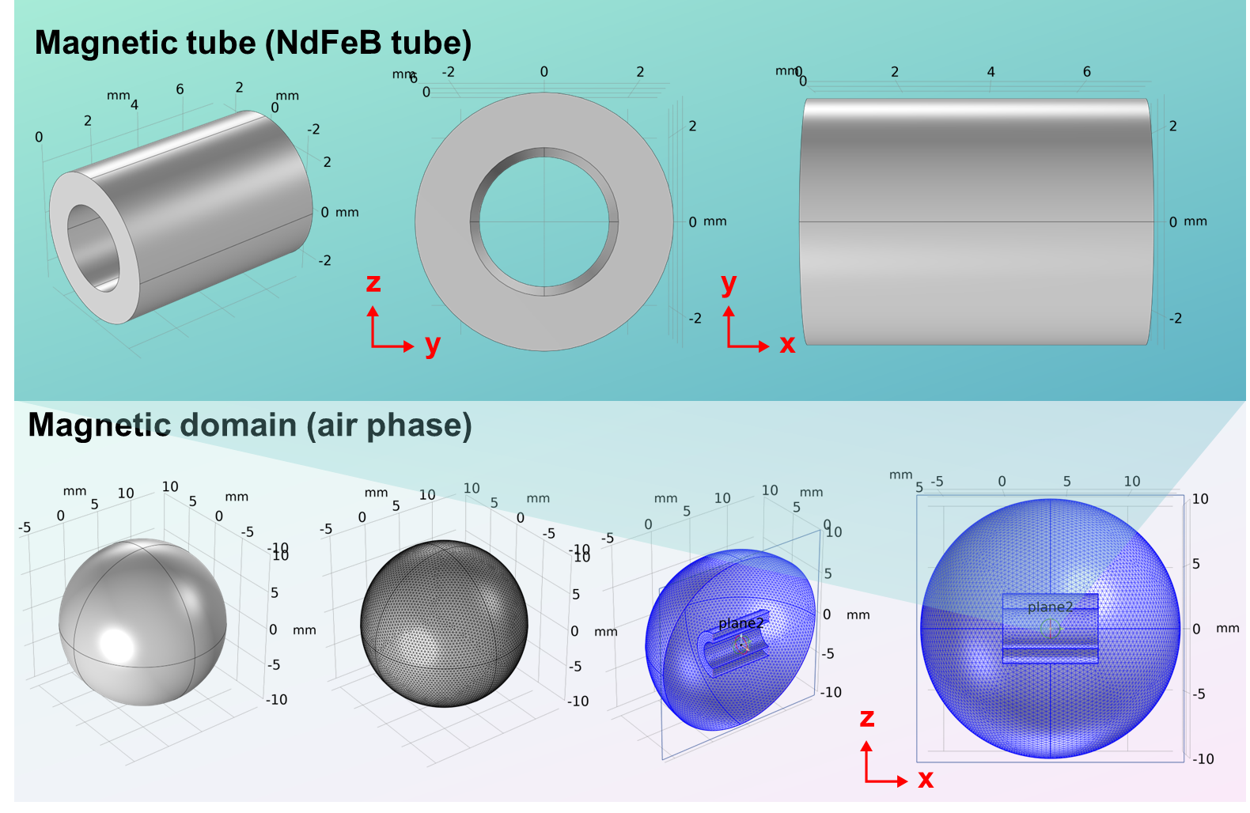
Fig. S6. The physical model of magnetic tube with mesh situations.

6.5 Finite-difference and time-domain (FDTD) simulations
FDTD simulations were carried out to provide more detailed insights of photoelectrical intensity of as-prepared MIL-88 (A) and Fe₃S₄ particles with Lumerical Solutions software ²⁴. The typical field strength variation within the specified size (1 μm × 1 μm) on the surface of catalysts was investigated here. The computational domain (cubic volume) was discretized by a structured mesh, and the field distribution simulation at models were used a Maxwell’s solver based on the finite element methods ²⁵. The wavelength of the polarized light along with Z-axis direction was 300~800 nm.

- Results
Fig. S7. N₂ adsorption-desorption isotherms of as-prepared MIL-88 (A) and Fe₃S₄.

7.1 Photo-response characteristics and photo-electrochemical properties
The higher light absorption ability and photo-electrochemical properties will endow the catalyst with an enhanced electron transfer efficiency in photo-assisted PMS activation. As depicted in Fig. S8a, as-prepared Fe₃S₄ exhibited a fantastic light adsorption in the full light spectrum than merely ultraviolet activity of MIL-88 (A), indicating that Fe₃S₄ can be photoexcited by ultraviolet (UV), visible (Vis) as well as near-infrared (NIR) light to trigger the photo-induced Fenton-like reaction. Specifically, the band gap value (E_{g}) can be calculated as Kubelka-Munk equation (Eq. S10):
$$\begin{aligned}{\left(\text{αhv}\right)}^{\text{n}}\text{=k}\left(\text{hv}-{\text{E}}_{\text{g}}\right)\#(S10)\end{aligned}$$
here, α, h and ν represents the adsorption coefficient, the Planck’ s constant and the light frequency, respectively. Additionally, n value is 2 for the direct band-gap semiconductor ^{26, 27}.
As shown in Tauc-plots (inset of Fig. S8a), E_{g} values of as-prepared MIL-88 (A) and Fe₃S₄ are 2.50 eV and 1.55 eV, respectively. The narrower bandgap value of Fe₃S₄ indicates that the enhanced visible light activity. To clarify the accurate band structure of as-prepared catalysts, Mott-Schottky (M-S) tests were further carried out. As shown in Fig. S8b-d, M-S plots of as-prepared samples exhibit positive slopes, which demonstrates both MIL-88 (A) and Fe₃S₄ are n-type semiconductor. And the flat band potentials (E_{f}) of them are determined to be around -0.37 V and -0.15 V (vs. NHE at pH=7.0), respectively ^{28, 29}. The valence band potentials (E_{VB}) of MIL-88 (A) and Fe₃S₄ are respectively calculated to be 2.13 V and 1.40 V with the empirical equation of E_{CB}=E_{VB}-E_{g}.
According to energy band theory, the narrower E_{g} is more readily excited by light irradiation, which will promote catalysts to adsorb and utilize more photons for sequential photocatalytic reactions ^{30, 31}. As shown in inset of Fig. S8, the calculated E_{g} of Fe₃S₄ is 1.55 eV, which is considerably lower than that of MIL-88 (A) of 2.50 eV. As depicted in photoluminescence (PL) and time-resolution PL (TRPL) spectra (Fig. S8e & f), the peak intensity at ~ 550 nm of Fe₃S₄ was much lower than that of MIL-88 (A), confirming a lower recombination rate of photogenerated carriers after sulfation. Moreover, there is a longer lifetime in Fe₃S₄ (5.28 ns) compared to MIL-88 (A) (4.83 ns), which demonstrates that Fe₃S₄ possesses an enhanced separation efficiency of charge carriers. In addition, it also has a smaller semicircle radius than that of MIL-88 (A) in electrochemical impedance spectroscopy (EIS) curves (Fig. S8g), illustrating a lower impedance and faster electrons transfer rate. The transient photocurrent response curves further verified above results due to its remarkable photocurrent density (Fig. S8h). As shown in Fig. S8i, a negative current flow appears rapidly in Fe₃S₄ photoelectrolyte after PMS addition, indicating the generation of surface-active substances in Fe₃S₄ and PMS system ³². And the current flow is dramatically enhanced after light irradiation, which can be attributed to the contribution of photoinduced electrons. The subsequent injection of TC also gives rise to a negative peak (downward signal), suggesting electrons migration direction is from TC to Fe₃S₄ surface.
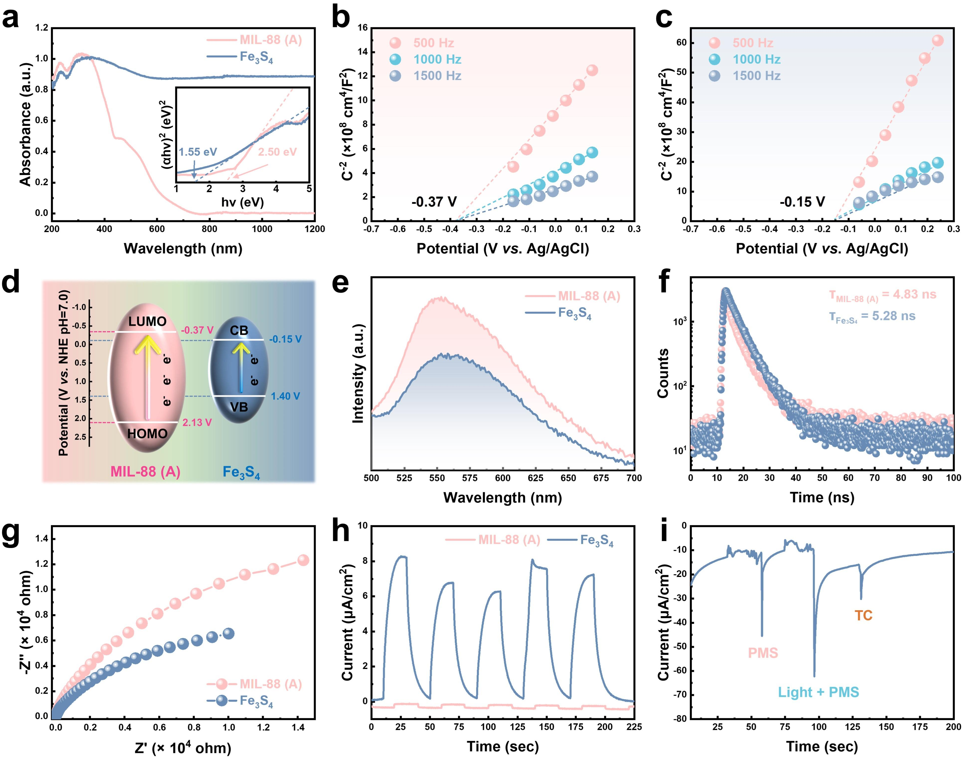
Fig. S8. (a) UV-vis-DRS spectra of as-prepared and Tauc-plots (inset) of as-prepared MIL-88 (A) and Fe₃S₄; Mott-Schottky curves of as-prepared (b) MIL-88 (A) and (c) Fe₃S₄; (d) band structure, (e) PL spectra, (f) TRPL spectra, (g) EIS-Nyquist plots and (h) transient-photocurrent of as-prepared MIL-88 (A) and Fe₃S₄; (i) I-T curve obtained vs. Ag/AgCl using 0.5 M Na₂SO₄ as electrolyte.

7.2 XPS analysis of as-prepared catalysts
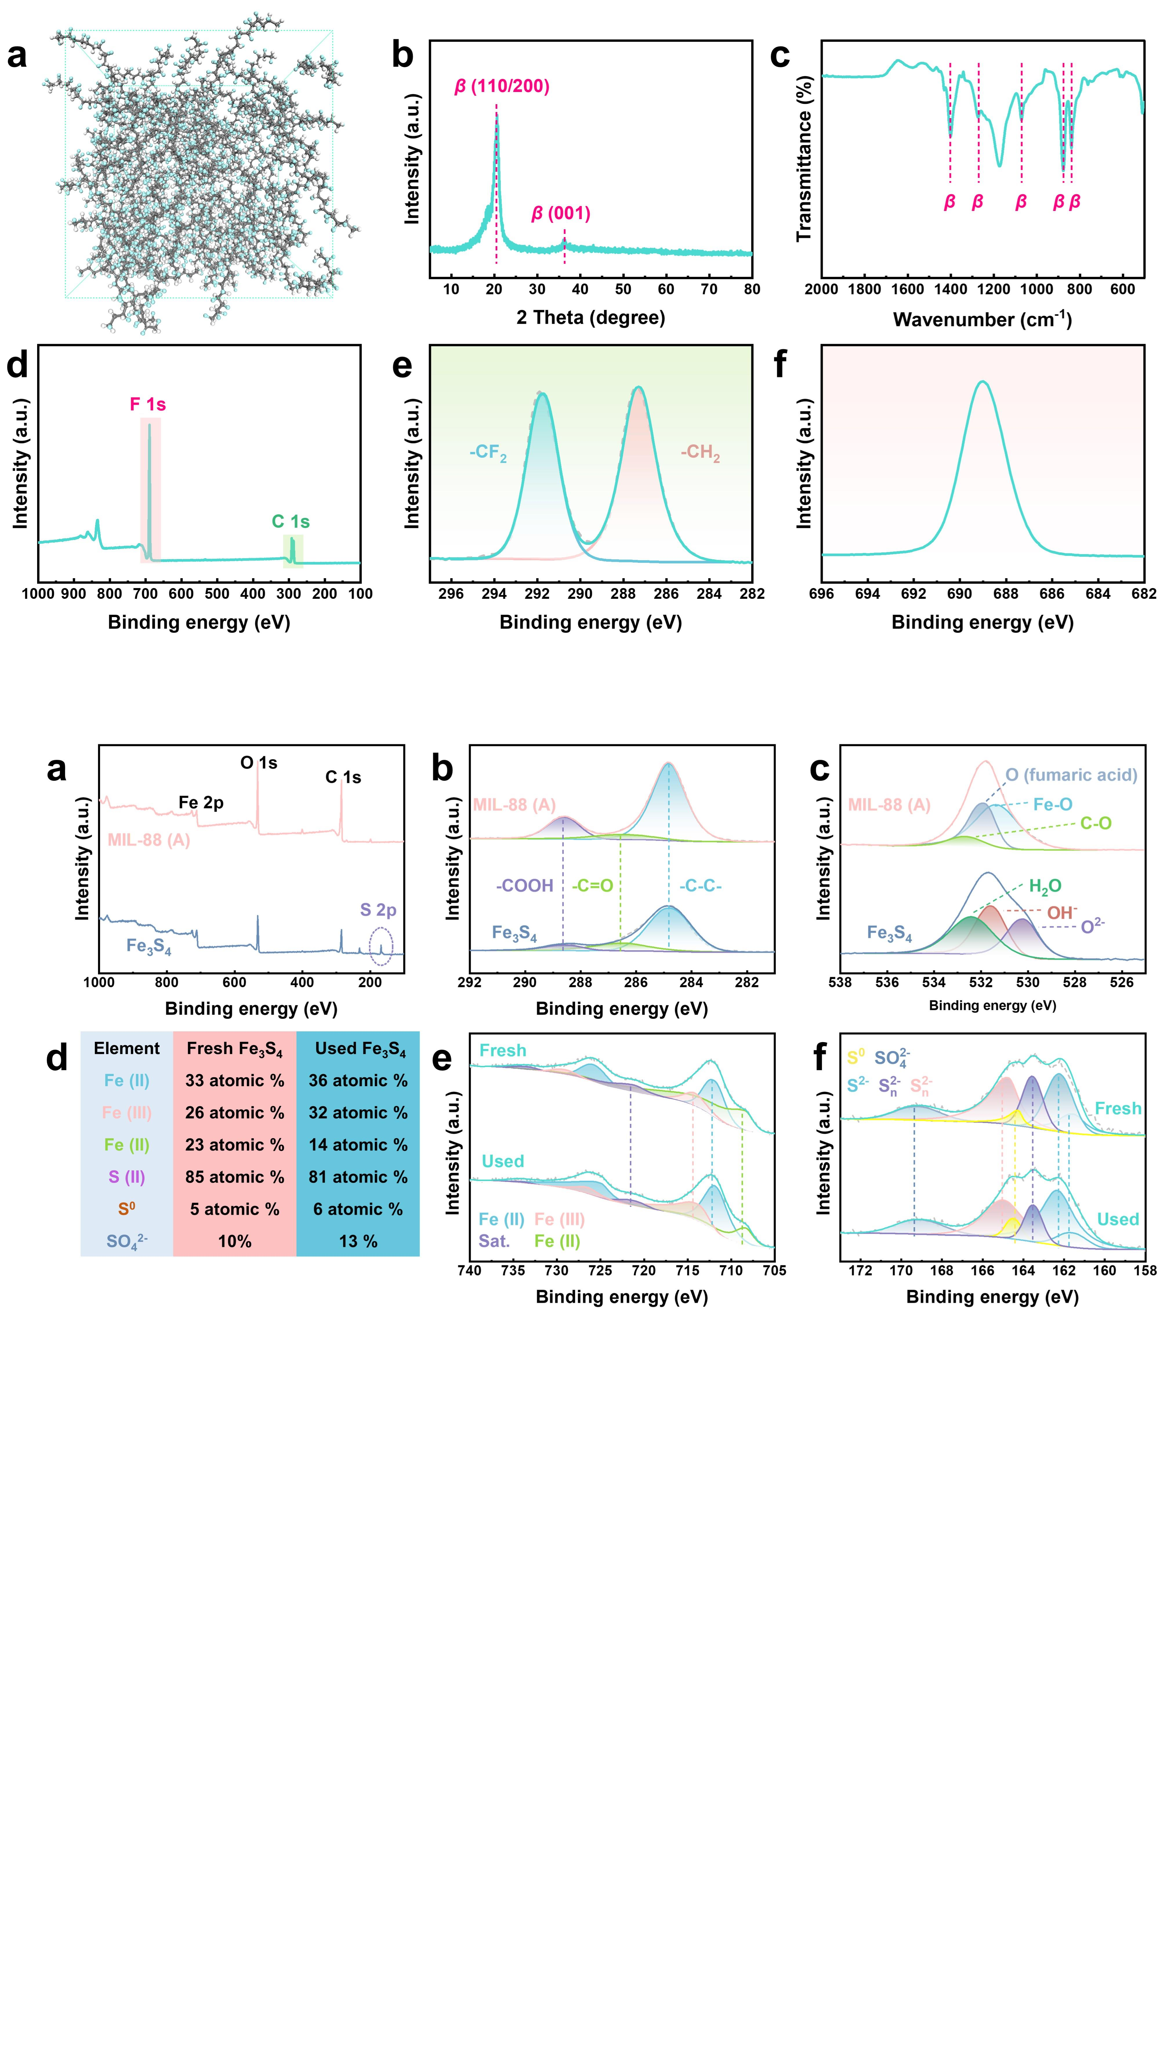
Fig. S9. (a) XPS survey spectra, (b) C 1s and (c) O 1s spectra of as-prepared MIL-88 (A) and Fe₃S₄; (d) comparison of Fe atomic content and S atomic content in fresh and used Fe₃S₄ after catalysis; (e) Fe 2p and (f) S 2p spectra of fresh and used Fe₃S₄ after catalysis.
XPS was also applied to characterize the surface physiochemical properties and chemical states of as-prepared catalysts. A new peak (~ 165 eV) in XPS survey spectrum of Fe₃S₄ can be credited to the S element in Fe₃S₄ (no signal can be found in pristine MIL-88 (A), Fig. S9a). High-resolution XPS spectra calibrated with 284.8 eV as the reference position involving in C 1s, O 1s, Fe 2p and S 2p of as-prepared samples are shown in Fig. S9b~f (the same relative intensity range of the vertical axis is displayed in these figures). An abundant signal peak is ascribed to C 1s in MIL-88 (A), which can be divided into three peaks located at 284.8, 286.5 and 288.6 eV respectively corresponding to the C-C, carbonyl group and carboxylic acid group in fumaric acid ^{7, 33, 34}. Specifically, the signal intensity of C 1s in Fe₃S₄ is obviously lower than that of MIL-88 (A), which may be attributed to the reduced residual carbon-based substances including the reaction between fumaric acid and TAA after sulfation (hydrothermal reaction with TAA for Fe₃S₄ preparation, Fig. S9b). As depicted in Fig. S9c, the O 1s curve in MIL-88 (A) can be deconvoluted into three peaks at 531.4, 532.1 and 532.8 eV, respectively, and these peaks can be ascribed to Fe-O metal cluster, oxygen component on fumaric acid and C-O bonds ^{8, 26}. Note that there are three different peaks respectively located at 530.2, 531.6 and 532.4 eV in Fe₃S₄ pattern, which are assigned to the various forms of O²⁻ groups, such as O²⁻ (SO2- 4), OH⁻ and H₂O ^{8, 33}.
For high-resolution spectra of Fe 2p (Fig. S9e), the main peaks located at 713.5 eV and 725.1 eV are credited to the mixed-valence Fe ions. Briefly, the fitting peaks at 712.5 eV and 725.6 eV can be attributed to Fe (II), while the peaks at 713.8 eV and 726.9 eV is corresponded to Fe (III) ³³. Specifically, a small diagnostic peak located at 708.1 eV may be induced by electron-deficient Fe (II) sites in Fe-S bonds breaking, which has been confirmed in previous reports ^{35, 36}. After catalysis, the peak area of Fe (II) at 708.1 eV decreases obviously (from 23 atomic % to 14 atomic %), implying that some ≡Fe(II) sites with high activity in Fe₃S₄ has been transformed into Fe(III)³⁷. For high-resolution spectra of S 2p (Fig. S9f), the fitting peaks located at 161.5, 162.6 and 163.8 are attributed to S (II) including S²⁻ and S2- n, and the peaks at 164.3 and 168.7 eV are assigned to S⁰ and SO2- 4, respectively ^{35, 36}. Obviously, the peak area of SO2- 4increased from 10% to 13% after reaction, while the peak area of S (II) has a slight drop from 85% to 81%, demonstrating a small amount of S (II) ions on Fe₃S₄ surface was oxidized into S (VI) as illustrated in Fig. S9d. Therefore, as-prepared Fe₃S₄ can bring benefits to maintaining high catalytic activity in PMS activation.

7.3 FTIR results of as-prepared catalysts
FTIR spectra of as-prepared MIL-88 (A) and Fe₃S₄ was shown in Fig. S10. For MIL-88 (A), the peaks at 560, 976 and 1210 cm⁻¹ were corresponded to the stretching vibration of C-C bonds, the bending vibration of C-H in trans-diene units and the stretching vibration of Fe-O bonds, respectively. Furthermore, the asymmetric and symmetric C=O stretching peaks at 1394 and 1589 cm⁻¹ were attributed to the coordinated carboxylates in fumaric acid. Notably, there were no clear adsorption signals regarding to Fe₃S₄ due to the blindness of FTIR for inorganic substance, which has been confirmed in previous literature ³⁸.
Fig. S10. FTIR spectra of as-prepared MIL-88 (A) and Fe₃S₄.

7.4 Phase structure and surface chemical compositions of PVDF nanofiber layer in MTNFM
Fig. S11. (a) β-phase PVDF molecular chains; (b) XRD, (c) FTIR and (d) XPS spectrum of PVDF nanofiber layer pilled from MTNFM; high-resolution spectra of (e) C 1s and (f) F 1s in PVDF.
The phase structure and surface chemical compositions of PVDF nanofiber membrane layer were further investigated via XRD, FTIR and XPS. Fig. S11a shows the typical structure corresponding to β-phase PVDF molecular chains. As shown in Fig. S11b, a sharp diffraction peak at 2 θ = 20.5° and a faint peak at 2 θ = 36.3° can be ascribed to the β planes of 110, 200 and 001, respectively. Moreover, the specific adsorption peaks respectively located at 838, 878, 1068, 1271 and 1392 cm⁻¹ are credited to typical β-phase of PVDF molecular chains (Fig. S11c) ^{39, 40}. The electric dipoles arranged randomly in PVDF electro-doping solution can be realigned and reoriented under a high voltage during electrospinning process ⁴¹. In addition, only two signal peaks can be observed in XPS survey spectrum in PVDF substrate membrane, which can be ascribed to C1s and F 1s (Fig. S11d). In terms of high-resolution spectrum of C 1s (Fig. S11e), there are double fitting peaks (peak area ~ 1:1) located at 287.3 eV and 291.9 eV corresponding to -CH₂ and -CF₂ in PVDF, respectively. As depicted in Fig. S11f, a strong signal peak is ascribed to F atoms (-CF₂) in PVDF.

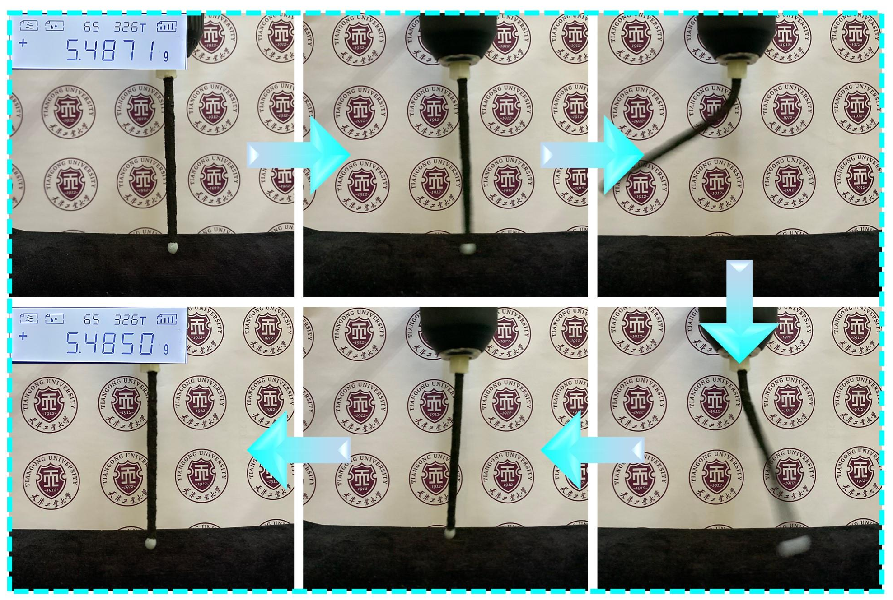
Fig. S12. Flexible MTNFM attached Fe₃S₄ particles without falling off after high-speed rotation (1000 rpm lasted for 5 min).
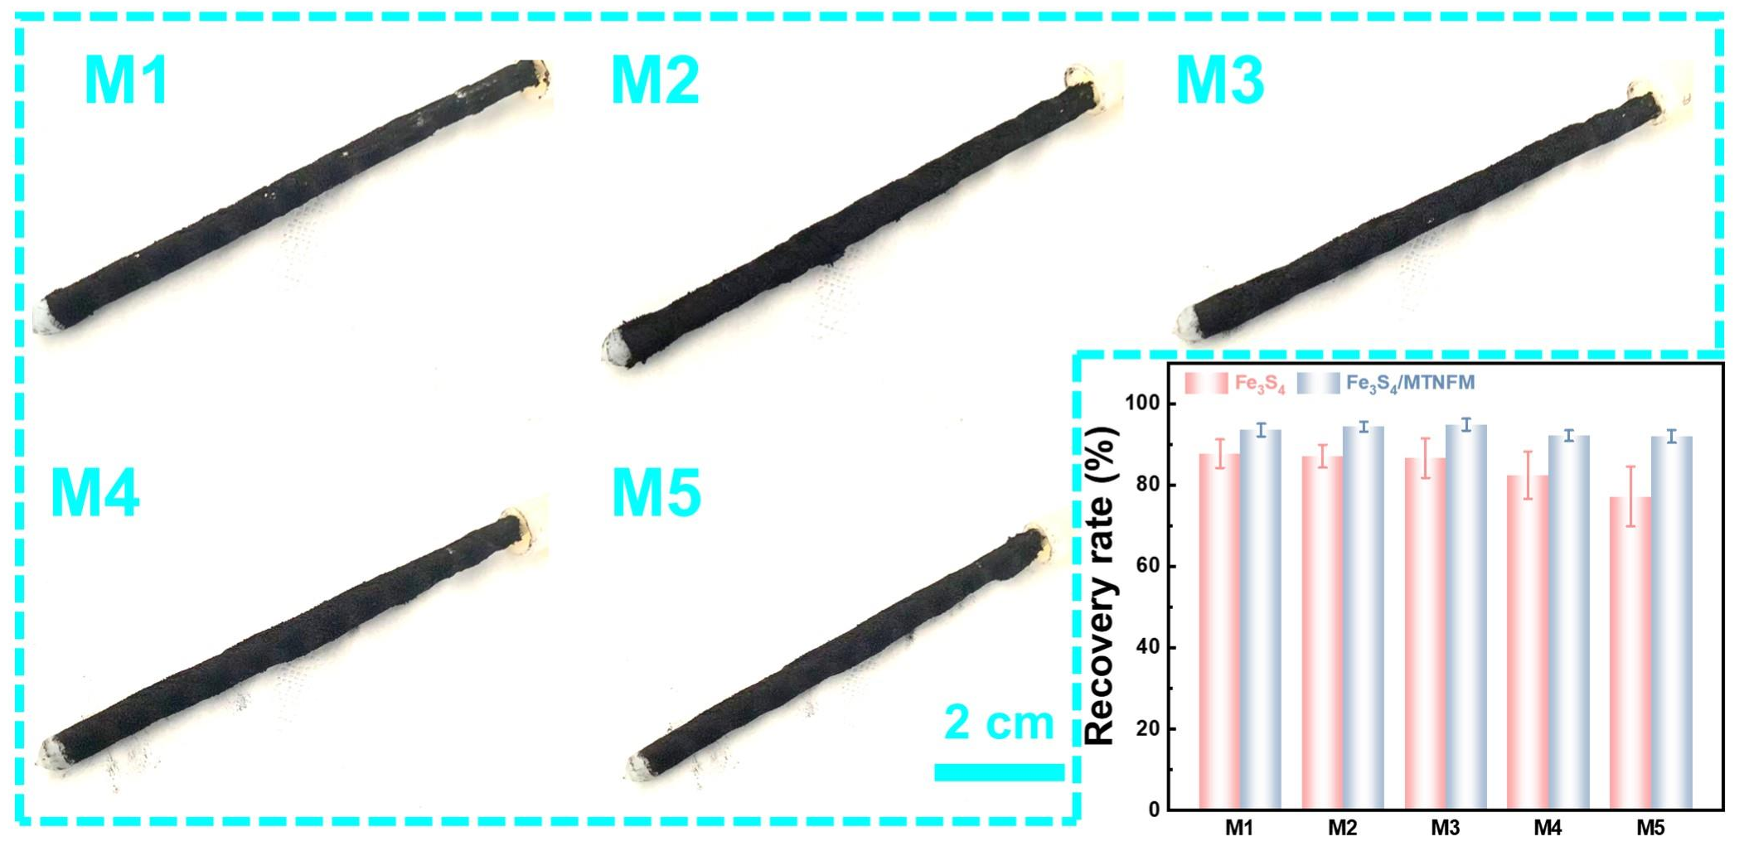
Fig. S13. Digital images of MTNFM attached with different amount of Fe₃S₄ (M1: 0.1 g; M2: 0.2 g; M3: 0.3 g; M4: 0.4 g; M5: 0.5 g) and the recovery rate (recovery rate = initial weight/weight after use by magnetic detaching-reloading, %) of Fe₃S₄ particles from membrane surface after 1 h of water filtration.

7.5 Portability of membrane fouling elimination by attaching/detaching Fe₃S₄
SiO₂ powder filtration tests were conducted to assess the portability of membrane fouling elimination of as-prepared membranes. Briefly, a desired amount of SiO₂ powder were dispersed in DI water with a concentration of 1 g·L⁻¹ by vigorous stirring more than 12 h. M0 and M3 were used to filtrate the SiO₂ suspension in cross-flow mode with the operation pressure of 0.02 MPa more than 1 h and then cleaned with different methods (hydraulic cleaning for M0 and magnetic cleaning for M3).
For intuitively observing the containment staining situation, in another experiment, some oils and phosphor powder were sprayed on the membrane surface and then removed (hydraulic cleaning, simply shaking off for M0 and magnetic cleaning for M3, respectively).
As shown in Fig. S14 a&b, the membrane fouling caused by SiO₂ of M0 is significantly more serious than that of M3, illustrating that most SiO₂ powder can be removed accompanying with the Fe₃S₄ detaching. The foulant particles adhered to the membrane surface or embedded in Fe₃S₄ layer in the filtration can be almost completely eliminated. The interaction between foulants and membrane surface is relatively weak because of the fouled Fe₃S₄ particles rubbing and slipping each other driven by external magnetic force. In addition, M0 surface is easily fouled by oil (dyed red) and phosphor powders as shown in Fig. S14c & e, while M3 can effectively resist contamination and recover fast by virtue of the detachability of Fe₃S₄ particles (Fig. S14d&f).
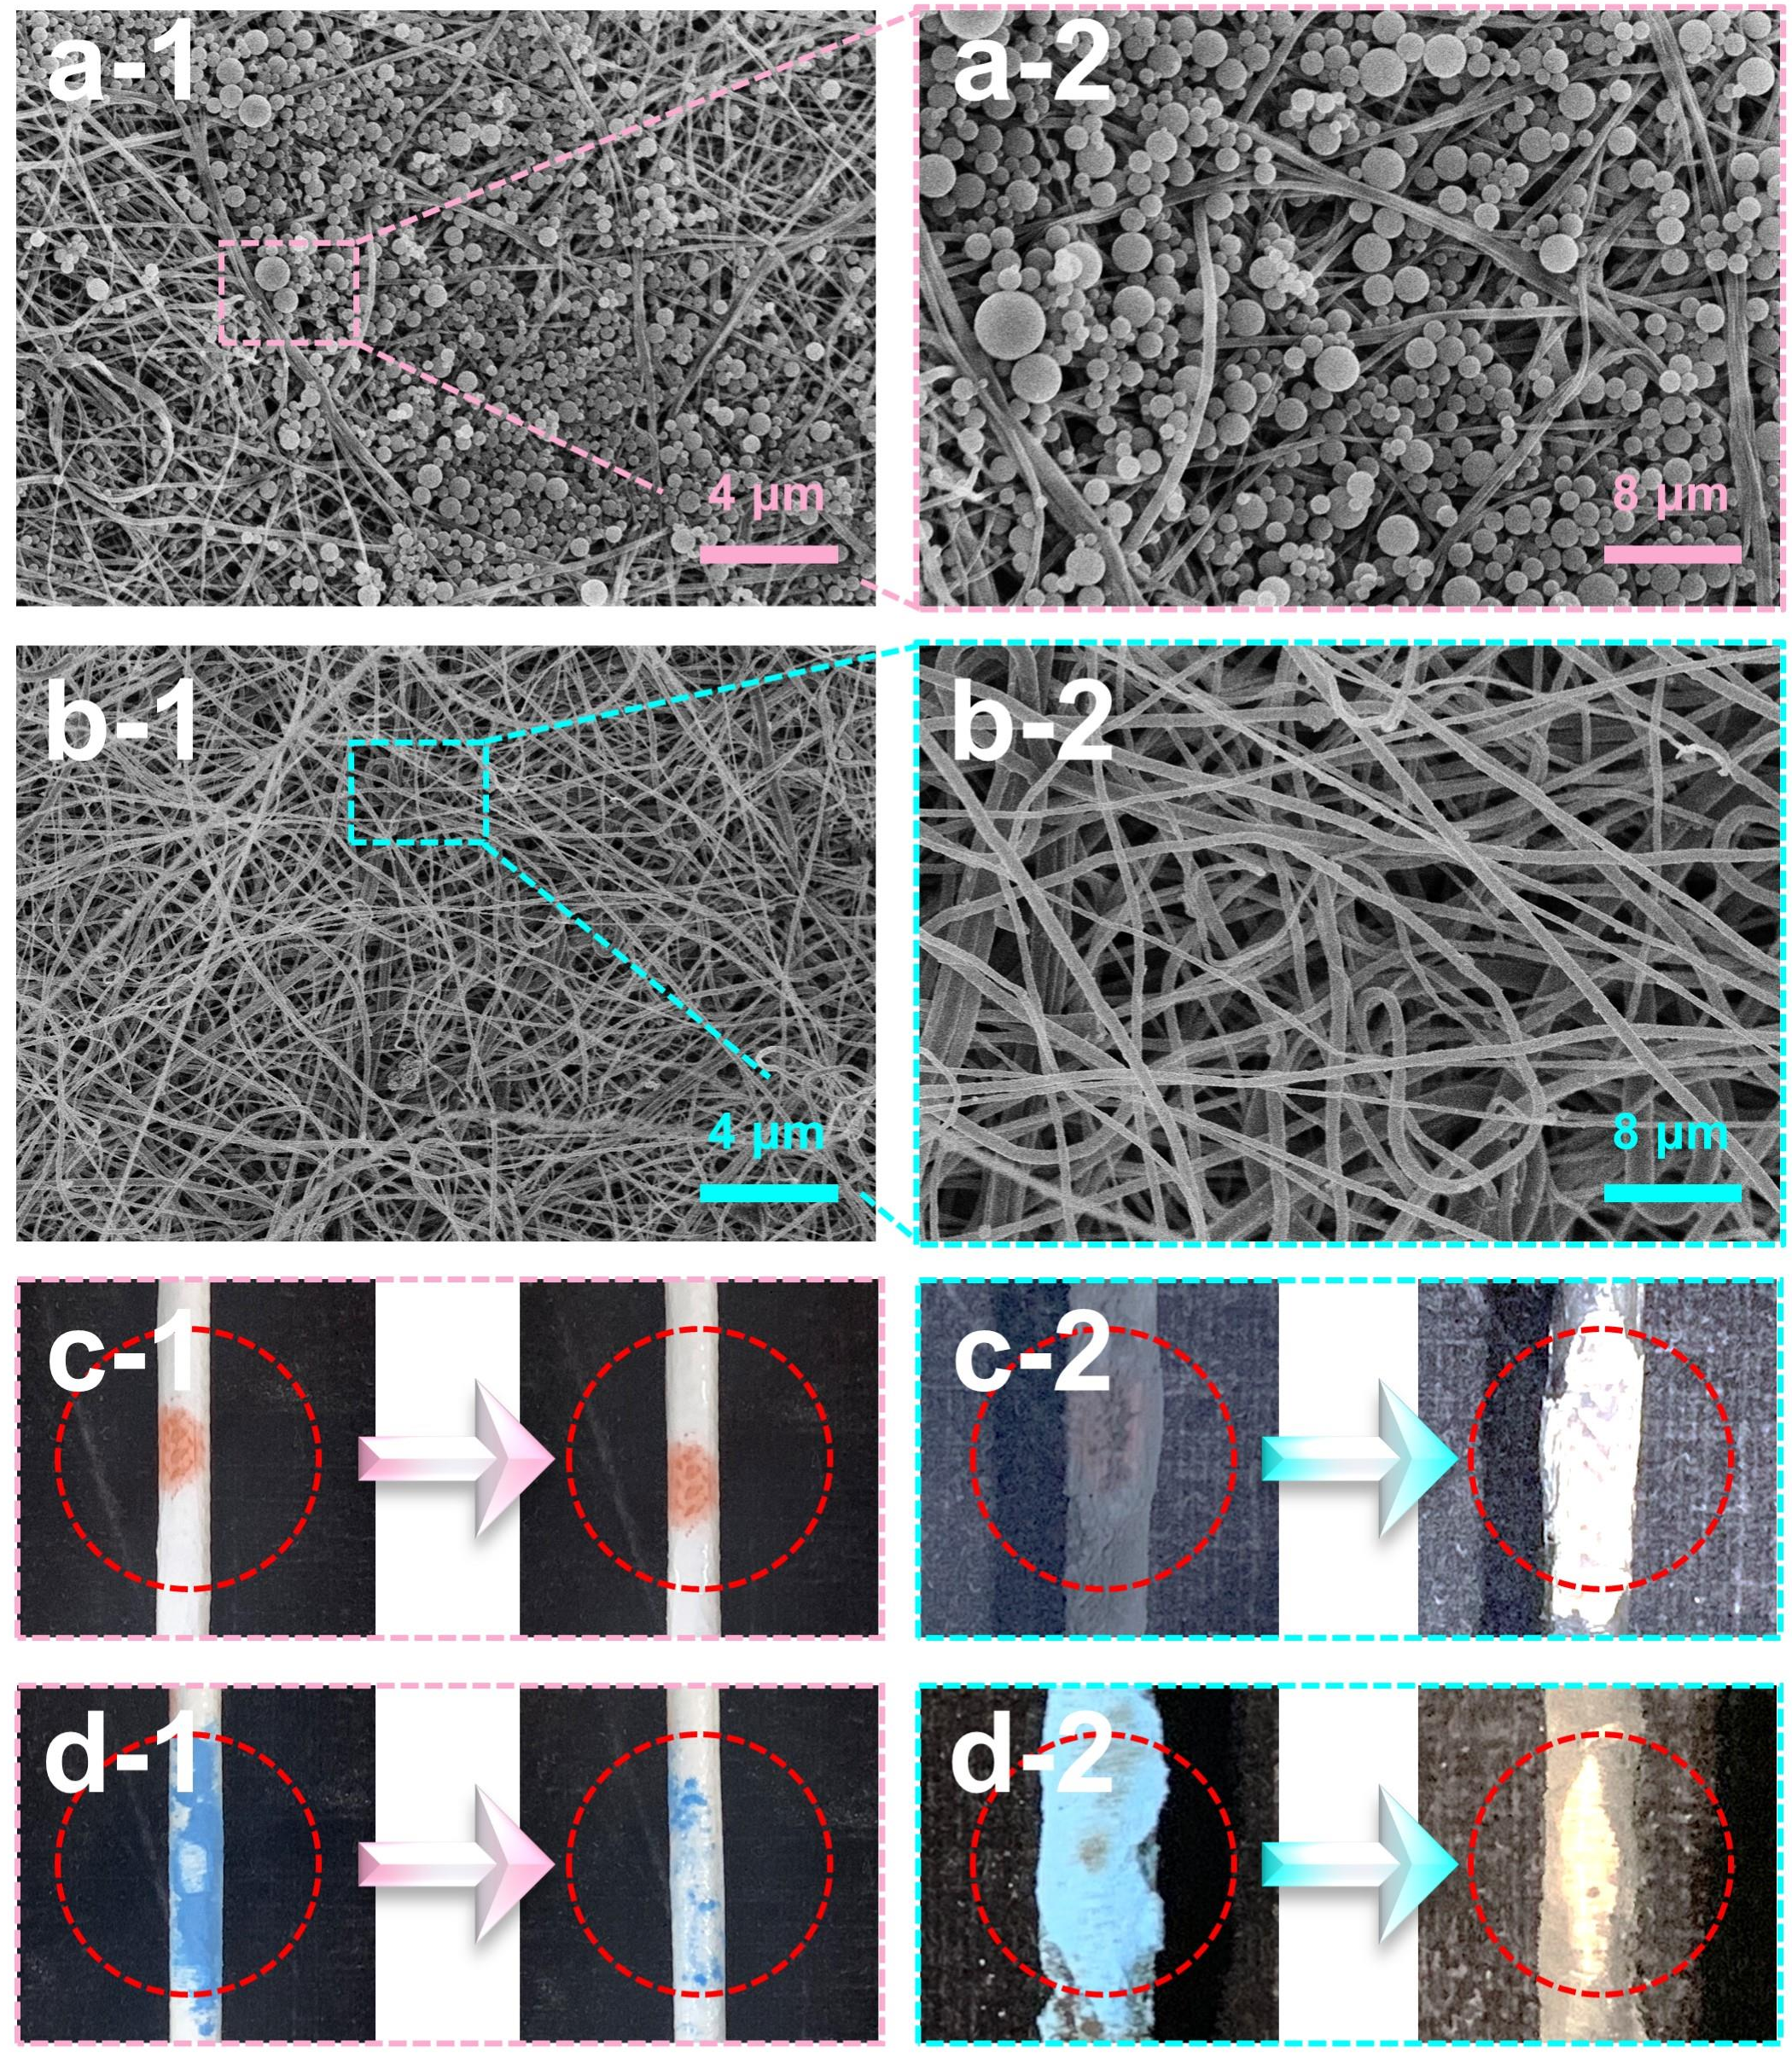
Fig. S14. SEM images of (a) hydraulic-cleaning M0 after SiO₂ fouling and (b) magnetic-cleaning M3 after SiO₂ fouling (right: enlarged images); Digital images of (c) oil fouled and (d) phosphor powder fouled M0 and M3 with different cleaning methods (c, d-1: fouled and after hydraulic cleaning M0; c, d-2: fouled and after magnetic cleaning M3).

7.6 Wettability of as-prepared MIL-88 (A) and Fe₃S₄
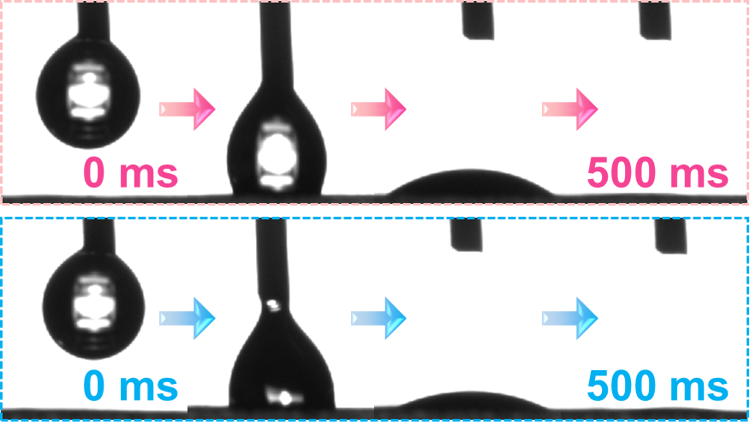
Fig. S15.WCA of as-prepared MIL-88 (A) and Fe₃S₄.

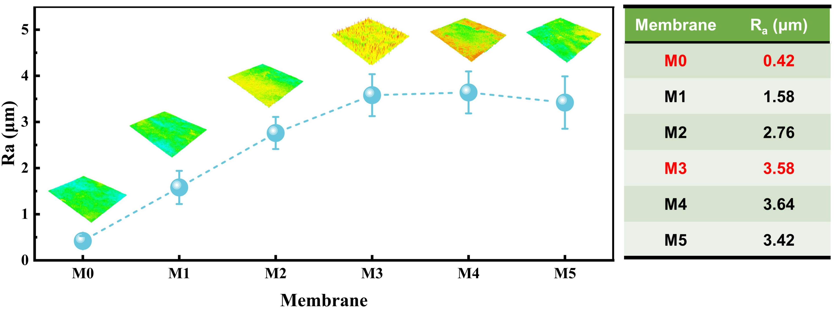
Fig. S16. R_{a} values of as-prepared membranes.

Fig. S17. (a) Time-dependent water flux and (b) stable water flux of as-prepared membranes.

Fig. S18. (a) Pore size distribution and (b) porosity of as-prepared membranes.

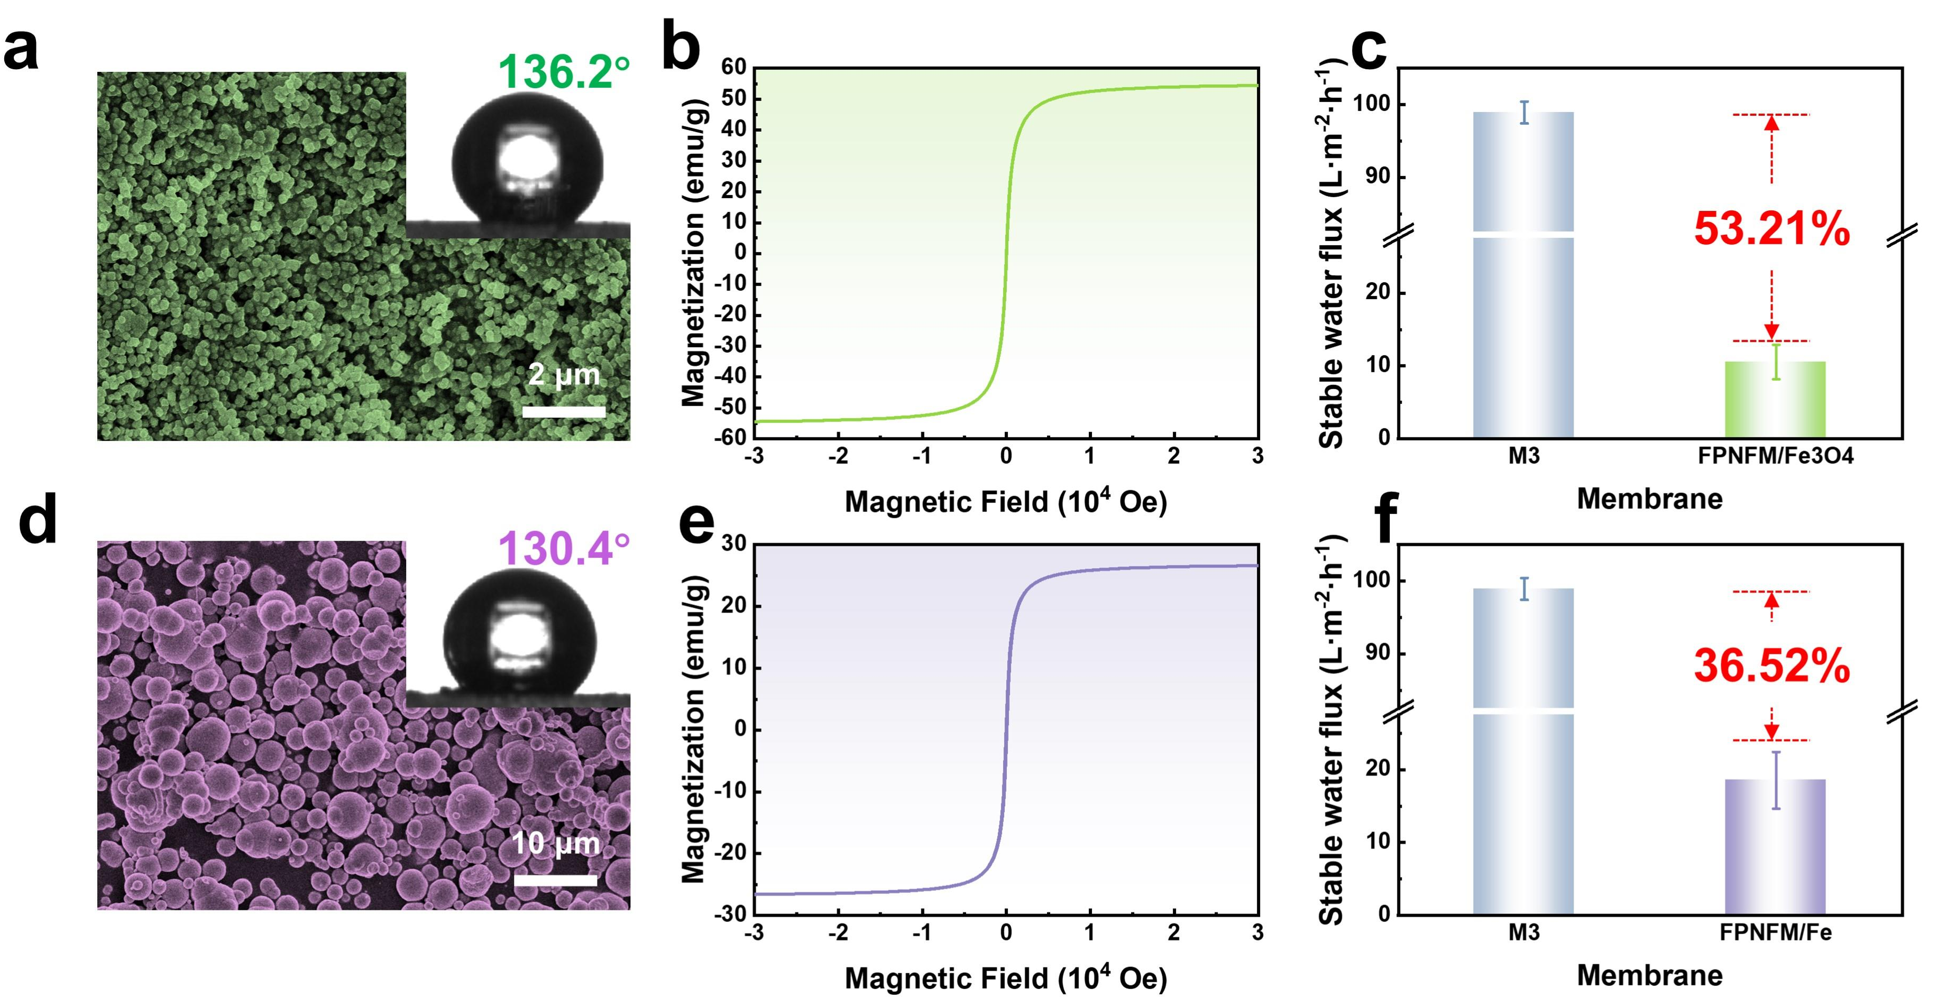
Fig. S19. Morphologies of (a) Fe₃O₄ and (d) iron particles; magnetization hysteresis curve of (b) Fe₃O₄ and (e) iron particles; stable water flux of (c) Fe₃O₄/MTNFM and (f) iron particles/MTNFM.

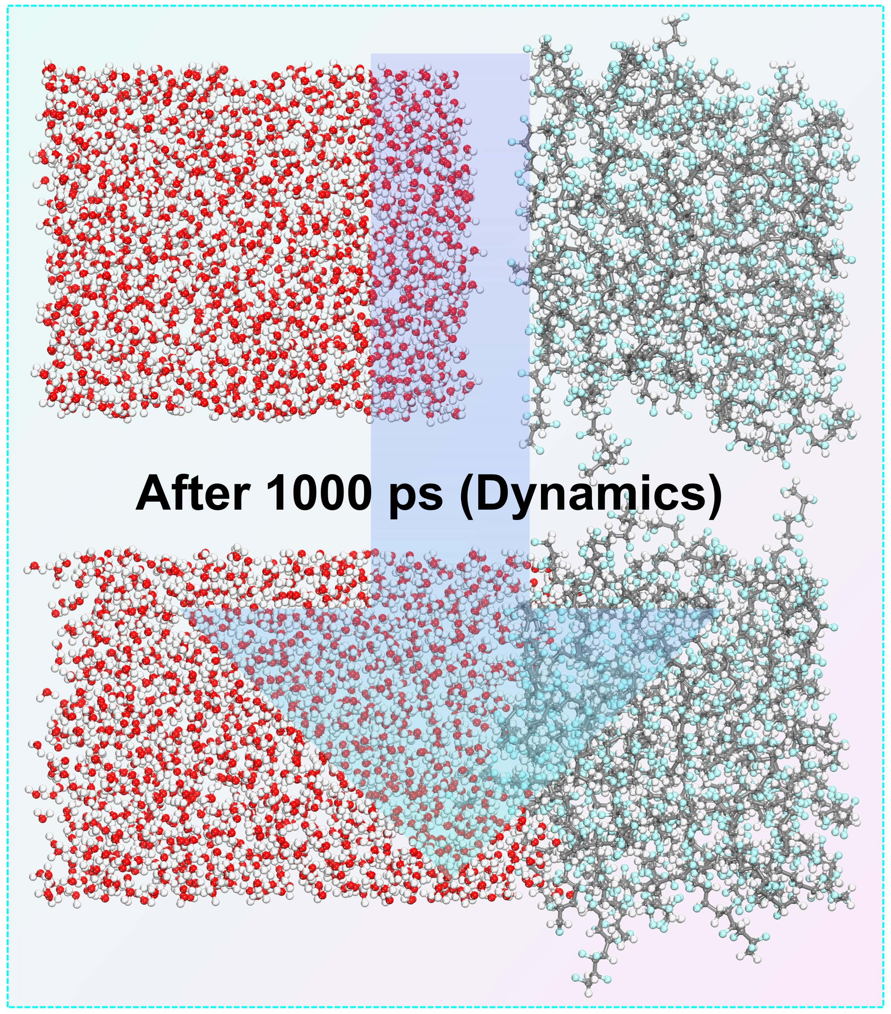
Fig. S20. The original stabilized model and the stabilized model after 1000 ps dynamics simulation of H₂O/PVDF interface (a similar model contained Fe₃S₄ was constructed as shown in Fig. 4f).

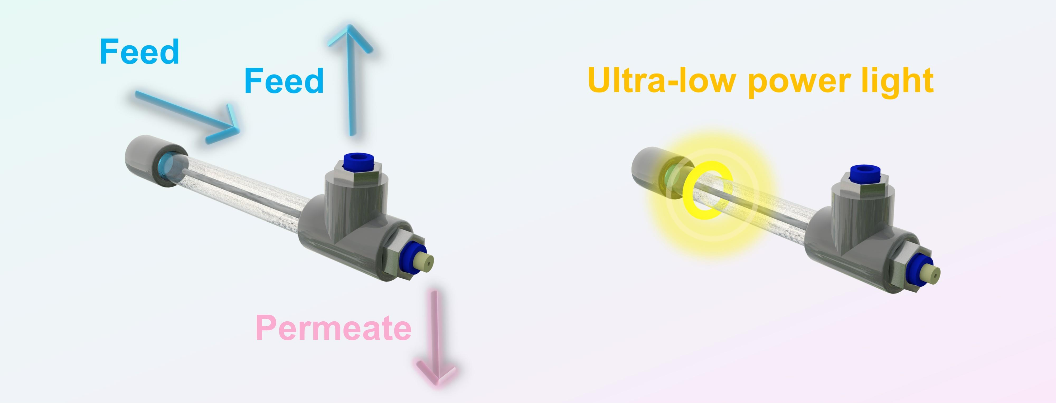
Fig. S21. Lab-scale cross-flow filtration system in our works.

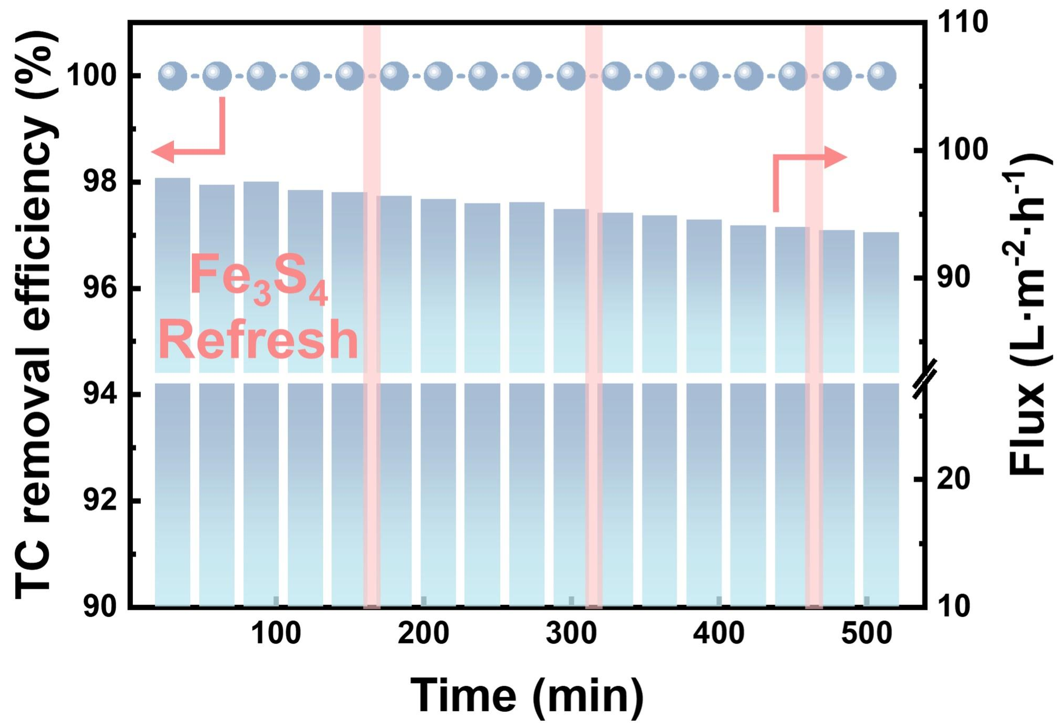
Fig. S22. Long-term catalytic stability of Fe₃S₄/MTNFM system.

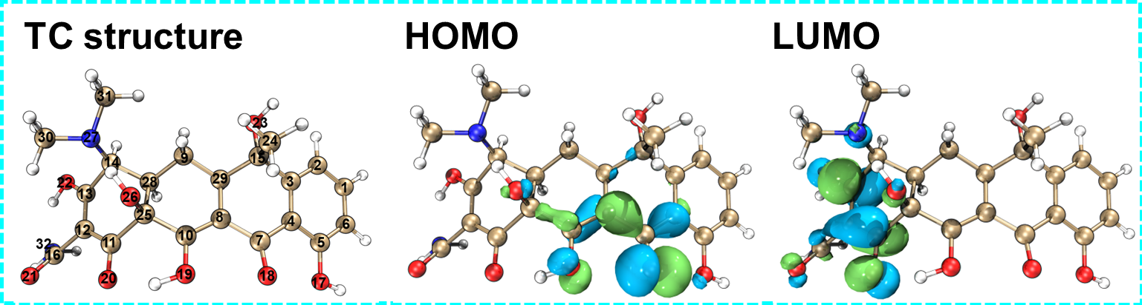
Fig. S23. Molecular structure, HOMO and LUMO isosurface of TC.

Table. S4. Fukui index of TC.
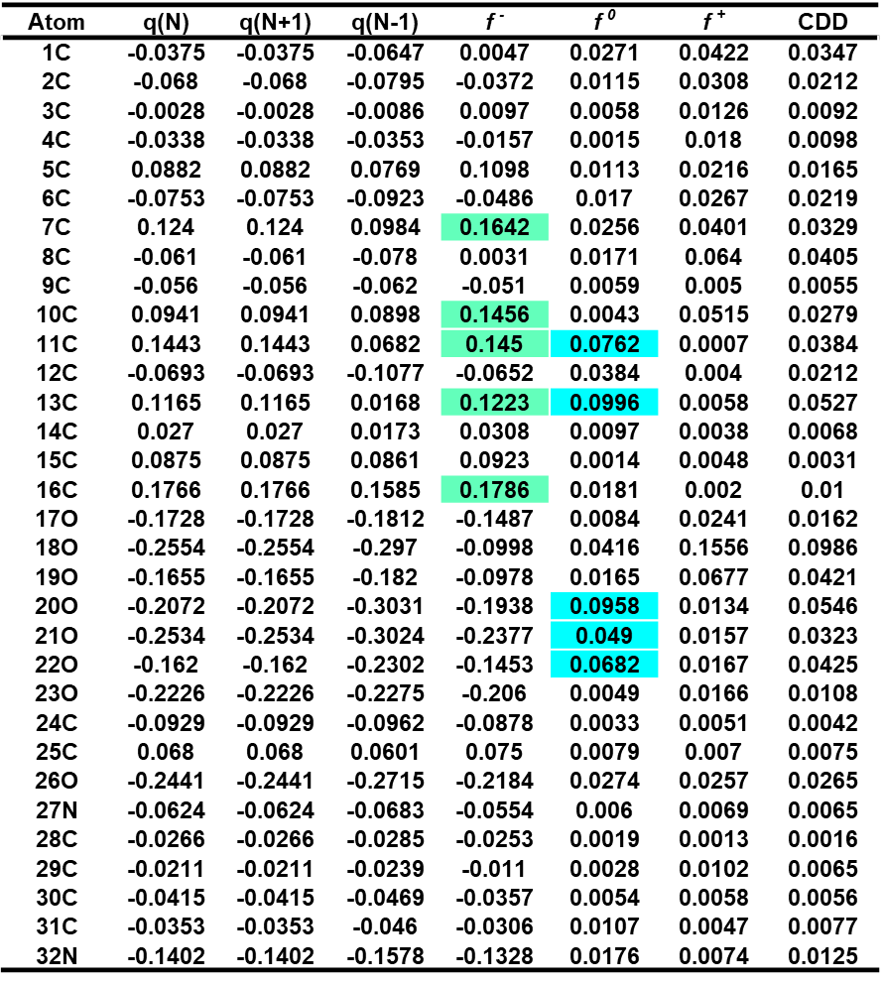

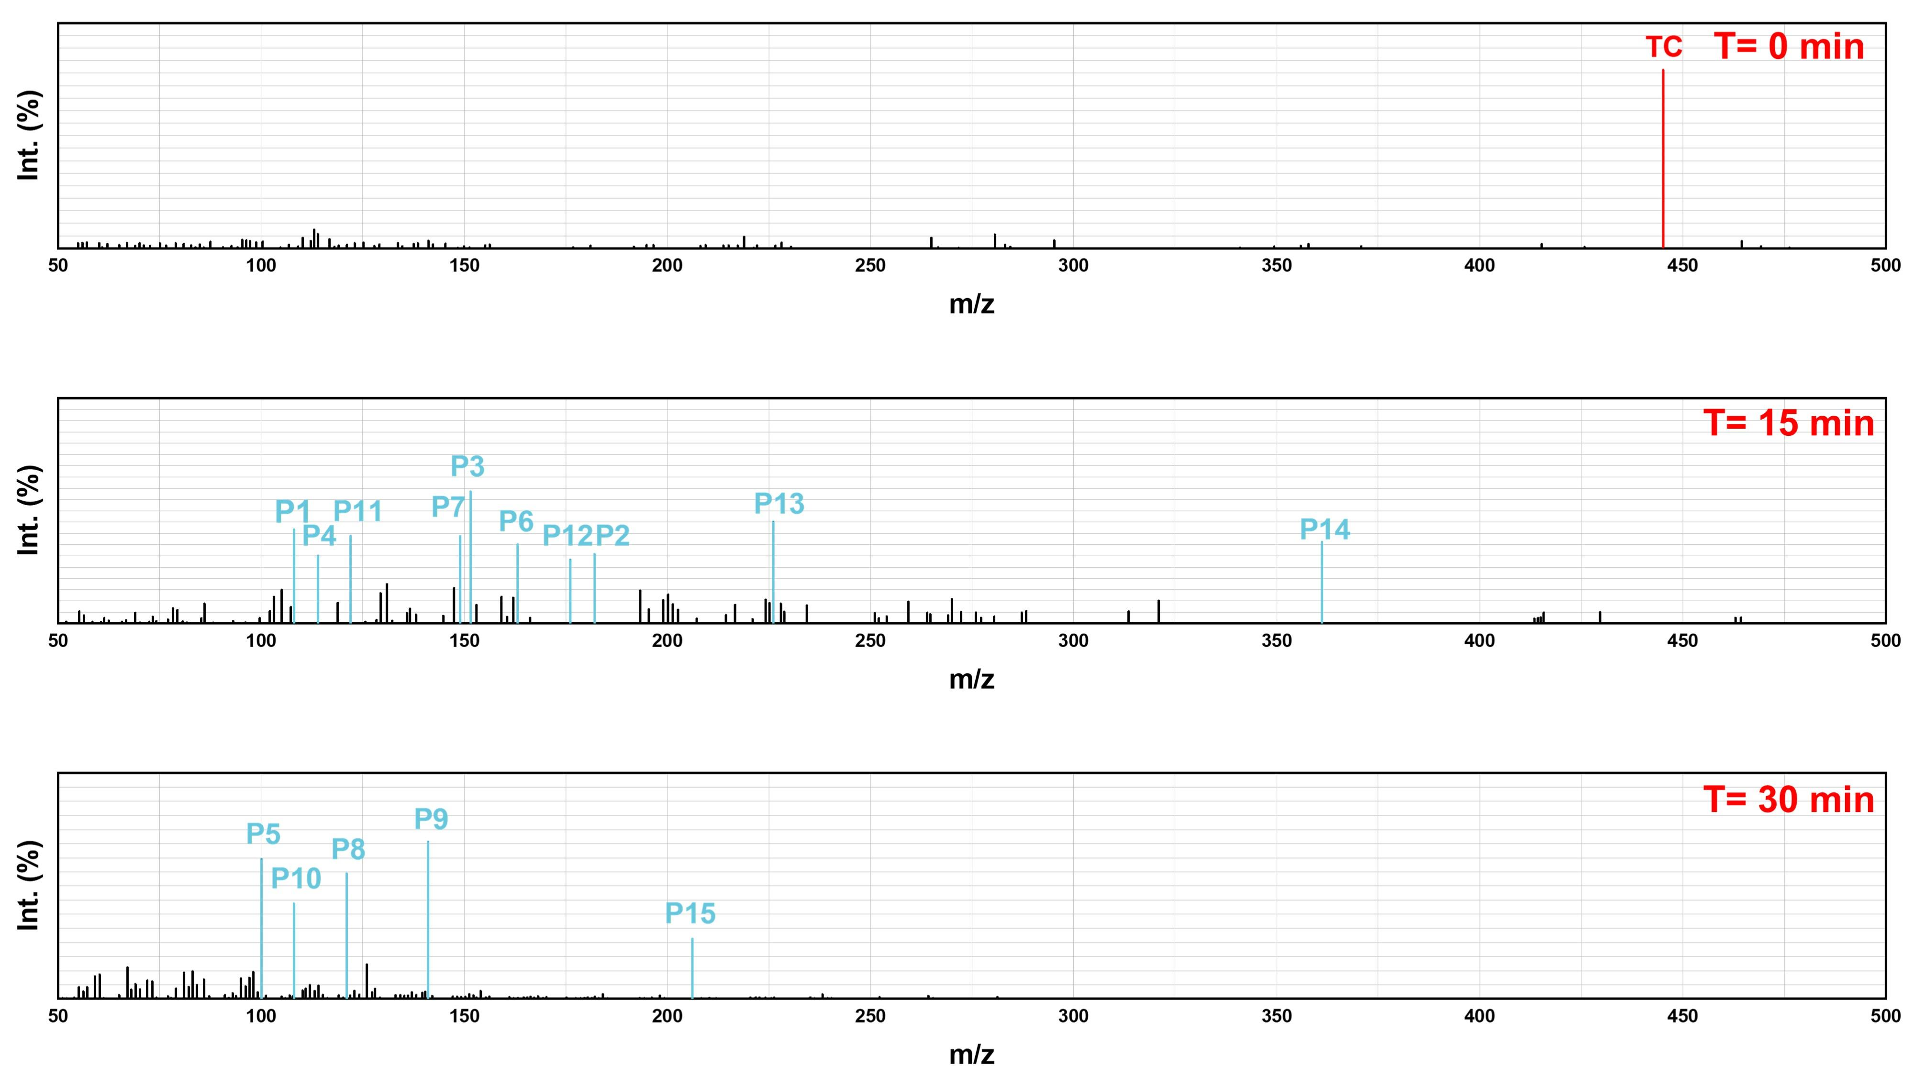
Fig. S24. The degradation intermediates of TC: mass spectra obtained from HPLC-MS in ESI (+)-MS mode.

Table. S5. Intermediates detected by HPLC-MS during TC degradation.
Compounds | m/z | Chemical structure
TC | 445
C₇H₈O (P1) | 108
C₈H₁₀O₄ (P2) | 182
C₈H₉NO₂ (P3) | 151
C₈H₁₈ (P4) | 114
C₇H₁₆ (P5) | 100
C₁₀H₁₃NO (P6) | 163
C₉H₁₁NO (P7) | 149
C₇H₇NO (P8) | 121
C₈H₁₅NO (P9) | 141
C₇H₈O (P10) | 108
C₇H₆O₂ (P11) | 122
C₁₁H₁₂O₂ (P12) | 176
C₁₄H₁₀O₃ (P13) | 226
C₁₉H₂₃NO₆ (P14) | 361
C₁₃H₁₈O₂ (P15) | 206

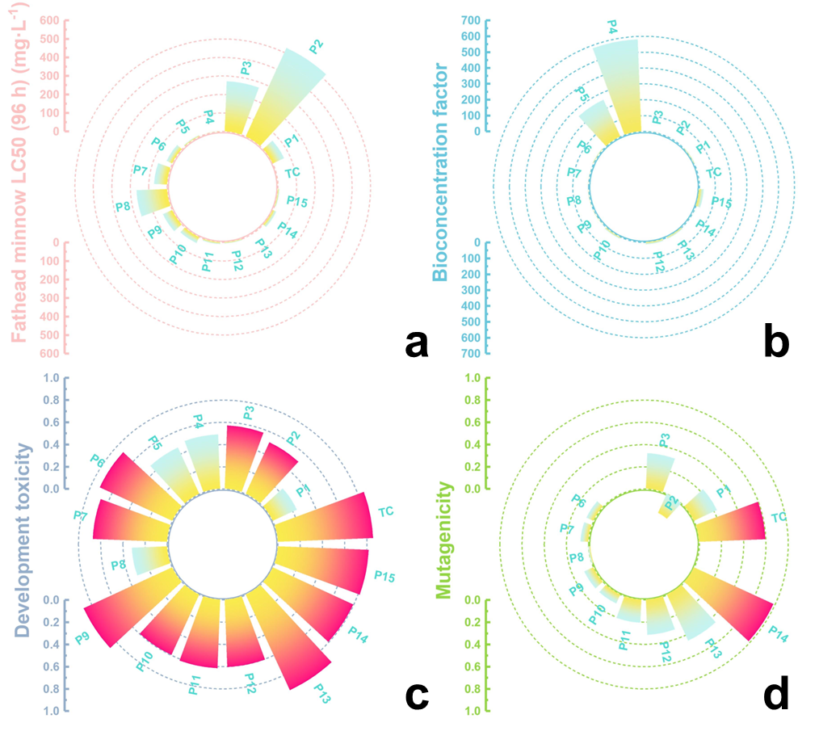
Fig. S25. Toxicity estimation of TC and its intermediates after catalysis by Fe₃S₄/MTNFM system with the T.E.S.T.: (a) acute toxicity LC50-96h (Fathead minnow); (b) bioaccumulation factor; (c) development toxicity and (d) mutagenicity. The red color bar in development toxicity and mutagenicity means “harmful” or “toxic”.

The reaction equations of ROS generation in our PMS/Fe₃S₄/MTNFM system driven by an ultralow power of light (1 W) are listed as follows:
≡Fe(II) + HSO- 5 → ≡Fe(III) + SO•− 4+ OH⁻
Fe₃S₄ + hv → e⁻ + h⁺
≡Fe(III) + e⁻ → ≡Fe(II)
HSO- 5 + e⁻ → SO•− 4+ OH⁻
HSO- 5 + e⁻ → SO•− 4+ •OH
SO•− 4+ OH⁻ → SO2− 4+•OH
SO•− 4+ H₂O → SO2− 4+•OH + H⁺
≡Fe(III) + HSO- 5 → ≡Fe(II) + SO•− 5+ H⁺
HSO- 5→ HSO− 4+ 1/2 ¹O₂
HSO- 5 + ≡Fe(II) → HSO− 4+ ≡Fe(III)+ 1/2 ¹O₂
SO•− 4+ •OH → HSO− 4+ 1/2 ¹O₂
SO•− 5+ H₂O → HSO− 4+ ¹O₂
Pollutants + SO•− 4/•OH/¹O₂ → Degradation products + CO₂ + H₂O

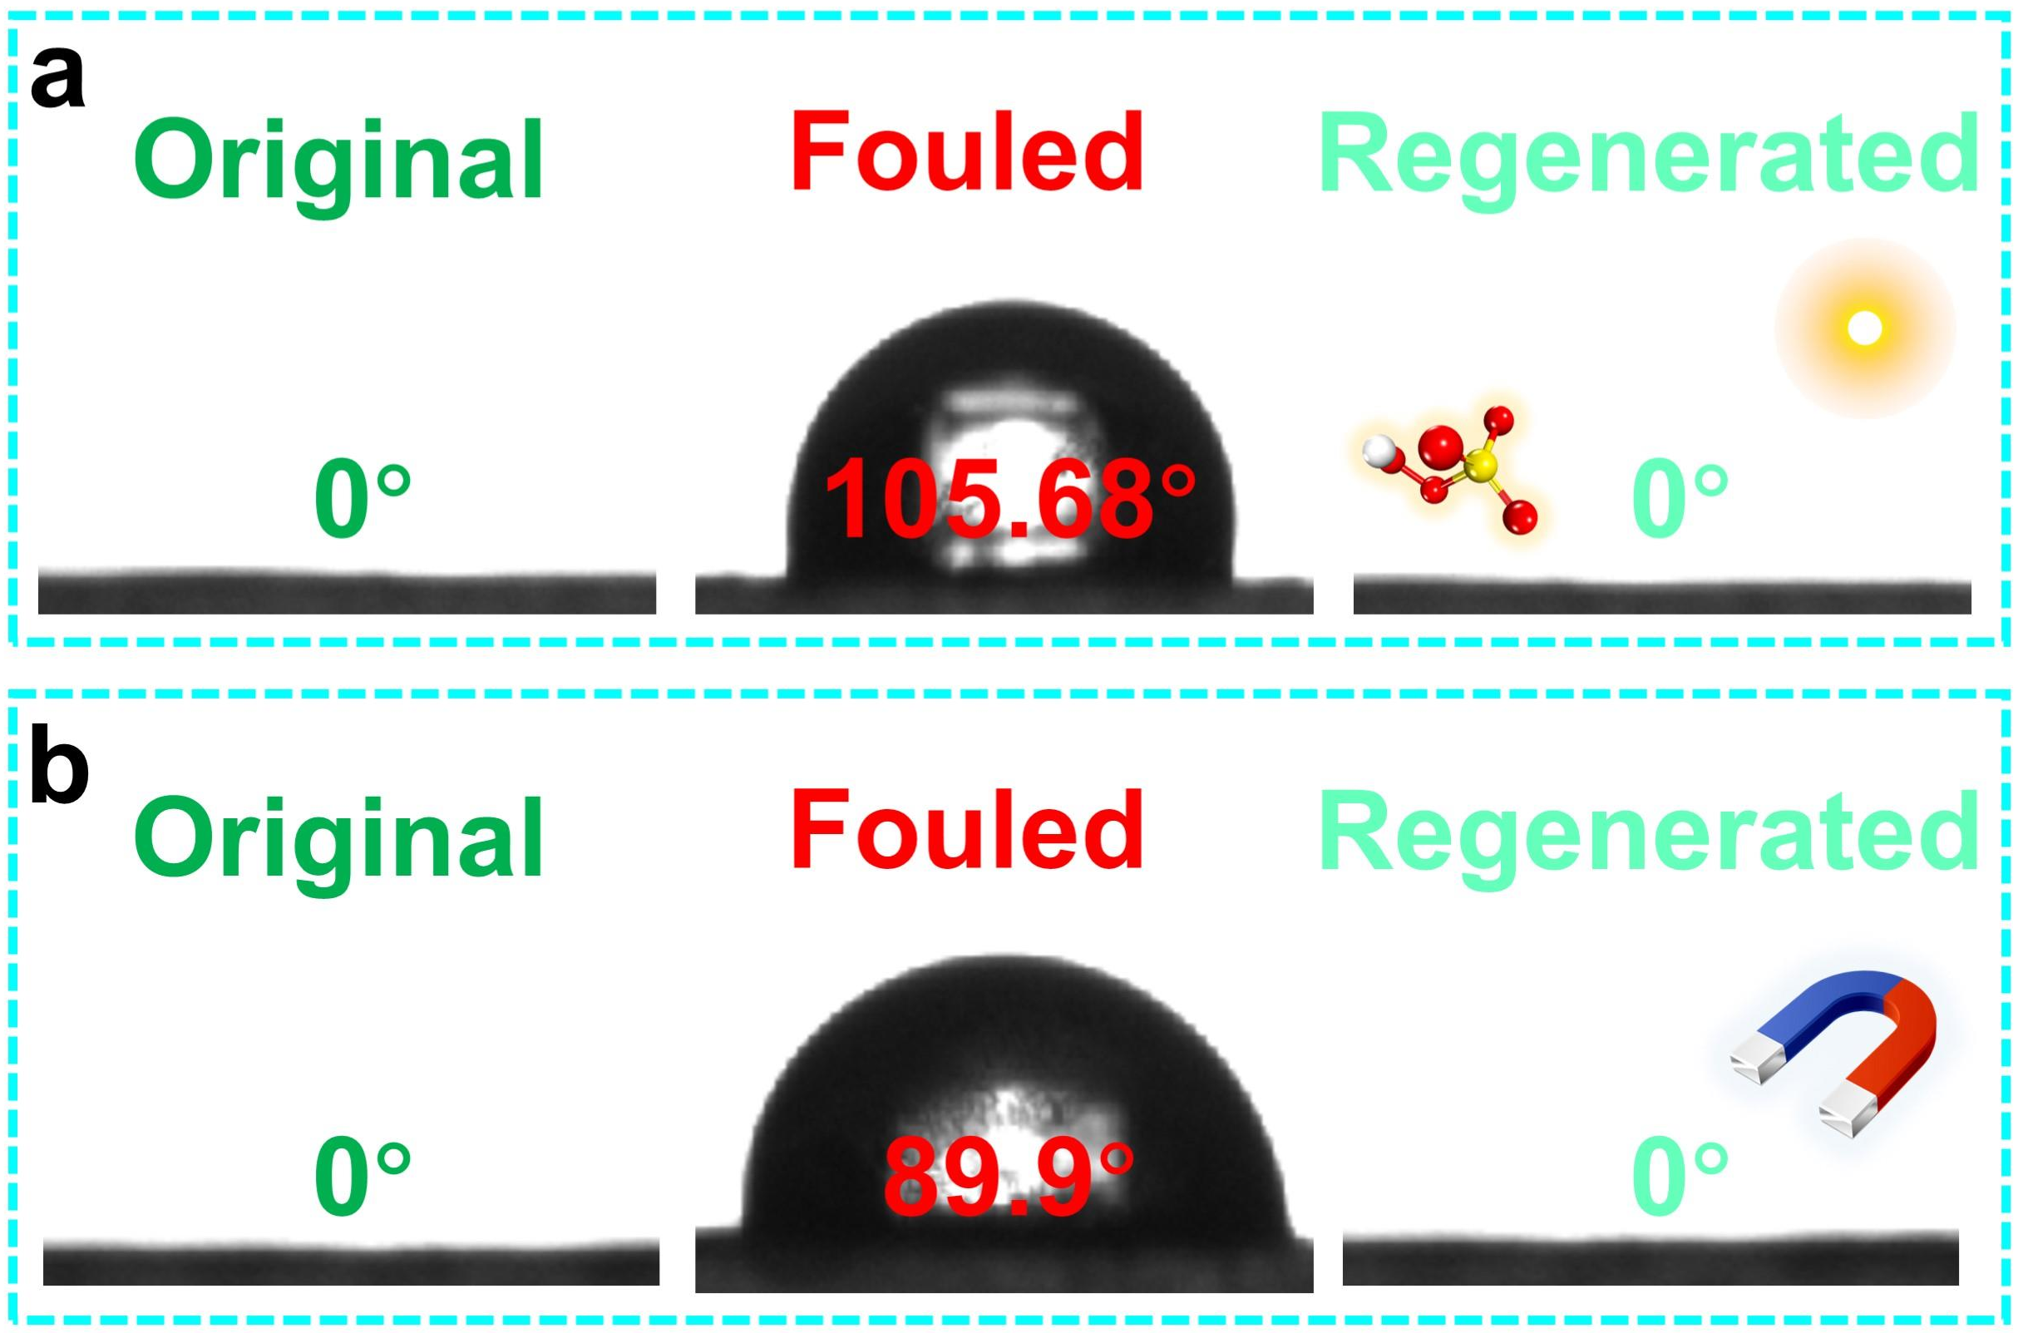
Fig. S26. Water contact angles of original M3, fouled M3 (after emulsion filtration) and regenerated M3 (a. photocatalytic regeneration; b. magnetic regeneration).

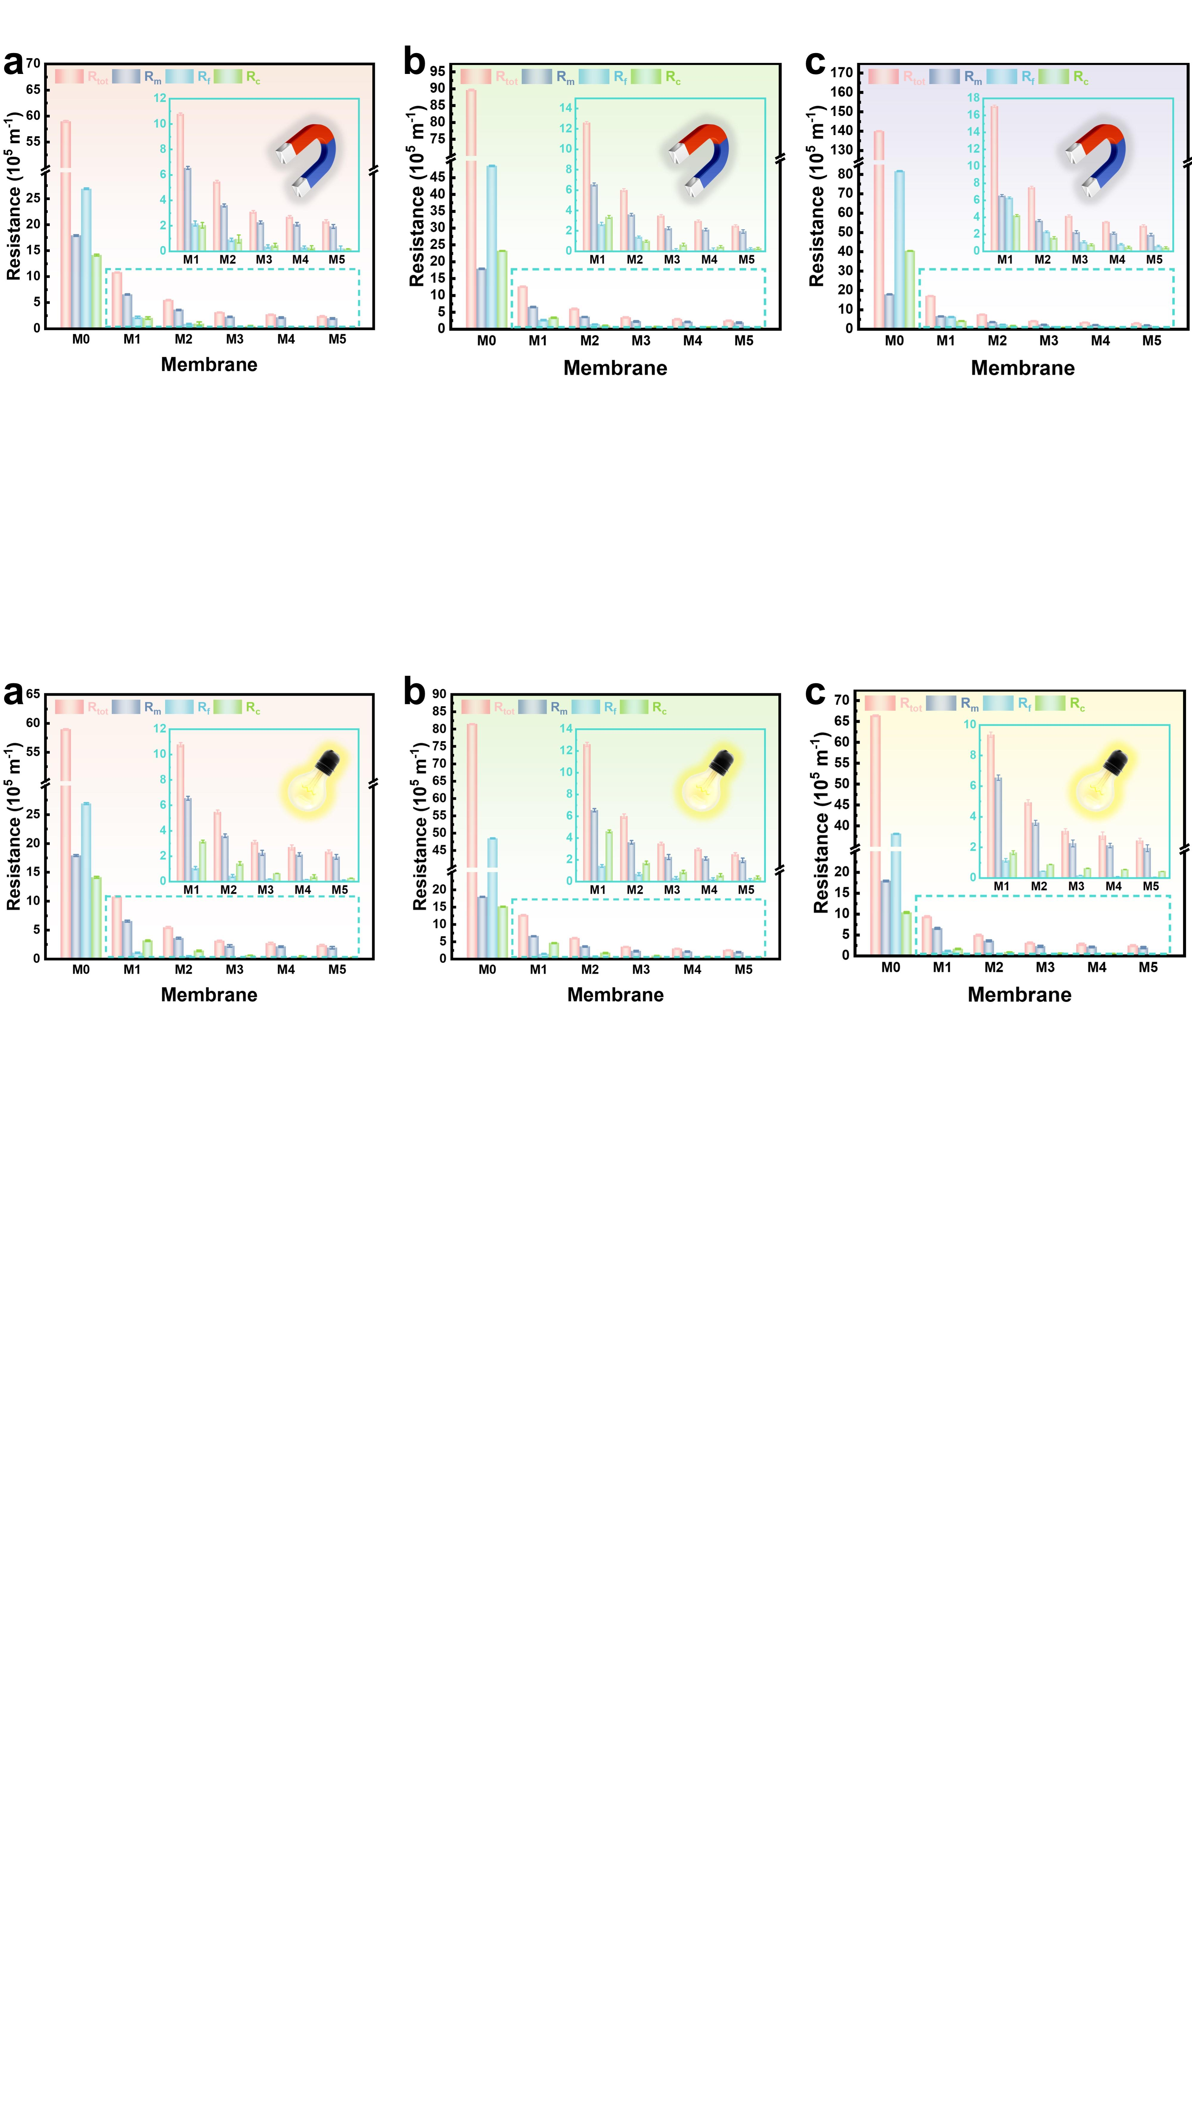
Fig. S27. Filtration resistances of as-prepared membranes in magnetic cleaning mode: (a) BSA; (b) HA; (c) SA.

Fig. S28. Filtration resistances of as-prepared membranes in catalytic cleaning mode: (a) BSA; (b) HA; (c) SA.

7.7 Derjaguin-Landau-Verwey-Overbeek (XDLVO) analysis
Based on the extended Derjaguin-Landau-Verwey-Overbeek (XDLVO) theory, the final adhesion of the foulant on a given membrane surface is determined by the short-ranged interaction energy between each other ⁴². Herein, the XDLVO theory is used to quantitively analyze thermodynamic interactions between as-prepared membranes and various foulants. Detailly, the total interaction energy is composed of three parts: Van der waals interaction (LW), acid-base (AB) interaction and electrostatic double layer interaction (EL). The interaction energy of membrane-foulants at the separation distance (d, nm) can be described as following ^{42, 43}:
$$\begin{aligned}∆G^{LW}\left(d\right)=∆G_{d_{0}}^{LW}\frac{d_{0}^{2}}{d^{2}}\end{aligned}$$
$$∆G^{AB}\left(d\right)=∆G_{d_{0}}^{AB}exp\left(\frac{d_{0}-d}{λ}\right)$$
$$∆G^{EL}\left(d\right)=kε_{r}ε_{0}ζ_{m}ζ_{f}(\frac{ζ_{m}^{2}ζ_{f}^{2}}{2ζ_{m}ζ_{f}}(1-\coth{kd)+\frac{1}{\sinh{kd}}}$$
$$∆G^{tot}\left(d\right)=∆G^{LW}\left(d\right)+∆G^{AB}\left(d\right)+∆G^{EL}(d)$$
here, d₀ (=0.158 nm) is regarded as the minimum equilibrium cut-off distance between membrane and foulants ⁴⁴; λ (=0.6 nm) represents the attenuated AB interaction length in water; k is assigned to the reciprocal of Debye length (nm⁻¹); ε₀ and ε_{r} are the dielectric constant in vacuum and water, respectively (C·V⁻¹·m⁻¹); ζ_{m} and ζ_{f} are the surface of potential of membrane and foulants, respectively (mV).
The parameters values of above ∆G^{LW} (d), ∆G^{AB} (d) and ∆G^{EL} (d) can be estimated according the following formulas:
$$∆G^{LW}\left(d\right)=-2(\sqrt{γ_{m}^{LW}}-\sqrt{γ_{w}^{LW}})(\sqrt{γ_{f}^{LW}}-\sqrt{γ_{w}^{LW}})$$
$$∆G^{AB}\left(d\right)=2\left[\sqrt{γ_{w}^{+}}\left(\sqrt{γ_{f}^{-}}+\sqrt{γ_{m}^{-}}-\sqrt{γ_{w}^{-}}\right)+\sqrt{γ_{w}^{-}}\left(\sqrt{γ_{f}^{+}}+\sqrt{γ_{m}^{+}}-\sqrt{γ_{w}^{+}}\right)-\sqrt{γ_{f}^{-}γ_{m}^{+}}-\sqrt{γ_{f}^{+}γ_{m}^{-}}\right]$$
$$∆G^{EL}(d)=\frac{kε_{0}ε_{r}}{2}(ζ_{m}^{2}+ζ_{f}^{2})(1-\coth\left(kd_{0}\right)+\frac{2ζ_{m}ζ_{f}}{ζ_{m}^{2}{+ζ}_{f}^{2}}\operatorname{csch}{(kd_{0}))}$$
where γ⁻, γ⁺ and γ^{LW} denote the surface tension components of electron acceptor, electron donor and LW, respectively. And the different subscripts (m, f, w) represent membrane, foulants and water, respectively. Moreover, the calculated value of γ⁻, γ⁺ and γ^{LW} can be obtained by Young’s equation with data of 3 different probe liquids as following ^{45, 46}:
$$\frac{(1+\cos{θ})}{2}γ_{l}^{TOT}=\sqrt{γ_{l}^{LW}γ_{s}^{LW}}+\sqrt{γ_{l}^{-}γ_{s}^{+}}+\sqrt{γ_{l}^{+}γ_{s}^{-}}$$
where the subscripts (l and s) represent the probe liquid and solid surface (membrane or foulants), respectively. The detailed values of surface tension components are summarized in Table.S6~8.

Table S6. Surface tension components of different probe liquids (mJ·m⁻², temperature=20℃) ⁴².
Probe Liquid | γ⁺ | γ⁻ | γ ^{AB} | γ ^{LW} | γ ^{TOT}
DI Water | 25.5 | 25.5 | 51.0 | 21.8 | 72.8
Glycerol | 3.92 | 57.4 | 30.0 | 34.0 | 64.0
Diiodomethane | 0.0 | 0.0 | 0.0 | 50.8 | 50.8

Table S7. The measured and theoretical values of physicochemical properties and surface energic parameters of as-prepared membranes (M0 and M3) and various foulants (BSA, HA and SA)
Samples | θ_{w} | θ_{G} (°) | θ_{D} (°) | ζ-Potential (mV)
M0 | 115.70 ± 2.35 | 105.36 ± 4.68 | 88.96 ± 5.52 | -30.61 ± 2.35
M3 | 0.00 ± 0.10 | 29.35 ± 4.85 | 36.67 ± 5.98 | -38.09 ± 3.96
BSA | 47.90 ± 2.86 | 56.88 ± 2.97 | 42.32 ± 3.87 | -14.12 ± 1.32
HA | 45.38 ± 1.95 | 50.58 ± 2.86 | 41.28 ± 2.25 | -45.36 ± 0.95
SA | 49.02 ± 3.88 | 40.97 ± 2.33 | 43.26 ± 2.58 | -44.57 ± 0.75

Table S8. Adhesion free energy between M0 or M3 and various foulants (BSA, HA and SA) (mJ·m⁻²)
Samples | ∆GLW d0 | ∆GAB d0 | ∆GEL d0 | ∆GTOT d0
M0-BSA | 3.18 | -33.14 | -9.16E-05 | -29.96
M0-HA | 3.27 | -31.59 | -2.39E-04 | -28.32
M0-SA | 3.10 | -34.81 | -2.06E-04 | -31.71
M3-BSA | -5.36 | 32.64 | -2.11E-04 | 27.27
M3-HA | -5.51 | 29.08 | 5.71E-06 | 23.57
M3-SA | -5.22 | 15.83 | 2.37E-05 | 10.60

Fig. S28. XDLVO analysis of (a) BSA-, (b) HA- and (c) SA-M0; (d) BSA-, (e) HA- and (f) SA-M3.

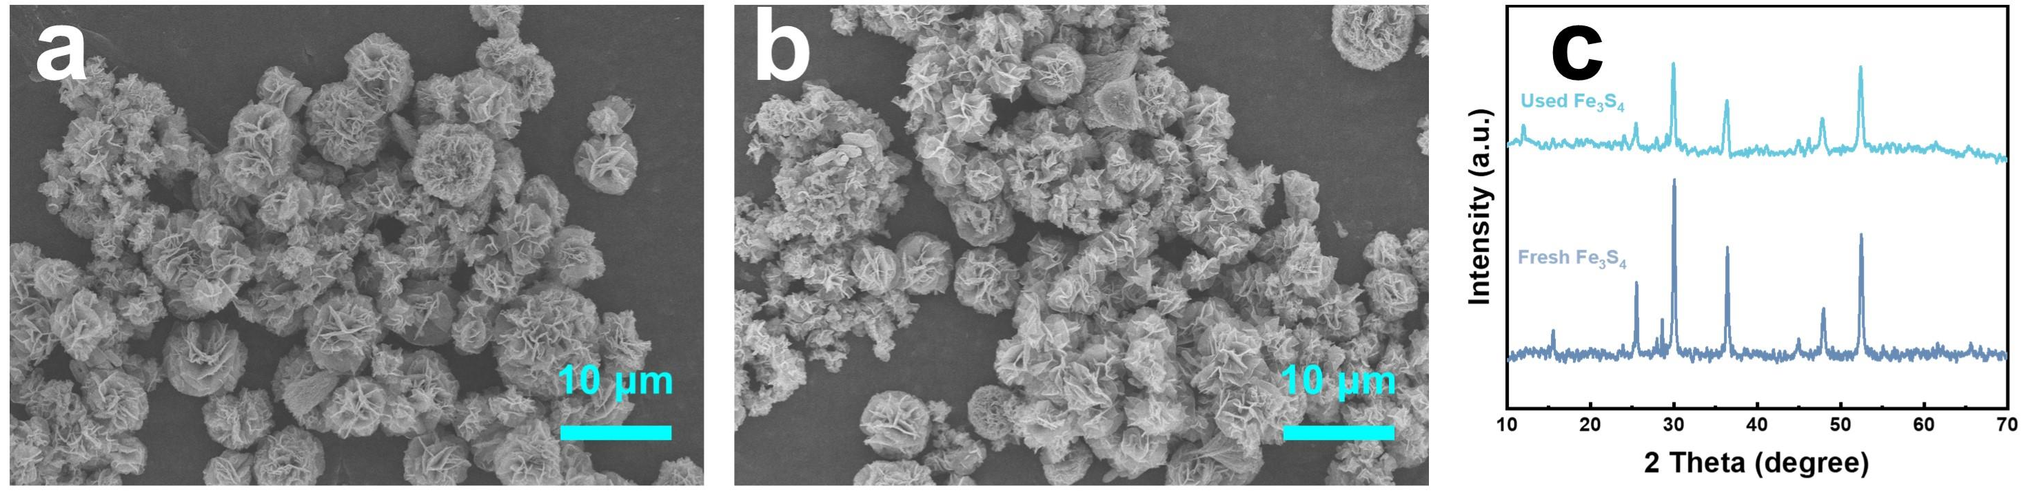
Fig. S29. SEM images of (a) fresh Fe₃S₄; (b) used Fe₃S₄; (c) XRD patterns of fresh and used Fe₃S₄.

Reference
1. Zhang H, et al. Drawing on Membrane Photocatalysis for Fouling Mitigation. ACS Appl. Mater. Interfaces 13, 14844-14865 (2021).
2. Zhang L, et al. Hierarchically Stabilized PAN/beta-FeOOH Nanofibrous Membrane for Efficient Water Purification with Excellent Antifouling Performance and Robust Solvent Resistance. ACS Appl. Mater. Interfaces 11, 34487-34496 (2019).
3. Chen C, et al. Graphene nanofiltration membrane intercalated with AgNP@g-C₃N₄ for efficient water purification and photocatalytic self-cleaning performance. Chem. Eng. J. 441, 136089 (2022).
4. Ma WJ, et al. Biomimetic Durable Multifunctional Self-Cleaning Nanofibrous Membrane with Outstanding Oil/Water Separation, Photodegradation of Organic Contaminants, and Antibacterial Performances. ACS Appl. Mater. Interfaces 12, 34999-35010 (2020).
5. Lotfi S, et al. Photocatalytic degradation of steroid hormone micropollutants by TiO₂-coated polyethersulfone membranes in a continuous flow-through process. Nat. Nanotechnol. 17, 417-423 (2022).
6. Wang J-S, et al. Eliminating tetracycline antibiotics matrix via photoactivated sulfate radical-based advanced oxidation process over the immobilized MIL-88A: Batch and continuous experiments. Chem. Eng. J. 431, 133213 (2022).
7. Pang D, et al. Superior removal of inorganic and organic arsenic pollutants from water with MIL-88A(Fe) decorated on cotton fibers. Chemosphere 254, 126829 (2020).
8. Zheng S, et al. Synergistic effect of MIL-88A/g-C₃N₄ and MoS₂ to construct a self-cleaning multifunctional electrospun membrane. Chem. Eng. J. 421, 129621 (2021).
9. Zhang M, et al. Activate Fe₃S₄ Nanorods by Ni Doping for Efficient Dye-Sensitized Photocatalytic Hydrogen Production. ACS Appl. Mater. Interfaces 13, 14198-14206 (2021).
10. Hang J, et al. Heterogeneous photo-Fenton degradation toward sulfonamide matrix over magnetic Fe₃S₄ derived from MIL-100(Fe). J. Hazard. Mater. 424, 127415 (2022).
11. Xie A, et al. Photo-Fenton self-cleaning membranes with robust flux recovery for an efficient oil/water emulsion separation. J. Mater. Chem. A. 7, 8491-8502 (2019).
12. Xie X, et al. Accelerated iron cycle inducing molecular oxygen activation for deep oxidation of aromatic VOCs in MoS₂ co-catalytic Fe³⁺/PMS system. Appl. Catal. B. 309, 121235 (2022).
13. Liang H, et al. Synergistic effect of dual sites on bimetal-organic frameworks for highly efficient peroxide activation. J. Hazard. Mater. 406, 124692 (2021).
14. Wang A, et al. MOF Derived Co−Fe nitrogen doped graphite carbon@crosslinked magnetic chitosan Micro−nanoreactor for environmental applications: Synergy enhancement effect of adsorption−PMS activation. Appl. Catal. B. 319, 121926 (2022).
15. Meng C, et al. Angstrom-confined catalytic water purification within Co-TiO_{x} laminar membrane nanochannels. Nat. Commun. 13, 4010 (2022).
16. Lu T, et al. Multiwfn: A multifunctional wavefunction analyzer. J. Comput. Chem. 33, 580-592 (2012).
17. Lu T, et al. Quantitative analysis of molecular surface based on improved Marching Tetrahedra algorithm. J. Mol. Graph. Model. 38, 314-323 (2012).
18. Zhang J, et al. Efficient evaluation of electrostatic potential with computerized optimized code. Phys. Chem. Chem. Phys. 23, 20323-20328 (2021).
19. Wang Y, et al. An integrated strategy for achieving oil-in-water separation, removal, and anti-oil/dye/bacteria-fouling. Chem. Eng. J. 413, 127493 (2021).
20. Liao X, et al. Engineering omniphobic corrugated membranes for scaling mitigation in membrane distillation. J. Membr. Sci. 665, 121130 (2023).
21. Zhao C, et al. Polyamide membranes with nanoscale ordered structures for fast permeation and highly selective ion-ion separation. Nat. Commun. 14, 1112 (2023).
22. Peng L, et al. Slug-inspired Magnetic Soft Millirobot Fully Integrated with Triboelectric Nanogenerator for On‐board Sensing and Self‐powered Charging. Nano Energy 99, 107367 (2022).
23. Wang X, et al. A high-applicability, high-durability wearable hybrid nanogenerator with magnetic suspension structure toward health monitoring applications. Nano Energy 103, 107774 (2022).
24. Zhu Z, et al. Research progress on methane conversion coupling photocatalysis and thermocatalysis. Carbon Energy 3, 519-540 (2021).
25. Wu W, et al. In Situ Preparation and Analysis of Bimetal Co-doped Mesoporous Graphitic Carbon Nitride with Enhanced Photocatalytic Activity. Nano-Micro Lett. 11, 10 (2019).
26. Piao H, et al. Ultra-low power light driven lycopodium-like nanofiber membrane reinforced by PET braid tube with robust pollutants removal and regeneration capacity based on photo-Fenton catalysis. Chem. Eng. J. 450, 138204 (2022).
27. Zhao J, et al. Ultra-highly photocatalytic removal of pollutants by polypyrrole/cadmium sulfide/polyether sulfone hybrid porous membrane in single-pass mode. Chem. Eng. J. 432, 134300 (2022).
28. Xu L, et al. Direct Z-scheme polymeric heterojunction boosts photocatalytic hydrogen production via a rebuilt extended π-delocalized network. Energy Environ. Sci. 15, 5059-5068 (2022).
29. Xu W, et al. Size-dependent electron injection over sensitized semiconductor heterojunctions for enhanced photocatalytic hydrogen production. Appl. Catal. B. 308, 121218 (2022).
30. Yuan L, et al. A S‐Scheme MOF‐on‐MOF Heterostructure. Adv. Funct. Mater. 33, (2023).
31. Guo Y, et al. Perylenetetracarboxylic acid nanosheets with internal electric fields and anisotropic charge migration for photocatalytic hydrogen evolution. Nat. Commun. 13, 2067 (2022).
32. Guo X, et al. Derivatives of two-dimensional MXene-MOFs heterostructure for boosting peroxymonosulfate activation: Enhanced performance and synergistic mechanism. Appl. Catal. B. 323, 122136 (2023).
33. Hua J, et al. Synthesis of type II heterojunction 2D/3D Bi₂S₃/MIL-88(A) with enhanced photocatalytic activity under visible-light irradiation. J. Phys. Chem. Solids 177, 111299 (2023).
34. Dapaah MF, et al. Efficient persistent organic pollutant removal in water using MIL-metal–organic framework driven Fenton-like reactions: A critical review. Chem. Eng. J. 431, 134182 (2022).
35. Li J, et al. New insight into the mechanism of peroxymonosulfate activation by Fe₃S₄: Radical and non-radical oxidation. Sep. Purif. Technol. 286, 120471 (2022).
36. Xiang S, et al. A comparative study of activation of peroxymonosulfate and peroxydisulfate by greigite (Fe₃S₄) for the degradation of sulfamethazine in water. Sep. Purif. Technol. 290, 120873 (2022).
37. Liu X, et al. Benzoquinone-assisted heterogeneous activation of PMS on Fe₃S₄ via formation of active complexes to mediate electron transfer towards enhanced bisphenol A degradation. Water Res. 226, 119218 (2022).
38. Kong L, et al. β-Cyclodextrin stabilized magnetic Fe₃S₄ nanoparticles for efficient removal of Pb(II). J. Mater. Chem. A. 3, 15755-15763 (2015).
39. Pan T, et al. ZnO Nanowires@PVDF nanofiber membrane with superhydrophobicity for enhanced anti-wetting and anti-scaling properties in membrane distillation. J. Membr. Sci. 621, 118877 (2021).
40. Xie AT, et al. Photo-Fenton self-cleaning PVDF/NH₂-MIL-88B(Fe) membranes towards highly-efficient oil/water emulsion separation. J. Membr. Sci. 595, 117499 (2020).
41. Yang T, et al. Hierarchically structured PVDF/ZnO core-shell nanofibers for self-powered physiological monitoring electronics. Nano Energy 72, 104706 (2020).
42. van Oss CJ. Acid—base interfacial interactions in aqueous media. Colloids Surf., A. 78, 1-49 (1993).
43. van Oss CJ. Hydrophobicity of biosurfaces — Origin, quantitative determination and interaction energies. Colloids Surf., B. 5, 91-110 (1995).
44. Meinders JM, et al. Deposition Efficiency and Reversibility of Bacterial Adhesion under Flow. J. Colloid Interface Sci. 176, 329-341 (1995).
45. Adam NK. Use of the Term ‘Young's Equation’ for Contact Angles. Nature 180, 809-810 (1957).
46. Brant JA, et al. Colloidal adhesion to hydrophilic membrane surfaces. J. Membr. Sci. 241, 235-248 (2004).

