Supplementary Materials for

Platelets as Delivery Vehicles for Targeted Enrichment of NO• to Cerebral Glioma for Magnetic Resonance Imaging
Yuchen Ding ¹†, Min Ge ¹†, Juncheng Yu ¹, Donglin Xia ^{2*}, Jian He ^{3*}, Zhongzheng Jia ^{1*}
¹ Department of Medical Imaging, Affiliated Hospital of Nantong University, Medical School of Nantong University, Nantong, 226001, PR China
² School of Public Health of Nantong University, Nantong, 226019, PR China
³ Department of Nuclear Medicine, Nanjing Drum Tower Hospital, Affiliated Hospital of Medical School, Nanjing University, Nanjing, Jiangsu 210008, PR China
* Corresponding authors. E-mails: xiadonglin@ntu.edu.cn (D.L Xia), hjxueren@126.com (J. He), jzz2397@163.com (Z.Z Jia)
† These authors contributed equally to this work.

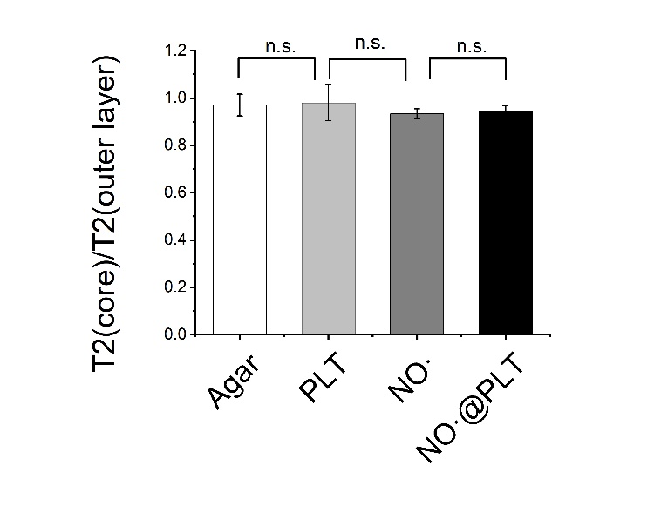
Figure S1. The ratio of T2 (core)/ T2 (outer layer) in each group. There were no much difference in T2WI between NO•@PLT and the other groups.
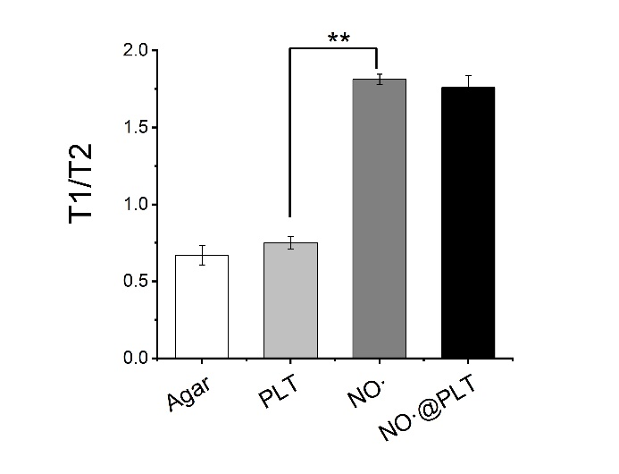
Figure S2. The changes of MRI value as indicated by T1/T2 of Figure 4C.

Figure S3. Fluorescence intensity quantification of heart after treated with NO• or NO•@PLT.

Figure S4. Fluorescence intensity quantification of liver after treated with NO• or NO•@PLT.

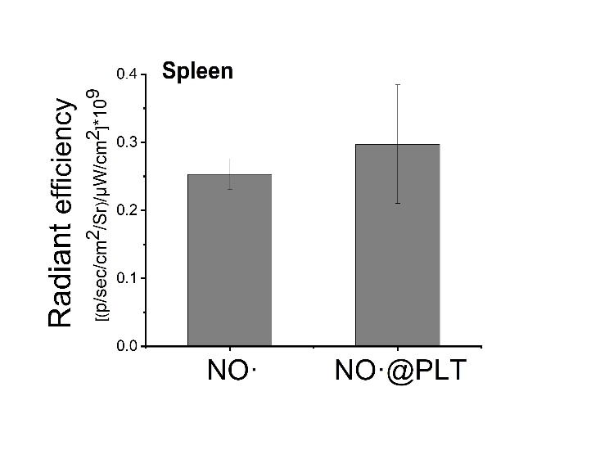
Figure S5. Fluorescence intensity quantification of spleen after treated with NO• or NO•@PLT.

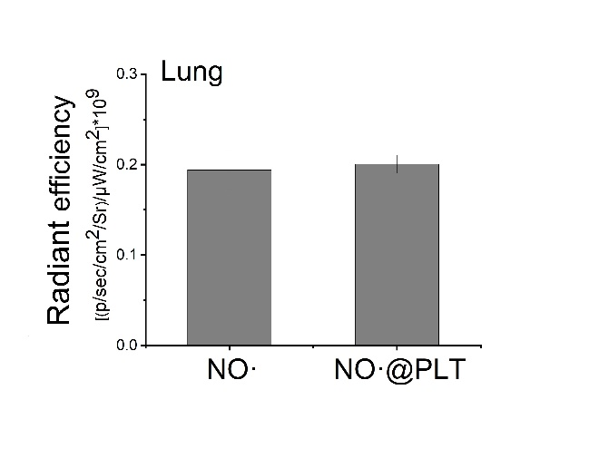
Figure S6. Fluorescence intensity quantification of lung after treated with NO• or NO•@PLT.

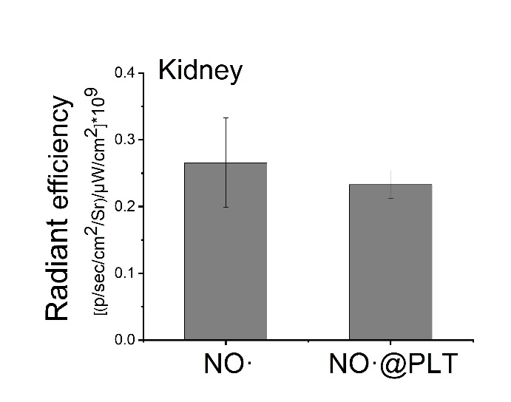
Figure S7. Fluorescence intensity quantification of kidney after treated with NO• or NO•@PLT.

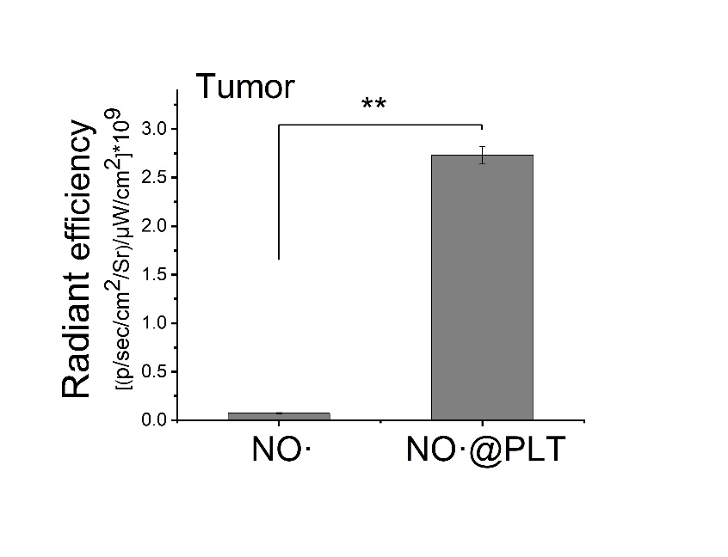
Figure S8. Fluorescence intensity quantification of tumor after treated with NO• or NO•@PLT.
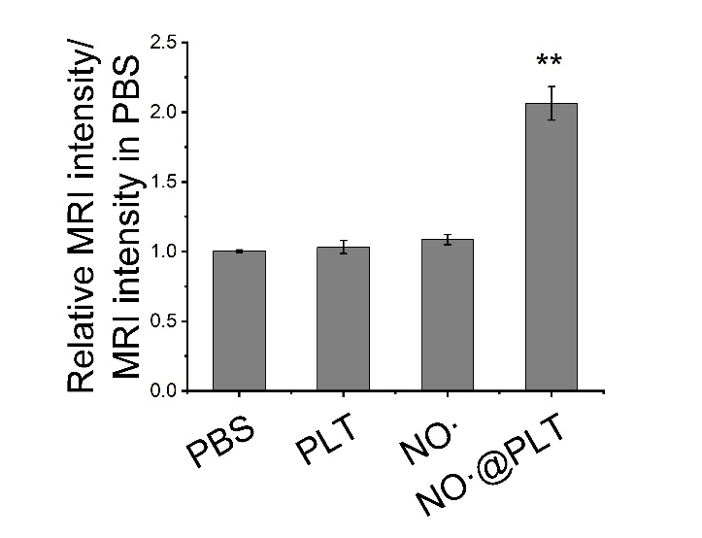
Figure S9. The changes of MRI intensity as indicated by relative MRI intensity/ MRI intensity in PBS treated group of (Figure 6A).

Figure S10. T1-weighted MR images of subcutaneous brain tumor after NO•@PLT administration for 5min and 4.5 h.

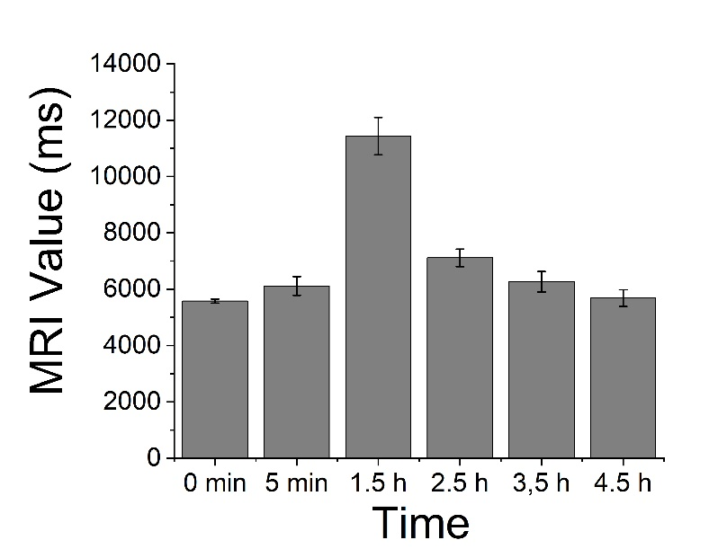
Figure S11. The changes of MRI value after NO•@PLT administration with time.

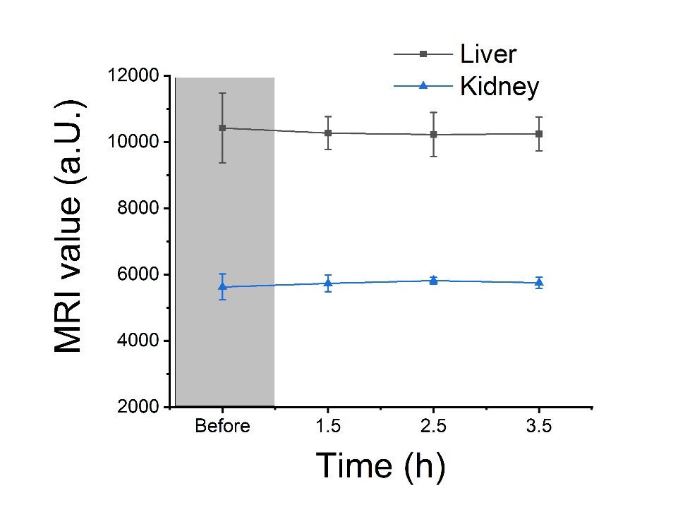
Figure S12. The changes of MRI intensity in liver and kidney after NO•@PLT administration of (Figure 6C).

