SUPPLEMENTARY MATERIALS

Figure S1. Age at MRI scan in the extremely preterm individuals. Every bar represents a child. The beginning of the bar represents the age at the brain scan acquired at the beginning of the treatment, and the end of the bar represents the age at the scan after treatment.

Figure S2. Representative segmentations of the subcortical structures in a participant of this work. CA, chronological age.

Figure S3. Bayley’s Mental (MDI) and Psychomotor (PDI) development scores are associated with the number of treatment follow-up sessions attended.

Table S1. Non-parametric correlations controlled by sex
Measurement Time Point | Hemi | Variable | Tx Adherence |  | Age at Scan 1 |  | Time b/Scans |  | MDI |  | PDI
Measurement Time Point | Hemi | Variable | R | p | R | p | R | p | R | p | R | p
Measurement Time Point | Hemi | Age at Scan 1 | 0.537 | 0.047 | - | -
Measurement Time Point | Hemi | Time b/Scans |  |  |  |  | - | - | 0.589 | 0.027 | 0.547 | 0.043
Measurement Time Point | Hemi | MDI | 0.653 | 0.011 |  |  | 0.589 | 0.027 | - | - | 0.813 | 0.000
Measurement Time Point | Hemi | PDI | 0.644 | 0.013 |  |  | 0.547 | 0.043 | 0.813 | 0.000 | - | -
Beginning of Treatment | L | Amygdala |  |  | -0.703 | 0.005
Beginning of Treatment | L | Caudate
Beginning of Treatment | L | Hippocampus |  |  | -0.641 | 0.014
Beginning of Treatment | L | Pallidum |  |  | -0.857 | 0.000
Beginning of Treatment | L | Putamen |  |  | -0.814 | 0.000 |  |  |  |  | -0.589 | 0.027
Beginning of Treatment | L | Thalamus |  |  | -0.910 | 0.000
Beginning of Treatment | R | Amygdala |  |  | -0.669 | 0.009
Beginning of Treatment | R | Caudate
Beginning of Treatment | R | Hippocampus |  |  | -0.673 | 0.008
Beginning of Treatment | R | Pallidum | -0.604 | 0.022 | -0.793 | 0.001
Beginning of Treatment | R | Putamen |  |  | -0.727 | 0.003
Beginning of Treatment | R | Thalamus |  |  | -0.835 | 0.000
Beginning of Treatment | Subcortical Gray Matter |  |  |  | -0.818 | 0.000
Beginning of Treatment | Cortex |  | -0.553 | 0.040
Beginning of Treatment | White Matter |  | 0.758 | 0.002 |  |  |  |  | 0.556 | 0.039
After Treatment | L | Amygdala
After Treatment | L | Caudate
After Treatment | L | Hippocampus
After Treatment | L | Pallidum
After Treatment | L | Putamen
After Treatment | L | Thalamus
After Treatment | R | Amygdala
After Treatment | R | Caudate
After Treatment | R | Hippocampus
After Treatment | R | Pallidum
After Treatment | R | Putamen |  |  |  |  | -0.615 | 0.019
After Treatment | R | Thalamus
After Treatment | Cortex |  |  |  |  |  | -0.621 | 0.018
Note: Hemi, hemisphere; MDI, Bayley’s mental development index; PDI, Bayley’s psychomotor development index; L, left; R, right; Time b/Scans, time between scans; Tx Adherence, treatment adherence.

Figure S1

Figure S2
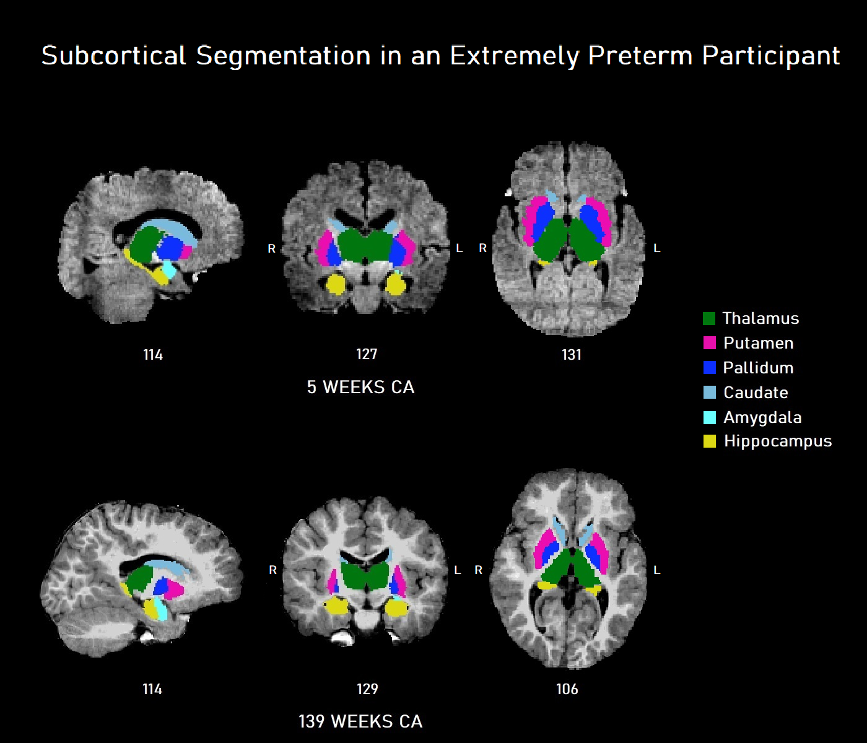

Figure S3

