Effects of substituting natural prey for ancestral prey on food preference in the Alcatrazes Island dwarf pitviper

João Miguel Alves-Nunes^{1,2} *, Adriano Fellone¹ and Otavio A. V. Marques ^{1,2}
Supplementary material
Table S1. Bothrops alcatraz TFAS index model summary. Intercept- Prey (mouse) and birth (captivity). Bold p-values indicate p < 0.05.
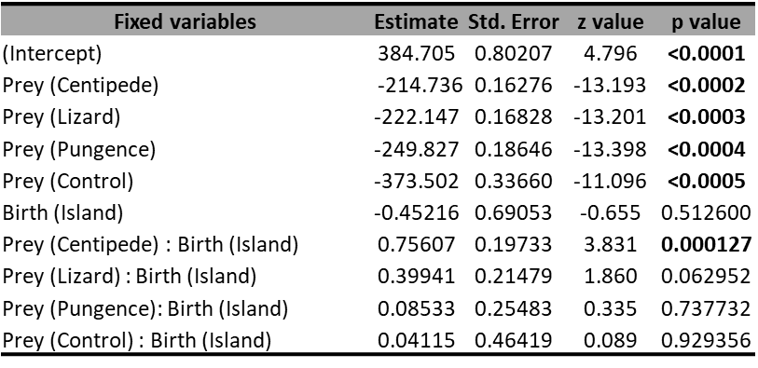
Table S2. Bothrops alcatraz TFAS index model summary for experiment 2. Intercept- Prey (lizard). Bold p-values indicate p < 0.05.
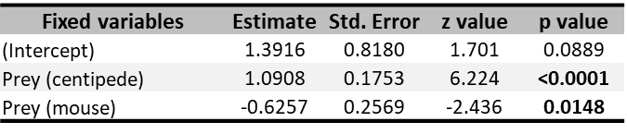
Table S3. Bothrops alcatraz time inspection model summary for experiment 2. Intercept- Prey (centipede). Bold p-values indicate p < 0.05.
