Supplementary Materials
Table S1 Primers used for the qRT-PCR assay.
Gene symbol |  | Primer sequence (5' to 3')
NODE64739g19765i1 (MYB) | Forward primer | CCACAAGCTCCTAGGGAACAG
NODE64739g19765i1 (MYB) | Reverse primer | GAGTTGGTTTTGGGTCTTCGC
NODE70694g17362i1  (NAC) | Forward primer | TCCGGTTCCATCCCACTGAT
NODE70694g17362i1  (NAC) | Reverse primer | TGCTCTGTTGGGTCGATTCC
NODE124009g10109i7  (F3’H) | Forward primer | ACGACTTCCGCCACATCC
NODE124009g10109i7  (F3’H) | Reverse primer | CCATCATCTCCACCACCATCT
NODE121843g1147i21  (CHI) | Forward primer | GGCACTGAGATGGTTATGGTTG
NODE121843g1147i21  (CHI) | Reverse primer | TCTCCTGCTTTCCCCTTAAACT
NODE35349g1787i29  (DFR) | Forward primer | AGCCACAACAGTTAAGCGTG
NODE35349g1787i29  (DFR) | Reverse primer | TTCTCCTTGGCAAAGTCCCA
NODE68908g7600i7  (ANR) | Forward primer | TGTCCCCAGTAGCACTTCTC
NODE68908g7600i7  (ANR) | Reverse primer | GCAGCATATGTATCGCCCAG
NODE61499g421i59  (C4H) | Forward primer | GCGATTCAAGCTTCCTCCTG
NODE61499g421i59  (C4H) | Reverse primer | CCCCTGAGTGTGGAGAACTT
NODE59740g460i7  (LAR) | Forward primer | ATTCTCGACCAGCTCACCTTG
NODE59740g460i7  (LAR) | Reverse primer | CGAGAGGAGGAAGAACATCGG
NODE43762g421i48  (CHS) | Forward primer | CCAGAGCGAGTACCCTGATTAC
NODE43762g421i48  (CHS) | Reverse primer | ACTTCAACCACCACCATGTCTT
NODE66606g8635i14  (FLS) | Forward primer | AGGAGAAGGAGGAGTATGCGAT
NODE66606g8635i14  (FLS) | Reverse primer | TTTGAGCACCCTTTCTTCCAGT
NODE27869g1717i6  (GRAS) | Forward primer | CGCCTTCTTCGACTCTACTCTC
NODE27869g1717i6  (GRAS) | Reverse primer | CTGAAATCGATGACATGGACGC
NODE57759g18792i1  (18S rRNA) | Forward primer | CAAAGTCGATGCTTGATGTTGC
NODE57759g18792i1  (18S rRNA) | Reverse primer | GCACCATCAATAACTCCAGGTC

Table S2 Litsea coreana var. sinensis full-length transcripts annotated in public databases
Databases | Number of annotated genes | Percentage(%)
GO | 52,892 | 41.65
KEGG | 53,827 | 42.39
KOG | 61,557 | 48.48
NR | 76,446 | 60.20
Pfam | 96,438 | 75.95
Swiss-Prot | 66,072 | 52.03
TrEMBL | 53,978 | 42.51
Total unigenes | 107,977 | 85.04

Supplementary Figures

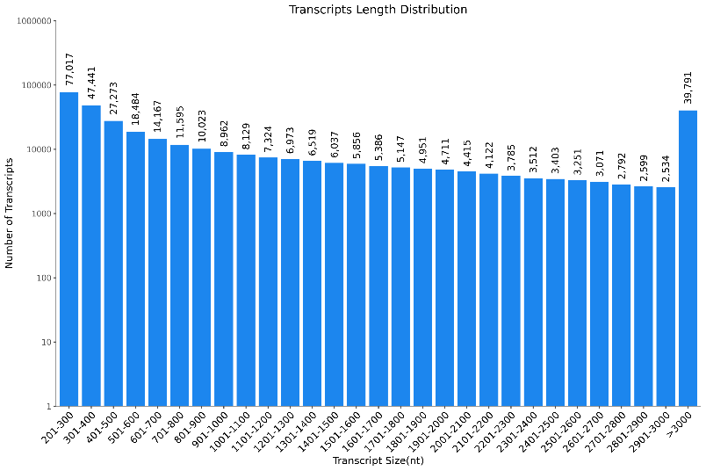
Fig. S1 Length distribution of Nanopore transcripts.

Fig. S2 Gene Ontology (GO) classification of unigenes.
Fig. S3 Number of unigenes of L. coreana var sinensis in each transcription factor families.

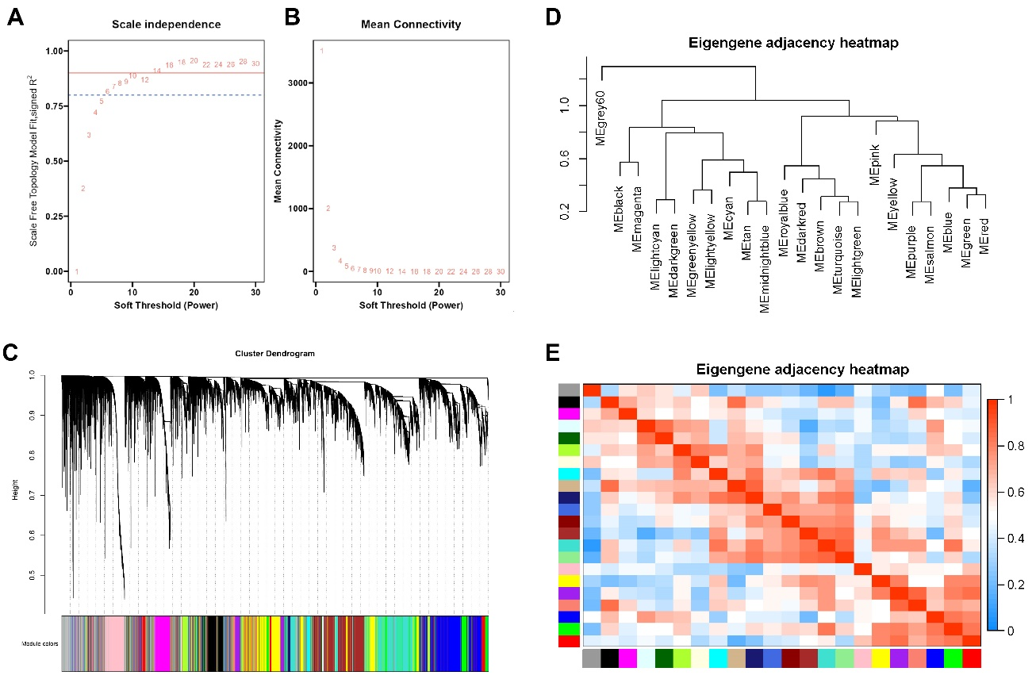
Fig. S4 Construction of gene co-expression networks with WGCNA. A B Analysis of the network topology for various soft-thresholding (β value) powers. The blue dotted line is drawn at 0.8. C. Hierarchical clustering dendrogram of module eigengenes. D. Hierarchical clustering dendrogram of module eigengenes. E. Heatmap plot of the adjacencies in the eigengene network.

