Supplemental Materials, Figures
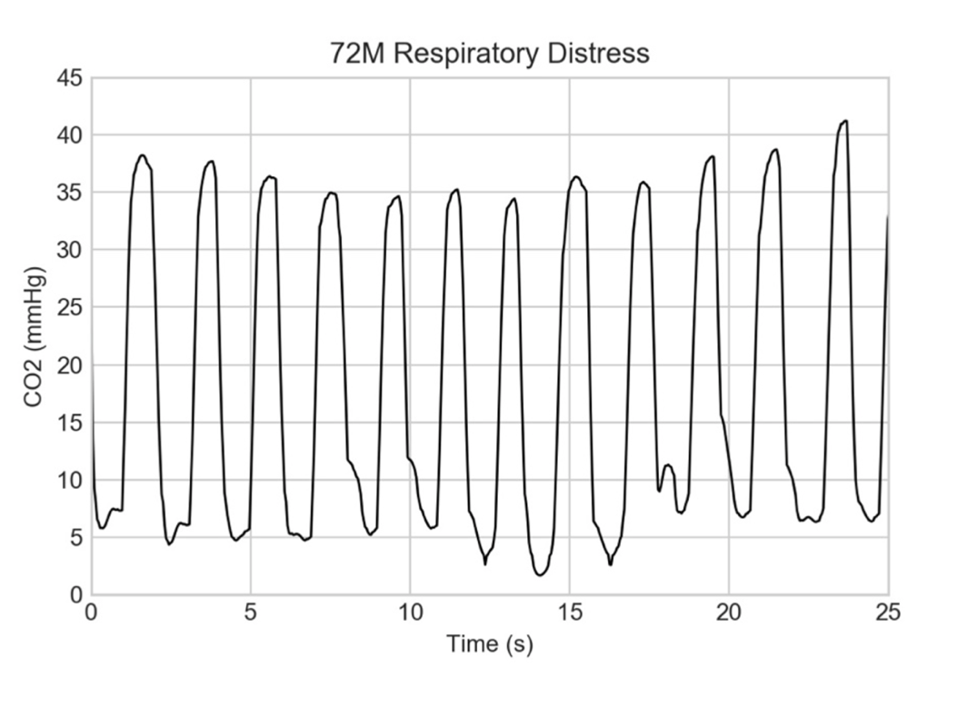
Supplemental Figure 1 Unusual capnogram of patient later found with a large pericardial effusion

(A)
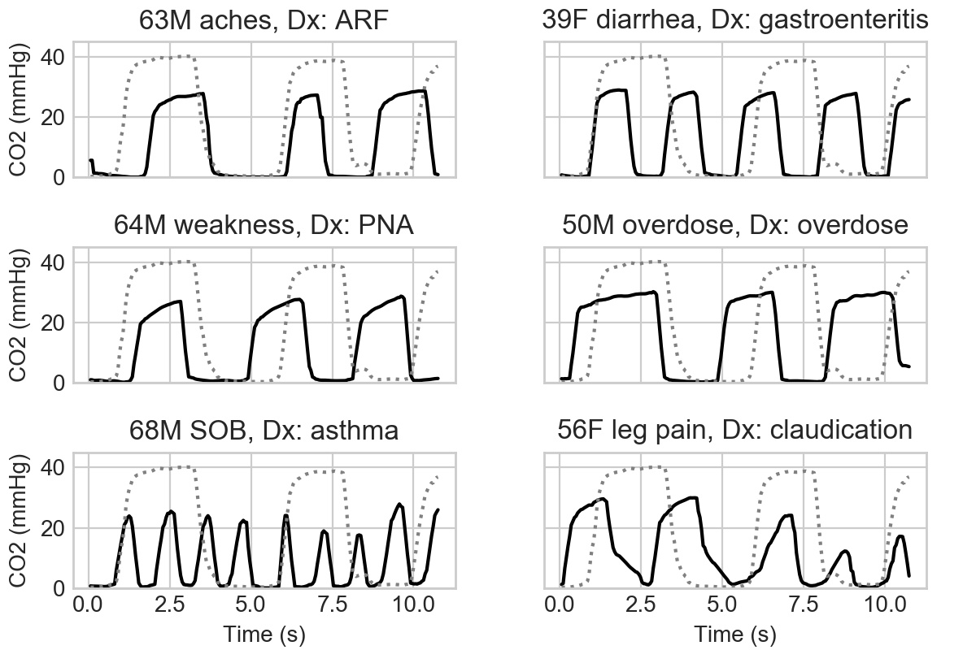

(B)
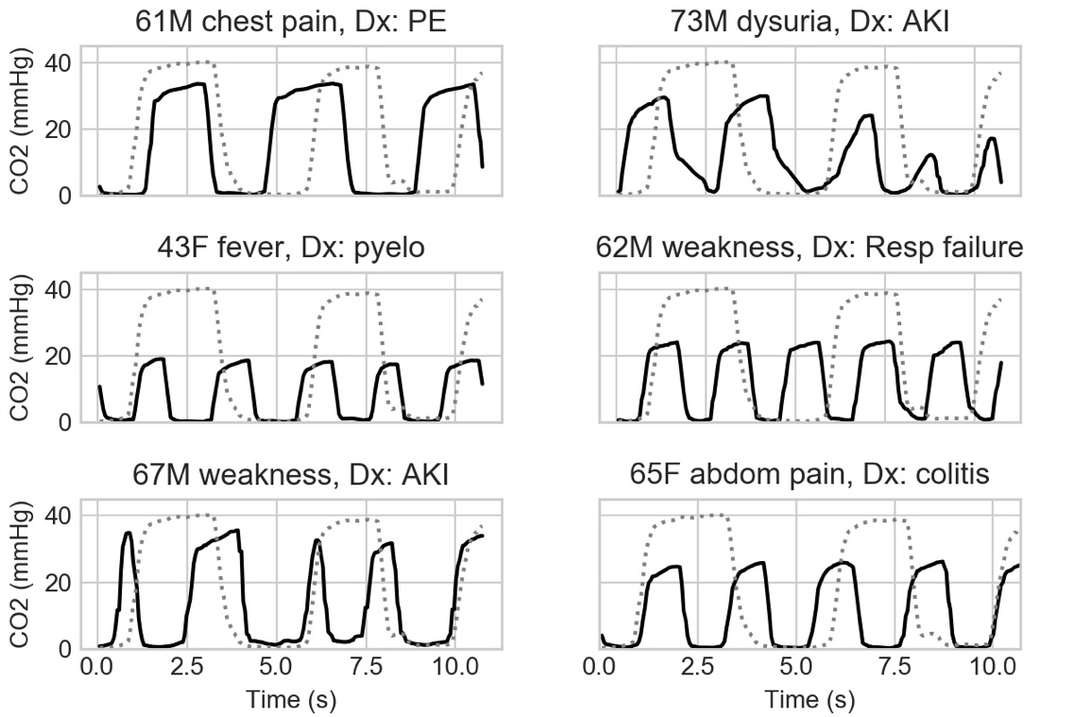

(C)
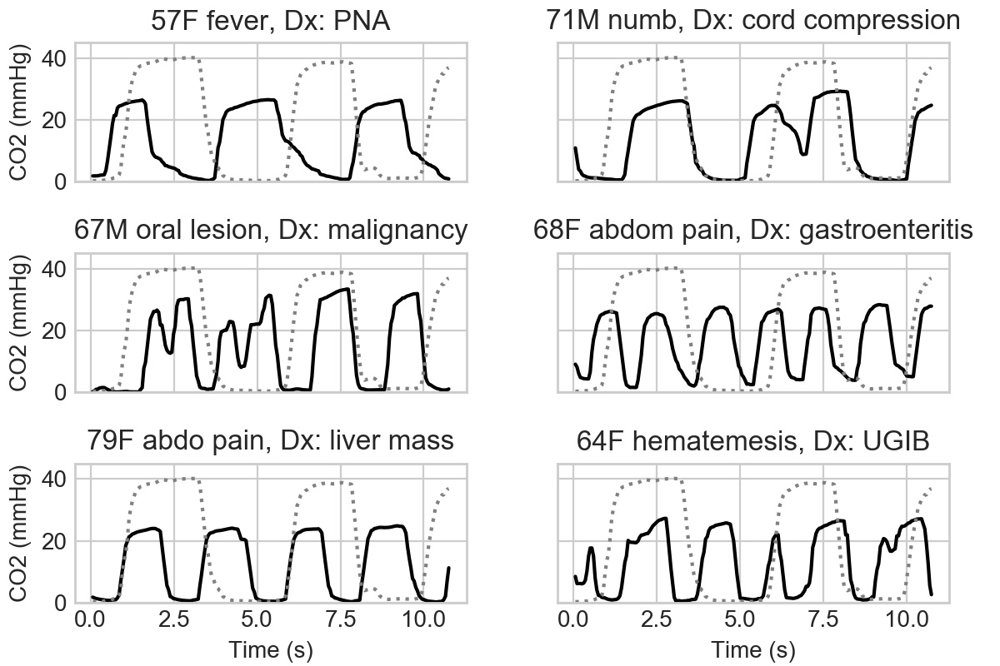
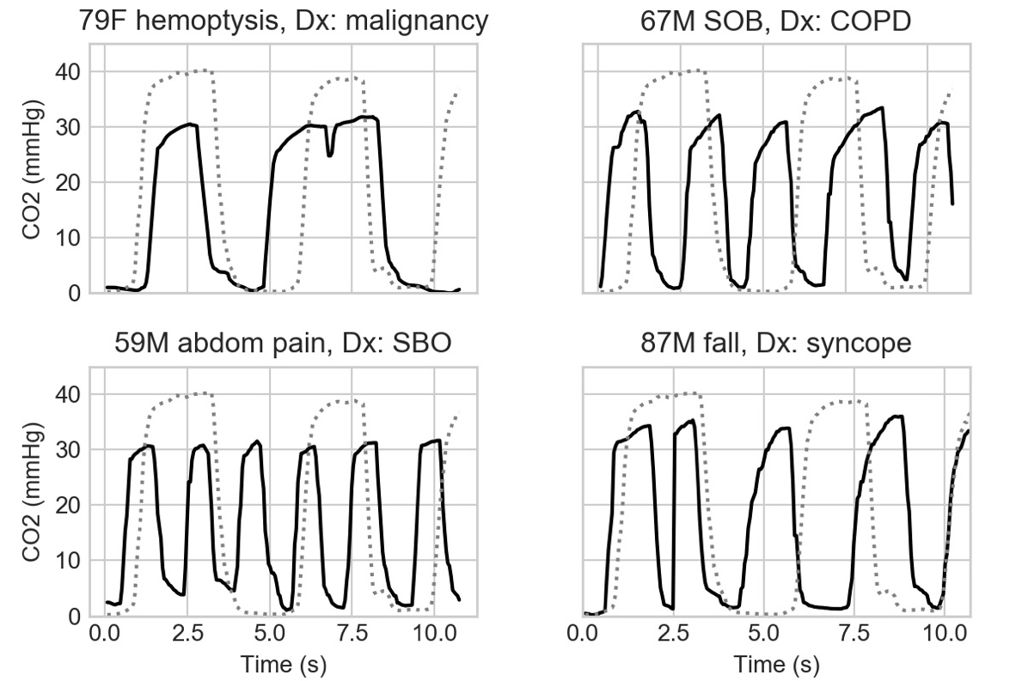
Supplemental Figure 2 Capnograms of 22 patients

