Table 1. Overview of the single aptamers of P. aeruginosa (C2R10, C2R2, C10R5, C10R6, C1R1, C2R1, C6R3, C4R2) and A. muciniphila (Akk. 2.1, Akk. 13.1). Melting curves of the respective single aptamers analyzed by quantitative PCR using the qTOWER³G touch (Analytik Jena, Jena, Germany) are shown on the right. ddRn/dT describes the change in fluorescence divided by the change in temperature. From the eight individual P. aeruginosa aptamers, four individual aptamers were shown as examples in the figure (right side).
 | Aptamer | Aptamer sequence without primer regions | Tm [°C] | GC content [%] | Melting curve
P. aeruginosa | C2R10 | GCGGGAGGTGCGAGGTTGTGGTAGGGCAGAGGGCGGCTGG | 82 | 54.65 | 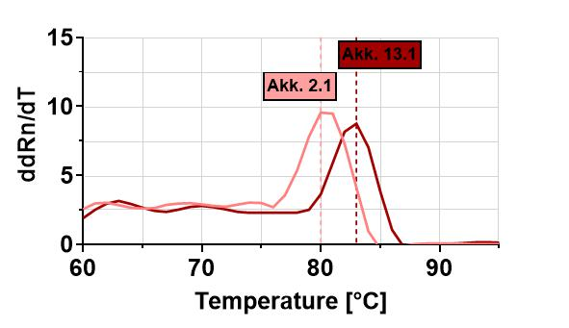  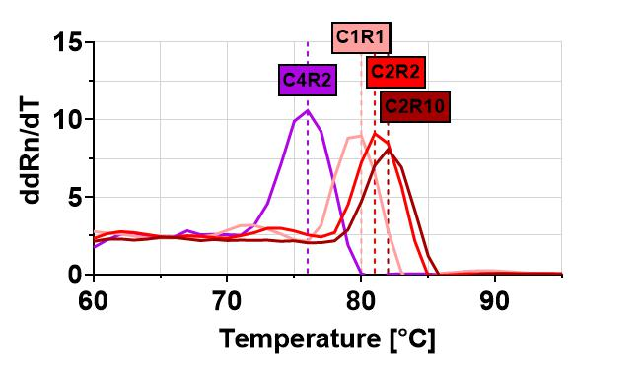
P. aeruginosa | C2R2 | GCAGCGGGATGGGGTAAATGGTGGCGAGAGGCGTCGGGGG | 81 | 53.49
P. aeruginosa | C10R5 | GCAGCCACAGCAGAGACGGGAAGGGCCAGGGTTGAGCGGG | 81 | 53.49
P. aeruginosa | C10R6 | GCGGCGGTGGGGCTTTCGGTGATTTGGGCGGTTTGGCGGG | 81 | 53.49
P. aeruginosa | C1R1 | GCGCGCGAGATTAACCCCCCAATGCTGCACCGAGCCACGA | 80 | 51.16
P. aeruginosa | C2R1 | GCGGCAGGGAAGGACTATGTGGGTGAAAGGAGTGCGCGGG | 80 | 51.16
P. aeruginosa | C6R3 | GCGGGGAGAGGCGAAAGAAGCTGGGATGGAAGGGCGTAGG | 80 | 51.16
P. aeruginosa | C4R2 | GCGCGTTGACTAGTACATGACCACTTGAGTCGCTTGAACT | 76 | 44.19
A. muciniphila | Akk2.1 | GCGGGGAGAGGCGAAAGAAGCTGGGATGGAAGGGCGTAGG | 81 | 53.29
A. muciniphila | Akk13.1 | CCGCCACACCACCACAGCTCGCCGACCGACTCACCGCGCC | 83 | 57.21

