Supporting information

Combining X-ray Nano-CT and XANES Techniques
for 3D Operando Monitoring of Lithiation
Spatial Composition evolution in NMC Electrode
Tuan-Tu Nguyen^{1,2}, Jiahui Xu^{1,3}, Zeliang Su^{1,3}, Vincent De Andrade⁵, Alejandro A. Franco^{1,3,4}
Bruno Delobel², Charles Delacourt^{1,3}, Arnaud Demortière^{1,3,4*}

¹Laboratoire de Réactivité et Chimie des Solides (LRCS), CNRS-UPJV UMR 7314, rue Baudelocque, 80039 Amiens Cedex, France.
²Renault Technocentre, 78084 Guyancourt, France
³Réseau sur le Stockage Electrochimique de l’Energie (RS2E), CNRS FR 3459, rue Baudelocque, 80039 Amiens Cedex, France.
⁴ALISTORE-European Research Institute, CNRS FR 3104, Hub de l’Energie, Rue Baudelocque, 80039 Amiens Cedex, France.
⁵ Advanced Photon Source, Argonne National Laboratory, Lemont, USA.

Corresponding Author: Arnaud Demortière : arnaud.demortiere@cnrs.fr

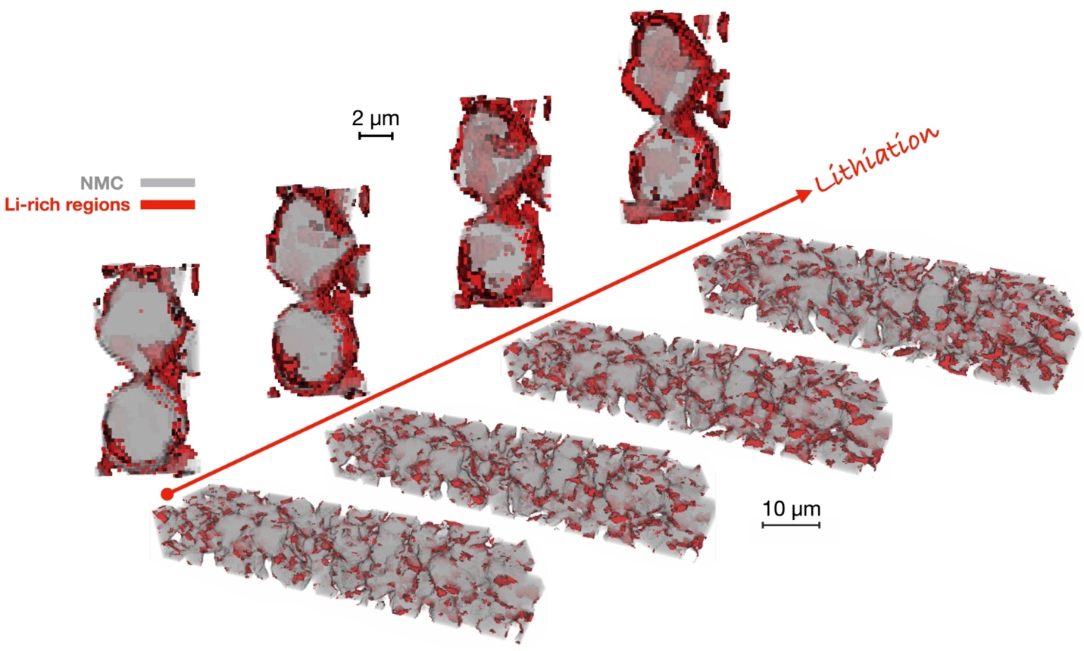
Figure S1: The detachment of the AM particles between two TXM acquisitions.

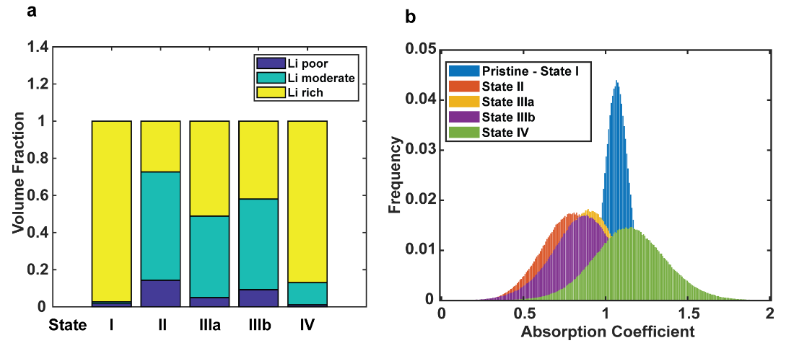
Figure S2: a. The bar graph represents the volume fraction of AM with different Li contents obtained from 3D quantitative analysis. b. The distribution of absorption coefficient at each voxel within the volume.

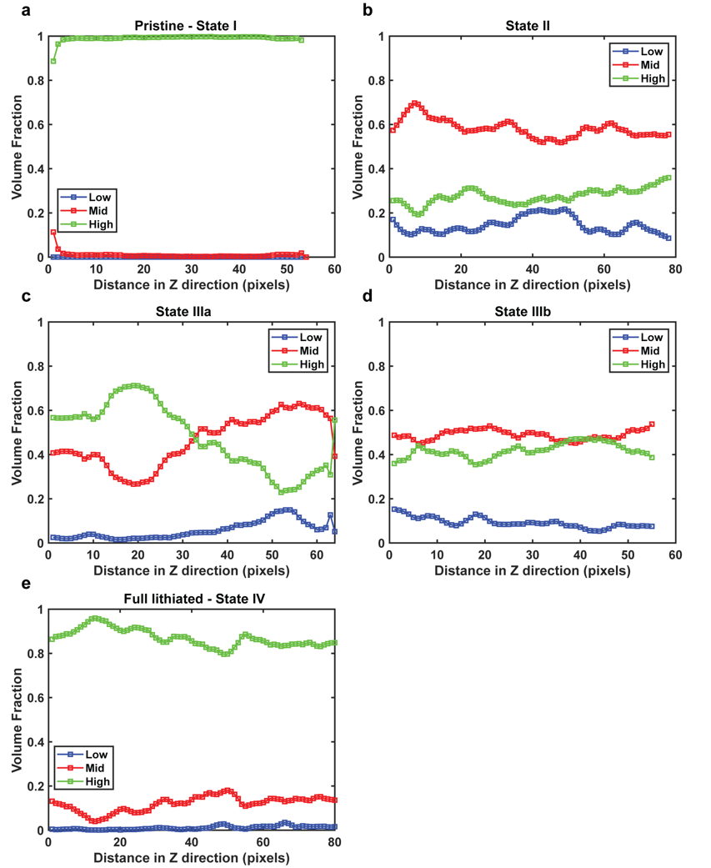
Figure S3. The volume fraction profiles along the Z-axis direction (through-plane) of the electrode. Each point was obtained by calculating the fraction of the phase in a 2D slice across the Z-axis. a. State I (Pristine electrode). b. State II (CCCV charge to 4.3 V). c-d. Discharge 1C to 50% DoD captured at position 1 and 2, respectively. e. State III (CCCV discharge to 2.5 V).

