Supplementary information

Scanpro: robust proportion analysis for single cell resolution data
Yousef Alayoubi, Mette Bentsen, Mario Looso

Content
Supplementary figures 2
Supplementary Figure 1: Choice of FDR for scCODA analysis 2
Supplementary Figure 2: Proportions of cells per sample across clusters 3
Supplementary Figure 3: Comparison of Scanpro with propeller and scCODA for heart development data 4
Supplementary Figure 4: Scanpro results on COVID-19 data 5
Supplementary Figure 5: Scanpro results on unreplicated COVID-19 data using pseudo-replicates 6
Supplementary Figure 6: Percent correct assignments for Scanpro runs 7
Supplementary Figure 7: Human myocardial infarction atlas cell type proportions 8
Supplementary Figure 8: Human myocardial infarction atlas cell type proportions using pseudo-replicates 9
Supplementary Figure 9: Fetal scATAC atlas cell type proportions for all tissues 10
Supplementary methods 11
Scanpro software architecture 11
Transform Proportions 11
Empirical Bayes statistics 11
Bootstrapping method to simulate replicates for unreplicated data 12

Supplementary figures

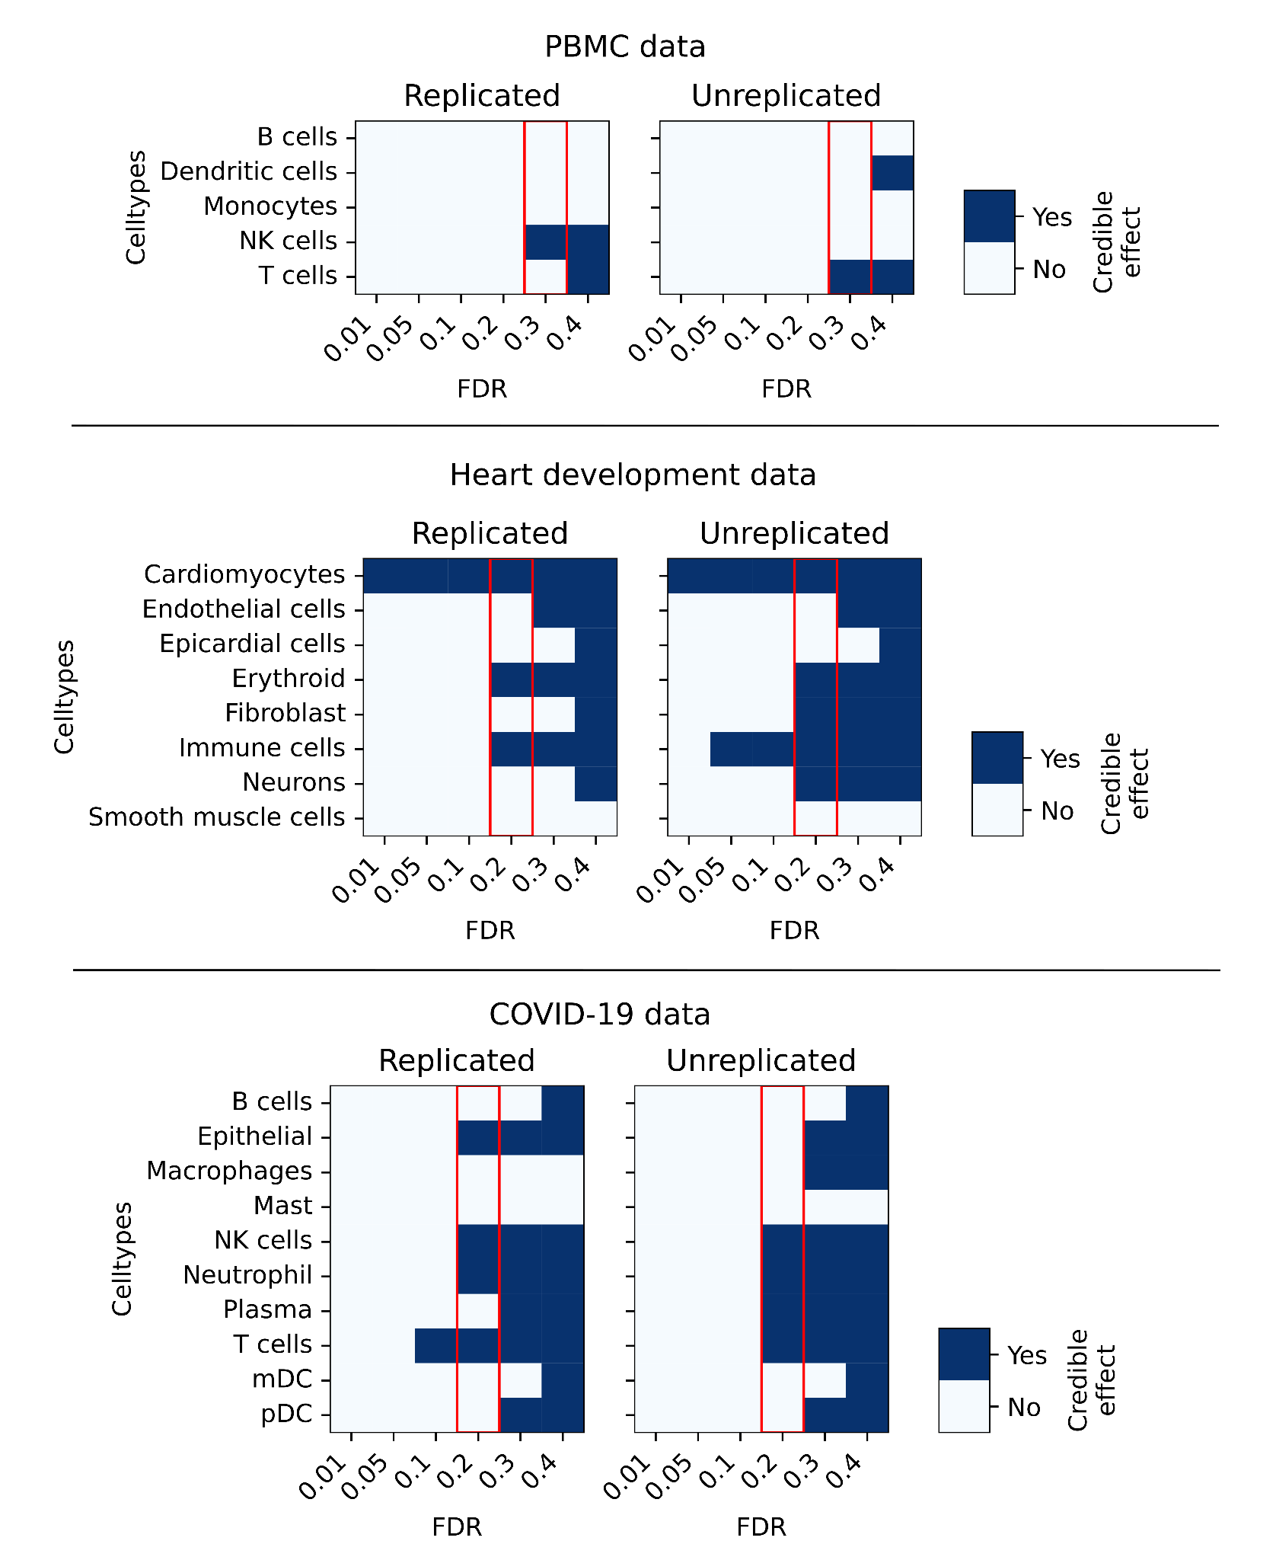

Supplementary Figure 1: Choice of FDR for scCODA analysis
scCODA was run for all three datasets with increasing FDR and the credible effect of each cluster was estimated at each FDR level. Red blocks indicate the chosen FDR level.

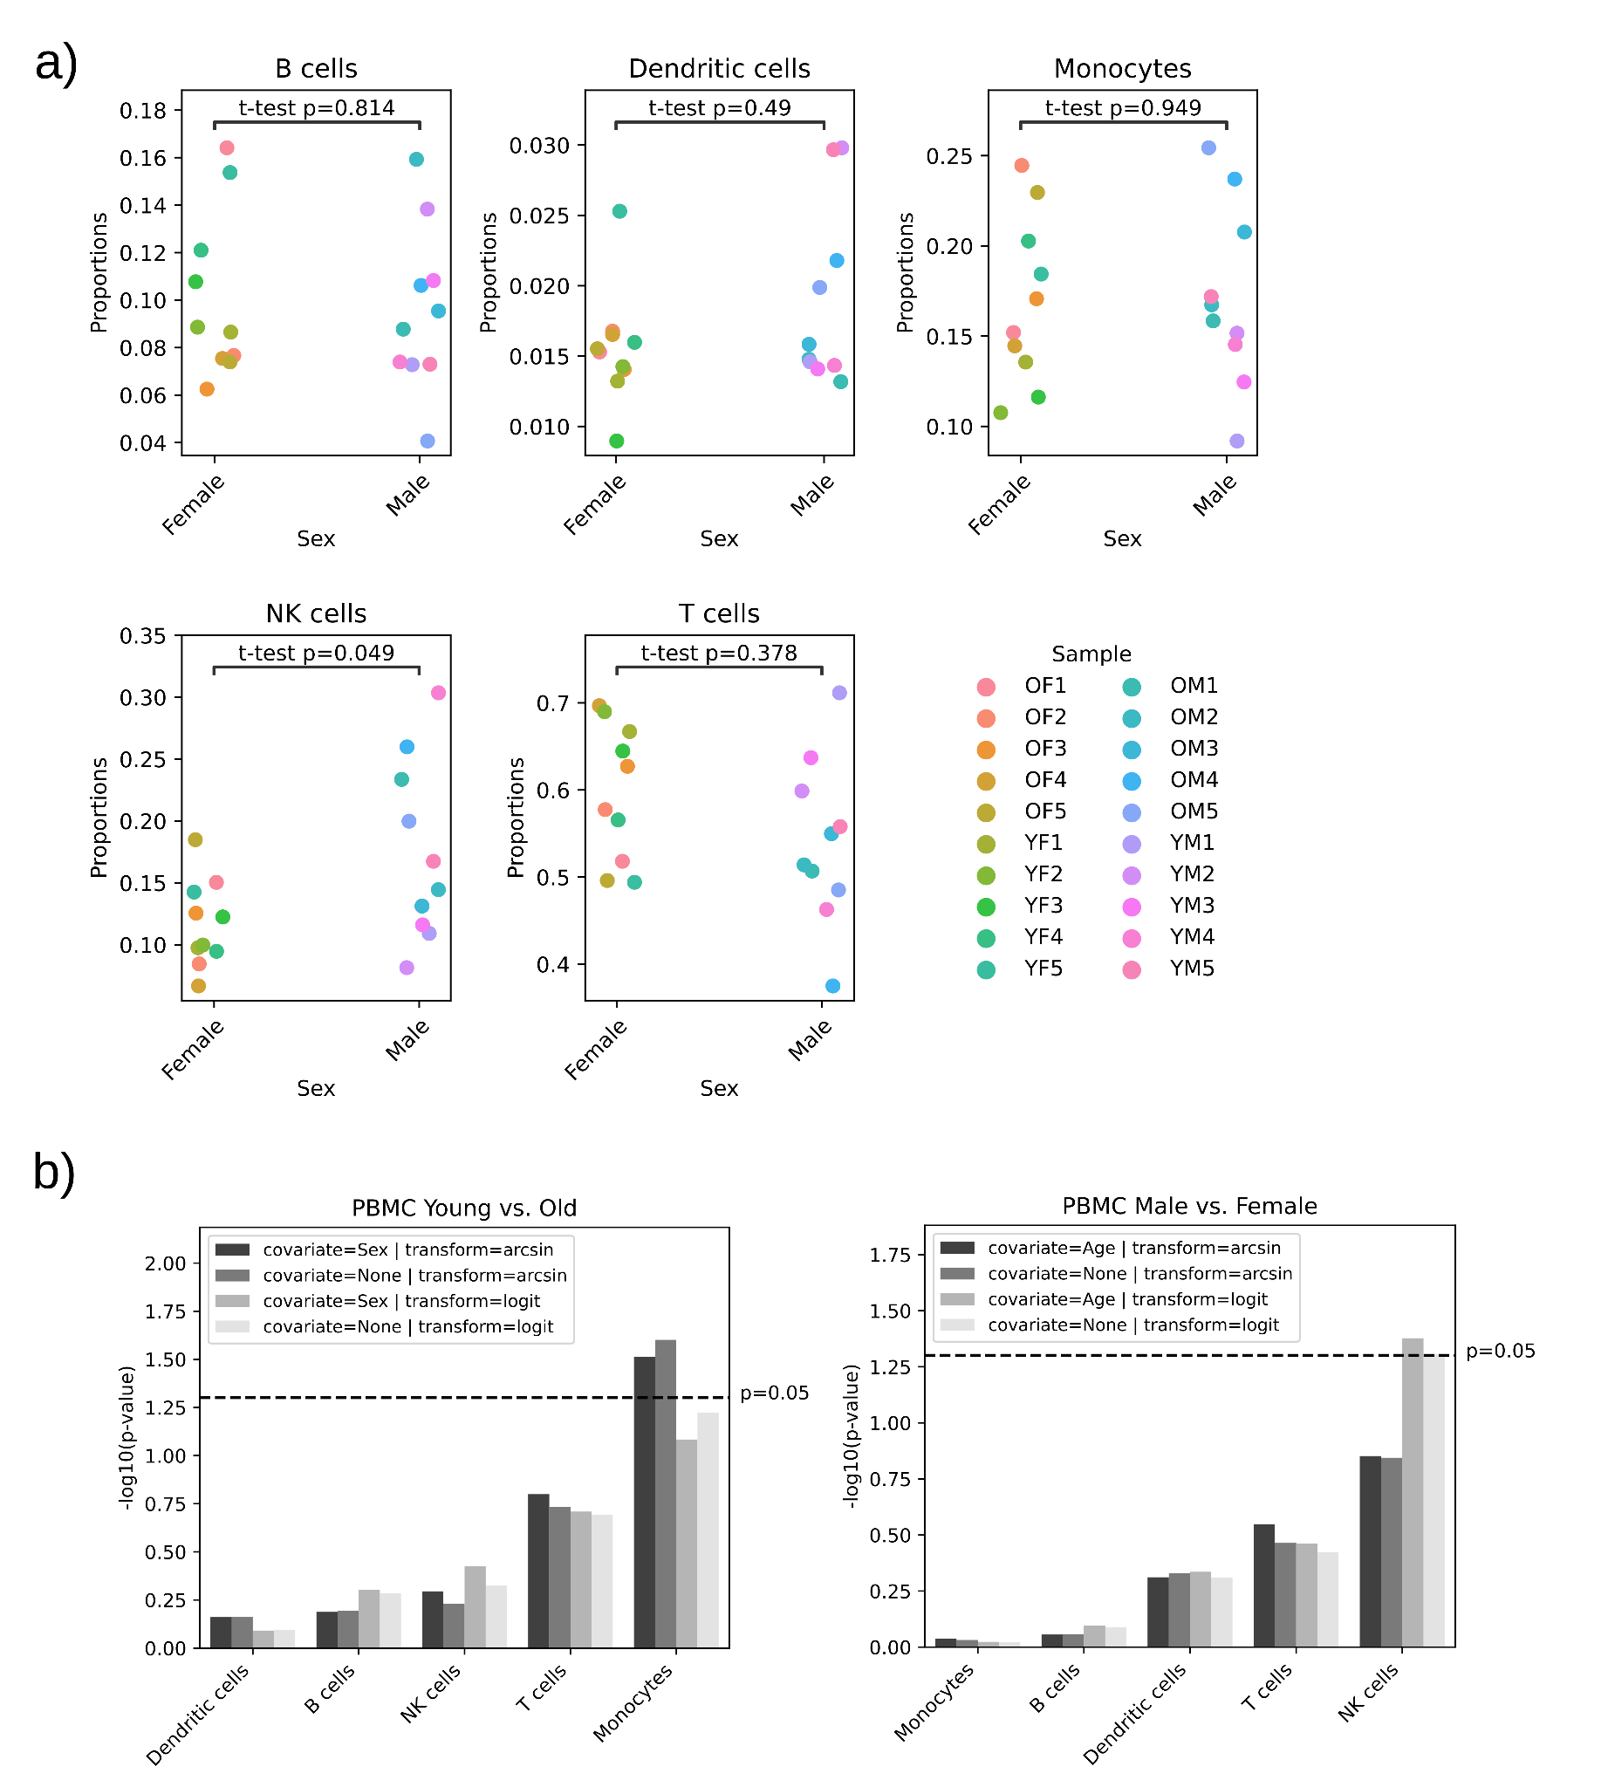

Supplementary Figure 2: Proportions of cells per sample across clusters
a) Output from Scanpro showing the raw proportions of cells from the PBMC dataset in each cluster. The samples are split between male and female samples per cluster. OF = Old female; YF = Young female; OM = Old male; YM = Young male. The p-values are calculated by Scanpro using “logit” transformed data. b) Comparison of Scanpro runs with/without covariates and for transformation “logit”/“arcsin”. Left shows -log10 transformed p-values for young vs. old samples per cluster; right side shows male vs. female per cluster.

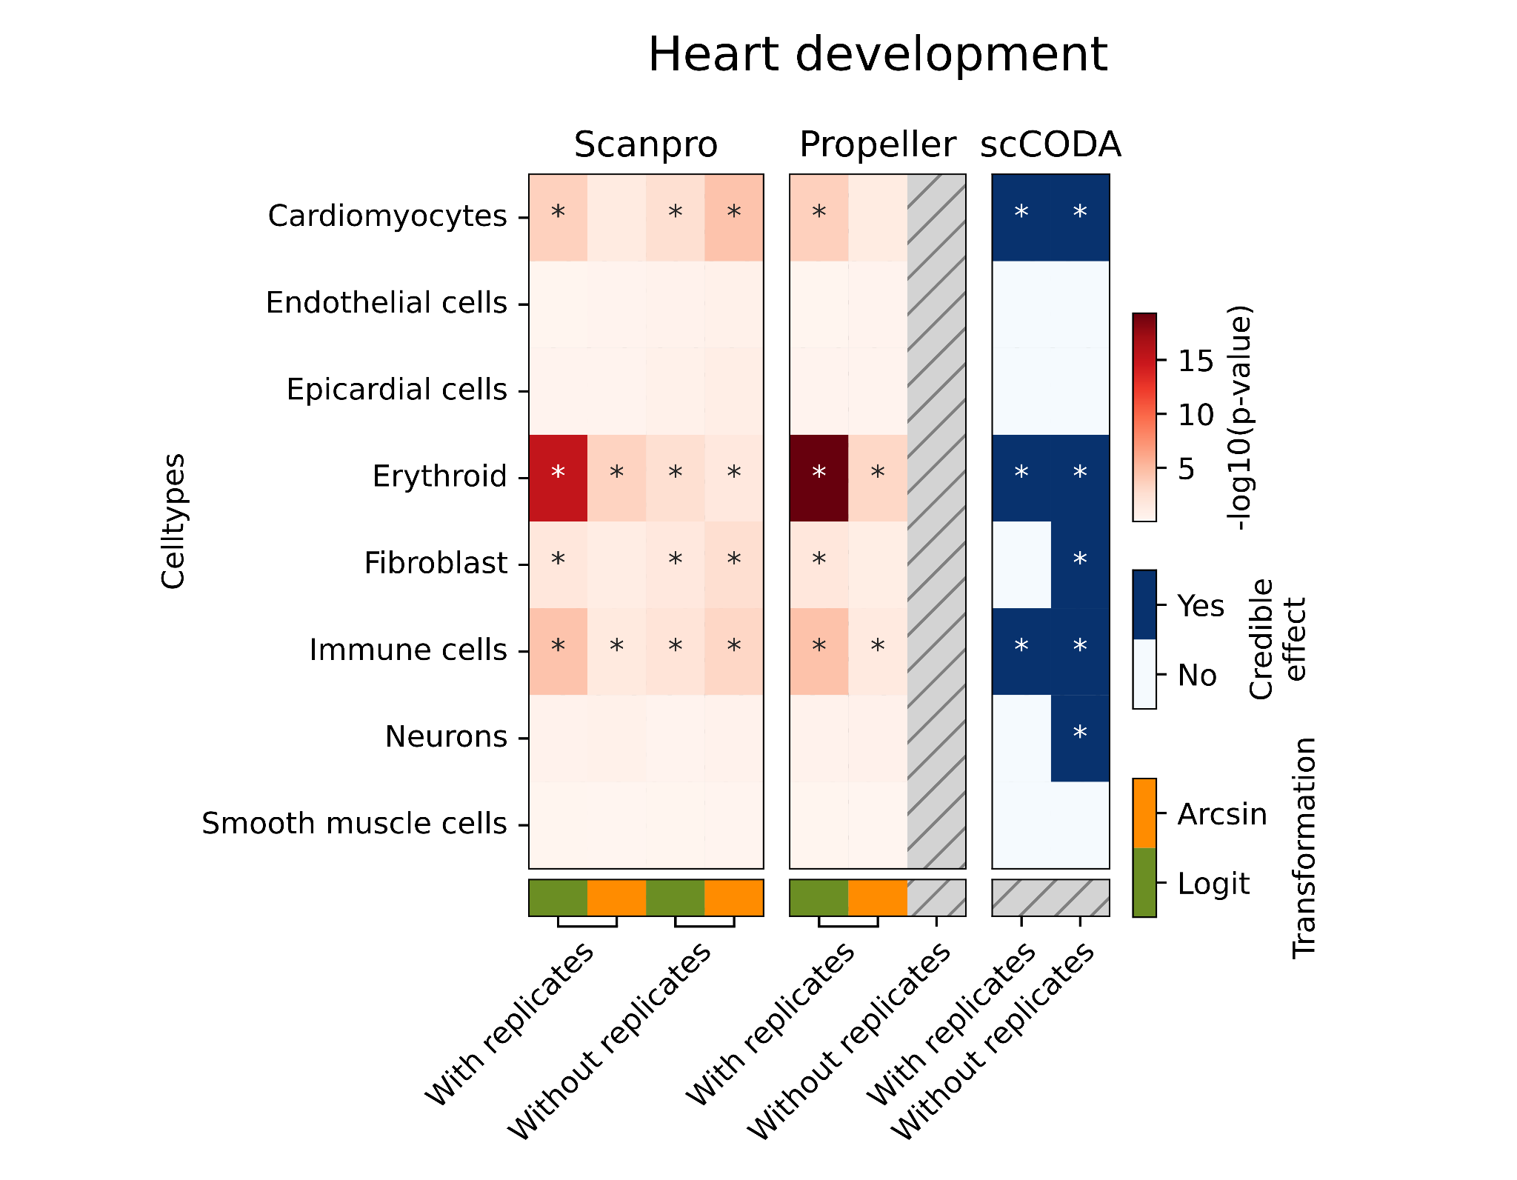

Supplementary Figure 3: Comparison of Scanpro with propeller and scCODA for heart development data
-log10(p-values) were calculated for scanpro and propeller (red color in the heatmap). For scCODA, credible effects are plotted. Asterisks denote significant changes (p-value < 0.05 or credible effect=TRUE). For scCODA, default settings were used.

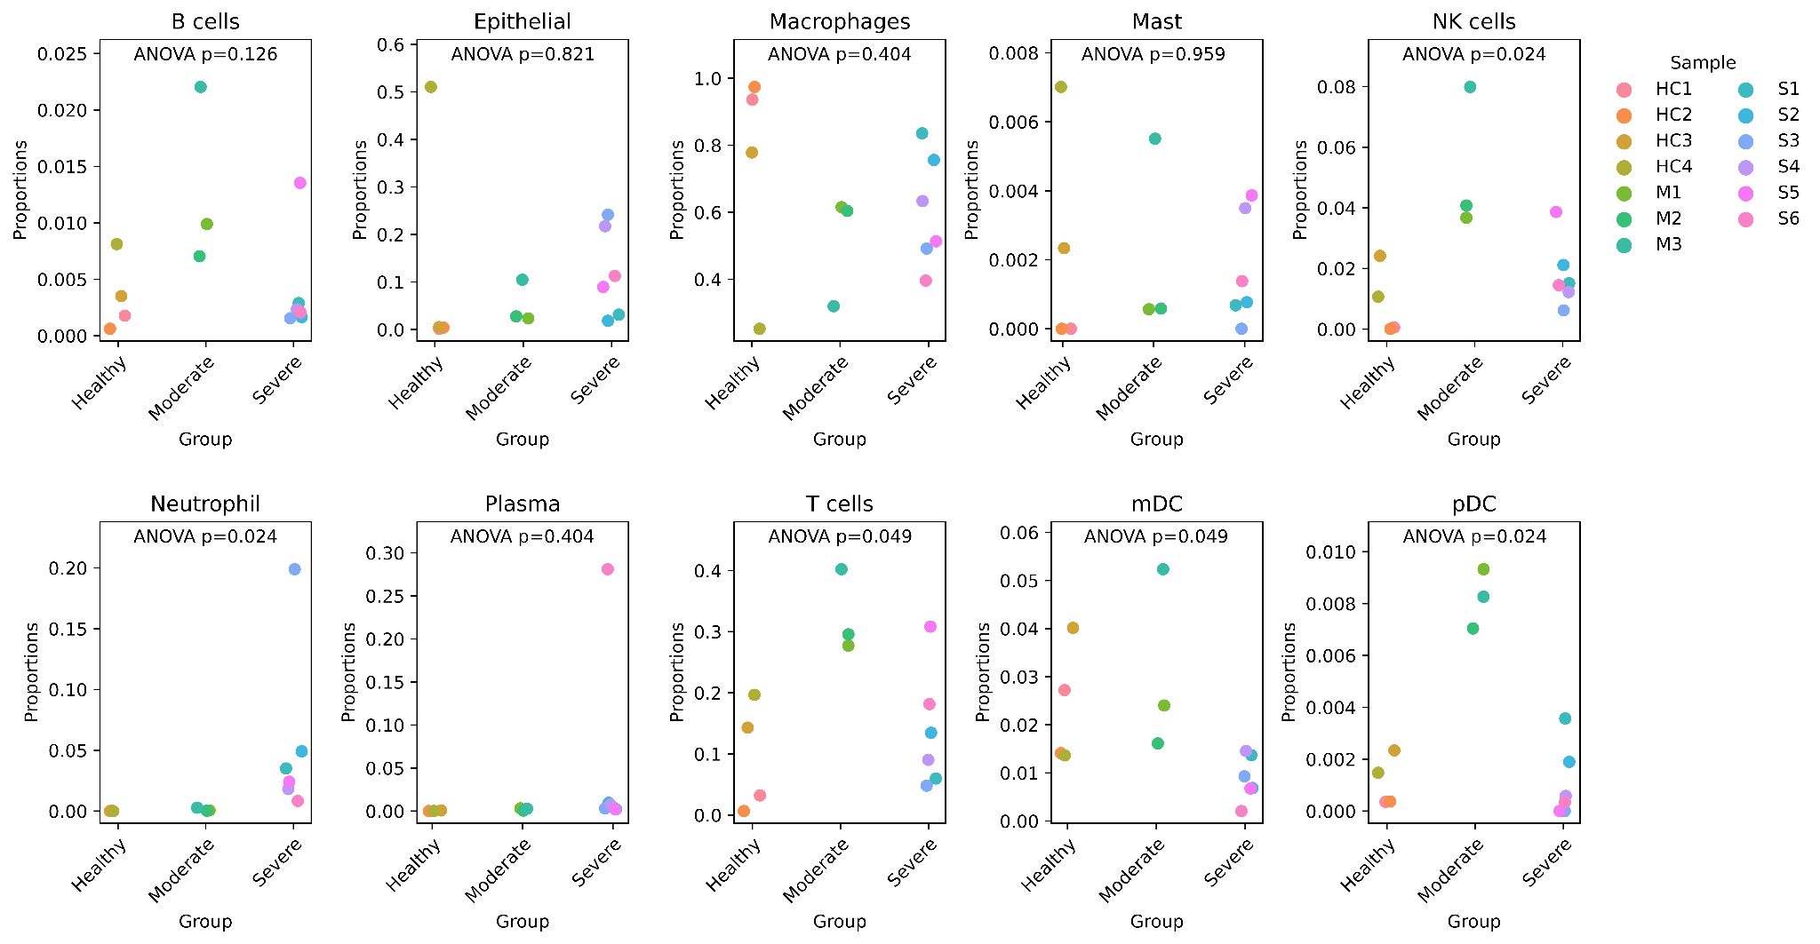

Supplementary Figure 4: Scanpro results on COVID-19 data
Output from Scanpro showing the proportion of each cell type per sample. p-values represent ANOVA comparison of Healthy, Moderate and Severe groups with arcsin transformation. HC = Healthy control; M = Moderate; S = Severe.

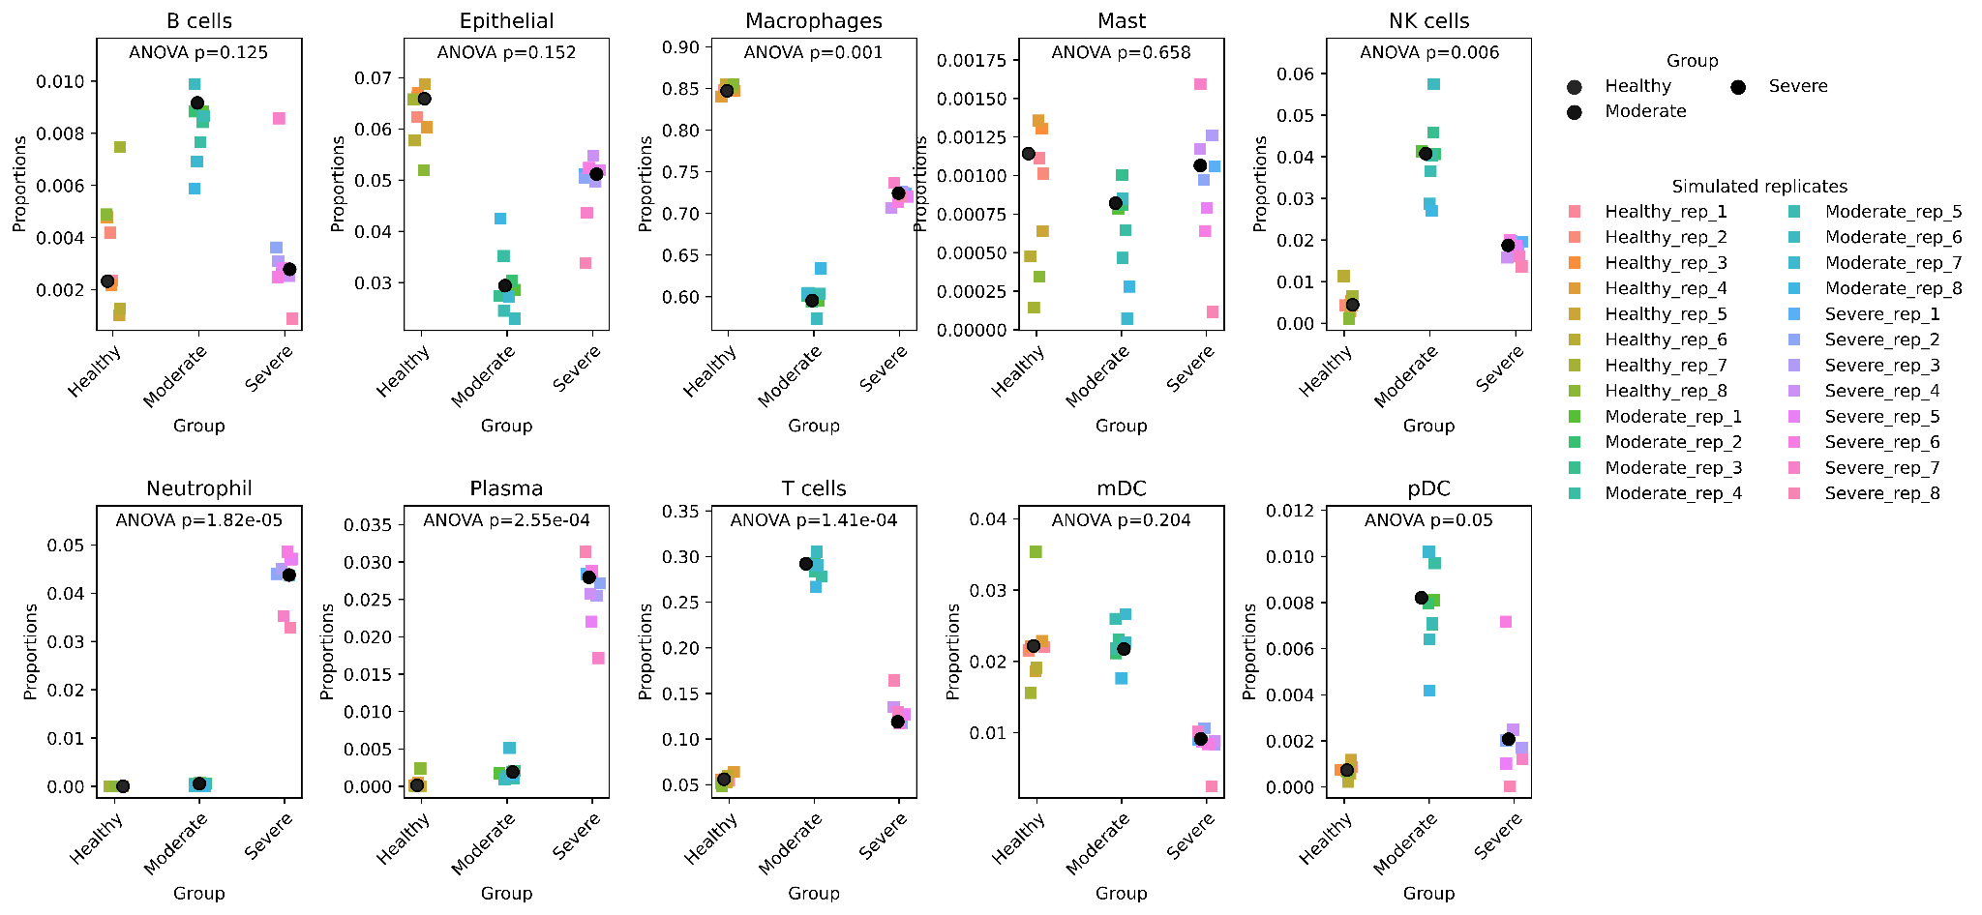

Supplementary Figure 5: Scanpro results on unreplicated COVID-19 data using pseudo-replicates
Stripplots show the proportion of each cell type per sample. The group means are plotted in black circles. The colored squares represent simulated replicates per group/cluster. p-value is calculated in arcsin transformed data.

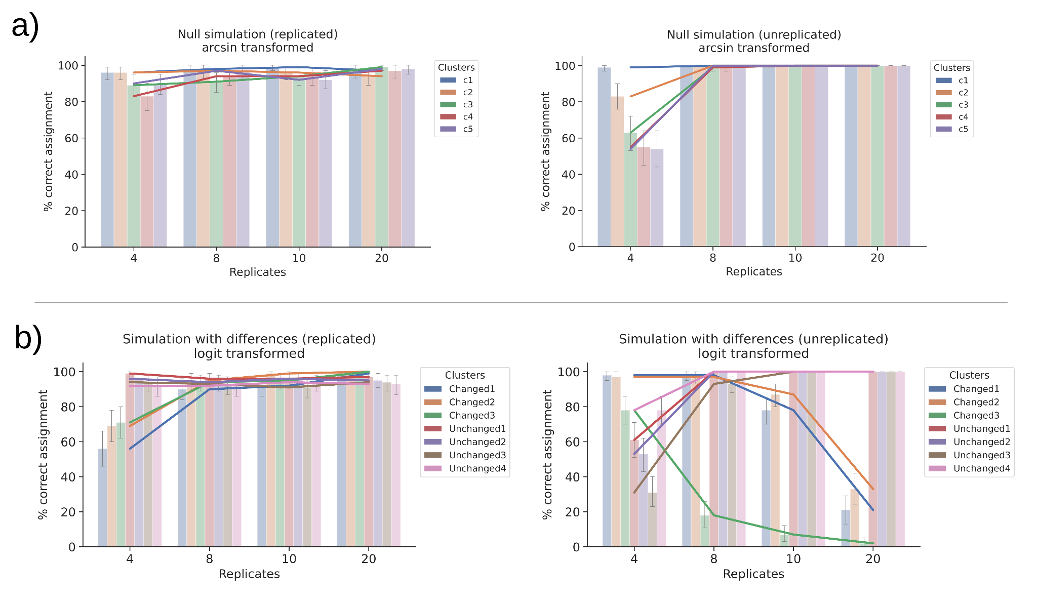

Supplementary Figure 6: Percent correct assignments for Scanpro runs
a) Results of a null simulation where none of the clusters are significantly changed. Left shows replicated data, right shows unreplicated data. b) Results of a simulation with differences in three of seven clusters with logit transformation. Left shows replicated data, right shows unreplicated data. Lines represent the mean values given by 100 iterations.

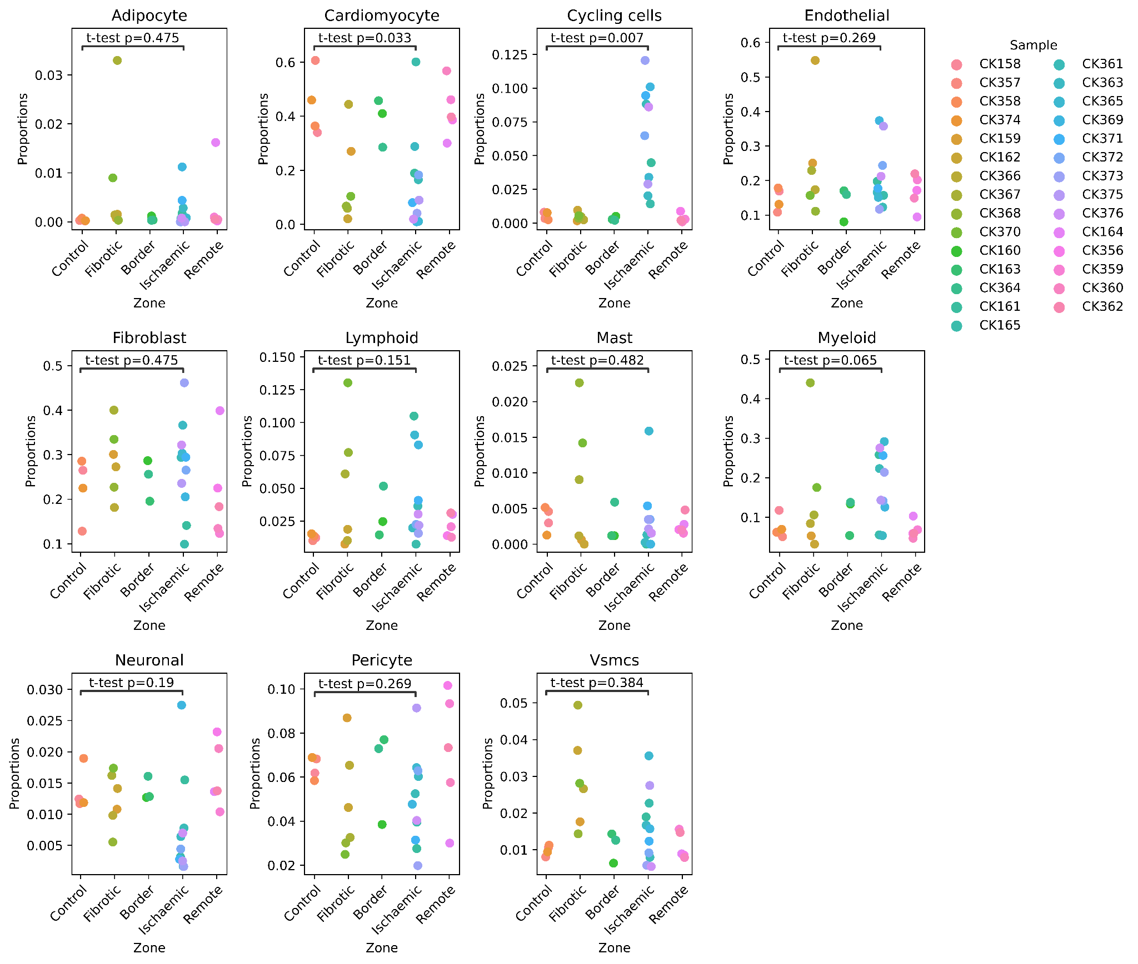

Supplementary Figure 7: Human myocardial infarction atlas cell type proportions
Scanpro stripplots showing the proportion of cell types within the original samples. p-values are calculated between control and Ischaemic groups with arcsin transformation.

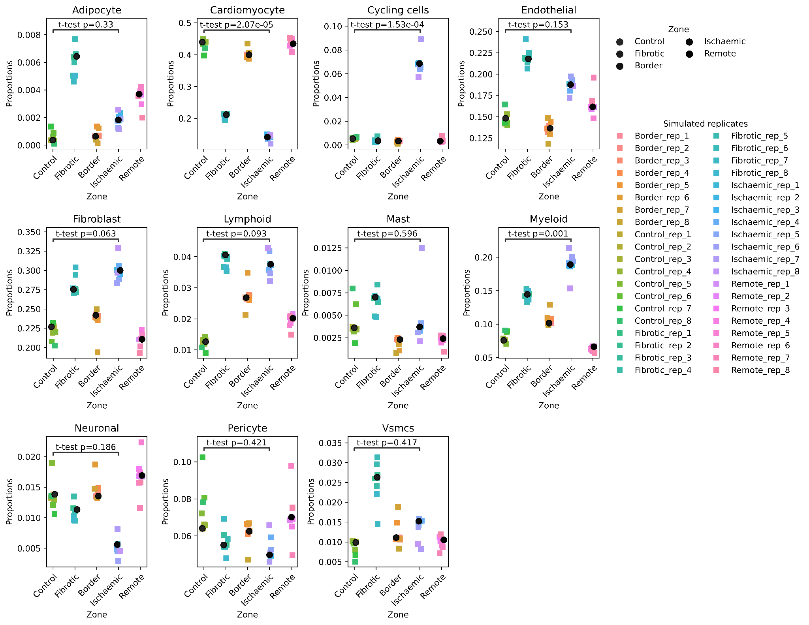

Supplementary Figure 8: Human myocardial infarction atlas cell type proportions using pseudo-replicates
Stripplots show the proportion of each cell type per sample. The group means are plotted in black circles. The colored squares represent simulated replicates per group/cluster. p-value is calculated in arcsin transformed data.

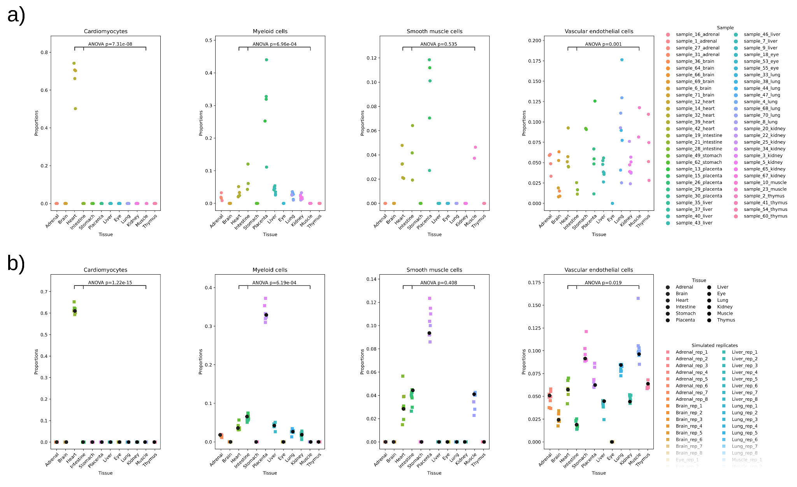

Supplementary Figure 9: Fetal scATAC atlas cell type proportions for all tissues
Stripplots show the proportion of each cell type per sample across all tissues. The p-values are calculated on arcsin transformed data. a) The proportions of original samples. b) The proportions of pseudoreplicates simulated by Scanpro.

Supplementary methods

Scanpro software architecture

Transform Proportions

The workflow of the {get_transformed_props} function is shown below:
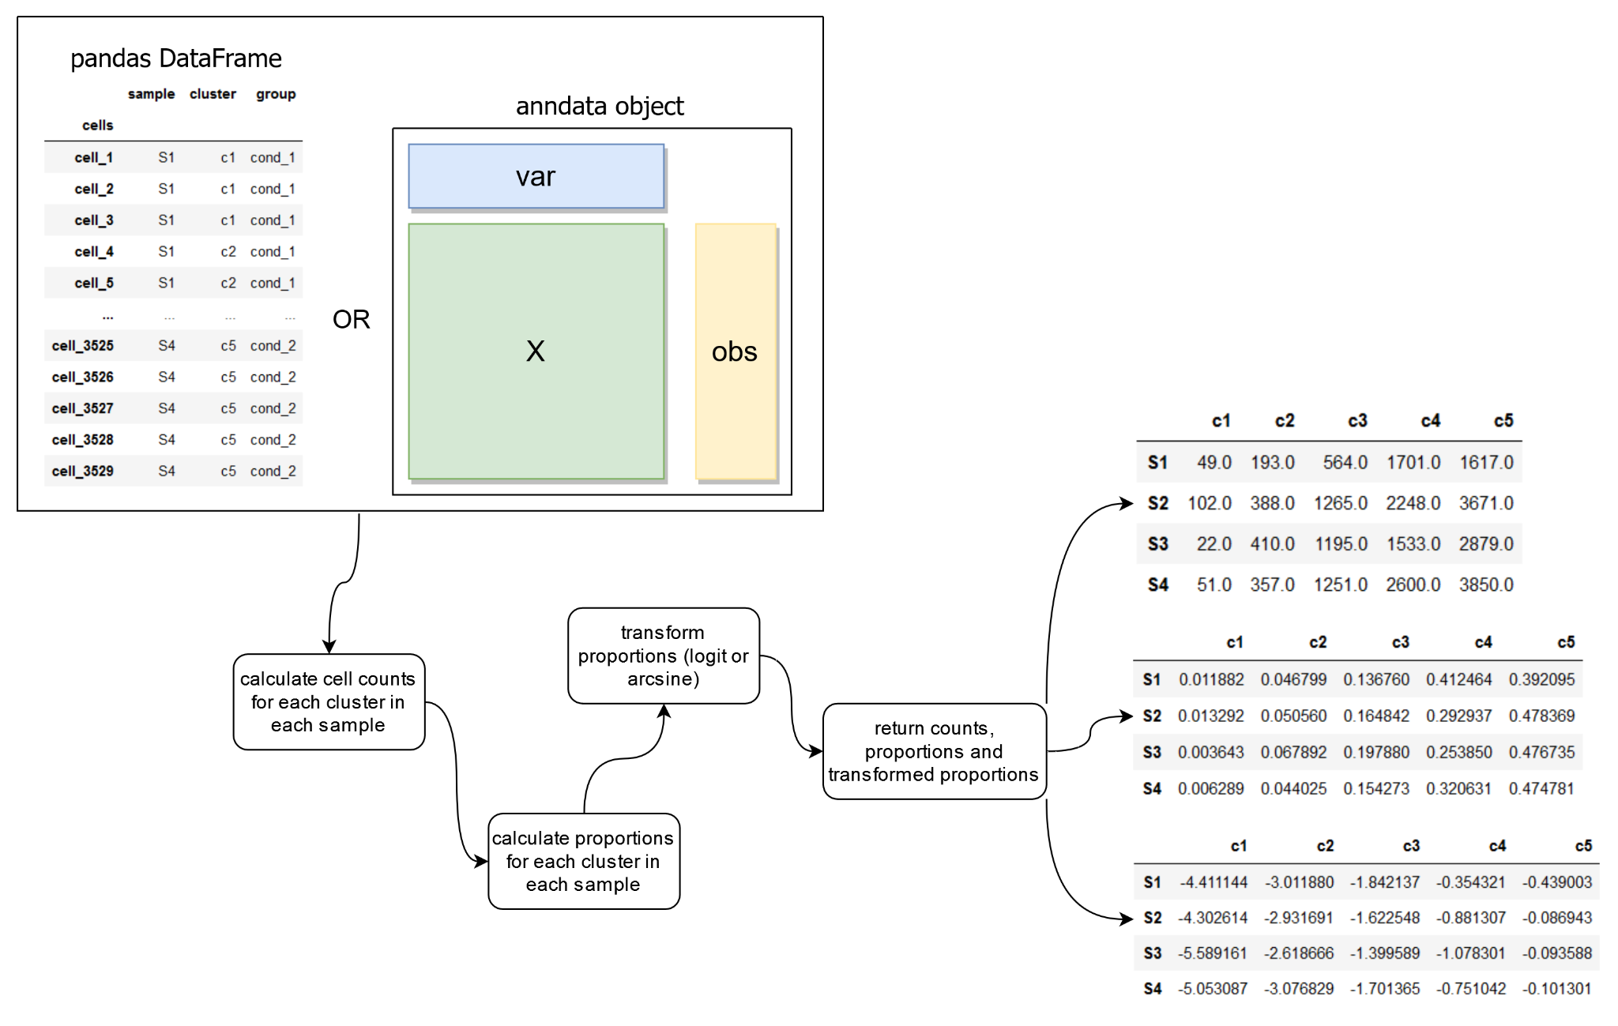
The function returns three matrices: counts (top), proportions (middle), and transformed proportions (bottom).

Empirical Bayes statistics
The empirical bayes method is implemented in scanpro as {ebayes}. To test significance, empirical bayes moderated t-test (for two conditions) and ANOVA (for more than two conditions) are used. Estimated p-values are then adjusted for multiple testing using the Benjamini-Hochberg method. The two functions {t_test} and {anova} are implemented as wrapper functions to perform the linear model fitting and empirical bayes statistics. The function {run_scanpro} is implemented to perform all steps.The function takes a cell proportion matrix and a design matrix as input. The output is p-values and adjusted p-values.

The workflow of the {run_scanpro} function is:
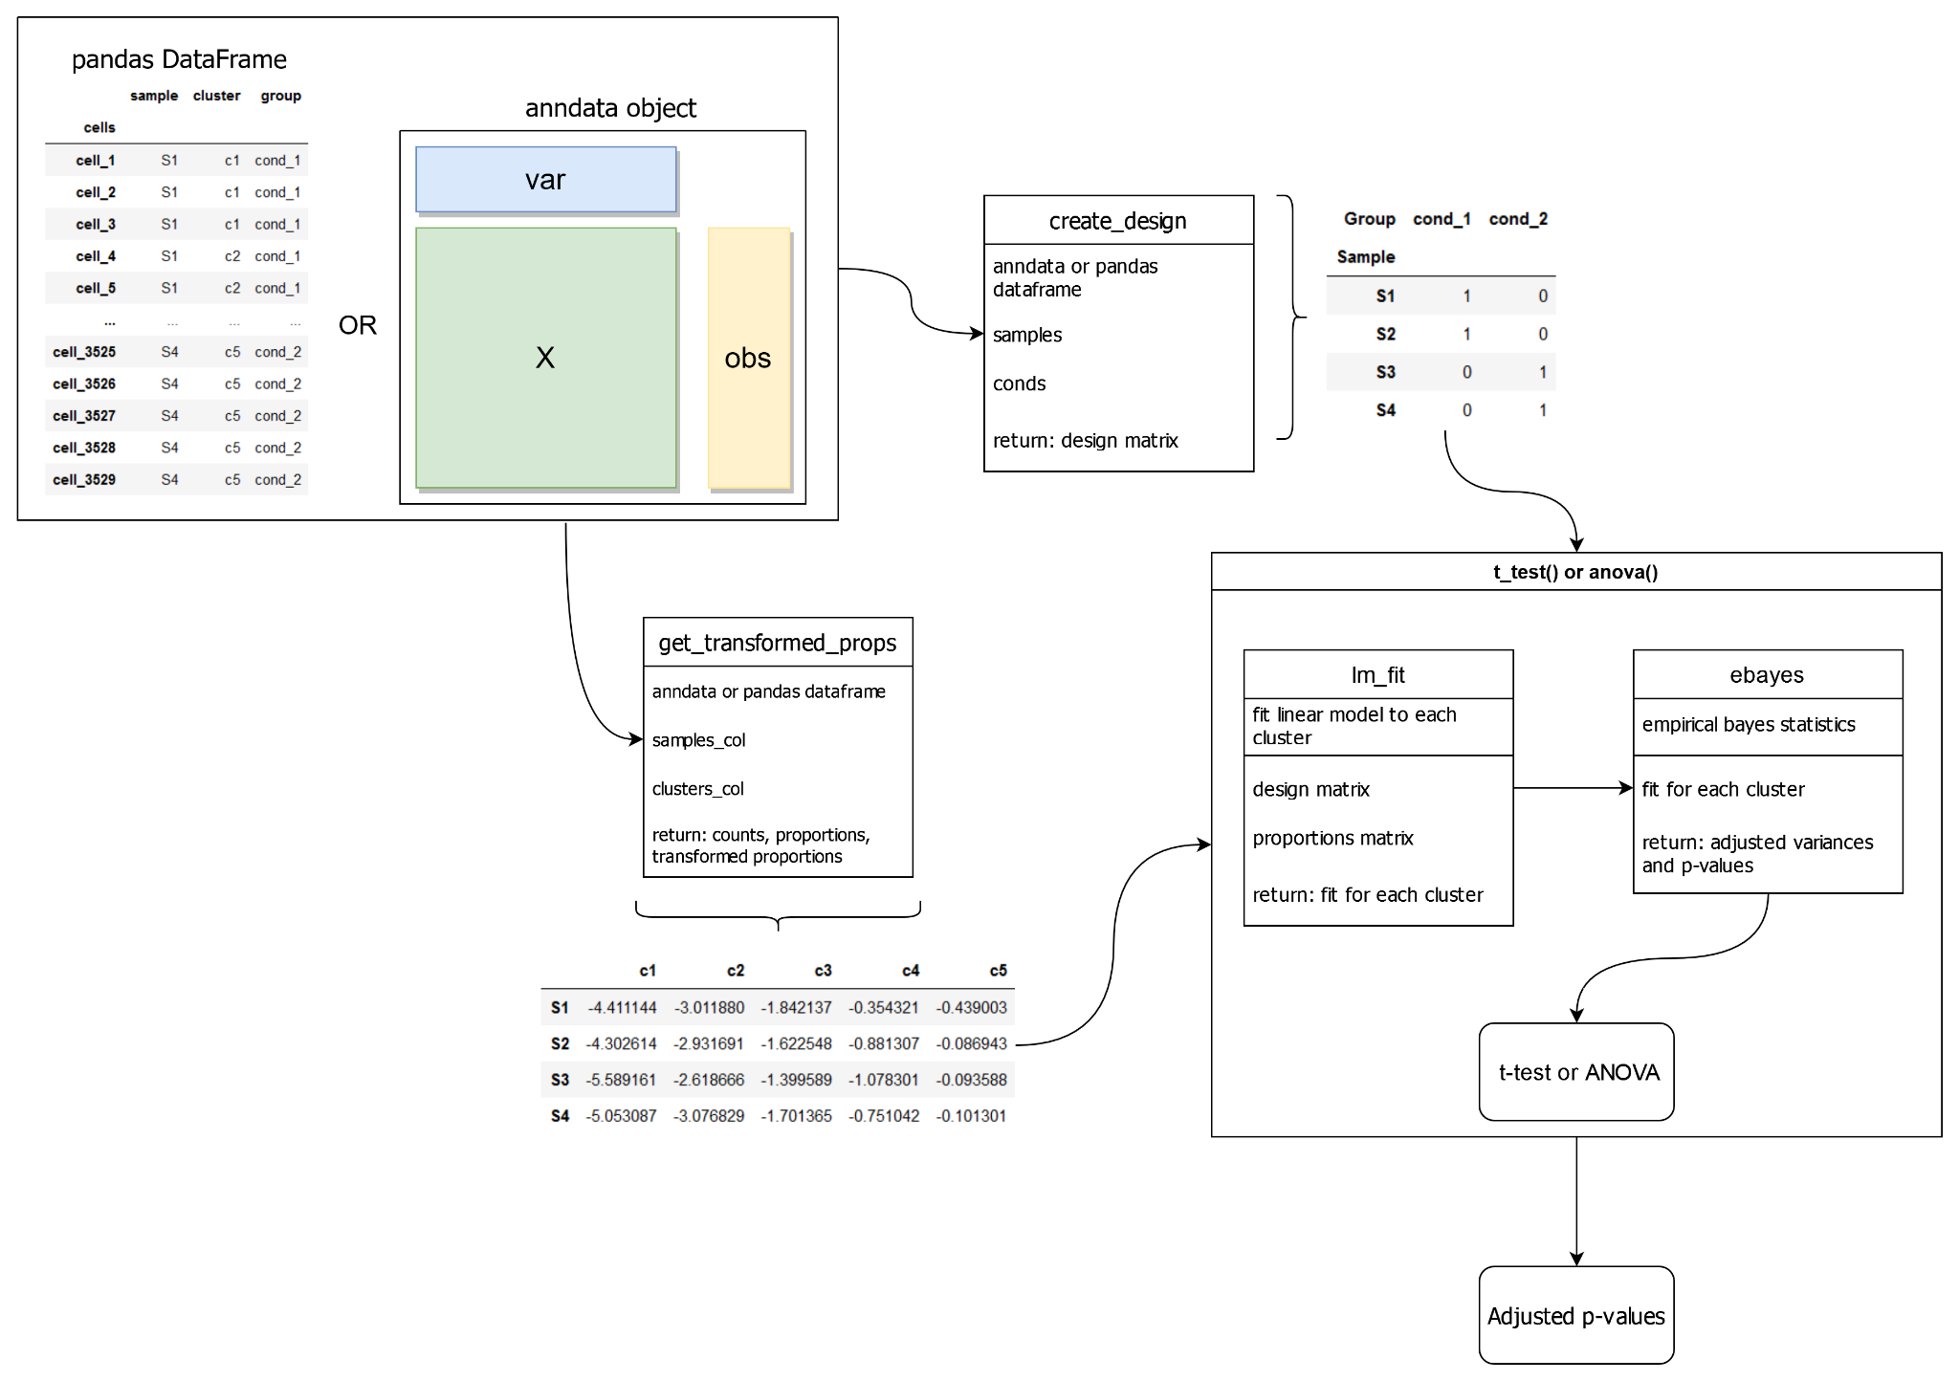

Bootstrapping method to simulate replicates for unreplicated data
The bootstrapping method to generate replicates is implemented as {generate_reps} function. The function {sim_scanpro} is a wrapper function that performs the simulations. It also allows setting the number of simulations {n_sims} and the number of replicates {n_reps} manually. The default value for {n_sims} is 100 and for {n_reps} is 8. The bootstrapping without replacement method generates pseudo-replicates for each sample to run the scanpro method. The workflow of the {generate_reps} function is as follows:
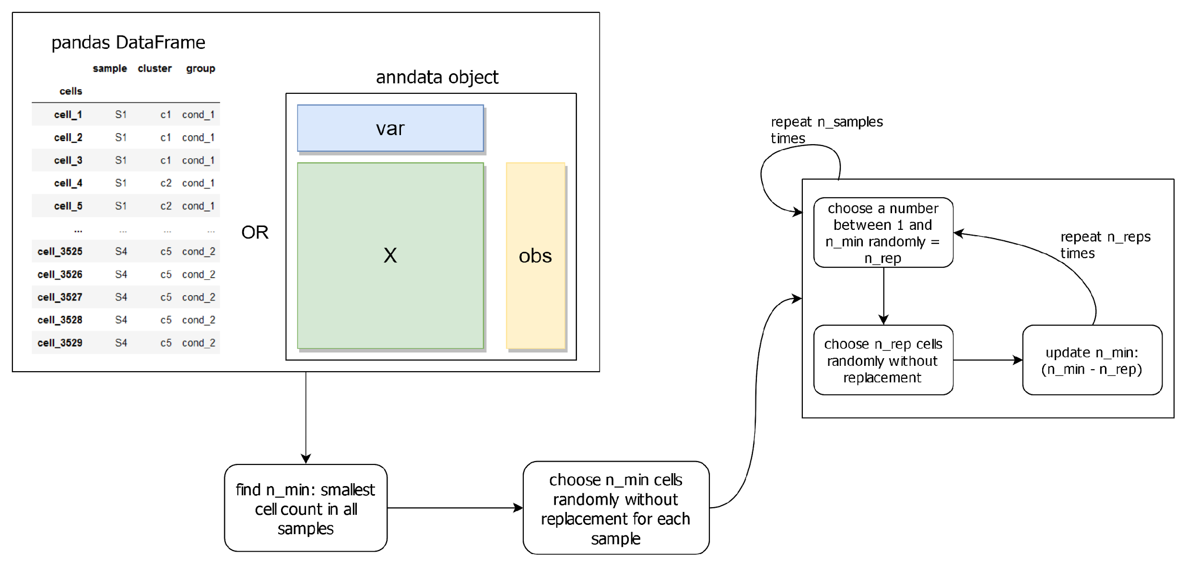
The adjusted p-values from {n_sims} runs are collected and the median is calculated as a final result:

