Supplementary Materials for

Earthquake detection capacity of the Dense Oceanfloor Network system for Earthquakes and Tsunamis (DONET)

K. Z. Nanjo*, Y. Yamamoto, K. Ariyoshi, H. Horikawa, S. Yada, N. Takahashi
*Correspondence to: nanjo@u-shizuoka-ken.ac.jp

This file includes: Supplementary Figs. S1-S4.

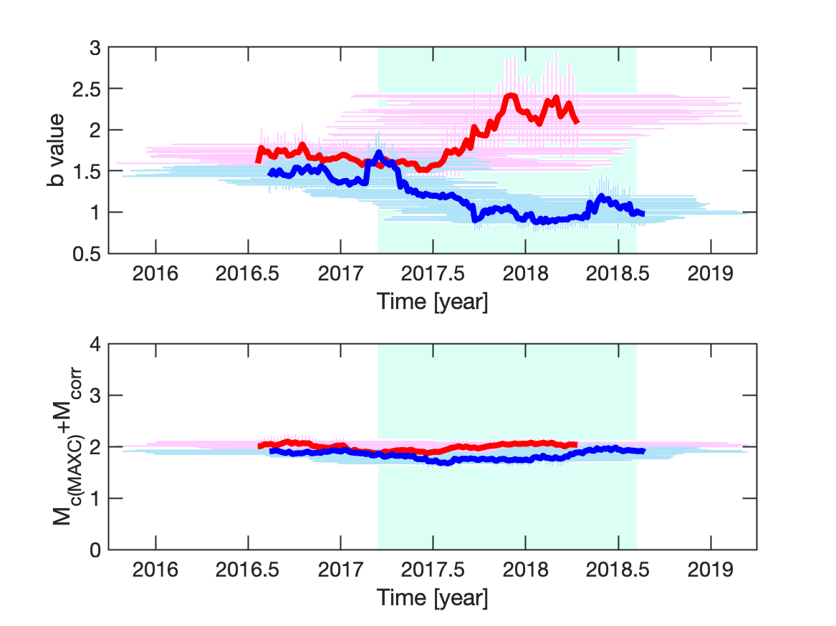
Supplementary Fig. S1 Same as the thick red and blue curves in Fig. 8a,b, except that the windows covering 80 events (horizontal bars) are included in the top and bottom panels.

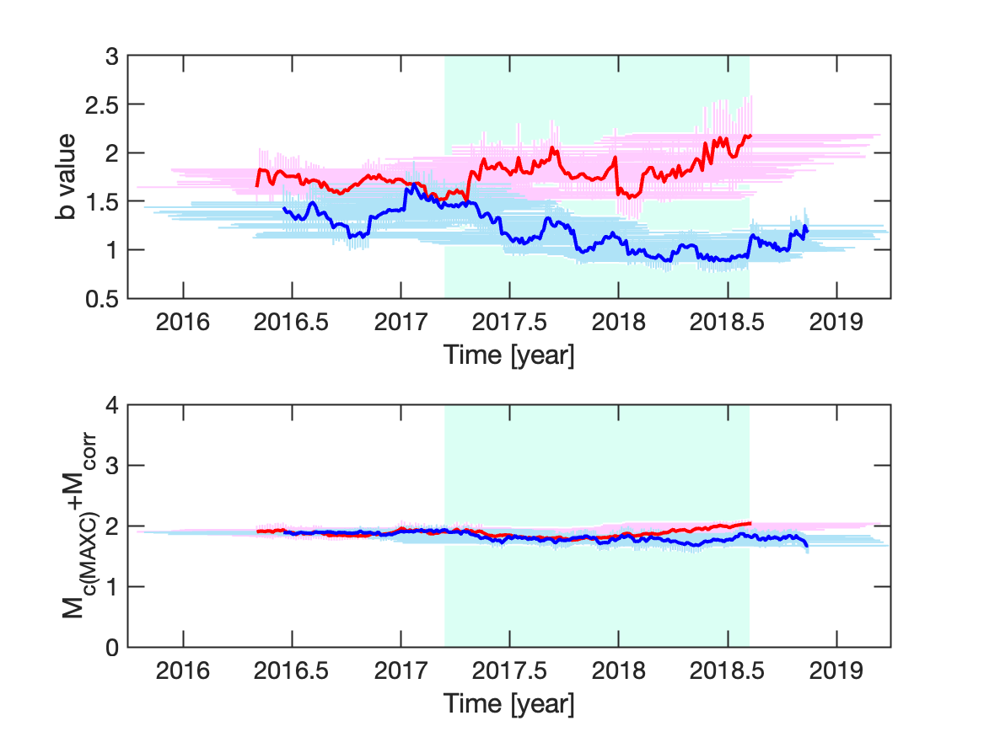
Supplementary Fig. S2 Same as the thin red and blue curves in Fig. 8a,b, except that the windows covering 80 events (horizontal bars) are included in the top and bottom panels.
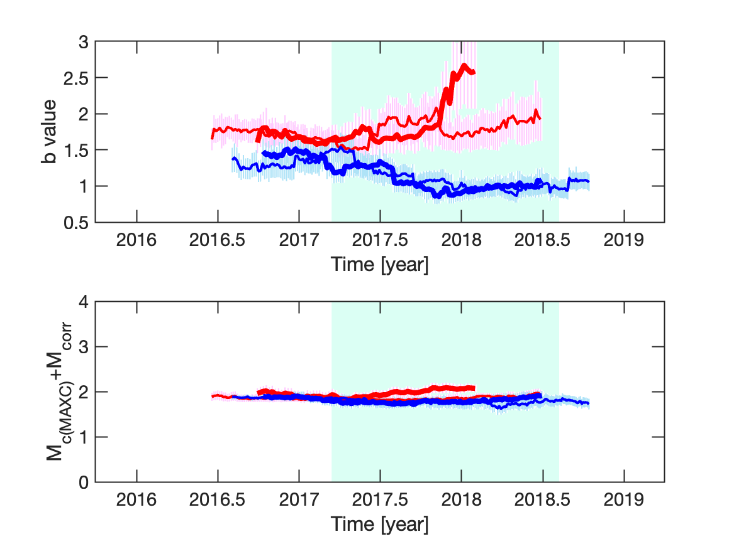
Supplementary Fig. S3 Same as Fig. 8a,b for the window covering 100 events.
Supplementary Fig. S4 Plot of b as a function of time for using the JMA catalog. a, Red curve: seismicity in the pink rectangle in Fig. 1a in a depth of 20-60 km (this depth is the same as that used by Nanjo and Yoshida 2018). We used the same moving window (80 earthquakes) as that for Fig. 8. Each b value was computed for events with M≥M_{c(EMR)}, and plotted at the mean of the occurrence times of earthquakes covered by the window, where M_{c(EMR)} (M_{c} computed by using the EMR method: Woessner and Wiemer 2005) is the same as that used by Nanjo and Yoshida (2018). Blue curve: same as the red curve for seismicity in the blue rectangle in Fig. 1a. See the caption in Fig. 8 for an explanation of a green region. b, Same as a for M_{c(EMR)}. c, Frequency-magnitude distribution of earthquakes for the period same as that used in Fig. 8c (this period is indicated by the vertical grey lines in a and b). Asterisks: seismicity used for the red curves in a and b. Circles: same as the asterisks for the blue curves in a and b. The procedure to compute b and M_{c(EMR)} is the same as that used in a and b. logP_{b}=-0.58 indicates an insignificant difference in b.

