Supplementary data
L.major -------------MSKLLQKVAIGAMAAGLSVYSCCFVVYPGEACILYNKISGLKDSVYG 47
P.falciparum ----------MERILSSIGKLSVVAGGLSLIPYTFIYDVDGGERCVMFNRFGGVSENTFG 50
A.thaliana MNNVKVPKIPGGGAISTLLKVGIIGGLGLYGATHSLYNVEGGHRAIMFNRLVGIKDKVYP 60
S.cerevisiae MS-------NSAKLIDVVTKVALPIGIIASGIQYSMYDVKGGSRGVIFDRINGVKQQVVG 53
D.melanogaster ---------MAAQFFNRIGQMGLGVAVLGGVVNSALYNVEGGHRAVIFDRFTGIKENVVG 51
H.sapiens ---------MAAKVFESIGKFGLALAVAGGVVNSALYNVDAGHRAVIFDRFRGVQDIVVG 51
M.musculus ---------MAAKVFESIGKFGLALAVAGGVVNSALYNVDAGHRAVIFDRFRGVQDIVVG 51
. : :..: : * * :::::: *:.: .

L.major EGLQGRIIGLDEILRFNVRVRPRTLHTMTGTKDLQMVNVRLRVLFRPMADRLPQIYRTFG 107
P.falciparum EGSHFYVPWFQTPYIYDIKMKPKVINTTTGTRDLQIVTISLRLLFRPHTQHLPYLHSTLG 110
A.thaliana EGTHLMIPWFERPVIYDVRARPYLVESTSGSRDLQMVKIGLRVLTRPMADQLPEIYRSLG 120
S.cerevisiae EGTHFLVPWLQKAIIYDVRTKPKSIATNTGTKDLQMVSLTLRVLHRPEVLQLPAIYQNLG 113
D.melanogaster EGTHFFIPWVQRPIIFDIRSQPRNVPVITGSKDLQNVNITLRILYRPIPDQLPKIYTILG 111
H.sapiens EGTHFLIPWVQKPIIFDCRSRPRNVPVITGSKDLQNVNITLRILFRPVASQLPRIFTSIG 111
M.musculus EGTHFLIPWVQKPIIFDCRSRPRNVPVITGSKDLQNVNITLRILFRPVASQLPRIYTSIG 111
** : : .: :: : :* : :*::*** *.: **:* ** :** :. :*

L.major LDYDERILPSVSNEILKAVVAEYKAEELIQKRDAVSARIYQLMQEKVNQFGLIIEDLSLV 167
P.falciparum PDYDERVLPSIGNEVLKAVVAKYNAESLLTQRDKISKEIRESITARAKHFNILLDDVAIT 170
A.thaliana ENYSERVLPSIINETLKAVVAQYNASQLITQREAVSREIRKILTERAANFNVALDDVSIT 180
S.cerevisiae LDYDERVLPSIGNEVLKSIVAQFDAAELITQREIISQKIRKELSMRANEFGIKLEDVSIT 173
D.melanogaster QDYDERVLPSIAPEVLKAVVAQFDAGELITQREMVSQRVSQELTVRAKQFGFILDDISLT 171
H.sapiens EDYDERVLPSITTEILKSVVARFDAGELITQRELVSRQVSDDLTERAATFGLILDDVSLT 171
M.musculus EDYDERVLPSITTEILKSVVARFDAGELITQRELVSRQVSDDLTERAATFGLILDDVSLT 171
:*.**:***: * **::**.:.* .*: :*: :* .: . : :. *.. ::*:::.

L.major DIQFGADFMTAVEQKQVAQQEAERYRYVVMENEQKRRAAVVRAEGEAESARLISEAIQKS 227
P.falciparum HLSYGKEFAKAIEDKQVAQQESERVKFIVAKTEQEKIAAVIKAQGEAEAAKLISSAVKEY 230
A.thaliana NLTFGKEFTAAIEAKQVAAQEAERAKFIVEKAEQDKRSAVIRAQGEAKSAQLIGQAIAN- 239
S.cerevisiae HMTFGPEFTKAVEQKQIAQQDAERAKFLVEKAEQERQASVIRAEGEAESAEFISKALAKV 233
D.melanogaster HLTFGREFTLAVEMKQVAQQEAEKARFVVEKAEQQKLASIISAEGDAEAAGLLAKSFGEA 231
H.sapiens HLTFGKEFTEAVEAKQVAQQEAERARFVVEKAEQQKKAAIISAEGDSKAAELIANSLATA 231
M.musculus HLTFGKEFTEAVEAKQVAQQEAERARFVVEKAEQQKKAAIISAEGDSKAAELIANSLATA 231
.: :* :* *:* **:* *::*: :::* : **.: :::: *:*::::* ::..:.

L.major GSGLLELRRIEAAVEVANQIVPMQNVTFVPKDANMLMNMSR--------------- 268
P.falciparum GKSLIEIRKLEAAKEIAENLSKSKNVTYFPSNSNILLNPRDF-------------- 272
A.thaliana NQAFITLRKIEAAREIAQTIANSANKVYLSSDDLLLN-LQGMN------LDVDAKN 288
S.cerevisiae GDGLLLIRRLEASKDIAQTLANSSNVVYLPSQHSGGGNSESSGSPNSLLLNIGR-- 287
D.melanogaster GDGLVELRRIEAAEDIAYQLSRSRGVAYLPSGQSTLLNLPSTIAQ----------- 276
H.sapiens GDGLIELRKLEAAEDIAYQLSRSRNITYLPAGQSVLLQLPQ--------------- 272
M.musculus GDGLIELRKLEAAEDIAYQLSRSRNITYLPAGQSVLLQLPQ--------------- 272
...:: :*::**: ::* : . .:.
Fig. S1: Multiple sequence alignment of Plasmodium falciparum Prohibitin (PfPHB1) with its homologs in Leishmania major, Saccharomyces cerevisiae, Arabidopsis thaliana, Drosophila melanogaster, Homo sapiens, Mus musculus.

L.major ---------------------MA---AEARKKMNAYGGF-------GNIIGMSALVGVGC 29
P.falciparum MYKFKFKLRNIYKIHFKPYINMNAPPNFDIHQVKKLG---------KLGATIGAIIGVTS 51
S.cerevisiae --------MNRSPGEFQRYAKAF---QKQLSKVQQTGGRGQVPSPRGAFAGLGG-LLLLG 48
A.thaliana ---------------------------MSFN------KVPNIPGAPALSALLKV-SVIGG 26
D.melanogaster ---------------------------MAQSKLNDLAGKLGKGGPPGLGIGLKV-LAAVG 32
H.sapiens ----------------------------MAQNLKDLAGRLP-AGPRGMGTALKL-LLGAG 30
M.musculus ----------------------------MAQNLKDLAGRLP-AGPRGMGTALKL-LLGAG 30
:

L.major VSIYALYKSVFFVPGGFRAVKFNCITGLYNR-TYGEGANFAIPFLETPVVFDIRNKPIEV 88
P.falciparum FGSWFFKNSLYNVEAGKRAIKYNRIFGLSNK-IYGEGTHFLIPFFERSIIYDVRTKPRVL 110
S.cerevisiae GGALFINNALFNVDGGHRAIVYSRIHGVSSR-IFNEGTHFIFPWLDTAIIYDVRAKPRNV 107
A.thaliana LGVYALTNSLYNVDGGHRAVMFNRLTGIKEK-VYPEGTHFMVPWFERPIIYDVRARPYLV 85
D.melanogaster AAAYGVSQSLYTVEGGHRAIIFSRLGGIQSD-IYSEGLHVRIPWFQYPIIYDIRSRPRKI 91
H.sapiens AVAYGVRESVFTVEGGHRAIFFNRIGGVQQDTILAEGLHFRIPWFQYPIIYDIRARPRKI 90
M.musculus AVAYGVRESVFTVEGGHRAIFFNRIGGVQQDTILAEGLHFRIPWFQYPIIYDIRARPRKI 90
. :::: * .* **: :. : *: . ** :. .*::: :::*:* :* :

L.major PTASGSRDLQTVNMAVRVLYQPNVENLYHIYRHIGVNYAETVLPSLINEIIRAVIAQFNA 148
P.falciparum MSLTGSRDLQMVNITCRVLSRPNEKKLVEIYRTLGKEYDEKVLPSIINEVLKSVVAQYNA 170
S.cerevisiae ASLTGTKDLQMVNITCRVLSRPDVVQLPTIYRTLGQDYDERVLPSIVNEVLKAVVAQFNA 167
A.thaliana ESTTGSHDLQMVKIGLRVLTRPMGDRLPQIYRTLGENYSERVLPSIIHETLKAVVAQYNA 145
D.melanogaster SSPTGSKDLQMINISLRVLSRPDSLNLPYLHKQLGVDYDEKVLPSICNEVLKSVIAKFNA 151
H.sapiens SSPTGSKDLQMVNISLRVLSRPNAQELPSMYQRLGLDYEERVLPSIVNEVLKSVVAKFNA 150
M.musculus SSPTGSKDLQMVNISLRVLSRPNAQELPSMYQRLGLDYEERVLPSIVNEVLKSVVAKFNA 150
: :*::*** ::: *** :* .* ::: :* :* * ****: :* :::*:*::**

L.major SDLLIKRPEVSHRIGVMLAERAKRFNIDITDVSITQMSFGKEYTNAVEAKQVAQQMAERA 208
P.falciparum SQLITQREVVSKSVREQLVQRAKDFNILLDDASITHLSFSNEYEKAVEAKQVAQQEAERS 230
S.cerevisiae SQLITQREKVSRLIRENLVRRASKFNILLDDVSITYMTFSPEFTNAVEAKQIAQQDAQRA 227
A.thaliana SQLITQREAVSREIRKILTERASNFDIALDDVSITTLTFGKEFTAAIEAKQVAAQEAERA 205
D.melanogaster SQLITQRQQVSLLIRKELVERARDFNIILDDVSLTELSFGKEYTAAIEAKQVAQQEAQRA 211
H.sapiens SQLITQRAQVSLLIRRELTERAKDFSLILDDVAITELSFSREYTAAVEAKQVAQQEAQRA 210
M.musculus SQLITQRAQVSLLIRRELTERAKDFSLILDDVAITELSFSREYTAAVEAKQVAQQEAQRA 210
*:*: :* ** : *..** *.: : *.::* ::*. *: *:****:* * *:*:

L.major KFRVEQAEQEKQAAILLAQGEAEAATLVGNAVKRNPAFLELRGLEAARTIAKTLRDHGNG 268
P.falciparum KYVVLKAEQEKKSTIIKAQGEAEVAKLIGLAVKDNPAFMELKKIELSREVSNIISKCQN- 289
S.cerevisiae AFVVDKARQEKQGMVVRAQGEAKSAELIGEAIKKSRDYVELKRLDTARDIAKILASSPN- 286
A.thaliana KFIVEKAEQDRRSAVIRAQGEAKSAQLIGQAIANNQAFITLRKIEAAREIAQTIAQSAN- 264
D.melanogaster VFFVERAKQEKQQKIVQAEGEAEAAKMLGLAVKQNPAYLKLRKLRAAQSIARTIASSQN- 270
H.sapiens QFLVEKAKQEQRQKIVQAEGEAEAAKMLGEALSKNPGYIKLRKIRAAQNISKTIATSQN- 269
M.musculus QFLVEKAKQEQRQKIVQAEGEAEAAKMLGEALSKNPGYIKLRKIRAAQNISKTIATSQN- 269
: * :*.*::: :: *:***: * ::* *: . :: *: : :: ::. : *

L.major RYYLDSDSLYVNVKDLKIDHSGTK------ 292
P.falciparum KVMLPTDSLLINFTK--------------- 304
S.cerevisiae RVILDNEALLLNTVVDARIDGRGK------ 310
A.thaliana KVYLSSNDLLLNLQEMNLEPKK-------- 286
D.melanogaster KVYLSADSLMLNIQDSGFDDMTEKVYKSK- 299
H.sapiens RIYLTADNLVLNLQDESFTR---------- 289
M.musculus RIYLTADNLVLNLQDESFTRGSDSLIKGKK 299
: * : * :*
Fig. S2: Multiple sequence alignment of Plasmodium falciparum Prohibitin (PfPHB2) with its homologs in Leishmania major, Saccharomyces cerevisiae, Arabidopsis thaliana, Drosophila melanogaster, Homo sapiens, Mus musculus.

 | S. No. | Primer Name | Primer sequence (5’-3’)
Cloning Primers | 1. | PfPHB2_HAglmS_BglII | ACTGAGATCTCAAATGGTAAACATAACATGTCGTG
Cloning Primers | 2. | PfPHB2_HAglmS_PstI | ACTGCTGCAGTTTTGTAAAATTTATCAACAACG
Episomal and Integration Primers | 3. | HAglmS FP | CCGCTAACGTAACAGACTTAGGAGG
Episomal and Integration Primers | 4. | HAglmS RP | CGGGCGCTATAATTACAGCTGGTCT
Episomal and Integration Primers | 5. | PfPHB2 HAGlms 5´ FP | ATGTATAAATTTAAATTT AAATTA AGGAAC
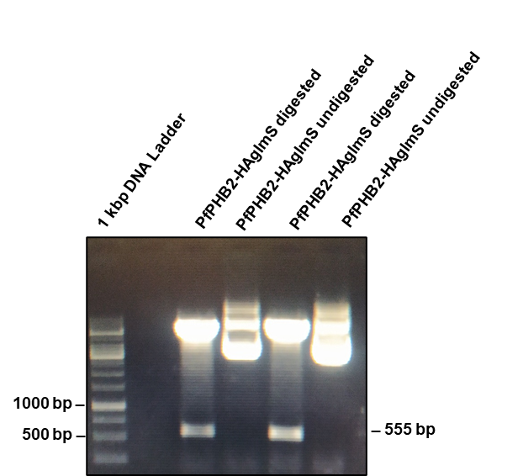
(B)
(A)

Fig. S3: (A) Primer details used for cloning of PfPHB2 in HA-glmS vector, and to check for plamid uptake and its integration in Pf3D7 genome. (B) Restriction digestion with BglII and PstI for clone confirmation in HA-glmS vector. Desired band size of the fallout (555 bp) was observed.

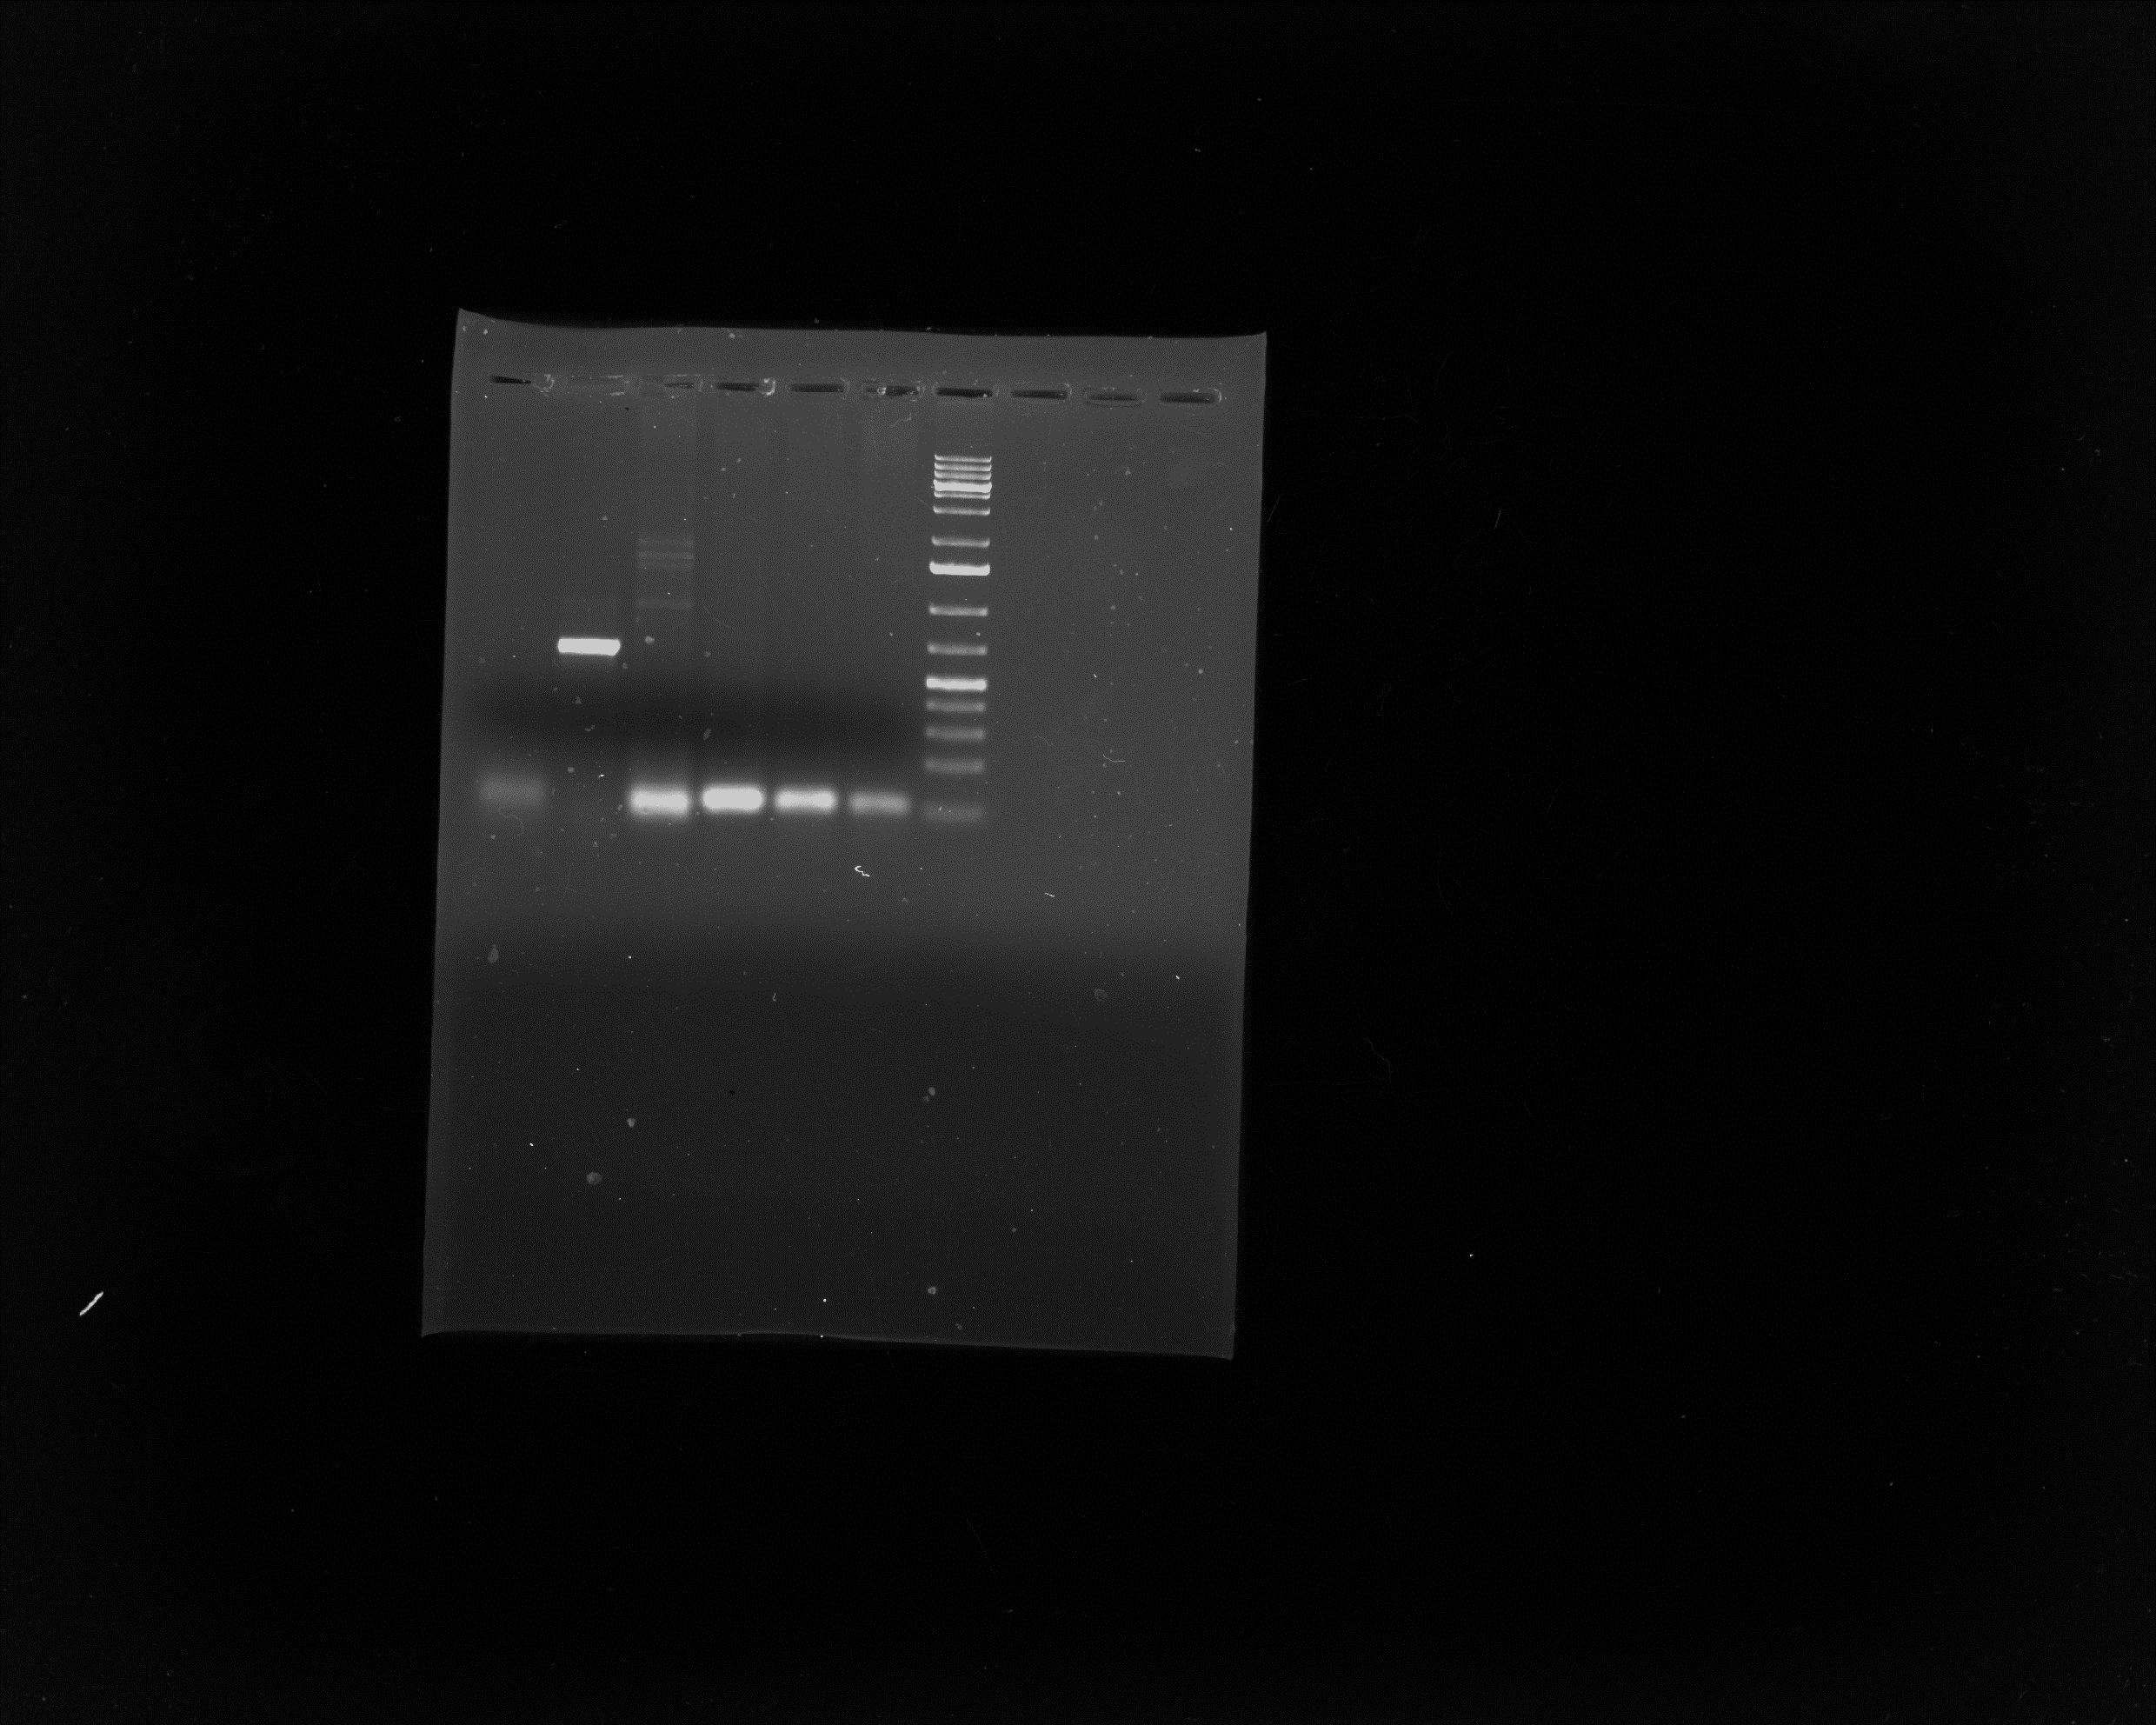
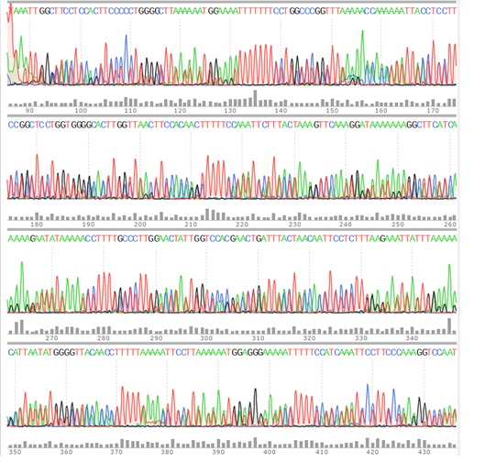
1500 bp
500 bp
983 bp
1000 bp
1 kb DNA plus
ladder
Lane 1
Lane 2
A (i)
(ii)

Fig. S4: A (i) Chromatogram plot of the PfPHB2-HAglmS plasmid. A (ii) PCR showing confirmation of PfPHB2-HA-glmS plasmid uptake and transfection in Pf knock down line. Lane 1 showing the presence of plasmid as episome in transfected Pf line. White arrow depict a band of PfPHB2 along with HA-glmS sequence (total band size 657 bp) in Pf knock down line using specific primer sets (3 and 4 mentioned in fig. S3 A). Lane 2 showing the integration of PfPHB2 in transfected Pf line. Black arrow depict a band of PfPHB2 (full length; 912 bp) along with HA-glmS sequence (total band size 983 bp) in Pf knock down line using primer sets (5 and 4 mentioned in fig. S3 A).

Table S1: Patient details whose sera were used to detect the presence of anti-PfPHB2 antibodies

S.NO. | NAME | AGE | PARA (Location) | KIT RESULT (Rapid diagnostic test) | FEBRILE STATUS | MEDICINE STATUS
P1 | Dabari Tripura | 9 | Sumbunath | Pf | 3 days fever | Before medicine
P2 | Tilyarani Tripura | 24 | Baharai | Pf + Pv | 6 days fever | Before Medicine
P3 | Karasa Tripura | 35 | Khagendra | Pf | 1 day fever | Before Medicine
P4 | Parenbati Reang | 32 | Annaram | Pf | 2 days fever | After medicine
P5 | Kunjari Tripura | 26 | Dhansingh | Pf | 2 days fever | Before medicine
P6 | Dhansari Tripura | 17 | Dhansingh | Pf | 1 day fever | Before medicine
P7 | Hemali Tripura | 8 | Acharjee | Pf | 3 days fever | Before medicine
P8 | Sandali Reang | 12 | Dongkarai | Pf | 2 days fever | Before medicine
P9 | Biswajay Tripura | 6 | Dhansingh | Pf | 2 days fever | Before Medicine
P10 | Jamirung Reang | 32 | Dongkarai | Pf | 1 day fever | Before medicine
Fig. S5: Semi-quantitative ELISA. 1000ng of recombinant PfPHB2 was coated on ELISA plates and treated with four different patient sera (P2, P1, P6, P9) at different dilutions (1:1000, 1:2500, 1:5000, 1:7500, 1:10000) followed by secondary human HRP conjugated antibody (1:10000). Error bars represent standard deviation among three replicates.

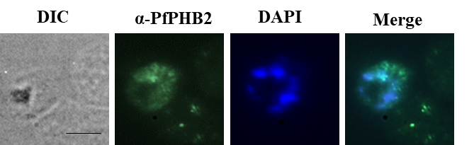
Fig. S6: Immunofluorescence Assay (IFA) showing the expression of PfPHB2 in the patient derived laboratory adapted parasite line using anti-PfPHB2 antibodies (1:200). Alexa Fluor 488 conjugated anti-mouse (1:500; green) were used as secondary antibodies. The parasite nuclei were counterstained with DAPI (40, 60-diamidino- 2-phenylindole; blue) and mounted with a coverslip. The slides were examined using a confocal microscope. Merge represents overlay of green (PfPHB2) with blue (parasite nuclei).

