Supplementary table 1

ANOVA
 |  | Sum of Squares | df | Mean Square | F | Sig.
GRRI_mean | Between Groups | 2.979 | 5 | .596 | 79.072 | .000
GRRI_mean | Within Groups | .362 | 48 | .008
GRRI_mean | Total | 3.341 | 53
GBRI_mean | Between Groups | 3.911 | 5 | .782 | 98.521 | .000
GBRI_mean | Within Groups | .381 | 48 | .008
GBRI_mean | Total | 4.293 | 53
RBRI_mean | Between Groups | 2.115 | 5 | .423 | 39.064 | .000
RBRI_mean | Within Groups | .520 | 48 | .011
RBRI_mean | Total | 2.634 | 53
INT_mean | Between Groups | 2.074 | 5 | .415 | 30.820 | .000
INT_mean | Within Groups | .646 | 48 | .013
INT_mean | Total | 2.720 | 53
WI_mean | Between Groups | 3.197 | 5 | .639 | 47.417 | .000
WI_mean | Within Groups | .647 | 48 | .013
WI_mean | Total | 3.845 | 53
GRVI_mean | Between Groups | 3.583 | 5 | .717 | 89.474 | .000
GRVI_mean | Within Groups | .384 | 48 | .008
GRVI_mean | Total | 3.967 | 53
IKAW_mean | Between Groups | 3.501 | 5 | .700 | 112.420 | .000
IKAW_mean | Within Groups | .299 | 48 | .006
IKAW_mean | Total | 3.800 | 53
ExG_mean | Between Groups | 3.834 | 5 | .767 | 102.321 | .000
ExG_mean | Within Groups | .360 | 48 | .007
ExG_mean | Total | 4.194 | 53
NDI_mean | Between Groups | 3.583 | 5 | .717 | 89.474 | .000
NDI_mean | Within Groups | .384 | 48 | .008
NDI_mean | Total | 3.967 | 53
ExR_mean | Between Groups | 3.823 | 5 | .765 | 104.200 | .000
ExR_mean | Within Groups | .352 | 48 | .007
ExR_mean | Total | 4.175 | 53
ExGR_mean | Between Groups | 3.606 | 5 | .721 | 104.807 | .000
ExGR_mean | Within Groups | .330 | 48 | .007
ExGR_mean | Total | 3.936 | 53
GLI_mean | Between Groups | 3.735 | 5 | .747 | 90.173 | .000
GLI_mean | Within Groups | .398 | 48 | .008
GLI_mean | Total | 4.133 | 53
VARI_mean | Between Groups | 3.847 | 5 | .769 | 79.072 | .000
VARI_mean | Within Groups | .467 | 48 | .010
VARI_mean | Total | 4.314 | 53
CIVE_mean | Between Groups | 3.872 | 5 | .774 | 124.922 | .000
CIVE_mean | Within Groups | .298 | 48 | .006
CIVE_mean | Total | 4.170 | 53
VEG_mean | Between Groups | 3.566 | 5 | .713 | 117.864 | .000
VEG_mean | Within Groups | .290 | 48 | .006
VEG_mean | Total | 3.857 | 53
COM1_mean | Between Groups | 3.645 | 5 | .729 | 105.840 | .000
COM1_mean | Within Groups | .331 | 48 | .007
COM1_mean | Total | 3.975 | 53
NDVI | Between Groups | 3.993 | 5 | .799 | 120.573 | .000
NDVI | Within Groups | .318 | 48 | .007
NDVI | Total | 4.311 | 53

One way ANOVA (line no 324)

Supplementary table 2

Post Hoc Tests

Multiple Comparisons
Tukey HSD
Dependent Variable | (I) Crop | (J) Crop | Mean Difference (I-J) | Std. Error | Sig. | 95% Confidence Interval
 |  |  |  |  |  | Lower Bound | Upper Bound
GRRI_mean | Brinjal | Cabbage | -.17787* | .04092 | .001 | -.2993 | -.0564
GRRI_mean | Brinjal | Chick Pea | .06394 | .04092 | .626 | -.0575 | .1854
GRRI_mean | Brinjal | Mustard | .18718* | .04092 | .000 | .0657 | .3086
GRRI_mean | Brinjal | Pigeon Pea | .21167* | .04092 | .000 | .0902 | .3331
GRRI_mean | Brinjal | Wheat | -.47031* | .04092 | .000 | -.5918 | -.3489
GRRI_mean | Cabbage | Brinjal | .17787* | .04092 | .001 | .0564 | .2993
GRRI_mean | Cabbage | Chick Pea | .24181* | .04092 | .000 | .1204 | .3633
GRRI_mean | Cabbage | Mustard | .36505* | .04092 | .000 | .2436 | .4865
GRRI_mean | Cabbage | Pigeon Pea | .38954* | .04092 | .000 | .2681 | .5110
GRRI_mean | Cabbage | Wheat | -.29245* | .04092 | .000 | -.4139 | -.1710
GRRI_mean | Chick Pea | Brinjal | -.06394 | .04092 | .626 | -.1854 | .0575
GRRI_mean | Chick Pea | Cabbage | -.24181* | .04092 | .000 | -.3633 | -.1204
GRRI_mean | Chick Pea | Mustard | .12324* | .04092 | .045 | .0018 | .2447
GRRI_mean | Chick Pea | Pigeon Pea | .14773* | .04092 | .009 | .0263 | .2692
GRRI_mean | Chick Pea | Wheat | -.53426* | .04092 | .000 | -.6557 | -.4128
GRRI_mean | Mustard | Brinjal | -.18718* | .04092 | .000 | -.3086 | -.0657
GRRI_mean | Mustard | Cabbage | -.36505* | .04092 | .000 | -.4865 | -.2436
GRRI_mean | Mustard | Chick Pea | -.12324* | .04092 | .045 | -.2447 | -.0018
GRRI_mean | Mustard | Pigeon Pea | .02449 | .04092 | .991 | -.0970 | .1459
GRRI_mean | Mustard | Wheat | -.65750* | .04092 | .000 | -.7790 | -.5360
GRRI_mean | Pigeon Pea | Brinjal | -.21167* | .04092 | .000 | -.3331 | -.0902
GRRI_mean | Pigeon Pea | Cabbage | -.38954* | .04092 | .000 | -.5110 | -.2681
GRRI_mean | Pigeon Pea | Chick Pea | -.14773* | .04092 | .009 | -.2692 | -.0263
GRRI_mean | Pigeon Pea | Mustard | -.02449 | .04092 | .991 | -.1459 | .0970
GRRI_mean | Pigeon Pea | Wheat | -.68199* | .04092 | .000 | -.8034 | -.5605
GRRI_mean | Wheat | Brinjal | .47031* | .04092 | .000 | .3489 | .5918
GRRI_mean | Wheat | Cabbage | .29245* | .04092 | .000 | .1710 | .4139
GRRI_mean | Wheat | Chick Pea | .53426* | .04092 | .000 | .4128 | .6557
GRRI_mean | Wheat | Mustard | .65750* | .04092 | .000 | .5360 | .7790
GRRI_mean | Wheat | Pigeon Pea | .68199* | .04092 | .000 | .5605 | .8034
GBRI_mean | Brinjal | Cabbage | .12456 | .04201 | .050 | -.0001 | .2492
GBRI_mean | Brinjal | Chick Pea | -.08280 | .04201 | .374 | -.2075 | .0419
GBRI_mean | Brinjal | Mustard | .12072 | .04201 | .063 | -.0040 | .2454
GBRI_mean | Brinjal | Pigeon Pea | .09158 | .04201 | .266 | -.0331 | .2162
GBRI_mean | Brinjal | Wheat | -.64390* | .04201 | .000 | -.7686 | -.5192
GBRI_mean | Cabbage | Brinjal | -.12456 | .04201 | .050 | -.2492 | .0001
GBRI_mean | Cabbage | Chick Pea | -.20735* | .04201 | .000 | -.3320 | -.0827
GBRI_mean | Cabbage | Mustard | -.00384 | .04201 | 1.000 | -.1285 | .1208
GBRI_mean | Cabbage | Pigeon Pea | -.03298 | .04201 | .969 | -.1576 | .0917
GBRI_mean | Cabbage | Wheat | -.76845* | .04201 | .000 | -.8931 | -.6438
GBRI_mean | Chick Pea | Brinjal | .08280 | .04201 | .374 | -.0419 | .2075
GBRI_mean | Chick Pea | Cabbage | .20735* | .04201 | .000 | .0827 | .3320
GBRI_mean | Chick Pea | Mustard | .20351* | .04201 | .000 | .0788 | .3282
GBRI_mean | Chick Pea | Pigeon Pea | .17438* | .04201 | .002 | .0497 | .2990
GBRI_mean | Chick Pea | Wheat | -.56110* | .04201 | .000 | -.6858 | -.4364
GBRI_mean | Mustard | Brinjal | -.12072 | .04201 | .063 | -.2454 | .0040
GBRI_mean | Mustard | Cabbage | .00384 | .04201 | 1.000 | -.1208 | .1285
GBRI_mean | Mustard | Chick Pea | -.20351* | .04201 | .000 | -.3282 | -.0788
GBRI_mean | Mustard | Pigeon Pea | -.02914 | .04201 | .982 | -.1538 | .0955
GBRI_mean | Mustard | Wheat | -.76461* | .04201 | .000 | -.8893 | -.6399
GBRI_mean | Pigeon Pea | Brinjal | -.09158 | .04201 | .266 | -.2162 | .0331
GBRI_mean | Pigeon Pea | Cabbage | .03298 | .04201 | .969 | -.0917 | .1576
GBRI_mean | Pigeon Pea | Chick Pea | -.17438* | .04201 | .002 | -.2990 | -.0497
GBRI_mean | Pigeon Pea | Mustard | .02914 | .04201 | .982 | -.0955 | .1538
GBRI_mean | Pigeon Pea | Wheat | -.73547* | .04201 | .000 | -.8601 | -.6108
GBRI_mean | Wheat | Brinjal | .64390* | .04201 | .000 | .5192 | .7686
GBRI_mean | Wheat | Cabbage | .76845* | .04201 | .000 | .6438 | .8931
GBRI_mean | Wheat | Chick Pea | .56110* | .04201 | .000 | .4364 | .6858
GBRI_mean | Wheat | Mustard | .76461* | .04201 | .000 | .6399 | .8893
GBRI_mean | Wheat | Pigeon Pea | .73547* | .04201 | .000 | .6108 | .8601
RBRI_mean | Brinjal | Cabbage | .30139* | .04905 | .000 | .1558 | .4470
RBRI_mean | Brinjal | Chick Pea | -.13541 | .04905 | .082 | -.2810 | .0102
RBRI_mean | Brinjal | Mustard | .02266 | .04905 | .997 | -.1229 | .1682
RBRI_mean | Brinjal | Pigeon Pea | -.08684 | .04905 | .494 | -.2324 | .0587
RBRI_mean | Brinjal | Wheat | -.35878* | .04905 | .000 | -.5044 | -.2132
RBRI_mean | Cabbage | Brinjal | -.30139* | .04905 | .000 | -.4470 | -.1558
RBRI_mean | Cabbage | Chick Pea | -.43680* | .04905 | .000 | -.5824 | -.2912
RBRI_mean | Cabbage | Mustard | -.27873* | .04905 | .000 | -.4243 | -.1332
RBRI_mean | Cabbage | Pigeon Pea | -.38823* | .04905 | .000 | -.5338 | -.2427
RBRI_mean | Cabbage | Wheat | -.66017* | .04905 | .000 | -.8057 | -.5146
RBRI_mean | Chick Pea | Brinjal | .13541 | .04905 | .082 | -.0102 | .2810
RBRI_mean | Chick Pea | Cabbage | .43680* | .04905 | .000 | .2912 | .5824
RBRI_mean | Chick Pea | Mustard | .15807* | .04905 | .026 | .0125 | .3036
RBRI_mean | Chick Pea | Pigeon Pea | .04857 | .04905 | .919 | -.0970 | .1941
RBRI_mean | Chick Pea | Wheat | -.22337* | .04905 | .000 | -.3689 | -.0778
RBRI_mean | Mustard | Brinjal | -.02266 | .04905 | .997 | -.1682 | .1229
RBRI_mean | Mustard | Cabbage | .27873* | .04905 | .000 | .1332 | .4243
RBRI_mean | Mustard | Chick Pea | -.15807* | .04905 | .026 | -.3036 | -.0125
RBRI_mean | Mustard | Pigeon Pea | -.10950 | .04905 | .242 | -.2551 | .0361
RBRI_mean | Mustard | Wheat | -.38144* | .04905 | .000 | -.5270 | -.2359
RBRI_mean | Pigeon Pea | Brinjal | .08684 | .04905 | .494 | -.0587 | .2324
RBRI_mean | Pigeon Pea | Cabbage | .38823* | .04905 | .000 | .2427 | .5338
RBRI_mean | Pigeon Pea | Chick Pea | -.04857 | .04905 | .919 | -.1941 | .0970
RBRI_mean | Pigeon Pea | Mustard | .10950 | .04905 | .242 | -.0361 | .2551
RBRI_mean | Pigeon Pea | Wheat | -.27194* | .04905 | .000 | -.4175 | -.1264
RBRI_mean | Wheat | Brinjal | .35878* | .04905 | .000 | .2132 | .5044
RBRI_mean | Wheat | Cabbage | .66017* | .04905 | .000 | .5146 | .8057
RBRI_mean | Wheat | Chick Pea | .22337* | .04905 | .000 | .0778 | .3689
RBRI_mean | Wheat | Mustard | .38144* | .04905 | .000 | .2359 | .5270
RBRI_mean | Wheat | Pigeon Pea | .27194* | .04905 | .000 | .1264 | .4175
INT_mean | Brinjal | Cabbage | -.19571* | .05469 | .010 | -.3580 | -.0334
INT_mean | Brinjal | Chick Pea | -.43404* | .05469 | .000 | -.5963 | -.2717
INT_mean | Brinjal | Mustard | -.27409* | .05469 | .000 | -.4364 | -.1118
INT_mean | Brinjal | Pigeon Pea | .16329* | .05469 | .048 | .0010 | .3256
INT_mean | Brinjal | Wheat | -.03000 | .05469 | .994 | -.1923 | .1323
INT_mean | Cabbage | Brinjal | .19571* | .05469 | .010 | .0334 | .3580
INT_mean | Cabbage | Chick Pea | -.23833* | .05469 | .001 | -.4006 | -.0760
INT_mean | Cabbage | Mustard | -.07838 | .05469 | .707 | -.2407 | .0839
INT_mean | Cabbage | Pigeon Pea | .35899* | .05469 | .000 | .1967 | .5213
INT_mean | Cabbage | Wheat | .16571* | .05469 | .043 | .0034 | .3280
INT_mean | Chick Pea | Brinjal | .43404* | .05469 | .000 | .2717 | .5963
INT_mean | Chick Pea | Cabbage | .23833* | .05469 | .001 | .0760 | .4006
INT_mean | Chick Pea | Mustard | .15995 | .05469 | .056 | -.0023 | .3223
INT_mean | Chick Pea | Pigeon Pea | .59733* | .05469 | .000 | .4350 | .7596
INT_mean | Chick Pea | Wheat | .40404* | .05469 | .000 | .2417 | .5663
INT_mean | Mustard | Brinjal | .27409* | .05469 | .000 | .1118 | .4364
INT_mean | Mustard | Cabbage | .07838 | .05469 | .707 | -.0839 | .2407
INT_mean | Mustard | Chick Pea | -.15995 | .05469 | .056 | -.3223 | .0023
INT_mean | Mustard | Pigeon Pea | .43737* | .05469 | .000 | .2751 | .5997
INT_mean | Mustard | Wheat | .24409* | .05469 | .001 | .0818 | .4064
INT_mean | Pigeon Pea | Brinjal | -.16329* | .05469 | .048 | -.3256 | -.0010
INT_mean | Pigeon Pea | Cabbage | -.35899* | .05469 | .000 | -.5213 | -.1967
INT_mean | Pigeon Pea | Chick Pea | -.59733* | .05469 | .000 | -.7596 | -.4350
INT_mean | Pigeon Pea | Mustard | -.43737* | .05469 | .000 | -.5997 | -.2751
INT_mean | Pigeon Pea | Wheat | -.19329* | .05469 | .011 | -.3556 | -.0310
INT_mean | Wheat | Brinjal | .03000 | .05469 | .994 | -.1323 | .1923
INT_mean | Wheat | Cabbage | -.16571* | .05469 | .043 | -.3280 | -.0034
INT_mean | Wheat | Chick Pea | -.40404* | .05469 | .000 | -.5663 | -.2417
INT_mean | Wheat | Mustard | -.24409* | .05469 | .001 | -.4064 | -.0818
INT_mean | Wheat | Pigeon Pea | .19329* | .05469 | .011 | .0310 | .3556
WI_mean | Brinjal | Cabbage | -.46388* | .05474 | .000 | -.6264 | -.3014
WI_mean | Brinjal | Chick Pea | .20011* | .05474 | .008 | .0376 | .3626
WI_mean | Brinjal | Mustard | .08574 | .05474 | .624 | -.0767 | .2482
WI_mean | Brinjal | Pigeon Pea | -.31434* | .05474 | .000 | -.4768 | -.1519
WI_mean | Brinjal | Wheat | .12695 | .05474 | .207 | -.0355 | .2894
WI_mean | Cabbage | Brinjal | .46388* | .05474 | .000 | .3014 | .6264
WI_mean | Cabbage | Chick Pea | .66399* | .05474 | .000 | .5015 | .8265
WI_mean | Cabbage | Mustard | .54963* | .05474 | .000 | .3872 | .7121
WI_mean | Cabbage | Pigeon Pea | .14954 | .05474 | .087 | -.0129 | .3120
WI_mean | Cabbage | Wheat | .59083* | .05474 | .000 | .4284 | .7533
WI_mean | Chick Pea | Brinjal | -.20011* | .05474 | .008 | -.3626 | -.0376
WI_mean | Chick Pea | Cabbage | -.66399* | .05474 | .000 | -.8265 | -.5015
WI_mean | Chick Pea | Mustard | -.11436 | .05474 | .310 | -.2768 | .0481
WI_mean | Chick Pea | Pigeon Pea | -.51444* | .05474 | .000 | -.6769 | -.3520
WI_mean | Chick Pea | Wheat | -.07316 | .05474 | .764 | -.2356 | .0893
WI_mean | Mustard | Brinjal | -.08574 | .05474 | .624 | -.2482 | .0767
WI_mean | Mustard | Cabbage | -.54963* | .05474 | .000 | -.7121 | -.3872
WI_mean | Mustard | Chick Pea | .11436 | .05474 | .310 | -.0481 | .2768
WI_mean | Mustard | Pigeon Pea | -.40008* | .05474 | .000 | -.5626 | -.2376
WI_mean | Mustard | Wheat | .04121 | .05474 | .974 | -.1213 | .2037
WI_mean | Pigeon Pea | Brinjal | .31434* | .05474 | .000 | .1519 | .4768
WI_mean | Pigeon Pea | Cabbage | -.14954 | .05474 | .087 | -.3120 | .0129
WI_mean | Pigeon Pea | Chick Pea | .51444* | .05474 | .000 | .3520 | .6769
WI_mean | Pigeon Pea | Mustard | .40008* | .05474 | .000 | .2376 | .5626
WI_mean | Pigeon Pea | Wheat | .44129* | .05474 | .000 | .2788 | .6038
WI_mean | Wheat | Brinjal | -.12695 | .05474 | .207 | -.2894 | .0355
WI_mean | Wheat | Cabbage | -.59083* | .05474 | .000 | -.7533 | -.4284
WI_mean | Wheat | Chick Pea | .07316 | .05474 | .764 | -.0893 | .2356
WI_mean | Wheat | Mustard | -.04121 | .05474 | .974 | -.2037 | .1213
WI_mean | Wheat | Pigeon Pea | -.44129* | .05474 | .000 | -.6038 | -.2788
GRVI_mean | Brinjal | Cabbage | -.26023* | .04219 | .000 | -.3854 | -.1350
GRVI_mean | Brinjal | Chick Pea | -.01803 | .04219 | .998 | -.1432 | .1072
GRVI_mean | Brinjal | Mustard | .24557* | .04219 | .000 | .1204 | .3708
GRVI_mean | Brinjal | Pigeon Pea | .25650* | .04219 | .000 | .1313 | .3817
GRVI_mean | Brinjal | Wheat | -.46197* | .04219 | .000 | -.5872 | -.3368
GRVI_mean | Cabbage | Brinjal | .26023* | .04219 | .000 | .1350 | .3854
GRVI_mean | Cabbage | Chick Pea | .24220* | .04219 | .000 | .1170 | .3674
GRVI_mean | Cabbage | Mustard | .50580* | .04219 | .000 | .3806 | .6310
GRVI_mean | Cabbage | Pigeon Pea | .51673* | .04219 | .000 | .3915 | .6419
GRVI_mean | Cabbage | Wheat | -.20174* | .04219 | .000 | -.3269 | -.0765
GRVI_mean | Chick Pea | Brinjal | .01803 | .04219 | .998 | -.1072 | .1432
GRVI_mean | Chick Pea | Cabbage | -.24220* | .04219 | .000 | -.3674 | -.1170
GRVI_mean | Chick Pea | Mustard | .26360* | .04219 | .000 | .1384 | .3888
GRVI_mean | Chick Pea | Pigeon Pea | .27453* | .04219 | .000 | .1493 | .3997
GRVI_mean | Chick Pea | Wheat | -.44394* | .04219 | .000 | -.5692 | -.3187
GRVI_mean | Mustard | Brinjal | -.24557* | .04219 | .000 | -.3708 | -.1204
GRVI_mean | Mustard | Cabbage | -.50580* | .04219 | .000 | -.6310 | -.3806
GRVI_mean | Mustard | Chick Pea | -.26360* | .04219 | .000 | -.3888 | -.1384
GRVI_mean | Mustard | Pigeon Pea | .01093 | .04219 | 1.000 | -.1143 | .1361
GRVI_mean | Mustard | Wheat | -.70755* | .04219 | .000 | -.8328 | -.5823
GRVI_mean | Pigeon Pea | Brinjal | -.25650* | .04219 | .000 | -.3817 | -.1313
GRVI_mean | Pigeon Pea | Cabbage | -.51673* | .04219 | .000 | -.6419 | -.3915
GRVI_mean | Pigeon Pea | Chick Pea | -.27453* | .04219 | .000 | -.3997 | -.1493
GRVI_mean | Pigeon Pea | Mustard | -.01093 | .04219 | 1.000 | -.1361 | .1143
GRVI_mean | Pigeon Pea | Wheat | -.71847* | .04219 | .000 | -.8437 | -.5933
GRVI_mean | Wheat | Brinjal | .46197* | .04219 | .000 | .3368 | .5872
GRVI_mean | Wheat | Cabbage | .20174* | .04219 | .000 | .0765 | .3269
GRVI_mean | Wheat | Chick Pea | .44394* | .04219 | .000 | .3187 | .5692
GRVI_mean | Wheat | Mustard | .70755* | .04219 | .000 | .5823 | .8328
GRVI_mean | Wheat | Pigeon Pea | .71847* | .04219 | .000 | .5933 | .8437
IKAW_mean | Brinjal | Cabbage | .54462* | .03721 | .000 | .4342 | .6550
IKAW_mean | Brinjal | Chick Pea | -.22248* | .03721 | .000 | -.3329 | -.1121
IKAW_mean | Brinjal | Mustard | .02789 | .03721 | .974 | -.0825 | .1383
IKAW_mean | Brinjal | Pigeon Pea | .08824 | .03721 | .187 | -.0222 | .1987
IKAW_mean | Brinjal | Wheat | -.20791* | .03721 | .000 | -.3183 | -.0975
IKAW_mean | Cabbage | Brinjal | -.54462* | .03721 | .000 | -.6550 | -.4342
IKAW_mean | Cabbage | Chick Pea | -.76710* | .03721 | .000 | -.8775 | -.6567
IKAW_mean | Cabbage | Mustard | -.51673* | .03721 | .000 | -.6272 | -.4063
IKAW_mean | Cabbage | Pigeon Pea | -.45638* | .03721 | .000 | -.5668 | -.3460
IKAW_mean | Cabbage | Wheat | -.75253* | .03721 | .000 | -.8630 | -.6421
IKAW_mean | Chick Pea | Brinjal | .22248* | .03721 | .000 | .1121 | .3329
IKAW_mean | Chick Pea | Cabbage | .76710* | .03721 | .000 | .6567 | .8775
IKAW_mean | Chick Pea | Mustard | .25036* | .03721 | .000 | .1399 | .3608
IKAW_mean | Chick Pea | Pigeon Pea | .31071* | .03721 | .000 | .2003 | .4211
IKAW_mean | Chick Pea | Wheat | .01456 | .03721 | .999 | -.0959 | .1250
IKAW_mean | Mustard | Brinjal | -.02789 | .03721 | .974 | -.1383 | .0825
IKAW_mean | Mustard | Cabbage | .51673* | .03721 | .000 | .4063 | .6272
IKAW_mean | Mustard | Chick Pea | -.25036* | .03721 | .000 | -.3608 | -.1399
IKAW_mean | Mustard | Pigeon Pea | .06035 | .03721 | .588 | -.0501 | .1708
IKAW_mean | Mustard | Wheat | -.23580* | .03721 | .000 | -.3462 | -.1254
IKAW_mean | Pigeon Pea | Brinjal | -.08824 | .03721 | .187 | -.1987 | .0222
IKAW_mean | Pigeon Pea | Cabbage | .45638* | .03721 | .000 | .3460 | .5668
IKAW_mean | Pigeon Pea | Chick Pea | -.31071* | .03721 | .000 | -.4211 | -.2003
IKAW_mean | Pigeon Pea | Mustard | -.06035 | .03721 | .588 | -.1708 | .0501
IKAW_mean | Pigeon Pea | Wheat | -.29615* | .03721 | .000 | -.4066 | -.1857
IKAW_mean | Wheat | Brinjal | .20791* | .03721 | .000 | .0975 | .3183
IKAW_mean | Wheat | Cabbage | .75253* | .03721 | .000 | .6421 | .8630
IKAW_mean | Wheat | Chick Pea | -.01456 | .03721 | .999 | -.1250 | .0959
IKAW_mean | Wheat | Mustard | .23580* | .03721 | .000 | .1254 | .3462
IKAW_mean | Wheat | Pigeon Pea | .29615* | .03721 | .000 | .1857 | .4066
ExG_mean | Brinjal | Cabbage | .05256 | .04081 | .790 | -.0686 | .1737
ExG_mean | Brinjal | Chick Pea | -.09909 | .04081 | .167 | -.2202 | .0220
ExG_mean | Brinjal | Mustard | .23229* | .04081 | .000 | .1112 | .3534
ExG_mean | Brinjal | Pigeon Pea | .29814* | .04081 | .000 | .1770 | .4193
ExG_mean | Brinjal | Wheat | -.52037* | .04081 | .000 | -.6415 | -.3993
ExG_mean | Cabbage | Brinjal | -.05256 | .04081 | .790 | -.1737 | .0686
ExG_mean | Cabbage | Chick Pea | -.15165* | .04081 | .007 | -.2728 | -.0305
ExG_mean | Cabbage | Mustard | .17973* | .04081 | .001 | .0586 | .3008
ExG_mean | Cabbage | Pigeon Pea | .24558* | .04081 | .000 | .1245 | .3667
ExG_mean | Cabbage | Wheat | -.57293* | .04081 | .000 | -.6940 | -.4518
ExG_mean | Chick Pea | Brinjal | .09909 | .04081 | .167 | -.0220 | .2202
ExG_mean | Chick Pea | Cabbage | .15165* | .04081 | .007 | .0305 | .2728
ExG_mean | Chick Pea | Mustard | .33138* | .04081 | .000 | .2103 | .4525
ExG_mean | Chick Pea | Pigeon Pea | .39723* | .04081 | .000 | .2761 | .5183
ExG_mean | Chick Pea | Wheat | -.42127* | .04081 | .000 | -.5424 | -.3002
ExG_mean | Mustard | Brinjal | -.23229* | .04081 | .000 | -.3534 | -.1112
ExG_mean | Mustard | Cabbage | -.17973* | .04081 | .001 | -.3008 | -.0586
ExG_mean | Mustard | Chick Pea | -.33138* | .04081 | .000 | -.4525 | -.2103
ExG_mean | Mustard | Pigeon Pea | .06585 | .04081 | .594 | -.0553 | .1870
ExG_mean | Mustard | Wheat | -.75266* | .04081 | .000 | -.8738 | -.6315
ExG_mean | Pigeon Pea | Brinjal | -.29814* | .04081 | .000 | -.4193 | -.1770
ExG_mean | Pigeon Pea | Cabbage | -.24558* | .04081 | .000 | -.3667 | -.1245
ExG_mean | Pigeon Pea | Chick Pea | -.39723* | .04081 | .000 | -.5183 | -.2761
ExG_mean | Pigeon Pea | Mustard | -.06585 | .04081 | .594 | -.1870 | .0553
ExG_mean | Pigeon Pea | Wheat | -.81850* | .04081 | .000 | -.9396 | -.6974
ExG_mean | Wheat | Brinjal | .52037* | .04081 | .000 | .3993 | .6415
ExG_mean | Wheat | Cabbage | .57293* | .04081 | .000 | .4518 | .6940
ExG_mean | Wheat | Chick Pea | .42127* | .04081 | .000 | .3002 | .5424
ExG_mean | Wheat | Mustard | .75266* | .04081 | .000 | .6315 | .8738
ExG_mean | Wheat | Pigeon Pea | .81850* | .04081 | .000 | .6974 | .9396
NDI_mean | Brinjal | Cabbage | -.26023* | .04219 | .000 | -.3854 | -.1350
NDI_mean | Brinjal | Chick Pea | -.01803 | .04219 | .998 | -.1432 | .1072
NDI_mean | Brinjal | Mustard | .24557* | .04219 | .000 | .1204 | .3708
NDI_mean | Brinjal | Pigeon Pea | .25650* | .04219 | .000 | .1313 | .3817
NDI_mean | Brinjal | Wheat | -.46197* | .04219 | .000 | -.5872 | -.3368
NDI_mean | Cabbage | Brinjal | .26023* | .04219 | .000 | .1350 | .3854
NDI_mean | Cabbage | Chick Pea | .24220* | .04219 | .000 | .1170 | .3674
NDI_mean | Cabbage | Mustard | .50580* | .04219 | .000 | .3806 | .6310
NDI_mean | Cabbage | Pigeon Pea | .51673* | .04219 | .000 | .3915 | .6419
NDI_mean | Cabbage | Wheat | -.20174* | .04219 | .000 | -.3269 | -.0765
NDI_mean | Chick Pea | Brinjal | .01803 | .04219 | .998 | -.1072 | .1432
NDI_mean | Chick Pea | Cabbage | -.24220* | .04219 | .000 | -.3674 | -.1170
NDI_mean | Chick Pea | Mustard | .26360* | .04219 | .000 | .1384 | .3888
NDI_mean | Chick Pea | Pigeon Pea | .27453* | .04219 | .000 | .1493 | .3997
NDI_mean | Chick Pea | Wheat | -.44394* | .04219 | .000 | -.5692 | -.3187
NDI_mean | Mustard | Brinjal | -.24557* | .04219 | .000 | -.3708 | -.1204
NDI_mean | Mustard | Cabbage | -.50580* | .04219 | .000 | -.6310 | -.3806
NDI_mean | Mustard | Chick Pea | -.26360* | .04219 | .000 | -.3888 | -.1384
NDI_mean | Mustard | Pigeon Pea | .01093 | .04219 | 1.000 | -.1143 | .1361
NDI_mean | Mustard | Wheat | -.70755* | .04219 | .000 | -.8328 | -.5823
NDI_mean | Pigeon Pea | Brinjal | -.25650* | .04219 | .000 | -.3817 | -.1313
NDI_mean | Pigeon Pea | Cabbage | -.51673* | .04219 | .000 | -.6419 | -.3915
NDI_mean | Pigeon Pea | Chick Pea | -.27453* | .04219 | .000 | -.3997 | -.1493
NDI_mean | Pigeon Pea | Mustard | -.01093 | .04219 | 1.000 | -.1361 | .1143
NDI_mean | Pigeon Pea | Wheat | -.71847* | .04219 | .000 | -.8437 | -.5933
NDI_mean | Wheat | Brinjal | .46197* | .04219 | .000 | .3368 | .5872
NDI_mean | Wheat | Cabbage | .20174* | .04219 | .000 | .0765 | .3269
NDI_mean | Wheat | Chick Pea | .44394* | .04219 | .000 | .3187 | .5692
NDI_mean | Wheat | Mustard | .70755* | .04219 | .000 | .5823 | .8328
NDI_mean | Wheat | Pigeon Pea | .71847* | .04219 | .000 | .5933 | .8437
ExR_mean | Brinjal | Cabbage | .27534* | .04038 | .000 | .1555 | .3952
ExR_mean | Brinjal | Chick Pea | -.00819 | .04038 | 1.000 | -.1280 | .1116
ExR_mean | Brinjal | Mustard | -.21556* | .04038 | .000 | -.3354 | -.0957
ExR_mean | Brinjal | Pigeon Pea | -.25112* | .04038 | .000 | -.3710 | -.1313
ExR_mean | Brinjal | Wheat | .50485* | .04038 | .000 | .3850 | .6247
ExR_mean | Cabbage | Brinjal | -.27534* | .04038 | .000 | -.3952 | -.1555
ExR_mean | Cabbage | Chick Pea | -.28353* | .04038 | .000 | -.4034 | -.1637
ExR_mean | Cabbage | Mustard | -.49090* | .04038 | .000 | -.6107 | -.3711
ExR_mean | Cabbage | Pigeon Pea | -.52646* | .04038 | .000 | -.6463 | -.4066
ExR_mean | Cabbage | Wheat | .22952* | .04038 | .000 | .1097 | .3494
ExR_mean | Chick Pea | Brinjal | .00819 | .04038 | 1.000 | -.1116 | .1280
ExR_mean | Chick Pea | Cabbage | .28353* | .04038 | .000 | .1637 | .4034
ExR_mean | Chick Pea | Mustard | -.20737* | .04038 | .000 | -.3272 | -.0875
ExR_mean | Chick Pea | Pigeon Pea | -.24293* | .04038 | .000 | -.3628 | -.1231
ExR_mean | Chick Pea | Wheat | .51305* | .04038 | .000 | .3932 | .6329
ExR_mean | Mustard | Brinjal | .21556* | .04038 | .000 | .0957 | .3354
ExR_mean | Mustard | Cabbage | .49090* | .04038 | .000 | .3711 | .6107
ExR_mean | Mustard | Chick Pea | .20737* | .04038 | .000 | .0875 | .3272
ExR_mean | Mustard | Pigeon Pea | -.03556 | .04038 | .949 | -.1554 | .0843
ExR_mean | Mustard | Wheat | .72042* | .04038 | .000 | .6006 | .8403
ExR_mean | Pigeon Pea | Brinjal | .25112* | .04038 | .000 | .1313 | .3710
ExR_mean | Pigeon Pea | Cabbage | .52646* | .04038 | .000 | .4066 | .6463
ExR_mean | Pigeon Pea | Chick Pea | .24293* | .04038 | .000 | .1231 | .3628
ExR_mean | Pigeon Pea | Mustard | .03556 | .04038 | .949 | -.0843 | .1554
ExR_mean | Pigeon Pea | Wheat | .75597* | .04038 | .000 | .6361 | .8758
ExR_mean | Wheat | Brinjal | -.50485* | .04038 | .000 | -.6247 | -.3850
ExR_mean | Wheat | Cabbage | -.22952* | .04038 | .000 | -.3494 | -.1097
ExR_mean | Wheat | Chick Pea | -.51305* | .04038 | .000 | -.6329 | -.3932
ExR_mean | Wheat | Mustard | -.72042* | .04038 | .000 | -.8403 | -.6006
ExR_mean | Wheat | Pigeon Pea | -.75597* | .04038 | .000 | -.8758 | -.6361
ExGR_mean | Brinjal | Cabbage | -.06147 | .03910 | .620 | -.1775 | .0546
ExGR_mean | Brinjal | Chick Pea | -.06178 | .03910 | .615 | -.1778 | .0543
ExGR_mean | Brinjal | Mustard | .22647* | .03910 | .000 | .1104 | .3425
ExGR_mean | Brinjal | Pigeon Pea | .28179* | .03910 | .000 | .1657 | .3978
ExGR_mean | Brinjal | Wheat | -.51497* | .03910 | .000 | -.6310 | -.3989
ExGR_mean | Cabbage | Brinjal | .06147 | .03910 | .620 | -.0546 | .1775
ExGR_mean | Cabbage | Chick Pea | -.00031 | .03910 | 1.000 | -.1164 | .1157
ExGR_mean | Cabbage | Mustard | .28795* | .03910 | .000 | .1719 | .4040
ExGR_mean | Cabbage | Pigeon Pea | .34326* | .03910 | .000 | .2272 | .4593
ExGR_mean | Cabbage | Wheat | -.45350* | .03910 | .000 | -.5696 | -.3374
ExGR_mean | Chick Pea | Brinjal | .06178 | .03910 | .615 | -.0543 | .1778
ExGR_mean | Chick Pea | Cabbage | .00031 | .03910 | 1.000 | -.1157 | .1164
ExGR_mean | Chick Pea | Mustard | .28826* | .03910 | .000 | .1722 | .4043
ExGR_mean | Chick Pea | Pigeon Pea | .34357* | .03910 | .000 | .2275 | .4596
ExGR_mean | Chick Pea | Wheat | -.45319* | .03910 | .000 | -.5692 | -.3371
ExGR_mean | Mustard | Brinjal | -.22647* | .03910 | .000 | -.3425 | -.1104
ExGR_mean | Mustard | Cabbage | -.28795* | .03910 | .000 | -.4040 | -.1719
ExGR_mean | Mustard | Chick Pea | -.28826* | .03910 | .000 | -.4043 | -.1722
ExGR_mean | Mustard | Pigeon Pea | .05531 | .03910 | .718 | -.0607 | .1714
ExGR_mean | Mustard | Wheat | -.74144* | .03910 | .000 | -.8575 | -.6254
ExGR_mean | Pigeon Pea | Brinjal | -.28179* | .03910 | .000 | -.3978 | -.1657
ExGR_mean | Pigeon Pea | Cabbage | -.34326* | .03910 | .000 | -.4593 | -.2272
ExGR_mean | Pigeon Pea | Chick Pea | -.34357* | .03910 | .000 | -.4596 | -.2275
ExGR_mean | Pigeon Pea | Mustard | -.05531 | .03910 | .718 | -.1714 | .0607
ExGR_mean | Pigeon Pea | Wheat | -.79676* | .03910 | .000 | -.9128 | -.6807
ExGR_mean | Wheat | Brinjal | .51497* | .03910 | .000 | .3989 | .6310
ExGR_mean | Wheat | Cabbage | .45350* | .03910 | .000 | .3374 | .5696
ExGR_mean | Wheat | Chick Pea | .45319* | .03910 | .000 | .3371 | .5692
ExGR_mean | Wheat | Mustard | .74144* | .03910 | .000 | .6254 | .8575
ExGR_mean | Wheat | Pigeon Pea | .79676* | .03910 | .000 | .6807 | .9128
GLI_mean | Brinjal | Cabbage | .04775 | .04291 | .874 | -.0796 | .1751
GLI_mean | Brinjal | Chick Pea | -.11905 | .04291 | .079 | -.2464 | .0083
GLI_mean | Brinjal | Mustard | .25999* | .04291 | .000 | .1326 | .3873
GLI_mean | Brinjal | Pigeon Pea | .30970* | .04291 | .000 | .1824 | .4370
GLI_mean | Brinjal | Wheat | -.48488* | .04291 | .000 | -.6122 | -.3575
GLI_mean | Cabbage | Brinjal | -.04775 | .04291 | .874 | -.1751 | .0796
GLI_mean | Cabbage | Chick Pea | -.16680* | .04291 | .004 | -.2941 | -.0395
GLI_mean | Cabbage | Mustard | .21224* | .04291 | .000 | .0849 | .3396
GLI_mean | Cabbage | Pigeon Pea | .26195* | .04291 | .000 | .1346 | .3893
GLI_mean | Cabbage | Wheat | -.53262* | .04291 | .000 | -.6600 | -.4053
GLI_mean | Chick Pea | Brinjal | .11905 | .04291 | .079 | -.0083 | .2464
GLI_mean | Chick Pea | Cabbage | .16680* | .04291 | .004 | .0395 | .2941
GLI_mean | Chick Pea | Mustard | .37904* | .04291 | .000 | .2517 | .5064
GLI_mean | Chick Pea | Pigeon Pea | .42875* | .04291 | .000 | .3014 | .5561
GLI_mean | Chick Pea | Wheat | -.36583* | .04291 | .000 | -.4932 | -.2385
GLI_mean | Mustard | Brinjal | -.25999* | .04291 | .000 | -.3873 | -.1326
GLI_mean | Mustard | Cabbage | -.21224* | .04291 | .000 | -.3396 | -.0849
GLI_mean | Mustard | Chick Pea | -.37904* | .04291 | .000 | -.5064 | -.2517
GLI_mean | Mustard | Pigeon Pea | .04971 | .04291 | .854 | -.0776 | .1771
GLI_mean | Mustard | Wheat | -.74487* | .04291 | .000 | -.8722 | -.6175
GLI_mean | Pigeon Pea | Brinjal | -.30970* | .04291 | .000 | -.4370 | -.1824
GLI_mean | Pigeon Pea | Cabbage | -.26195* | .04291 | .000 | -.3893 | -.1346
GLI_mean | Pigeon Pea | Chick Pea | -.42875* | .04291 | .000 | -.5561 | -.3014
GLI_mean | Pigeon Pea | Mustard | -.04971 | .04291 | .854 | -.1771 | .0776
GLI_mean | Pigeon Pea | Wheat | -.79458* | .04291 | .000 | -.9219 | -.6672
GLI_mean | Wheat | Brinjal | .48488* | .04291 | .000 | .3575 | .6122
GLI_mean | Wheat | Cabbage | .53262* | .04291 | .000 | .4053 | .6600
GLI_mean | Wheat | Chick Pea | .36583* | .04291 | .000 | .2385 | .4932
GLI_mean | Wheat | Mustard | .74487* | .04291 | .000 | .6175 | .8722
GLI_mean | Wheat | Pigeon Pea | .79458* | .04291 | .000 | .6672 | .9219
VARI_mean | Brinjal | Cabbage | -.41506* | .04650 | .000 | -.5531 | -.2770
VARI_mean | Brinjal | Chick Pea | -.03735 | .04650 | .966 | -.1754 | .1007
VARI_mean | Brinjal | Mustard | .25343* | .04650 | .000 | .1154 | .3914
VARI_mean | Brinjal | Pigeon Pea | .19221* | .04650 | .002 | .0542 | .3302
VARI_mean | Brinjal | Wheat | -.42936* | .04650 | .000 | -.5674 | -.2913
VARI_mean | Cabbage | Brinjal | .41506* | .04650 | .000 | .2770 | .5531
VARI_mean | Cabbage | Chick Pea | .37771* | .04650 | .000 | .2397 | .5157
VARI_mean | Cabbage | Mustard | .66849* | .04650 | .000 | .5305 | .8065
VARI_mean | Cabbage | Pigeon Pea | .60727* | .04650 | .000 | .4693 | .7453
VARI_mean | Cabbage | Wheat | -.01430 | .04650 | 1.000 | -.1523 | .1237
VARI_mean | Chick Pea | Brinjal | .03735 | .04650 | .966 | -.1007 | .1754
VARI_mean | Chick Pea | Cabbage | -.37771* | .04650 | .000 | -.5157 | -.2397
VARI_mean | Chick Pea | Mustard | .29077* | .04650 | .000 | .1528 | .4288
VARI_mean | Chick Pea | Pigeon Pea | .22956* | .04650 | .000 | .0915 | .3676
VARI_mean | Chick Pea | Wheat | -.39201* | .04650 | .000 | -.5300 | -.2540
VARI_mean | Mustard | Brinjal | -.25343* | .04650 | .000 | -.3914 | -.1154
VARI_mean | Mustard | Cabbage | -.66849* | .04650 | .000 | -.8065 | -.5305
VARI_mean | Mustard | Chick Pea | -.29077* | .04650 | .000 | -.4288 | -.1528
VARI_mean | Mustard | Pigeon Pea | -.06122 | .04650 | .775 | -.1992 | .0768
VARI_mean | Mustard | Wheat | -.68279* | .04650 | .000 | -.8208 | -.5448
VARI_mean | Pigeon Pea | Brinjal | -.19221* | .04650 | .002 | -.3302 | -.0542
VARI_mean | Pigeon Pea | Cabbage | -.60727* | .04650 | .000 | -.7453 | -.4693
VARI_mean | Pigeon Pea | Chick Pea | -.22956* | .04650 | .000 | -.3676 | -.0915
VARI_mean | Pigeon Pea | Mustard | .06122 | .04650 | .775 | -.0768 | .1992
VARI_mean | Pigeon Pea | Wheat | -.62157* | .04650 | .000 | -.7596 | -.4836
VARI_mean | Wheat | Brinjal | .42936* | .04650 | .000 | .2913 | .5674
VARI_mean | Wheat | Cabbage | .01430 | .04650 | 1.000 | -.1237 | .1523
VARI_mean | Wheat | Chick Pea | .39201* | .04650 | .000 | .2540 | .5300
VARI_mean | Wheat | Mustard | .68279* | .04650 | .000 | .5448 | .8208
VARI_mean | Wheat | Pigeon Pea | .62157* | .04650 | .000 | .4836 | .7596
CIVE_mean | Brinjal | Cabbage | -.00878 | .03712 | 1.000 | -.1189 | .1014
CIVE_mean | Brinjal | Chick Pea | .23480* | .03712 | .000 | .1246 | .3450
CIVE_mean | Brinjal | Mustard | -.25170* | .03712 | .000 | -.3619 | -.1415
CIVE_mean | Brinjal | Pigeon Pea | -.19304* | .03712 | .000 | -.3032 | -.0829
CIVE_mean | Brinjal | Wheat | .54004* | .03712 | .000 | .4299 | .6502
CIVE_mean | Cabbage | Brinjal | .00878 | .03712 | 1.000 | -.1014 | .1189
CIVE_mean | Cabbage | Chick Pea | .24359* | .03712 | .000 | .1334 | .3537
CIVE_mean | Cabbage | Mustard | -.24292* | .03712 | .000 | -.3531 | -.1328
CIVE_mean | Cabbage | Pigeon Pea | -.18425* | .03712 | .000 | -.2944 | -.0741
CIVE_mean | Cabbage | Wheat | .54882* | .03712 | .000 | .4387 | .6590
CIVE_mean | Chick Pea | Brinjal | -.23480* | .03712 | .000 | -.3450 | -.1246
CIVE_mean | Chick Pea | Cabbage | -.24359* | .03712 | .000 | -.3537 | -.1334
CIVE_mean | Chick Pea | Mustard | -.48650* | .03712 | .000 | -.5967 | -.3763
CIVE_mean | Chick Pea | Pigeon Pea | -.42784* | .03712 | .000 | -.5380 | -.3177
CIVE_mean | Chick Pea | Wheat | .30524* | .03712 | .000 | .1951 | .4154
CIVE_mean | Mustard | Brinjal | .25170* | .03712 | .000 | .1415 | .3619
CIVE_mean | Mustard | Cabbage | .24292* | .03712 | .000 | .1328 | .3531
CIVE_mean | Mustard | Chick Pea | .48650* | .03712 | .000 | .3763 | .5967
CIVE_mean | Mustard | Pigeon Pea | .05866 | .03712 | .615 | -.0515 | .1688
CIVE_mean | Mustard | Wheat | .79174* | .03712 | .000 | .6816 | .9019
CIVE_mean | Pigeon Pea | Brinjal | .19304* | .03712 | .000 | .0829 | .3032
CIVE_mean | Pigeon Pea | Cabbage | .18425* | .03712 | .000 | .0741 | .2944
CIVE_mean | Pigeon Pea | Chick Pea | .42784* | .03712 | .000 | .3177 | .5380
CIVE_mean | Pigeon Pea | Mustard | -.05866 | .03712 | .615 | -.1688 | .0515
CIVE_mean | Pigeon Pea | Wheat | .73308* | .03712 | .000 | .6229 | .8432
CIVE_mean | Wheat | Brinjal | -.54004* | .03712 | .000 | -.6502 | -.4299
CIVE_mean | Wheat | Cabbage | -.54882* | .03712 | .000 | -.6590 | -.4387
CIVE_mean | Wheat | Chick Pea | -.30524* | .03712 | .000 | -.4154 | -.1951
CIVE_mean | Wheat | Mustard | -.79174* | .03712 | .000 | -.9019 | -.6816
CIVE_mean | Wheat | Pigeon Pea | -.73308* | .03712 | .000 | -.8432 | -.6229
VEG_mean | Brinjal | Cabbage | -.02419 | .03667 | .985 | -.1330 | .0846
VEG_mean | Brinjal | Chick Pea | -.02742 | .03667 | .975 | -.1363 | .0814
VEG_mean | Brinjal | Mustard | .19647* | .03667 | .000 | .0876 | .3053
VEG_mean | Brinjal | Pigeon Pea | .23350* | .03667 | .000 | .1247 | .3423
VEG_mean | Brinjal | Wheat | -.55403* | .03667 | .000 | -.6629 | -.4452
VEG_mean | Cabbage | Brinjal | .02419 | .03667 | .985 | -.0846 | .1330
VEG_mean | Cabbage | Chick Pea | -.00323 | .03667 | 1.000 | -.1121 | .1056
VEG_mean | Cabbage | Mustard | .22066* | .03667 | .000 | .1118 | .3295
VEG_mean | Cabbage | Pigeon Pea | .25770* | .03667 | .000 | .1489 | .3665
VEG_mean | Cabbage | Wheat | -.52984* | .03667 | .000 | -.6387 | -.4210
VEG_mean | Chick Pea | Brinjal | .02742 | .03667 | .975 | -.0814 | .1363
VEG_mean | Chick Pea | Cabbage | .00323 | .03667 | 1.000 | -.1056 | .1121
VEG_mean | Chick Pea | Mustard | .22389* | .03667 | .000 | .1151 | .3327
VEG_mean | Chick Pea | Pigeon Pea | .26093* | .03667 | .000 | .1521 | .3698
VEG_mean | Chick Pea | Wheat | -.52660* | .03667 | .000 | -.6354 | -.4178
VEG_mean | Mustard | Brinjal | -.19647* | .03667 | .000 | -.3053 | -.0876
VEG_mean | Mustard | Cabbage | -.22066* | .03667 | .000 | -.3295 | -.1118
VEG_mean | Mustard | Chick Pea | -.22389* | .03667 | .000 | -.3327 | -.1151
VEG_mean | Mustard | Pigeon Pea | .03703 | .03667 | .912 | -.0718 | .1459
VEG_mean | Mustard | Wheat | -.75050* | .03667 | .000 | -.8593 | -.6417
VEG_mean | Pigeon Pea | Brinjal | -.23350* | .03667 | .000 | -.3423 | -.1247
VEG_mean | Pigeon Pea | Cabbage | -.25770* | .03667 | .000 | -.3665 | -.1489
VEG_mean | Pigeon Pea | Chick Pea | -.26093* | .03667 | .000 | -.3698 | -.1521
VEG_mean | Pigeon Pea | Mustard | -.03703 | .03667 | .912 | -.1459 | .0718
VEG_mean | Pigeon Pea | Wheat | -.78753* | .03667 | .000 | -.8964 | -.6787
VEG_mean | Wheat | Brinjal | .55403* | .03667 | .000 | .4452 | .6629
VEG_mean | Wheat | Cabbage | .52984* | .03667 | .000 | .4210 | .6387
VEG_mean | Wheat | Chick Pea | .52660* | .03667 | .000 | .4178 | .6354
VEG_mean | Wheat | Mustard | .75050* | .03667 | .000 | .6417 | .8593
VEG_mean | Wheat | Pigeon Pea | .78753* | .03667 | .000 | .6787 | .8964
COM1_mean | Brinjal | Cabbage | -.04420 | .03912 | .867 | -.1603 | .0719
COM1_mean | Brinjal | Chick Pea | .17682* | .03912 | .001 | .0607 | .2929
COM1_mean | Brinjal | Mustard | -.26587* | .03912 | .000 | -.3820 | -.1498
COM1_mean | Brinjal | Pigeon Pea | -.25566* | .03912 | .000 | -.3718 | -.1396
COM1_mean | Brinjal | Wheat | .48715* | .03912 | .000 | .3710 | .6033
COM1_mean | Cabbage | Brinjal | .04420 | .03912 | .867 | -.0719 | .1603
COM1_mean | Cabbage | Chick Pea | .22102* | .03912 | .000 | .1049 | .3371
COM1_mean | Cabbage | Mustard | -.22167* | .03912 | .000 | -.3378 | -.1056
COM1_mean | Cabbage | Pigeon Pea | -.21147* | .03912 | .000 | -.3276 | -.0954
COM1_mean | Cabbage | Wheat | .53135* | .03912 | .000 | .4152 | .6475
COM1_mean | Chick Pea | Brinjal | -.17682* | .03912 | .001 | -.2929 | -.0607
COM1_mean | Chick Pea | Cabbage | -.22102* | .03912 | .000 | -.3371 | -.1049
COM1_mean | Chick Pea | Mustard | -.44269* | .03912 | .000 | -.5588 | -.3266
COM1_mean | Chick Pea | Pigeon Pea | -.43248* | .03912 | .000 | -.5486 | -.3164
COM1_mean | Chick Pea | Wheat | .31033* | .03912 | .000 | .1942 | .4264
COM1_mean | Mustard | Brinjal | .26587* | .03912 | .000 | .1498 | .3820
COM1_mean | Mustard | Cabbage | .22167* | .03912 | .000 | .1056 | .3378
COM1_mean | Mustard | Chick Pea | .44269* | .03912 | .000 | .3266 | .5588
COM1_mean | Mustard | Pigeon Pea | .01020 | .03912 | 1.000 | -.1059 | .1263
COM1_mean | Mustard | Wheat | .75302* | .03912 | .000 | .6369 | .8691
COM1_mean | Pigeon Pea | Brinjal | .25566* | .03912 | .000 | .1396 | .3718
COM1_mean | Pigeon Pea | Cabbage | .21147* | .03912 | .000 | .0954 | .3276
COM1_mean | Pigeon Pea | Chick Pea | .43248* | .03912 | .000 | .3164 | .5486
COM1_mean | Pigeon Pea | Mustard | -.01020 | .03912 | 1.000 | -.1263 | .1059
COM1_mean | Pigeon Pea | Wheat | .74281* | .03912 | .000 | .6267 | .8589
COM1_mean | Wheat | Brinjal | -.48715* | .03912 | .000 | -.6033 | -.3710
COM1_mean | Wheat | Cabbage | -.53135* | .03912 | .000 | -.6475 | -.4152
COM1_mean | Wheat | Chick Pea | -.31033* | .03912 | .000 | -.4264 | -.1942
COM1_mean | Wheat | Mustard | -.75302* | .03912 | .000 | -.8691 | -.6369
COM1_mean | Wheat | Pigeon Pea | -.74281* | .03912 | .000 | -.8589 | -.6267
NDVI | Brinjal | Cabbage | .32487* | .03836 | .000 | .2110 | .4387
NDVI | Brinjal | Chick Pea | -.31111* | .03836 | .000 | -.4250 | -.1973
NDVI | Brinjal | Mustard | -.06032 | .03836 | .620 | -.1742 | .0535
NDVI | Brinjal | Pigeon Pea | .26667* | .03836 | .000 | .1528 | .3805
NDVI | Brinjal | Wheat | -.41587* | .03836 | .000 | -.5297 | -.3020
NDVI | Cabbage | Brinjal | -.32487* | .03836 | .000 | -.4387 | -.2110
NDVI | Cabbage | Chick Pea | -.63598* | .03836 | .000 | -.7498 | -.5221
NDVI | Cabbage | Mustard | -.38519* | .03836 | .000 | -.4990 | -.2713
NDVI | Cabbage | Pigeon Pea | -.05820 | .03836 | .655 | -.1721 | .0557
NDVI | Cabbage | Wheat | -.74074* | .03836 | .000 | -.8546 | -.6269
NDVI | Chick Pea | Brinjal | .31111* | .03836 | .000 | .1973 | .4250
NDVI | Chick Pea | Cabbage | .63598* | .03836 | .000 | .5221 | .7498
NDVI | Chick Pea | Mustard | .25079* | .03836 | .000 | .1369 | .3647
NDVI | Chick Pea | Pigeon Pea | .57778* | .03836 | .000 | .4639 | .6916
NDVI | Chick Pea | Wheat | -.10476 | .03836 | .088 | -.2186 | .0091
NDVI | Mustard | Brinjal | .06032 | .03836 | .620 | -.0535 | .1742
NDVI | Mustard | Cabbage | .38519* | .03836 | .000 | .2713 | .4990
NDVI | Mustard | Chick Pea | -.25079* | .03836 | .000 | -.3647 | -.1369
NDVI | Mustard | Pigeon Pea | .32698* | .03836 | .000 | .2131 | .4408
NDVI | Mustard | Wheat | -.35556* | .03836 | .000 | -.4694 | -.2417
NDVI | Pigeon Pea | Brinjal | -.26667* | .03836 | .000 | -.3805 | -.1528
NDVI | Pigeon Pea | Cabbage | .05820 | .03836 | .655 | -.0557 | .1721
NDVI | Pigeon Pea | Chick Pea | -.57778* | .03836 | .000 | -.6916 | -.4639
NDVI | Pigeon Pea | Mustard | -.32698* | .03836 | .000 | -.4408 | -.2131
NDVI | Pigeon Pea | Wheat | -.68254* | .03836 | .000 | -.7964 | -.5687
NDVI | Wheat | Brinjal | .41587* | .03836 | .000 | .3020 | .5297
NDVI | Wheat | Cabbage | .74074* | .03836 | .000 | .6269 | .8546
NDVI | Wheat | Chick Pea | .10476 | .03836 | .088 | -.0091 | .2186
NDVI | Wheat | Mustard | .35556* | .03836 | .000 | .2417 | .4694
NDVI | Wheat | Pigeon Pea | .68254* | .03836 | .000 | .5687 | .7964
*. The mean difference is significant at the 0.05 level.

Supplementary fig 1
VI maps for different crops used in this study
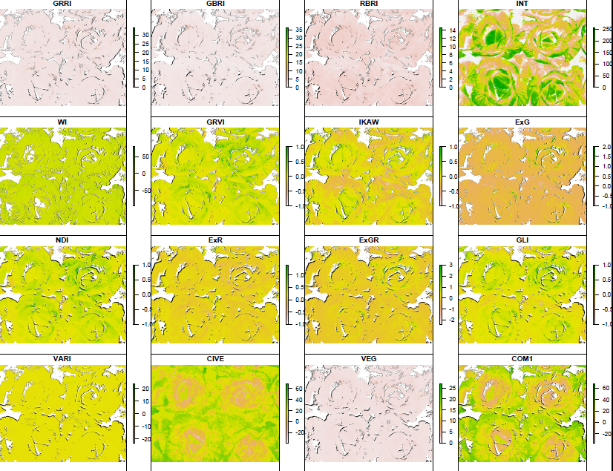
VI map for the cabbage.
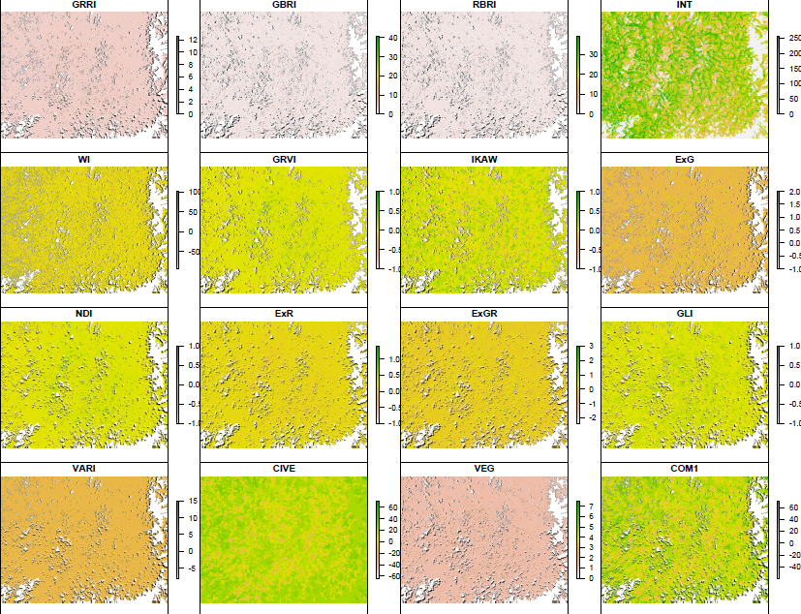
VI map for the chick pea.
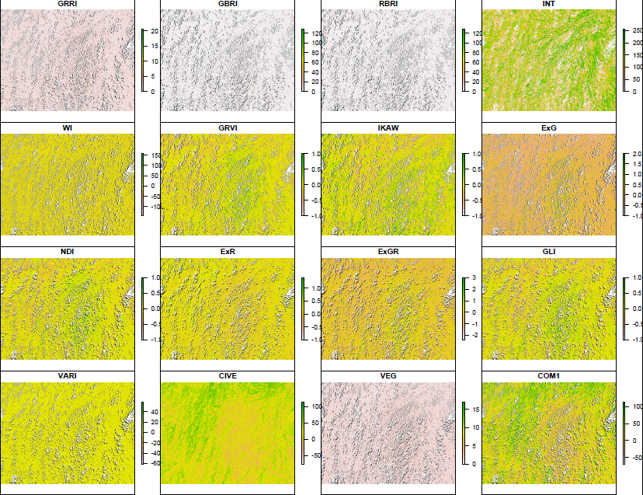
VI map for the mustard.

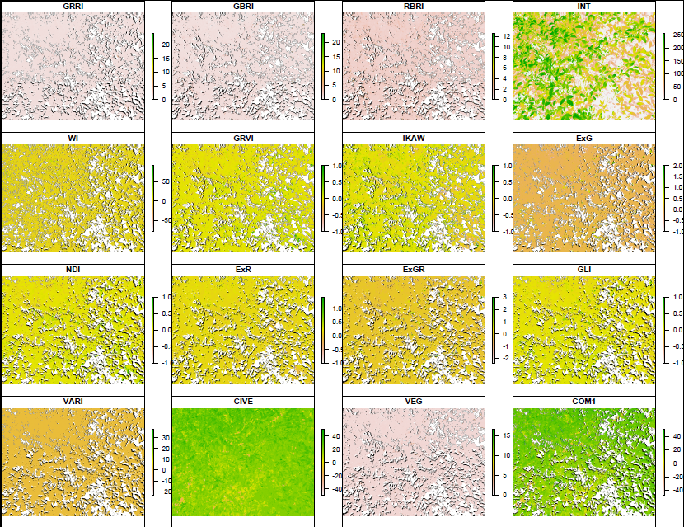
VI map for the pigeon pea.
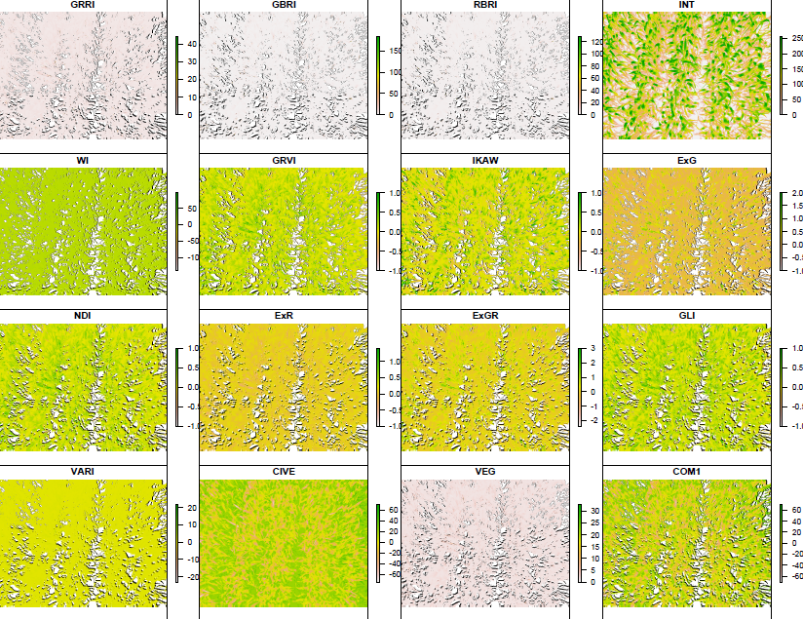
VI map for the wheat.

