Mental health and professional outcomes in parents of children with chronic kidney disease

Elke De Bruyne¹, Sunny Eloot², Lore Willem³, Koen Van Hoeck⁴, Johan Vande Walle^{5*}, Ann Raes^{5*}, Wim Van Biesen^{2*}, Liesbet Goubert^{6†}, Eline Van Hoecke^{1†}, Evelien Snauwaert^{2*†}

Supplementary material

Supplemental Figure 1. Boxplot of stress in parents of healthy children (N=45) and parents of children with CKD (N=45), based on the total score of the Parenting Stress Index – Short Form

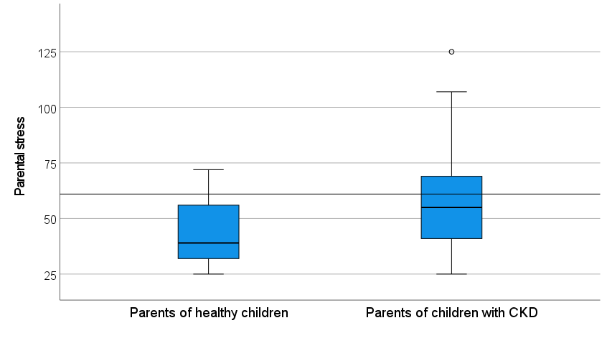
Scores above 61 represent clinical levels of stress
U (88) = 578.5 (P < 0.001)
N: number; CKD: chronic kidney disease; U: Mann-Whitney test; P: p-value.

Supplemental Figure 2. Boxplot of anxiety symptoms in parents of healthy children (N=45) and parents of children with CKD (N=45), based on the Anxiety scale scores of the Hospital Anxiety and Depression Scale
U (88) = 624.5 (P < 0.01)

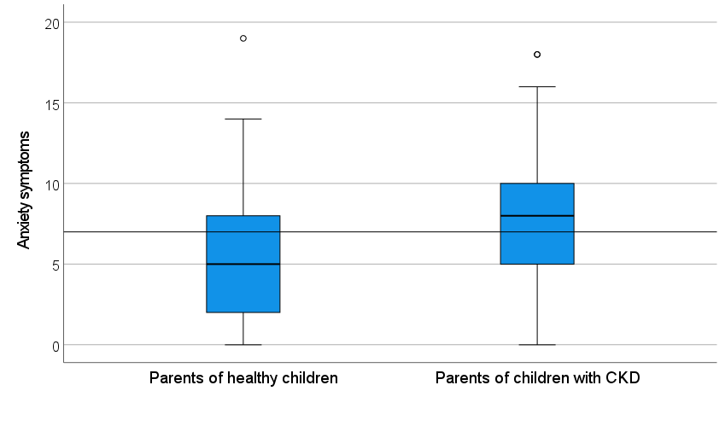
Scores above 7 represent clinical levels of anxiety symptoms
N: number; CKD: chronic kidney disease; U: Mann-Whitney test; P: p-value.

Supplemental Figure 3. Boxplot of depression symptoms in parents of healthy children (N=45) and parents of children with CKD (N=45), based on the Depression scale scores of the Hospital Anxiety and Depression Scale
U (88) = 817.5 (P > 0.05)

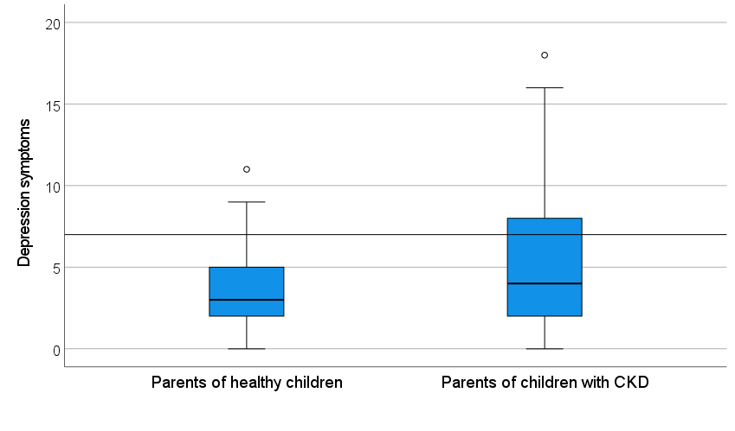
Scores above 7 represent clinical levels of depression symptoms
N: number; CKD: chronic kidney disease; U: Mann-Whitney test; P: p-value.

