Supplementary Information

Preparation of zirconia/zinc oxide nanocomposites by sol-gel method for highly sensitive determination of dopamine

Liqiang Chen¹ · Shuangshuang Tian¹ · Jinghua Zhang¹ · Hong Zhang^{1,2,3} · Liangquan Sheng^{1,2,3} · Xinxin Wang¹ · Jiajing Fan¹ · Deqian Huang^{,2,3*}

¹ School of Chemistry and Material Engineering, Fuyang Normal University, Anhui, Fuyang,
236037, P. R. China
²Engineering Research Centre of Biomass Conversion and Pollution Prevention Control of Anhui Provincial Department of Education, Fuyang Normal University, Fuyang 236037, P.R. China
³ Anhui Provincial Key Laboratory for Degradation and Monitoring of Pollution of the Environment, Fuyang Normal University, Fuyang 236037, P.R. China

Calculation and interpretation of charge transfer rates
Fig S2 shows the relationship between the oxidation peak potential (E_{pa}) and reduction peak potential (E_{pc}) and lnv. When △E_{p}≥100 mV, the logarithm of peak potential (E_{p}) and scanning speed accords with the Laviron equation:
${\text{E}}_{\text{pa}}\text{=}{\text{E}}^{\text{θ}}\text{+}\frac{\text{RT}}{\left(\text{1}\text{–}\text{α}\right)\text{nF}}\text{ln}\frac{\text{RT}{\text{K}}_{\text{s}}}{\left(\text{1}\text{–}\text{α}\right)\text{nF}}\text{+}\frac{\text{RT}}{\left(\text{1}\text{–}\text{α}\right)\text{nF}}\text{ln}\text{v}$ ⑴
${\text{E}}_{\text{pc}}\text{=}{\text{E}}^{\text{θ}}\text{+}\frac{\text{RT}}{\text{αnF}}\text{ln}\frac{\text{RT}{\text{K}}_{\text{s}}}{\text{αnF}}-\frac{\text{RT}}{\text{αnF}} \text{ln}\text{v}$ ⑵
Through two linear regression equations E_{pa} = 0.0628lnv + 0.5268 (R²=0.999), E_{pc} = –0.0394 lnv –0.1537 (R²=0.998) and Equation (1) and (2), α and n can be calculated of 0.373 and 1.73 (about 2).

The electron transfer rate constant can be obtained from the following equation K_{s}：
$\log{k_{s}=α\log\left(1-α\right)}+\left(1-α\right)\log{α}-\log{\frac{RT}{nFv}}-\frac{α\left(1-α\right)nF∆E_{p}}{2.303RT}$ ⑶
In the above equation, α is the electron transfer coefficient, n is the number of electrons gained and lost in the reaction, R, T and F are the gas constant, thermodynamic temperature and Faraday constant (R=8.314 J mol^{–1} k^{–1}, T =298 K, F=96480 C mol^{–1}). When the scanning speed is 100 mV s^{–1}, the ∆E_{p} is 0.447 V, so K_{s} can be calculated to be 2.59 s^{–1}.
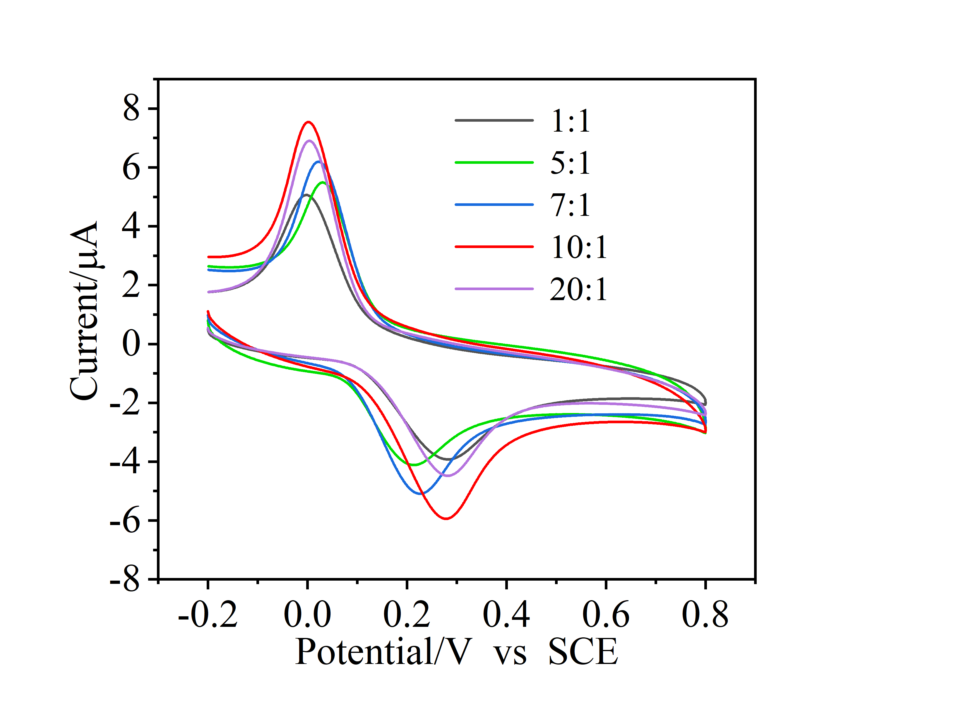
Fig S1 CV plots of different proportions of ZrO₂/ZnO nanocompounds

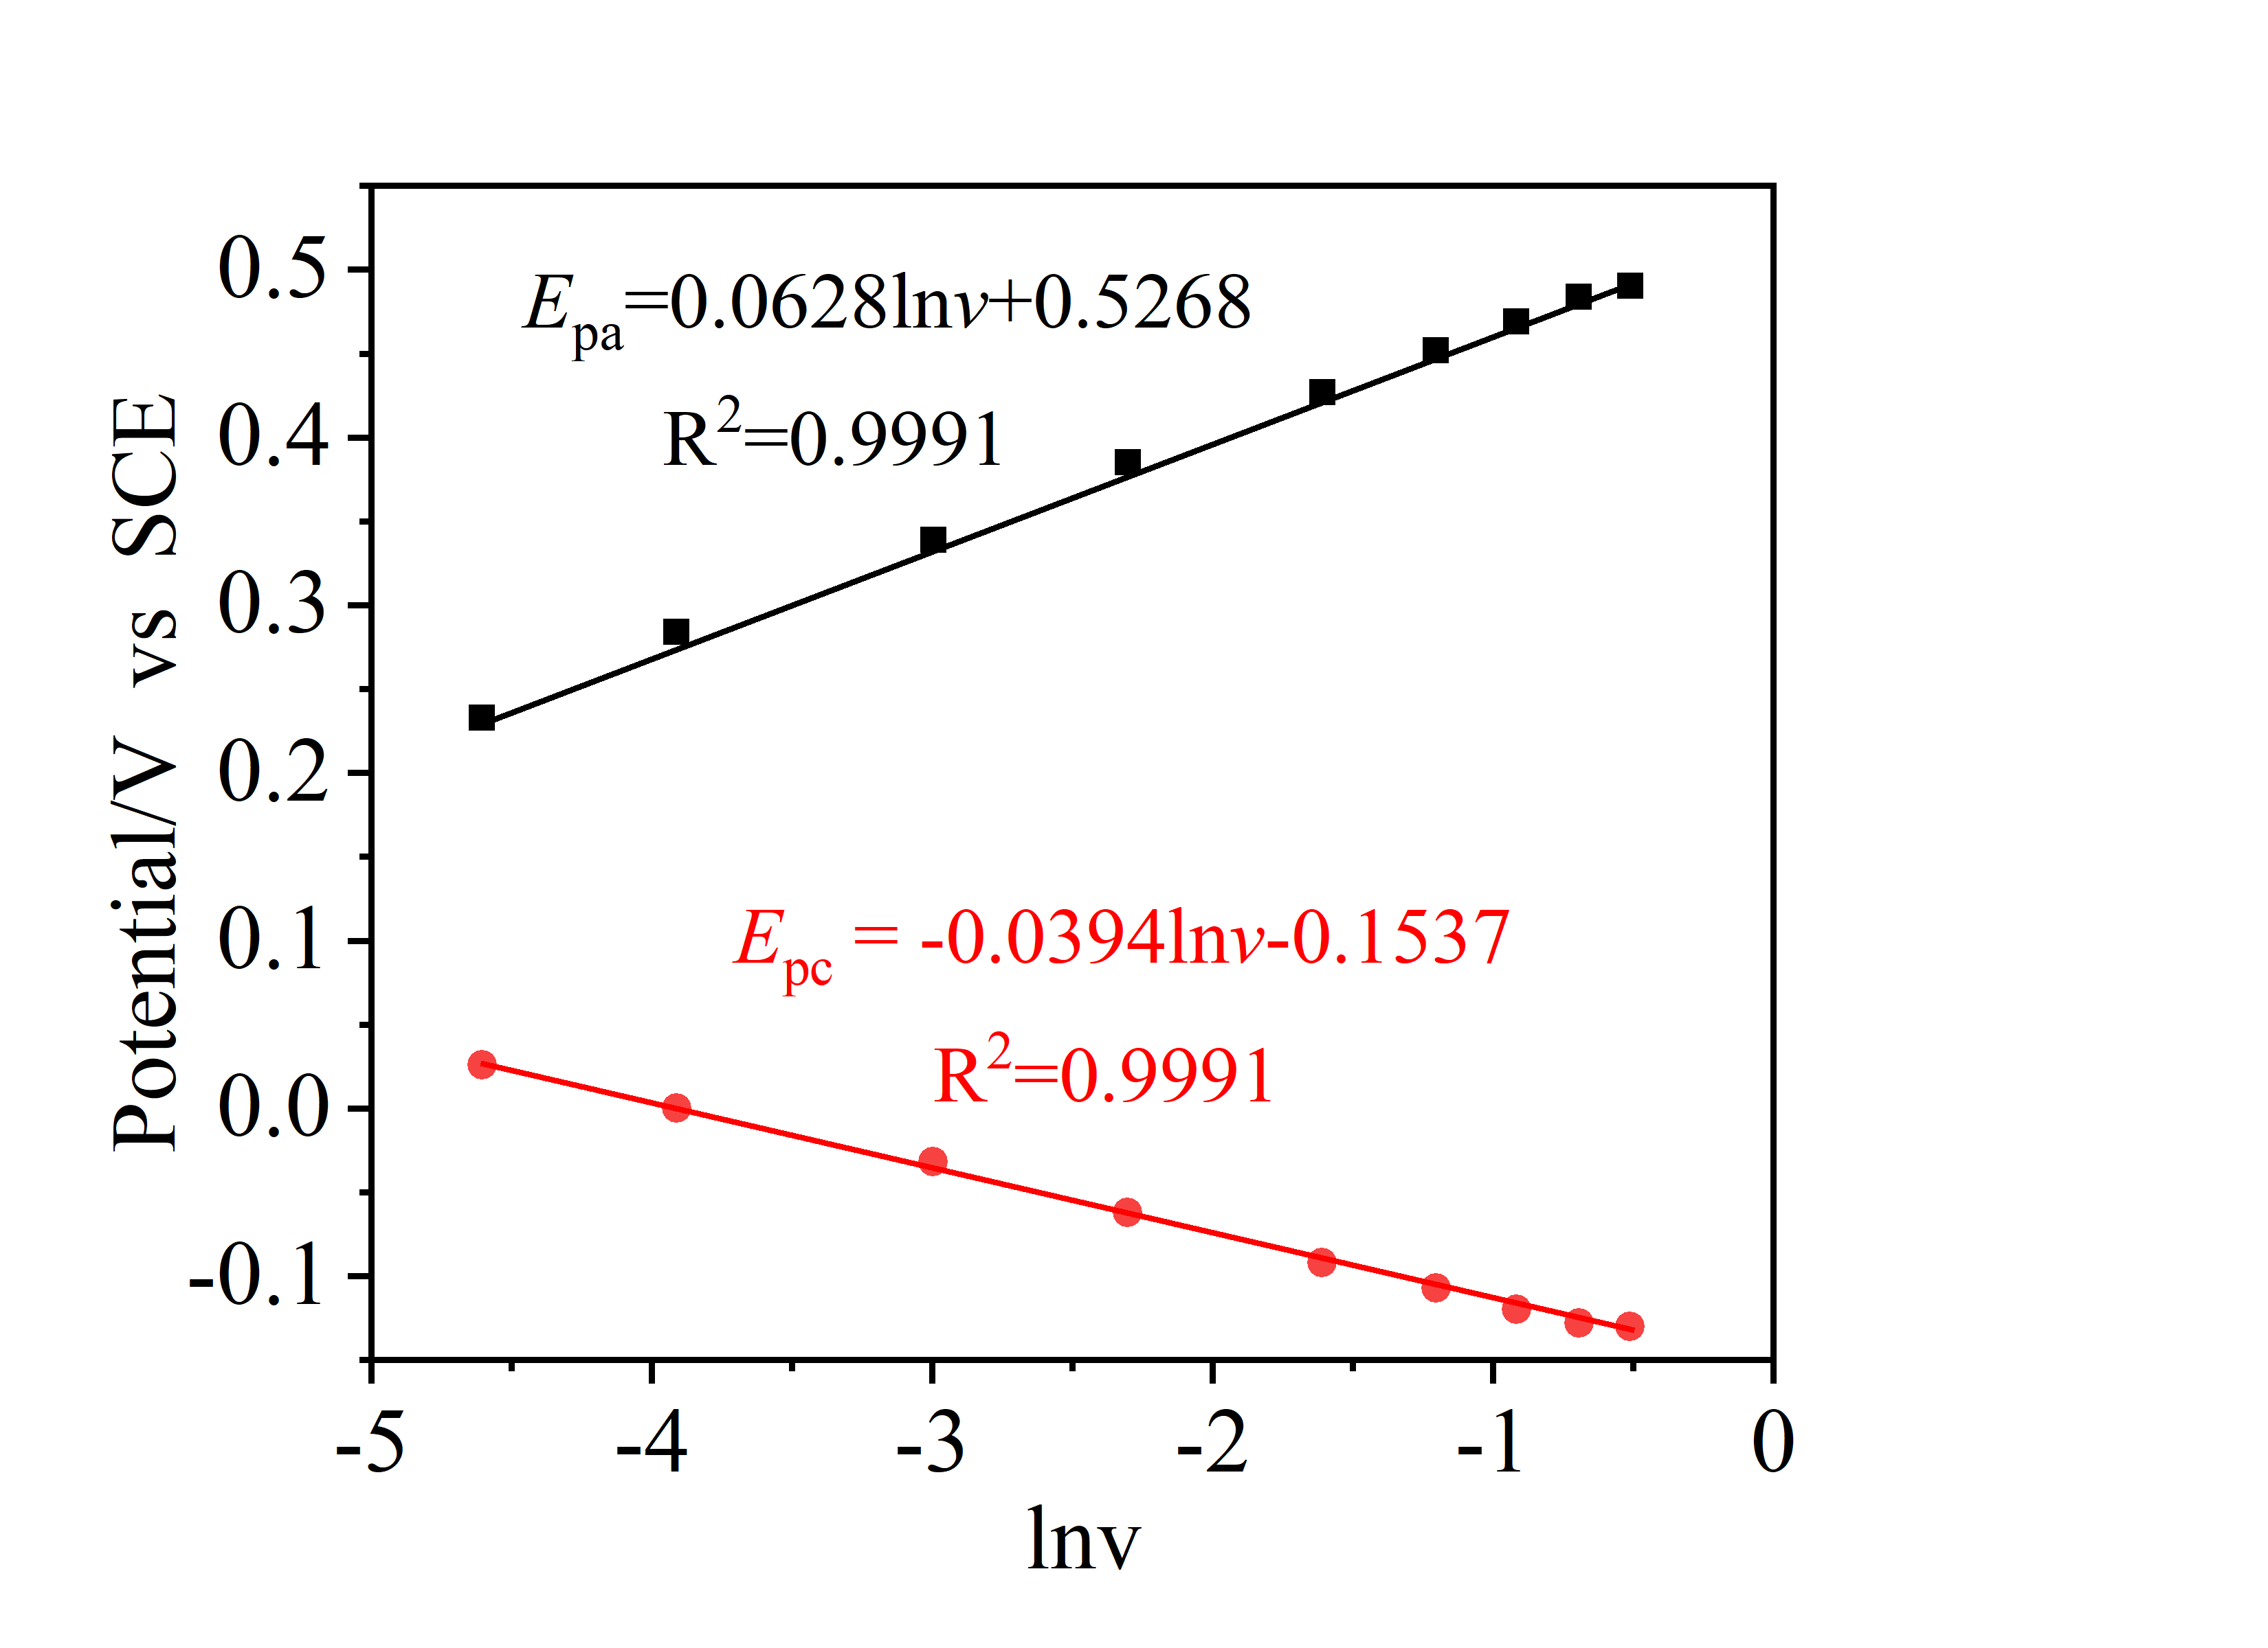
Fig S2 Relationship between Oxidation and reduction peak potentials and logarithm of scan rate

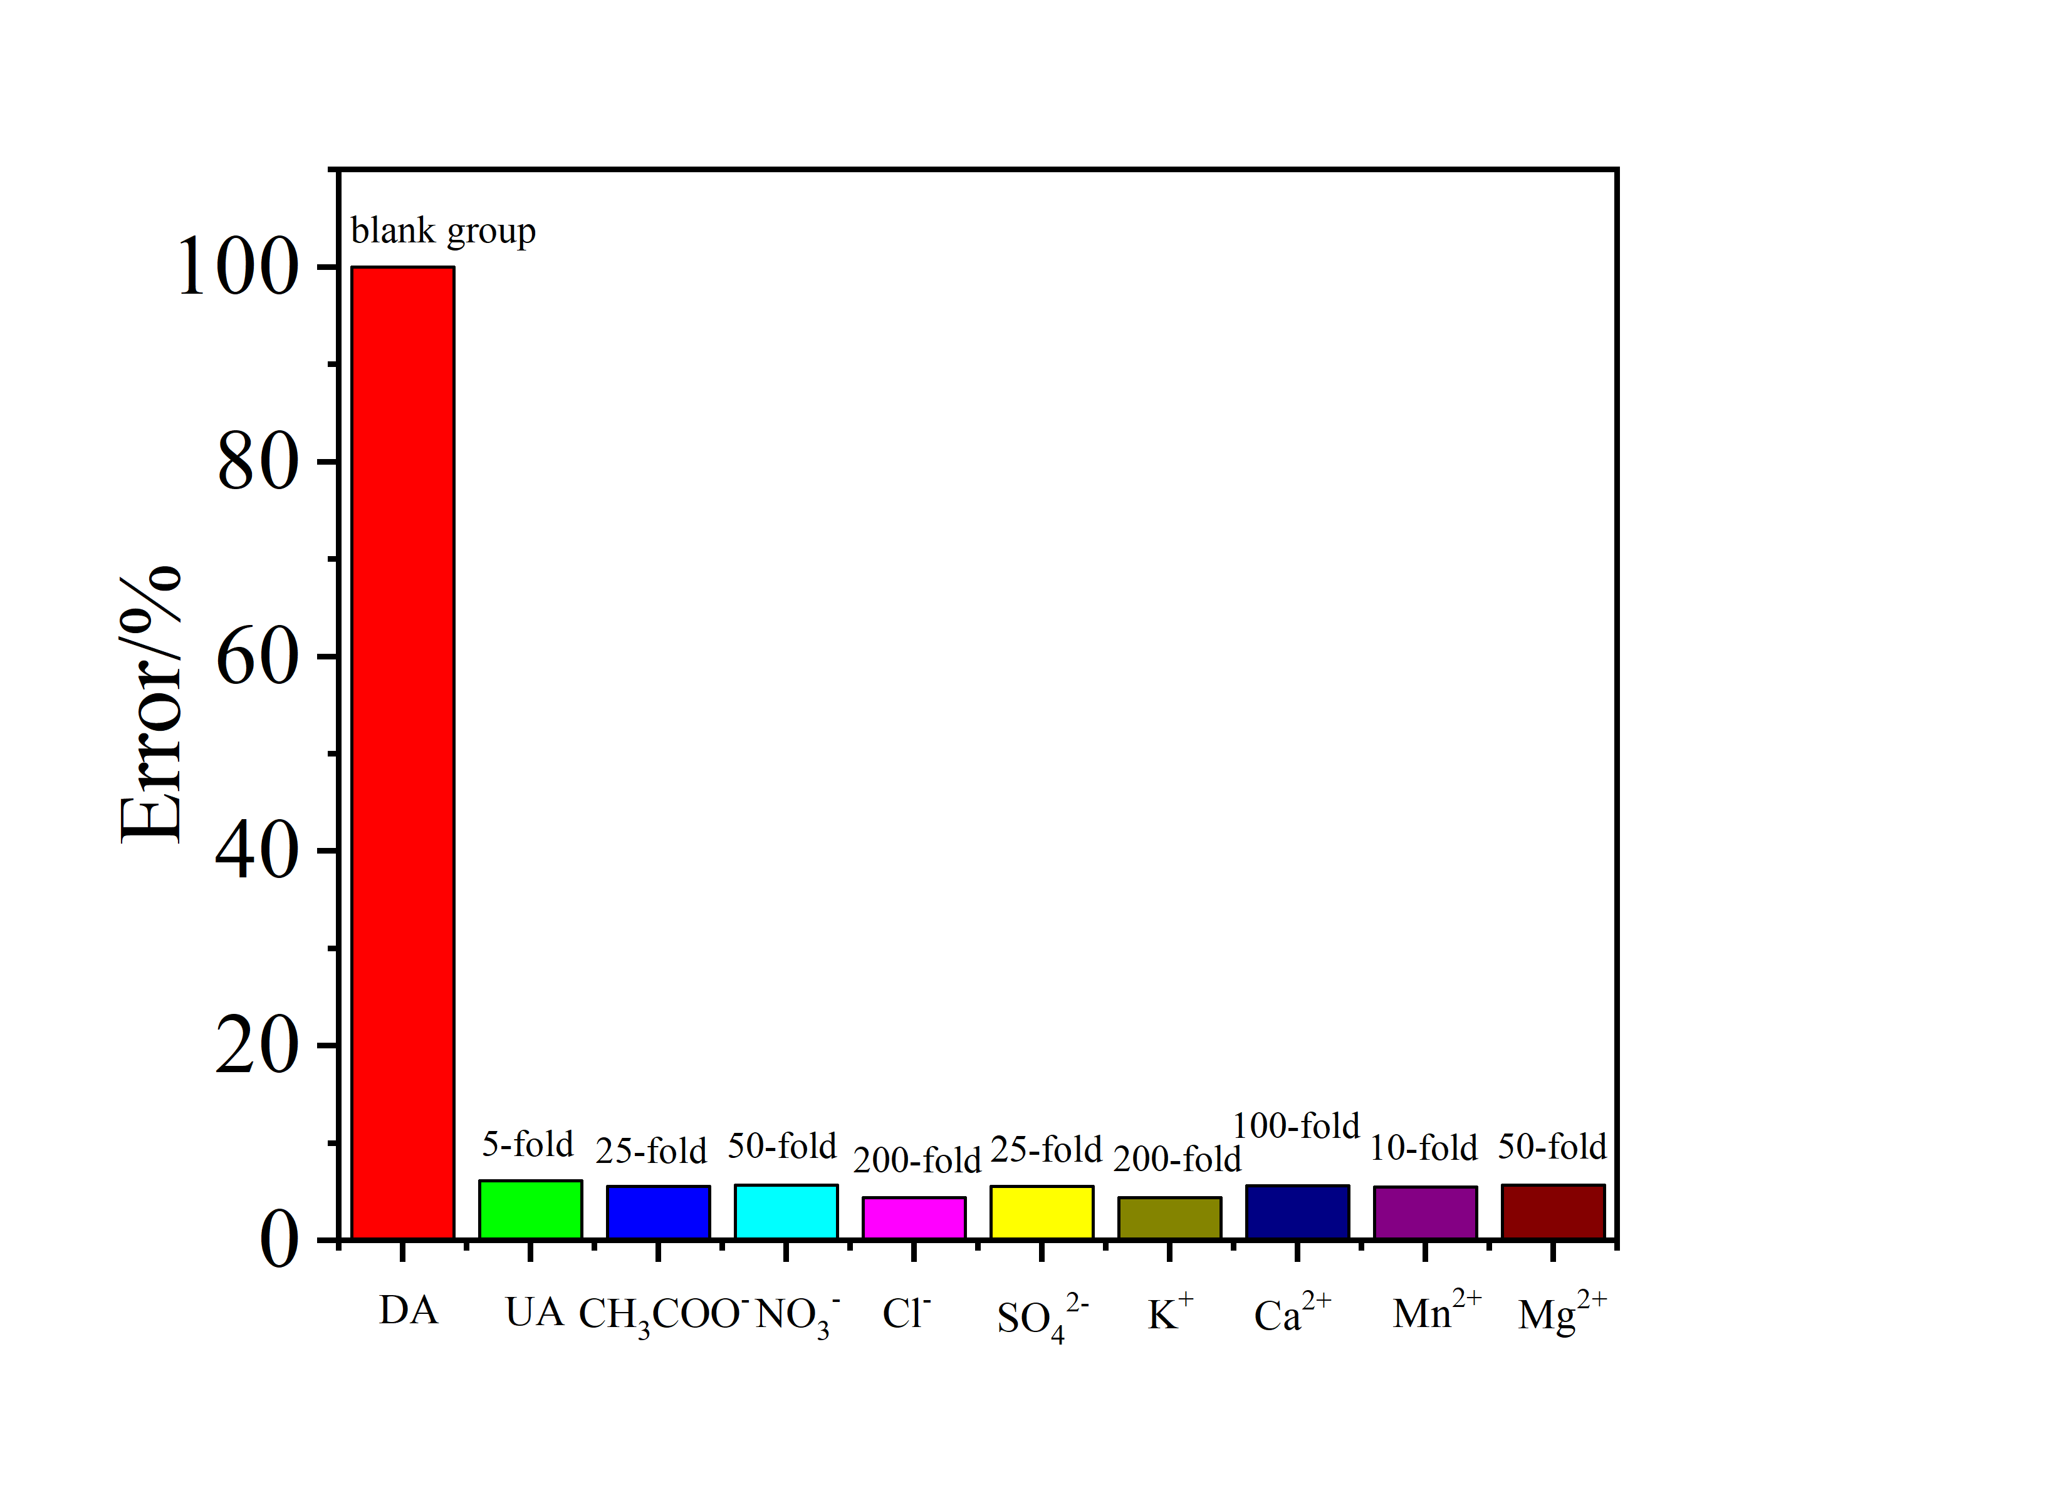
Fig S3 DA selectivity error graph of ZrO₂/ZnO/GCE

Table S1 EDX element content map of ZrO₂/ZnO nanocomposites

Element | Atomic weight percentage
Zr | 65.32
Zn | 1.76
O | 30.31

Deqian Huang(D. Huang) huangdeqian@163.com

