Article type: Research Paper

Nanotheranostic Trojan Horse for Visualization and Photo-Immunotherapy of Multidrug-Resistant Bacterial Infection

Xin Pang^{1,#,}, Haohang Xu^{1,#}, Qishun Geng², Heng Liu³, Xiao Zhang¹, Mingsan Miao^{4,} 
- School of Pharmacy, Henan University of Traditional Chinese Medicine, Zhengzhou 450046, China.
- China-Japan Friendship Hospital (Institute of Clinical Medical Sciences), Chinese Academy of Medical Sciences & Peking Union Medical College, Beijing 100193, China.
- Department of Radiology, PLA Rocket Force Characteristic Medical Center, Beijing 100088, China
- Academy of Chinese Medical Sciences, Henan University of Traditional Chinese Medicine, Zhengzhou 450046, China

#These two authors contributed equally to this work.
Corresponding author: E-mails: pangxin116@163.com (X. Pang), miaomingsan@163.com (M. Miao)

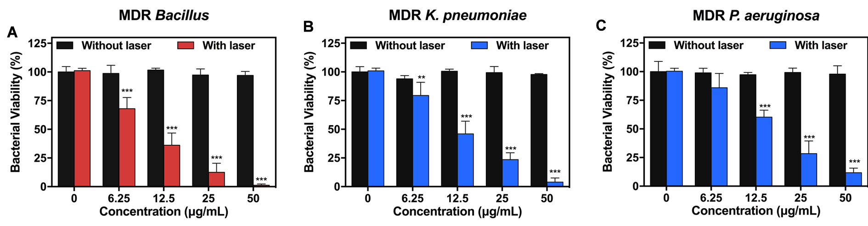
Figure S1. The bacterial viability of (A) MDR Bacillus, (B) MDR K. pneumoniae, and (C) MDR P. aeruginosa versus the MP-MENP concentrations with/without laser irradiation (808 nm, 2 W/cm², 5 min).

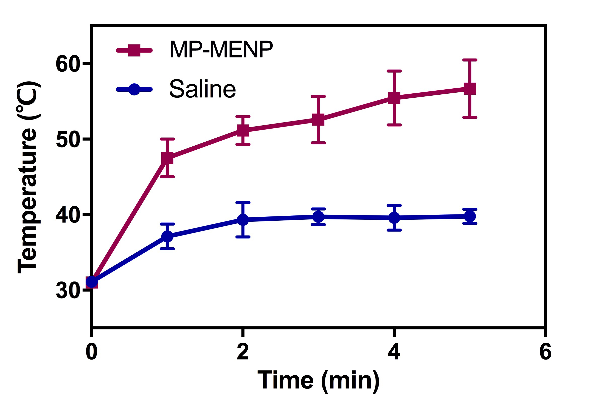
Figure S2. The temperature change at MRSA-infected site from mice treated with saline or MP-MENP, followed by laser irradiation (808 nm, 2 W/cm², 5 min).

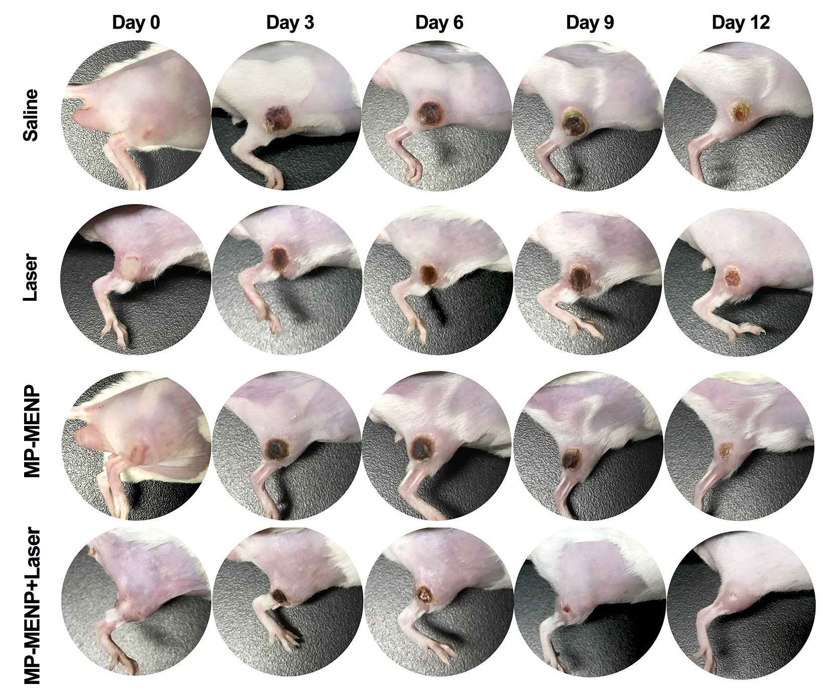
Figure S3. Representative photographs of the MRSA-infected area within 12 days postinjection in four different treatment groups.

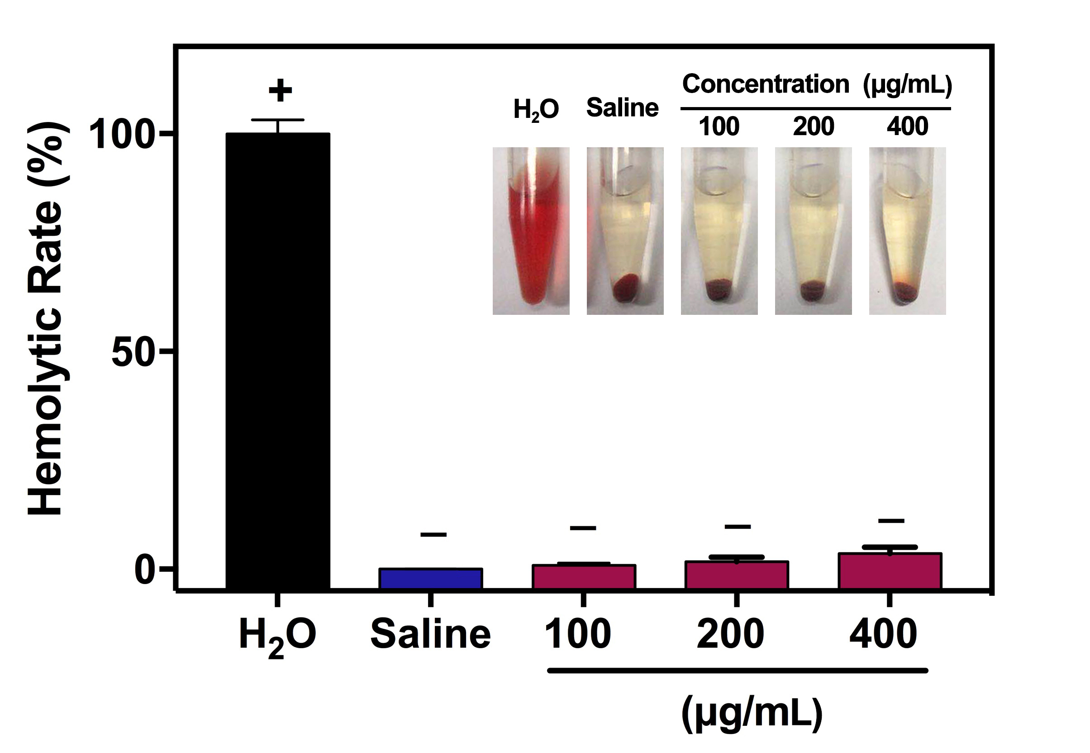
Figure S4. Quantitative results and photographs of hemolysis activity of MP-MENP with different concentrations.
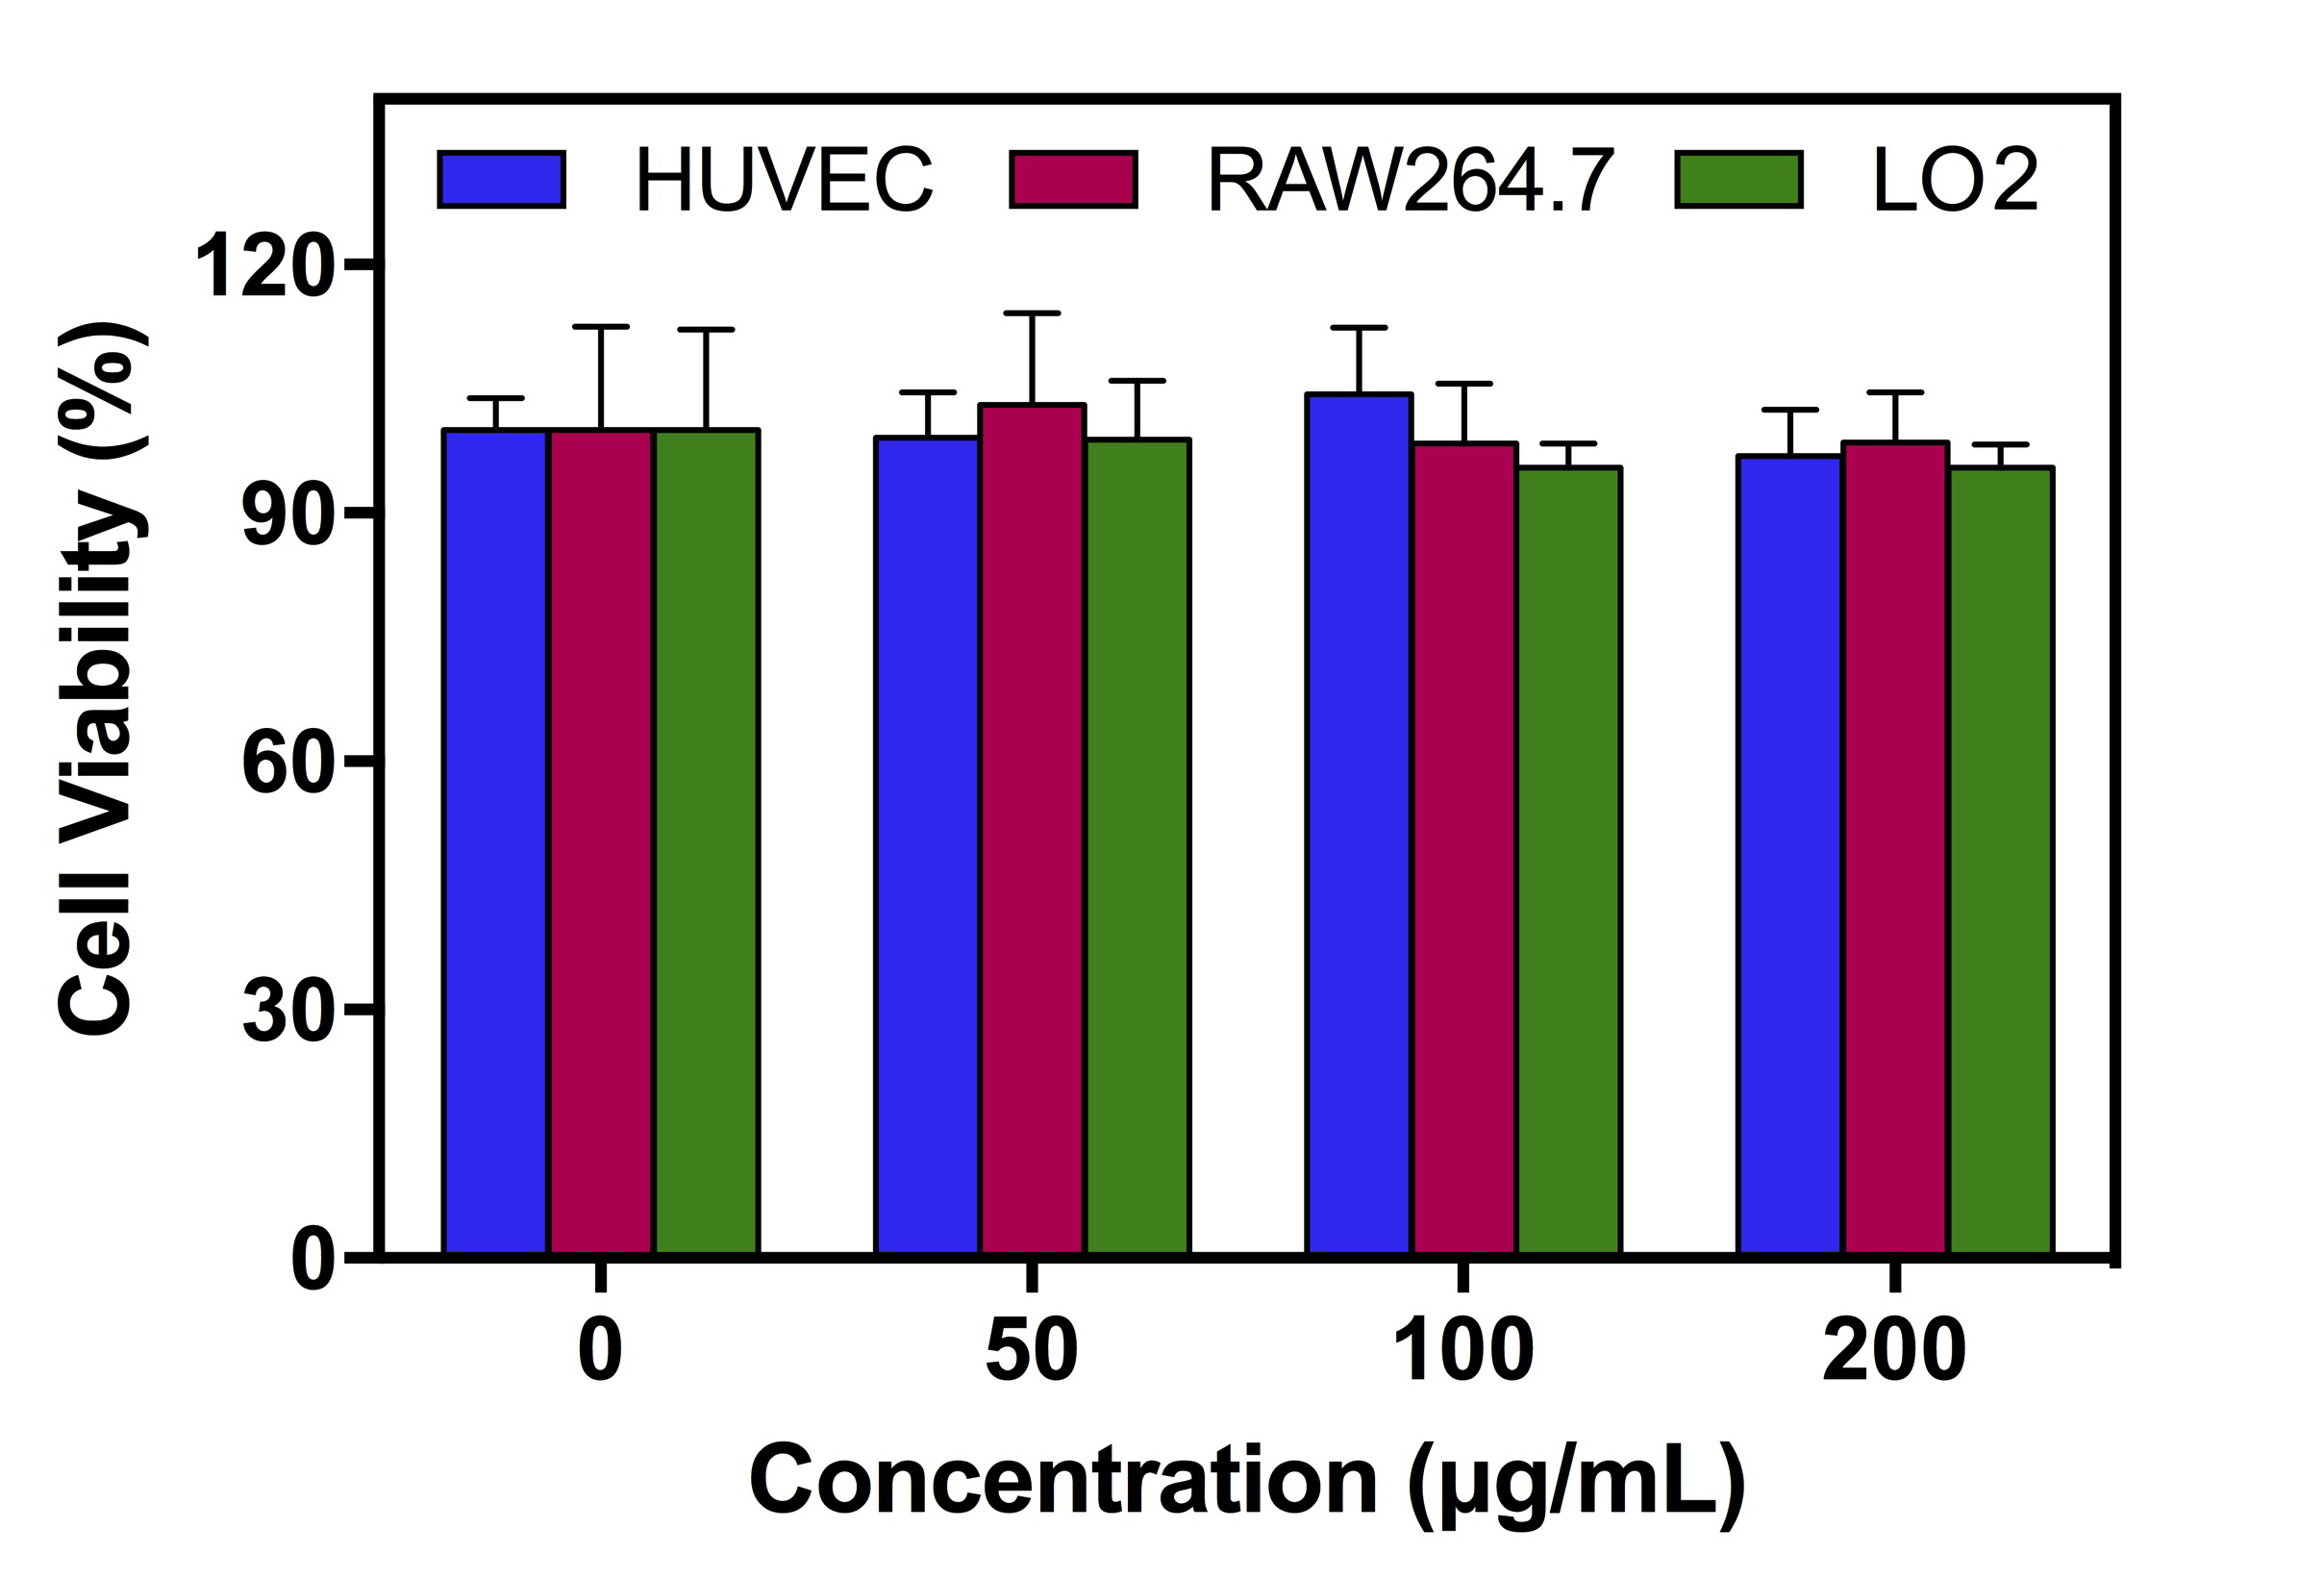
Figure S5. Cell viability of HUVEC cells, RAW264.7 cells, and LO2 cells treated with MP-MENP at different concentrations.

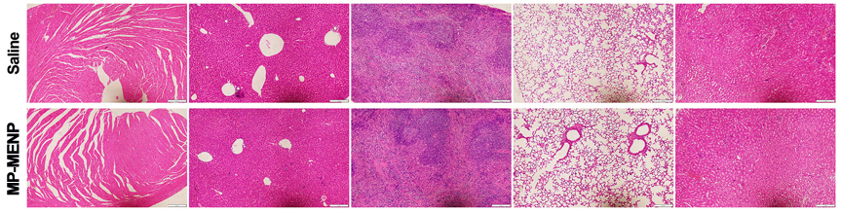
Figure S6. Histopathologic examination of the major organs including heart, liver, spleen, lung, and kidney from mice with saline or MP-MENP injection.

