Table S1: The interatomic distances and bonds angles (C₅H₈N₆)₃[BiCl₆].4Cl.2H₂O

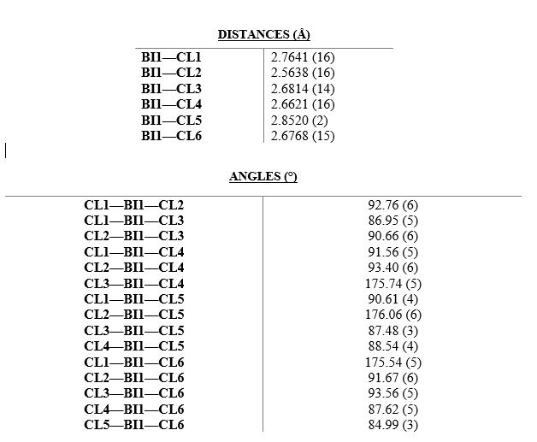

Table S2: Assignments of the IR and Raman wavenumbers in the range 400–4000 cm⁻¹ for (C₅H₈N₆)₃[BiCl₆].4Cl.2H₂O.
Frequency observed (cm⁻¹) |  | Attributions
IR | Raman | Attributions
3615 | - | $ν_{as}({NH}_{2})$
3338 | - | ν_{s} (NH₃⁺)
3135 | - | $$ν(N-H)$$
3070 | - | $ν(O-H…Cl)$
3001 |  | $ν(O-H)$
2960 | - | $ν(C-H)$
2551 | - | $ν(N-H…Cl)$
1740 | - | δ_{as}(NH₂)
1668 | - | δ_{as}(NH₂)
1620 | 1630 | δ (N-H…Cl) + δ_{as} (NH₃⁺)
1605 | 1589 | δ(O- H)
1530 | 1512 | $ν(C=N)$
1450 | 1432 | δ(C- N- H)
1411 | - | δ(C- N- H)
1335 | 1347 | $$ν_{as}(C-N)$$
1217 | - | β(C-H)
1142 | 1143 | $$ν_{s}(C-N)$$
1081 | - | $ν_{as}(C-C)$
- | 1110 | β(C-H)
983 | - | $ν(C-N)$
950 | - | δ(C- H)
884 | - | γ(C-H)
833 | - | $ν(C-C-N)$
804 | - | γ(C-H)
780 | - | δ(C- C-N)
748 | - | ω(NH₂)
651 | 632 | $$ν(C-N)$$
578 | 598 | δ(C- C-N)
535 | 536 | δ(C- C=C)
- | 494 | δ(C- C= C)
- | 307 | $ν_{as}\left(Bi-Cl\right)$
- | 280 | $ν\left(Bi-Cl\right)$
- | 247 | $ν(Bi-Cl)$
- | 178 | δ(Cl- Bi- Cl)

Fig S1: Hirshfeld surfaces of (C₅H₈N₆)₃[BiCl₆].4Cl.2H₂O: (a) 3D d_{norm} surface, (b) surface index, (c) curvedness.

