Supporting information
From kitchen garden to multifunctionality: Leek-inspired Surface Structures Introduce Optical and Self-cleaning Properties to Cellulose-based Films
Hamidreza Daghigh Shiraziª, Seyed Mehran Mirmohammadiª, Seyede Maryam Mousaviª, Magnus Markkanenª, Janne Halme^{b}, Ville Jokinenª, Jaana Vapaavuori ª*
ª Department of Chemistry and Materials Science, Aalto University School of Chemical Engineering, Espoo, Finland

^{b} Department of Applied Physics, Aalto University School of Science, Espoo, Finland

*E-mail: Jaana.vapaavuori@aalto.fi

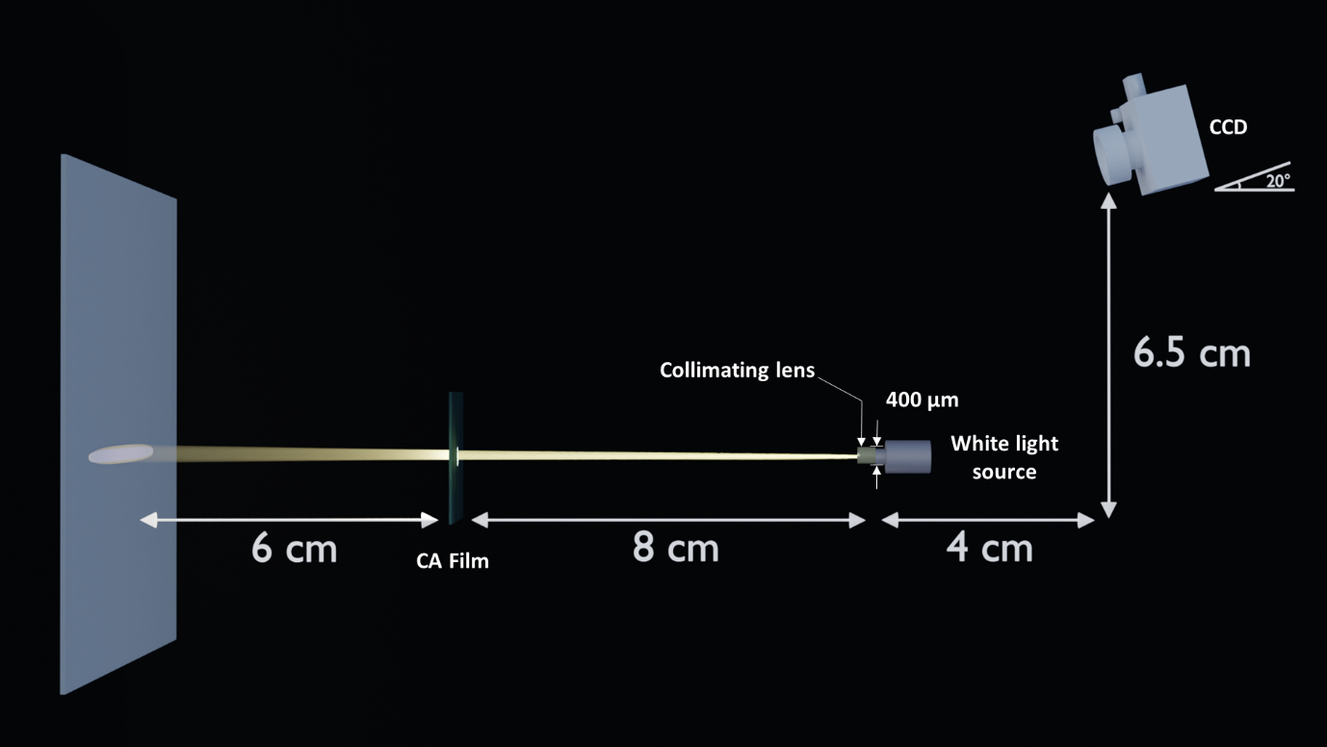
Figure S1. Schematic of the imaging setup.

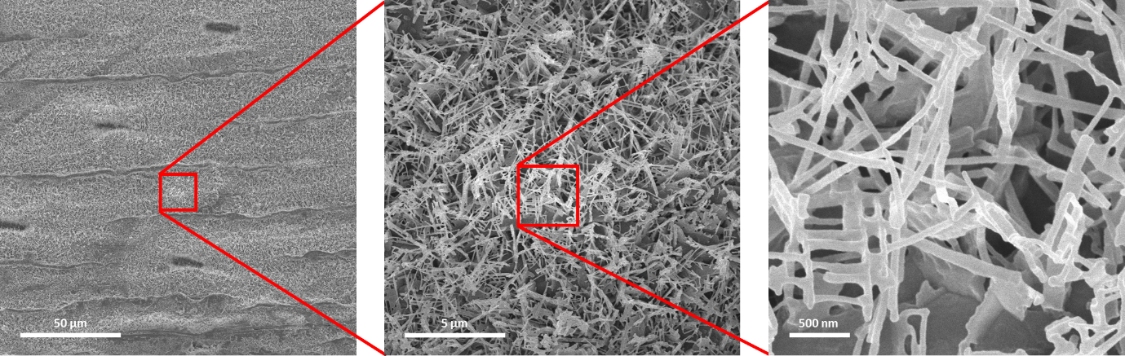
Figure S2. Leek’s epicuticular wax.

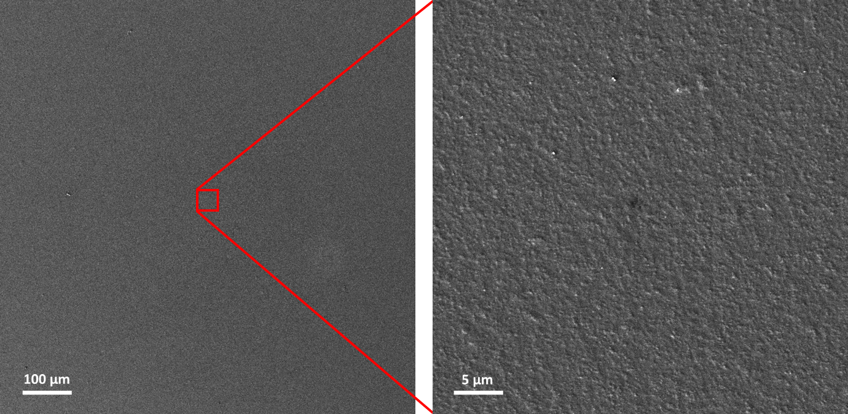
Figure S3. SEM images of a plain (flat) CA film and plain CA spin-coated with 2wt.% CW solution.

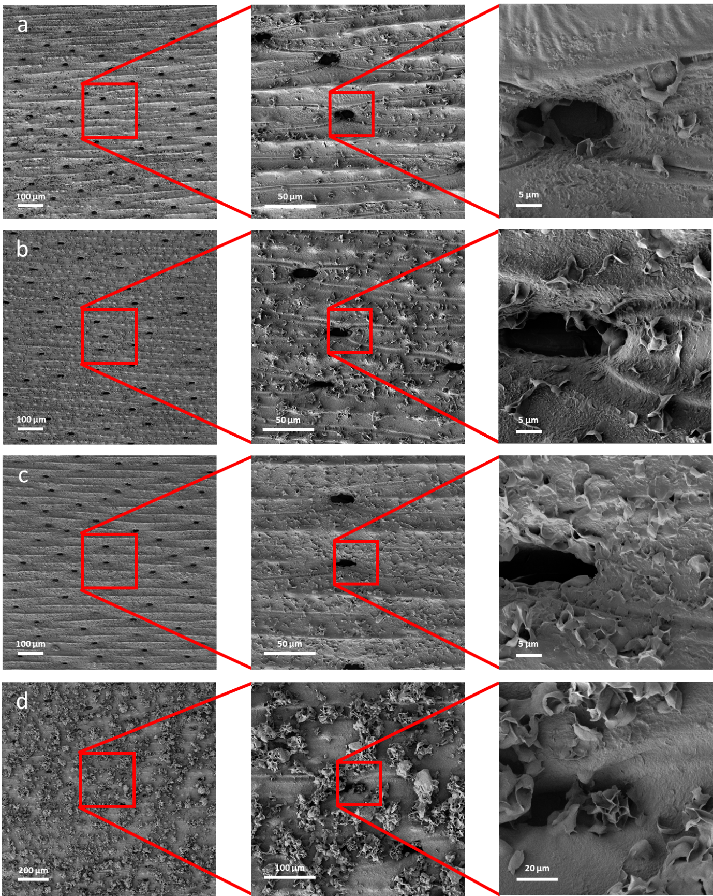
Figure S4. SEM images of replicas coated with a) 0.5 wt.%, b) 1 wt.%, c) 2 wt.%, and d) 3 wt.% carnauba wax.

Figure S5. Water contact angles of replicas coated with different CW concentrations, plain CA with and without CW coating. The contact angle increases by increasing the CW concentration, however in the case of 3% CW, the large clusters and small anisotropy suggest that the effect of replicated structures are dominated by the wax.

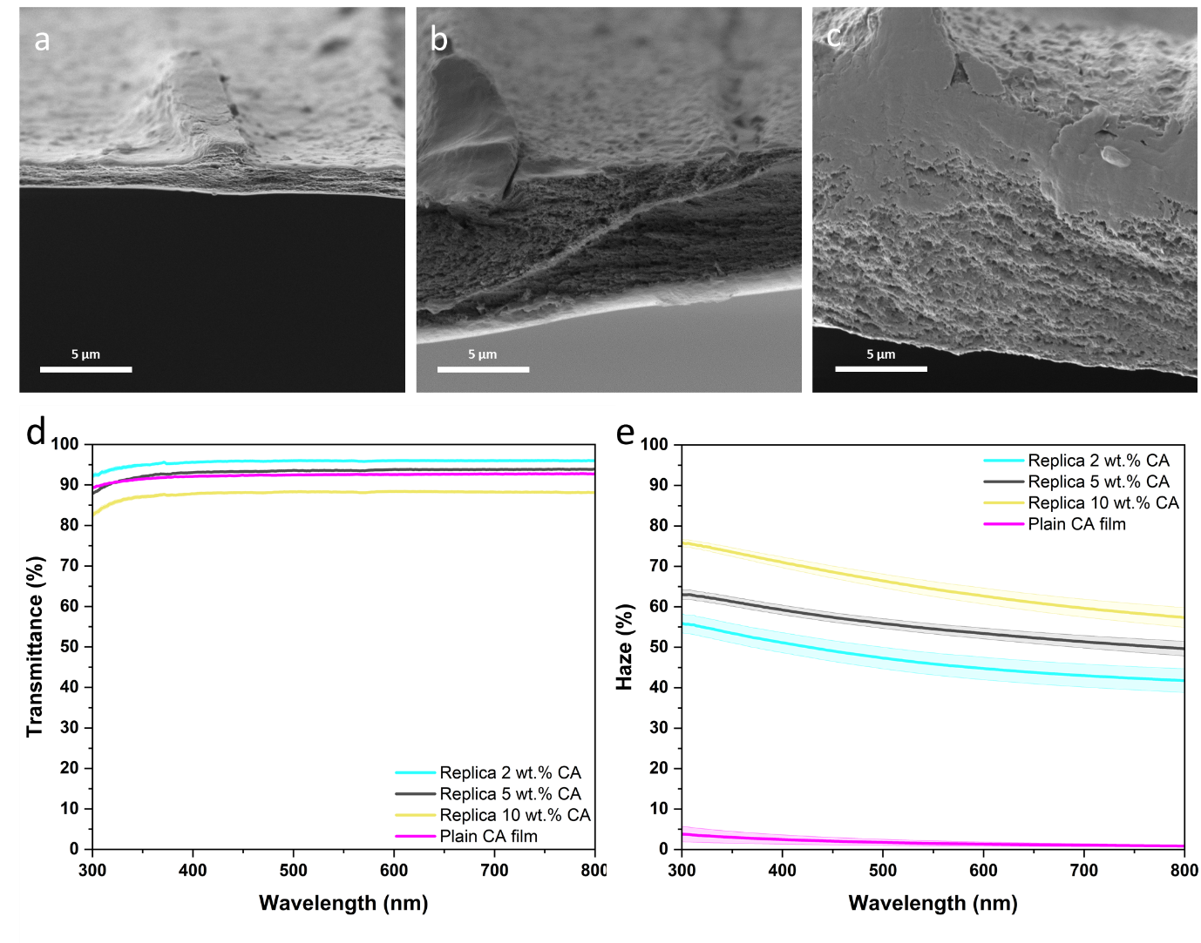
Figure S6. Cross-sectional SEM images of the replicas fabricated using a) 2, b) 5, and c) 10 wt.% cellulose acetate concentrations, as well as their d) Transmittance and e) haze compared to a plain thick CA film.

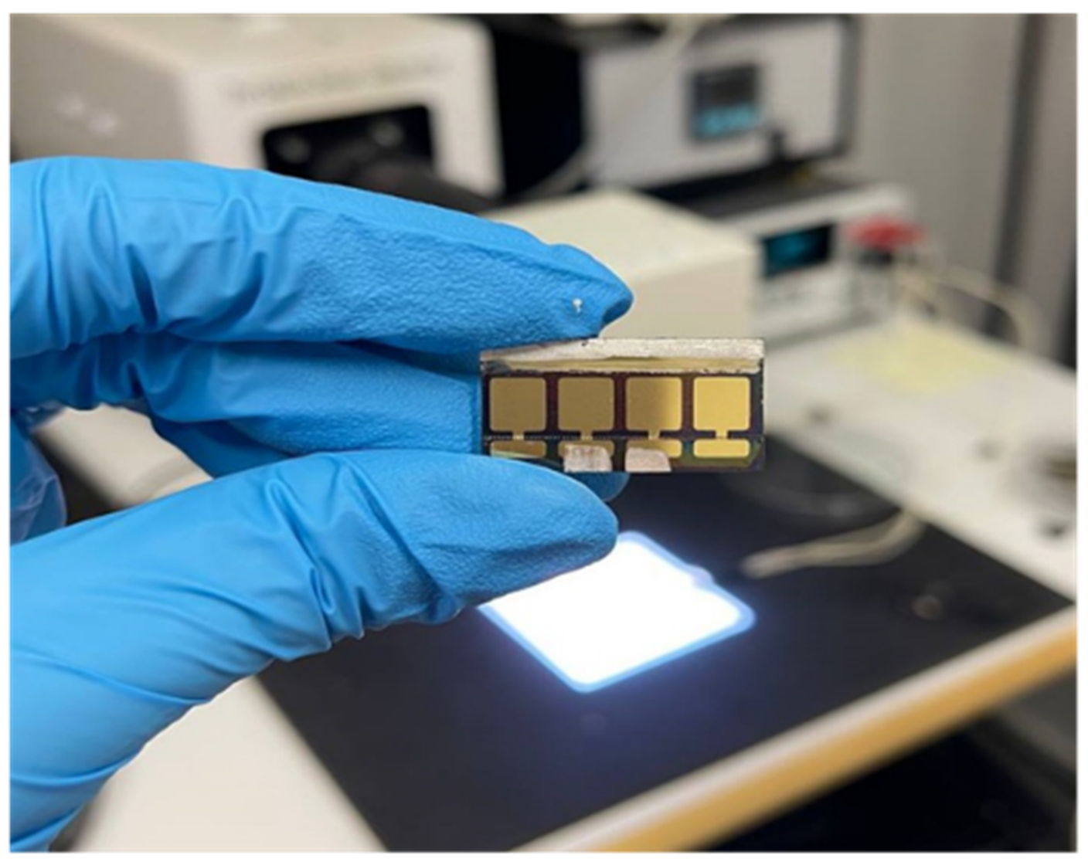Figure S8. A PSC painted with silver paste for improved electrical contact.

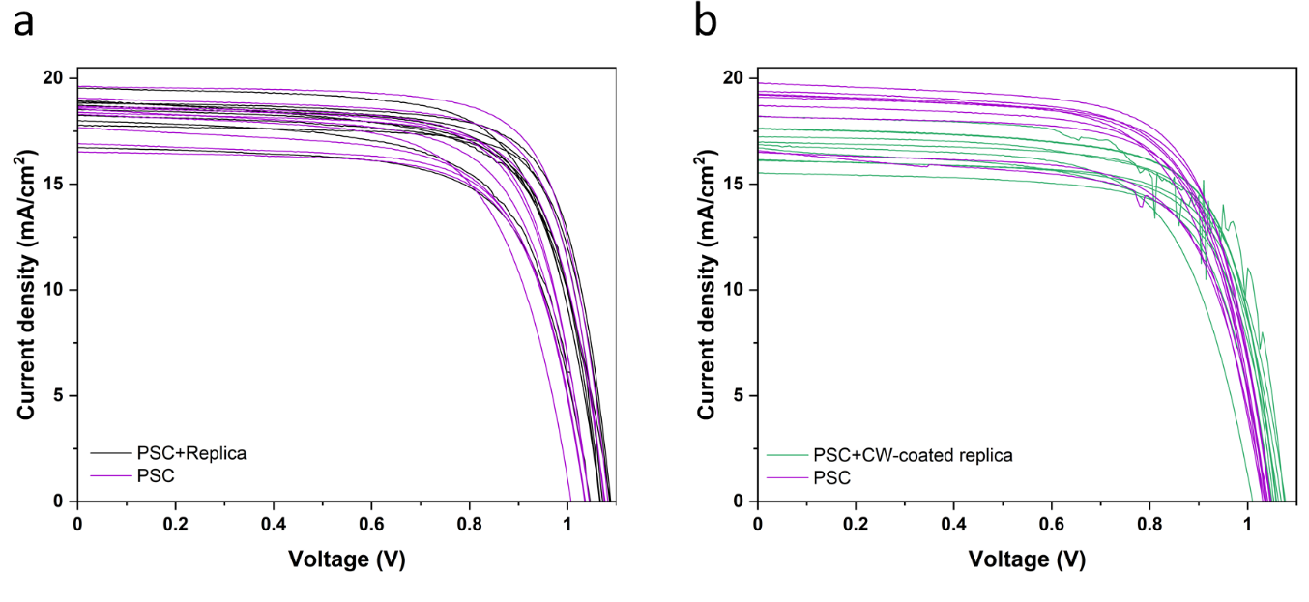Figure S9. The J-V characteristics of PSCs with a) replica and b) 2% CW-coated replica in comparison with the pristine devices. The cells were made in multiple batches.

