SUPPLEMENTARY MATERIALS

This document contains supplementary material for:

Boyle, Bradley L.^{1,2,5}, Warn Franklin³, Alison Burton³, Raymond E. Gullison^{1,4}. Vegetation Quality Assessment: a sampling-based, loss-gain accounting framework for native, disturbed and reclaimed vegetation. Environmental Management.

¹Hardner & Gullison Associates, LLC, 15 Woodland Drive, Amherst, NH 03031 USA
²Department of Ecology and Evolutionary Biology, University of Arizona, Biosciences West 310, Tucson, AZ 85721 USA
³Teck Coal Limited, P.O. Box 3000, Sparwood, BC V0B 2G1 Canada
⁴ The Biodiversity Research Centre, University of British Columbia, 2212 Main Mall, Vancouver, BC, V6T 1Z4, Canada
⁵Corresponding author. Email: bboyle@arizona.edu
Supplementary text
Text S1. Like-for-like-or-better
In general, restoration seeks to reestablish vegetation of the same type that existed prior to all project impacts. However, in some cases a different target vegetation type may be appropriate, for example, when an industrial project alters the topography and soils to such an extent that conditions no longer support the baseline vegetation. An extreme example of such alteration is mountain top removal resulting in the loss not only of alpine plant communities but also of the alpine environment which they require. A more common example is the filling in and replacement of wetlands with terrestrial habitats. If a different restoration target is chosen, there is generally an expectation that the replacement vegetation (at the site itself or in an offset) is of equal or greater conservation or cultural value than the original vegetation ("like-for-like or better"; Quétier and Lavorel 2011). For example, a site converted to a mine tailings storage facility may be difficult or impossible to restore to forest due to shallower soil and reduced moisture holding capacity and may be more effectively restored to grassland. This transformation may be acceptable if native grasslands are of equal or greater conservation concern within the region and "like-for-like-or-better" exchanges are permitted. In such cases, quality of the new vegetation should be scored relative to benchmark attributes of the new target vegetation. The decision to assign a different target vegetation may be based on other attributes in addition to vegetation quality—such as presence of endangered species, regional or global rarity of the vegetation, cultural significance, or value as habitat or forage for wildlife.
Text S2. One-tailed quality
The default VQA quality algorithm described in the main text compares overlap of the focal distribution with the entire benchmark distribution. For some indicators, it may be appropriate to reduce quality at low values or high values only. For example, if high species richness is always considered desirable, then quality should be reduced only when focal probability exceeds benchmark probability at richness values below the benchmark mean. This alternative algorithm is called "one-tailed quality". One-tailed quality is calculated by subtracting from 1 (i.e., the total potential overlap) the area of the focal distribution which exceeds the benchmark probability on one side of the benchmark mean only. Focal probabilities exceeding the benchmark probability on the opposite side of the benchmark mean are ignored. This approach is illustrated graphically in Fig. S1, which compares regular (two-tailed) overlap quality to one-tailed quality discounted in the lower tail. As shown in panel S1b, a focal distribution which exceeds the benchmark probability only at indicator values greater than the benchmark mean would have one-tailed quality of 100%, despite having a total overlap of <100%. Because one-tailed quality will be greater than two-tailed quality for the same distribution, the decision to use one-tailed overlap for specific indicators should be declared prior to the initial assessment, and the decision adhered to for all later assessments to avoid bias.
Text S3. Fixed-benchmark quality
For some vegetation types, benchmark indicator distributions may be difficult or impossible to measure empirically, thereby precluding the calculation of overlap-based quality. For example, widespread forest clearing and fire suppression following European settlement of North America have dramatically altered the majority of North American forests; indeed, some forest types previously maintained by indigenous burning practices may no longer exist (Bjorkman and Vellend, 2010). Although mean attributes of pre-settlement forests can sometimes be estimated using historical data or modeling approaches (Battaglia et al., 2018; Steel et al., 2015), accurate reconstruction of entire distributions is far more challenging. In such cases, calibration of quality relative to a single, fixed benchmark value may be the only option.
Alternatively, for indicators of disease or dysfunction, a fixed benchmark value representing the "healthy" state may be preferred. For example, invasion by exotic species is the norm rather than the exception in many plant communities (Lonsdale, 1999; van Kleunen et al., 2015), and quality of an indicator such as "percent cover of invasive species" is more meaningfully scored relative to a benchmark of 0% cover of invasive species. Similarly, indicators of disease prevalence or infection rates are best scored relative to a fixed benchmark of 0%. For example, white pine blister rust (Cronartium ribicola) is nearly ubiquitous throughout the southern Rocky Mountain Region of Canada (Shepherd et al., 2018), and infection by white pine blister rust is best scored relative to a benchmark of 0% of individuals infected rather than by comparison to the empirical distribution of infestations in old growth forests.
VQA supports calculation of fixed-benchmark quality for beta distributed indicators based on percentages and proportions. Quality is determined by comparing the mean and 95% confidence limits (CLs) of the focal distribution to the fixed benchmark value (Fig. S2a). Quality=1 (100%) if the focal CLs overlap the fixed benchmark. For focal distributions whose CLs do not overlap the benchmark, quality is discounted in a two-step process, dropping to 0 at the boundaries of the beta distribution at 0 and 1. First, the relative distance between the benchmark value and focal mean is calculated as follows:

$D_{rel}=\frac{abs(\overline{f}-b)}{max⁡(b, 1-b)}$ , (1)

where $\overline{f}$ is the focal distribution mean, and b is the fixed benchmark, and $D_{rel}$is the difference between $\overline{f}$ and b, relative to the greatest possible difference (i.e., the distance from b to the distribution boundary on the domain encompassing $\overline{f}$). Second, $D_{rel}$ is then transformed to Q by a beta-distributed function with shape parameters s1=0.3 and s2=1 (Fig. S2b). This transformation causes Q to drop more steeply to zero than a simple linear transformation, ensuring that only indicator values close to the benchmark receive high quality scores.
Text S4. Overlap-means quality for beta-distributed indicators
Measuring overlap between beta distributions presents special challenges. Although the beta distribution resembles the normal distribution near the middle of its range, expected values near 0 or 1 result in strongly peaked right- or left-skewed distribution. The beta distribution can also be bimodal, with multiple maxima near 0 and 1. In addition, mixed beta-like distributions may be zero-inflated, one-inflated, or both, with large numbers of exact zeros or ones, both of which lie outside the beta domain of (0,1). Zero-inflated mixed distributions and highly skewed beta distributions with many values close to zero and one are common in ecological data, especially for indicators measured as percentages or proportions (Damgaard and Irvine, 2019).
For beta distributions with expected values close to 0.5, overlap-based quality accurately reflects distribution similarity (e.g., Fig. S3a). This is true over most of the central region of the beta domain. However, for beta distributions with expected values close to zero or one, overlap can change erratically, dropping precipitously despite nearly identical expected values. This behavior is principally the result of low overlap between a steeply-peaked zero- or one-inflated distribution and a non-inflated distribution with a mean close to zero or one; overlap—and thus quality—can be very low, despite similar expected values (Fig. S3b). This combination of low overlap-based quality with high similarity of means occurs only when both means are close to the same boundary.
Rather than developing quality algorithms specific to zero- and one-inflated distributions, we devised a general approach, "overlap-means quality", that accommodates both highly-skewed non-inflated and mixed zero- and one-inflated beta distributions. In this approach, quality is calculated twice; once using overlap-based quality (Q_{o}) and a second time using means-based quality (Q_{m}). Q_{m} is the difference between the focal and benchmark means, relative to the largest possible difference from the benchmark mean, such that

$Q_{m} = 1 - \frac{abs\left( \overline{f} - \overline{b} \right)}{max\left( \overline{b} , (1- \overline{b}) \right)}$ , (2)

where $\overline{f}$ and $\overline{b}$ are the focal and benchmark means, respectively. Q_{m} provides an effective measure of similarity when the benchmark and focal means are both very close to the same boundary of the beta distribution. In these circumstances, most observed values of both distributions are concentrated close to the expected value, and Q_{m} accurately reflects similarity. In all other configurations, differences in variance become important, in addition to differences between the means, and Q_{o} provides a superior measure of similarity.
Overlap-means quality ($Q_{om}$) combines these two approaches using the weighting function shown in Fig. S4. $Q_{om}$ is calculated as a weighted average of overlap- and means-based quality, as follows:

$Q_{om}=\left(1-\overline{W}\right)*Q_{o}+\overline{W}*Q_{m} ,$ (3)

where $\overline{W}$, the overlap-means weighting factor, is the average of weights W calculated separately for the benchmark and focal means. Note that at $\overline{W}$ = 1, $Q_{om}$ = $Q_{m}$, and when$\overline{W}$= 0, $Q_{om}$= $Q_{o}$. The effect of $\overline{W}$is to cause $Q_{m}$ to predominate when both means are close to the same boundary of the beta distribution (either 0 or 1). Up-weighting $Q_{m}$ masks the erratic behavior of $Q_{o}$ caused by inflated distributions. In all other configurations, $\overline{W}$drops rapidly to 0, causing $Q_{o}$to predominate elsewhere. $Q_{om}$ performs well with all types of beta distribution pairs, including combinations of mixed (zero- and one-inflated) and non-mixed distributions, and even multimodal distributions (Fig. S3).
Text S5. Estimating minimum sample sizes
We use Monte Carlo methods to estimate the minimum sample size required to detect a given target effect size (expected MDES, MDES_{exp}) at α=0.05 and a conventional statistical power of 0.80. Our general approach is to calculate power across a range of sample sizes drawn randomly from the actual data. A simulation consists of 999 “experiments" in which is a random sample (from the actual data) of n focal plots and n benchmark plots is used to calculate the bootstrapped 95% CLs of overall quality and subsequently compare the observed MDES (MDES_{obs}) to the target MDES_{exp}. Statistical power of the full simulation for sample size n is the proportion of experiments where MDES_{obs} < MDES_{exp} (i.e., a difference in quality ≥ MDES_{exp} is statistically significant at α=0.05). Fitting a curve to a plot of power vs. n across a series of simulations at different sample sizes approximates the relationship between power and sample size for the effect size MDES_{exp}. The point at which the curve crosses power=0.80 gives n_{min}, the minimum sample size required to detect a difference at least as small as MDES_{exp}.
Text S6. Calculation of indicator Taxonomic Distance
Indicator “Taxonomic distance” (TD) measured dissimilarity of species composition of the focal plots relative to the benchmark plots, as determined by non-metric multidimensional scaling (NMDS) using the following procedure. We first performed NMDS on all plots within the same vegetation class, using percent cover of each species in each plot as the input data, and the Bray-Curtis index as the distance metric. After determining the centroid of the benchmark plots in NMDS space, we then calculated TD as the Euclidean distance of each plot to the benchmark centroid (Fig. S5). The focal and benchmark probability distributions of TD were then determined using the overlap method. As a continuous variable with a zero lower bound, the sampling distribution of TD was best fit by the gamma distribution.

Supplementary tables

Table S1. Baseline vegetation indicator quality scores, with 95% confidence limits in square brackets. MDES = minimum detectable effect size (see main text for details).
Ecosystem Group | Indicator | Quality | MDES
Alpine | Percent Cover Decomposing Wood | 0.82 [0.73, 0.97] | 0.15
Alpine Dwarf Shrub | Percent Cover Decomposing Wood | 0.64 [0.35, 0.94] | 0.30
Avalanche feature | Percent Cover Decomposing Wood | 0.81 [0.68, 0.95] | 0.14
Brushland/Grassland | Percent Cover Decomposing Wood | 0.91 [0.82, 0.98] | 0.09
Dry forest, Early-mid | Percent Cover Decomposing Wood | 0.79 [0.68, 0.88] | 0.11
Dry forest, Mature | Percent Cover Decomposing Wood | 0.84 [0.72, 0.96] | 0.12
Dry forest, Old | Percent Cover Decomposing Wood | 0.44 [0.26, 0.73] | 0.29
Intermediate forest, Early-mid | Percent Cover Decomposing Wood | 0.70 [0.62, 0.78] | 0.08
Intermediate forest, Mature | Percent Cover Decomposing Wood | 0.94 [0.83, 1.01] | 0.11
Intermediate forest, Old | Percent Cover Decomposing Wood | 0.72 [0.58, 0.86] | 0.14
Krummholz | Percent Cover Decomposing Wood | 0.55 [0.32, 0.90] | 0.35
Rock/Talus | Percent Cover Decomposing Wood | 0.80 [0.59, 0.95] | 0.21
Wet forest, Early-mid | Percent Cover Decomposing Wood | 0.98 [0.86, 1.05] | 0.12
Wet forest, Mature | Percent Cover Decomposing Wood | 0.79 [0.58, 0.97] | 0.21
Wet forest, Old | Percent Cover Decomposing Wood | 0.83 [0.62, 0.99] | 0.21
Wetland | Percent Cover Decomposing Wood | 0.93 [0.83, 1.01] | 0.10
Alpine | Percent Cover Organic Matter | 0.69 [0.32, 0.96] | 0.37
Alpine Dwarf Shrub | Percent Cover Organic Matter | 0.84 [0.56, 1.02] | 0.28
Avalanche feature | Percent Cover Organic Matter | 0.89 [0.72, 1.01] | 0.17
Brushland/Grassland | Percent Cover Organic Matter | 0.74 [0.60, 0.89] | 0.15
Dry forest, Early-mid | Percent Cover Organic Matter | 0.76 [0.61, 0.89] | 0.15
Dry forest, Mature | Percent Cover Organic Matter | 0.75 [0.56, 0.91] | 0.19
Dry forest, Old | Percent Cover Organic Matter | 0.56 [0.12, 0.96] | 0.44
Intermediate forest, Early-mid | Percent Cover Organic Matter | 0.77 [0.62, 0.87] | 0.15
Intermediate forest, Mature | Percent Cover Organic Matter | 0.79 [0.62, 0.92] | 0.17
Intermediate forest, Old | Percent Cover Organic Matter | 0.49 [0.30, 0.71] | 0.22
Krummholz | Percent Cover Organic Matter | 0.81 [0.19, 1.08] | 0.62
Rock/Talus | Percent Cover Organic Matter | 0.80 [0.66, 0.94] | 0.14
Wet forest, Early-mid | Percent Cover Organic Matter | 0.83 [0.66, 0.95] | 0.17
Wet forest, Mature | Percent Cover Organic Matter | 0.70 [0.41, 0.90] | 0.29
Wet forest, Old | Percent Cover Organic Matter | 0.57 [0.33, 0.87] | 0.30
Wetland | Percent Cover Organic Matter | 0.77 [0.56, 0.94] | 0.21
Wetland | Percent Cover Water | 0.61 [0.37, 0.88] | 0.27
Alpine | Percent Cover Exotic Species | 0.96 [0.93, 0.98] | 0.03
Alpine Dwarf Shrub | Percent Cover Exotic Species | 1.00 [0.99, 1.00] | 0.01
Avalanche feature | Percent Cover Exotic Species | 0.93 [0.84, 0.99] | 0.09
Brushland/Grassland | Percent Cover Exotic Species | 0.77 [0.66, 0.85] | 0.11
Dry forest, Early-mid | Percent Cover Exotic Species | 0.94 [0.90, 0.98] | 0.04
Dry forest, Mature | Percent Cover Exotic Species | 0.98 [0.96, 1.00] | 0.02
Dry forest, Old | Percent Cover Exotic Species | 1.00 [1.00, 1.00] | 0.00
Intermediate forest, Early-mid | Percent Cover Exotic Species | 0.91 [0.87, 0.94] | 0.04
Intermediate forest, Mature | Percent Cover Exotic Species | 0.96 [0.93, 0.99] | 0.03
Intermediate forest, Old | Percent Cover Exotic Species | 1.00 [1.00, 1.00] | 0.00
Krummholz | Percent Cover Exotic Species | 1.00 [1.00, 1.00] | 0.00
Rock/Talus | Percent Cover Exotic Species | 0.98 [0.96, 0.99] | 0.02
Wet forest, Early-mid | Percent Cover Exotic Species | 0.79 [0.68, 0.90] | 0.11
Wet forest, Mature | Percent Cover Exotic Species | 0.97 [0.92, 0.99] | 0.05
Wet forest, Old | Percent Cover Exotic Species | 0.99 [0.98, 1.00] | 0.01
Wetland | Percent Cover Exotic Species | 0.96 [0.93, 0.99] | 0.03
Alpine | Percent Cover Herb | 0.78 [0.58, 0.94] | 0.20
Alpine Dwarf Shrub | Percent Cover Herb | 0.67 [0.43, 0.85] | 0.24
Avalanche feature | Percent Cover Herb | 0.69 [0.56, 0.81] | 0.13
Brushland/Grassland | Percent Cover Herb | 0.94 [0.80, 1.05] | 0.14
Dry forest, Early-mid | Percent Cover Herb | 0.84 [0.72, 0.96] | 0.12
Dry forest, Mature | Percent Cover Herb | 0.61 [0.46, 0.75] | 0.15
Dry forest, Old | Percent Cover Herb | 0.41 [0.11, 0.74] | 0.33
Intermediate forest, Early-mid | Percent Cover Herb | 0.92 [0.83, 1.00] | 0.09
Intermediate forest, Mature | Percent Cover Herb | 0.82 [0.71, 0.94] | 0.12
Intermediate forest, Old | Percent Cover Herb | 0.62 [0.38, 0.80] | 0.24
Krummholz | Percent Cover Herb | 0.88 [0.52, 1.11] | 0.36
Rock/Talus | Percent Cover Herb | 0.59 [0.46, 0.72] | 0.13
Wet forest, Early-mid | Percent Cover Herb | 0.84 [0.68, 0.98] | 0.16
Wet forest, Mature | Percent Cover Herb | 0.92 [0.81, 1.01] | 0.11
Wet forest, Old | Percent Cover Herb | 0.91 [0.69, 1.07] | 0.22
Wetland | Percent Cover Herb | 0.84 [0.71, 0.97] | 0.13
Alpine | Percent Cover Moss | 0.69 [0.50, 0.87] | 0.19
Alpine Dwarf Shrub | Percent Cover Moss | 0.63 [0.47, 0.82] | 0.19
Avalanche feature | Percent Cover Moss | 0.78 [0.63, 0.88] | 0.15
Brushland/Grassland | Percent Cover Moss | 0.71 [0.59, 0.84] | 0.13
Dry forest, Early-mid | Percent Cover Moss | 0.80 [0.68, 0.92] | 0.12
Dry forest, Mature | Percent Cover Moss | 0.81 [0.63, 0.95] | 0.18
Dry forest, Old | Percent Cover Moss | 0.52 [0.11, 0.88] | 0.41
Intermediate forest, Early-mid | Percent Cover Moss | 0.75 [0.67, 0.84] | 0.09
Intermediate forest, Mature | Percent Cover Moss | 0.75 [0.62, 0.86] | 0.13
Intermediate forest, Old | Percent Cover Moss | 0.93 [0.72, 1.04] | 0.21
Krummholz | Percent Cover Moss | 0.67 [0.36, 0.95] | 0.31
Rock/Talus | Percent Cover Moss | 0.87 [0.71, 0.96] | 0.16
Wet forest, Early-mid | Percent Cover Moss | 0.82 [0.63, 0.98] | 0.19
Wet forest, Mature | Percent Cover Moss | 0.79 [0.59, 0.93] | 0.20
Wet forest, Old | Percent Cover Moss | 0.89 [0.66, 1.04] | 0.23
Wetland | Percent Cover Moss | 0.76 [0.61, 0.89] | 0.15
Alpine | Percent Cover Shrub | 0.73 [0.45, 0.98] | 0.28
Alpine Dwarf Shrub | Percent Cover Shrub | 0.76 [0.58, 0.94] | 0.18
Avalanche feature | Percent Cover Shrub | 0.78 [0.65, 0.89] | 0.13
Brushland/Grassland | Percent Cover Shrub | 0.78 [0.65, 0.89] | 0.13
Dry forest, Early-mid | Percent Cover Shrub | 0.88 [0.73, 1.01] | 0.15
Dry forest, Mature | Percent Cover Shrub | 0.88 [0.75, 0.99] | 0.13
Dry forest, Old | Percent Cover Shrub | 0.93 [0.23, 1.18] | 0.70
Intermediate forest, Early-mid | Percent Cover Shrub | 0.88 [0.76, 0.99] | 0.12
Intermediate forest, Mature | Percent Cover Shrub | 0.91 [0.82, 1.00] | 0.09
Intermediate forest, Old | Percent Cover Shrub | 0.78 [0.56, 0.96] | 0.22
Krummholz | Percent Cover Shrub | 0.86 [0.61, 1.03] | 0.25
Rock/Talus | Percent Cover Shrub | 0.96 [0.85, 1.03] | 0.11
Wet forest, Early-mid | Percent Cover Shrub | 0.84 [0.68, 0.99] | 0.16
Wet forest, Mature | Percent Cover Shrub | 0.88 [0.76, 0.99] | 0.12
Wet forest, Old | Percent Cover Shrub | 0.83 [0.57, 1.01] | 0.26
Wetland | Percent Cover Shrub | 0.74 [0.58, 0.85] | 0.16
Alpine | Percent Cover Tree | 0.79 [0.68, 0.96] | 0.17
Alpine Dwarf Shrub | Percent Cover Tree | 0.99 [0.99, 0.99] | 0.00
Avalanche feature | Percent Cover Tree | 0.98 [0.98, 0.98] | 0.00
Brushland/Grassland | Percent Cover Tree | 0.93 [0.86, 1.00] | 0.07
Dry forest, Early-mid | Percent Cover Tree | 0.56 [0.45, 0.67] | 0.11
Dry forest, Mature | Percent Cover Tree | 0.83 [0.70, 0.95] | 0.13
Dry forest, Old | Percent Cover Tree | 0.68 [0.08, 0.98] | 0.60
Intermediate forest, Early-mid | Percent Cover Tree | 0.61 [0.51, 0.70] | 0.10
Intermediate forest, Mature | Percent Cover Tree | 0.78 [0.69, 0.88] | 0.10
Intermediate forest, Old | Percent Cover Tree | 0.78 [0.57, 0.97] | 0.21
Krummholz | Percent Cover Tree | 0.54 [0.21, 0.92] | 0.38
Rock/Talus | Percent Cover Tree | 0.97 [0.91, 1.00] | 0.06
Wet forest, Early-mid | Percent Cover Tree | 0.51 [0.39, 0.63] | 0.12
Wet forest, Mature | Percent Cover Tree | 0.86 [0.72, 0.98] | 0.14
Wet forest, Old | Percent Cover Tree | 0.68 [0.42, 0.94] | 0.26
Wetland | Percent Cover Tree | 0.84 [0.72, 0.97] | 0.13
Alpine | Species Richness | 0.99 [0.80, 1.04] | 0.19
Alpine Dwarf Shrub | Species Richness | 0.79 [0.63, 0.94] | 0.16
Avalanche feature | Species Richness | 1.00 [0.90, 1.02] | 0.10
Brushland/Grassland | Species Richness | 0.94 [0.81, 1.05] | 0.13
Dry forest, Early-mid | Species Richness | 0.83 [0.72, 0.94] | 0.11
Dry forest, Mature | Species Richness | 0.88 [0.73, 1.00] | 0.15
Dry forest, Old | Species Richness | 1.00 [0.77, 1.03] | 0.23
Intermediate forest, Early-mid | Species Richness | 0.75 [0.67, 0.83] | 0.08
Intermediate forest, Mature | Species Richness | 0.94 [0.85, 1.02] | 0.09
Intermediate forest, Old | Species Richness | 0.98 [0.79, 1.07] | 0.19
Krummholz | Species Richness | 0.87 [0.62, 1.01] | 0.25
Rock/Talus | Species Richness | 0.90 [0.78, 1.02] | 0.12
Wet forest, Early-mid | Species Richness | 0.51 [0.38, 0.65] | 0.14
Wet forest, Mature | Species Richness | 0.81 [0.67, 0.94] | 0.14
Wet forest, Old | Species Richness | 1.00 [0.78, 1.05] | 0.22
Wetland | Species Richness | 1.00 [0.98, 1.00] | 0.02
Alpine | Taxonomic distance | 0.67 [0.43, 0.92] | 0.25
Alpine Dwarf Shrub | Taxonomic distance | 0.56 [0.39, 0.73] | 0.17
Avalanche feature | Taxonomic distance | 0.83 [0.65, 0.98] | 0.18
Brushland/Grassland | Taxonomic distance | 0.67 [0.50, 0.83] | 0.17
Dry forest, Early-mid | Taxonomic distance | 0.87 [0.76, 0.98] | 0.11
Dry forest, Mature | Taxonomic distance | 0.96 [0.84, 1.04] | 0.12
Dry forest, Old | Taxonomic distance | 0.41 [0.14, 0.67] | 0.27
Intermediate forest, Early-mid | Taxonomic distance | 0.93 [0.85, 1.01] | 0.08
Intermediate forest, Mature | Taxonomic distance | 0.91 [0.82, 0.99] | 0.09
Intermediate forest, Old | Taxonomic distance | 0.79 [0.56, 0.98] | 0.23
Krummholz | Taxonomic distance | 0.56 [0.33, 0.80] | 0.24
Rock/Talus | Taxonomic distance | 0.58 [0.43, 0.72] | 0.15
Wet forest, Early-mid | Taxonomic distance | 0.56 [0.41, 0.71] | 0.15
Wet forest, Mature | Taxonomic distance | 0.73 [0.61, 0.85] | 0.12
Wet forest, Old | Taxonomic distance | 0.82 [0.48, 1.01] | 0.34
Wetland | Taxonomic distance | 0.83 [0.71, 0.96] | 0.13

Table S2. Baseline vegetation functional group quality scores, with 95% confidence limits in square brackets. MDES = minimum detectable effect size (see main text for details).
Ecosystem Group | Functional Group | Quality | MDES
Alpine Dwarf Shrub | Composition | 0.78 [0.71, 0.86] | 0.08
Alpine Dwarf Shrub | Environment | 0.74 [0.54, 0.95] | 0.21
Alpine Dwarf Shrub | Structure | 0.76 [0.65, 0.87] | 0.11
Alpine | Composition | 0.87 [0.78, 0.97] | 0.10
Alpine | Environment | 0.75 [0.60, 0.94] | 0.19
Alpine | Structure | 0.75 [0.64, 0.87] | 0.12
Avalanche feature | Composition | 0.92 [0.86, 0.99] | 0.07
Avalanche feature | Environment | 0.85 [0.75, 0.96] | 0.11
Avalanche feature | Structure | 0.81 [0.74, 0.98] | 0.17
Brushland/Grassland | Composition | 0.79 [0.72, 0.87] | 0.08
Brushland/Grassland | Environment | 0.83 [0.75, 0.92] | 0.09
Brushland/Grassland | Structure | 0.84 [0.78, 0.91] | 0.07
Dry forest, Early-mid | Composition | 0.88 [0.83, 0.94] | 0.06
Dry forest, Early-mid | Environment | 0.78 [0.69, 0.87] | 0.09
Dry forest, Early-mid | Structure | 0.77 [0.71, 0.95] | 0.18
Dry forest, Mature | Composition | 0.94 [0.89, 1.00] | 0.06
Dry forest, Mature | Environment | 0.80 [0.70, 0.92] | 0.12
Dry forest, Mature | Structure | 0.78 [0.71, 0.88] | 0.10
Dry forest, Old | Composition | 0.80 [0.71, 0.91] | 0.11
Dry forest, Old | Environment | 0.50 [0.27, 0.76] | 0.26
Dry forest, Old | Structure | 0.64 [0.44, 0.89] | 0.25
Intermediate forest, Early-mid | Composition | 0.86 [0.82, 0.90] | 0.04
Intermediate forest, Early-mid | Environment | 0.73 [0.66, 0.83] | 0.10
Intermediate forest, Early-mid | Structure | 0.79 [0.74, 0.98] | 0.19
Intermediate forest, Mature | Composition | 0.94 [0.90, 0.98] | 0.04
Intermediate forest, Mature | Environment | 0.86 [0.79, 0.97] | 0.11
Intermediate forest, Mature | Structure | 0.82 [0.76, 0.96] | 0.14
Intermediate forest, Old | Composition | 0.92 [0.84, 1.02] | 0.10
Intermediate forest, Old | Environment | 0.60 [0.47, 0.73] | 0.13
Intermediate forest, Old | Structure | 0.78 [0.69, 0.91] | 0.13
Krummholz | Composition | 0.81 [0.70, 0.93] | 0.12
Krummholz | Environment | 0.68 [0.47, 0.99] | 0.31
Krummholz | Structure | 0.74 [0.57, 0.91] | 0.17
Rock/Talus | Composition | 0.82 [0.76, 0.89] | 0.07
Rock/Talus | Environment | 0.80 [0.68, 0.93] | 0.13
Rock/Talus | Structure | 0.85 [0.79, 0.91] | 0.06
Wet forest, Early-mid | Composition | 0.62 [0.55, 0.70] | 0.08
Wet forest, Early-mid | Environment | 0.90 [0.82, 1.01] | 0.11
Wet forest, Early-mid | Structure | 0.75 [0.68, 0.92] | 0.17
Wet forest, Mature | Composition | 0.83 [0.77, 0.90] | 0.07
Wet forest, Mature | Environment | 0.74 [0.60, 0.93] | 0.19
Wet forest, Mature | Structure | 0.86 [0.80, 1.01] | 0.15
Wet forest, Old | Composition | 0.94 [0.86, 1.06] | 0.12
Wet forest, Old | Environment | 0.70 [0.53, 0.85] | 0.17
Wet forest, Old | Structure | 0.83 [0.73, 0.97] | 0.14
Wetland | Composition | 0.93 [0.89, 0.98] | 0.05
Wetland | Environment | 0.77 [0.66, 0.90] | 0.13
Wetland | Structure | 0.80 [0.73, 0.88] | 0.08

Table S3. Reclaimed vegetation indicator quality scores, with 95% confidence limits in square brackets. MDES = minimum detectable effect size (see main text for details).
Ecosystem Group | Indicator | Quality | MDES
Brushland/Grassland (reclaimed) | Percent Cover Decomposing Wood | 0.94 [0.79, 1.01] | 0.15
Brushland/Grassland (reclaimed) | Percent Cover Herb | 0.87 [0.74, 0.99] | 0.13
Brushland/Grassland (reclaimed) | Percent Cover Exotic Species | 0.11 [0.07, 0.15] | 0.04
Brushland/Grassland (reclaimed) | Percent Cover Moss | 0.69 [0.53, 0.83] | 0.16
Brushland/Grassland (reclaimed) | Percent Cover Organic Matter | 0.69 [0.53, 0.84] | 0.16
Brushland/Grassland (reclaimed) | Percent Cover Shrub | 0.57 [0.42, 0.72] | 0.15
Brushland/Grassland (reclaimed) | Percent Cover Tree | 0.97 [0.97, 0.97] | 0.00
Brushland/Grassland (reclaimed) | Species Richness | 0.02 [0.00, 0.06] | 0.04
Brushland/Grassland (reclaimed) | Taxonomic distance | 0.08 [0.04, 0.13] | 0.05
Dry forest, Early-mid (reclaimed) | Percent Cover Decomposing Wood | 0.72 [0.64, 0.81] | 0.09
Dry forest, Early-mid (reclaimed) | Percent Cover Herb | 0.66 [0.54, 0.79] | 0.13
Dry forest, Early-mid (reclaimed) | Percent Cover Exotic Species | 0.53 [0.46, 0.61] | 0.08
Dry forest, Early-mid (reclaimed) | Percent Cover Moss | 0.63 [0.50, 0.76] | 0.13
Dry forest, Early-mid (reclaimed) | Percent Cover Organic Matter | 0.37 [0.21, 0.52] | 0.16
Dry forest, Early-mid (reclaimed) | Percent Cover Shrub | 0.50 [0.41, 0.59] | 0.09
Dry forest, Early-mid (reclaimed) | Percent Cover Tree | 0.15 [0.12, 0.19] | 0.04
Dry forest, Early-mid (reclaimed) | Species Richness | 0.11 [0.07, 0.16] | 0.05
Dry forest, Early-mid (reclaimed) | Taxonomic distance | 0.19 [0.13, 0.25] | 0.06
Intermediate forest, Early-mid (reclaimed) | Percent Cover Decomposing Wood | 0.67 [0.58, 0.74] | 0.09
Intermediate forest, Early-mid (reclaimed) | Percent Cover Herb | 0.47 [0.23, 0.60] | 0.24
Intermediate forest, Early-mid (reclaimed) | Percent Cover Exotic Species | 0.38 [0.27, 0.51] | 0.13
Intermediate forest, Early-mid (reclaimed) | Percent Cover Moss | 0.12 [0.07, 0.19] | 0.07
Intermediate forest, Early-mid (reclaimed) | Percent Cover Organic Matter | 0.41 [0.27, 0.50] | 0.14
Intermediate forest, Early-mid (reclaimed) | Percent Cover Shrub | 0.25 [0.15, 0.34] | 0.10
Intermediate forest, Early-mid (reclaimed) | Percent Cover Tree | 0.05 [0.03, 0.07] | 0.02
Intermediate forest, Early-mid (reclaimed) | Species Richness | 0.26 [0.17, 0.36] | 0.10
Intermediate forest, Early-mid (reclaimed) | Taxonomic distance | 0.13 [0.07, 0.18] | 0.06
Wet forest, Early-mid (reclaimed) | Percent Cover Decomposing Wood | 0.56 [0.47, 0.65] | 0.09
Wet forest, Early-mid (reclaimed) | Percent Cover Herb | 0.51 [0.15, 0.85] | 0.36
Wet forest, Early-mid (reclaimed) | Percent Cover Exotic Species | 0.30 [0.15, 0.49] | 0.19
Wet forest, Early-mid (reclaimed) | Percent Cover Moss | 0.26 [0.07, 0.44] | 0.19
Wet forest, Early-mid (reclaimed) | Percent Cover Organic Matter | 0.37 [0.13, 0.63] | 0.26
Wet forest, Early-mid (reclaimed) | Percent Cover Shrub | 0.20 [0.12, 0.28] | 0.08
Wet forest, Early-mid (reclaimed) | Percent Cover Tree | 0.07 [0.03, 0.12] | 0.05
Wet forest, Early-mid (reclaimed) | Species Richness | 0.09 [0.03, 0.20] | 0.11
Wet forest, Early-mid (reclaimed) | Taxonomic distance | 0.03 [0.01, 0.06] | 0.03

Table S4. Reclaimed vegetation functional group quality scores, with 95% confidence limits in square brackets. MDES = minimum detectable effect size (see main text for details).
Ecosystem Group | Functional Group | Quality | MDES
Brushland/Grassland (reclaimed) | Composition | 0.07 [0.05, 0.09] | 0.02
Brushland/Grassland (reclaimed) | Environment | 0.82 [0.73, 0.94] | 0.12
Brushland/Grassland (reclaimed) | Structure | 0.78 [0.70, 0.87] | 0.09
Dry forest, Early-mid (reclaimed) | Composition | 0.28 [0.24, 0.31] | 0.04
Dry forest, Early-mid (reclaimed) | Environment | 0.55 [0.46, 0.64] | 0.09
Dry forest, Early-mid (reclaimed) | Structure | 0.49 [0.43, 0.56] | 0.07
Intermediate forest, Early-mid (reclaimed) | Composition | 0.25 [0.20, 0.31] | 0.06
Intermediate forest, Early-mid (reclaimed) | Environment | 0.54 [0.48, 0.62] | 0.08
Intermediate forest, Early-mid (reclaimed) | Structure | 0.22 [0.18, 0.29] | 0.07
Wet forest, Early-mid (reclaimed) | Composition | 0.14 [0.07, 0.20] | 0.07
Wet forest, Early-mid (reclaimed) | Environment | 0.46 [0.32, 0.60] | 0.14
Wet forest, Early-mid (reclaimed) | Structure | 0.26 [0.15, 0.37] | 0.11

Supplementary figures

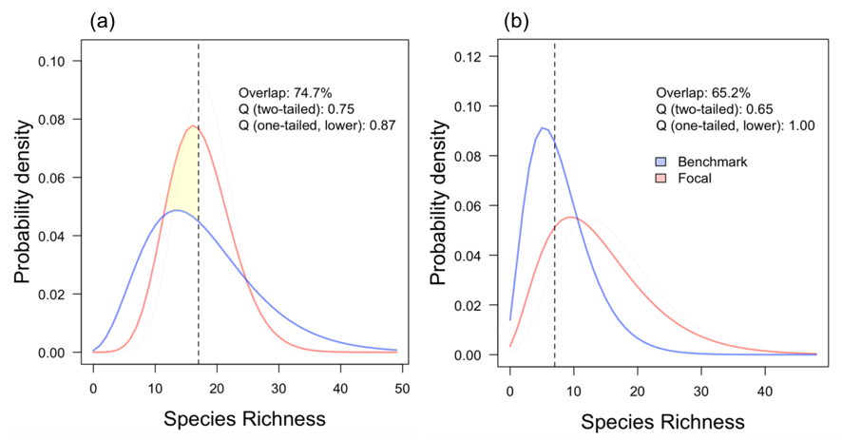
Fig. S1. One-tailed overlap-based quality discounted in the lower tail. In (a) the area of the focal probability density function (pdf) which exceeds the benchmark probability below the benchmark mean (yellow shaded area) is 0.13. This is subtracted from one to give a one-tailed quality of 0.87. In (b) the focal distribution does not exceed the benchmark distribution in the lower tail and one-tailed quality is therefore 100%. Two-tailed (overlap-based) quality shown for comparison. Vertical dashed line: benchmark mean.
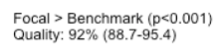
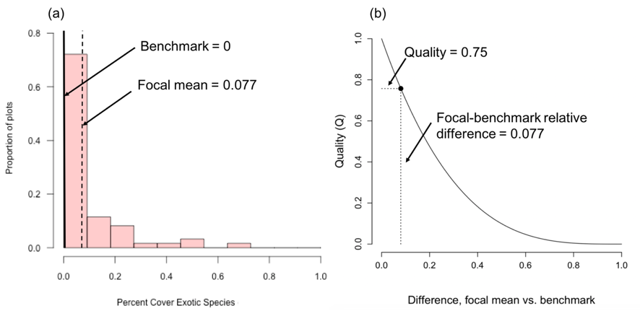
Fig. S2. Fixed-benchmark quality of a beta-distributed indicator (Percent cover of exotic species). (a) Mean of focal distribution (0.077) compared to fixed benchmark value (0). (b) Beta function used to transform the difference between the focal and benchmark means into a quality score over [0,1].
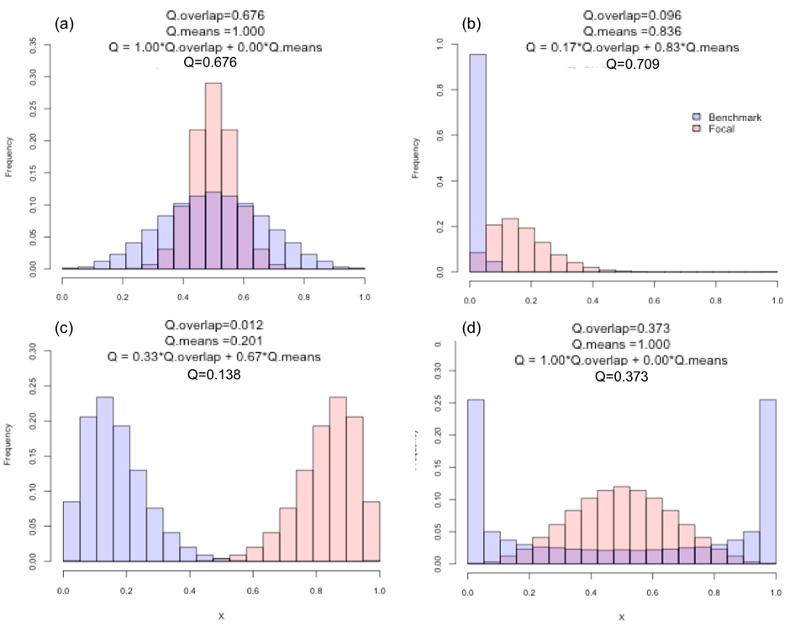
Fig. S3. Example quality calculations for beta-distributed indicators using the combined overlap-means comparison algorithm. (a) Focal distributions leptokurtic, both means = 0.5, quality based on overlap only. (b) Benchmark distribution zero-inflated, mean ≈ 0; focal mean slightly > 0; quality based mostly on means. (c) Benchmark mean ≈ 0.2, focal mean ≈ 0.8; quality based on both means and overlap. (d) Focal distribution unimodal & symmetrical, benchmark bimodal with peaks near 0 and 1; both means = 0.5, quality based on overlap only. Q.overlap: overlap-base quality; Q.means: means-based based quality; Q: overlap-means quality.

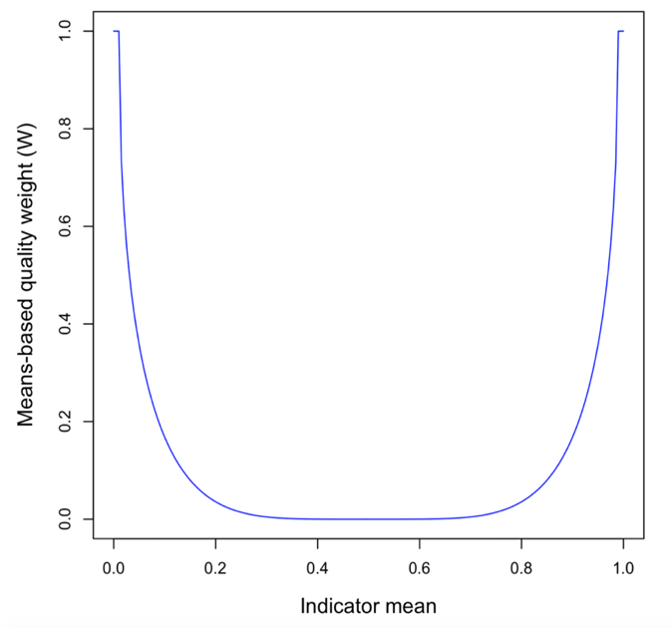
Fig. S4. Weighting function for mixed overlap-means quality for beta-distributed indicators.

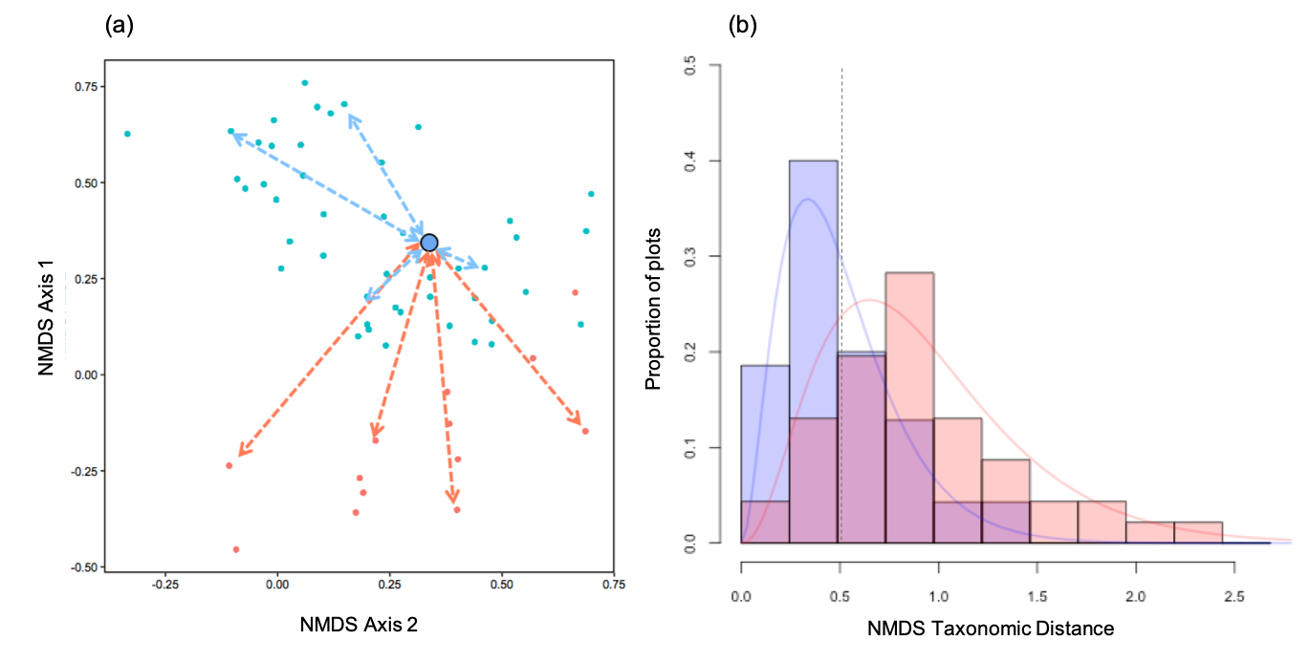
Fig. S5. Calculation of quality for indicator “Taxonomic distance” (TD). (a) Two-axis solution to an NMDS analysis of species composition of benchmark and focal plots. Indicator TD is the distance (double-headed arrows) from each plot to the benchmark centroid (blue circle with black outline). (b) Benchmark and focal sampling distributions (histograms) of TD with fitted probability density functions (pdf) based on the gamma distribution (curves). Vertical dashed line: benchmark mean. Pink: focal; blue: benchmark; purple: overlap.

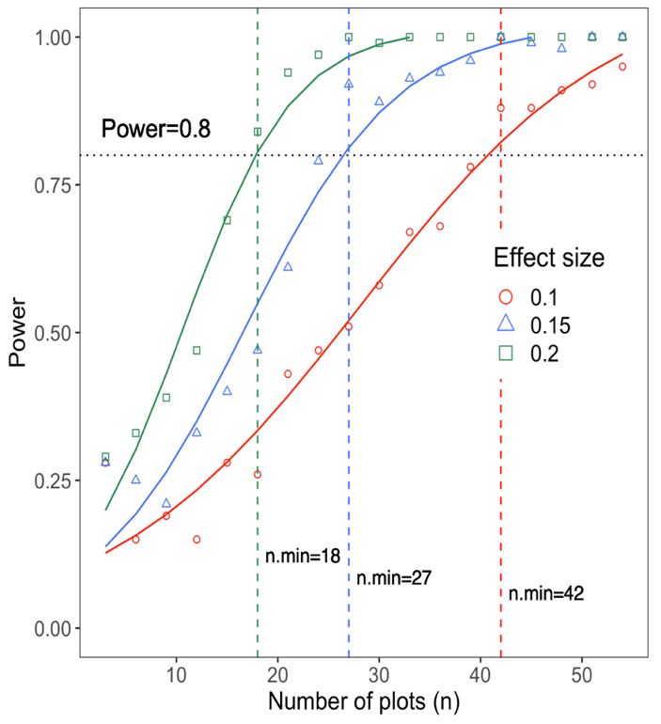
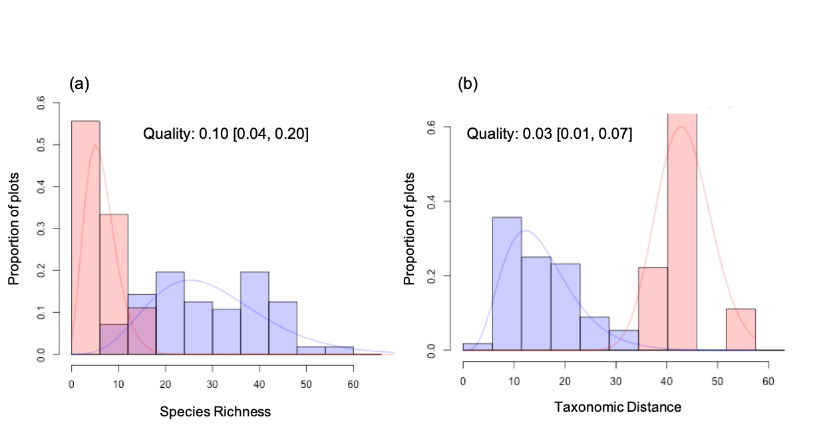
Fig. S7. Monte Carlo simulation of the relationship between sample size and power for quality of indicator Species Richness for vegetation "Avalanche Feature". Each point represent a simulations of the power to detect a known value of quality at a given target effect size, at the sample size shown. Curves are logistic fits to power simulations at the same effect size. Vertical dotted lines indicate the minimum sample sizes (n_{min}) required to detect a change equivalent to the effect size shown, at α=0.05 and power=0.8.

Fig. S6. Sampling distributions (histograms), probability density functions (curves) and quality [95% CLs in square brackets] of selected indicators for reclaimed Wet Forest, Early-mid. Pink: focal; blue: benchmark; purple: overlap.

References
Battaglia, M.A., Gannon, B., Brown, P.M., Fornwalt, P.J., Cheng, A.S., Huckaby, L.S., 2018. Changes in forest structure since 1860 in ponderosa pine dominated forests in the Colorado and Wyoming Front Range, USA. For. Ecol. Manage. 422, 147–160. https://doi.org/10.1016/j.foreco.2018.04.010
Bjorkman, A.D., Vellend, M., 2010. Defining historical baselines for conservation: Ecological changes since European settlement on Vancouver Island, Canada. Conserv. Biol. 24, 1559–1568. https://doi.org/10.1111/j.1523-1739.2010.01550.x
Cousineau, D., 2017. Varieties of confidence intervals. Adv. Cogn. Psychol. 13, 140–155. https://doi.org/10.5709/acp-0214-z
Damgaard, C.F., Irvine, K.M., 2019. Using the beta distribution to analyse plant cover data. J. Ecol. 107, 2747–2759. https://doi.org/10.1111/1365-2745.13200
Lonsdale, W.M., 1999. Global patterns of plant invasions and the concept of invasibility. Ecology 80, 8–11.
Shepherd, B., Jones, B., Sissons, R., Cochrane, J., Park, J., Smith, C.M., Stafl, N., 2018. Ten years of monitoring illustrates a cascade of effects of white pine blister rust and focuses whitebark pine restoration in the canadian Rocky and Columbia Mountains. Forests 9. https://doi.org/10.3390/f9030138
Steel, Z.L., Safford, H.D., Viers, J.H., 2015. The fire frequency-severity relationship and the legacy of fire suppression in California forests http://www.esajournals.org/doi/pdf/10.1890/ES14-00224.1. Ecosphere 6. https://doi.org/10.1890/ES14-00224.1
van Kleunen, M., Dawson, W., Essl, F., Pergl, J., Winter, M., Weber, E., Kreft, H., Weigelt, P., Kartesz, J., Nishino, M., Antonova, L. a., Barcelona, J.F., Cabezas, F.J., Cárdenas, D., Cárdenas-Toro, J., Castaño, N., Chacón, E., Chatelain, C., Ebel, A.L., Figueiredo, E., Fuentes, N., Groom, Q.J., Henderson, L., Inderjit, Kupriyanov, A., Masciadri, S., Meerman, J., Morozova, O., Moser, D., Nickrent, D.L., Patzelt, A., Pelser, P.B., Baptiste, M.P., Poopath, M., Schulze, M., Seebens, H., Shu, W., Thomas, J., Velayos, M., Wieringa, J.J., Pyšek, P., 2015. Global exchange and accumulation of non-native plants. Nature. https://doi.org/10.1038/nature14910

