Supplementary Information for

Hemispheric Asymmetric Response of Tropical Cyclones to CO₂ Emission Reduction
Chao Liu¹, Soon-Il An^{1,2,3*}, Jiuwei Zhao⁴, Seok-Woo Son⁵, Fei-Fei Jin⁶
¹Irreversible Climate Change Research Center, Yonsei University, Seodaemun-gu, Seoul 03722, Republic of Korea
²Department of Atmospheric Sciences, Yonsei University, Seodaemun-gu, Seoul 03722, Republic of Korea
³Division of Environmental Science and Engineering, Pohang University of Science and Technology (POSTECH), Pohang, Republic of Korea
⁴Collaborative Innovation Center on Forecast and Evaluation of Meteorological Disasters (CIC-FEMD), Institute of Climate and Application Research (ICAR), Nanjing University of Information Science & Technology (NUIST), Nanjing, China
⁵School of Earth and Environmental Sciences, Seoul National University, Seoul, South Korea
⁶Department of Atmospheric Sciences, School of Ocean and Earth Science and Technology (SOEST), University of Hawai‘i at Mānoa, Honolulu, HI 96822, USA
*Corresponding author: Soon-Il An (sian@yonsei.ac.kr)

This PDF file includes:
Supplementary Text 1
Supplementary Figures S1 to S12
Supplementary References

Supplementary Text S1. A brief introduction to the various GPI indices
To further validate the hysteresis effects of the large-scale circulation on TC formation, we also used three different definitions of GPI in addition to the DGPI, including the classical ENGPI¹, the improved GPI (GPI10)², which incorporates the saturation deficit to better represent the effect of midlevel water vapor, and the ventilation index (VI12)³, which represents the hostile cooler and drier airflow into the TC. Their detailed formulas are as follows:
$$\begin{aligned}ENGPI={{\left(ζ_{a850}×{10}^{5}\right)}^{1.5}{\left(\frac{{RH}_{600}}{50}\right)}^{3}{\left(\frac{MPI}{70}\right)}^{3}\left(1+0.1×V_{s}\right)}^{-2}\#\left(1\right)\end{aligned}$$
$$\begin{aligned}GPI10={{ζ_{a850}}^{3}{{×χ_{m}}^{-4/3}×MAX\left((MPI-35 ms^{-1}),0\right)}^{2}×\left(25 ms^{-1}+V_{s}\right)}^{-4}\#\left(2\right)\end{aligned}$$
$$\begin{aligned}VI12=\frac{U_{s}×χ_{m}}{MPI}\#\left(3\right)\end{aligned}$$
In the above equations, $ζ_{a850}$, RH₆₀₀, MPI, Vs, $χ_{m}$, and U_{S} represent the absolute vorticity (s⁻¹) at 850 hPa, the relative humidity (%) at 600 hPa, the maximum potential intensity (m s⁻¹), the vertical wind shear (m s⁻¹) between 200 hPa and 850 hPa, the midlevel moisture entropy deficit (unitless) at 600 hPa, and the vertical zonal wind shear (m s⁻¹) between 200 hPa and 850 hPa, respectively.
The maximum potential intensity (MPI)⁴ can be calculated as follows:
$$\begin{aligned}{MPI}^{2}=\frac{C_{k}}{C_{d}}\frac{SST-T_{o}}{T_{o}}\left(k_{0}^{*}-k\right)\#\left(4\right)\end{aligned}$$
where the $C_{k}$ is the exchange coefficient (J kg⁻¹ K⁻¹) for entropy and the $C_{d}$ is the drag coefficient (unitless). The value of $\frac{C_{k}}{C_{d}}$ in our study is 0.9. SST and $T_{o}$ are the sea surface temperature (K) and mean outflow temperature (K), respectively; $k_{0}^{*}$ and $k$ are the saturated enthalpy (K) at the sea surface and the enthalpy (K) of an ambient boundary layer air, respectively.
The midlevel moisture entropy deficit ($χ_{m}$) can be calculated as follows:
$$\begin{aligned}χ_{m}=\frac{s^{*}-s_{m}}{s_{0}^{*}-s^{*}} \#\left(5\right)\end{aligned}$$
$$\begin{aligned}s=c_{p}\log\left(T\right)-R_{d}\log\left(p_{d}\right)+\frac{L_{v}r_{v}}{T}-R_{v}r_{v}\log\left(RH\right)\#\left(6\right)\end{aligned}$$
where the $s_{m}$ is the midlevel moist entropy (J kg⁻¹ K⁻¹) at 600 hPa while the $s_{0}^{*}$ and $s^{*}$ are the saturation moist entropies (J kg⁻¹ K⁻¹) of the sea surface and the midlevel at 600 hPa. In Eq. 6, T is the temperature (K) and RH is the relative humidity (%). $p_{d}$ is the dry air partial pressure (Pa), $r_{v}$ is the mixing ratio (unitless), and the other parameters are constant. Specifically, the $c_{p}$ is the specific heat of dry air at constant pressure (1005.7 J kg⁻¹ K⁻¹), the $R_{d}$ is the gas constant for dry air (287 J kg⁻¹ K⁻¹), the $R_{v}$ is the gas constant for water vapor (461 J kg⁻¹ K⁻¹), and the $L_{v}$ is the specific latent heat of vaporization (2.26e6 J kg⁻¹).
Our analysis results suggest that all the above three GPI indices consistently capture the hemispheric asymmetric hysteresis phenomenon of TC formation to CO₂ reduction, despite the notable magnitude and spatial structural differences arising from their definitions. In particular, the VI12 is constructed to represent the large-scale environment hostile to cyclogenesis and thus shows the opposite sign of the evolution trajectories (Supplementary Fig. S3) and hysteresis pattern (Supplementary Fig. S4) compared to other GPIs. Considering that the subtropical to midlatitude regions and the Pacific cold tongue region are climatologically less favorable for TC formation than the deep tropics, the higher climatological ventilation index in the former region also leads to larger hysteresis centers in these areas. Although the ENGPI generally shows similar evolution trajectories of TC hysteresis as the DGPI and GPI10, its absolute magnitude is more positive than other GPIs (Supplementary Fig. S3). This may be related to the main contribution of the MPI term⁵, which increases everywhere with the projected increase in absolute SST, masking the effects of other dynamical factors. However, such systematic influences on the hysteresis phenomenon can be largely reduced by accessing the differences between the N3 and P1 time slices in the IRCC experiment, resulting in highly identical hemispheric asymmetric patterns in the ENGPI changes (Supplementary Fig. S4).

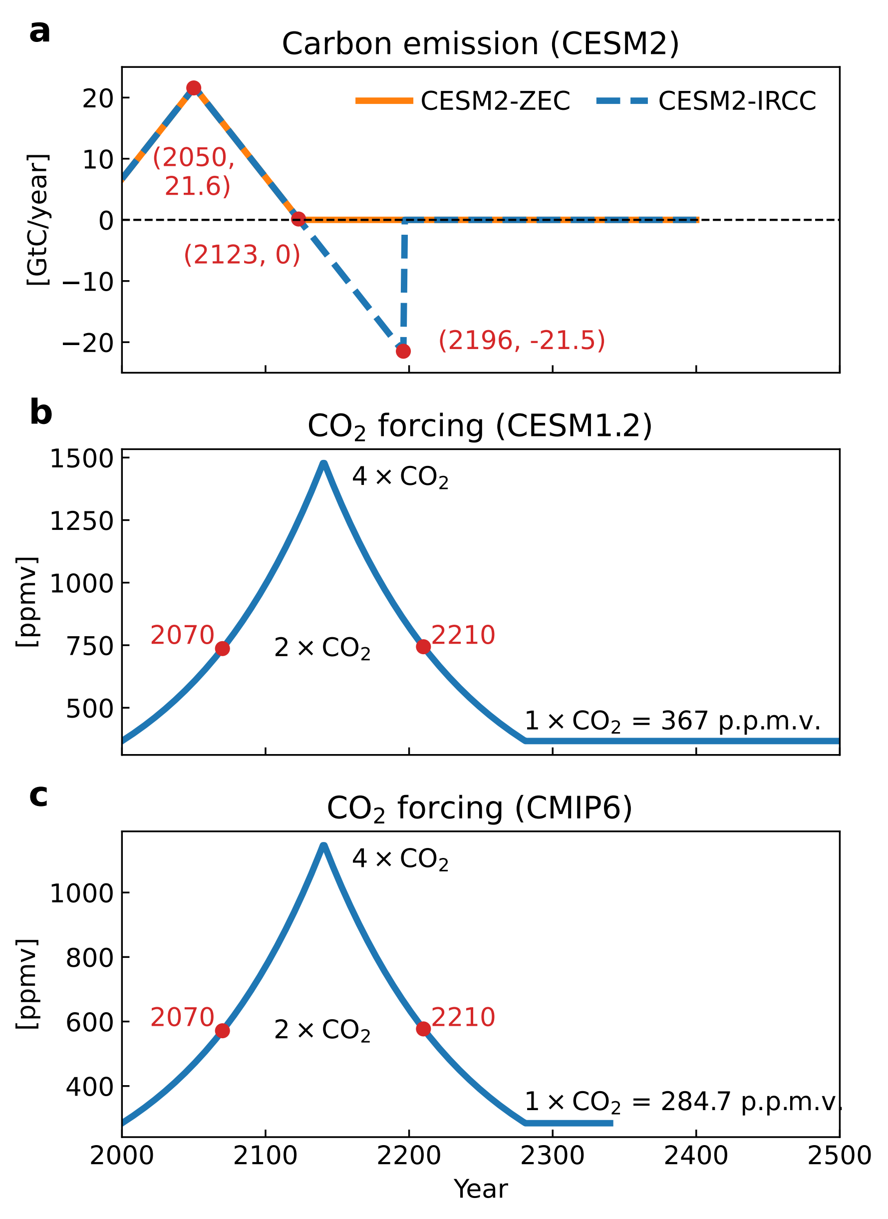
Fig. S1 External forcing in different CO₂ mitigation experiments. (a) Time series of global carbon emissions (GtC year⁻¹) applied in the CESM2 ZEC (orange line) and IRCC (blue dashed line) experiments. In both setups, carbon emission starts from 6.7 GtC year⁻¹ in 2000, increases linearly to a peak of 21.6 GtC year⁻¹ in 2050, and then declines to zero in 2123. The ZEC experiment maintains this net-zero emission until the end of the simulation (i.e., year 2400), while the carbon emission in the IRCC experiment continues to decrease to a negative minimum of -21.5 GtC year⁻¹ in 2196, and abruptly shifts to zero and remains there for the remaining period. Time series of CO₂ concentration (p.p.m.v.) applied in (b) the CESM1.2 and (c) the CMIP6 experiments. The CO₂ trajectories consist of a 1% yr⁻¹ increase for 140 years until the concentration quadruples (4×CO₂, ramp-up period); and a subsequent symmetric 1% yr⁻¹ decrease for another 140 years until it returns to the initial level (1×CO₂, ramp-down period). The CO₂ forcing in the CESM1.2 model and CMIP6 models differ from each other in terms of the initial levels, which are 367 p.p.m.v. and 284.7 p.p.m.v., respectively. Red dots in each plot denote some key coordinates of the forcing.

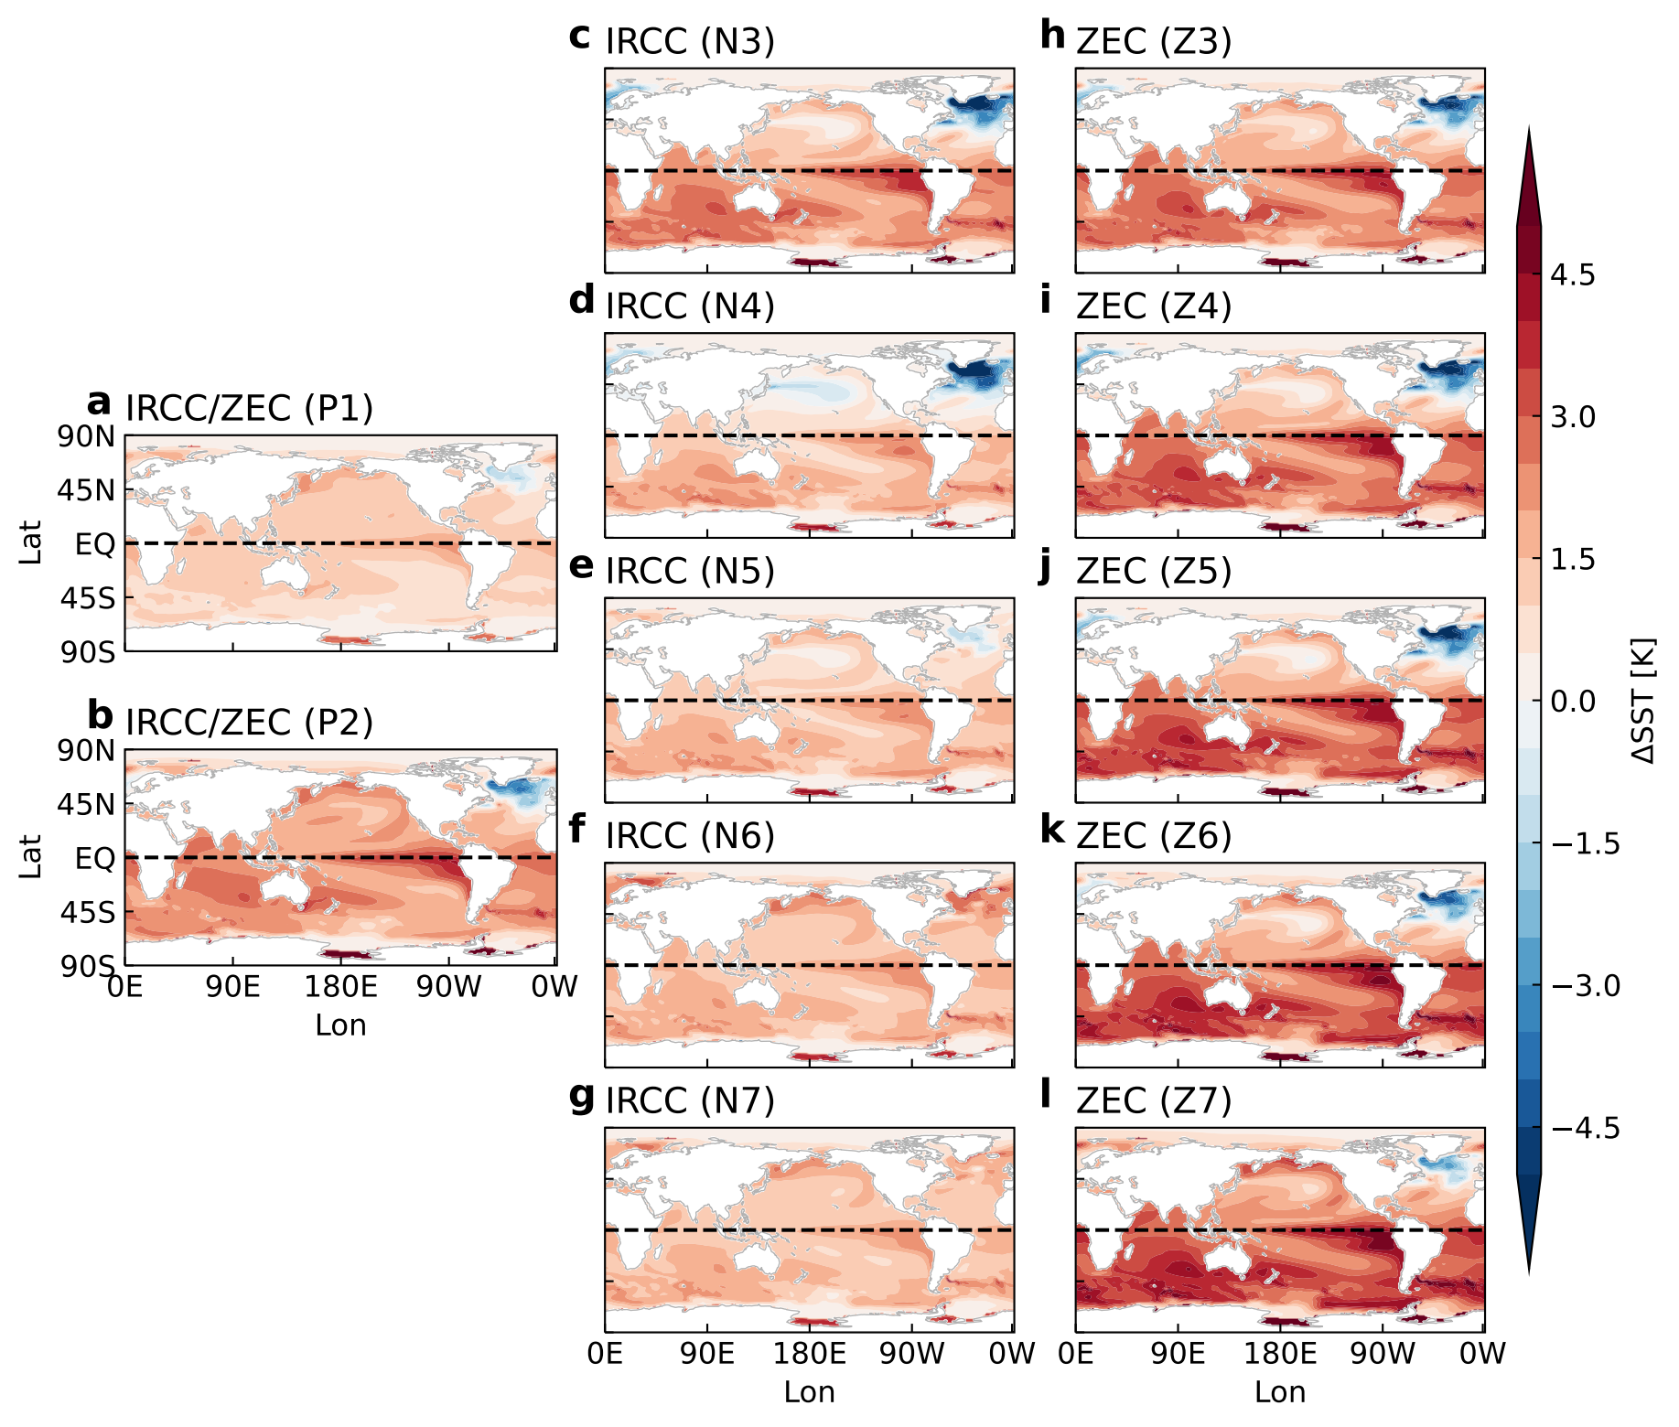
Fig. S2 Changes in SST forcing applied in the HiRAM model. CESM2 ensemble-averaged annual SST changes relative to the CTRL simulation, averaged over a 31-year window centered on the time slice of (a) P1, (b) P2, (c) N3, (d) N4, (e) N5, (f) N6, (g) N7, (h) Z3, (i) Z4, (j) Z5, (k) Z6, (l) Z7 in the IRCC and ZEC experiments, respectively.

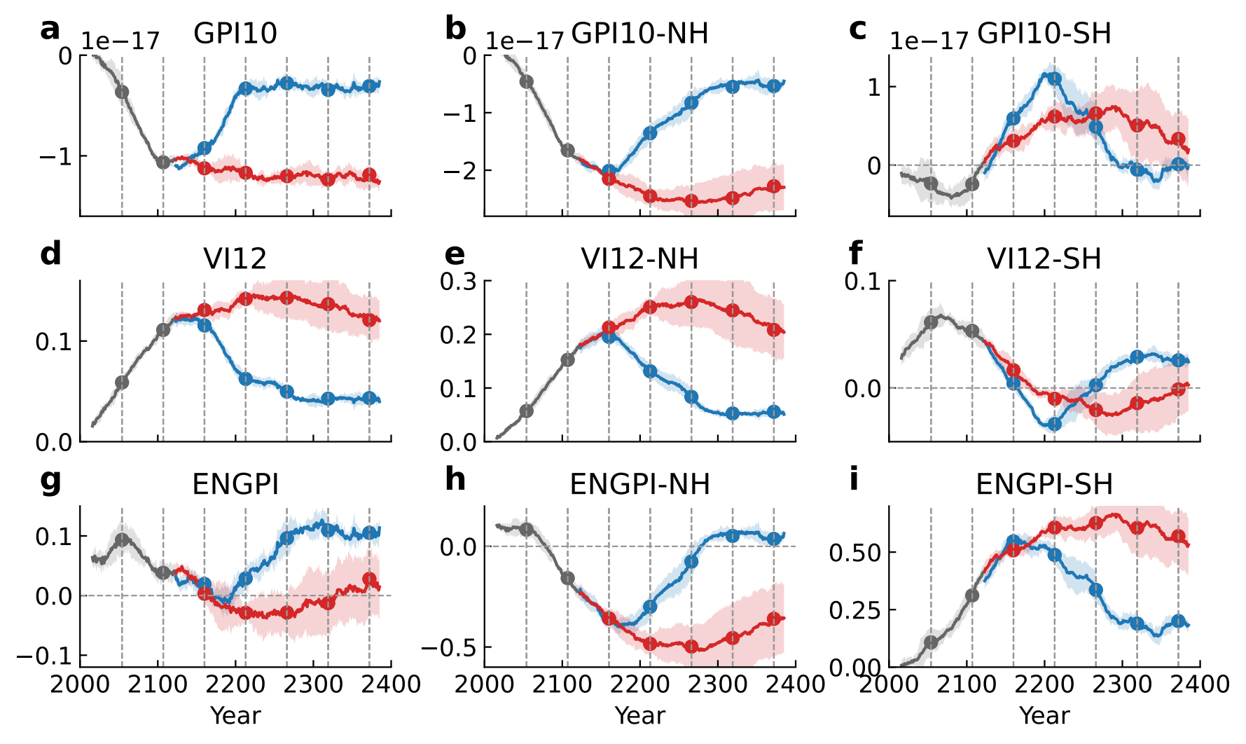
Fig. S3 Evolution of different GPI indices in the CESM2. CESM2 ensemble-averaged time series of GPI10 (unitless) changes averaged in the (a) global, (b) northern hemisphere, and (c) southern hemisphere of the main TC genesis region. (d)-(f) as (a)-(c), but for the ventilation index. (g)-(i) as (a)-(c), but for the ENGPI. In each plot, the red and blue colors represent the decarbonization phases of the ZEC and IRCC experiments, respectively, while the gray line represents their common ramp-up period. Dots and vertical dashed lines are used to denote the equally spaced time slices centered at the years 2054 (P1), 2107 (P2), 2160 (Z3/N3), 2213 (Z4/N4), 2266 (Z5/N5), 2319 (Z6/N6), and 2372 (Z7/N7). Colored shading represents two inter-member standard deviation spreads. The main TC genesis region is outlined in Figure 2 and consists of two parts, the northern hemisphere (5°-30°N, 100°E-360°E) and the southern hemisphere (5°-30°S, 40°E-220°E). The Δ symbol indicates the ensemble-averaged change relative to the climatological value in the control simulation. See Supplementary Text 1 for definitions and discussion of different GPI indices.

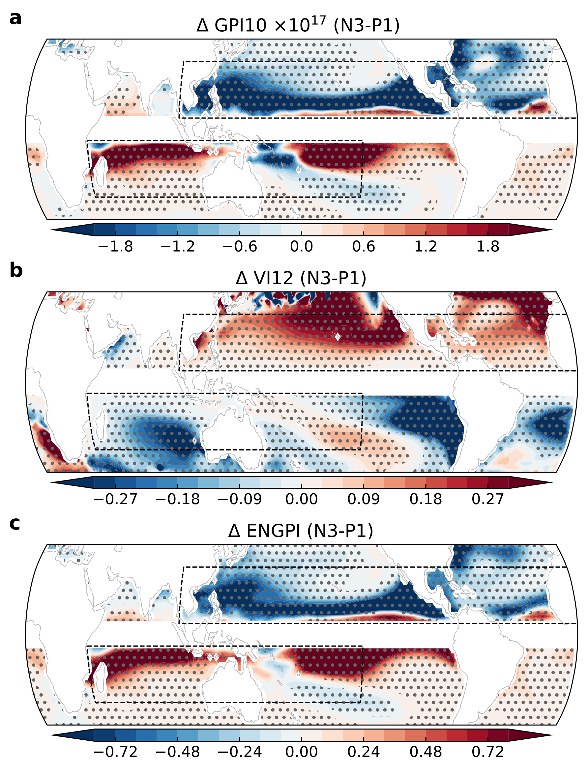
Fig. S4 Hysteresis maps of different GPI indices in the CESM2. (a) CESM2 ensemble-averaged GPI10 difference between two 31-year windows centered on the P1 and N3 time slices of the IRCC experiment. (b), (c) as (a), but for ventilation index (VI12) and ENGPI, respectively. The outlined main TC genesis region is the same as those in Figure 2, which consists of two parts, the northern hemisphere (5°-30°N, 100°E-360°E) and the southern hemisphere (5°-30°S, 40°E-220°E). Values exceeding the 90% confidence level are stippled. See Supplementary Text 1 for definitions and discussion of different GPI indices.

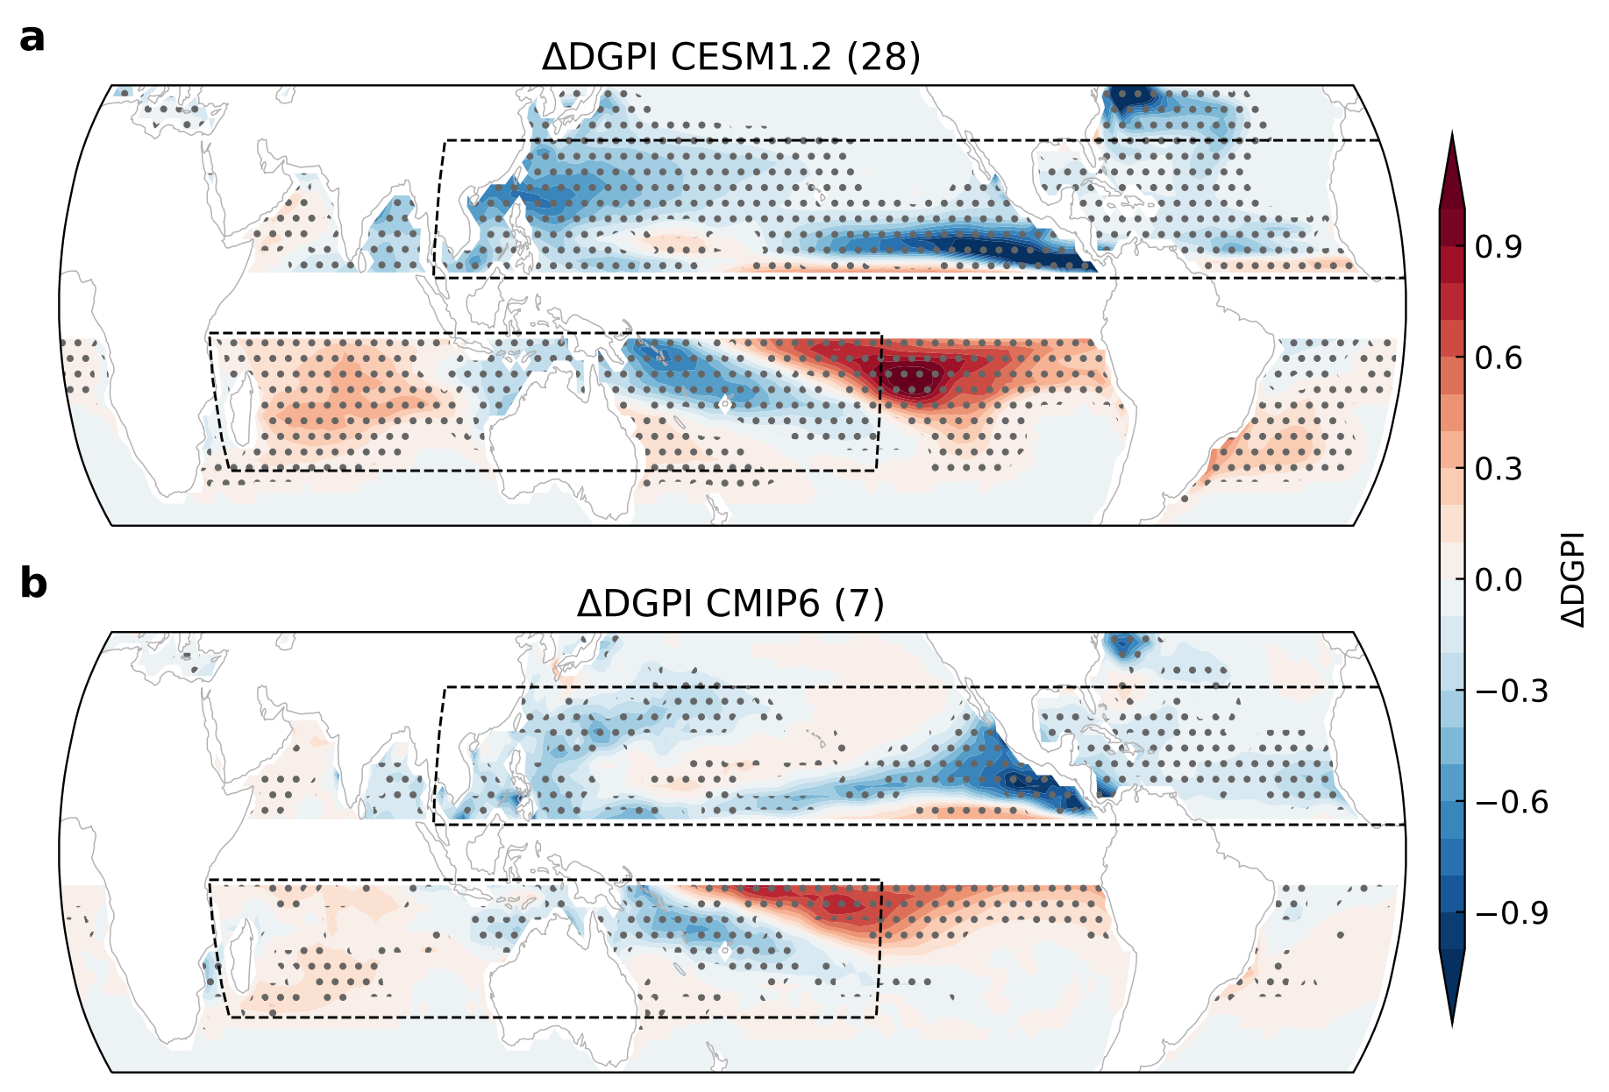
Fig. S5 Hysteresis maps of the DGPI in other climate models. Difference maps of ensemble-mean DGPI changes averaged over a 31-year window centered in the middle of the CO₂ ramp-down (210th year) and ramp-up (70th year) periods in the (a) CESM1.2 model and the (b) CMIP6 models. Stippled areas in (a) denote values exceeding the 90% confidence level based on the two-tailed Student's t-test while those in (b) indicate that 70% (i.e., 5 out of 7) of the models agree with the sign of the multi-model ensemble mean differences.

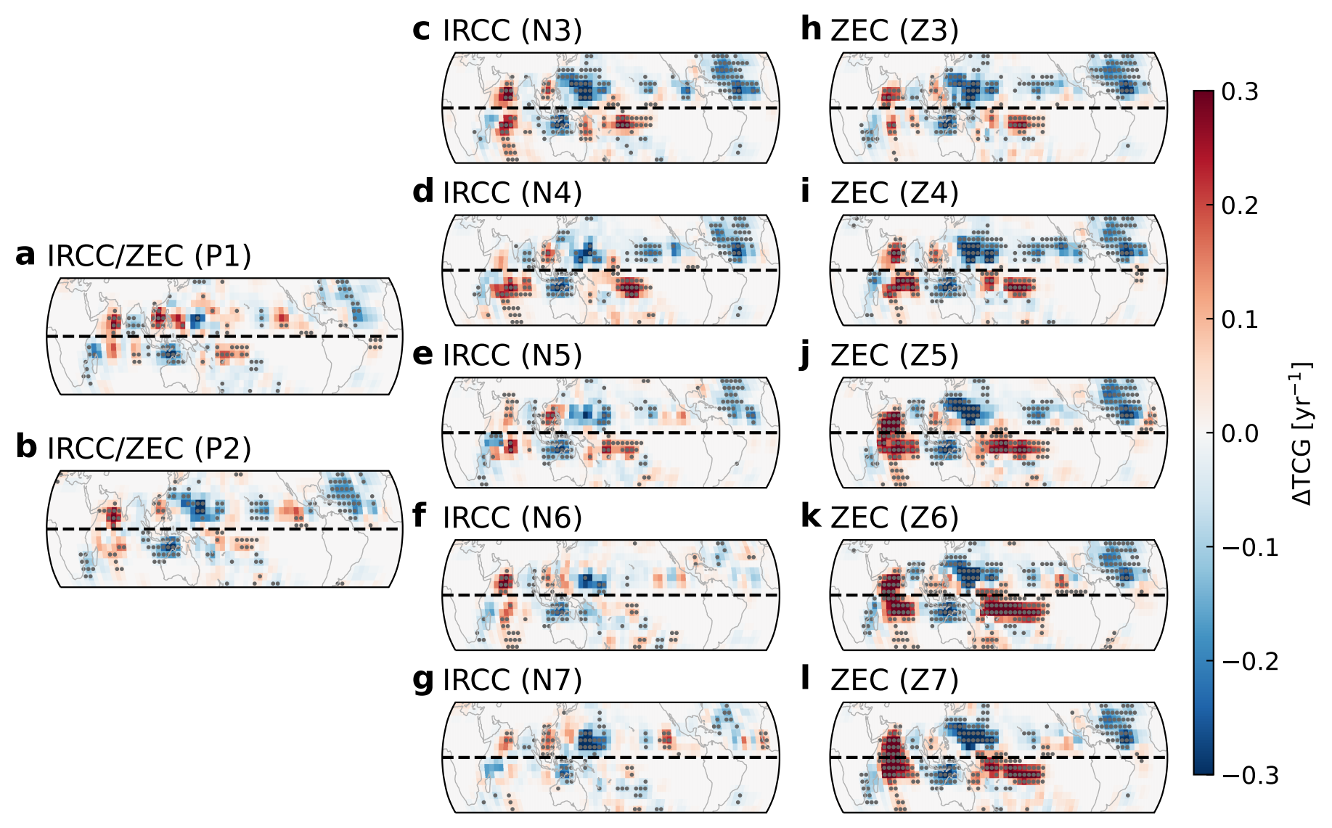
Fig. S6 Changes in TC genesis density in the HiRAM model. HiRAM ensemble-averaged annual TC genesis frequency (unit: year⁻¹) changes relative to the CTRL simulation, driven by SST forcing averaged over a 31-year window centered on the time slice of (a) P1, (b) P2, (c) N3, (d) N4, (e) N5, (f) N6, (g) N7, (h) Z3, (i) Z4, (j) Z5, (k) Z6, (l) Z7 in the IRCC and ZEC experiments, respectively. Values exceeding the 90% bootstrap confidence level are stippled.

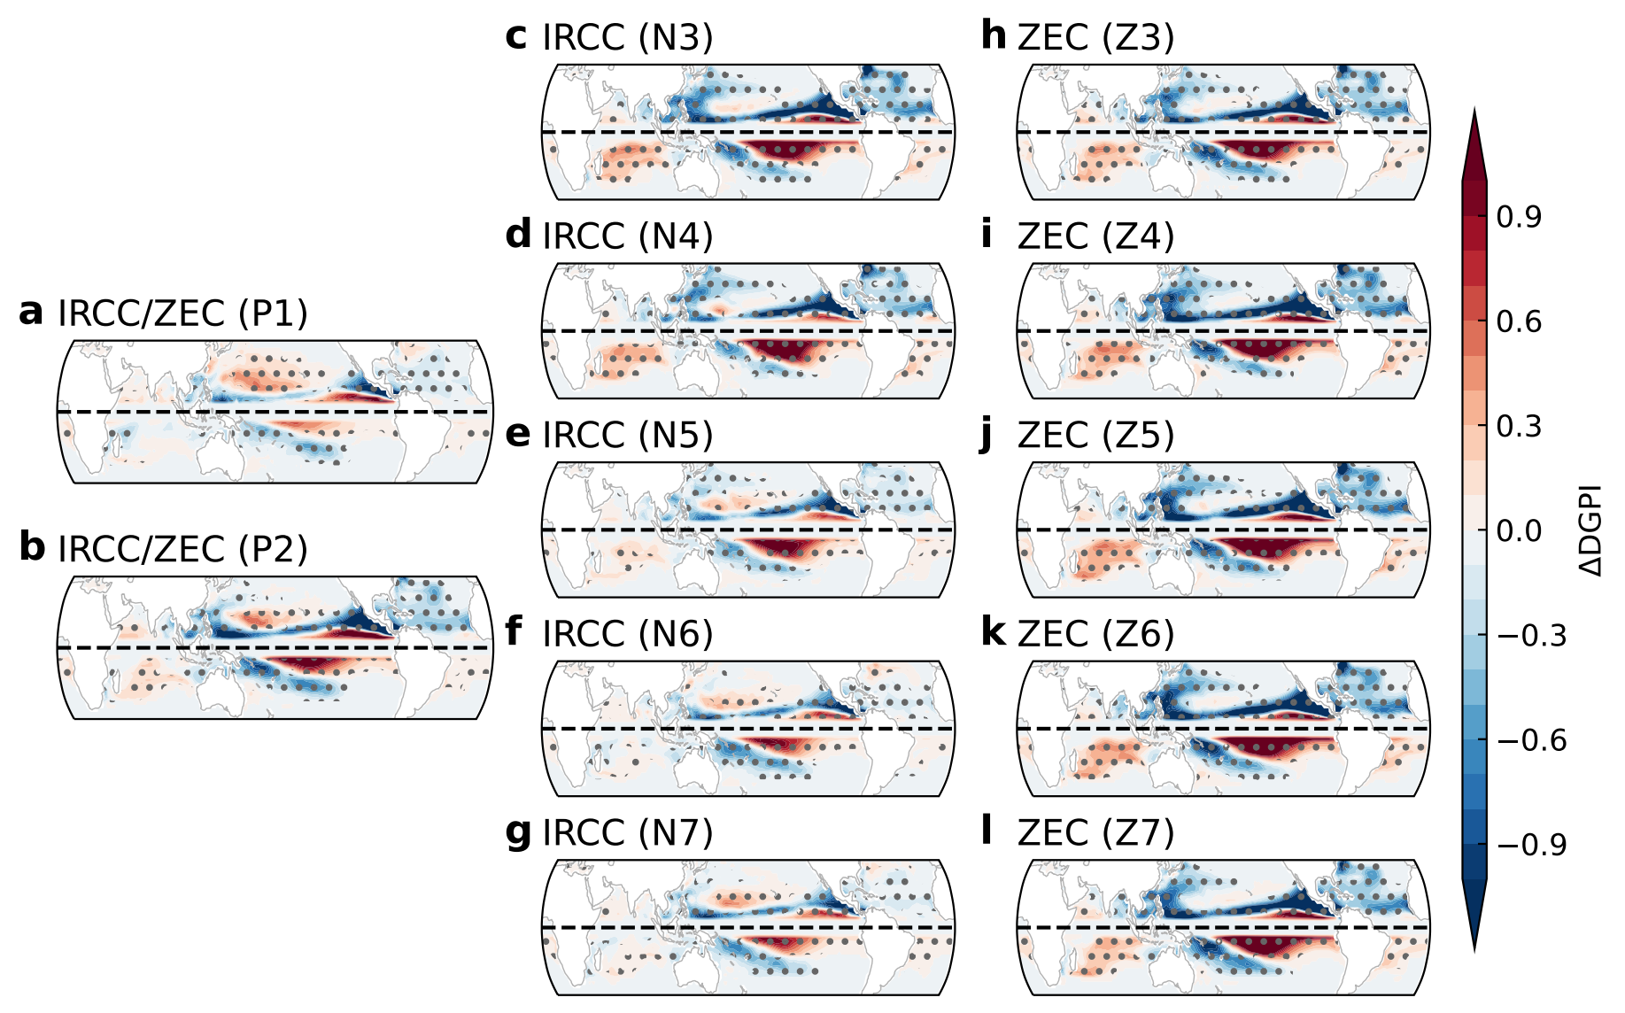
Fig. S7 Changes in DGPI patterns in the CESM2 model. CESM2 ensemble-averaged annual DGPI changes relative to the CTRL simulation, averaged over a 31-year window centered on the time slice of (a) P1, (b) P2, (c) N3, (d) N4, (e) N5, (f) N6, (g) N7, (h) Z3, (i) Z4, (j) Z5, (k) Z6, (l) Z7 in the IRCC and ZEC experiments, respectively. Values exceeding the 90% two-tailed Student’s-t test confidence level are stippled.

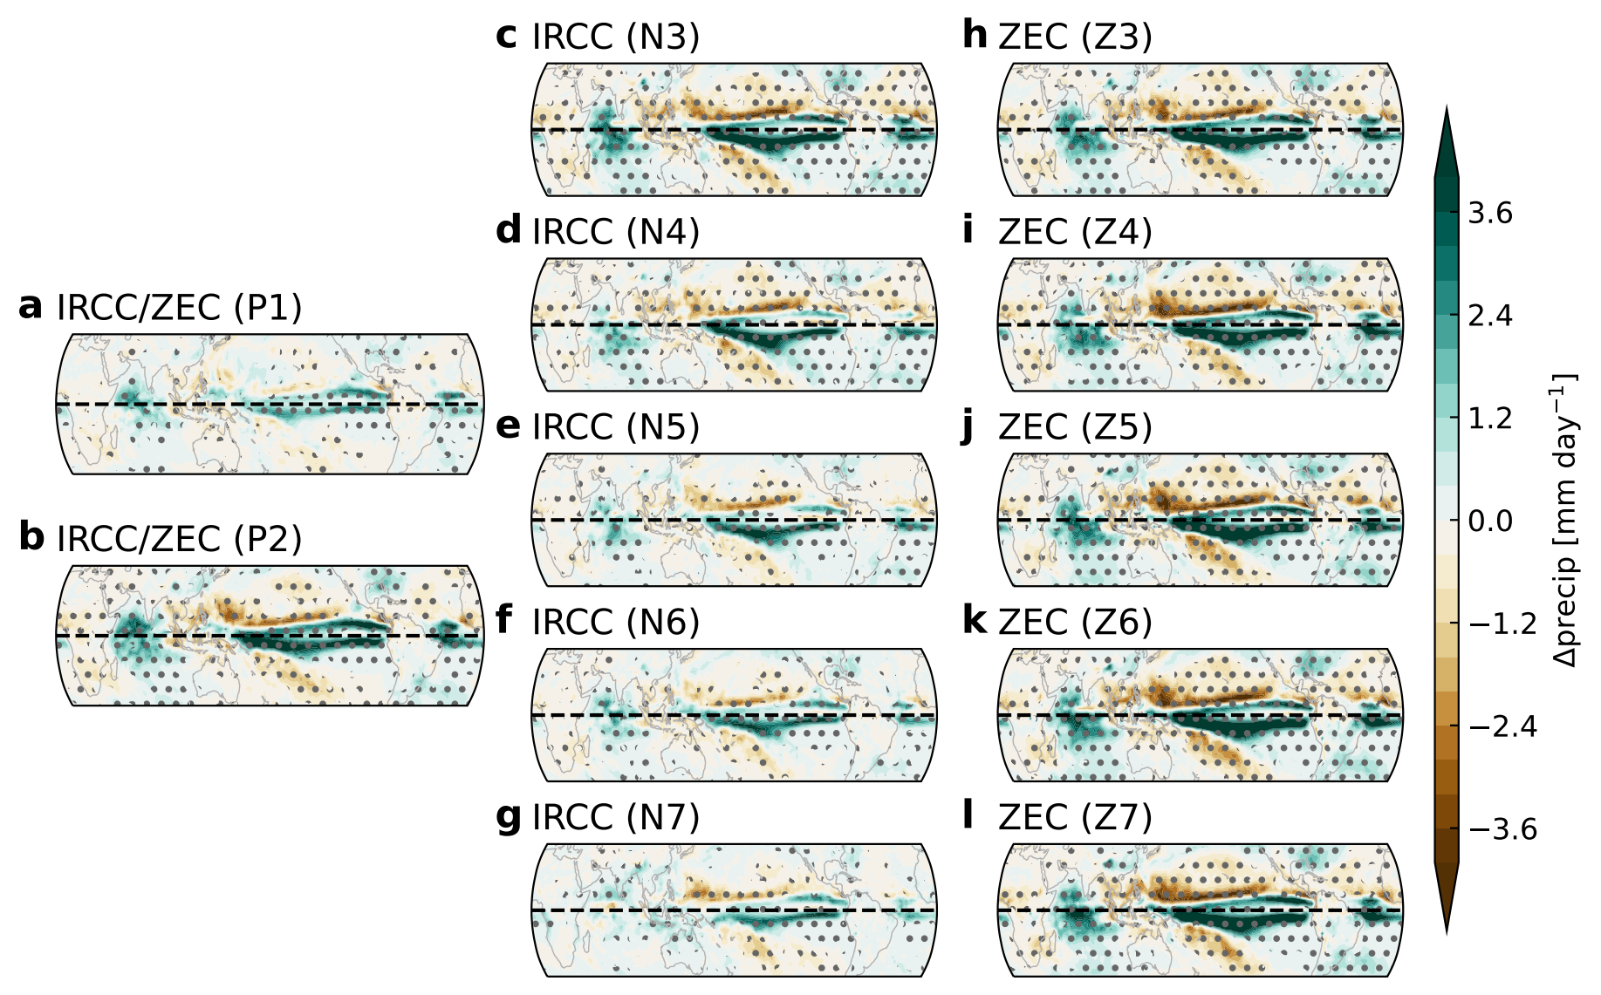
Fig. S8 Changes in precipitation in the HiRAM model. HiRAM ensemble-averaged annual precipitation (unit: mm/day) changes relative to the CTRL simulation, driven by SST averaged over a 31-year window centered on the time slice of (a) P1, (b) P2, (c) N3, (d) N4, (e) N5, (f) N6, (g) N7, (h) Z3, (i) Z4, (j) Z5, (k) Z6, (l) Z7 in the IRCC and ZEC experiments, respectively. Values exceeding the 90% two-tailed Student’s-t confidence level are stippled.

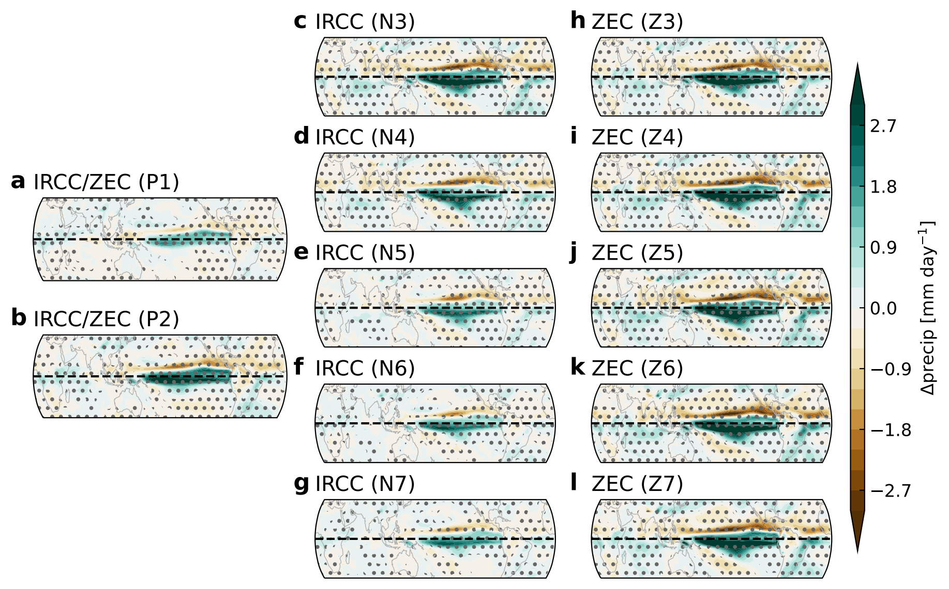
Fig. S9 Changes in precipitation in the CESM2 model. CESM2 ensemble-averaged annual precipitation (unit: mm/day) changes relative to the CTRL simulation, averaged over a 31-year window centered on the time slice of (a) P1, (b) P2, (c) N3, (d) N4, (e) N5, (f) N6, (g) N7, (h) Z3, (i) Z4, (j) Z5, (k) Z6, (l) Z7 in the IRCC and ZEC experiments, respectively. Values exceeding the 90% two-tailed Student’s-t confidence level are stippled.

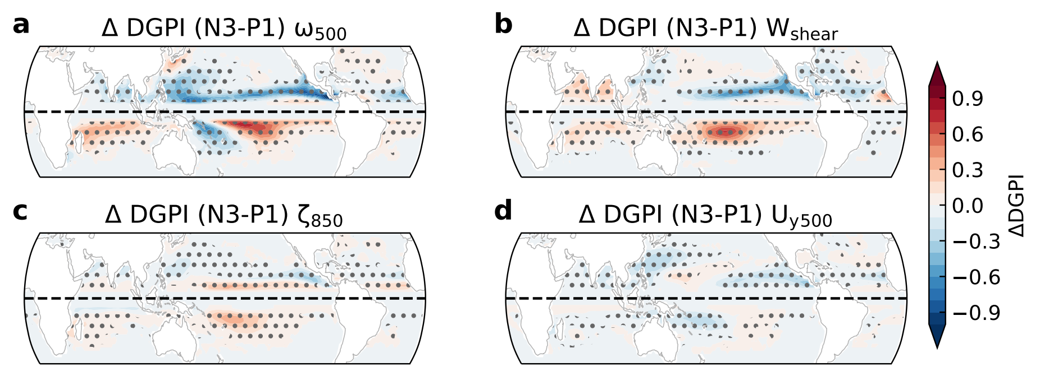
Fig. S10 Decomposition of the DGPI hysteresis in the CESM2 model. CESM2 ensemble-averaged DGPI differences between the N3 and P1 time slices contributed by the (a) 500 hPa vertical velocity, (b) vertical wind shear between the 200 hPa and 850 hPa, (c) 850 hPa absolute vorticity and (d) meridional shear vorticity of 500 hPa zonal wind. Values exceeding the 90% confidence level are stippled.

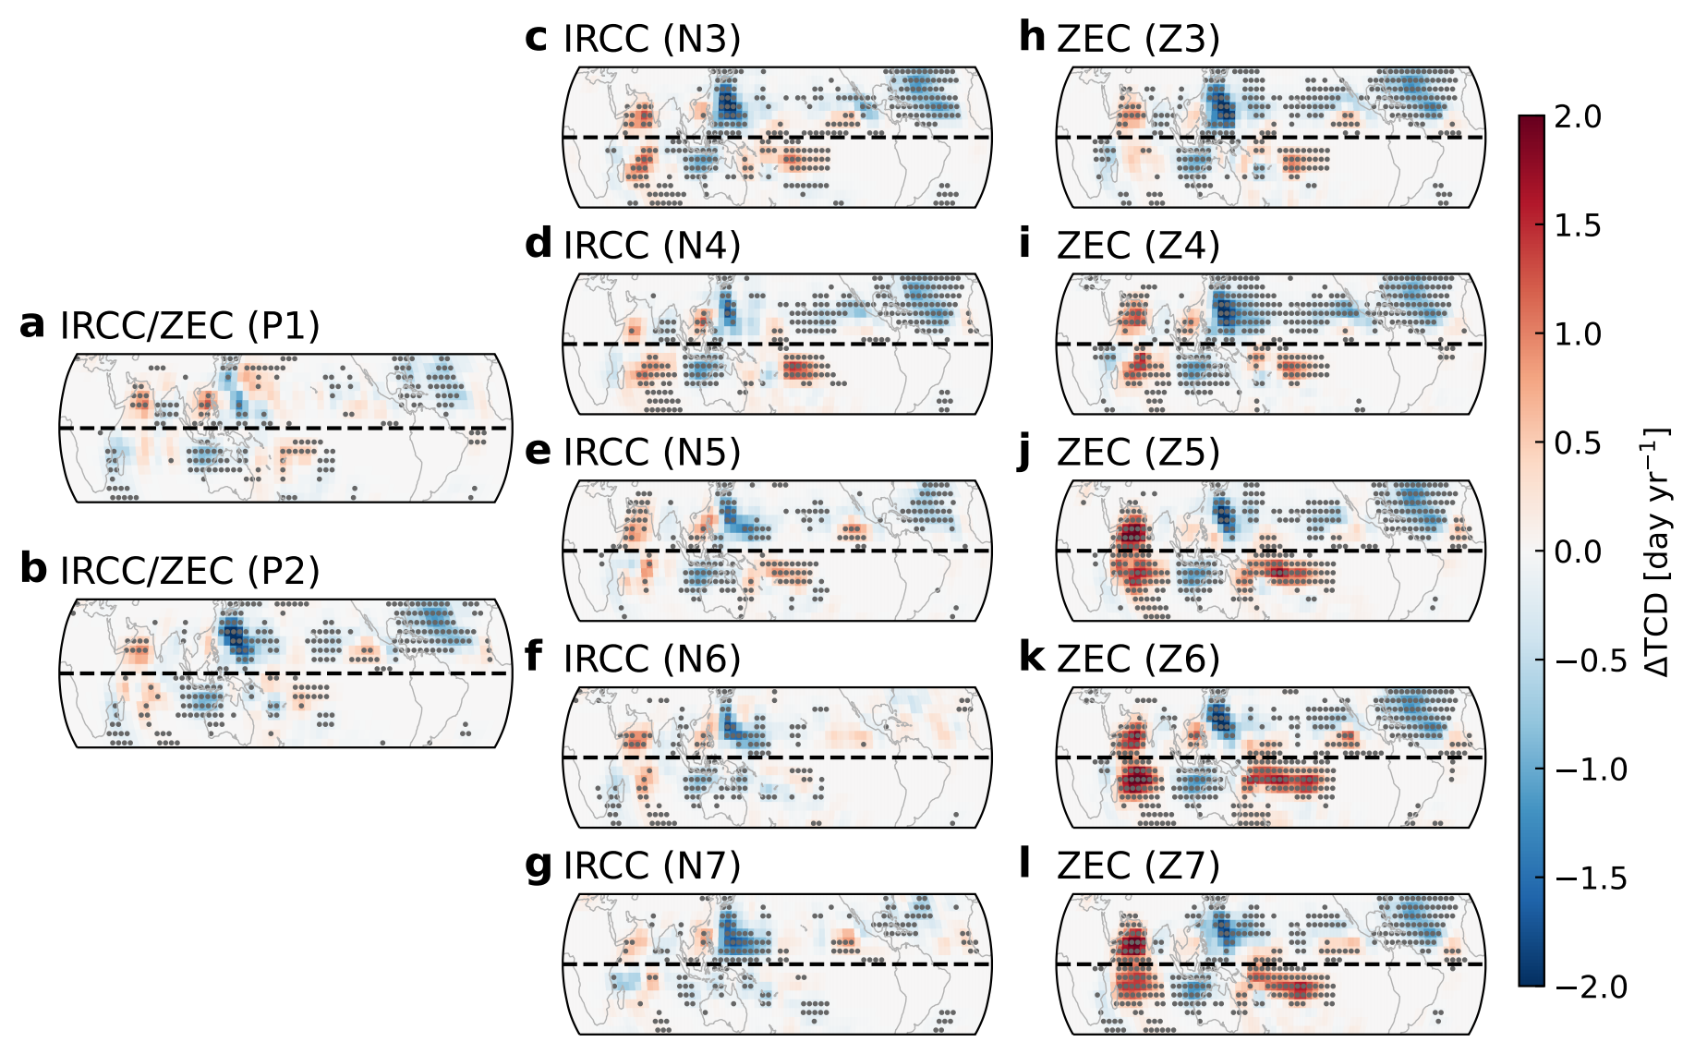
Fig. S11 Changes in TC days in the HiRAM model. HiRAM ensemble-averaged annual TC days (unit: year⁻¹) changes relative to the CTRL simulation, driven by SST forcing averaged over a 31-year window centered on the time slice of (a) P1, (b) P2, (c) N3, (d) N4, (e) N5, (f) N6, (g) N7, (h) Z3, (i) Z4, (j) Z5, (k) Z6, (l) Z7 in the IRCC and ZEC experiments, respectively. Values exceeding the 90% bootstrap confidence level are stippled.

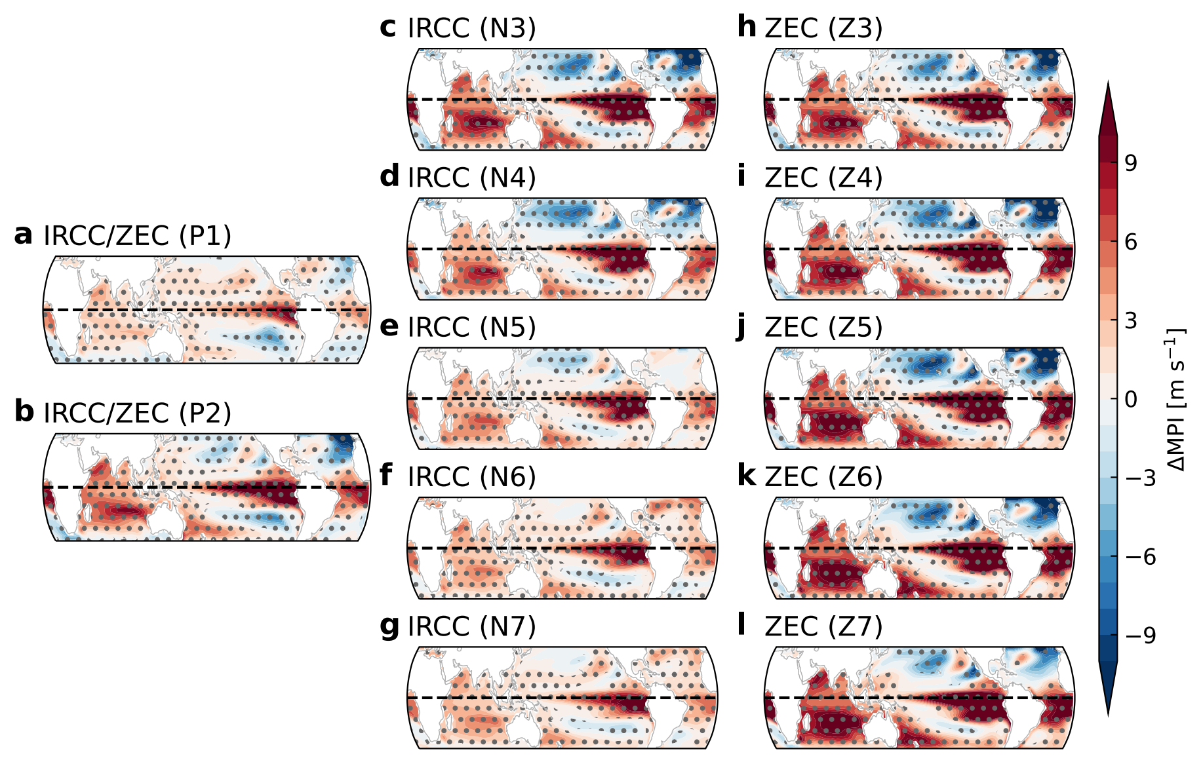
Fig. S12 Changes in maximum potential intensity in the CESM2 model. CESM2 ensemble-averaged maximum potential intensity (unit: m s⁻¹) changes relative to the CTRL simulation, averaged over a 31-year window centered on the time slice of (a) P1, (b) P2, (c) N3, (d) N4, (e) N5, (f) N6, (g) N7, (h) Z3, (i) Z4, (j) Z5, (k) Z6, (l) Z7 in the IRCC and ZEC experiments, respectively. Values exceeding the 90% confidence level based on the two-tailed Student’s-t test are stippled.

Supplementary References
1. Emanuel, K. A. & Nolan, D. S. Tropical cyclone activity and the global climate system. in Preprints, 26th conf. on hurricanes and tropical meteorology, Miami, FL, Amer. Meteor. Soc. A vol. 10 (2004).
2. Emanuel, K. Tropical cyclone activity downscaled from NOAA-CIRES Reanalysis, 1908–1958. J Adv Model Earth Syst 2, 1 (2010).
3. Tang, B. & Emanuel, K. A Ventilation Index for Tropical Cyclones. Bull Am Meteorol Soc 93, 1901–1912 (2012).
4. Emanuel, K. A. The dependence of hurricane intensity on climate. Nature 326, 483–485 (1987).
5. Murakami, H. & Wang, B. Patterns and frequency of projected future tropical cyclone genesis are governed by dynamic effects. Commun Earth Environ 3, 77 (2022).

