Periostin+ macrophages improved long bone regeneration in a mechanosensitive manner

Ziyan Wang¹, Minmin Lin¹, Yonghao Pan¹, Yang Liu¹, Chengyu Yang¹, Jianqun Wu¹, Yan Wang¹, Bingtong Yan¹, Jingjing Zhou¹, Chao Liu^{1,2}*

¹Department of Biomedical Engineering, Southern University of Science and Technology, Shenzhen, Guangdong, 518055, China
²Guangdong Provincial Key Laboratory of Advanced Biomaterials, Southern University of Science and Technology, Shenzhen, Guangdong, 518055, China

*Corresponding author
E-mail: liuc33@sustech.edu.cn

This PDF file includes:
Supplementary Figures 1 to 14
Supplementary Table 1

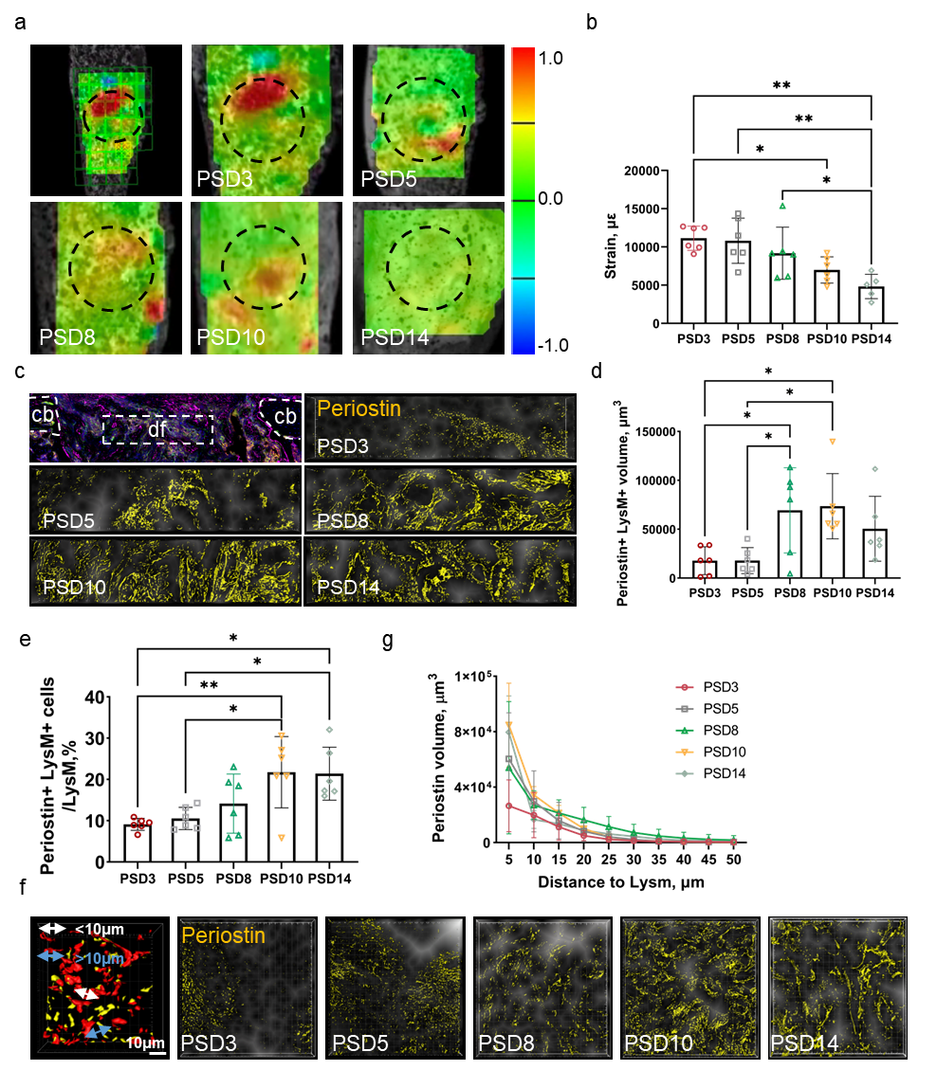
Supplementary Fig. 1 Periostin-expressing macrophage mediated bone regeneration. a Distribution of microstrain within the defect site in tdTomato mice on PSD 3, 5, 8, 10, and 14. b Quantification of the strain in tdTomato mice. n = 6. c Spatial location of macrophage and periostin in the defect site in tdTomato mice on PSD 3, 5, 8, 10, and 14. d Quantification of the periostin volume less than 10 microns from macrophages in the defect site. n = 6. e Quantification of the ratio of periostin+ LysM+ cells in total LysM+ cells in throughout the defect site from colocalization analysis. n = 6. f Spatial location analysis of periostin and macrophages throughout the defect site in tdTomato mice on PSD 3, 5, 8, 10, and 14. g Quantification of the periostin volume at different distance to macrophages. n = 6. cb= cortical bone, df= bone defect, PSD= postsurgical day. *P < 0.05; **P < 0.01; ***P < 0.001; ****P < 0.0001. Ordinary one-way ANOVA. Data were mean ± SD.

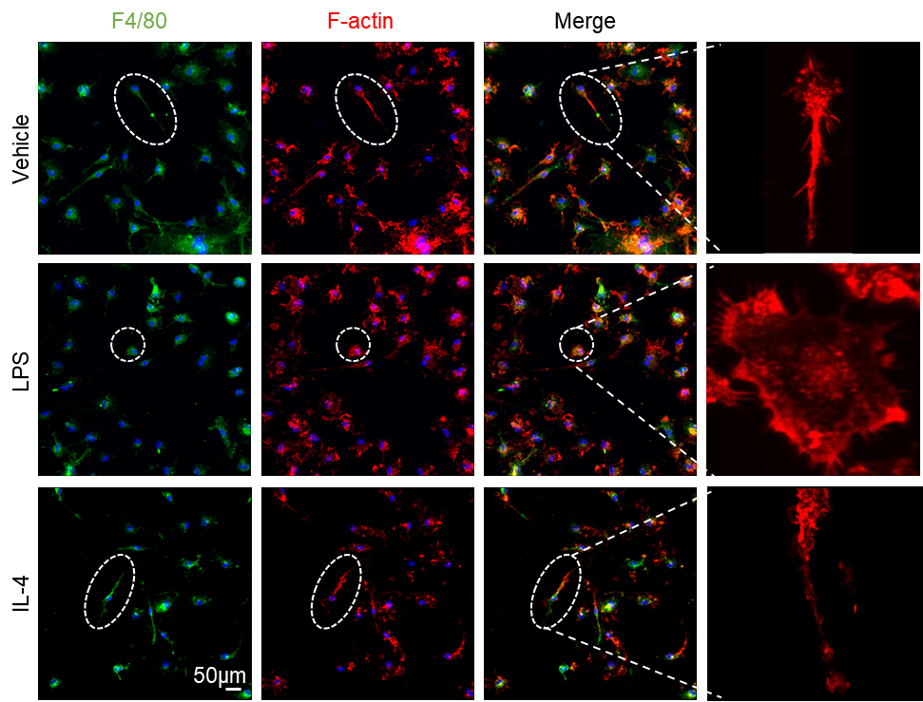
Supplementary Fig. 2 Induction of M1 and M2 polarization in macrophage. Immunofluorescence staining for the expression of F-actin and F4/80 within macrophages categorized into distinct subtypes: M0 subtype (vehicle-treatment), M1 subtype (LPS-treatment), and M2 subtype (IL-4-treatment).

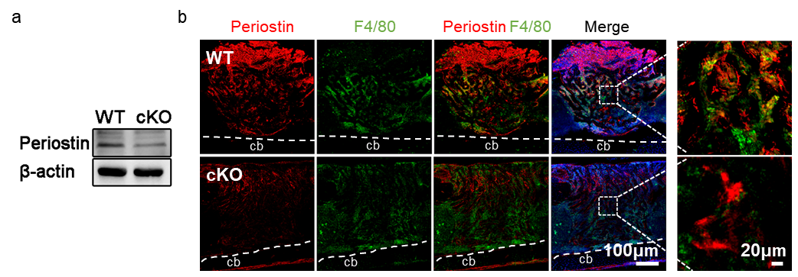
Supplementary Fig. 3 The validation of periostin knockout in macrophages. a Western blot analysis of the expression of periostin in BMDMs from WT or cKO mice. b Immunofluorescence assay of the colocalization of periostin and F4/80 in WT or cKO mice.

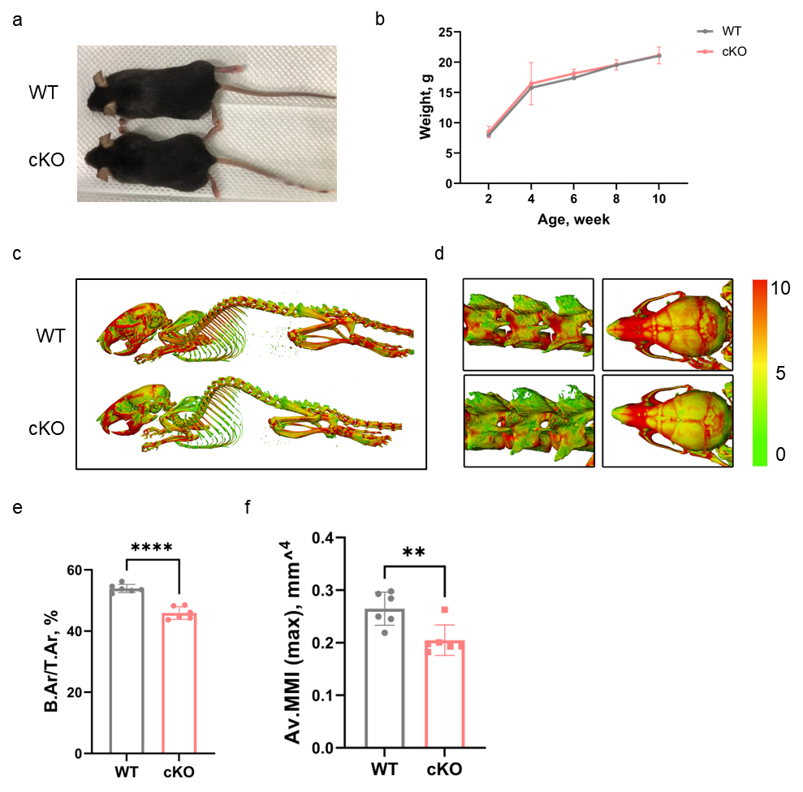
Supplementary Fig. 4 Knockout of periostin in macrophages led to diminished bone mass in mice. a Body sizes of WT or cKO mice at 12 weeks of age. b Body weight of WT or cKO mice from 2 to 12 weeks of age. c-d 3D Micro-CT images of (c) the whole-mount skeletal, and (d) spine and skull from WT or cKO mice. e-f Quantitative of the cortical bone Micro-CT parameters including, (e) B.Ar/T.Ar and (f) Av.MMI (Max) of WT or cKO mice. n = 6. **P < 0.01; ****P < 0.0001. Student’s t test. Data were mean ± SD.

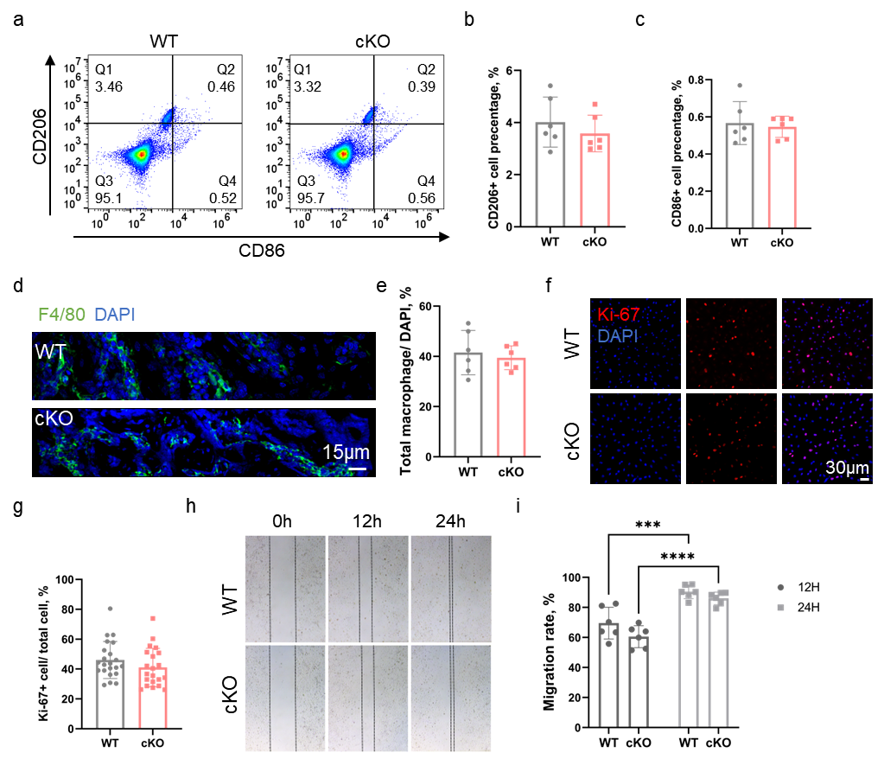
Supplementary Fig. 5 Knockout of periostin in macrophages did not impact macrophage proliferation and migration. a Flow cytometry analysis of CD86+ CD206- macrophages and CD86- CD206+ macrophages isolated from defect site in WT or cKO mice. b-c Quantification of the proportion of (b) CD206+ cells or (c) CD86+ macrophages in total cells. n = 6. d Immunofluorescence assay of the expression of F4/80 in the defect site of WT or cKO mice. e Quantification of the ratio of F4/80+ cells in WT or cKO mice. n = 6. f Immunofluorescence assay of Ki67+ BMDMs from WT or cKO mice. g Quantification of the ratio of Ki67+ BMDMs in WT or cKO mice. n = 6. h Cell scratch test results of BMDMs from WT or cKO mice after 0, 12, and 48 h in culture. i Quantification of the ratio of migration rate in BMDMs from WT or cKO mice. n = 6. **P < 0.01; ***P < 0.001; ****P < 0.0001. Ordinary two-way ANOVA or Student’s t test. Data were mean ± SD.

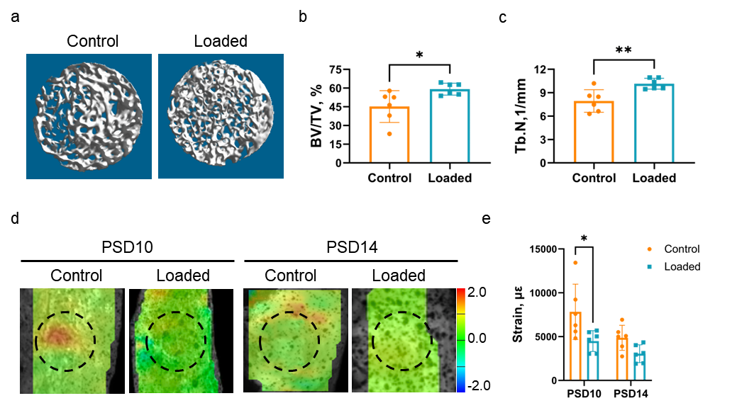
Supplementary Fig. 6 Mechanical loading increased bone formation and mechanical stiffness. a 3D Micro-CT images of new bone accrual isolated from WT mice on PSD 14 after MTD surgery in control and loaded tibia. b-c Quantitative parameters of Micro-CT analysis of new bone accrual including (b) BV/ TV and (c) Tb. N. n = 6. d Distribution of microstrain within the defect site in control and loaded tibia on PSD10 and 14. e Quantification of the strain in control and loaded tibia. n = 6. PSD = postsurgical day. *P < 0.05; **P < 0.01. Ordinary two-way ANOVA or Student’s t test. Data were mean ± SD.

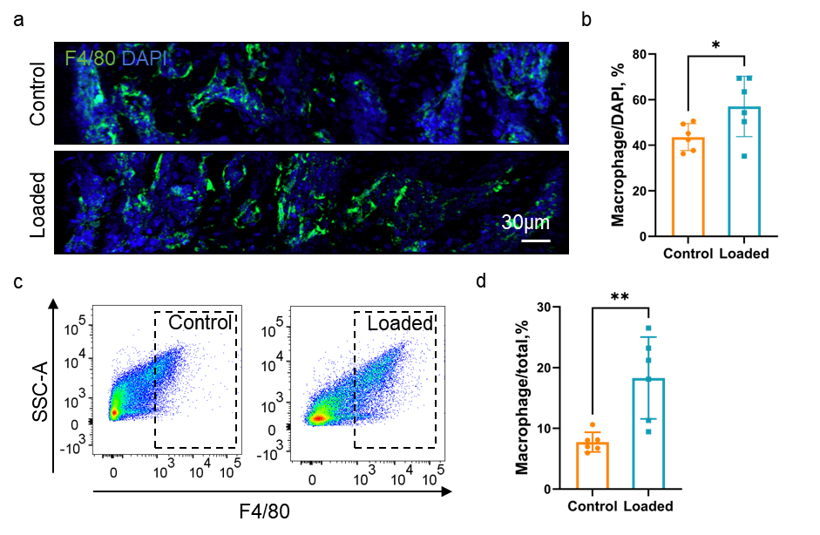
Supplementary Fig. 7 Mechanical loading increased the number of macrophages in bone defect during bone regeneration. a Immunofluorescence assay of the expression of F4/80+ macrophages in control and loaded tibia on PSD 10. b Quantification of the ratio of F4/80+ macrophages in total cells in response to mechanical loading. n = 6. c FACS analysis of F4/80+ macrophages isolated from defect site in in control and loaded tibia. d Quantification of the proportion of F4/80+ macrophages in total cells via FACS analysis. n = 6. *P < 0.05; **P < 0.01. Student’s t test. Data were mean ± SD.

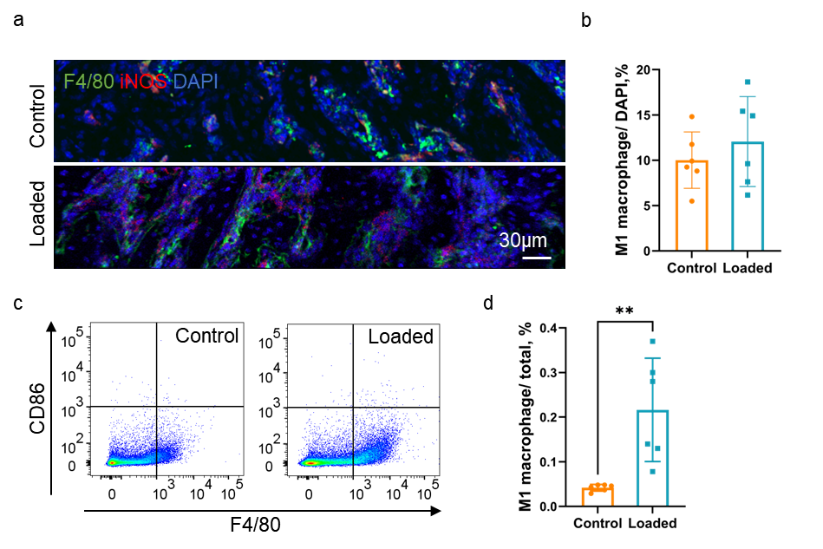
Supplementary Fig. 8 Mechanical loading promoted a minority toward M1 polarization in the bone defect. a Immunofluorescence assay of the expression of F4/80+ iNOS+ macrophages (M1 macrophages) in control and loaded tibia on PSD 10. b Quantification of the ratio of M1 macrophages in total cells in response to mechanical loading. n = 6. c FACS analysis of F4/80+ CD86+ macrophages (M1 macrophages) isolated from defect site in in control and loaded tibia. d Quantification of the proportion of M1 macrophages in total cells via FACS analysis. n = 6. PSD= postsurgical day. **P < 0.01. Student’s t test. Data were mean ± SD.

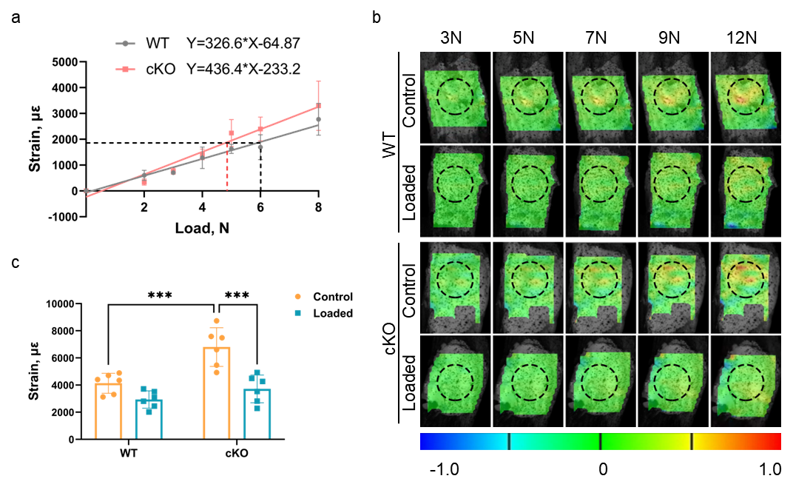
Supplementary Fig. 9 Mechanical loading rescued mechanically-weak new bone tissue caused by periostin knockout. a The strain magnitude of the defect site in WT or cKO mice under different loading actions. b Distribution of microstrain within the defect site in control and loaded tibia from WT or cKO mice in applied the force of 3, 5, 7 ,9, 12 N. c Quantification of the strain in control and loaded tibia. n = 6. ***P < 0.001. Ordinary two-way ANOVA. Data were mean ± SD.

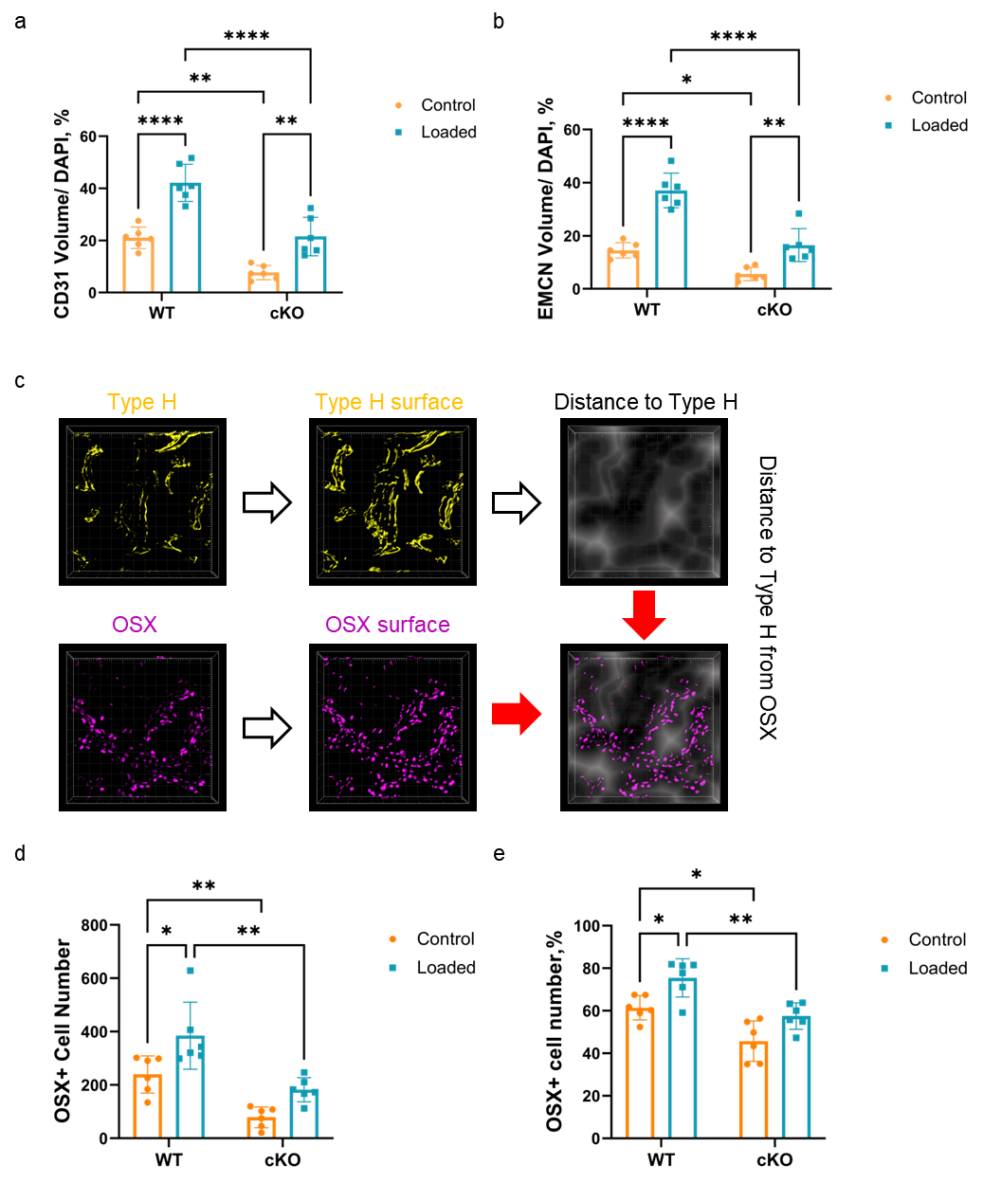
Supplementary Fig. 10 Mechanical loading alleviated low number of OSX+ cells in contact with type H vessels caused by periostin knockout. a-b Quantification of the volume of (a) CD31+, (b) EMCN+ blood vessels in control and loaded tibia. n = 6. c Schematic diagram of spatial location analysis between osteoblasts and blood vessels. d-e Quantification of the (d) number and (e) percentage of OSX+ cell numbers in the distance less than 10μm to type H vessels in control and loaded tibia. n = 6. *P < 0.05; **P < 0.01; ****P < 0.0001. Ordinary two-way ANOVA. Data were mean ± SD.

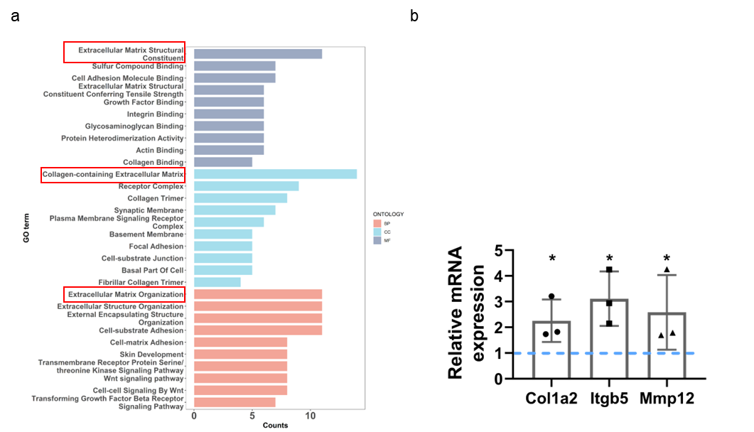
Supplementary Fig. 11 Mechanical loading regulated the bone extracellular matrix in bone regeneration. a GO analysis of biological processes, cellular component, and molecular function enrichment between control and loaded tibia of WT mice. b Quantification of differential genes associated with extracellular matrix in loaded tibiae by RNA-seq analysis. n = 3. *P < 0.05. Student’s t test. Data were mean ± SD.

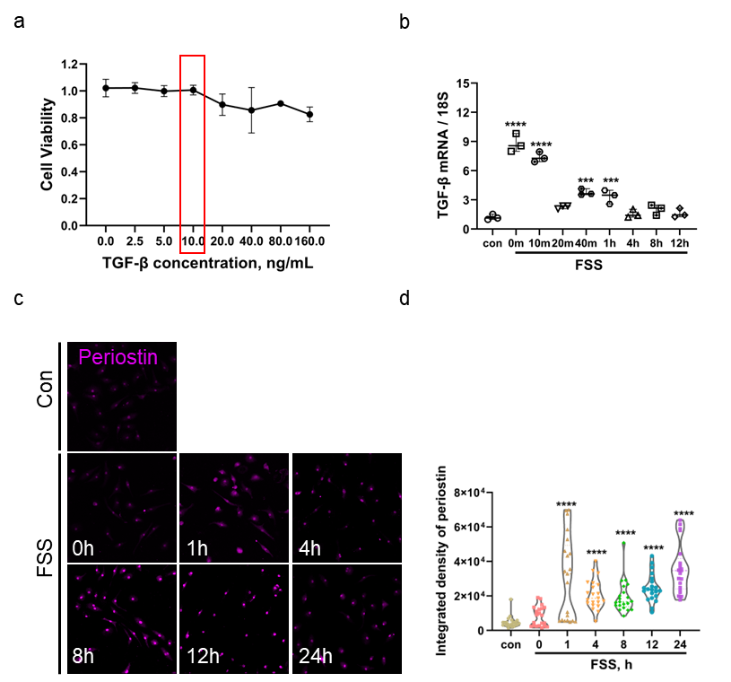
Supplementary Fig. 12 Fluid shear stress increased the expression of periostin in macrophages. a Toxicity of TGF-β to BMDMs measured by CCK8. n = 6. b Quantitative RT-PCR analyses of the expression of TGF-β after fluid shear stress treatment. n = 3. c Immunofluorescence assay of the expression of periostin in BMDMs after FSS treatment at timepoints. d Quantification of the integrated density of periostin in BMDMs. n = 20. ***P < 0.001; ****P < 0.0001. Ordinary one-way ANOVA. Data were mean ± SD.

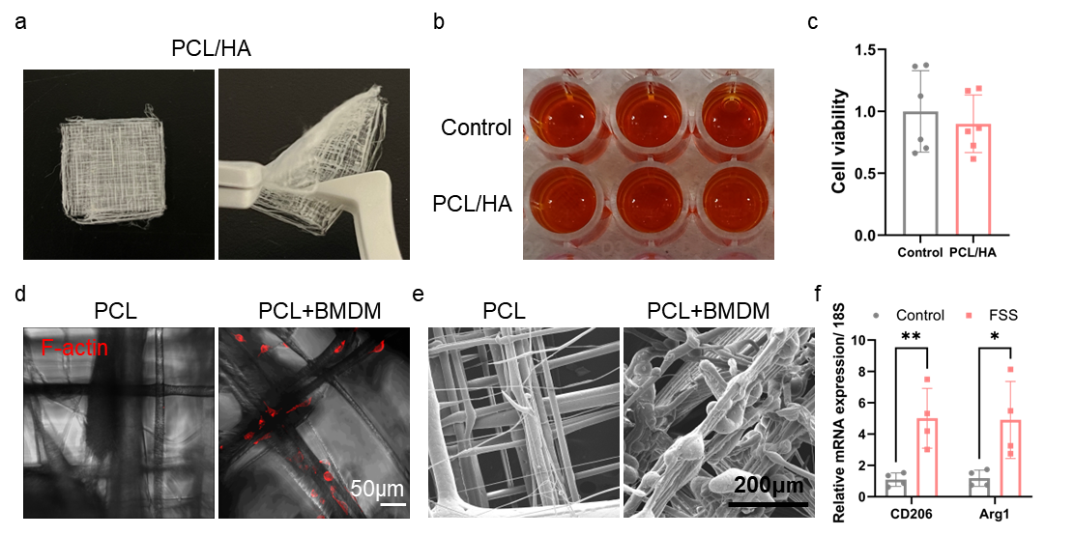
Supplementary Fig. 13 Biocompatibility of PCL/HA membrane. a Flexibility of PCL/HA membrane. b-c Cytotoxicity of PCL/HA membrane measured by CCK8 test. n = 6. c Toxicity of TGF-β to BMDMs measured by CCK8. n = 6. d Immunofluorescence images of the morphology of the PCL/HA with or without BMDMs from C57BL/6J mice. e SEM images of the morphology of the PCL/HA with or without BMDMs from C57BL/6J mice. f Quantitative RT-PCR analyses of the expression of Arg1, and CD206 in BMDMs after FSS treated. n = 3. *P < 0.05; **P < 0.01. Ordinary one-way ANOVA or Student’s t test. Data were mean ± SD.

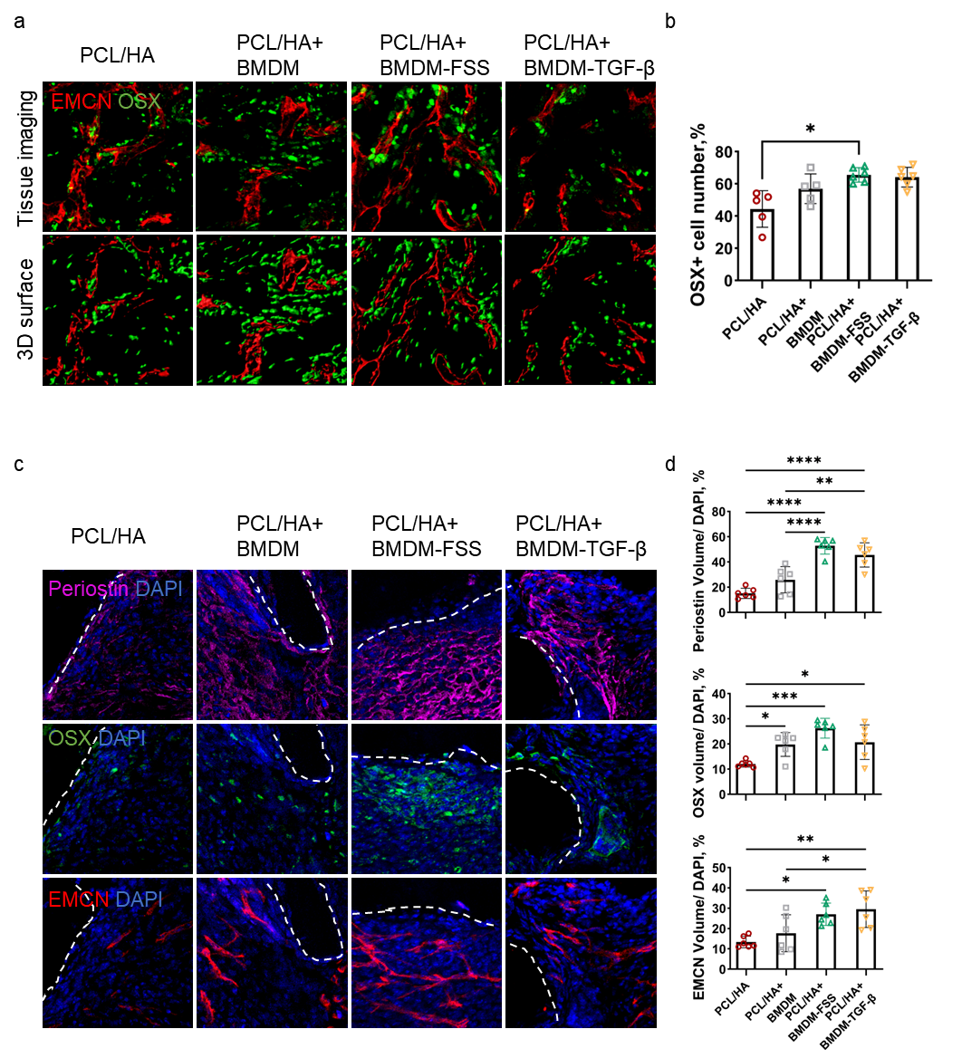
Supplementary Fig. 14 Enhancement of angiogenesis-osteogenesis coupling through mechanically conditioned macrophages. a Immunofluorescence assay of the coupling of OSX+ cells and EMCN+ vessels in in PCL/HA, PCL/HA with BMDMs from C57BL/6J mice, PCL/HA with FSS-treated BMDMs, and PCL/HA with TGF-β-treated BMDMs. b Quantitative immunofluorescence assay of the number of OSX+ cells in contact with type H vessels. n = 6. c Immunofluorescence assay of the volume of EMCN+ vessels, periostin, and the number of OSX+ cells in different implanted subcutaneously groups on PSD 10. d Quantitative immunofluorescence assay of the volume of EMCN+ vessels, periostin, and the number of OSX+ cells. n = 6. *P < 0.05; **P < 0.01; ***P < 0.001; ****P < 0.0001. Ordinary one-way ANOVA. Data were mean ± SD.

Supplementary Table 1

Primers of mouse used for RT-PCR
Gene | Primers
F4/80 | Forward 5’- GCATCATGGCATACCTGTTC -3’
 | Reverse 5’- AGTCTGGGAATGGGAGCTAA -3’
iNOS | Forward 5’- TCAGCTACGCCTTCAACACC -3’
 | Reverse 5’- TTCCCAAATGTGCTTGTCACC -3’
CD80 | Forward 5’- TTCGTCTTTCACAAGTGTCTTCA -3’
 | Reverse 5’- TGCCAGTAGATTCGGTCTTCA -3’
CD206 | Forward 5’- CATTCCCTCAGCAAGCGATG -3’
 | Reverse 5’- GGGTTCCATCACTCCACTCA -3’
Arg-1 | Forward 5’- CAGCACTGAGGAAAGCTGGT -3’
 | Reverse 5’- CAGACCGTGGGTTCTTCACA -3’
POSTN | Forward 5’- CCTGCCCTTATATGCTCTGCT -3’
 | Reverse 5’- CCTGCCCTTATATGCTCTGCT -3’
TGF-β | Forward 5’- ATGCTAAAGAGGTCACCCGC -3’
 | Reverse 5’- ATGCTAAAGAGGTCACCCGC-3’
18s | Forward 5’- GAGAAACGGCTACCACATCC -3’
 | Reverse 5’- CCTCCAATGGATCCTCGTTA -3’

