Title: Landscape genetic analysis of population structure and barriers to gene flow in a managed forest range of boreal woodland caribou (Rangifer tarandus caribou)
Journal: Conservation: Genetics
Author List: Nicole Anderson and Ashley M. Thomson
Corresponding Author: A. Thomson, email: athomson@lakeheadu.ca, Faculty of Natural Resources Management, Lakehead University

Supplementary Material

Supplementary Table S1. Sample location information.
Site ID | Number of Samples Collected | Number Unique Genotypes Detected | Region
A01 | 14 | 10 | Unmanaged
A02 | 15 | 13 | Unmanaged
A03 | 19 | 9 | Unmanaged
A04 | 14 | 5 | Unmanaged
A05 | 30 | 14 | Managed
A06 | 11 | 8 | Managed
A07 | 8 | 6 | Unmanaged
A08 | 15 | 9 | Unmanaged
A09 | 18 | 13 | Unmanaged
A10 | 9 | 8 | Unmanaged
A11 | 9 | 4 | Unmanaged
A12 | 9 | 5 | Unmanaged
A13 | 7 | 3 | Managed
A14 | 22 | 11 | Managed
A15 | 17 | 11 | Unmanaged
A16 | 16 | 11 | Unmanaged
A17 | 31 | 18 | Unmanaged
A18 | 11 | 8 | Unmanaged
A19 | 5 | 5 | Unmanaged
A20 | 3 | 3 | Unmanaged
A21 | 11 | 7 | Unmanaged
A22 | 9 | 7 | Unmanaged
A23 | 4 | 2 | Unmanaged
A24 | 7 | 4 | Managed
A25 | 5 | 3 | Unmanaged
A26 | 15 | 10 | Unmanaged
A27 | 6 | 5 | Managed
A28 | 16 | 10 | Managed
B01 | 5 | 4 | Unmanaged
B02 | 11 | 7 | Unmanaged
B03 | 36 | 12 | Unmanaged
B04 | 19 | 9 | Unmanaged
B06 | 13 | 5 | Unmanaged
B07 | 3 | 3 | Unmanaged
B08 | 10 | 6 | Unmanaged
B09 | 3 | 3 | Unmanaged
B10 | 9 | 7 | Unmanaged
B11 | 1 | 1 | Unmanaged
B12 | 47 | 19 | Unmanaged
B13 | 46 | 12 | Unmanaged
B14 | 2 | 2 | Unmanaged
B15 | 3 | 3 | Unmanaged
B16 | 7 | 4 | Unmanaged
B17 | 2 | 2 | Unmanaged
B18 | 46 | 16 | Unmanaged
B19 | 11 | 5 | Unmanaged
B20 | 2 | 1 | Unmanaged
B21 | 40 | 18 | Unmanaged
B22 | 6 | 3 | Unmanaged
B23 | 5 | 5 | Unmanaged
B24 | 14 | 7 | Unmanaged
B26 | 8 | 6 | Unmanaged
B27 | 5 | 4 | Unmanaged
B29 | 18 | 8 | Unmanaged
B30 | 7 | 4 | Unmanaged
B31 | 3 | 2 | Unmanaged
B32 | 7 | 3 | Unmanaged
B33 | 20 | 8 | Managed
B35 | 2 | 1 | Managed
B36 | 17 | 9 | Unmanaged
B37 | 5 | 3 | Unmanaged
Note: Geographic coordinates of sampling locations are not included because of the threatened status of this species.

Supplementary Table S2. Concentration, dye, and description of the microsatellite primers used in this study.

Supplementary Table S3. Genetic diversity statistics for all sampling locations with at least five unique genotypes.
Pop | N | AR | Ae | Ho | He | F
A01 | 10 | 3.79 | 3.2 | 0.65 | 0.66 | 0.005
A02 | 13 | 3.84 | 3.0 | 0.70 | 0.65 | -0.073
A03 | 9 | 4.01 | 3.1 | 0.73 | 0.66 | -0.100
A04 | 5 | 4.25 | 3.2 | 0.70 | 0.62 | -0.127
A05 | 14 | 3.93 | 3.3 | 0.71 | 0.66 | -0.069
A06 | 8 | 4.10 | 3.3 | 0.71 | 0.65 | -0.083
A07 | 6 | 3.63 | 2.9 | 0.76 | 0.62 | -0.241
A08 | 9 | 4.36 | 3.6 | 0.70 | 0.70 | -0.019
A09 | 13 | 4.08 | 3.3 | 0.66 | 0.66 | -0.003
A10 | 8 | 4.02 | 3.0 | 0.66 | 0.63 | -0.046
A12 | 5 | 4.17 | 3.0 | 0.73 | 0.63 | -0.175
A14 | 11 | 3.52 | 2.8 | 0.67 | 0.61 | -0.104
A15 | 11 | 4.05 | 3.3 | 0.68 | 0.68 | -0.008
A16 | 11 | 3.92 | 3.1 | 0.67 | 0.64 | -0.054
A17 | 18 | 3.98 | 3.5 | 0.68 | 0.67 | -0.011
A18 | 8 | 3.61 | 2.9 | 0.65 | 0.64 | -0.010
A19 | 5 | 4.25 | 3.2 | 0.75 | 0.65 | -0.167
A21 | 7 | 3.66 | 2.7 | 0.66 | 0.62 | -0.069
A22 | 7 | 4.04 | 3.3 | 0.63 | 0.68 | 0.070
A26 | 10 | 3.85 | 3.0 | 0.74 | 0.63 | -0.177
A27 | 5 | 4.25 | 3.0 | 0.70 | 0.65 | -0.061
A28 | 10 | 3.69 | 3.1 | 0.70 | 0.66 | -0.051
B02 | 7 | 3.89 | 2.8 | 0.69 | 0.62 | -0.107
B03 | 12 | 4.05 | 3.2 | 0.72 | 0.67 | -0.083
B04 | 9 | 3.97 | 3.2 | 0.69 | 0.68 | -0.013
B06 | 5 | 4.08 | 2.9 | 0.72 | 0.60 | -0.170
B08 | 6 | 4.01 | 2.9 | 0.72 | 0.61 | -0.187
B10 | 7 | 3.73 | 2.9 | 0.66 | 0.62 | -0.067
B12 | 19 | 3.88 | 3.1 | 0.71 | 0.67 | -0.063
B13 | 12 | 4.02 | 3.3 | 0.71 | 0.65 | -0.060
B18 | 16 | 3.84 | 3.1 | 0.64 | 0.65 | 0.008
B19 | 5 | 3.83 | 2.8 | 0.65 | 0.59 | -0.103
B21 | 18 | 3.70 | 3.0 | 0.68 | 0.63 | -0.066
B23 | 5 | 3.67 | 2.9 | 0.67 | 0.58 | -0.162
B24 | 7 | 4.04 | 3.1 | 0.71 | 0.65 | -0.093
B26 | 6 | 3.81 | 2.8 | 0.71 | 0.61 | -0.179
B29 | 8 | 3.92 | 3.2 | 0.64 | 0.62 | -0.036
B33 | 8 | 3.83 | 3.2 | 0.71 | 0.67 | -0.063
B36 | 9 | 3.63 | 3.0 | 0.60 | 0.63 | 0.039
Mean | 9.3 | 3.92 | 3.1 | 0.69 | 0.64 | -0.076
Number of individuals (N), rarefied allelic richness (A_{R}), average effective number of alleles (A_{e}), mean observed heterozygosity (H_{o}), mean expected heterozygosity (H_{e}), and mean fixation index (F) : number of individuals (N), rarefied allelic richness (A_{R}), average effective number of alleles (A_{e}), mean observed heterozygosity (H_{o}), mean expected heterozygosity (H_{e}), and mean fixation index (F).

Supplementary Table S4. AMOVA results indicating the partitioning of molecular variation among regions, populations within regions, individuals within sites, and within individuals.
Source | df | Sum Square Difference | Mean Square Difference | Variance Component | Total Variance
Among Regions  (Managed and Active forests) | 1 | 7.858 | 7.858 | 0.018 | 0.42%
Among Populations (Sample Sites) | 37 | 165.276 | 4.467 | 0.021 | 0.52%
Among Individuals | 323 | 1314.948 | 4.071 | 0 | 0%
Within Individuals | 362 | 1491.5 | 4.12 | 4.12 | 99.06%
Total | 723 | 2979.581 |  | 4.159 | 100.00%

Supplementary Table S5. F-statistics from AMOVA for managed and Active forest regions, sites (populations), and individuals.
Source | F-Statistics | Value | Probability (rand >= data)
Among regions | Frt | 0.004 | 0.013*
Among populations within regions | Fsr | 0.005 | 0.018*
Within subpopulations relative to the total population | Fst | 0.009 | 0.001*
Within individuals relative to the subpopulation | Fis | -0.006 | 0.717
Within individuals relative to the total population | Fit | 0.004 | 0.360
* value significant at the 0.05 level

Supplementary Table S6. Pairwise F_{ST} values among fecal pellet sampling locations. Significant comparisons are highlighted in yellow. F_{ST} values are below the diagonal and significance thresholds are denoted be * -0.05, **0.01,***0.001.
 | A01 | A02 | A03 | A04 | A05 | A06 | A07 | A08
A01 | 0.000
A02 | 0.014 | 0.000
A03 | 0.021 | 0.020 | 0.000
A04 | 0.037 | 0.036 | 0.038 | 0.000
A05 | 0.023 | 0.022 | 0.029 | 0.041 | 0.000
A06 | 0.023 | 0.024 | 0.030 | 0.035 | 0.025 | 0.000
A07 | 0.035 | 0.026 | 0.036 | 0.045 | 0.039 | 0.048 | 0.000
A08 | 0.026 | 0.026 | 0.041 | 0.045 | 0.027 | 0.032 | 0.024 | 0.000
A09 | 0.016 | 0.017 | 0.010 | 0.028 | 0.023 | 0.024 | 0.029 | 0.032
A10 | 0.023 | 0.020 | 0.030 | 0.048 | 0.023 | 0.034 | 0.044 | 0.031
A12 | 0.028 | 0.025 | 0.033 | 0.040 | 0.039 | 0.037 | 0.033 | 0.037
A14 | 0.021 | 0.020 | 0.026 | 0.037 | 0.028 | 0.027 | 0.037 | 0.032
A15 | 0.027 | 0.021 | 0.027 | 0.035 | 0.023 | 0.022 | 0.045 | 0.030
A16 | 0.028 | 0.026 | 0.024 | 0.024 | 0.030 | 0.029 | 0.034 | 0.035
A17 | 0.016 | 0.016 | 0.019 | 0.029 | 0.021 | 0.019 | 0.034 | 0.023
A18 | 0.043 | 0.048 | 0.035 | 0.056 | 0.051 | 0.049 | 0.064 | 0.058
A19 | 0.033 | 0.033 | 0.042 | 0.055 | 0.030 | 0.022 | 0.054 | 0.029
A21 | 0.021 | 0.024 | 0.033 | 0.046 | 0.030 | 0.033 | 0.049 | 0.039
A22 | 0.029 | 0.031 | 0.032 | 0.045 | 0.029 | 0.036 | 0.050 | 0.035
A26 | 0.025 | 0.026 | 0.034 | 0.038 | 0.017 | 0.032 | 0.045 | 0.033
A27 | 0.025 | 0.029 | 0.040 | 0.042 | 0.032 | 0.035 | 0.041 | 0.024
A28 | 0.031 | 0.035 | 0.042 | 0.065 | 0.030 | 0.038 | 0.056 | 0.041
B02 | 0.028 | 0.033 | 0.042 | 0.046 | 0.026 | 0.035 | 0.047 | 0.028
B03 | 0.018 | 0.018 | 0.027 | 0.036 | 0.016 | 0.024 | 0.033 | 0.017
B04 | 0.022 | 0.026 | 0.032 | 0.032 | 0.027 | 0.021 | 0.042 | 0.028
B06 | 0.045 | 0.043 | 0.049 | 0.054 | 0.044 | 0.046 | 0.060 | 0.048
B08 | 0.036 | 0.027 | 0.042 | 0.046 | 0.042 | 0.042 | 0.035 | 0.031
B10 | 0.026 | 0.021 | 0.029 | 0.045 | 0.030 | 0.045 | 0.039 | 0.035
B12 | 0.012 | 0.016 | 0.021 | 0.025 | 0.020 | 0.017 | 0.032 | 0.022
B13 | 0.034 | 0.026 | 0.034 | 0.051 | 0.016 | 0.028 | 0.049 | 0.032
B18 | 0.017 | 0.013 | 0.026 | 0.045 | 0.024 | 0.025 | 0.046 | 0.029
B19 | 0.042 | 0.041 | 0.048 | 0.061 | 0.045 | 0.052 | 0.064 | 0.059
B21 | 0.018 | 0.020 | 0.028 | 0.043 | 0.017 | 0.022 | 0.042 | 0.025
B23 | 0.041 | 0.047 | 0.049 | 0.054 | 0.036 | 0.052 | 0.059 | 0.046
B24 | 0.014 | 0.014 | 0.024 | 0.042 | 0.020 | 0.016 | 0.041 | 0.028
B26 | 0.035 | 0.038 | 0.022 | 0.054 | 0.042 | 0.043 | 0.049 | 0.055
B29 | 0.025 | 0.027 | 0.036 | 0.052 | 0.023 | 0.040 | 0.036 | 0.025
B33 | 0.032 | 0.035 | 0.040 | 0.060 | 0.030 | 0.036 | 0.057 | 0.042
B36 | 0.022 | 0.023 | 0.028 | 0.047 | 0.023 | 0.034 | 0.042 | 0.032

 | A09 | A10 | A12 | A14 | A15 | A16 | A17 | A18
A01
A02 |  |  |  |  |  |  |  | **
A03
A04
A05 |  |  |  | * |  | * |  | **
A06
A07 |  |  |  |  |  |  |  | *
A08 |  |  |  |  |  |  |  | *
A09 | 0.000 |  |  |  |  |  |  | *
A10 | 0.024 | 0.000 |  |  |  |  |  | **
A12 | 0.027 | 0.044 | 0.000
A14 | 0.029 | 0.036 | 0.036 | 0.000 |  | * |  | **
A15 | 0.022 | 0.029 | 0.036 | 0.025 | 0.000
A16 | 0.014 | 0.027 | 0.032 | 0.033 | 0.030 | 0.000 |  | *
A17 | 0.012 | 0.027 | 0.026 | 0.026 | 0.018 | 0.020 | 0.000 | ***
A18 | 0.042 | 0.063 | 0.046 | 0.051 | 0.042 | 0.050 | 0.047 | 0.000
A19 | 0.036 | 0.030 | 0.048 | 0.043 | 0.026 | 0.040 | 0.034 | 0.058
A21 | 0.031 | 0.033 | 0.030 | 0.025 | 0.035 | 0.040 | 0.025 | 0.057
A22 | 0.030 | 0.029 | 0.037 | 0.039 | 0.029 | 0.037 | 0.032 | 0.050
A26 | 0.025 | 0.033 | 0.037 | 0.034 | 0.025 | 0.032 | 0.018 | 0.051
A27 | 0.030 | 0.034 | 0.029 | 0.033 | 0.025 | 0.032 | 0.024 | 0.050
A28 | 0.041 | 0.045 | 0.043 | 0.043 | 0.036 | 0.054 | 0.039 | 0.051
B02 | 0.030 | 0.033 | 0.044 | 0.033 | 0.029 | 0.031 | 0.021 | 0.069
B03 | 0.018 | 0.020 | 0.033 | 0.026 | 0.018 | 0.021 | 0.014 | 0.050
B04 | 0.023 | 0.038 | 0.035 | 0.025 | 0.020 | 0.025 | 0.020 | 0.039
B06 | 0.032 | 0.049 | 0.050 | 0.057 | 0.039 | 0.033 | 0.035 | 0.076
B08 | 0.027 | 0.029 | 0.048 | 0.049 | 0.042 | 0.036 | 0.030 | 0.079
B10 | 0.021 | 0.022 | 0.035 | 0.043 | 0.034 | 0.030 | 0.024 | 0.061
B12 | 0.017 | 0.018 | 0.028 | 0.021 | 0.021 | 0.019 | 0.015 | 0.043
B13 | 0.029 | 0.027 | 0.048 | 0.041 | 0.024 | 0.038 | 0.027 | 0.057
B18 | 0.024 | 0.026 | 0.031 | 0.022 | 0.019 | 0.032 | 0.018 | 0.048
B19 | 0.043 | 0.036 | 0.059 | 0.057 | 0.049 | 0.053 | 0.049 | 0.082
B21 | 0.020 | 0.018 | 0.040 | 0.025 | 0.021 | 0.029 | 0.018 | 0.050
B23 | 0.046 | 0.047 | 0.051 | 0.047 | 0.044 | 0.050 | 0.036 | 0.061
B24 | 0.022 | 0.026 | 0.028 | 0.022 | 0.019 | 0.034 | 0.017 | 0.041
B26 | 0.033 | 0.046 | 0.045 | 0.031 | 0.047 | 0.036 | 0.042 | 0.045
B29 | 0.022 | 0.025 | 0.038 | 0.043 | 0.033 | 0.033 | 0.023 | 0.063
B33 | 0.037 | 0.042 | 0.046 | 0.041 | 0.031 | 0.048 | 0.036 | 0.056
B36 | 0.020 | 0.024 | 0.027 | 0.033 | 0.020 | 0.035 | 0.022 | 0.045

 | A19 | A21 | A22 | A26 | A27 | A28 | B02 | B03
A01
A02 |  |  |  |  |  | *
A03 |  |  |  |  |  | *
A04 |  |  |  |  |  | *
A05
A06
A07 |  |  |  | * |  | *
A08 |  |  |  |  |  | *
A09 |  |  |  |  |  | **
A10 |  |  |  |  |  | *
A12
A14 |  |  |  | * |  | **
A15 |  |  |  |  |  | *
A16 |  |  |  |  |  | **
A17 |  |  |  |  |  | **
A18 |  | * |  | ** |  | * | ** | **
A19 | 0.000
A21 | 0.050 | 0.000
A22 | 0.030 | 0.044 | 0.000
A26 | 0.039 | 0.033 | 0.034 | 0.000
A27 | 0.037 | 0.041 | 0.034 | 0.031 | 0.000
A28 | 0.044 | 0.037 | 0.033 | 0.031 | 0.046 | 0.000
B02 | 0.040 | 0.045 | 0.037 | 0.025 | 0.024 | 0.051 | 0.000
B03 | 0.021 | 0.033 | 0.025 | 0.019 | 0.019 | 0.035 | 0.011 | 0.000
B04 | 0.031 | 0.034 | 0.032 | 0.026 | 0.026 | 0.033 | 0.031 | 0.021
B06 | 0.053 | 0.060 | 0.057 | 0.038 | 0.047 | 0.069 | 0.040 | 0.033
B08 | 0.044 | 0.048 | 0.047 | 0.037 | 0.048 | 0.054 | 0.046 | 0.026
B10 | 0.044 | 0.043 | 0.034 | 0.032 | 0.035 | 0.045 | 0.032 | 0.018
B12 | 0.024 | 0.022 | 0.021 | 0.020 | 0.024 | 0.031 | 0.026 | 0.016
B13 | 0.031 | 0.041 | 0.030 | 0.025 | 0.043 | 0.038 | 0.037 | 0.023
B18 | 0.033 | 0.025 | 0.031 | 0.027 | 0.024 | 0.039 | 0.032 | 0.021
B19 | 0.055 | 0.040 | 0.039 | 0.053 | 0.067 | 0.056 | 0.067 | 0.047
B21 | 0.028 | 0.025 | 0.029 | 0.020 | 0.029 | 0.031 | 0.027 | 0.017
B23 | 0.070 | 0.050 | 0.047 | 0.029 | 0.046 | 0.049 | 0.042 | 0.045
B24 | 0.027 | 0.021 | 0.026 | 0.026 | 0.025 | 0.026 | 0.035 | 0.019
B26 | 0.055 | 0.040 | 0.047 | 0.051 | 0.050 | 0.054 | 0.064 | 0.042
B29 | 0.040 | 0.037 | 0.038 | 0.026 | 0.037 | 0.041 | 0.031 | 0.022
B33 | 0.039 | 0.039 | 0.035 | 0.032 | 0.047 | 0.005 | 0.048 | 0.032
B36 | 0.036 | 0.027 | 0.021 | 0.023 | 0.027 | 0.033 | 0.031 | 0.021

 | B04 | B06 | B08 | B10 | B12 | B13 | B18 | B19
A01 |  |  |  |  |  | *
A02
A03
A04 |  |  |  |  |  | *
A05
A06
A07 |  |  |  |  |  | * | * | *
A08 |  |  |  |  |  |  |  | *
A09
A10
A12
A14 |  | * | * | * |  | ** |  | *
A15
A16 |  |  |  |  |  | * | * | *
A17 |  |  |  |  |  | * |  | *
A18 |  | * | ** | * | ** | ** | * | *
A19
A21 |  |  |  |  |  | *
A22
A26 |  |  |  |  |  |  |  | *
A27
A28 |  | * | * |  | * | * | **
B02 |  |  |  |  |  |  |  | *
B03
B04 | 0.000 |  |  |  |  |  |  | *
B06 | 0.042 | 0.000 |  |  |  |  | *
B08 | 0.041 | 0.047 | 0.000 |  |  |  | *
B10 | 0.039 | 0.051 | 0.027 | 0.000
B12 | 0.015 | 0.042 | 0.025 | 0.025 | 0.000
B13 | 0.035 | 0.051 | 0.038 | 0.034 | 0.024 | 0.000 | ** | *
B18 | 0.023 | 0.050 | 0.047 | 0.035 | 0.018 | 0.032 | 0.000
B19 | 0.059 | 0.061 | 0.053 | 0.056 | 0.038 | 0.058 | 0.047 | 0.000
B21 | 0.024 | 0.040 | 0.032 | 0.035 | 0.017 | 0.021 | 0.019 | 0.039
B23 | 0.045 | 0.068 | 0.063 | 0.057 | 0.034 | 0.044 | 0.041 | 0.074
B24 | 0.019 | 0.051 | 0.037 | 0.030 | 0.016 | 0.027 | 0.015 | 0.042
B26 | 0.042 | 0.074 | 0.061 | 0.057 | 0.037 | 0.050 | 0.042 | 0.068
B29 | 0.037 | 0.038 | 0.031 | 0.029 | 0.025 | 0.032 | 0.032 | 0.043
B33 | 0.031 | 0.059 | 0.050 | 0.042 | 0.031 | 0.039 | 0.041 | 0.053
B36 | 0.029 | 0.042 | 0.039 | 0.026 | 0.021 | 0.028 | 0.023 | 0.035

 | B21 | B23 | B24 | B26 | B29 | B33 | B36
A01
A02
A03
A04
A05
A06
A07 | * |  |  |  |  | *
A08 |  |  |  | *
A09
A10
A12
A14 |  |  |  |  | * | *
A15 |  |  |  | *
A16 | * |  |  |  |  | *
A17 |  |  |  | * |  | *
A18 | *** |  |  |  | ** | *
A19
A21
A22
A26 |  |  |  | *
A27
A28 | * |  |  | *
B02 |  |  |  | *
B03
B04
B06 |  |  |  | *
B08 |  | * |  | *
B10
B12
B13 |  |  |  | * |  | *
B18 |  |  |  |  |  | *
B19
B21 | 0.000 |  |  | *
B23 | 0.030 | 0.000
B24 | 0.014 | 0.040 | 0.000
B26 | 0.040 | 0.067 | 0.034 | 0.000 | *
B29 | 0.017 | 0.036 | 0.029 | 0.062 | 0.000
B33 | 0.031 | 0.055 | 0.027 | 0.054 | 0.041 | 0.000
B36 | 0.017 | 0.034 | 0.018 | 0.049 | 0.021 | 0.035 | 0.000

Supplementary Table S7. Matrix of pairwise correlation coefficients (Pearson’s r) between resistance values for different landscape variables.
 | harvest10 | water10 | roads10T | fire10T | IBD
harvest10 | 1 | 0.83144 | 0.78309 | 0.52337 | 0.94023
water10 | 0.83144 | 1 | 0.7159 | 0.45048 | 0.89541
roads10T | 0.78309 | 0.7159 | 1 | 0.40967 | 0.79355
fire10T | 0.52337 | 0.45048 | 0.40967 | 1 | 0.54336
IBD | 0.94023 | 0.89541 | 0.79355 | 0.54336 | 1

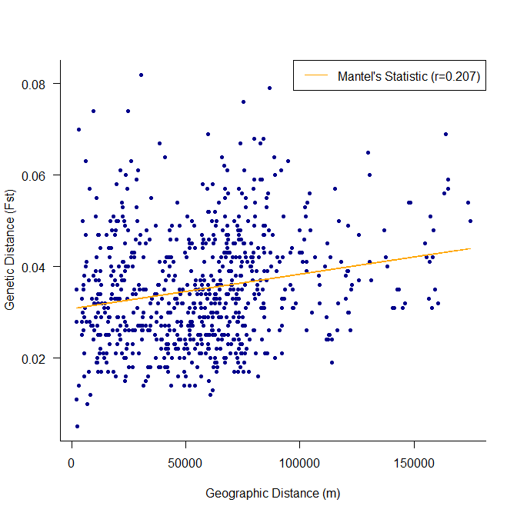
Supplementary Figure S1.Mantel test of regressions of pairwise genetic distance (F_{ST}) and geographic distance (metres) matrices between all sites with n≥5.

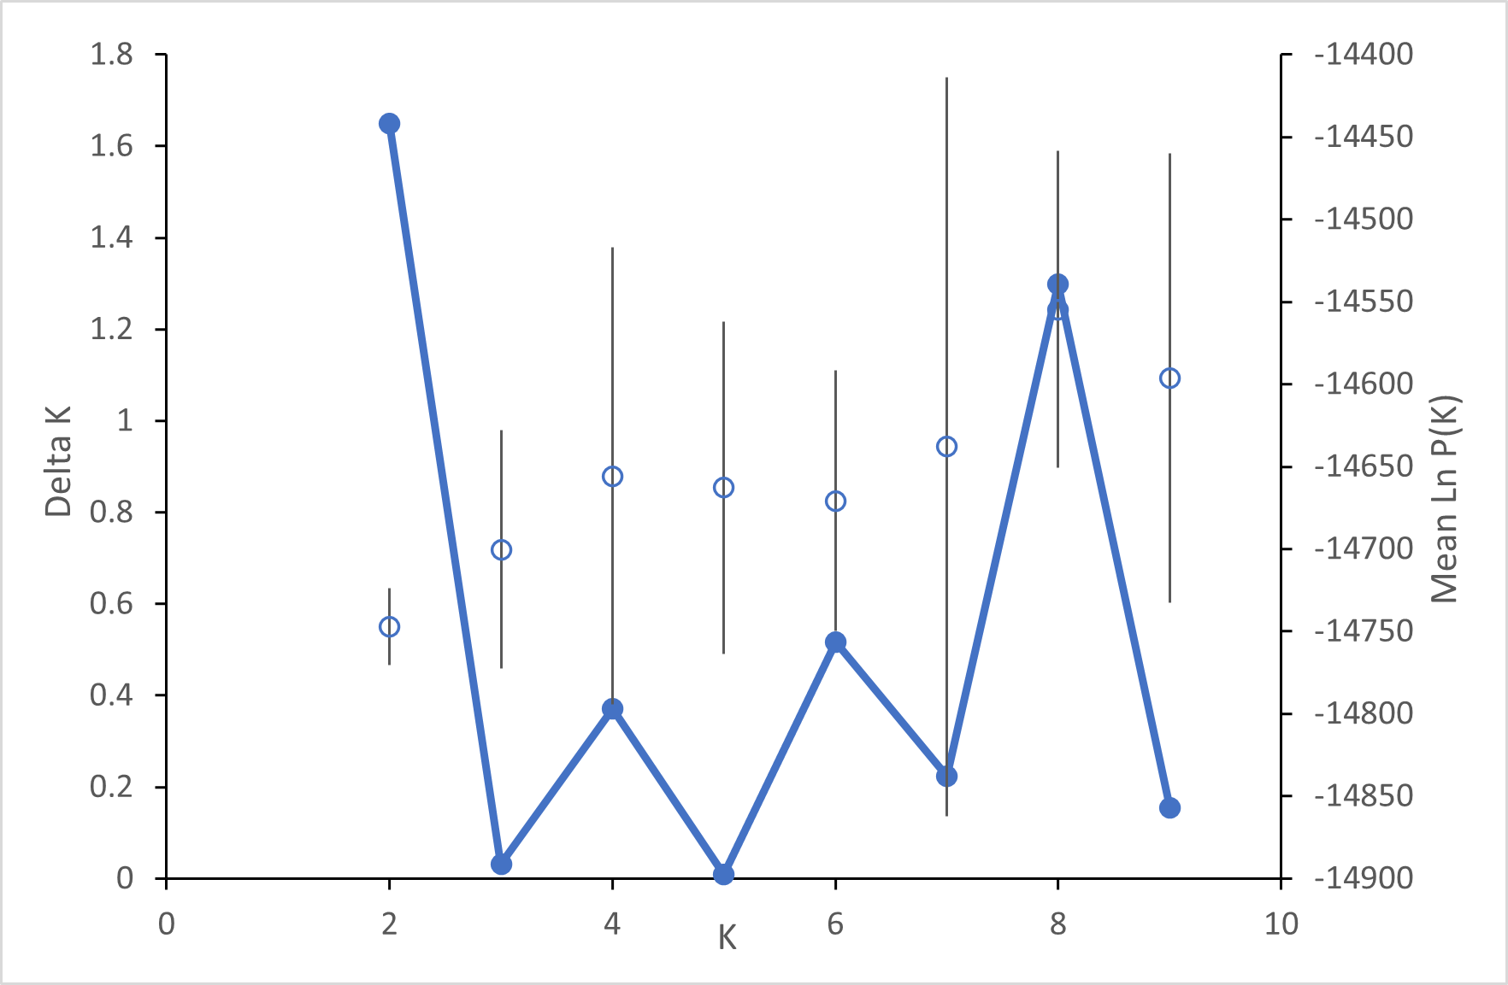
Supplementary Figure S2. Plot of Delta K and mean LnP(K) values for varying number of population clusters (K) analyzed in Structure.

