Supplementary Information for
Occurrence, source apportionment, and ecological risk assessment of organophosphate esters in surface sediment from the Ogun and Osun Rivers, Southwest Nigeria
Muideen Remilekun Gbadamosi ^{a, b}, Adeyemi Lawrence Ogunneye ^{b}, David Olaoluwa Jegede ^{c}, Mohamed Abou-Elwafa Abdallah ª, Stuart Harrad ª
ª School of Geography, Earth, and Environmental Sciences, University of Birmingham, Birmingham, B15 2TT, UK
^{b} Department of Chemical Sciences, Tai Solarin University of Education, Ijebu-Ode, Ogun State, Nigeria
^{c} Chemistry Unit, Department of Basic Science, Babcock University, Ilishan-Remo, Ogun State, Nigeria
*Author for correspondence (Muideen Gbadamosi)
Number of Section: 1
Number of Tables: 10
Number of Figures: 2
Number of Pages: 27
Section 1: Standards and reagents
Detailed information about the target OPEs are provided in Table S1. Reference standards of all eight OPEs namely: TCEP, TCIPP, TDCIPP, TPHP, EHDPP, tri-n-buty phosphate (TnBP), tri-m-tolyl phosphate (TMTP) and TBOEP as well as two internal (surrogate) standards (TBP-d₂₇ and TPHP-d₁₅), and 2,3,4,6-tetrachlorobiphenyl (PCB-62) used as a recovery determination (or syringe) standard (RDS) were purchased from Wellington Laboratories, (Guelph, ON, Canada). The purity of all analytical standards was ˃ 98 %, except TBOEP (˃ 94%). HPLC-grade solvents: acetone (ACE, 99.8 %), ethyl acetate (ETAC, 99.8%), n-hexane (HEX, 95%) and iso-octane (ISOC, 99.5%) were purchased from Fisher Scientific (Loughborough, UK) and Sigma-Aldrich (St Louis, MO, USA). Anhydrous sodium sulfate was purchased from Fisher Scientific (Loughborough, UK) and heated in a furnace for 4 h at 450 °C before use. Hypersep Florisil® SPE cartridges were purchased from Thermo Scientific (Rockwood, USA), with the nitrogen gas used for solvent evaporation purchased from BOC gases, United Kingdom.

Table S1: Names, abbreviations, formulas, and physicochemical properties of the target OPEs in the present study
OPEs classification | Name of target OPEs | Acronym | CAS#. | Boiling Point (°C) | Ρ (mmHg at 25°C) | Molecular weight | Log Koc (kg/L) | Water solubility (mg/L at 25°C) | Log K_{OW} | Density (kg/L) at 25°C
Cl-OPEs | Tris (2-chloroethyl) phosphate | TCEP | 115-96-8 | 210-220 | 6.13x10⁻² | 285.49 | 2.48 | 7000 | 1.43 | 1.4
Cl-OPEs | Tris(2-chloroisopropyl) Phosphate | TCIPP | 13674-84-5 | 235-248 | 9.23x10⁻³ | 327.56 | 3.05 | 1.6x10³ | 2.59 | 1.29
Cl-OPEs | Tris (1, 3-dichloro-2-propyl) phosphate | TDCPP | 13674-87-8 | 236-237 | 2.86x10⁻⁷ | 430.90 | 2.35 | 7 | 3.65 | 1.48
Aryl-OPEs | Triphenyl phosphate | TPHP | 115-86-6 | 370 | 2.00x10⁻⁶ | 326.28 | 3.72 | 4.59 | 4.70 | 1.2055
Aryl-OPEs | 2-Ethylhexyl diphenyl phosphate | EHDPP | 1241-94-7 | 232 | 3.3x10⁻⁵ | 362.40 | 4.21 | 1.9 | 5.73 | 1.090
Aryl-OPEs | Tri-m-tolyl phosphate | TMTP | 563-04-2 | 260 | 7.8x10⁻⁷ | 368.4 | 4.1x10⁴ | - | 6.34 | 1.150
Alkyl-OPEs | Tris (butoxyethyl) Phosphate | TBOEP | 78-51-3 | 255 | 1.2x10⁻⁶ | 398.47 |  | 604 | 3.75 | 13.8
Alkyl-OPEs | Tri-n-butyl phosphate | TnBP | 126-73-8 | 289 | 1.13x10⁻³ | 266.31 | 3.28 | 280 | 4.00 | 0.98
Where: S = solubility (mg/L) in water at 25°C; P = vapor pressure (mmHg) at 25°C; log K_{ow} = n-octanol: water partition coefficient; KOC=Organic carbon-water partition coefficient & MW = molecular weight. The data are compiled from databases (Pubchem, 2022) and Pantelaki and Voutsa (2019).

Table S2. Retention time, quantification and confirmation ions selected for target organophosphate esters (OPEs) and their deuterated IS.
OPEs | Abbreviation | Retention time (min) | Quantification ion (m/z) | Confirmation ion (m/z)
Deuterated IS | d₂₇-TnBP | 8.06 | 103 | 167
Tri-n-butyl phosphate | TnBP | 8.17 | 99 | 155
Tris(2-chloroethyl) phosphate | TCEP | 8.87 | 249 | 251
Tris(2-chloroisopropyl) phosphate | TCIPP | 9.10 | 277 | 279
Deuterated IS | d₁₅-TPHP | 12.69 | 342 | 339
Tris(1,3-dichloro-2-propyl) phosphate | TDCIPP | 12.16 | 380.9 | 382.9
Triphenyl phosphate  Tris(2-butoxyethyl) phosphate | TPHP  TBOEP | 12.75  12.58 | 326  124 | 325  199
2-Ethylhexyl diphenyl phosphate | EHDPP | 12.99 | 251 | 250
Tri-m-tolyl phosphate | TMTP | 14.37 | 368 | 367
RDS: 2,3,4,6 – Tetrachlorobiphenyl | PCB-62 | 10.09 | 291.9 | 293.9

Table S3: Internal standard recovery, blank concentrations, and limit of detection (LOD) and limit of quantification (LOQ) of OPEs.
Target OPEs | Calibration range (ng/µL) | Linear (R²) | Internal standard | Range of IS Recovery (%) (mean ± SD, RSD %) (n=5) | Target OPEs Recovery (%) (n=5) (Spiked at 50 ng/µL) | Procedural Blanks (ng/g) (n=20) | Instrument detection limit (IDL) (LOD) (ng/injection) | LOQ (ng/injection
TnBP | 0.05-0.75 | 0.999 | d₂₇-TnBP | 79.3 – 105 (89.5 ± 10.5, 11.7) | 90.4±8.21 | ND | 7x10⁻³ | 0.95
TCEP | 0.05-0.75 | 0.998 | d₂₇-TnBP | 79.3 – 105 (89.5 ± 10.5, 11.7) | 88.4±11.6 | 0.29 ± 0.14 | 3x10⁻³ | 0.43
TCIPP | 0.05-0.75 | 0.997 | d₂₇-TnBP | 79.3 – 105 (89.5 ± 10.5, 11.7) | 82.4±7.20 | ND | 3x10⁻³ | 0.38
TDCIPP | 0.05-0.75 | 0.998 | d₁₅-TPHP | 72.2 – 88.2 (80.6 ± 6.0, 7.42) | 99.8±6.71 | ND | 5x10⁻³ | 0.57
TPHP | 0.05-0.75 | 0.996 | d₁₅-TPHP | 72.2 – 88.2 (80.6 ± 6.0, 7.42) | 100.5±11.6 | ND | 3x10⁻³ | 0.35
EHDPP | 0.05-0.75 | 0.998 | d₁₅-TPHP | 72.2 – 88.2 (80.6 ± 6.0, 7.42) | 101.1±12.3 | ND | 2x10⁻³ | 0.28
TBOEP | 0.05-0.75 | 0.999 | d₁₅-TPHP | 72.2 – 88.2 (80.6 ± 6.0, 7.42) | 87.9 ± 7.95 | ND | 1.3x10⁻² | 1.59
TMTP | 0.05-0.75 | 0.982 | d₁₅-TPHP | 72.2 – 88.2 (80.6 ± 6.0, 7.42) | 86.3 ± 6.71 | ND | 3x10⁻³ | 0.40

Table S4: KMO and Bartlett’s test for the Ogun and Osun River
KMO and Bartlett’s Test Ogun River |  |  | Osun River
Kaiser-Meyer-Olkin Measure of Sampling Adequacy. |  | .769 | 0.716
Bartlett’s Test of Sphericity | Approx. Chi-Square | 123.217 | 37.504
Bartlett’s Test of Sphericity | Df | 21 | 21
Bartlett’s Test of Sphericity | Sig. | <.001 | 0.001

Table S5: Comparison of the concentrations of OPEs (ng/g dw) in the sediments from the two rivers with previous studies worldwide.
Study locations and period | TEP | TPRP | TIBP | TNBP | TEHP | TPHP | TMPP | EHDPP | TCEP | TCIPP | TDCIPP | TBOEP | ∑OPEs | Ref
Ogun River, Nigeria, 2021 | - | - | - | ˂LOQ-LOQ | - | 3.90-121 | - | ˂LOQ-32.1 | 0.74-6.73 | 5.00-46.1 | ˂LOQ-114 | ˂LOQ-1567 | 13.1-2110 | Present study
Osun River, Nigeria, 2021 | - | - | - | ˂LOQ-LOQ | - | 0.02-2.61 | - | ˂LOQ-9.85 | 6.71-48.3 | 15.3-70.9 | ˂LOQ-209 | ˂LOQ-245 | 247-589 | Present study
Vaal River catchment, South Africa, 2017 | - | - | - | ˂LOQ-166 | ˂LOQ—14.06 | ˂LOQ-6.49 | - | - | ˂LOQ-8.61 | ˂LOQ-4.66 | ˂LOQ-3.35 | 3.53-125.9 | 67.8-278 | Chokwe and Okonkwo, 2019
Guangzhou, South China, 2016-2017 | - | - | - | 0.36-7.5 | 16-3200 | 1.0-29 | - | 0.42-1100 | 0.30-5.8 | 0.30-3.3 | 0.75-47 | 0.47-27 | 17-4400 | Liang et al. 2021
Lake Superior, USA, 2010-2013 | ND-0.39 | NA | 0.63-1.96 | NQ-1.36 | ND | ND-1.04 | - | ND-0.19 | ND-1.90 | ND-1.10 | ND-1.88 | ND-0.46 | 0.80-5.80 | Cao et al. 2017
Lake Michigan, USA, 2010-2013 | ND-NQ | NA | ND-0.59 | ND-1.86 | ND-0.17 | ND-0.91 | - | ND-0.32 | ND-NQ | ND-1.60 | ND-1.99 | ND-1.90 | 0.44-17.6 | Cao et al. 2017
Lake Ontario, USA, 2010-2013 | ND | NA | 0.23-1.07 | 0.22-7.62 | ND-8.38 | ND-9.03 | - | ND-1.44 | ND-NQ | ND-3.37 | ND-NQ | ND-23.7 | 1.38-47.8 | Cao et al. 2017
Sanitary and ship canal, Chicago, USA, 2014 | - | - | - | - | 29-250 | 18-170 | - | 28-690 | 13-44 | 25-190 | - | 320-1600 | - | Peverly et al. 2015
Bagmati River, Nepal, 2014 | - | - | - | 5.04-320 | 657-3020 | 3.33-130 | - | 33.9-418 | 10.9-38.3 | 1.69-892 | 3.89-8.93 | - | 983-7450 | Yadav et al. 2018
Luoma Lake, Fanting and Yi River, China, 2016 | ˂LOD-34.5 | - | - | ˂LOD-0.05 | 0.003-016 | ˂LOD-0.03 | - | ˂LOD-0.14 | 0.01-1.72 | ˂LOD-0.11 | ˂LOD-0.03 | ˂LOD-0.001 | 0.04-35.9 | Xing et al. 2018
Yangtze River Estuary, China, 2017 | ND | ND | - | ND-3.11 | ND-0.623 | ND-2.22 | - | - | 0.113-2.43 | 0.54-17.0 | ND-0.603 | ND-0.305 | 0.977-19.0 | Ji et al. 2022
Beibu Gulf, China, 2020 | n.d.~0.3 | n.d.~2.1 | n.d.~7.2 | n.d.~7.2 | n.d.~<LOQ | n.d.~<LOQ | n.d.~5.4 | n.d.~<LOQ | n.d.~14.5 | n.d.~11.9 | n.d.~0.3 | - | <LOQ~32.2 | Zhang et al. 2021
Pearl River Delta, China, 2010 | n.d.~9.5 | n.d.~2.3 | - | n.d.~37 | 0.9~56 | n.d.~253 | n.d.~11 | n.d.~5.1 | n.d.~58 | n.d.~185 | n.d.~10 | n.d.~46 | 8.3~470 | Tan et al. 2016
Pearl River, South China, 2015 | <MDL~0.52 | 0.21~3.40 | 3.5 | 1.29~12.8 | 0.15~26.7 | 0.42~316.5 | - | <MDL~2.38 | 1.0-26.5 | 2.27~186.3 | <MDL~6.05 | <MDL~19.7 | 13.2~377.1 | Hu et al. 2017
North Pacific and the Arctic Ocean, 2010 | - | - | 0.047~0.55 | 0.06~0.55 | - | n.d.~0.10 | - | - | 0.08~3.90 | 0.94×10⁻³~0.46 | n.d.~0.16 | - | 0.16~4.66 | Ma et al. 2017
Yellow sea and East China sea | <MDL~20.4 | <MDL | - | <MDL~1.11 | 0.08~0.66 | <MDL~0.32 | <MDL~0.075 | <MDL~0.26 | <MDL~5.87 | 0.53~20.3 | <MDL~0.46 | <MDL~1.12 | 1.66~28.7 | Chen et al. 2019
Coast of LOS Angeles, 2007 | n.d.~251 | - | n.d.~251 | n.d.~39.9 | n.d.~176 | n.d.~537 | n.d.~358 | - | n.d.~17.0 | n.d.~13.6 | n.d.~18.5 | n.d.~180 | 0.68~1064 | Li et al. 2019
San Francisco Bay, 2014 | 0.03~0.06 | <0.05 | - | 0.35~1.2 | 2.3-20 | 0.44~7.5 | <0.05 | 0.1~1.5 | 0.03~0.13 | 0.26~1.6 | 0.73~2.0 | 0.51~4.8 | 9.5~33 | Sutton et al. 2019
Bohai and Yellow Seas, China, 2010 | - | - | 0.008~1.11 | 0.004~0.054 | 0.008~3.44 | 0.007~0.21 | - | - | 0.007~0.67 | 0.029~1.52 | 0.002~0.054 | - | 0.083~4.55 | Mi et al. 2019
Laizhou Bay, China, 2017-2018 | 15.0ª | 14.2 ª | 11 ª | 33.8 ª | 32.1 ª | 14.2 ª | - | 18.4 ª | 7.4 ª | 16.3 ª | 20.1 ª | 68.2 ª | 304.2 ª | Bekele et al. 2019
Beibu Gulf, 2019 | - | - | 0.6-5.7 | 0.7-4.8 | <MLQ-0.4 | 1.3-5.8 | n.d. | - | 6.1-82.1 | 13.9-92.5 | <MLOQ-1.7 | 5.9-34.5 | 32.9-227 | Zhang et al. 2020
Liao River, North East, China, 2018 | 0.56-11.4 | - | 0.30-12.7 | 2.88-49.1 | 1.36-20.2 | 0.55-6.35 | 0.53-11.1 | 1.19-16.4 | 1.15-30.1 | 0.44-13.3 | 0.48-27.7 | 1.11-69.0 | 19.7-234 | Luo et al. 2020
Bohai Sea, China, 2011-2016 | ND-3.59 | - | ND-125 | ND-25.7 | - | ND-34.5 | ND-7.77 | ND-7.28 | ND-14.8 | ND-39.8 | ND-4.44 | ND-11.9 | 1.76-169 | Liao et al. 2020
Note: ND: Not detected; NA: Not available; NQ: Not quantified; MDL: Method detection limit; MLOQ/LOQ: limit of quantitation

Table S6: Concentrations of OPEs (ng/g dw) in sediment samples from the Ogun River
Sample ID | TnBP | TCEP | TCIPP | TDCIPP | TPHP | EHDPP | TBOEP | TMTP
ARA1 | ˂0.60 | 6.57 | 21.2 | ˂ 0.57 | 16.7 | ˂ 0.28 | ˂ 1.59 | ˂ 0.40
ARA2 | ˂0.60 | 6.73 | 21.0 | ˂ 0.57 | 24.7 | 32.1 | ˂ 1.59 | 89.0
ARA3 | ˂0.60 | 3.53 | 15.6 | ˂ 0.57 | 14.3 | 23.9 | 1194 | ˂ 0.40
ARA4 | ˂0.60 | 5.27 | 15.8 | ˂ 0.57 | 14.3 | 24.3 | 1022 | 121
ARA5 | ˂0.60 | 4.50 | 21.7 | 96.6 | 14.4 | 14.9 | 1295 | 104
ARA6 | ˂0.60 | 3.41 | 13.6 | ˂ 0.57 | 16.9 | ˂ 0.28 | 1205 | ˂ 0.40
ARA7 | ˂0.60 | 1.78 | 10.6 | ˂ 0.57 | 10.1 | 8.55 | 1101 | 51.5
ARA8 | ˂0.60 | 3.68 | 13.4 | ˂ 0.57 | 14.4 | 24.5 | 1353 | ˂ 0.40
ARA9 | ˂0.60 | 4.30 | 15.3 | ˂ 0.57 | 15.2 | 18.6 | 1313 | 13.2
ARA10 | ˂0.60 | 3.71 | 20.6 | 114 | 17.0 | 22.3 | 1563 | 223
ARA11 | ˂0.60 | 2.45 | 12.9 | ˂ 0.57 | 13.3 | 29.2 | 1227 | ˂ 0.40
ARA12 | ˂0.60 | 3.34 | 14.2 | 48.8 | 6.78 | 11.1 | ˂ 1.59 | ˂ 0.40
ARA13 | ˂0.60 | 2.05 | 10.5 | ˂ 0.57 | 9.57 | 10.4 | 1089 | ˂ 0.40
ARA14 | ˂0.60 | 6.17 | 20.2 | ˂ 0.57 | 17.3 | 16.6 | 1197 | ˂ 0.40
ARA15 | ˂0.60 | 2.04 | 9.0 | ˂ 0.57 | 13.6 | 13.8 | 1567 | 121
ARA16 | ˂0.60 | 3.16 | 17.3 | ˂ 0.57 | 18.3 | 29.2 | 1440 | ˂ 0.40
ARA17 | ˂0.60 | 3.55 | 17.3 | 12.04 | 8.9 | 13.8 | 1377 | ˂ 0.40
ARA18 | ˂0.60 | 2.47 | 13.0 | ˂ 0.57 | 13.5 | 16.8 | 1181 | 115
ARA19 | ˂0.60 | 2.05 | 11.0 | ˂ 0.57 | 8.92 | 8.95 | 899 | 27.4
ARA20 | ˂0.60 | 3.02 | 12.1 | ˂ 0.57 | 6.38 | 13.7 | 678 | ˂ 0.40
IRO1 | ˂0.60 | 4.45 | 12.4 | ˂ 0.57 | 121 | 22.4 | 48.8 | 166
IRO2 | ˂0.60 | 2.66 | 10.9 | 14.92 | 21.5 | 28.0 | 1260 | 26.7
IRO3 | ˂0.60 | 2.51 | 8.54 | ˂ 0.57 | 14.7 | 24.1 | 1104 | ˂ 0.40
IRO4 | ˂0.60 | 1.48 | 7.85 | ˂ 0.57 | 5.75 | ˂ 0.28 | 1503 | 67.8
IRO5 | ˂0.60 | 3.10 | 12.4 | 83.6 | 11.7 | 11.9 | 1084 | 12.8
IRO6 | ˂0.60 | 2.09 | 8.04 | 7.96 | 9.90 | 14.6 | 961 | 23.0
IRO7 | ˂0.60 | 2.07 | 9.22 | 3.22 | 7.70 | 11.1 | 634 | 64.4
IRO8 | ˂0.60 | 2.08 | 6.46 | 7.78 | 10.3 | 9.34 | 755 | ˂ 0.40
IRO9 | ˂0.60 | 0.97 | 5.03 | 2.94 | 4.27 | 4.48 | 369 | 29.4
IRO10 | ˂0.60 | 1.59 | 10.2 | 7.56 | 5.78 | 7.22 | 390 | 0.40
IRO11 | ˂0.60 | 2.09 | 8.46 | 7.04 | 7.73 | 10.3 | 228 | 63.8
IR012 | ˂0.60 | 5.41 | 12.7 | ˂ 0.57 | 16.5 | 21.4 | 1215 | 153
IRO13 | ˂0.60 | 0.74 | 5.17 | 5.13 | 3.91 | 5.17 | 390 | 9.56
IRO14 | ˂0.60 | 2.60 | 8.22 | ˂ 0.57 | 9.49 | 16.4 | 993 | ˂ 0.40
IRO15 | ˂0.60 | 2.07 | 10.3 | 4.76 | 6.36 | 10.3 | ˂ 1.59 | 67.5
IRO16 | ˂0.60 | 1.49 | 5.72 | ˂ 0.57 | 4.75 | 6.04 | 175 | ˂ 0.40
IRO17 | ˂0.60 | 2.17 | 9.36 | ˂ 0.57 | 6.54 | 14.3 | ˂ 1.59 | 124
IRO18 | ˂0.60 | 2.62 | 12.6 | ˂ 0.57 | 7.55 | 10.4 | 306 | ˂ 0.40
IRO19 | ˂0.60 | 3.23 | 14.8 | 8.61 | 9.94 | 10.6 | 226 | ˂ 0.40
IRO20 | ˂0.60 | 2.31 | 11.4 | ˂ 0.57 | 14.0 | 13.0 | 396 | ˂ 0.40
KARA_1 | ˂ 0.60 | 3.78 | 13.5 | 8.09 | 9.02 | 12.1 | 36.7 | 142
KARA_2 | ˂ 0.60 | 6.55 | 46.1 | ˂ 0.57 | 21.3 | ˂ 0.28 | 124 | ˂ 0.40
KARA_3 | ˂ 0.60 | 4.25 | 14.2 | 10.7 | 16.5 | 13.9 | 77.3 | ˂ 0.40
KARA_4 | ˂ 0.60 | 4.17 | 15.1 | 10.5 | 11.5 | ˂ 0.28 | 158 | ˂ 0.40
KARA_5 | ˂ 0.60 | 1.02 | 5.72 | 3.45 | 4.36 | 8.70 | 35.2 | ˂ 0.40
KARA_6 | ˂ 0.60 | 3.31 | 12.1 | ˂ 0.57 | 10.4 | 19.1 | 25.6 | ˂ 0.40
KARA_7 | ˂ 0.60 | 5.99 | 14.3 | ˂ 0.57 | 14.5 | 21.0 | 75.1 | 148
KARA_8 | ˂ 0.60 | 3.09 | 17.4 | ˂ 0.57 | 16.8 | 19.0 | 24.7 | 89.2
KARA_9 | ˂ 0.60 | 2.39 | 11.0 | ˂ 0.57 | 8.42 | 16.5 | 68.6 | 172
KARA_10 | ˂ 0.60 | 1.77 | 10.1 | ˂ 0.57 | 5.68 | 9.51 | 22.3 | 124
KARA_11 | ˂ 0.60 | 3.83 | 14.1 | 9.66 | 11.8 | 20.7 | 24.1 | ˂ 0.40
KARA_12 | ˂ 0.60 | 2.31 | 13.5 | 11.5 | 9.57 | 17.0 | 86.0 | ˂ 0.40
KARA_13 | ˂ 0.60 | 2.51 | 13.0 | ˂ 0.57 | 8.23 | 6.13 | 59.7 | ˂ 0.40
KARA_14 | ˂ 0.60 | 3.96 | 14.9 | 10.6 | 10.1 | 15.1 | 24.8 | ˂ 0.40
KARA_15 | ˂ 0.60 | 3.78 | 23.1 | ˂ 0.57 | 15.9 | 23.2 | 35.8 | ˂ 0.40
KARA_16 | ˂ 0.60 | 2.71 | 11.3 | 5.40 | 5.74 | 8.63 | 25.6 | 86.6
KARA_17 | ˂ 0.60 | 2.63 | 9.84 | 6.61 | 11.2 | 12.1 | 25.2 | 77.2
KARA_18 | ˂ 0.60 | 1.97 | 7.71 | ˂ 0.57 | 8.11 | 12.6 | 28.6 | ˂ 0.40
KARA_19 | ˂ 0.60 | 2.38 | 10.4 | 26.5 | 10.4 | 15.2 | 13.5 | ˂ 0.40
KARA_20 | ˂ 0.60 | 2.18 | 9.66 | ˂ 0.57 | 10.4 | 14.8 | 50.1 | 94.0 | ΣOPEs
Mean | ˂ 0.60 | 3.10 | 13.1 | 9.12 | 13.2 | 14.2 | 563 | 43.7 | 660
Median | ˂ 0.60 | 2.64 | 12.4 | 0.57 | 10.4 | 13.8 | 337 | 0.40 | 378
SD |  | 1.41 | 6.0 | 22.1 | 14.9 | 7.60 | 560 | 58.8 | 671
95th Percentile | ˂ 0.60 | 6.18 | 21.2 | 50.5 | 21.3 | 28.0 | 1443 | 153 | 1724
Min | ˂ 0.60 | 0.74 | 5.0 | 0.57 | 3.9 | 0.28 | 1.59 | 0.40 | 13.1
Max | ˂ 0.60 | 6.73 | 46.1 | 114 | 121 | 32.1 | 1567 | 223 | 2110
DF (%) | 0 | 100 | 100 | 42 | 100 | 92 | 92 | 48 | -

Table S7: Concentrations of OPEs (ng/g dw) in sediment samples from Osun River
Sample ID | TnBP | TCEP | TCIPP | TDCIPP | TPHP | EHDPP | TBOEP | TMTP
OSSED1 | ˂0.60 | 27.5 | 25.8 | ˂ 0.57 | 0.39 | ˂ 0.28 | 128 | 1.14
OSSED2 | ˂0.60 | 20.7 | 22.9 | ˂ 0.57 | 1.29 | ˂ 0.28 | ˂ 1.59 | 0.60
OSSED3 | ˂0.60 | 22.9 | 24.2 | 0.02 | 1.14 | 9.85 | ˂ 1.59 | 1.34
OSSED4 | ˂0.60 | 32.9 | 25.2 | ˂ 0.57 | 0.02 | ˂ 0.28 | ˂ 1.59 | 0.10
OSSED5 | ˂0.60 | 48.3 | 70.9 | 6.65 | 0.83 | ˂ 0.28 | ˂ 1.59 | ˂0.40
OSSED6 | ˂0.60 | 19.5 | 22.0 | ˂ 0.57 | 0.53 | 1.96 | 176 | ˂0.40
OSSED7 | ˂0.60 | 22.6 | 24.3 | 19.2 | 0.50 | 2.48 | 245 | 1.75
OSSED8 | ˂0.60 | 22.4 | 23.9 | 0.59 | 0.49 | 2.15 | 133 | 0.42
OSSED9 | ˂0.60 | 16.8 | 22.2 | ˂ 0.57 | 0.53 | 2.07 | 130 | ˂0.40
OSSED10 | ˂0.60 | 20.1 | 31.0 | ˂ 0.57 | 0.58 | 3.19 | 130 | ˂0.40
OSSED11 | ˂0.60 | 22.0 | 28.9 | 41.8 | 0.54 | 2.65 | 136 | ˂0.40
OSSED12 | ˂0.60 | 32.1 | 33.6 | 209 | 0.54 | 2.89 | 168 | 2.15
OSSED13 | ˂0.60 | 20.2 | 29.0 | ˂ 0.57 | 0.49 | 2.07 | 146 | 1.90
OSSED14 | ˂0.60 | 6.71 | 15.3 | ˂ 0.57 | 0.51 | 2.54 | 125 | 1.88
OSSED15 | ˂0.60 | 22.2 | 20.0 | ˂ 0.57 | 0.58 | 3.19 | 130 | ˂0.40
OSSED16 | ˂0.60 | 13.1 | 15.4 | 0.56 | 2.61 | 2.45 | 55.8 | 1.56
OSSED17 | ˂0.60 | 11.9 | 21.6 | 2.05 | 1.67 | 2.34 | 80.0 | 0.23
OSSED18 | ˂0.60 | 18.8 | 17.3 | ˂ 0.57 | 1.21 | ˂ 0.28 | 66.2 | ˂0.40
OSSED19 | ˂0.60 | 13.8 | 16.7 | 8.21 | 2.29 | 1.71 | 123 | ˂0.40
OSSED20 | ˂0.60 | 14.6 | 18.1 | ˂ 0.57 | 2.22 | 1.74 | 89.4 | ˂0.40 | ΣOPEs
Mean | ˂ 0.60 | 21.5 | 25.4 | 14.7 | 0.95 | 2.24 | 103 | 0.83 | 169
Median | ˂ 0.60 | 20.4 | 23.4 | 0.57 | 0.56 | 2.11 | 126 | 0.40 | 174
SD |  | 8.97 | 11.8 | 46.8 | 0.72 | 2.06 | 65.9 | 0.67 | 137
95th Percentile | ˂ 0.60 | 33.6 | 35.5 | 50.1 | 2.31 | 3.53 | 179 | 1.92 | 307
Min | ˂ 0.60 | 6.71 | 15.3 | 0.02 | 0.02 | 0.28 | 1.59 | 0.10 | 24.7
Max | ˂ 0.60 | 48.3 | 70.9 | 209 | 2.61 | 9.85 | 245 | 2.15 | 589
DF (%) | 0 | 100 | 100 | 45 | 100 | 75 | 80 | 55 | -

Table S8a: Pearson correlation coefficients between concentrations of target OPEs in sediment samples from the Ogun River
Correlations
OPES |  | TCEP | TCIPP | TDCIPP | TPHP | EHDPP | TBOEP | TMTP
TCEP | Pearson Correlation | 1 | .850** | -.040 | .696** | .038 | -.116 | -.042
TCEP | Sig. (2-tailed) |  | <.001 | .762 | <.001 | .773 | .379 | .749
TCIPP | Pearson Correlation |  | 1 | .008 | .581** | -.061 | -.084 | -.104
TCIPP | Sig. (2-tailed) |  |  | .951 | <.001 | .642 | .524 | .429
TDCIPP | Pearson Correlation |  |  | 1 | -.151 | .054 | -.057 | .021
TDCIPP | Sig. (2-tailed) |  |  |  | .250 | .679 | .664 | .874
TPHP | Pearson Correlation |  |  |  | 1 | .159 | .093 | .084
TPHP | Sig. (2-tailed) |  |  |  |  | .226 | .480 | .523
EHDPP | Pearson Correlation |  |  |  |  | 1 | .055 | .169
EHDPP | Sig. (2-tailed) |  |  |  |  |  | .679 | .197
TBOEP | Pearson Correlation |  |  |  |  |  | 1 | -.038
TBOEP | Sig. (2-tailed) |  |  |  |  |  |  | .770
TMTP | Pearson Correlation |  |  |  |  |  |  | 1
TMTP | Sig. (2-tailed)
**. Correlation is significant at the 0.01 level (2-tailed).

Table S8b: Pearson correlation coefficients between concentrations of target OPEs in sediment samples from the Osun River
Correlations
OPEs |  | TCEP | TCIPP | TDCIPP | TPHP | EHDPP | TBOEP | TMTP
TCEP | Pearson Correlation | 1 | .790** | .232 | -.428 | -.382 | -.419 | -.159
TCEP | Sig. (2-tailed) |  | <.001 | .324 | .060 | .097 | .066 | .503
TCIPP | Pearson Correlation |  | 1 | .347 | -.263 | -.232 | -.346 | -.050
TCIPP | Sig. (2-tailed) |  |  | .134 | .263 | .326 | .135 | .835
TDCIPP | Pearson Correlation |  |  | 1 | -.018 | -.045 | .337 | .093
TDCIPP | Sig. (2-tailed) |  |  |  | .939 | .852 | .146 | .698
TPHP | Pearson Correlation |  |  |  | 1 | .271 | .177 | .280
TPHP | Sig. (2-tailed) |  |  |  |  | .248 | .455 | .232
EHDPP | Pearson Correlation |  |  |  |  | 1 | .407 | .356
EHDPP | Sig. (2-tailed) |  |  |  |  |  | .075 | .123
TBOEP | Pearson Correlation |  |  |  |  |  | 1 | .257
TBOEP | Sig. (2-tailed) |  |  |  |  |  |  | .273
TMTP | Pearson Correlation |  |  |  |  |  |  | 1
TMTP | Sig. (2-tailed)
**. Correlation is significant at the 0.01 level (2-tailed).

Table S9a: Principal component analysis (after varimax rotation) showing contribution of statistically significant variables (in bold) for the Ogun River
Rotated Component Matrixª
 | Component
 | 1 | 2 | 3 | 4 | Communalities
TCEP | 0.950 | -0.019 | -0.098 | 0.009 | 0.913
TCIPP | 0.909 | -0.154 | -0.093 | 0.068 | 0.864
TPHP | 0.829 | 0.217 | 0.167 | -0.170 | 0.791
TMTP | -0.065 | 0.792 | -0.241 | -0.135 | 0.708
EHDPP | 0.076 | 0.721 | 0.274 | 0.199 | 0.641
TBOEP | -0.046 | -0.008 | 0.937 | -0.066 | 0.884
TDCIPP | -0.047 | 0.032 | -0.060 | 0.966 | 0.941
Eigen-value | 2.430 | 1.220 | 1.060 | 1.030
% of variance explained | 34.721 | 17.431 | 15.143 | 14.711
Cumulative (%) | 34.721 | 52.152 | 67.295 | 82.007

Table S9b: Principal component analysis (after varimax rotation) showing contribution of statistically significant variables (in bold) for the Osun River
Rotated Component Matrixª
 | Component
 | 1 | 2 | 3
TCIPP | .926 | -.066 | .083
TCEP | .887 | -.277 | -.013
TMTP | .108 | .838 | .115
TPHP | -.274 | .642 | -.084
EHDPP | -.299 | .640 | .180
TDCIPP | .350 | -.006 | .842
TBOEP | -.468 | .232 | .762
Eigen-value | 2.162 | 1.658 | 1.349
% of variance explained | 30.883 | 26.681 | 20.278
Cumulative (%) | 30.883 | 57.564 | 77.842

Table S10: RQ values in Ogun and Osun River Sediments
 |  |  |  |  |  |  | Present study
 |  |  |  |  |  |  | Median (MEC) |  | Median RQ |  | 95th percentile (MEC) |  | 95th Percentile RQ
OPEs | Biota | Endpoint | Exposure time | Toxic effect | PNEC sediment (ng/g dw) | RQ max (sediment) | Ogun River | Osun River | Ogun River | Osun River | Ogun River | Osun River | Ogun River | Osun River | Reference
TCEP | Zebrafish | LC50 | 96 hr | mortality | 6100 | 0.03 | 2.64 | 20.5 | 0.0004 | 0.0034 | 6.18 | 33.6 | 0.0010 | 0.0055 | Du et al. 2015
 | Daphnia magna | EC50 | 48 hr | mortality | 11501 | 0.01 | 2.64 | 20.5 | 0.0002 | 0.0018 | 6.18 | 33.6 | 0.0005 | 0.0029 | Cristale et al. 2013
 | Scededesmus subspicatus | EC10 | 48 hr | growth rate | 1963 | 0.08 | 2.64 | 20.5 | 0.0013 | 0.0104 | 6.18 | 33.6 | 0.0031 | 0.0171 | European commission, 2009
TCIPP | Zebrafish | LC50 | 96 hr | mortality | 219 | 5.94 | 12.4 | 23.4 | 0.0566 | 0.1068 | 21.2 | 35.5 | 0.0968 | 0.1621 | Du et al. 2015
 | Daphnia magna | EC50 | 48 hr | mortality | 1318 | 0.99 | 12.4 | 23.4 | 0.0094 | 0.0178 | 21.2 | 35.5 | 0.0161 | 0.0269 | Cristale et al. 2013
 | Daphnia magna | NOEC | 21 d | reproduction | 10380 | 0.13 | 12.4 | 23.4 | 0.0012 | 0.0023 | 21.2 | 35.5 | 0.0020 | 0.0034 | European commission, 2009
TDCIPP | Zebrafish | LC50 | 96 hr | mortality | 9.4 | 2.03 | 0.57 | 0.57 | 0.0606 | 0.0606 | 50.5 | 50.2 | 5.3723 | 5.3404 | Du et al. 2015
 | Zebrafish | LC50 | 120 hr | mortality | 157 | 0.12 | 0.57 | 0.57 | 0.0036 | 0.0036 | 50.5 | 50.2 | 0.3217 | 0.3197 | Liu et al. 2013a
 | Zebrafish | LC50 | 90 hr | mortality | 82 | 0.23 | 0.57 | 0.57 | 0.0070 | 0.0070 | 50.5 | 50.2 | 0.6159 | 0.6122 | McGee et al. 2012
 | Daphnia magna | EC50 | 48 hr | mortality | 174 | 0.11 | 0.57 | 0.57 | 0.0033 | 0.0033 | 50.5 | 50.2 | 0.2902 | 0.2885 | Cristale et al. 2013
 | Zebrafish | LOEC | 5 d | mortality & malformations | 482 | 0.04 | 0.57 | 0.57 | 0.0012 | 0.0012 | 50.5 | 50.2 | 0.1048 | 0.1041 | Dishaw et al. 2014
 | Daphnia magna | NOEC | 21 d | reproduction | 224 | 0.09 | 0.57 | 0.57 | 0.0025 | 0.0025 | 50.5 | 50.2 | 0.2254 | 0.2241 | European commission, 2009
TPHP | Zebrafish | LC50 | 96 hr | mortality | 538 | 0.47 | 10.4 | 0.56 | 0.0193 | 0.0010 | 21.3 | 2.31 | 0.0396 | 0.0043 | Du et al. 2015
 | Zebrafish | LC50 | 96 hr | mortality | 803 | 0.32 | 10.4 | 0.56 | 0.0130 | 0.0007 | 21.3 | 2.31 | 0.0265 | 0.0029 | Du et al. 2015
 | Zebrafish | LC50 | 120 hr | mortality | 15534 | 0.02 | 10.4 | 0.56 | 0.0007 | 0.0000 | 21.3 | 2.31 | 0.0014 | 0.0001 | Liu et al. 2013a
 | Daphnia magna | EC50 | 48 hr | mortality | 890 | 0.28 | 10.4 | 0.56 | 0.0117 | 0.0006 | 21.3 | 2.31 | 0.0239 | 0.0026 | Cristale et al. 2013
 | Zebrafish | NOEC | 21 d | reproduction | 210 | 1.2 | 10.4 | 0.56 | 0.0495 | 0.0027 | 21.3 | 2.31 | 0.1014 | 0.0110 | Liu et al. 2013b
 | Ankistrodesmus falcatus | EC10 | 5 d | growth rate | 84 | 3.0 | 10.4 | 0.56 | 0.1238 | 0.0067 | 21.3 | 2.31 | 0.2536 | 0.0275 | Verbruggen et al. 2005
EHDPP | Daphnia magna | EC50 | 48 hr | mortality | 503 | 0.57 | 13.8 | 2.11 | 0.0274 | 0.0042 | 28 | 3.53 | 0.0557 | 0.0070 | Cristale et al. 2013
TBOEP | Zebrafish | LC50 | 96 hr | mortality | 8012 | 0.02 | 337 | 126 | 0.0421 | 0.0157 | 1442 | 179 | 0.1800 | 0.0223 | Du et al. 2015
 | Zebrafish | LC50 | 120 hr | mortality | 25668 | 0.005 | 337 | 126 | 0.0131 | 0.0049 | 1442 | 179 | 0.0562 | 0.0070 | Han et al. 2014
 | Daphnia magna | EC50 | 48 hr | mortality | 91156 | 0.001 | 337 | 126 | 0.0037 | 0.0014 | 1442 | 179 | 0.0158 | 0.0020 | Cristale et al. 2013
 | Pimephales promelas | LC50 | 96 hr | mortality | 31185 | 0.004 | 337 | 126 | 0.0108 | 0.0040 | 1442 | 179 | 0.0462 | 0.0057 | Verbruggen et al. 2005
TnBP | Zebrafish | LC50 | 96 hr | mortality | 1490 | 0.04 | 0.6 | 0.6 | 0.0004 | 0.0004 | 0.6 | 0.6 | 0.0004 | 0.0004 | Du et al. 2015
 | Daphnia magna | EC50 | 48 hr | mortality | 2287 | 0.03 | 0.6 | 0.6 | 0.0003 | 0.0003 | 0.6 | 0.6 | 0.0003 | 0.0003 | Cristale et al. 2013
 | Scededesmus subspicatus | EC10 | 48 hr | growth rate | 12576 | 0.005 | 0.6 | 0.6 | 0.0000 | 0.0000 | 0.6 | 0.6 | 0.0000 | 0.0000 | Verbruggen et al. 2005
 | Phaeodactylum tricornutum | EC50 | 72 hr | growth rate | 42 | 1.5 | 0.6 | 0.6 | 0.0143 | 0.0143 | 0.6 | 0.6 | 0.0143 | 0.0143 | Liu et al. 2019
TMTP | - | - | - | - | - | - | 0.4 | 0.4 |  |  | 153 | 1.92 | - | -
NB: Values highlighted in red indicate OPEs posing moderate or high ecological risk.
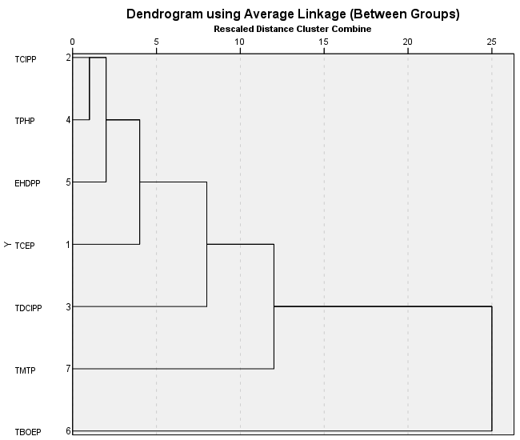
Fig. S1a: Dendrogram showing the cluster formation of OPEs in sediment samples from the Ogun River

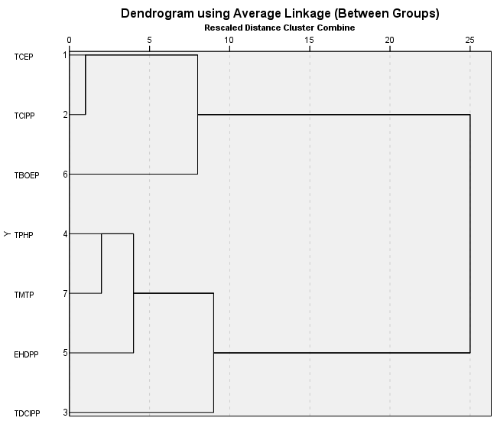
Fig. S1b: Dendrogram showing the cluster formation of OPEs in sediment samples from the Osun River

Fig. S2: Comparison of median OPEs concentrations (ng/g dw) in sediment from the Ogun and Osun rivers

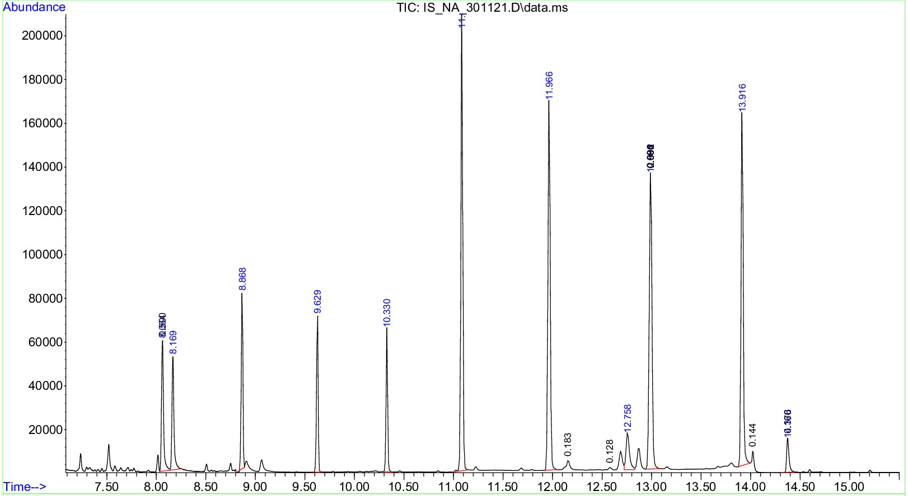
Fig. S3: Internal standard chromatogram
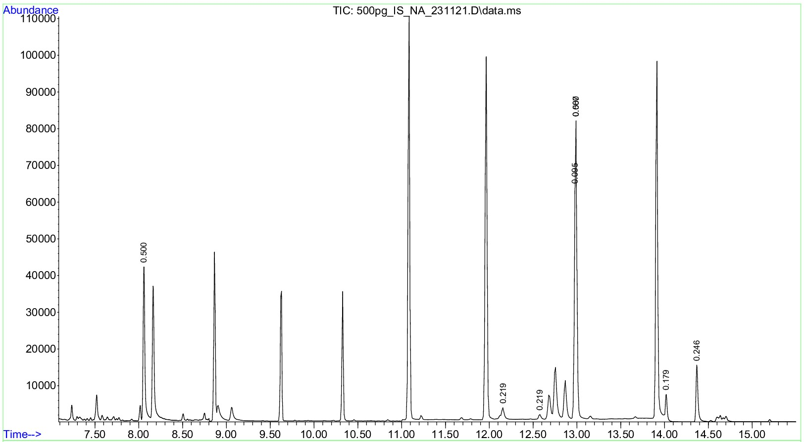
Fig. S4: Internal standard chromatogram

References
Bekele TG, Zhao H, Wang Q, Chen J (2019) Bioaccumulation and Trophic Transfer of Emerging Organophosphate Flame Retardants in the Marine Food Webs of Laizhou Bay, North China. Environ. Sci. Technol. 53, 13417-13426.

Cao D, Guo J, Wang Y, Li Z, Liang K, Corcoran MB, Hosseini S, Bonina SMC, Rockne KJ, Sturchio NC, Giesy JP, Liu J, Li A, Jiang G (2017) Organophosphate esters in sediment of the Great Lakes. Environ. Sci. Technol. 51 (3), 1441–1449.

Chen M, Gan Z, Qu B, Chen S, Dai Y, Bao X (2019) Temporal and seasonal variation and ecological risk evaluation of flame retardants in seawater and sediments from Bohai Bay near Tianjin, China during 2014 to 2017. Mar. Pollut. Bull. 146, 874-883.

Chokwe TB, Okonkwo JO (2019) Occurrence, distribution and ecological risk assessment of organophosphorus flame retardants and plasticizers in sediment samples along the Vaal River catchment, South Africa. Emerg. Contam. 5, 173–178. https://doi.org/10.1016/j.emcon.2019.05.003.

Cristale J, García VA, Barata C, Lacorte S (2013) Priority and emerging flame retardants in rivers: occurrence in water and sediment, Daphnia magna toxicity and risk assessment. Environ. Int. 59 (3), 232–243. https://doi.org/10.1016/j.envint.2013.06.011.

Dishaw LV, Hunter DL, Padnos B, Padilla S, Stapleton HM (2014) Developmental exposure to organophosphate flame retardants elicits overt toxicity and alters behavior in early life stage zebrafish (Danio rerio). Toxicol. Sci. 142 (2), 445–454. https://doi. org/10.1093/toxsci/kfu194.

Du ZK, Wang G.W, Gao SX, Wang ZY (2015) Aryl organophosphate flame retardants induced cardiotoxicity during zebrafish embryogenesis: by disturbing expression of the transcriptional regulators. Aquat. Toxicol. 161, 25–32. https://doi.org/10.1016/j. aquatox.2015.01.027.

European Commission (2009) European Union risk assessment report: tris (2-chloroethyl) phosphate, TCEP. https://echa.europa.eu/documents/10162/2663989d-1795-44a1- 8f50-153a81133258, Accessed date: 25/06/22.

Han Z, Wang Q, Fu J, Chen H, Zhao Y, Zhou B, Gong Z, Wei S, Li J, Liu H, Zhang X, Liu C, Yu H (2014) Multiple bio-analytical methods to reveal possible molecular mechanisms of developmental toxicity in zebrafish embryos/larvae exposed to tris (2-butoxyethyl) phosphate. Aquat. Toxicol. 150, 175–181. https://doi.org/10.1016/j. aquatox.2014.03.013.

Hu YX, Sun YX, Li X, Xu WH, Zhang Y, Luo XJ, Dai SH, Xu XR, Mai BX (2017) Organophosphorus flame retardants in mangrove sediments from the Pearl River Estuary, South China. Chemosphere, 181, 433-439.

Ji B, Liu Y, Wu Y, Liang Y, Gao S, Zeng X, Yao P, Yu Z (2022) Organophosphate esters and synthetic musks in the sediments of the Yangtze River Estuary and adjacent East China Sea: Occurrence, distribution, and potential ecological risks. Mar Pollut Bull. 179:113661. doi: 10.1016/j.marpolbul.2022.113661.

Li J, Wang J, Taylor AR, Cryder Z, Schlenk D, Gan J (2019) Inference of Organophosphate Ester Emission History from Marine Sediment Cores Impacted by Wastewater Effluents. Environ. Sci. Technol. 53, 8767-8775.

Liang C, Peng B, Wei G-L, Gong Y, Liu G, Zeng L, Liu L-Y, Zeng EY (2021) Organophosphate diesters in urban River sediment from South China: call for more research on their occurrence and fate in field environment. ACS EST Water 1, 871–880
Liao C, Kim U-J, Kannan K (2020) Occurrence and distribution of organophosphate esters in sediment from northern Chinese coastal waters. Sci. Total Environ. 704, 135328. https://doi.org/10.1016/j.scitotenv.2019.135328.
Liu Q, Tang X, Wang Y, Yang Y, Zhang W, Zhao Y, Zhang X (2019) ROS changes are responsible for tributyl phosphate (TBP)-induced toxicity in the alga Phaeodactylum tricornutum. Aquat. Toxicol. 208, 168–178. https://doi.org/ 10.1016/j.aquatox.2019.01.012.

Luo Q, Gu LY, Wu ZP, Shan Y, Wang H, Sun LN (2020) Distribution, source apportionment and ecological risks of organophosphate esters in surface sediments from the Liao River, Northeast China. Chemosphere, 250: 126297

Ma Y, Xie Z, Lohmann R, Mi W, Gao G (2017) Organophosphate Ester flame retardants and plasticizers in ocean sediments from the North Pacific to the Arctic Ocean. Environ. Sci. Technol. 51 (7), 3809–3815. https://doi.org/10.1021/acs.est.7b00755

McGee SP, Cooper EM, Stapleton HM, Volz DC (2012) Early zebrafish embryogenesis is susceptible to developmental TDCPP exposure. Environ. Health Perspect. 120 (11), 1585–1591. https://doi.org/10.1289/ehp.1205316.

Mi L, Xie Z, Zhao Z, Zhong M, Mi W, Ebinghaus R, Tang J (2019) Occurrence and spatial distribution of phthalate esters in sediments of the Bohai and Yellow seas. Sci. Total Environ. 653, 792-800.

Pantelaki I, Voutsa D (2019) Organophosphate flame retardants (OPFRs): A review on analytical methods and occurrence in wastewater and aquatic environment. Sci Total Environ., 649:247-263. doi: 10.1016/j.scitotenv.2018.08.286.
Peverly AA, O’Sullivan C, Liu LY, Venier M, Martinez A, Hornbuckle KC, Hites RA (2015) Chicago’s sanitary and ship canal sediment: polycyclic aromatic hydrocarbons, polychlorinated biphenyls, brominated flame retardants, and organophosphate esters. Chemosphere 134, 380–386.

Pubchem (2022) ˂https://pubchem.ncbi.nlm.nih.gov˃
Sutton R, Chen D, Sun J, Greig DJ, Wu Y (2019) Characterization of brominated, chlorinated, and phosphate flame retardants in San Francisco Bay, an urban estuary. Sci. Total Environ. 652, 212-223.

Tan XX, Luo XJ, Zheng XB, Li ZR, Sun RX, Mai BX (2016) Distribution of organophosphorus flame retardants in sediments from the Pearl River Delta in South China. Sci. Total Environ. 544, 77-84.

Verbruggen EMJ, Rila JP, Traas TP, Posthuma-Doodeman CJAM, Posthumus R, (2005) Environmental risk limits for several phosphate esters,with possible application as flame retardant. http://refhub.elsevier.com/S0160-4120(13)00129-3/rf0285, Accessed date: 10 May 2019.

Xing LQ, Zhang Q, Sun X, Zhu HX, Zhang SH, Xu HZ (2018) Occurrence, distribution and risk assessment of organophosphate esters in surface water and sediment from a shallow freshwater Lake, China. Sci. Total Environ. 636, 632–640.

Yadav IC, Devi NL, Li J, Zhang G, Covaci A. (2018) Concentration and spatial distribution of organophosphate esters in the soil-sediment profile of Kathmandu Valley, Nepal: Implication for risk assessment. Sci. Total Environ. 613–614, 502–512

Zhang R, Yu K, Li A, Zeng W, Lin T, Wang Y (2020) Occurrence, phase distribution, and bioaccumulation of organophosphate esters (OPEs) in mariculture farms of the Beibu Gulf, China: A health risk assessment through seafood consumption. Environ. Pollut. 263, 114426.

Zhang L, Lu L, Zhu W, Yang B, Lu D, Dan SF, Zhang S (2021) Organophosphorus flame retardants (OPFRs) in the seawater and sediments of the Qinzhou Bay, Northern Beibu Gulf: occurrence, distribution, and ecological risks. Mar. Pollut. Bull. 168, 112368. https://doi.org/10.1016/j.marpolbul.2021.112368

