Supplementary Material:

Experimental Infection Of Aquatic Bird Bornavirus 1 (ABBV-1) In Canada Geese (Branta canadensis)

Fernanda Ampuero¹, Alexander Leacy¹, Phuc H. Pham¹, Sunoh Che¹, Jaime Tuling¹, Antonius El-khoury¹, Eva Nagy¹, Claire Jardine¹, Pauline Delnatte¹, Brandon Lillie¹, Leonardo Susta^{1*}

¹University of Guelph, Pathobiology, Guelph, N1G2W1, Canada
fampuero@uoguelph.ca (F. Ampuero), aleacy@uoguelph.ca (A. Leacy), phpham@uoguelph.ca (P. Pham), ches@uoguelph.ca (S. Che), jtuling@uoguelph.ca (J. Tuling), aelkhour@uoguelph.ca (A. El-khoury), enagy@ovc.uoguelph.ca (E. Nagy), cjardi01@uoguelph.ca (C. Jardine), pdelna01@uoguelph.ca (P. Delnatte), blillie@uoguelph.ca (B. Lillie), lsusta@uoguelph.ca (L. Susta).

Corresponding author: Leonardo Susta, Pathobiology Department, University of Guelph, 50 Stone Road East, Guelph, Ontario, Canada, N1G 2W1, lsusta@uoguelph.ca, 519-824-4120 ext.54323.
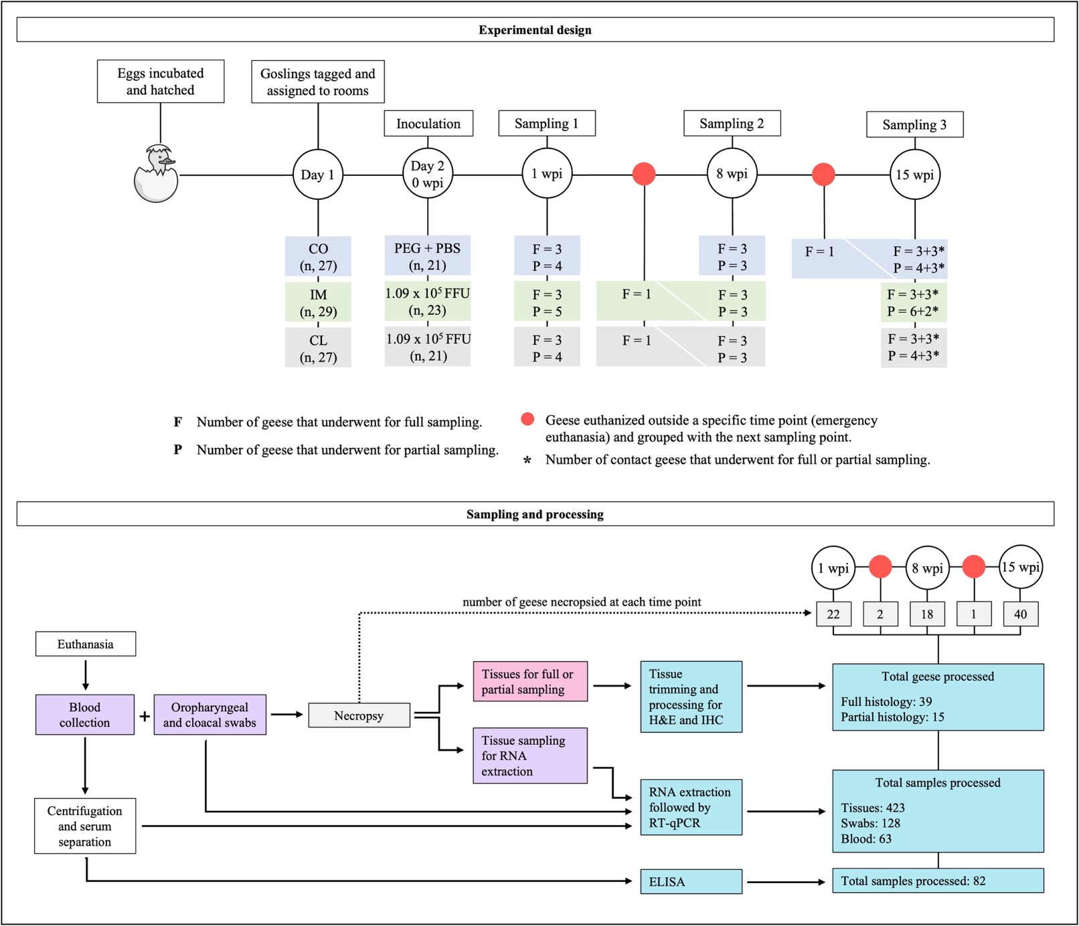
Supplementary Figure S1. Schematic representation of the experimental plan (design, sampling, and processing) for the experimental infection of Canada geese with aquatic bird bornavirus 1 (ABBV-1). Represented in the upper panel (experimental design) are the three experimental groups (CO, control; IM, intramuscular; CL, cloacal) with the respective total number (n) of birds, the infectious dose of inoculum used per bird, and number of birds euthanized at each time point and used for full (F) or partial (P) sampling. Red circle represents nonscheduled euthanasia, and the (*) symbol represents contact geese (noninoculated birds). In the lower panel (sampling and processing), there are the steps from euthanasia to sample processing, and the total number of samples processed in the entire experiment.

Supplementary Table 1. Total number of goose eggs hatched (stratified by hatching day), their destination group (CO, control; IM, intramuscular; CL, cloacal) and subgroup (I, inoculated; S, sentinel), and average age (days) at inoculation / placement for each group.
Inoculation day*and sampling week** | Hatch date | Number of hatchlings | Group |  |  |  |  |  |  |  | Age at inoculation
Inoculation day*and sampling week** | Hatch date | Number of hatchlings | CO |  |  | IM |  |  | CL |  | Age at inoculation
Inoculation day*and sampling week** | Hatch date | Number of hatchlings | I | S |  | I | S |  | I | S | Age at inoculation
05-May  8 and 15 wpi | 29-Apr | 15 | 5 | 0 |  | 5 | 0 |  | 5 | 0 | 6 d
05-May  8 and 15 wpi | 30-Apr | 8 | 3 | 0 |  | 3 | 0 |  | 2 | 0 | 5 d
05-May  8 and 15 wpi | 01-May | 10 | 3 | 0 |  | 3 | 0 |  | 4 | 0 | 4 d
05-May  8 and 15 wpi | 02-May | 3 | 1 | 0 |  | 1 | 0 |  | 1 | 0 | 3 d
05-May  8 and 15 wpi | 03-May | 7 | 2 | 0 |  | 3 | 0 |  | 2 | 0 | 2 d
05-May  8 and 15 wpi | 04-May | 9 | 0 | 3 |  | 0 | 3 |  | 0 | 3 | 1 d
11-May  1 wpi | 05-May | 10 | 1 | 2 |  | 2 | 2 |  | 1 | 2 | 6 d
11-May  1 wpi | 06-May | 6 | 1 | 1 |  | 1 | 1 |  | 1 | 1 | 5 d
11-May  1 wpi | 07-May | 7 | 3 | 0 |  | 2 | 0 |  | 2 | 0 | 4 d
11-May  1 wpi | 08-May | 4 | 1 | 0 |  | 1 | 0 |  | 2 | 0 | 3 d
11-May  1 wpi | 09-May | 4 | 1 | 0 |  | 2 | 0 |  | 1 | 0 | 2 d
Total bird number |  | 83 | 21 | 6 |  | 23 | 6 |  | 21 | 6
Average age at inoculation / placement |  |  | 4.3 d | 3.3 d |  | 4.2 d | 3.3 d |  | 4.2 d | 3.3 d
*Indicates the day when birds were moved from the Horsfall units and placed into the room where they were inoculated or kept as sentinels; birds were moved in two batches to decrease the age range at the time of inoculation.
**Separate batches were sampled at different weeks post infection (wpi), to maintain age distribution as similar as possible between time points.

