Supplementary Material:
Spin–Orbit-Lattice Locking in Strain-Engineered Sr₂FeReO₆ Double Perovskites
Gahee Noh^{1, †}, Hansol Lee^{2, †}, Yong-Jin Kim^{3, †}, Yeongrok Jin⁴, Donghwa Lee¹, Ho Nyung Lee⁵, Jaekwang Lee⁴, Chan-Ho Yang^{3,}*, Changhee Sohn^{6,}*, and Si-Young Choi^{1,7,8,}*

¹Department of Materials Science and Engineering, Pohang University of Science and Technology (POSTECH), Pohang 37673, Republic of Korea
²Department of Energy Engineering, Ulsan National Institute of Science and Technology (UNIST), Ulsan 44919, Republic of Korea
³Department of Physics, Korea Advanced Institute of Science and Technology (KAIST), Daejeon 34141, Republic of Korea
⁴Department of Physics, Pusan National University, Pusan 46241, Republic of Korea
⁵Materials Science and Technology Division, Oak Ridge National Laboratory, Oak Ridge Tennessee 37831, USA
⁶Department of Physics, Ulsan National Institute of Science and Technology (UNIST), Ulsan 44919, Republic of Korea
⁷Center for Van der Waals Quantum Solids, Institute for Basic Science (IBS), Pohang 37673, Republic of Korea
⁸ Department of Semiconductor Engineering, Pohang University of Science and Technology (POSTECH), Pohang 37673, Republic of Korea
* Authors to whom correspondence should be addressed: chyang@kaist.ac.kr, chsohn@unist.ac.kr, and youngchoi@postech.ac.kr
†These authors contributed equally to this work.

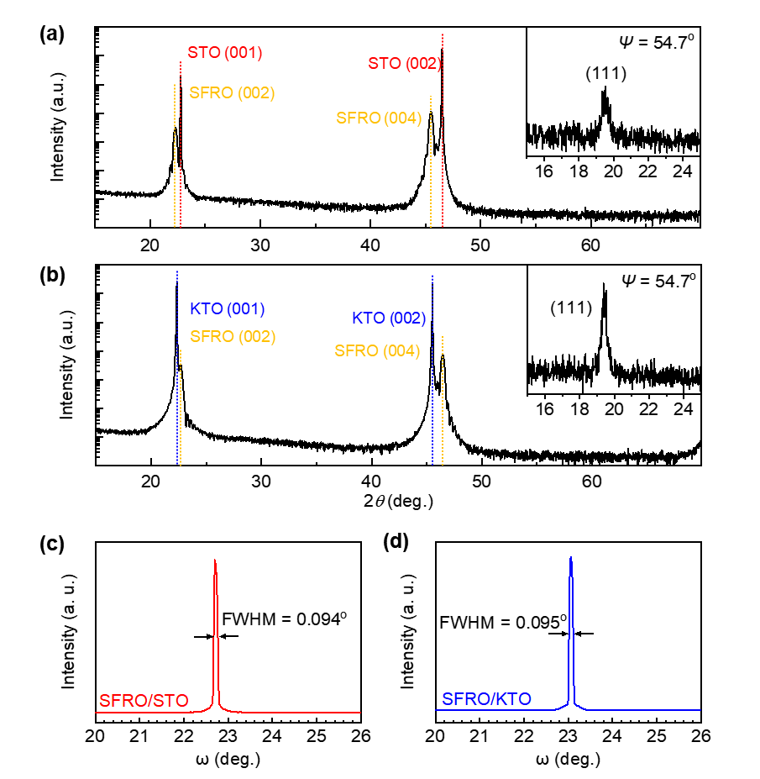
Supplementary Figures
Figure S1. XRD data for SFRO films. (a) XRD $θ$–2$θ$scans of SFRO films on STO. Red line and yellow lines indicate peaks from STO substrate and SFRO films, respectively. (b) XRD $θ$–2$θ$scans of SFRO films on KTO. The blue and yellow lines indicate peaks from KTO substrate SFRO films, respectively. The inset displays the (111) peaks of SFRO films deposited on STO and KTO substrates, indicating the Fe/Re ordering. (c), (d) The rocking-curve FWHM (full width at half maximum) shown by SFRO films on (c) STO and (d) KTO.

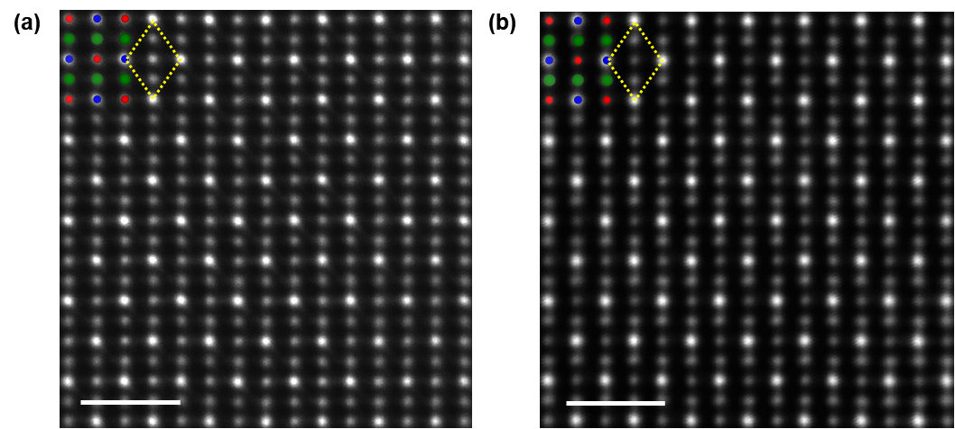
Figure S2. High magnification HAADF-STEM images of SFRO. (a) SFRO film on STO substrate (b) SFRO film on KTO substrate. The scale bar is 1 nm. Distinct diamond shapes are visible in both images, indicating well-ordered B cations in the rock-salt arrangement.

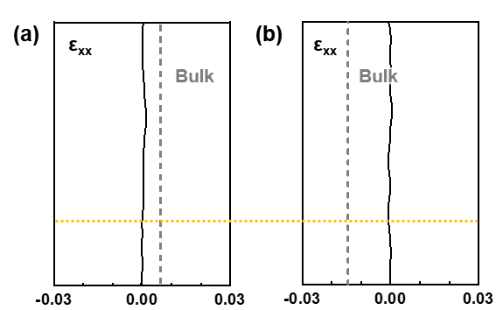
Figure S3. Intensity profile of in-plane strain (ε_{xx}) applied on SFRO film. GPA images of SFRO films on (a) STO and (b) KTO substrate. The yellow dashed line indicates interface between film and substrate. These intensity profile shows that in-plane lattice of SFRO film is similar as STO and KTO substrate, respectively, which means in-plane compressive (tensile) is induced in SFRO films on STO (KTO) substrates.

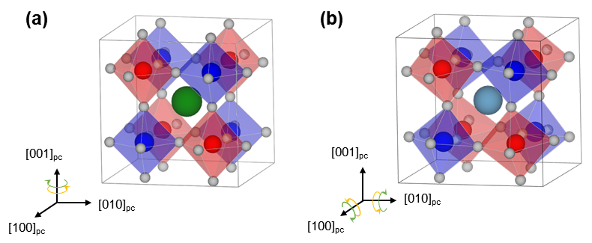
Figure S4. Oxygen octahedral structure of SFRO. (a) Tetragonal SFRO structure with an a⁰a⁰c⁻ tilt pattern. (b) Monoclinic CFRO structure with an a⁻a⁻c⁺ tilt pattern. (Sr, green; Ca, sky blue; Fe, red; Re, blue; O, gray)

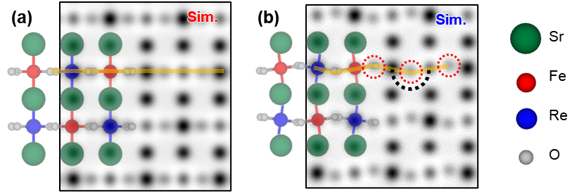
Figure S5. ABF-STEM simulation images of SFRO along the [110] zone axis. (a) a⁰a⁰c⁻ tilt pattern of SFRO. (b) a⁻a⁻c⁺ tilt pattern of SFRO.

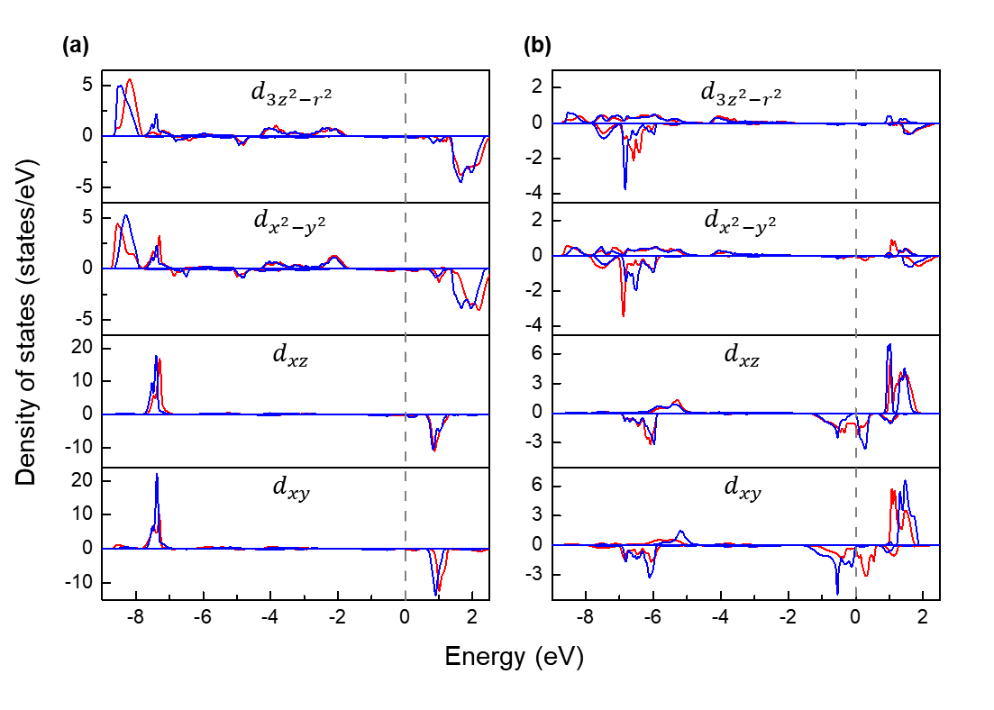
Figure S6. Projected density of states PDOS of d orbital of strained SFRO. (a) Fe d orbital. (b) Re d orbital. The red and blue lines correspond to spin-up and spin-down projected density of states of SFRO on STO and KTO substrate, respectively. The zero of energy is set to the E_{F}, the projected density of states close to the E_{F} level is mainly composed of t_{2g} orbitals of Re.

Figure S7. Effect of Fe orbitals on MAE under strain. MAE of Fe atom (red) is almost zero and remains unchanged with strain variation, whereas that of Re atom (blue) changes its sign from negative to positive as the strain sign changes. This indicates that the changes in magnetic anisotropy shown by a strained SFRO film predominantly originates from Re rather than Fe atom.

