Supplementary Information

Evolutionary dynamics of chromatin structure and duplicate gene expression in diploid and allopolyploid cotton

Guanjing Hu^{1,2*}, Corrinne E. Grover³, Daniel L. Vera⁴, Pei-Yau Lung⁵, Senthil B. Girimurugan⁶, Emma R. Miller³, Justin L. Conover^{3,11,12}, Shujun Ou⁷, Xianpeng Xiong², De Zhu², Dongming Li^{8,2}, Joseph P. Gallagher⁹, Joshua A Udall¹⁰, Xin Sui⁵, Jinfeng Zhang⁵, Hank W. Bass^{4*}, Jonathan F. Wendel^{3*}

¹ State Key Laboratory of Cotton Biology, Institute of Cotton Research, Chinese Academy of Agricultural Sciences, Anyang, China 455000
² Shenzhen Branch, Guangdong Laboratory of Lingnan Modern Agriculture, Key Laboratory of Synthetic Biology, Ministry of Agriculture and Rural Affairs, Agricultural Genomics Institute at Shenzhen, Chinese Academy of Agricultural Sciences, Shenzhen, China 518120
³ Department of Ecology, Evolution and Organismal Biology, Iowa State University, Ames, Iowa, USA 50011
⁴ Department of Biological Science, Florida State University, Tallahassee, Florida, USA 32306
⁵ Department of Statistics, Florida State University, Tallahassee, Florida, USA 32306
⁶ Dept of Mathematics, Florida Gulf Coast University, Florida, USA 33965
⁷ Department of Molecular Genetics, Ohio State University, Columbus, Ohio, USA 43210
⁸ Zhengzhou Research Base, State Key Laboratory of Cotton Biology, School of Agricultural Sciences, Zhengzhou University, Zhengzhou, China 450000
⁹ Forage Seed and Cereal Research Unit, USDA/Agricultural Research Service, Corvallis, Oregon, USA 97331
¹⁰ Crop Germplasm Research Unit, USDA/Agricultural Research Service, College Station, Texas, USA 77845
¹¹ Department of Ecology & Evolutionary Biology, University of Arizona, Tucson, AZ, USA 85721
¹² Department of Molecular & Cellular Biology, University of Arizona, Tucson, AZ, USA 85721

* Correspondence: Jonathan F. Wendel (jfw@iastate.edu), Hank W. Bass (bass@bio.fsu.edu), and Guanjing Hu (huguanjing@caas.cn)

Abbreviation box
ACR, accessible chromatin region
ASE, allele-specific expression
ATAC-seq, assay for transposase accessible chromatin sequencing
BC, biological cutoff
DA, differential accessibility
DNase-seq, DNase I hypersensitive site sequencing
DHS, DNase I-hypersensitive site
DNS, differential nuclease sensitivity
DNS-seq, differential micrococcal nuclease digested nucleosomal DNA sequencing
ELD, expression level dominance
GS, genome size
HEB, homoeolog expression bias
MH, MNase hypersensitive
MNase-seq, ​​micrococcal nuclease sequencing
MOA, MNase-defined cistrome-occupancy analysis
MSF, MNase sensitive footprints
NC, nucleosome coverage
NFL, nucleosome repeat length
NFR, nucleosome free region
OG, ortho-homoeolog group
RPM, reads per million
SPO, subnucleosomal particle occupancy
TE, transposable element
TSS, transcription start site
TTS, transcription termination site

Supplementary Text 1: Optimization of iSeg setting
To optimize iSeg performance, a range of biological cutoff (BC) stringencies from 4.0 to 7.0 (low to high) were applied to the DNS data. The positive DNS peaks identified represent MNase hypersensitive (HS) regions that are depleted of nucleosomes or relatively more accessible to regulatory transcription factors. Across diploid genomes (A₂ and D₅) and subgenomes (At and Dt) in F₁ and AD₁ genomes, the same stringency led to equal percentages of total genome sequence to be identified as ACRs: 1.85% at BC=4.0, 1.38% at BC=4.5, 1.06% at BC=5.0, 0.82% at BC=5.5, 0.65% at BC=6.0, 0.51% at BC=6.5, and 0.40% at BC=7.0. To understand how the choice of BC stringency affects ACR characterization, we inspected the profiles of ACR distribution across different stringency levels. Based on proximity to their nearest annotated genes, ACRs were categorized as genic (gACRs; overlapping a gene), proximal (pACRs; within 2 Kb of a gene) or distal (dACRs; >2 Kb from a gene). As the BC stringency increases, the ACR peak number and total length decrease (Supplementary Text 1 Figure 1-2), whereas the relative proportion of three ACR categories remains unaffected by stringency (Supplementary Text 1 Figure 3-4). Thus, we concluded that ACR identification and categorization is robust regardless of the choice of BC stringency. Given the amount of ACRs mapped by ATAC-seq and DNase-seq in cotton (0.45%-0.80% of genome; see main text and Supplementary Text 2: ATAC-seq analysis in G. raimondii), we chose BC=6.0 as the stringency parameter. For sub-nucleosomal particle occupancy (SPO) scores, the following BC stringencies were used to identify 0.83% of A₂ genome at BC=4, 0.68% of D₅ genome at BC=5, 0.67% of AD₁ genome at BC=4, and 0.77% of A₂×D₅ genome at BC=4.5.

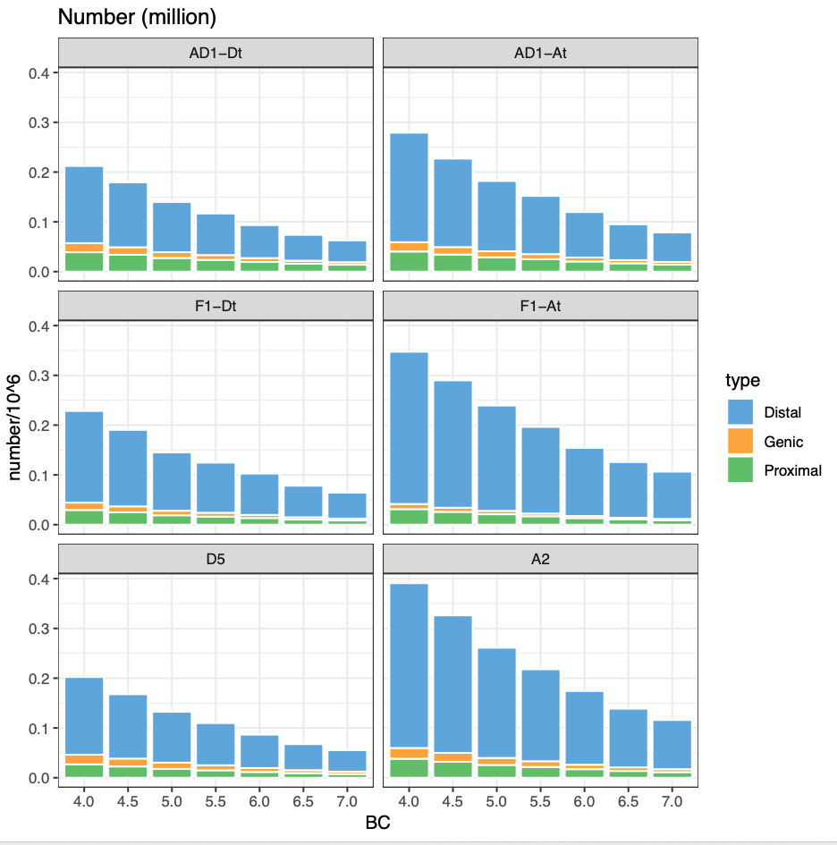
Supplementary Text 1 Figure 1. Peak number identified per genome under different iSeg stringencies.
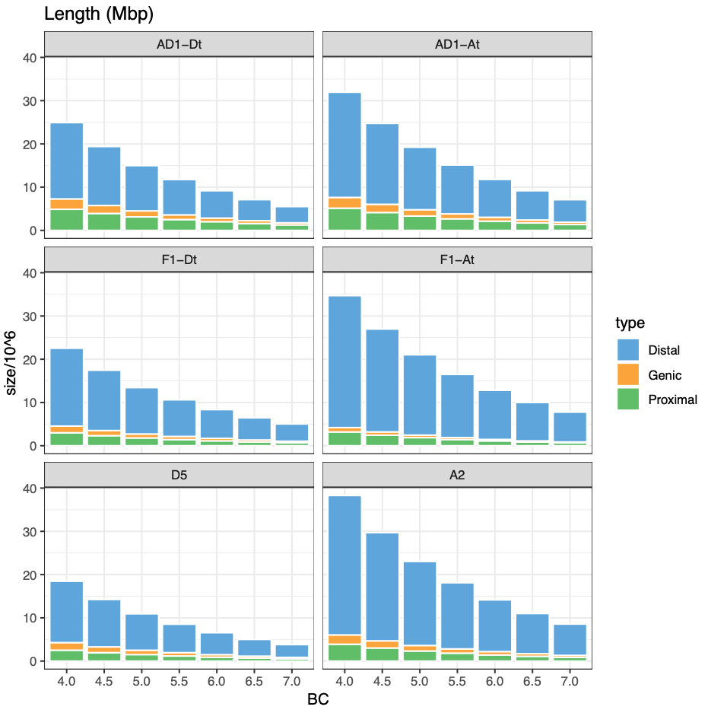
Supplementary Text 1 Figure 2. Peak length identified per genome under different iSeg stringencies.

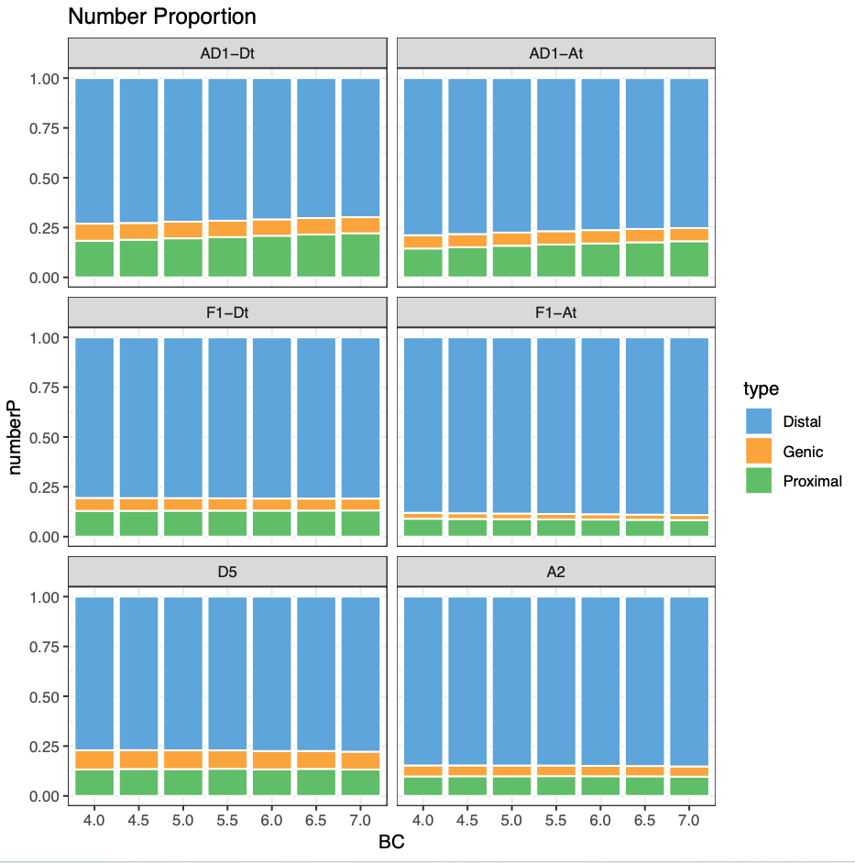
Supplementary Text 1 Figure 3. Relative proportion of peak numbers identified per genome under different iSeg stringencies.

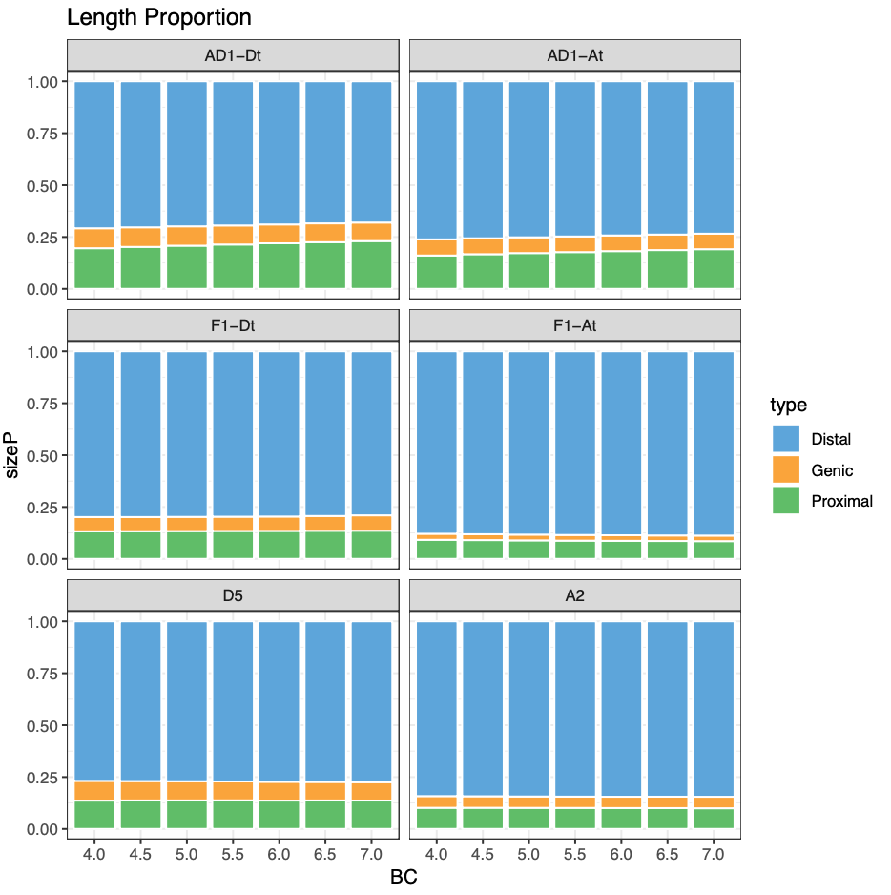
Supplementary Text 1 Figure 4. Relative proportion of peak length identified per genome under different iSeg stringencies.

Supplementary Text 2: ATAC-seq analysis in G. raimondii
We performed ATAC-seq to map accessible chromatin regions (ACRs) in young leaves. Two replicated ATAC-seq libraries were sequenced to 21.1 and 16.2 million reads per sample. The strand cross-correlation statistics supported the high quality of the ATAC-seq data, and the correlation of mapping read coverages (Pearson’s r = 1.00 and Spearman’s r = 0.72) suggested a high level of reproducibility between replicates (Table S4. Summary of ATAC-seq and DNase-seq data). Peak calling methods of HOMER, MACS2, and Genrich were applied for comparison, which identified 17,102 (6.0 Mb), 16,195 (5.5 Mb), 11,687 (4.6 Mb) ACRs by combining replicates, respectively (Table S5. ACR identification). Between these ACR lists, the overlaps of 41.2% to 79.5% indicated a relatively high consistency in ATAC-seq peak calling. The enrichment of ACRs around gene transcription start sites (Supplementary Text 1 Figure 1) suggested that these regions were potentially important for cis-regulatory control. Based on proximity to their nearest annotated genes, ACRs were categorized as genic (gACRs; overlapping a gene), proximal (pACRs; within 2 Kb of a gene) or distal (dACRs; >2 Kb from a gene). These three categories each represented about one third of the total number of ACRs, where Genrich detected more dACRs than did HOMER and MACS2 (41.9%, 31.3% and 35.2%, respectively; Supplementary Text 1 Figure 2-4, pie charts). The majority dACRs were located over 3 Kb from the nearest gene (Supplementary Text 1 Figure 2-4, density plots), and this finding of abundant dACRs implicated potentially long-range cis-regulatory elements and is consistent with the previous ATAC-seq studies in plants (Lu et al. 2019; Ricci et al. 2019). The three ACR categories exhibited similar width distribution and were 10% more GC-rich than the control regions that were randomly selected by maintaining the same width distribution (Supplementary Text 1 Figure 2-4, bar plot and boxplot). Because high GC content is associated with several distinct features that can affect the cis-regulatory potential of a sequence (Landolin et al. 2010; Wang et al. 2012), these results support the putative regulatory functions of ACRs. In addition, ACRs are generally depleted from TEs (negative enrichment scores from permutation tests).

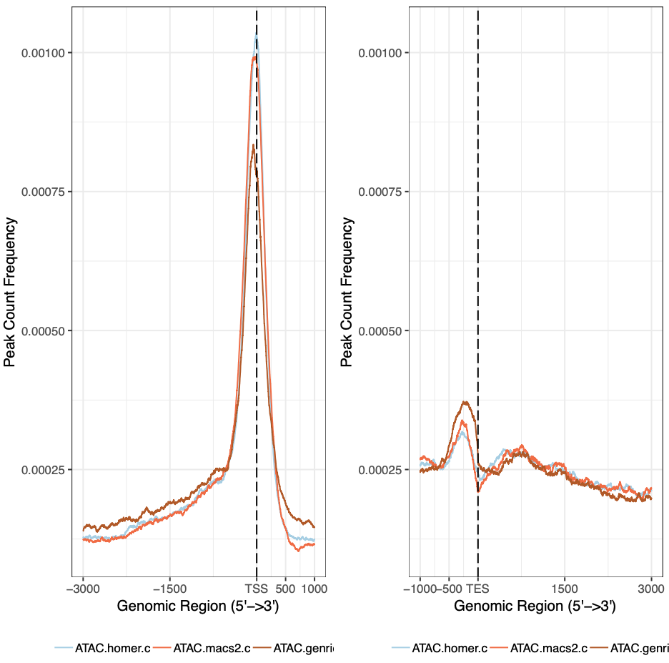
Supplementary Text 2 Figure 1. Peak count frequency of ACRs around gene transcription start sites (TSS) and transcription end sites (TES). Red, MACS2; blue, HOMER; brown - Genrich.

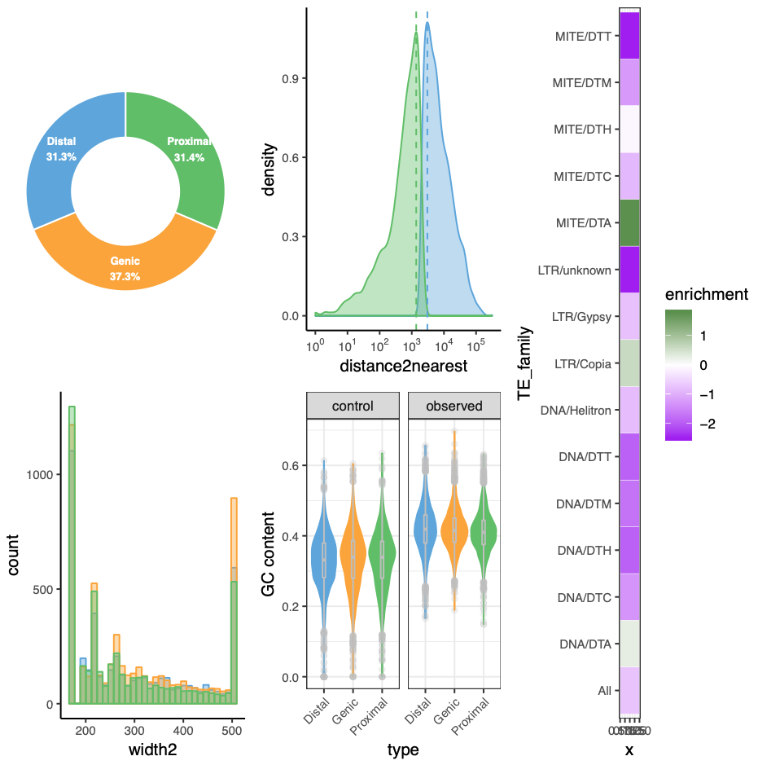
Supplementary Text 2 Figure 2. ATAC-seq ACRs called by HOMER. Top left pie chart presents the percentage of categorized ACR numbers. Top middle density plot presents the distance of proximal and distal ACRs to the nearest annotated genes. Bottom left bar plot present width distribution of ACRs. Bottom middle boxplot presents ACR GC contents as observed and simulated as control. The heatmap bar on the right presents the over- and under-representation scores of a certain transposable element (TE) family containing ACRs.

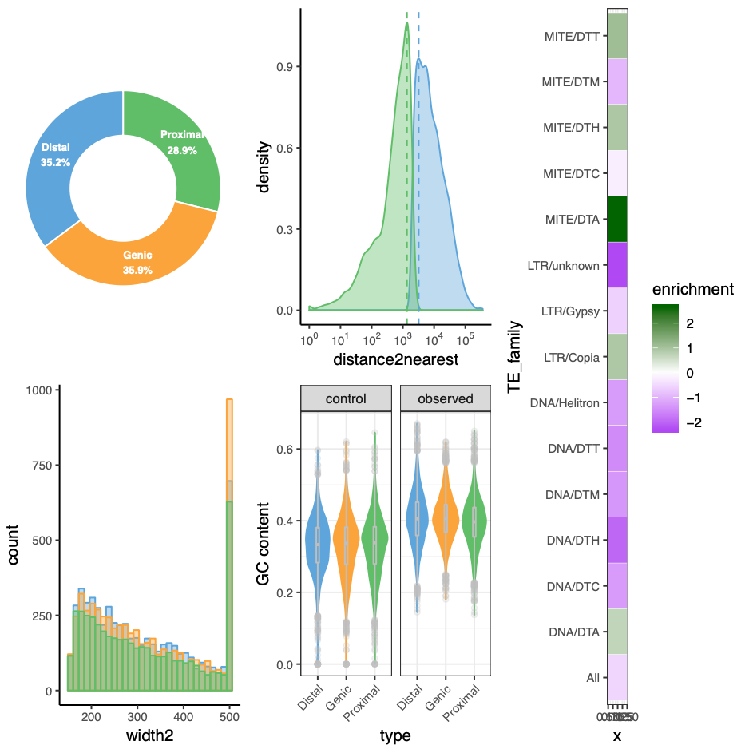
Supplementary Text 2 Figure 3. ATAC-seq ACRs called by MACS2. Top left pie chart presents the percentage of categorized ACR numbers. Top middle density plot presents the distance of proximal and distal ACRs to the nearest annotated genes. Bottom left bar plot present width distribution of ACRs. Bottom middle boxplot presents ACR GC contents as observed and simulated as control. The heatmap bar on the right presents the over- and under-representation scores of a certain transposable element (TE) family containing ACRs.

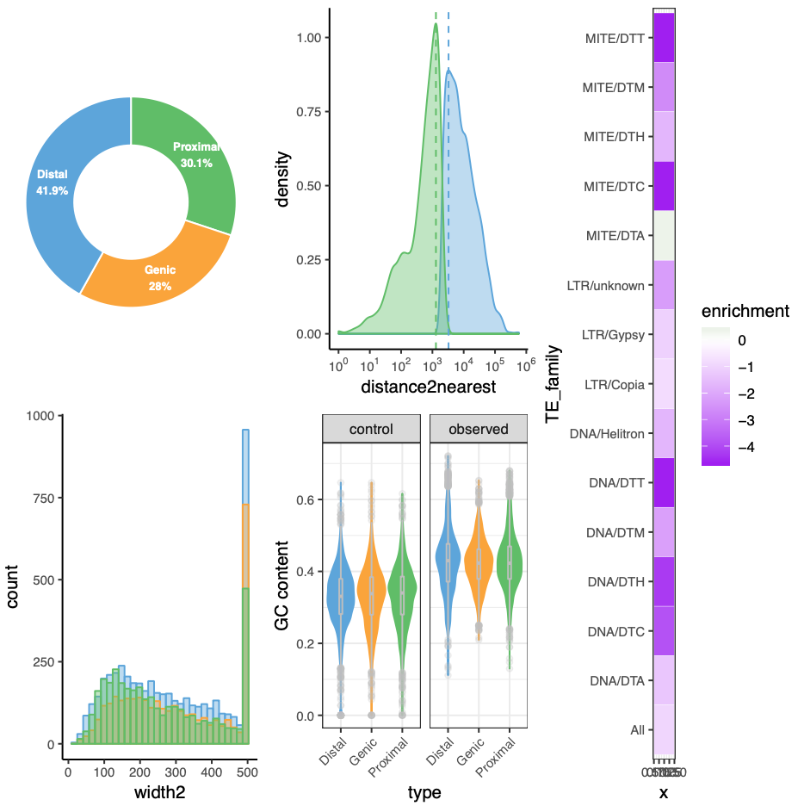
Supplementary Text 2 Figure 4. ATAC-seq ACRs called by Genrich. Top left pie chart presents the percentage of categorized ACR numbers. Top middle density plot presents the distance of proximal and distal ACRs to the nearest annotated genes. Bottom left bar plot present width distribution of ACRs. Bottom middle boxplot presents ACR GC contents as observed and simulated as control. The heatmap bar on the right presents the over- and under-representation scores of a certain transposable element (TE) family containing ACRs.

Supplementary Text 3: A hypersensitive region in G. raimondii chromosome 1
Chromatin accessibility assays, including differential MNase-seq, ATAC-seq, and DNase-seq analyses revealed a hypersensitive region in G. raimondii chromosome 1 (Ch01: 23,162,848 - 23,811,737; Supplementary Text 3 Figure 1). Derived from the high DNS scores (DNS=light-heavy), an unexpected high number of ACRs (1174 peaks of 417,072 bp) were identified from this 649 Kbp region. Previously, this region was annotated as a putative nuclear mitochondrial DNA sequence block, including many genes closely resembling mitochondrial homologues (Gorai.001G159900 - Gorai.001G168200) (Paterson et al. 2012). If this putative insertion of mitochondrial DNA was relatively recent, it may lack proper GC content or other physicochemical properties to array nucleosomes, thereby becoming highly sensitive to nuclease digestion. To test this hypothesis, we applied a sequence-based computational model to predict likelihood for nucleosome formation. Because the predicted nucleosome coverage of this region was even higher than the overall coverage in chromosome 1 (NC=78.2% vs 60.7%), we concluded that the observed hypersensitivity was unlikely to be intrinsically determined by DNA sequence. However, empirically, much lower nucleosome occupancies were observed in this region as revealed by heavy MNase digestion (NC=69.3% vs 91.2%; Supplementary Text 3 Figure 1: second track from top). This abnormal nucleosome organization may be controlled by trans-acting factors (e.g. chromatin remodelers), but such region-specific effect is less likely. An alternative explanation is assembly error that misassembled mitochondrial reads into nuclear DNA sequence, which requires further FISH experiment or long-read nuclear sequences for validation. Regardless of the cause of hypersensitivity, this region was blacklisted and excluded from following ACR analyses in this study.

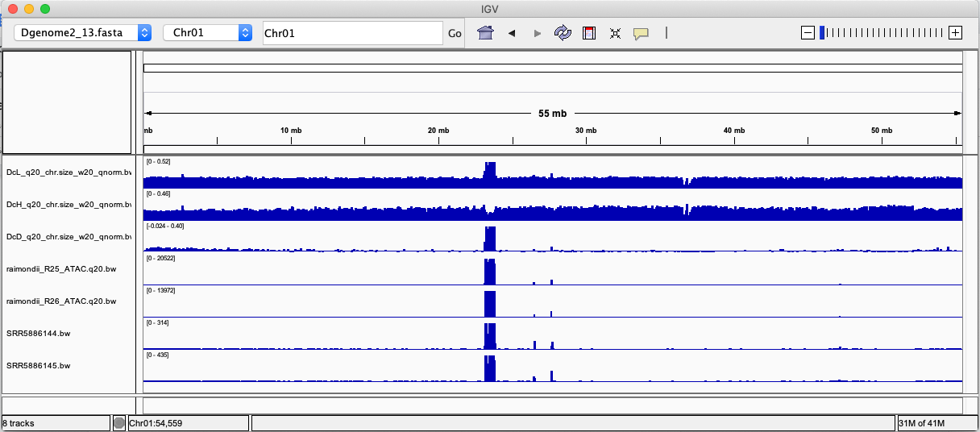
Supplementary Text 3 Figure 1. IGV visualization of G. raimondii chromosome 1. Tracks from top to bottom are: 1) nucleosome occupancy by light digestion; 2) nucleosome occupancy by heavy digestion; 3) DNS; 4) ATAC-seq rep 1; 5) ATAC-seq rep 2; 6) DNase-seq rep 1; 5) DNase-seq rep 2.

Supplementary Text 4: Comparison of different analytic approaches to conduct differential analysis (DA) analysis
Following a previously established workflow (Reske et al. 2020), we compared different approaches to conduct DNA analysis using the R package csaw [v1.16.1] (Lun and Smyth 2016). As shown in Supplementary Text 4 Table 1, methold 1 and 2 map MNase-seq read pairs to genomic regions of interest (i.e., detected ACRs as a given peak set) for examining DA, while method 3 and 4 first map read pairs to sliding windows of the whole genome and then aggregate DA signals on regions of interest. For normalization, method 1 and 3 implement TMM (the trimmed mean of M values), while 2 and 4 implement a non-linear loess-based (loess: locally estimated scatterplot smoothing) normalization method. By contrasting MNase-seq profiles between light and heavy digestion, we expected the observed DA regions to recover ACRs detected by the iSeg [v1.3.4] (Girimurugan et al. 2018) application on DNS scores. In other words, we asked if those previously detected ACRs can be supported by DA analysis; the higher recovery rate of ACRs could be used to identify the more suitable DA method. Except method 2, the other three methods recovered 38-43% of ACRs (Supplementary Text 4 Figure 1), indicating that the previous ACR detection was well supported by the DA analysis using default csaw parameters. It is worth pointing out that the recovery rate can be affected by the stringency of both iSeg (i.e. Biological cutoff) and csaw (analytic parameters and FDR threshold). Because method 3 and 4 are more versatile than method 1 in analyzing other genomic regions of interest, such as gene promoters, and method 3 performs slightly better than method 4, we chose method 3 for following analyses.
To conduct DA analysis between diploids, F₁, and AD₁, we tested the use of both concatenated diploid (A₂+D₅) and AD₁ references to mitigate biases introduced by the reference genome. Because the mapping rates of MNase-seq data were higher when mapped to the corresponding reference than those mapped to the other reference (Supplementary Text 4 Table 2), the A₂+D₅ reference is more suitable for comparing diploids and F₁ accessibility profiles (i.e., inferring hybridization effect), while the AD₁ reference is more suitable for comparing diploids and AD₁ accessibility profiles (i.e., inferring polyploidization effect). The stronger polyploidization than hybridization effect was found regardless of which reference genome was used (Supplementary Text 4 Figure 2).

Supplementary Text 4 Table 1. Four analytic approaches tested
# | csaw mode | Normalization | Description
1 | regionCounts() | TMM | Only ACR regions were used. TMM assumes that most regions are not truly DA, and it assesses for systematic signal differences present across the genome that are presumed to be technical. Therefore, the TMM method should control for technical error more than scaling to total read depth by eliminating any systematic biases while still permitting true asymmetric differences.
2 | regionCounts() | Loess | Only ACR regions were used. Loess assumes a symmetric global distribution in which there are no true biological global differences, and any evidence of these biases are technical and should be removed. This explains the low recovery and symmetric distribution of up and down changes.
3 | windowCounts() | TMM | TMM was globally applied to binned windows of the whole genome, and the DA signals of the ACR regions were extracted for significance tests.
4 | windowCounts() | Loess | Loess was globally applied to binned windows of the whole genome, and the DA signals of the ACR regions were extracted for significance tests.

Supplementary Text 4 Table 2. Mapping rate against different reference genomes
MNase-seq sample | AD₁ reference | A₂+D₅ reference
A6H | 49.22% | 68.55%
A6Hn | 66.78% | 73.97%
A6L | 57.04% | 75.10%
A6Ln | 56.13% | 76.45%
D1H | 53.36% | 89.63%
D1L | 53.39% | 87.49%
D2H | 47.50% | 81.84%
D2L | 54.20% | 88.35%
F2H | 51.51% | 77.82%
F2L | 55.16% | 80.22%
F3H | 52.76% | 77.83%
F3L | 54.00% | 78.81%
M1H | 84.49% | 57.00%
M1L | 85.30% | 57.47%
M2H | 84.11% | 56.12%
M2L | 84.68% | 57.81%

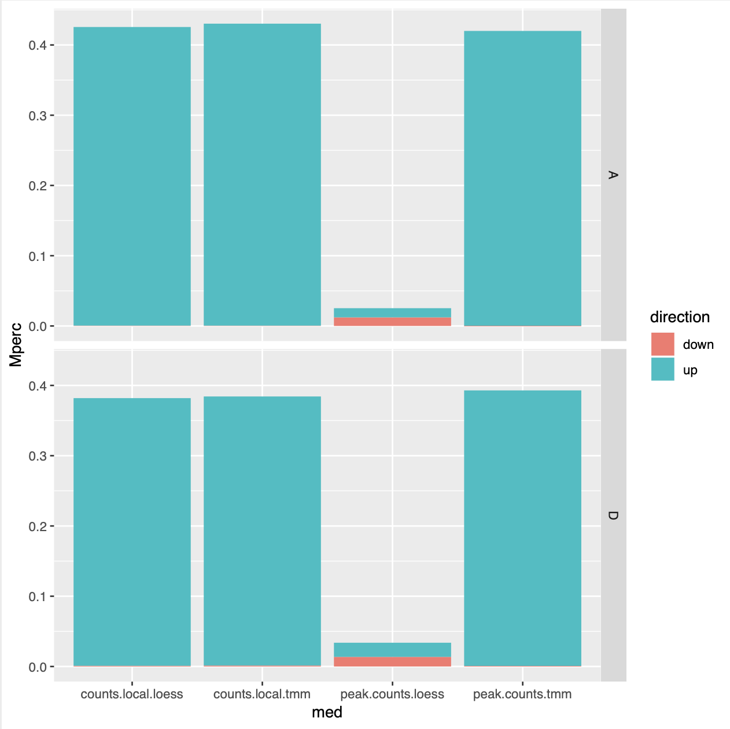
Supplementary Text 4 Figure 1. Comparison of four analytic approaches in identifying ACRs as DA between light and heavy conditions in AD₁. The up or down direction indicates higher mapping coverage in light (sensitive to light MNase digestion) or heavy (resistant to light digestion) condition, respectively. The A- and D- subgenome results were separately plotted with the y-axis representing the percentage recovery rate of ACRs.

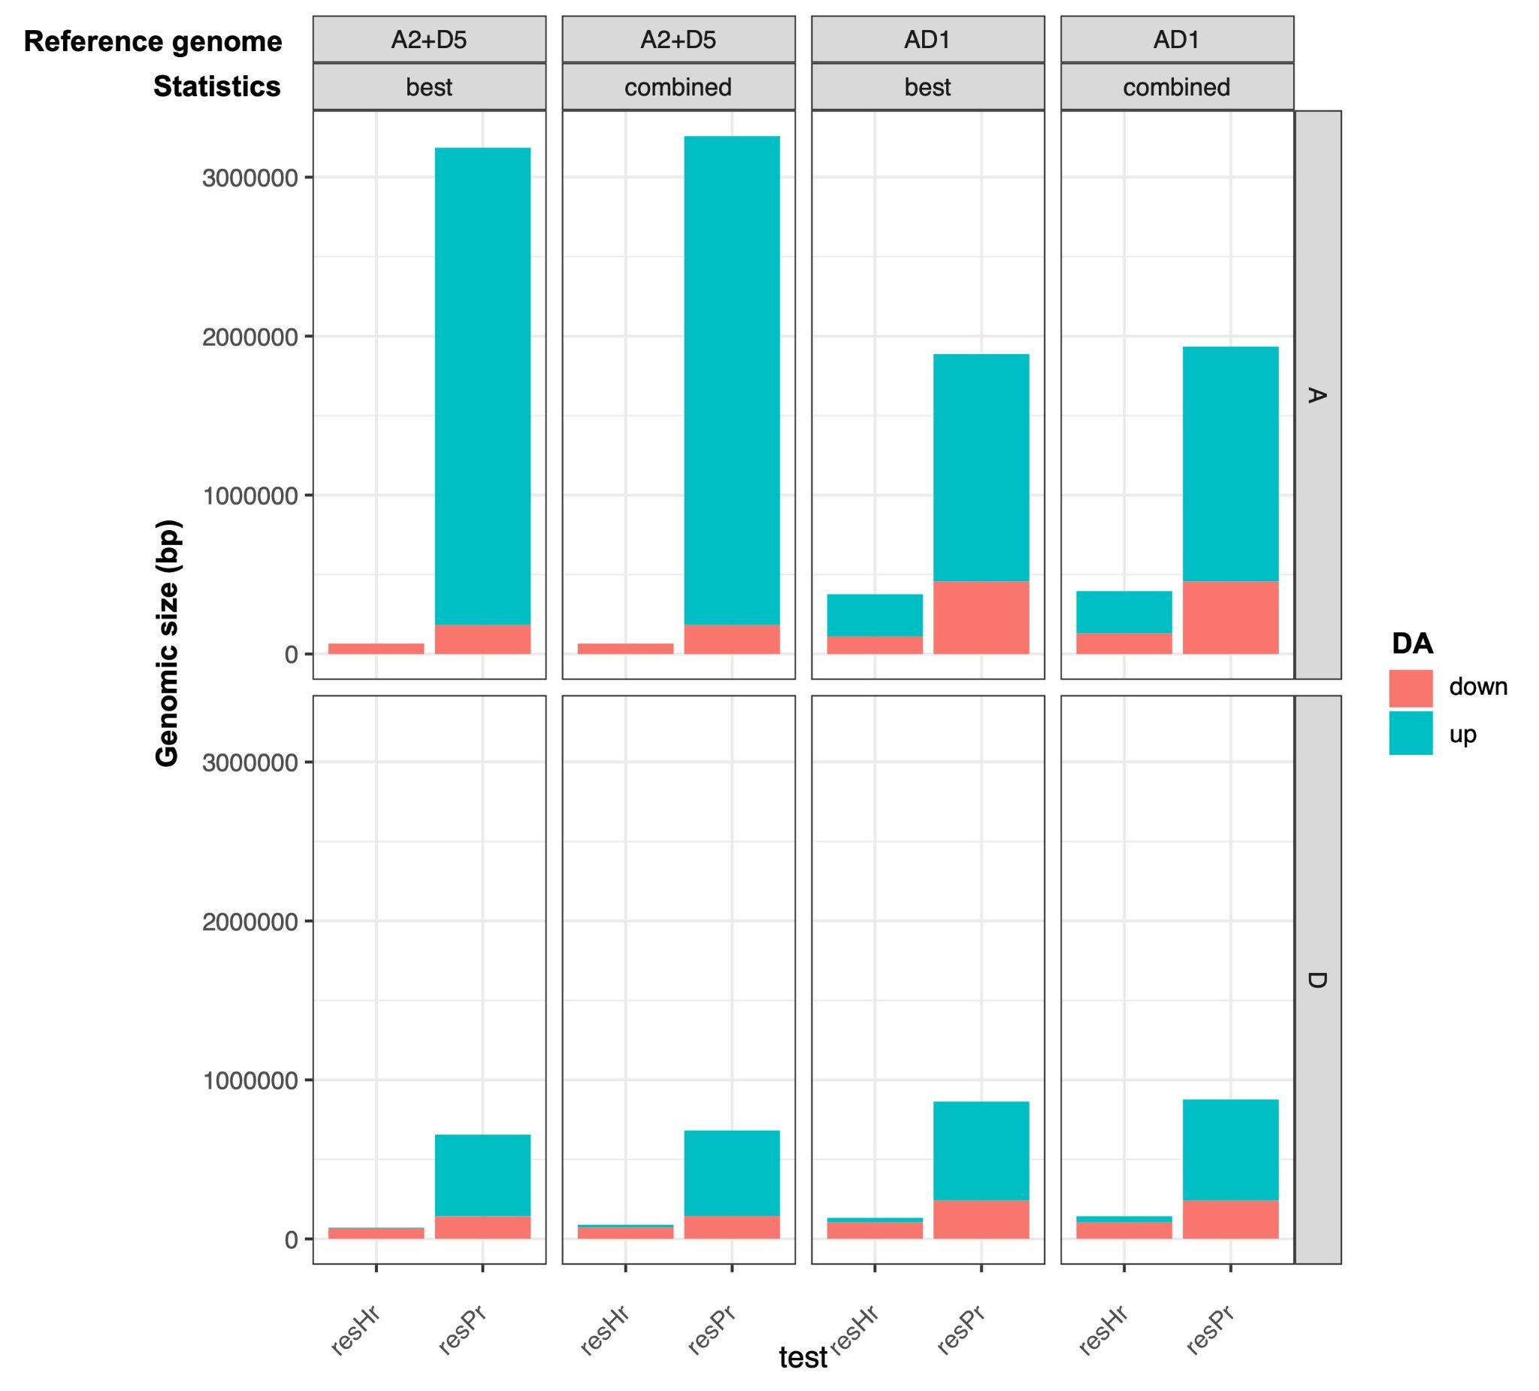
Supplementary Text 4 Figure 2. Comparison of DA results based on different reference genomes - A₂+D₅ and AD₁. In combination with each reference genome (top bar), two overlap statistics of csaw were used (combined and best; 2nd bar from top), and the A- and D- subgenome results were plotted below. Within each plot panel, the bars represent the detected genomic regions exhibiting DA of F₁ vs diploids and (resHr) AD₁ vs diploids (resPr); up- (blue) and down- (red) regulation (blue) represent increased and decreased accessibility, respectively, by genome evolution.

Supplementary Text 5: Analysis of duplicated gene expression patterns using different mapping strategies
Among the twelve RNA-seq samples generated, one D₅ sample turned out to be a mislabeled polyploid sample and was thereby excluded (Supplementary Text 5 Figure 1). To optimize the method to infer duplicated gene expression patterns, we tested three mapping strategies termed by (1) D₅-ref, (2) AD₁-ref, and (3) individual-ref. The mapping rates of diploid and F₁ RNA-seq reads were much higher using individual-ref and D₅-ref than those using AD₁-ref (80-90% vs 56-64%), while the mapping rates of AD₁ RNA-seq reads were comparable between different strategies (82-88%) (Table S12). It is reasonable to conclude that individual-ref and D₅-ref are more suitable than AD₁-ref to handle the interspecific analysis of diploid and allopolyploid cotton transcriptomes. It is also worth noting that both individual-ref and D₅-ref tend to map more D₅ than A₂ reads, while AD₁-ref tends to map more A₂ than D₅ reads, which can introduce technical bias in inferring expression asymmetry between A- and D- (sub)genomes. To mitigate the biases, we took a conservative approach to report the duplicated gene expression patterns that can be commonly identified by different mapping strategies. The commonly inferred total gene expression pattern of homoeologous gene pairs accounted for 37.2-67.8% of F₁/AD₁ differential expression relative to diploids (Table S13) and 62.0-74.8% of additivity test results (Table S14). The commonly inferred patterns based on partitioned homoeologous gene expression accounted for 41.5%-63.7% of parental divergence, 22.7-53.2% of HEB in F₁, 71.4-82.9% of HEB in AD₁, 15.9-61.9% of evolutionary impact, and 6.3-79.2% of cis-trans categories (Supplementary Text 5 Table 1).

Supplementary Text 5 Table 1. Inference of duplicated gene expression patterns
Regulation Pattern | common | D5-ref | D5-ref  % | AD1-ref | AD1-ref % | Individual-ref | Invidual-ref %
Diploid divergence (A ≠ 0) | 2923 | 4591 | 63.7% | 7043 | 41.5% | 5280 | 55.4%
HEB in F₁ (B ≠ 0) | 1483 | 2788 | 53.2% | 6538 | 22.7% | 3627 | 40.9%
HEB in AD₁ (Bp ≠ 0) | 3232 | 3901 | 82.9% | 4522 | 71.5% | 4522 | 71.5%
Hybridization (Hr ≠ 0) | 142 | 328 | 43.3% | 891 | 15.9% | 809 | 17.6%
Allopolyploidy (Pr ≠ 0) | 1155 | 1867 | 61.9% | 2821 | 40.9% | 2649 | 43.6%
Genome doubling (Wr ≠ 0) | 679 | 1383 | 49.1% | 2577 | 26.3% | 2337 | 29.1%
Cis-trans category total | 12645 | 22889 | - | 22889 | - | 22889 | -
1.Cis only | 849 | 1639 | 51.8% | 3805 | 22.3% | 1899 | 44.7%
2.Trans only | 62 | 161 | 38.5% | 215 | 28.8% | 277 | 22.4%
3.Cis+Trans: enhancing | 9 | 23 | 39.1% | 33 | 27.3% | 37 | 24.3%
4.Cis+Trans: compensating | 8 | 35 | 22.9% | 193 | 4.1% | 119 | 6.7%
5.Compensatory | 21 | 91 | 23.1% | 432 | 4.9% | 333 | 6.3%
6.Conserved | 8913 | 15428 | 57.8% | 11259 | 79.2% | 14218 | 62.7%
7.Ambiguous | 2783 | 5512 | 50.5% | 6952 | 40.0% | 6006 | 46.3%
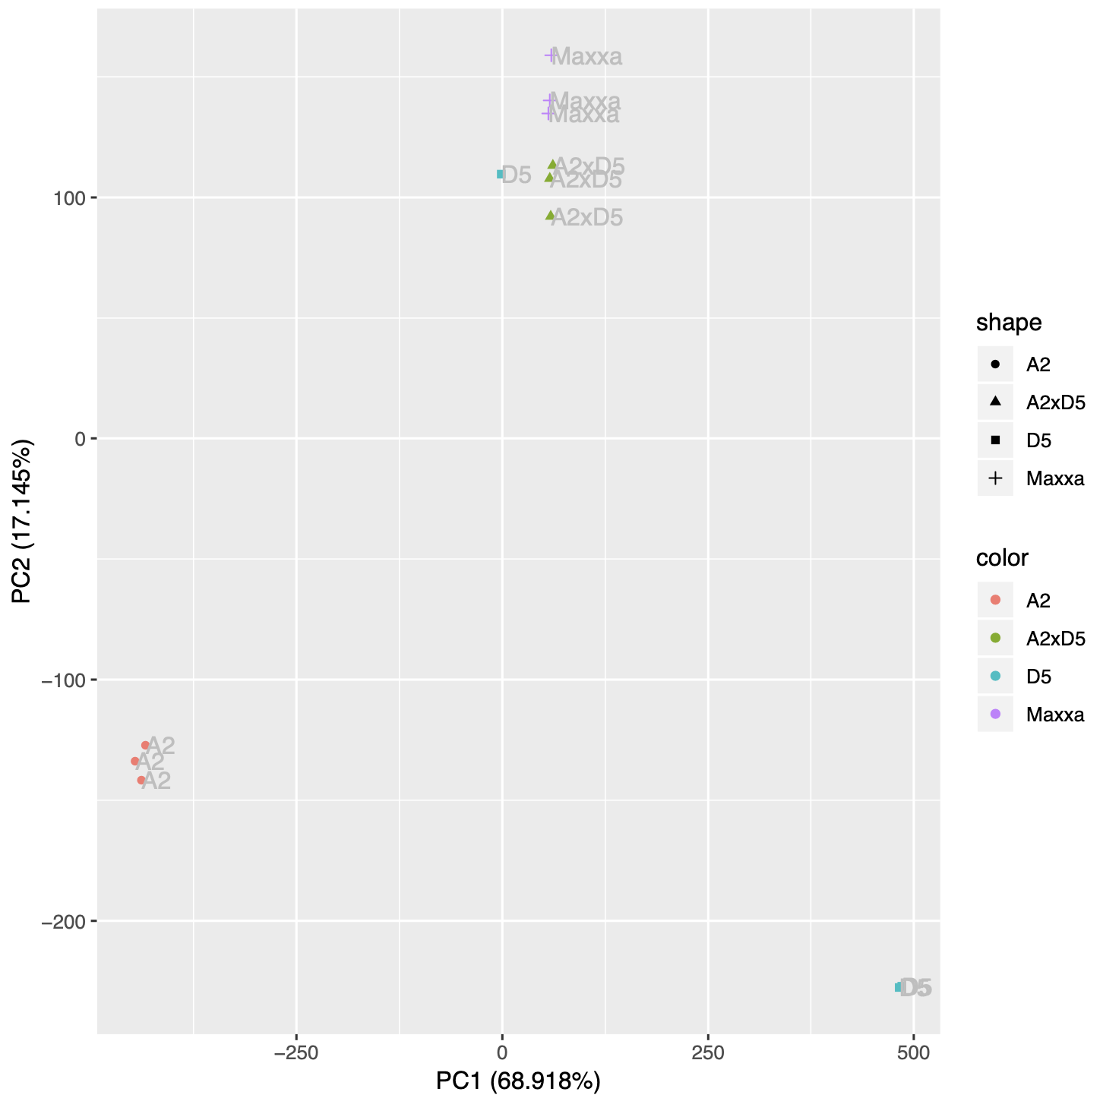
Supplementary Text 5 Figure 1. PCA analysis of log2 TPM using D₅-ref.

References
Girimurugan, S. B., Liu, Y., Lung, P.-Y., Vera, D. L., Dennis, J. H., Bass, H. W., & Zhang, J. (2018). iSeg: an efficient algorithm for segmentation of genomic and epigenomic data. In BMC Bioinformatics (Vol. 19, Issue 1). https://doi.org/10.1186/s12859-018-2140-3
Landolin, J. M., Johnson, D. S., Trinklein, N. D., Aldred, S. F., Medina, C., Shulha, H., Weng, Z., & Myers, R. M. (2010). Sequence features that drive human promoter function and tissue specificity. Genome Research, 20(7), 890–898.
Lun, A. T. L., & Smyth, G. K. (2016). csaw: a Bioconductor package for differential binding analysis of ChIP-seq data using sliding windows. Nucleic Acids Research, 44(5), e45.
Lu, Z., Marand, A. P., Ricci, W. A., Ethridge, C. L., Zhang, X., & Schmitz, R. J. (2019). The prevalence, evolution and chromatin signatures of plant regulatory elements. Nature Plants. https://doi.org/10.1038/s41477-019-0548-z
Paterson, A. H., Wendel, J. F., Gundlach, H., Guo, H., Jenkins, J., Jin, D., Llewellyn, D., Showmaker, K. C., Shu, S., Udall, J., Yoo, M.-J., Byers, R., Chen, W., Doron-Faigenboim, A., Duke, M. V., Gong, L., Grimwood, J., Grover, C., Grupp, K., … Schmutz, J. (2012). Repeated polyploidization of Gossypium genomes and the evolution of spinnable cotton fibres. Nature, 492(7429), 423–427.
Reske, J. J., Wilson, M. R., & Chandler, R. L. (2020). ATAC-seq normalization method can significantly affect differential accessibility analysis and interpretation. Epigenetics & Chromatin, 13(1), 22.
Ricci, W. A., Lu, Z., Ji, L., Marand, A. P., Ethridge, C. L., Murphy, N. G., Noshay, J. M., Galli, M., Mejía-Guerra, M. K., Colomé-Tatché, M., Johannes, F., Rowley, M. J., Corces, V. G., Zhai, J., Scanlon, M. J., Buckler, E. S., Gallavotti, A., Springer, N. M., Schmitz, R. J., & Zhang, X. (2019). Widespread long-range cis-regulatory elements in the maize genome. Nature Plants, 5(12), 1237–1249.
Wang, J., Zhuang, J., Iyer, S., Lin, X., Whitfield, T. W., Greven, M. C., Pierce, B. G., Dong, X., Kundaje, A., Cheng, Y., Rando, O. J., Birney, E., Myers, R. M., Noble, W. S., Snyder, M., & Weng, Z. (2012). Sequence features and chromatin structure around the genomic regions bound by 119 human transcription factors. In Genome Research (Vol. 22, Issue 9, pp. 1798–1812). https://doi.org/10.1101/gr.139105.112

