Flexible Ceramic Nanofibrous Aerogels with Hierarchically Entangled Graphene Networks Enable Full-Frequency Noise Absorptions

Zong et al.

Supporting Information contains:
Supplementary Methods
Supplementary Discussions
Supplementary Figures S1 – S17
Supplementary Tables S1 – S2
Supplementary Movies S1 – S3

Supplementary Methods
Materials. Phosphoric acid (H₃PO₄, AR), polyvinyl acetate (PVA, 1788), ethanol (EtOH, AR), tetraethyl orthosilicate (TEOS), and C₆H₈O₆ were bought from Aladdin Co., Ltd, China. Graphene oxide (GO) powder was provided by Jiangsu XFNANO Materials Tech. Co., Ltd, China. All chemicals were directly used without any purification.
Fabrication of flexible SiO₂ nanofibers. We prepared the SNFs by combining the sol-gel method and the electrospinning technique. Firstly, the silica sol was obtained by rapidly adding the H₃PO₄ drop by drop into the mixing solution of H₂O and TEOS in the molar ratio of 0.01:1:10, with the following stir for 8 h. Meanwhile, PVA powder was dissolved in deionized water at 80 °C and stirred for 5 h to form a PVA solution with a concentration of 10 wt%. Subsequently, the silica sol and PVA solution with the same weight were mixed and stirred for another 8 h to form a stable precursor solution. In a typical electrospinning process, the aforementioned precursor solution was transferred to the syringe with a metal tip for electrospinning, with the voltage of 17 kV, the feed rate of 1 mL/h, the spinning distance of 20 cm, the roller speed of 100 rpm, the ambient temperature of 25 ± 2 °C, and the ambient humidity of 45 ± 5%, respectively. Afterward, the prepared PVA/SiO₂ hybrid nanofiber membrane was dried in a vacuum oven at 70 °C for 2 h to remove water, then it was put in a temperature-programmed muffle furnace to remove organic components and obtained SNF membranes, with the heating rate of 5 °C/min and termination temperature of 800 °C in air atmosphere.
Fabrication of the flexible GCNAs. In the typical process for preparing the GCNA-8 with the GO loading amount of 70 wt%, the 0.67 g of GO powder was dispersed in 66.3 g of ultrapure water and sonicated for 4 h at an ultrasonic temperature of 25 ± 5 °C to get the GO dispersion with the content of 1 wt%. Then, 0.96 g of flexible SNF membrane was cut into pieces and placed in a 67 g of aforementioned GO dispersion by a high-speed homogenizer (13000 rpm and 20 min) to obtain a homogeneous and stable GO/nanofiber dispersion. Subsequently, 2.68 g of C₆H₈O₆ (m_{C6H8O6}: m_{GO} = 4/1 w/w) was added to the nanofiber/GO dispersion for further homogenization for 20 min. The dispersion was then poured into the pre-prepared mold, controlling the flow rate of liquid nitrogen just cover the bottom of the mold to obtain a directional frozen block. Following by transferring the frozen block to a lyophilizer for vacuum freeze-drying for 16 h to obtain the GO/SNFs aerogels. Afterward, the GO/SNFs aerogels were heated at 90 °C for 6 h to obtain GCNAs. Besides, other GCNAs with a wide range of densities from 2 to 20 mg cm⁻³ were obtained by controlling the concentrations of the precursor GO/SNFs dispersions.
Fabrication of sandwiched GCNAs. First, the nanofiber/GO dispersion of GCNA-5 was frozen in a pre-prepared mold according to the above method, after it was completely frozen, the dispersion of GCNA-18 was added immediately for further freezing. When the dispersion of GCNA-18 changed from liquid to solid, the frozen block of GCNA-5 was slightly thawed, thus mixing well with the dispersion with GCNA-18, then the interface was frozen again during the dispersion of GCNA-18 freezing. Subsequently, another dispersion of GCNA-5 was added on top of the GCNA-18/GCNA-5 frozen block and froze in the same method. Therefore, there was no obvious interface in the frozen sandwiched GCNAs, which ensured good structural continuity. Afterward, the composite frozen block was freeze-dried and heated at 90 °C for 6 h to obtain sandwiched GCNAs.
Characterization. The morphology and microstructures of the aerogels were characterized using SEM (VEGA 3, TESCAN Ltd., Czech Republic). Elemental mapping was recorded using EDS (Bruker Quantax 400) spectroscopy attached to SEM. FT-IR spectroscopic analysis was investigated by Nicolet iS10 Spectrometer (Thermo Fisher Scientific Inc., USA). The crystallinity of the GCNAs was tested by XRD (D8 Advance, Bruker, German) with a Cu radiation source (λ = 1.5406 Å). Raman spectra were taken on a Raman spectrometer (LabRAM HR Evolution, HORIBA Ltd., France) with 532 nm laser excitation. XPS analysis was characterized by a photoelectron spectrometer (Escalab 250Xi, USA). The diameters of SNFs were obtained by the measuring tool of Adobe Acrobat 9 Pro. The compressive and buckling performances were evaluated by a dynamic thermal mechanical analyzer (TA-Q850, TA Instruments, USA) equipped with corresponding compression and buckling clamp. During the compressive test process, cylindrical aerogels with a diameter of 20 mm were prepared, and the strain rate was maintained as 100 mm min⁻¹. During the buckling test process, rectangular aerogels with the size of 22 × 6 × 3 mm³ were prepared, and the strain rate was maintained as 20 mm min⁻¹. The tensile performances of aerogels were measured by the fiber tensile tester (XQ-1C, Shanghai New Fiber Instrument Co, Ltd, China). The water contact angle was detected by a contact angle goniometer (Kino SL200B, USA), and the volume of a water droplet was controlled in 3 μL.
The flow resistance of the GCNAs was tested by a flow resistance tester (Autoneum Management Co., Ltd, Switzerland) based on the ISO 9053 standard, where the diameter of the sample was 100 mm, and the airflow rate of controlled air was 0.0005 m/s. The noise reduction performance of obtained aerogels was evaluated using the impedance tube (SW422 and SW477, BSWA Technology Co., Ltd, China). A large tube (diameter of 10 cm) and a small tube (diameter of 3 cm) were used to measure the frequency range of 63-1600 Hz and 1000-6300 Hz, the cylindrical GCNAs with a diameter of 10 cm and 3 cm were prepared for measurement, respectively. The sound absorption coefficients for 1/3 octave band frequencies (63, 80, 100, 125, 160, 200, 250, 315, 400, 500, 630, 800, 1000, 1250, 1600, 2000, 2500, 3150, 4000, 5000, and 6300 Hz) were taken, and the results were plotted into absorption coefficient curves. Each sample was tested five times to minimize the error. All the tests of sound absorption properties were performed at a temperature of 25 ± 3 °C and RH of 50 ± 3%, respectively.
Determination of density and porosity of GCNAs. The volume density (ρ) of the GCNAs was estimated using the followed formula:
ρ = m/V
where m (mg) and V (cm³) are the mass and the volume of the GCNAs, respectively.
The porosity of the GCNAs was determined by the following formula:
ԑ_{P} = (V – (m₁/ρ₁+m₂/ρ₂))/V × 100%
where ԑ_{P} is the porosity, V is the volume of the GCNAs, m₁ and m₂ are the mass of the reduced graphene oxide and SNFs, ρ₁ and ρ₂ are the density of reduced graphene oxide and SNFs, respectively.
Acoustic simulation and calculation. The calculation of specific surface acoustic impedance and sound pressure was conducted using the finite element software based on a semi-phenomenological Johnson-Champoux-Allard (JCA) model. First, as for the GCNAs with various GO loading amount, four cylinders with a basal diameter of 3 cm and a height of 1 cm were modeled, respectively; as for the sandwiched GCNAs, three cylinders with a basal diameter of 3 cm and a height of 1 cm were simultaneously modeled. Subsequently, five parameters were necessary to calculate the absolute sound pressure simulation of the GCNAs, which include porosity (ԑ_{P}), flow resistance rate (R_{f}), viscous characteristic length (L_{v}), thermal characteristic length (L_{th}), and tortuosity factor (τ∞). The five parameters calculated in advance are as shown in Supplementary Tables 1 and 2.
Additionally, the calculated absolute sound pressure distributions in typical 250, 1000, and 2000 Hz of GCNA-5, GCNA-18, and sandwiched GCNAs were shown in Supplementary Fig. 15. The results were similar to that of 500 Hz in Fig. 4e, which showed that the sound pressure distribution mainly depends on the characteristic parameters of the GCNAs.
Supplementary Table 1 The acoustic characteristic parameter of GCNAs with various GO amounts.
 | ԑ_{P} (%) | R_{f} (Pa s m⁻²) | L_{v} (m) | L_{th} (m) | τ∞
GO-10 | 99.669 | 123420 | 0.00149 | 0.00298 | 1.00166
GO-40 | 99.490 | 306470 | 0.00227 | 0.00454 | 1.00256
GO-70 | 99.290 | 669750 | 0.00303 | 0.00607 | 1.00357
GO-100 | 99.113 | 545890 | 0.00382 | 0.00763 | 1.00447

Supplementary Table 2 The acoustic characteristic parameter of sandwiched GCNAs.
 | ԑ_{P} (%) | R_{f} (Pa s m⁻²) | L_{v} (m) | L_{th} (m) | τ∞
Unit 1 | 99.708 | 158350 | 0.00137 | 0.00274 | 1.00146
Unit 2 | 98.949 | 994100 | 0.00645 | 0.00930 | 1.00530
Unit 3 | 99.708 | 158350 | 0.00137 | 0.00274 | 1.00146

Supplementary Discussions
The formation mechanism of hierarchically entangled structures. The phase transition process and forming mechanism of the hierarchically entangled structures of the GCNAs during the freeze molding process were shown in Supplementary Fig. 7. First, the phase transition of solvent during the freeze-drying process was presented in Supplementary Fig. 7a. The GO nanosheets and SiO₂ nanofibers were uniformly dispersed in water after high-speed stirring, the water solidified into ice and formed ice crystals during the directional freezing process of liquid nitrogen. The front end of the ice crystal growth excluded the GO and SiO₂ nanofibers, the GO nanosheets were closely stacked and intertwined by strong π-π interaction; meanwhile, the GO nanosheets completely wrapped the nanofibers to form a 3D network structure. Subsequently, the ice crystals sublimated directly after the process of freeze-drying, and the GO nanosheets and nanofibers formed the hierarchically entangled structures.

Supplementary Fig. 1 (a) SEM image of SiO₂ nanofibers. (b) Histogram showing the fiber diameter distribution of SiO₂ nanofibers.
Supplementary Fig. 2 (a) SEM image of GO. (b) SEM image of the homogenized SiO₂ nanofibers. (c) Histogram showing fiber length distribution of the homogenized SiO₂ nanofibers.
Supplementary Fig. 3 Wettability of the samples before and after reduction: (a) GO/SiO₂ nanofibrous aerogels and (b) GCNAs.
Supplementary Fig. 4 (a) FTIR spectra of GO, SNF, GO/SNF aerogels, and GCNAs. (b) Raman spectra of GO/SNF aerogels and GCNAs. (c) XRD spectra of GO, SNF, GO/SNF aerogels, and GCNAs. (d) High-resolution XPS spectra of O 1s peak of GCNAs.
Supplementary Fig. 5 (a) Compression performance of the GCNAs with various content of GO. (b) Compression modulus, energy loss coefficient, and max stress versus compressive cycles. (c) The Poisson’s ratio of the GCNAs versus ε. (d) The frequency dependence of the storage modulus, loss modulus, and damping ratio for GCNAs (oscillatory ε of 1%).

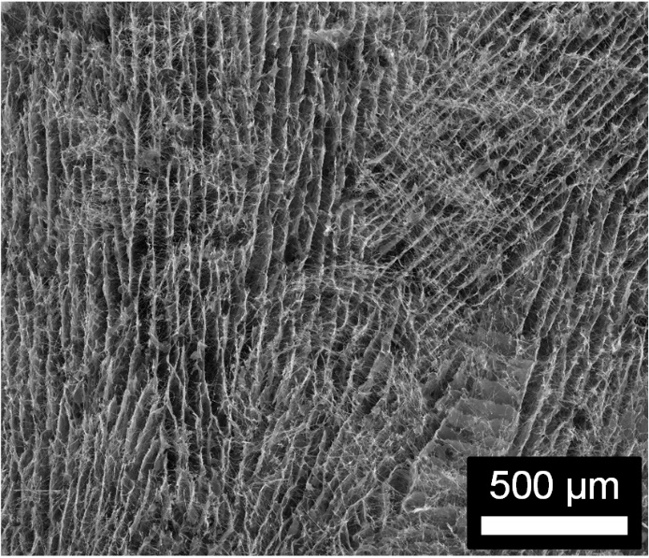
Supplementary Fig. 6 SEM image shows the micro-orientation structure of the GCNAs.
Supplementary Fig. 7 (a) Phase diagram of the three processing steps of freeze-shaping. (b-d) Schematical illustration of the formation principles for the hierarchically entangled structures.
Supplementary Fig. 8 Bulking stress versus bending cycles.
Supplementary Fig. 9 Optical images showing the concave deformation of the GCNAs during the compressive process with increased strain, illustrating the negative Poisson’s ratio of the GCNAs.
Supplementary Fig. 10 TGA analysis of GCNAs.
Supplementary Fig. 11 Digital photographs of the burning test showing the high-temperature stability of the GCNAs in the flame of an alcohol lamp.
Supplementary Fig. 12 Optical images showing the elastic resilience of a GCNA in the liquid nitrogen (–196 ºC).
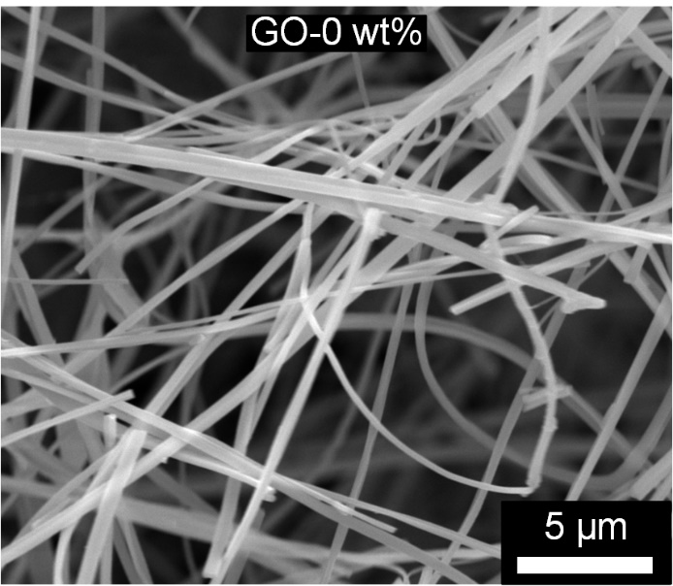
Supplementary Fig. 13 SEM image showing the cell wall of GCNAs without GO.
Supplementary Fig. 14 Sound absorption coefficients of GCNA-5 with various thicknesses.
Supplementary Fig. 15 Absolute sound pressure distribution of (a, d, g) GCNA-5, (b, e, h) GCNA-18, and (c, f, i) sandwiched GCNAs in 250, 1000, and 2000 Hz, respectively.
Supplementary Fig. 16 Schematic illustrations of the mechanism for the sound absorption of (a) GCNA-5, (b) GCNA-18, and (c) sandwiched GCNA.

Supplementary Fig. 17 Photographs showing the direct application of the commercial fiber felt and sandwiched GCNA on the (a) automobile engine noise absorption at 3000 rpm, (b) air compressor noise absorption at room temperature, and (c) air compressor noise absorption at 250 °C.

