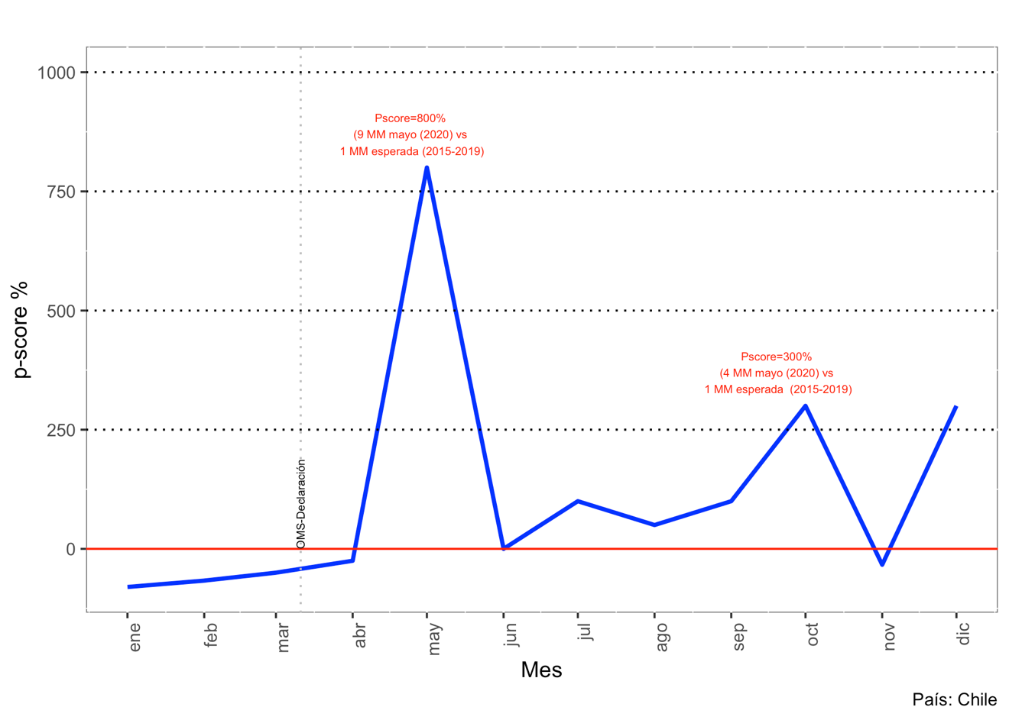
Supplementary Figure 3: Excess death (p-score). Country: Chile

Supplementary Figure 4: Excess death (p-score). Country: Colombia
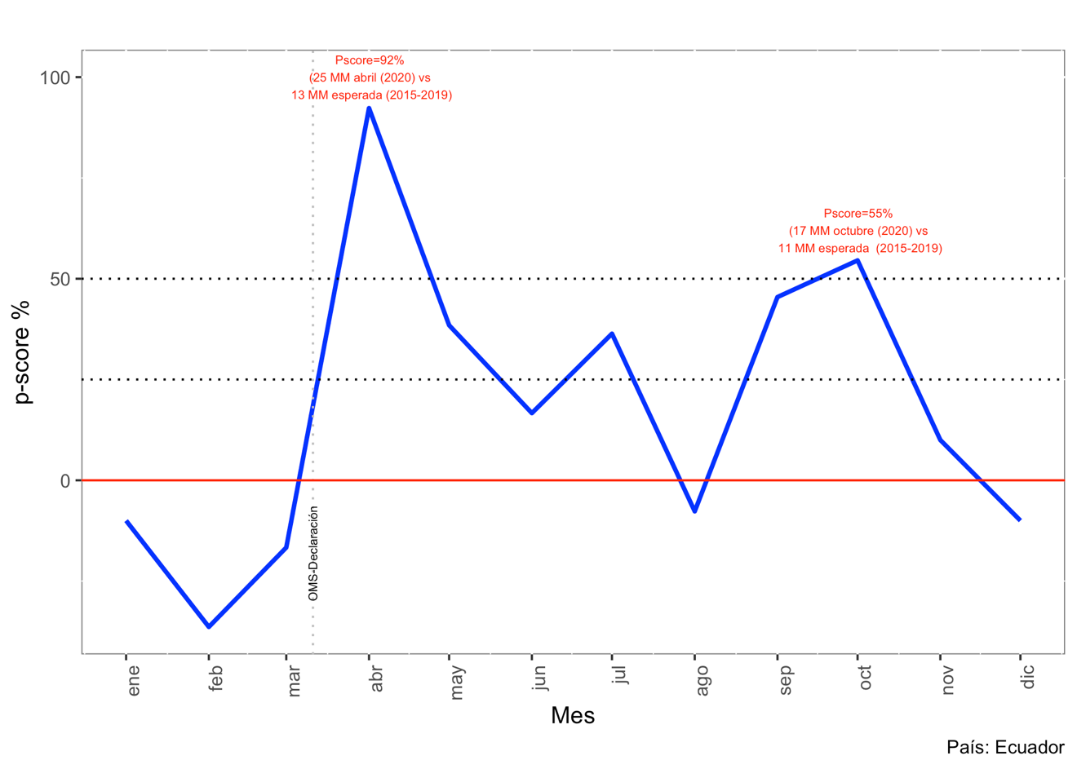
Supplementary Figure 5: Excess death (p-score). Country: Ecuador

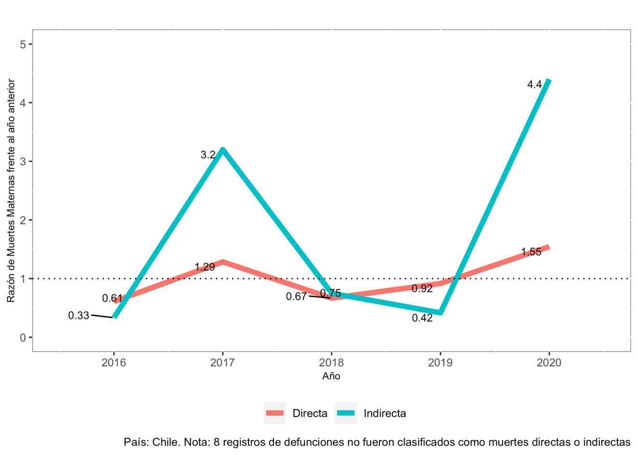
Supplementary Figure 6: Maternal mortality by classification (direct/indirect). Ratio vs. previous year. 2015-2021. Country: Chile
NOTE: 8 registered deaths were not classified as direct or indirect

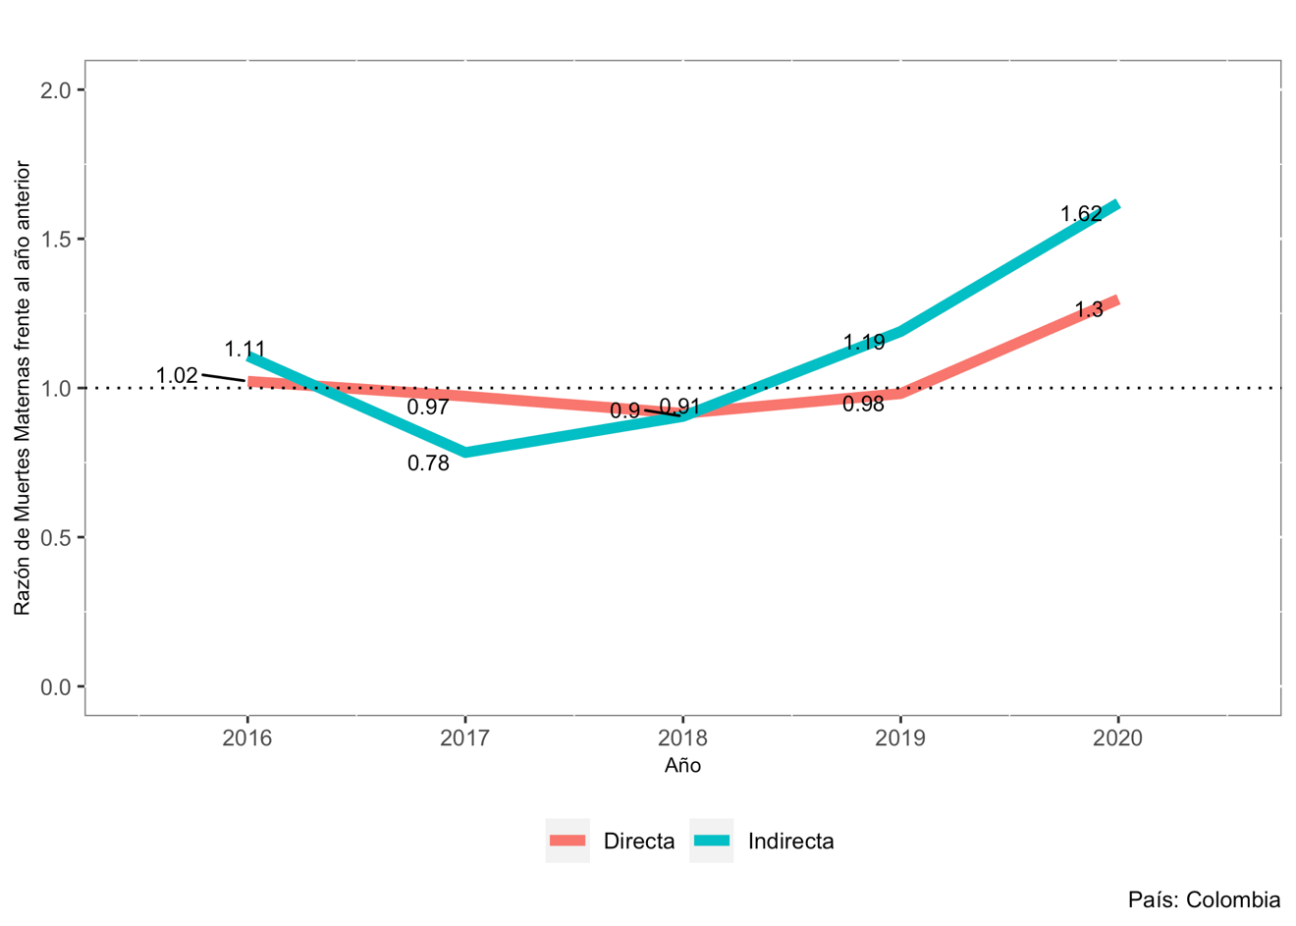
Supplementary Figure 7: Maternal mortality by classification (direct/indirect). Ratio vs. previous year. 2015-2021. Country: Colombia

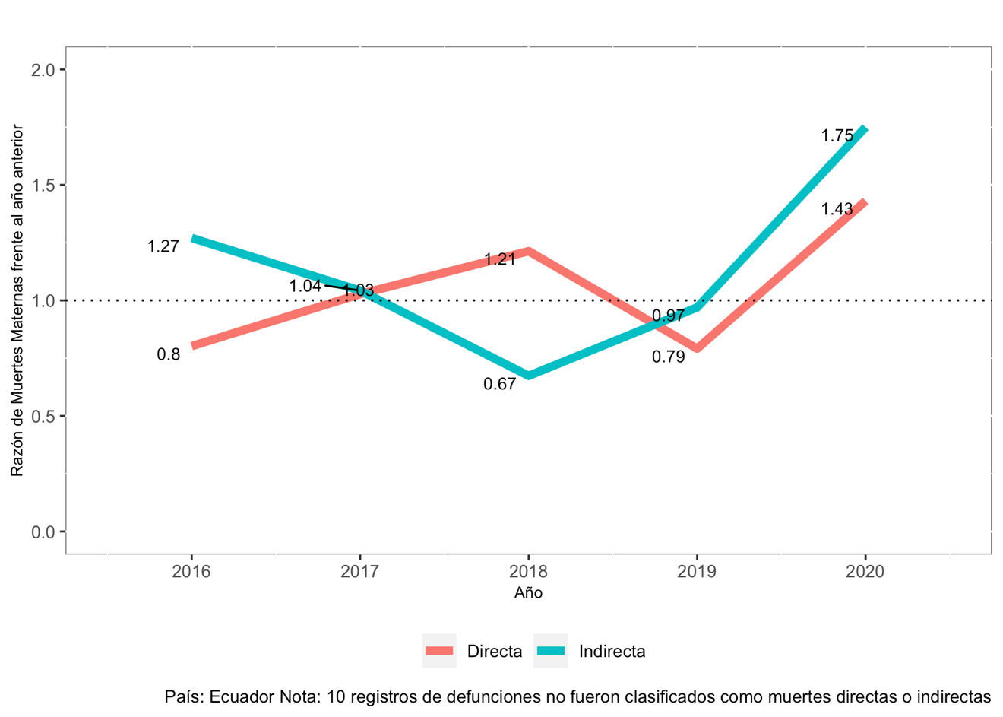
Supplementary Figure 8: Maternal mortality by classification (direct/indirect). Ratio vs. previous year. 2015-2021. Country: Ecuador
NOTE: 10 registered deaths were not classified as direct or indirect
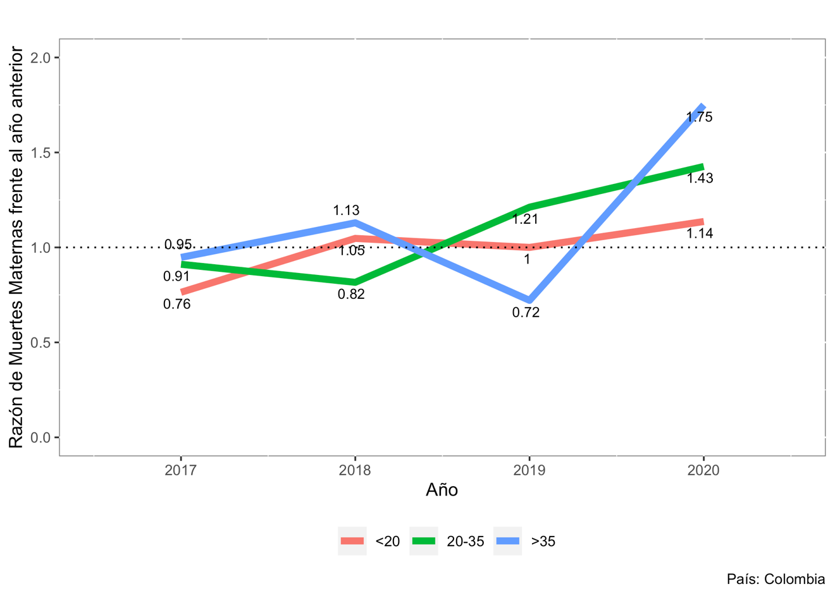
Supplementary Figure 9: Maternal mortality by age group. Ratio vs. previous year. 2015-2021. Country: Colombia

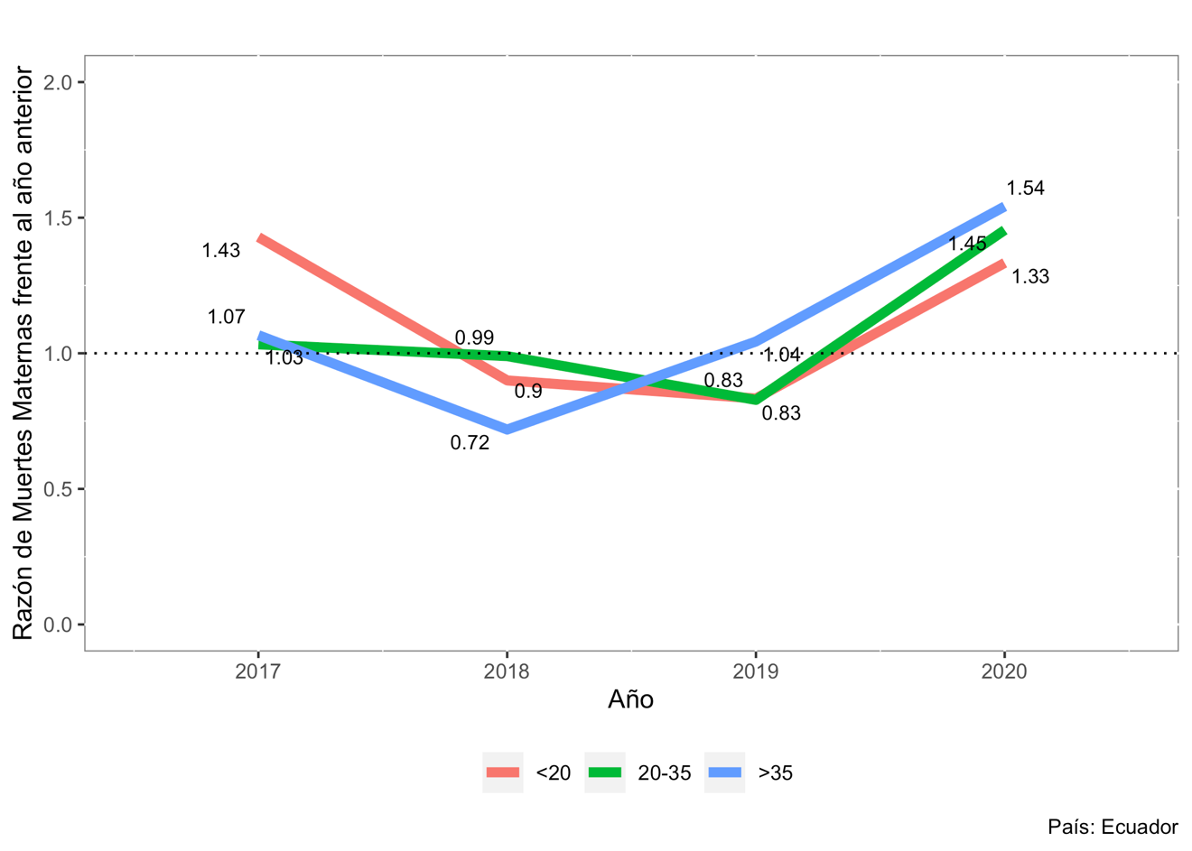
Supplementary Figure 10: Maternal mortality by age group. Ratio vs. previous year. 2015-2021. Country: Country: Ecuador
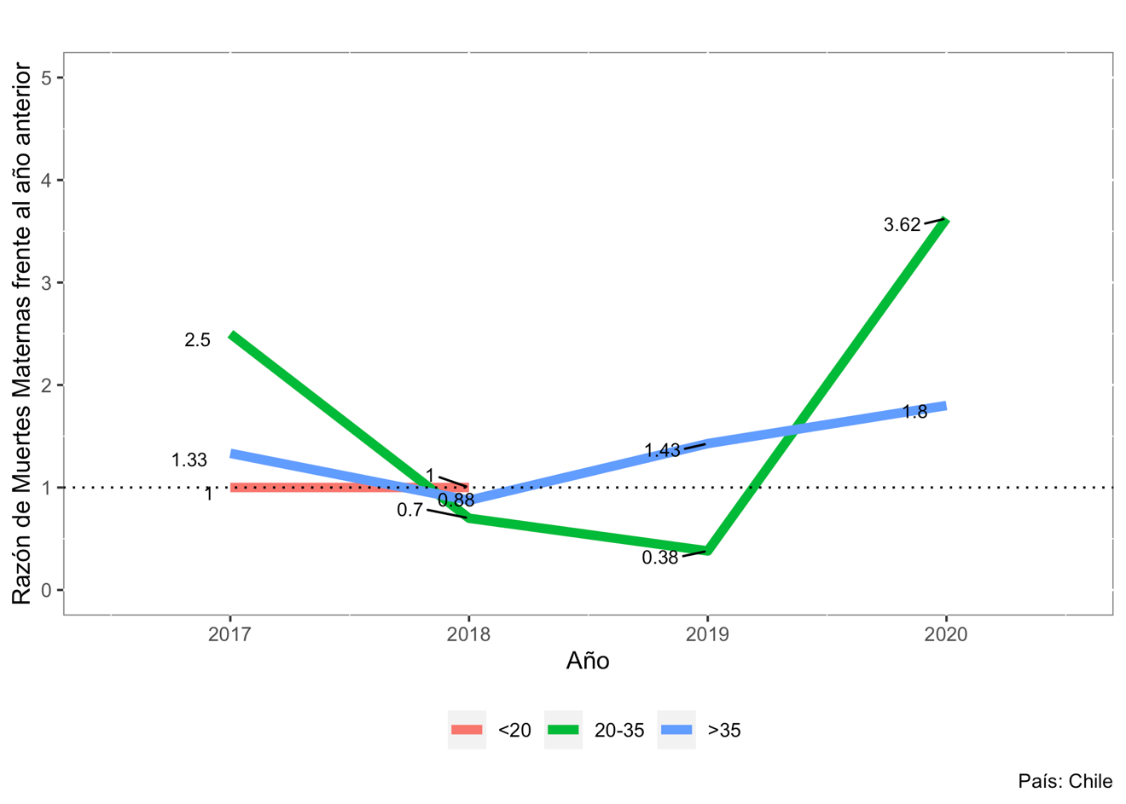Supplementary Figure 11: Maternal mortality by age group. Ratio vs. previous year. 2015-2021. Country: Chile

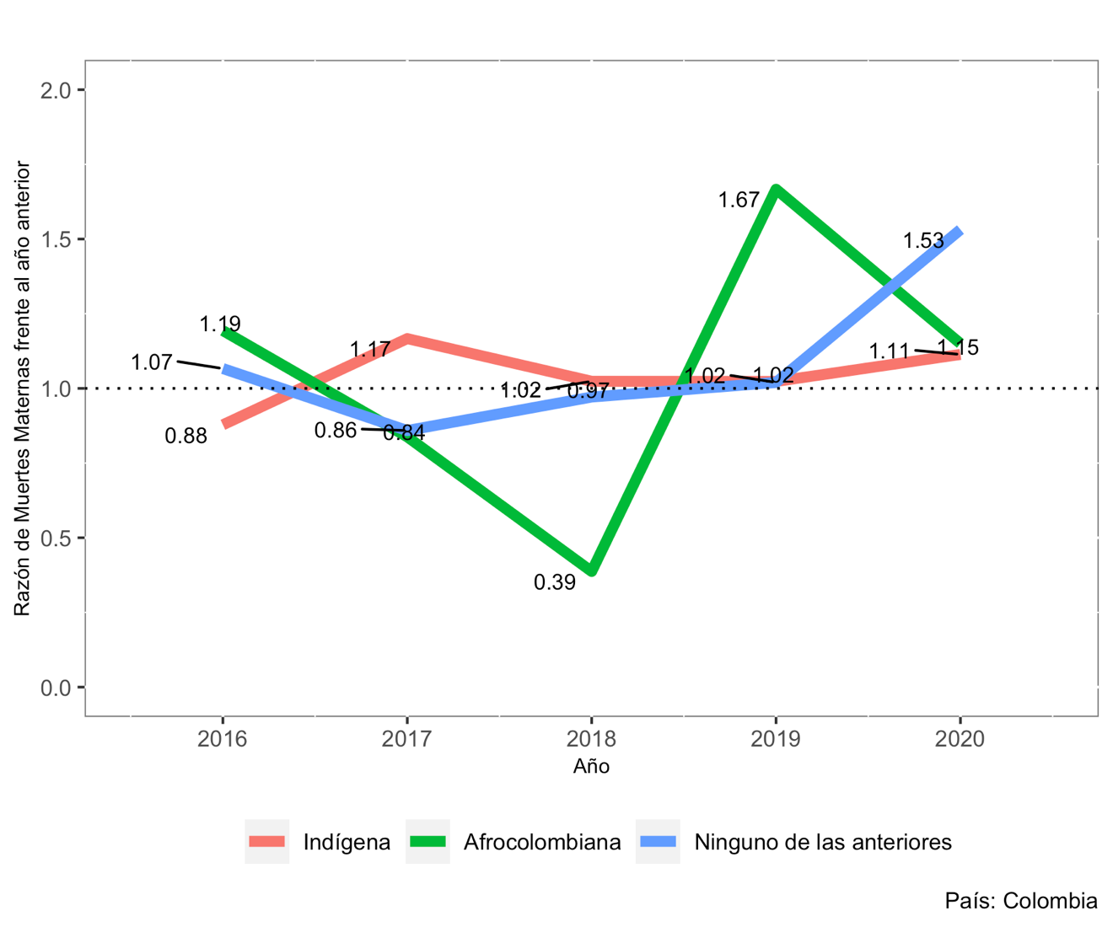
Supplementary Figure 12: Maternal mortality by ethnicity and classification of death. Ratio vs. previous year. 2015-2021. Country: Colombia
RED = Indiginous; GREEN = Afro-Colombian; BLUE = Neither category
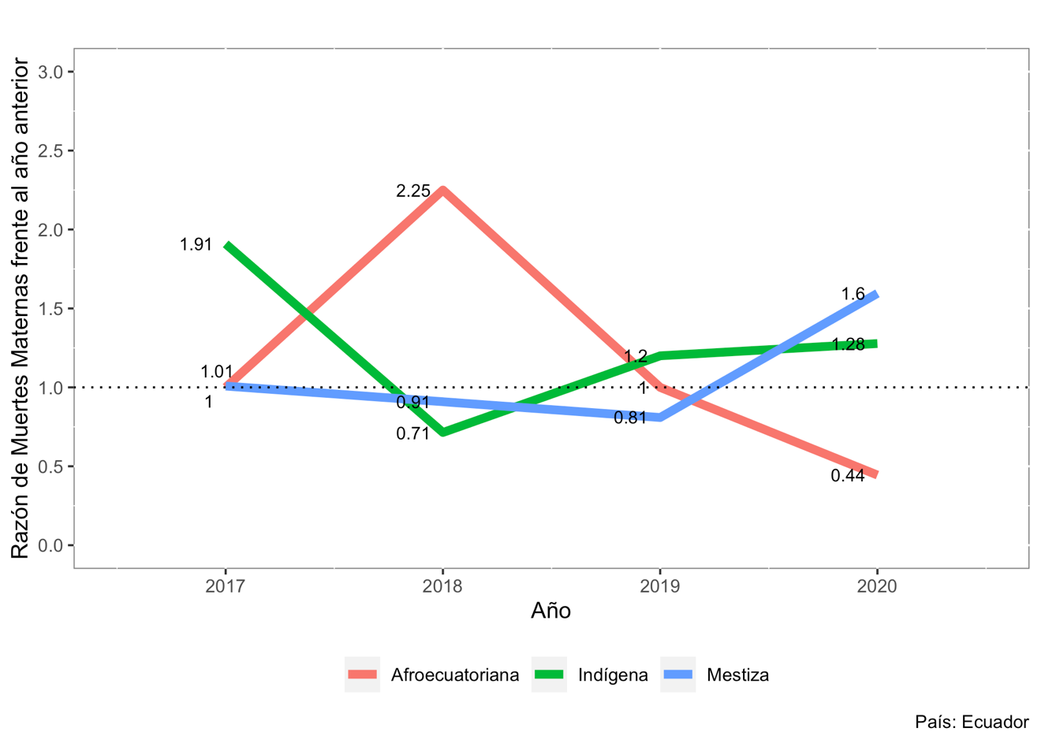
Supplementary Figure 13: Maternal mortality by ethnicity and classification of death. Ratio vs. previous year. 2015-2021. Country: Ecuador
RED = Afro-ecuadorian; GREEN = Indigenous; Blue = Mixed race
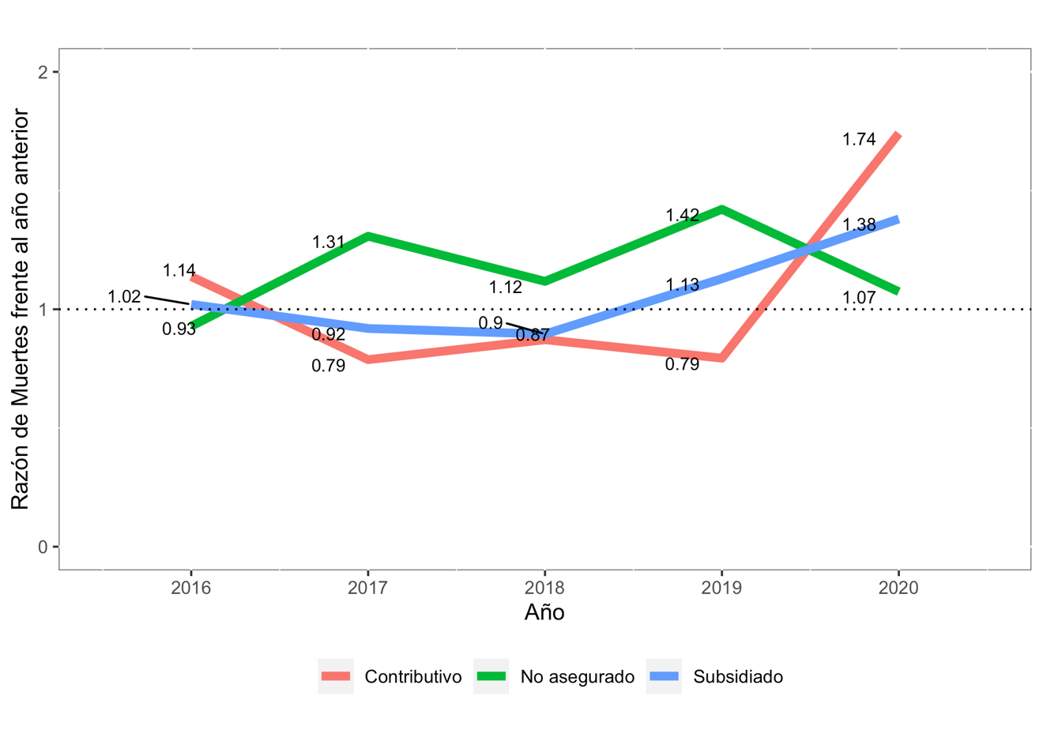Supplementary Figure 14: Maternal mortality according to type of affiliation in the General Social Security Health System. Ratio vs. previous year. 2015-2021. Country: Colombia
RED = Insured; GREEN = Uninsured; BLUE = Subsidized

