Application of response surface methodology in optimizing simultaneous extraction of multiple mycotoxins in maize via QuEChERS
Mesha Mbisana^{a*}, Dikabo Mogopodiª, Tshepho Rebagamang^{b}, Inonge Chibuaª, Bonang Nkoaneª
ª Chemistry Department, University of Botswana, Private Bag 00704 Gaborone, Botswana
^{b} Residues Section, Botswana National Veterinary Laboratory, Gaborone, Botswana
*Corresponding Author: mimimbisana@gmail.com
Phone +267 75465732
Supplementary Tables
Table S1: Binary gradient elusion profile for LC-MS/MS analysis
Time (minutes) | Flow rate (mL/min) | Mobile phase A (%) | Mobile phase B (%)
0.00 | 0.5000 | 95.0 | 5.0
0.50 | 0.5000 | 95.0 | 5.0
3.00 | 0.5000 | 5.0 | 95.0
4.00 | 0.5000 | 5.0 | 95.0
6.00 | 0.5000 | 95.0 | 5.0
7.00 | 0.5000 | 95.0 | 5.0

Table S2: Two-level full factorial design matrix with percentage recoveries for selected mycotoxins
Run Order | Center Pt | Blocks | MeCN (%) | FA (%) | Extraction time (%) | NaCl (g) | AFB1 | AFB2 | AFG1 | AFG2 | FB1 | FB2 | T2 | HT2 | OTA | ZEA
1 | 1 | 1 | 50 | 0.05 | 90 | 5 | 62 | 59.8 | 63 | 58.3 | 54.5 | 57.6 | 56.8 | 60.8 | 44.8 | 69.6
2 | 1 | 1 | 90 | 0.05 | 30 | 5 | 75.6 | 73.8 | 69.9 | 72.8 | 76.3 | 74.8 | 78.1 | 76.9 | 70.4 | 53.1
3 | 1 | 1 | 50 | 0.05 | 30 | 1 | 51.2 | 48.7 | 50.9 | 45.3 | 40.9 | 43.4 | 51.6 | 42.7 | 36.2 | 61.8
4 | 1 | 1 | 50 | 5 | 30 | 5 | 40.6 | 35.2 | 40.7 | 41.3 | 36.2 | 41.5 | 45.9 | 36.7 | 32.6 | 46.5
5 | 1 | 1 | 90 | 5 | 30 | 1 | 66.3 | 63.5 | 67.1 | 65 | 79.4 | 76.9 | 74.1 | 69.5 | 70.1 | 46.2
6 | 1 | 1 | 90 | 0.05 | 30 | 1 | 73.2 | 73.1 | 68.5 | 72.5 | 75.3 | 75.3 | 78.5 | 73.1 | 71.2 | 53.6
7 | 1 | 1 | 90 | 5 | 30 | 5 | 65.9 | 63.2 | 66.4 | 65.3 | 79.1 | 76.5 | 72.8 | 69.5 | 69.4 | 45.5
8 | 1 | 1 | 90 | 0.05 | 90 | 1 | 80.7 | 80.4 | 79.6 | 80.4 | 81.6 | 80.7 | 78.6 | 77.6 | 80.3 | 79.4
9 | 1 | 1 | 90 | 0.05 | 90 | 5 | 76.5 | 80.7 | 80.4 | 79.9 | 81.2 | 80.5 | 79.6 | 79.9 | 79.8 | 80.1
10 | 1 | 1 | 50 | 5 | 90 | 1 | 52 | 51.1 | 56.8 | 50.2 | 52.9 | 50.2 | 48 | 50.6 | 52.8 | 64.4
11 | 1 | 1 | 50 | 0.05 | 30 | 5 | 51.8 | 50.3 | 51.2 | 46.1 | 39.6 | 43.7 | 50.8 | 43.1 | 36.8 | 62.4
12 | 1 | 1 | 50 | 5 | 90 | 5 | 55.1 | 50.7 | 56.2 | 50.2 | 53.6 | 49.8 | 47.8 | 56.7 | 53.2 | 65.4
13 | 1 | 1 | 50 | 0.05 | 90 | 1 | 54.6 | 59.6 | 63.4 | 58.3 | 54.6 | 57.4 | 56.7 | 61.8 | 45.7 | 70.5
14 | 1 | 1 | 90 | 5 | 90 | 5 | 71.4 | 70.5 | 72.6 | 75.2 | 81.7 | 80.2 | 76.2 | 76.6 | 73.6 | 67.9
15 | 1 | 1 | 50 | 5 | 30 | 1 | 40.8 | 36 | 40.7 | 41.5 | 36.2 | 40.8 | 50.1 | 39.7 | 32.6 | 46.7
16 | 1 | 1 | 90 | 5 | 90 | 1 | 70.2 | 69.8 | 72.3 | 75.8 | 82 | 79.5 | 76.2 | 76.3 | 74.1 | 68.5
17 | 1 | 2 | 50 | 0.05 | 30 | 1 | 45.9 | 48.2 | 51.9 | 43.2 | 39.3 | 43 | 50.2 | 49.5 | 35.5 | 60.8
18 | 1 | 2 | 90 | 5 | 90 | 1 | 71.8 | 72.6 | 72 | 74.6 | 82.2 | 80.1 | 76.4 | 77.1 | 74.1 | 68.7
19 | 1 | 2 | 50 | 5 | 30 | 1 | 39.4 | 36.5 | 41.5 | 40.8 | 37.4 | 39.2 | 50.6 | 36.5 | 33.6 | 47.8
20 | 1 | 2 | 90 | 0.05 | 90 | 1 | 80.6 | 78.5 | 79.2 | 79.4 | 80.2 | 80.5 | 79 | 81.7 | 79.6 | 78.6
21 | 1 | 2 | 50 | 5 | 90 | 5 | 52.7 | 50.3 | 54.7 | 50.2 | 53.1 | 49.3 | 48.5 | 55.2 | 50.1 | 64.2
22 | 1 | 2 | 50 | 5 | 30 | 5 | 40.2 | 36.1 | 42.3 | 41.6 | 36.8 | 41.9 | 46.5 | 36.8 | 32.6 | 46.5
23 | 1 | 2 | 90 | 5 | 30 | 1 | 65.4 | 60.5 | 64.8 | 65.1 | 78.5 | 75.6 | 75.1 | 70.1 | 69.7 | 45
24 | 1 | 2 | 90 | 5 | 90 | 5 | 70.5 | 70.6 | 73.2 | 75.3 | 80.6 | 80.5 | 76.8 | 76.7 | 74.3 | 68.4
25 | 1 | 2 | 90 | 5 | 30 | 5 | 64.5 | 62.8 | 65.6 | 65.3 | 74.1 | 70.8 | 68.8 | 66.4 | 69.6 | 44.9
26 | 1 | 2 | 50 | 0.05 | 30 | 5 | 51.8 | 50.3 | 50.4 | 45.2 | 39.6 | 43.7 | 50.8 | 49.8 | 37.1 | 62.4
27 | 1 | 2 | 50 | 0.05 | 90 | 1 | 60.4 | 58.3 | 60.8 | 58 | 53.9 | 56.4 | 56.5 | 60.8 | 45.1 | 69.5
28 | 1 | 2 | 90 | 0.05 | 90 | 5 | 82.3 | 76.3 | 78.1 | 78.5 | 79.4 | 80.1 | 78.6 | 81.2 | 78.3 | 77.7
29 | 1 | 2 | 90 | 0.05 | 30 | 1 | 74.5 | 74.2 | 70.6 | 72.8 | 75.9 | 76.2 | 74.6 | 75.1 | 72.6 | 55.2
30 | 1 | 2 | 50 | 0.05 | 90 | 5 | 62.5 | 59.8 | 63.4 | 58.3 | 55 | 57.5 | 56.7 | 70.1 | 45.7 | 70.5
31 | 1 | 2 | 50 | 5 | 90 | 1 | 52.8 | 51.2 | 54.7 | 50.9 | 53.7 | 50.6 | 48.5 | 56.2 | 50.7 | 63.7
32 | 1 | 2 | 90 | 0.05 | 30 | 5 | 73.8 | 74.1 | 69.4 | 72.8 | 75.1 | 75.8 | 74.1 | 72.8 | 71.6 | 56.8

Table S3: CCD design matrix with percentage recoveries for all selected mycotoxins
RunOrder | PtType | Blocks | MeCN (%) | FA (%) | Extraction time (min) | AFB1 | AFB2 | AFG1 | AFG2 | FB1 | FB2 | T2 | HT2 | OTA | ZEA
1 | 0 | 1 | 70.00 | 0.2750 | 60.00 | 75.10 | 76.1 | 75.6 | 79.4 | 78.3 | 78.7 | 73.2 | 68.3 | 88.6 | 74.3
2 | 1 | 1 | 50.00 | 0.5000 | 30.00 | 40.80 | 43.8 | 35.2 | 39.7 | 42.3 | 33.7 | 32.8 | 42.0 | 32.8 | 46.9
3 | 1 | 1 | 90.00 | 0.5000 | 30.00 | 57.73 | 60.7 | 73.1 | 60.2 | 67.3 | 55.5 | 49.6 | 58.4 | 56.3 | 65.5
4 | 1 | 1 | 50.00 | 0.0500 | 90.00 | 46.20 | 53.0 | 42.7 | 49.2 | 50.9 | 46.9 | 49.7 | 51.6 | 50.2 | 65.1
5 | 1 | 1 | 50.00 | 0.5000 | 90.00 | 40.00 | 44.4 | 48.3 | 56.7 | 40.1 | 56.7 | 60.1 | 52.3 | 50.3 | 65.3
6 | 1 | 1 | 90.00 | 0.0500 | 30.00 | 58.60 | 66.2 | 80.2 | 74.0 | 83.7 | 72.9 | 67.8 | 65.8 | 60.6 | 66.8
7 | 0 | 1 | 70.00 | 0.2750 | 60.00 | 79.70 | 82.1 | 64.8 | 79.4 | 86.4 | 76.3 | 78.1 | 75.6 | 82.0 | 69.4
8 | 1 | 1 | 90.00 | 0.0500 | 90.00 | 83.40 | 92.1 | 78.4 | 87.3 | 83.1 | 89.4 | 79.2 | 71.8 | 74.9 | 82.2
9 | 0 | 1 | 70.00 | 0.2750 | 60.00 | 73.40 | 81.4 | 78.6 | 82.4 | 85.9 | 86.7 | 79.0 | 74.3 | 78.0 | 68.3
10 | 1 | 1 | 90.00 | 0.5000 | 90.00 | 65.40 | 57.3 | 66.9 | 53.1 | 69.4 | 65.9 | 70.3 | 69.4 | 52.1 | 75.1
11 | 0 | 1 | 70.00 | 0.2750 | 60.00 | 80.20 | 85.3 | 81.9 | 79.6 | 83.7 | 72.6 | 74.8 | 69.1 | 85.4 | 67.4
12 | 1 | 1 | 50.00 | 0.0500 | 30.00 | 30.60 | 41.8 | 33.7 | 39.5 | 41.5 | 30.8 | 25.7 | 41.6 | 23.9 | 32.4
13 | -1 | 4 | 102.66 | 0.2750 | 60.00 | 61.60 | 52.7 | 53.4 | 51.3 | 60.1 | 53.1 | 53.9 | 40.9 | 64.1 | 66.8
14 | 0 | 4 | 70.00 | 0.2750 | 60.00 | 82.60 | 79.1 | 73.0 | 75.3 | 86.6 | 86.0 | 75.8 | 66.7 | 78.2 | 65.2
15 | -1 | 4 | 70.00 | 0.6424 | 60.00 | 58.70 | 55.5 | 72.8 | 58.5 | 66.1 | 66.2 | 69.3 | 64.2 | 69.9 | 59.4
16 | -1 | 4 | 70.00 | 0.2750 | 108.99 | 70.30 | 75.1 | 73.9 | 70.3 | 66.7 | 72.2 | 73.4 | 69.3 | 58.3 | 53.1
17 | -1 | 4 | 70.00 | 0.2750 | 11.01 | 44.90 | 57.4 | 56.8 | 54.2 | 54.7 | 54.5 | 46.3 | 46.9 | 36.9 | 14.3
18 | -1 | 4 | 37.34 | 0.2750 | 60.00 | 30.40 | 32.9 | 25.7 | 25.9 | 30.7 | 26.7 | 23.8 | 25.0 | 34.9 | 54.9
19 | -1 | 4 | 70.00 | -0.0924 | 60.00 | 62.98 | 68.2 | 63.4 | 57.7 | 75.6 | 69.2 | 78.3 | 69.0 | 68.3 | 88.1
20 | 0 | 4 | 70.00 | 0.2750 | 60.00 | 75.20 | 81.8 | 79.3 | 85.3 | 73.1 | 80.7 | 79.5 | 70.4 | 76.6 | 68.4
21 | 1 | 3 | 50.00 | 0.5000 | 30.00 | 41.90 | 41.0 | 33.5 | 39.5 | 40.9 | 40.1 | 34.1 | 41.6 | 31.2 | 45.6
22 | 0 | 3 | 70.00 | 0.2750 | 60.00 | 72.10 | 77.3 | 76.0 | 79.4 | 80.9 | 84.3 | 76.4 | 79.4 | 80.9 | 76.1
23 | 1 | 3 | 50.00 | 0.0500 | 30.00 | 36.00 | 38.1 | 36.4 | 35.2 | 46.0 | 33.2 | 26.4 | 41.5 | 26.1 | 36.1
24 | 0 | 3 | 70.00 | 0.2750 | 60.00 | 79.30 | 78.4 | 78.6 | 81.7 | 70.9 | 76.3 | 75.2 | 76.5 | 76.2 | 65.7
25 | 1 | 3 | 90.00 | 0.0500 | 30.00 | 63.20 | 58.2 | 81.3 | 74.2 | 82.4 | 72.9 | 69.4 | 72.7 | 61.6 | 61.5
26 | 1 | 3 | 50.00 | 0.0500 | 90.00 | 48.60 | 50.9 | 50.9 | 50.1 | 46.1 | 46.1 | 52.4 | 51.3 | 42.7 | 82.7
27 | 1 | 3 | 90.00 | 0.5000 | 90.00 | 62.40 | 57.9 | 68.3 | 58.0 | 70.3 | 66.4 | 66.2 | 70.2 | 55.5 | 74.2
28 | 0 | 3 | 70.00 | 0.2750 | 60.00 | 75.30 | 77.7 | 82.9 | 78.6 | 79.3 | 79.1 | 84.9 | 80.4 | 70.5 | 68.6
29 | 1 | 3 | 50.00 | 0.5000 | 90.00 | 46.10 | 41.1 | 55.2 | 50.8 | 40.5 | 55.1 | 56.3 | 52.4 | 47.3 | 75.8
30 | 1 | 3 | 90.00 | 0.0500 | 90.00 | 89.70 | 80.6 | 84.3 | 78.9 | 74.3 | 90.2 | 86.7 | 85.7 | 70.7 | 85.4
31 | 0 | 3 | 70.00 | 0.2750 | 60.00 | 85.60 | 78.1 | 77.6 | 82.4 | 71.3 | 76.1 | 75.2 | 70.2 | 75.4 | 74.6
32 | 1 | 3 | 90.00 | 0.5000 | 30.00 | 59.40 | 53.5 | 69.2 | 57.0 | 66.7 | 62.9 | 52.1 | 50.1 | 54.4 | 58.6
33 | -1 | 2 | 70.00 | 0.2750 | 11.01 | 65.70 | 55.1 | 63.4 | 58.3 | 64.3 | 58.1 | 55.3 | 50.8 | 27.4 | 15.5
34 | -1 | 2 | 102.66 | 0.2750 | 60.00 | 50.30 | 44.2 | 58.3 | 53.3 | 52.9 | 56.6 | 55.2 | 53.8 | 49.7 | 62.5
35 | -1 | 2 | 70.00 | -0.0924 | 60.00 | 62.10 | 65.6 | 59.3 | 57.2 | 71.3 | 65.1 | 74.8 | 71.6 | 55.4 | 85.9
36 | 0 | 2 | 70.00 | 0.2750 | 60.00 | 79.30 | 75.2 | 83.4 | 86.9 | 81.4 | 82.9 | 85.1 | 72.5 | 79.8 | 73.9
37 | -1 | 2 | 70.00 | 0.6424 | 60.00 | 60.30 | 54.2 | 67.4 | 57.3 | 60.7 | 65.3 | 71.9 | 66.3 | 57.4 | 63.1
38 | 0 | 2 | 70.00 | 0.2750 | 60.00 | 80.20 | 71.6 | 85.4 | 76.4 | 85.6 | 79.3 | 84.6 | 78.6 | 73.2 | 63.2
39 | -1 | 2 | 37.34 | 0.2750 | 60.00 | 22.10 | 22.7 | 20.1 | 25.4 | 31.9 | 21.4 | 25.3 | 28.4 | 30.4 | 49.7
40 | -1 | 2 | 70.00 | 0.2750 | 108.99 | 69.40 | 69.5 | 78.4 | 62.9 | 66.0 | 75.3 | 77.2 | 62.8 | 54.2 | 59.7

Table S4: Detailed dilution scheme for preparation of calibration standards.
Working standard solution |  | 1 | 2 | 3 | 4 | 5
Volume of mixed stock solution added to 1 mL of sample extract |  | 0 | 25 | 100 | 150 | 200
Concentration of each mycotoxin (µg/Kg) | AFB₁, B₂, G₁ & G₂ | 0 | 2.5 | 10 | 15 | 20
Concentration of each mycotoxin (µg/Kg) | FB₁, FB₂ & T2-Toxin | 0 | 62.5 | 250 | 375 | 500
Concentration of each mycotoxin (µg/Kg) | HT2-Toxin & ZEA | 0 | 25 | 100 | 150 | 200
Concentration of each mycotoxin (µg/Kg) | OTA | 0 | 10 | 40 | 60 | 80

Table S5: MS/MS parameters for all analytes, including retention time (min), ionization, precursor ion (m/z), product ion (m/z) and collision energy (V).
Mycotoxin | Retention time (min) | Ionization | Precursor ion (m/z) | Product ion (m/z) | Collision energy (V)
Aflatoxin B₁ | 3.15 | [M+H] ⁺ | 313.0 | 285.0  213.0 | 30  24
Aflatoxin B₂ | 3.09 | [M+H] ⁺ | 315.0 | 287.0  259.0 | 34  30
Aflatoxin G₁ | 3.03 | [M+H] ⁺ | 329.0 | 243.0  213.0 | 30  20
Aflatoxin G₂ | 2.96 | [M+H] ⁺ | 331.0 | 245.0  189.0 | 30  22
Fumonisin B₁ | 2.99 | [M+H] ⁺ | 722.0 | 334.0  352.0 | 26  22
Fumonisin B₂ | 3.23 | [M+H] ⁺ | 706.0 | 336.0  318.1 | 18  16
Ochratoxin A | 3.62 | [M+H] ⁺ | 404.0 | 358.0  239.0 | 12  12
HT2-Toxin | 3.34 | [M+H] ⁺ | 447.0 | 345.0  285.0 | 18  14
T2-Toxin | 3.54 | [M+H] ⁺ | 489.0 | 327.0  387.0 | 22  16
Zearalenone | 3.66 | [M+H] ⁺ | 319.1 | 185.0  187.0 | 10  10

Table S6: Analysis of variance, AFB₁
Source | DF | Adj SS | Adj MS | F-Value | P-Value
Model | 16 | 5093.82 | 318.36 | 82.96 | 0.000
Blocks | 1 | 0.05 | 0.05 | 0.01 | 0.915
Linear | 4 | 4989.09 | 1247.27 | 325.01 | 0.000
MeCN (%) | 1 | 3815.01 | 3815.01 | 994.10 | 0.000
FA (%) | 1 | 593.40 | 593.40 | 154.63 | 0.000
Extraction time (%) | 1 | 571.22 | 571.22 | 148.85 | 0.000
NaCl (g) | 1 | 9.46 | 9.46 | 2.47 | 0.137
2-Way Interactions | 6 | 90.16 | 15.03 | 3.92 | 0.015
MeCN (%)*FA (%) | 1 | 0.66 | 0.66 | 0.17 | 0.684
MeCN (%)*Extraction time (%) | 1 | 64.98 | 64.98 | 16.93 | 0.001
MeCN (%)*NaCl (g) | 1 | 14.85 | 14.85 | 3.87 | 0.068
FA (%)*Extraction time (%) | 1 | 4.21 | 4.21 | 1.10 | 0.312
FA (%)*NaCl (g) | 1 | 5.28 | 5.28 | 1.38 | 0.259
Extraction time (%)*NaCl (g) | 1 | 0.18 | 0.18 | 0.05 | 0.831
3-Way Interactions | 4 | 13.40 | 3.35 | 0.87 | 0.503
MeCN (%)*FA (%)*Extraction time (%) | 1 | 6.13 | 6.13 | 1.60 | 0.226
MeCN (%)*FA (%)*NaCl (g) | 1 | 4.35 | 4.35 | 1.13 | 0.304
MeCN (%)*Extraction time (%)*NaCl (g) | 1 | 2.20 | 2.20 | 0.57 | 0.460
FA (%)*Extraction time (%)*NaCl (g) | 1 | 0.72 | 0.72 | 0.19 | 0.671
4-Way Interactions | 1 | 1.13 | 1.13 | 0.29 | 0.596
MeCN (%)*FA (%)*Extraction time (%)*NaCl (g) | 1 | 1.13 | 1.13 | 0.29 | 0.596
Error | 15 | 57.56 | 3.84
Total | 31 | 5151.39

Table S7: Analysis of variance, AFB₂
Source | DF | Adj SS | Adj MS | F-Value | P-Value
Model | 16 | 5810.59 | 363.16 | 258.64 | 0.000
Blocks | 1 | 1.16 | 1.16 | 0.83 | 0.377
Linear | 4 | 5700.80 | 1425.20 | 1014.99 | 0.000
MeCN (%) | 1 | 4106.45 | 4106.45 | 2924.51 | 0.000
FA (%) | 1 | 855.95 | 855.95 | 609.58 | 0.000
Extraction time (%) | 1 | 738.24 | 738.24 | 525.76 | 0.000
NaCl (g) | 1 | 0.17 | 0.17 | 0.12 | 0.736
2-Way Interactions | 6 | 103.47 | 17.24 | 12.28 | 0.000
MeCN (%)*FA (%) | 1 | 3.32 | 3.32 | 2.36 | 0.145
MeCN (%)*Extraction time (%) | 1 | 64.13 | 64.13 | 45.67 | 0.000
MeCN (%)*NaCl (g) | 1 | 0.38 | 0.38 | 0.27 | 0.609
FA (%)*Extraction time (%) | 1 | 32.60 | 32.60 | 23.22 | 0.000
FA (%)*NaCl (g) | 1 | 1.09 | 1.09 | 0.77 | 0.393
Extraction time (%)*NaCl (g) | 1 | 1.95 | 1.95 | 1.39 | 0.257
3-Way Interactions | 4 | 4.93 | 1.23 | 0.88 | 0.500
MeCN (%)*FA (%)*Extraction time (%) | 1 | 1.40 | 1.40 | 1.00 | 0.333
MeCN (%)*FA (%)*NaCl (g) | 1 | 3.06 | 3.06 | 2.18 | 0.160
MeCN (%)*Extraction time (%)*NaCl (g) | 1 | 0.43 | 0.43 | 0.30 | 0.589
FA (%)*Extraction time (%)*NaCl (g) | 1 | 0.04 | 0.04 | 0.03 | 0.872
4-Way Interactions | 1 | 0.23 | 0.23 | 0.16 | 0.693
MeCN (%)*FA (%)*Extraction time (%)*NaCl (g) | 1 | 0.23 | 0.23 | 0.16 | 0.693
Error | 15 | 21.06 | 1.40
Total | 31 | 5831.65

Table S8: Analysis of variance, AFG₁
Source | DF | Adj SS | Adj MS | F-Value | P-Value
Model | 16 | 4294.54 | 268.41 | 253.54 | 0.000
Blocks | 1 | 1.58 | 1.58 | 1.49 | 0.241
Linear | 4 | 4206.65 | 1051.66 | 993.40 | 0.000
MeCN (%) | 1 | 2947.20 | 2947.20 | 2783.93 | 0.000
FA (%) | 1 | 371.96 | 371.96 | 351.36 | 0.000
Extraction time (%) | 1 | 887.26 | 887.26 | 838.11 | 0.000
NaCl (g) | 1 | 0.23 | 0.23 | 0.22 | 0.649
2-Way Interactions | 6 | 66.86 | 11.14 | 10.53 | 0.000
MeCN (%)*FA (%) | 1 | 20.64 | 20.64 | 19.50 | 0.001
MeCN (%)*Extraction time (%) | 1 | 45.84 | 45.84 | 43.30 | 0.000
MeCN (%)*NaCl (g) | 1 | 0.00 | 0.00 | 0.00 | 0.960
FA (%)*Extraction time (%) | 1 | 0.09 | 0.09 | 0.09 | 0.774
FA (%)*NaCl (g) | 1 | 0.03 | 0.03 | 0.02 | 0.879
Extraction time (%)*NaCl (g) | 1 | 0.26 | 0.26 | 0.25 | 0.626
3-Way Interactions | 4 | 18.05 | 4.51 | 4.26 | 0.017
MeCN (%)*FA (%)*Extraction time (%) | 1 | 17.55 | 17.55 | 16.58 | 0.001
MeCN (%)*FA (%)*NaCl (g) | 1 | 0.20 | 0.20 | 0.18 | 0.674
MeCN (%)*Extraction time (%)*NaCl (g) | 1 | 0.04 | 0.04 | 0.04 | 0.853
FA (%)*Extraction time (%)*NaCl (g) | 1 | 0.26 | 0.26 | 0.25 | 0.626
4-Way Interactions | 1 | 1.40 | 1.40 | 1.33 | 0.268
MeCN (%)*FA (%)*Extraction time (%)*NaCl (g) | 1 | 1.40 | 1.40 | 1.33 | 0.268
Error | 15 | 15.88 | 1.06
Total | 31 | 4310.42

Table S9: Analysis of variance, AFG₂
Source | DF | Adj SS | Adj MS | F-Value | P-Value
Model | 16 | 5874.40 | 367.15 | 1286.08 | 0.000
Blocks | 1 | 1.16 | 1.16 | 4.07 | 0.062
Linear | 4 | 5827.56 | 1456.89 | 5103.31 | 0.000
MeCN (%) | 1 | 4784.87 | 4784.87 | 16760.82 | 0.000
FA (%) | 1 | 273.20 | 273.20 | 956.97 | 0.000
Extraction time (%) | 1 | 769.30 | 769.30 | 2694.77 | 0.000
NaCl (g) | 1 | 0.20 | 0.20 | 0.68 | 0.421
2-Way Interactions | 6 | 17.07 | 2.85 | 9.97 | 0.000
MeCN (%)*FA (%) | 1 | 0.07 | 0.07 | 0.25 | 0.627
MeCN (%)*Extraction time (%) | 1 | 14.99 | 14.99 | 52.50 | 0.000
MeCN (%)*NaCl (g) | 1 | 0.38 | 0.38 | 1.34 | 0.265
FA (%)*Extraction time (%) | 1 | 0.48 | 0.48 | 1.66 | 0.216
FA (%)*NaCl (g) | 1 | 0.07 | 0.07 | 0.25 | 0.627
Extraction time (%)*NaCl (g) | 1 | 1.09 | 1.09 | 3.81 | 0.070
3-Way Interactions | 4 | 28.60 | 7.15 | 25.05 | 0.000
MeCN (%)*FA (%)*Extraction time (%) | 1 | 27.57 | 27.57 | 96.56 | 0.000
MeCN (%)*FA (%)*NaCl (g) | 1 | 0.75 | 0.75 | 2.63 | 0.126
MeCN (%)*Extraction time (%)*NaCl (g) | 1 | 0.09 | 0.09 | 0.32 | 0.582
FA (%)*Extraction time (%)*NaCl (g) | 1 | 0.20 | 0.20 | 0.68 | 0.421
4-Way Interactions | 1 | 0.00 | 0.00 | 0.00 | 0.974
MeCN (%)*FA (%)*Extraction time (%)*NaCl (g) | 1 | 0.00 | 0.00 | 0.00 | 0.974
Error | 15 | 4.28 | 0.29
Total | 31 | 5878.68

Table S10: Analysis of variance, FB₁
Source | DF | Adj SS | Adj MS | F-Value | P-Value
Model | 16 | 9726.90 | 607.93 | 545.73 | 0.000
Blocks | 1 | 3.32 | 3.32 | 2.98 | 0.105
Linear | 4 | 9430.94 | 2357.73 | 2116.50 | 0.000
MeCN (%) | 1 | 8623.13 | 8623.13 | 7740.83 | 0.000
FA (%) | 1 | 0.75 | 0.75 | 0.67 | 0.425
Extraction time (%) | 1 | 805.01 | 805.01 | 722.64 | 0.000
NaCl (g) | 1 | 2.05 | 2.05 | 1.84 | 0.195
2-Way Interactions | 6 | 285.69 | 47.62 | 42.74 | 0.000
MeCN (%)*FA (%) | 1 | 28.31 | 28.31 | 25.42 | 0.000
MeCN (%)*Extraction time (%) | 1 | 253.69 | 253.69 | 227.73 | 0.000
MeCN (%)*NaCl (g) | 1 | 1.58 | 1.58 | 1.41 | 0.253
FA (%)*Extraction time (%) | 1 | 0.43 | 0.43 | 0.38 | 0.545
FA (%)*NaCl (g) | 1 | 1.16 | 1.16 | 1.04 | 0.323
Extraction time (%)*NaCl (g) | 1 | 0.53 | 0.53 | 0.47 | 0.503
3-Way Interactions | 4 | 6.01 | 1.50 | 1.35 | 0.298
MeCN (%)*FA (%)*Extraction time (%) | 1 | 4.88 | 4.88 | 4.38 | 0.054
MeCN (%)*FA (%)*NaCl (g) | 1 | 0.81 | 0.81 | 0.73 | 0.406
MeCN (%)*Extraction time (%)*NaCl (g) | 1 | 0.05 | 0.05 | 0.05 | 0.831
FA (%)*Extraction time (%)*NaCl (g) | 1 | 0.26 | 0.26 | 0.24 | 0.634
4-Way Interactions | 1 | 0.95 | 0.95 | 0.85 | 0.372
MeCN (%)*FA (%)*Extraction time (%)*NaCl (g) | 1 | 0.95 | 0.95 | 0.85 | 0.372
Error | 15 | 16.71 | 1.11
Total | 31 | 9743.61

Table S11: Analysis of variance, FB₂
Source | DF | Adj SS | Adj MS | F-Value | P-Value
Model | 16 | 7898.57 | 493.66 | 396.73 | 0.000
Blocks | 1 | 1.80 | 1.80 | 1.45 | 0.247
Linear | 4 | 7741.38 | 1935.34 | 1555.33 | 0.000
MeCN (%) | 1 | 7140.12 | 7140.12 | 5738.11 | 0.000
FA (%) | 1 | 58.32 | 58.32 | 46.87 | 0.000
Extraction time (%) | 1 | 542.85 | 542.85 | 436.26 | 0.000
NaCl (g) | 1 | 0.08 | 0.08 | 0.06 | 0.803
2-Way Interactions | 6 | 135.37 | 22.56 | 18.13 | 0.000
MeCN (%)*FA (%) | 1 | 39.61 | 39.61 | 31.83 | 0.000
MeCN (%)*Extraction time (%) | 1 | 82.56 | 82.56 | 66.35 | 0.000
MeCN (%)*NaCl (g) | 1 | 2.88 | 2.88 | 2.31 | 0.149
FA (%)*Extraction time (%) | 1 | 9.90 | 9.90 | 7.96 | 0.013
FA (%)*NaCl (g) | 1 | 0.32 | 0.32 | 0.26 | 0.619
Extraction time (%)*NaCl (g) | 1 | 0.10 | 0.10 | 0.08 | 0.779
3-Way Interactions | 4 | 15.96 | 3.99 | 3.21 | 0.043
MeCN (%)*FA (%)*Extraction time (%) | 1 | 11.76 | 11.76 | 9.45 | 0.008
MeCN (%)*FA (%)*NaCl (g) | 1 | 0.12 | 0.12 | 0.10 | 0.756
MeCN (%)*Extraction time (%)*NaCl (g) | 1 | 4.06 | 4.06 | 3.26 | 0.091
FA (%)*Extraction time (%)*NaCl (g) | 1 | 0.01 | 0.01 | 0.01 | 0.926
4-Way Interactions | 1 | 4.06 | 4.06 | 3.26 | 0.091
MeCN (%)*FA (%)*Extraction time (%)*NaCl (g) | 1 | 4.06 | 4.06 | 3.26 | 0.091
Error | 15 | 18.66 | 1.24
Total | 31 | 7917.23

Table S12: Analysis of variance, T2-toxin
Source | DF | Adj SS | Adj MS | F-Value | P-Value
Model | 16 | 5342.06 | 333.88 | 214.23 | 0.000
Blocks | 1 | 3.19 | 3.19 | 2.05 | 0.173
Linear | 4 | 5266.72 | 1316.68 | 844.85 | 0.000
MeCN (%) | 1 | 5037.57 | 5037.57 | 3232.36 | 0.000
FA (%) | 1 | 148.35 | 148.35 | 95.19 | 0.000
Extraction time (%) | 1 | 72.90 | 72.90 | 46.78 | 0.000
NaCl (g) | 1 | 7.90 | 7.90 | 5.07 | 0.040
2-Way Interactions | 6 | 41.46 | 6.91 | 4.43 | 0.009
MeCN (%)*FA (%) | 1 | 11.88 | 11.88 | 7.62 | 0.015
MeCN (%)*Extraction time (%) | 1 | 0.17 | 0.17 | 0.11 | 0.749
MeCN (%)*NaCl (g) | 1 | 0.03 | 0.03 | 0.02 | 0.900
FA (%)*Extraction time (%) | 1 | 11.64 | 11.64 | 7.47 | 0.015
FA (%)*NaCl (g) | 1 | 7.51 | 7.51 | 4.82 | 0.044
Extraction time (%)*NaCl (g) | 1 | 10.24 | 10.24 | 6.57 | 0.022
3-Way Interactions | 4 | 30.65 | 7.66 | 4.92 | 0.010
MeCN (%)*FA (%)*Extraction time (%) | 1 | 24.33 | 24.33 | 15.61 | 0.001
MeCN (%)*FA (%)*NaCl (g) | 1 | 0.09 | 0.09 | 0.06 | 0.813
MeCN (%)*Extraction time (%)*NaCl (g) | 1 | 0.03 | 0.03 | 0.02 | 0.900
FA (%)*Extraction time (%)*NaCl (g) | 1 | 6.21 | 6.21 | 3.99 | 0.064
4-Way Interactions | 1 | 0.04 | 0.04 | 0.02 | 0.878
MeCN (%)*FA (%)*Extraction time (%)*NaCl (g) | 1 | 0.04 | 0.04 | 0.02 | 0.878
Error | 15 | 23.38 | 1.56
Total | 31 | 5365.44

Table S13: Analysis of variance, HT2-toxin
Source | DF | Adj SS | Adj MS | F-Value | P-Value
Model | 16 | 6642.40 | 415.15 | 53.02 | 0.000
Blocks | 1 | 18.76 | 18.76 | 2.40 | 0.143
Linear | 4 | 6336.87 | 1584.22 | 202.33 | 0.000
MeCN (%) | 1 | 4838.82 | 4838.82 | 618.00 | 0.000
FA (%) | 1 | 353.12 | 353.12 | 45.10 | 0.000
Extraction time (%) | 1 | 1141.23 | 1141.23 | 145.75 | 0.000
NaCl (g) | 1 | 3.71 | 3.71 | 0.47 | 0.502
2-Way Interactions | 6 | 279.90 | 46.65 | 5.96 | 0.002
MeCN (%)*FA (%) | 1 | 36.34 | 36.34 | 4.64 | 0.048
MeCN (%)*Extraction time (%) | 1 | 218.93 | 218.93 | 27.96 | 0.000
MeCN (%)*NaCl (g) | 1 | 4.43 | 4.43 | 0.57 | 0.464
FA (%)*Extraction time (%) | 1 | 2.70 | 2.70 | 0.35 | 0.566
FA (%)*NaCl (g) | 1 | 5.87 | 5.87 | 0.75 | 0.400
Extraction time (%)*NaCl (g) | 1 | 11.64 | 11.64 | 1.49 | 0.242
3-Way Interactions | 4 | 6.57 | 1.64 | 0.21 | 0.929
MeCN (%)*FA (%)*Extraction time (%) | 1 | 2.05 | 2.05 | 0.26 | 0.616
MeCN (%)*FA (%)*NaCl (g) | 1 | 0.01 | 0.01 | 0.00 | 0.975
MeCN (%)*Extraction time (%)*NaCl (g) | 1 | 4.13 | 4.13 | 0.53 | 0.479
FA (%)*Extraction time (%)*NaCl (g) | 1 | 0.38 | 0.38 | 0.05 | 0.828
4-Way Interactions | 1 | 0.30 | 0.30 | 0.04 | 0.847
MeCN (%)*FA (%)*Extraction time (%)*NaCl (g) | 1 | 0.30 | 0.30 | 0.04 | 0.847
Error | 15 | 117.45 | 7.83
Total | 31 | 6759.85

Table S14: Analysis of variance, OTA
Source | DF | Adj SS | Adj MS | F-Value | P-Value
Model | 16 | 9344.09 | 584.01 | 765.83 | 0.000
Blocks | 1 | 0.36 | 0.36 | 0.47 | 0.502
Linear | 4 | 9059.47 | 2264.87 | 2969.99 | 0.000
MeCN (%) | 1 | 8243.28 | 8243.28 | 10809.68 | 0.000
FA (%) | 1 | 9.68 | 9.68 | 12.69 | 0.003
Extraction time (%) | 1 | 806.01 | 806.01 | 1056.95 | 0.000
NaCl (g) | 1 | 0.50 | 0.50 | 0.66 | 0.431
2-Way Interactions | 6 | 189.27 | 31.54 | 41.37 | 0.000
MeCN (%)*FA (%) | 1 | 50.50 | 50.50 | 66.22 | 0.000
MeCN (%)*Extraction time (%) | 1 | 118.58 | 118.58 | 155.50 | 0.000
MeCN (%)*NaCl (g) | 1 | 0.91 | 0.91 | 1.19 | 0.292
FA (%)*Extraction time (%) | 1 | 19.22 | 19.22 | 25.20 | 0.000
FA (%)*NaCl (g) | 1 | 0.01 | 0.01 | 0.01 | 0.905
Extraction time (%)*NaCl (g) | 1 | 0.04 | 0.04 | 0.06 | 0.811
3-Way Interactions | 4 | 94.74 | 23.69 | 31.06 | 0.000
MeCN (%)*FA (%)*Extraction time (%) | 1 | 93.16 | 93.16 | 122.17 | 0.000
MeCN (%)*FA (%)*NaCl (g) | 1 | 0.98 | 0.98 | 1.29 | 0.275
MeCN (%)*Extraction time (%)*NaCl (g) | 1 | 0.15 | 0.15 | 0.20 | 0.662
FA (%)*Extraction time (%)*NaCl (g) | 1 | 0.45 | 0.45 | 0.59 | 0.454
4-Way Interactions | 1 | 0.24 | 0.24 | 0.32 | 0.579
MeCN (%)*FA (%)*Extraction time (%)*NaCl (g) | 1 | 0.24 | 0.24 | 0.32 | 0.579
Error | 15 | 11.44 | 0.76
Total | 31 | 9355.53

Table S15: Analysis of variance, ZEA
Source | DF | Adj SS | Adj MS | F-Value | P-Value
Model | 16 | 3813.24 | 238.33 | 233.35 | 0.000
Blocks | 1 | 0.03 | 0.03 | 0.02 | 0.877
Linear | 4 | 3488.76 | 872.19 | 853.99 | 0.000
MeCN (%) | 1 | 8.93 | 8.93 | 8.74 | 0.010
FA (%) | 1 | 817.09 | 817.09 | 800.04 | 0.000
Extraction time (%) | 1 | 2662.68 | 2662.68 | 2607.11 | 0.000
NaCl (g) | 1 | 0.07 | 0.07 | 0.07 | 0.797
2-Way Interactions | 6 | 265.59 | 44.26 | 43.34 | 0.000
MeCN (%)*FA (%) | 1 | 0.26 | 0.26 | 0.26 | 0.619
MeCN (%)*Extraction time (%) | 1 | 231.66 | 231.66 | 226.83 | 0.000
MeCN (%)*NaCl (g) | 1 | 0.30 | 0.30 | 0.29 | 0.596
FA (%)*Extraction time (%) | 1 | 32.60 | 32.60 | 31.92 | 0.000
FA (%)*NaCl (g) | 1 | 0.75 | 0.75 | 0.73 | 0.405
Extraction time (%)*NaCl (g) | 1 | 0.01 | 0.01 | 0.01 | 0.931
3-Way Interactions | 4 | 58.39 | 14.60 | 14.29 | 0.000
MeCN (%)*FA (%)*Extraction time (%) | 1 | 56.98 | 56.98 | 55.79 | 0.000
MeCN (%)*FA (%)*NaCl (g) | 1 | 0.00 | 0.00 | 0.00 | 0.959
MeCN (%)*Extraction time (%)*NaCl (g) | 1 | 0.17 | 0.17 | 0.16 | 0.693
FA (%)*Extraction time (%)*NaCl (g) | 1 | 1.24 | 1.24 | 1.21 | 0.288
4-Way Interactions | 1 | 0.48 | 0.48 | 0.47 | 0.506
MeCN (%)*FA (%)*Extraction time (%)*NaCl (g) | 1 | 0.48 | 0.48 | 0.47 | 0.506
Error | 15 | 15.32 | 1.02
Total | 31 | 3828.55

Table S16: Model summaries from the two-level full factorial design experiments
Mycotoxin | S (%) | R-sq (%) | R-sq (adj) (%) | R-sq (pred) (%)
AFB₁ | 1.96 | 98.9 | 97.7 | 94.9
AFB2 | 1.18 | 99.6 | 99.3 | 98.4
AFG₁ | 1.03 | 99.6 | 99.2 | 98.3
AFG₂ | 0.53 | 99.9 | 99.9 | 99.7
FB₁ | 1.06 | 99.8 | 99.7 | 99.2
FB₂ | 1.12 | 99.8 | 99.5 | 98.9
T2 | 1.25 | 99.6 | 99.1 | 98.0
HT2 | 2.79 | 98.3 | 96.4 | 92.1
OTA | 0.873 | 99.9 | 99.8 | 99.4
ZEA | 1.01 | 99.6 | 99.1 | 98.1

Table S17: Analysis of Variance, AFB₁
Source | DF | Adj SS | Adj MS | F-Value | P-Value
Model | 12 | 10733.1 | 894.43 | 34.43 | 0.000
Blocks | 3 | 46.0 | 15.34 | 0.59 | 0.626
Linear | 3 | 4375.7 | 1458.55 | 56.15 | 0.000
MeCN (%) | 1 | 3525.8 | 3525.82 | 135.73 | 0.000
FA (%) | 1 | 103.4 | 103.35 | 3.98 | 0.056
Extraction time (min) | 1 | 746.5 | 746.49 | 28.74 | 0.000
Square | 3 | 5780.5 | 1926.84 | 74.17 | 0.000
MeCN (%)*MeCN (%) | 1 | 4706.7 | 4706.74 | 181.18 | 0.000
FA (%)*FA (%) | 1 | 912.9 | 912.95 | 35.14 | 0.000
Extraction time (min)*Extraction time (min) | 1 | 740.8 | 740.83 | 28.52 | 0.000
2-Way Interaction | 3 | 530.9 | 176.97 | 6.81 | 0.001
MeCN (%)*FA (%) | 1 | 205.7 | 205.71 | 7.92 | 0.009
MeCN (%)*Extraction time (min) | 1 | 57.6 | 57.65 | 2.22 | 0.148
FA (%)*Extraction time (min) | 1 | 267.6 | 267.57 | 10.30 | 0.003
Error | 27 | 701.4 | 25.98
Lack-of-Fit | 19 | 538.0 | 28.32 | 1.39 | 0.329
Pure Error | 8 | 163.4 | 20.42
Total | 39 | 11434.5

Table S18: Analysis of Variance, AFB₂
Source | DF | Adj SS | Adj MS | F-Value | P-Value
Model | 12 | 10504.2 | 875.35 | 73.33 | 0.000
Blocks | 3 | 330.2 | 110.05 | 9.22 | 0.000
Linear | 3 | 3301.5 | 1100.50 | 92.19 | 0.000
MeCN (%) | 1 | 2157.2 | 2157.17 | 180.71 | 0.000
FA (%) | 1 | 545.0 | 545.01 | 45.66 | 0.000
Extraction time (min) | 1 | 599.3 | 599.32 | 50.21 | 0.000
Square | 3 | 6339.6 | 2113.19 | 177.03 | 0.000
MeCN (%)*MeCN (%) | 1 | 5450.6 | 5450.65 | 456.62 | 0.000
FA (%)*FA (%) | 1 | 899.0 | 899.02 | 75.31 | 0.000
Extraction time (min)*Extraction time (min) | 1 | 549.0 | 549.02 | 45.99 | 0.000
2-Way Interaction | 3 | 532.9 | 177.65 | 14.88 | 0.000
MeCN (%)*FA (%) | 1 | 183.6 | 183.60 | 15.38 | 0.001
MeCN (%)*Extraction time (min) | 1 | 37.8 | 37.82 | 3.17 | 0.086
FA (%)*Extraction time (min) | 1 | 311.5 | 311.52 | 26.10 | 0.000
Error | 27 | 322.3 | 11.94
Lack-of-Fit | 19 | 267.8 | 14.10 | 2.07 | 0.147
Pure Error | 8 | 54.5 | 6.81
Total | 39 | 10826.5

Table S19: Analysis of Variance, AFG₁
Source | DF | Adj SS | Adj MS | F-Value | P-Value
Model | 12 | 11465.3 | 955.44 | 26.72 | 0.000
Blocks | 3 | 87.1 | 29.03 | 0.81 | 0.498
Linear | 3 | 5644.4 | 1881.47 | 52.62 | 0.000
MeCN (%) | 1 | 5228.9 | 5228.93 | 146.23 | 0.000
FA (%) | 1 | 3.5 | 3.47 | 0.10 | 0.758
Extraction time (min) | 1 | 412.0 | 412.01 | 11.52 | 0.002
Square | 3 | 5285.2 | 1761.72 | 49.27 | 0.000
MeCN (%)*MeCN (%) | 1 | 4981.8 | 4981.79 | 139.32 | 0.000
FA (%)*FA (%) | 1 | 392.0 | 392.00 | 10.96 | 0.003
Extraction time (min)*Extraction time (min) | 1 | 230.2 | 230.24 | 6.44 | 0.017
2-Way Interaction | 3 | 448.6 | 149.53 | 4.18 | 0.015
MeCN (%)*FA (%) | 1 | 190.4 | 190.44 | 5.33 | 0.029
MeCN (%)*Extraction time (min) | 1 | 257.6 | 257.60 | 7.20 | 0.012
FA (%)*Extraction time (min) | 1 | 0.6 | 0.56 | 0.02 | 0.901
Error | 27 | 965.5 | 35.76
Lack-of-Fit | 19 | 752.7 | 39.62 | 1.49 | 0.289
Pure Error | 8 | 212.7 | 26.59
Total | 39 | 12430.7

Table S20: Analysis of Variance, AFG₂
Source | DF | Adj SS | Adj MS | F-Value | P-Value
Model | 12 | 10732.6 | 894.38 | 40.39 | 0.000
Blocks | 3 | 218.1 | 72.70 | 3.28 | 0.036
Linear | 3 | 3272.9 | 1090.98 | 49.26 | 0.000
MeCN (%) | 1 | 2714.3 | 2714.31 | 122.56 | 0.000
FA (%) | 1 | 194.0 | 194.02 | 8.76 | 0.006
Extraction time (min) | 1 | 364.6 | 364.60 | 16.46 | 0.000
Square | 3 | 6500.4 | 2166.80 | 97.84 | 0.000
MeCN (%)*MeCN (%) | 1 | 5119.8 | 5119.82 | 231.18 | 0.000
FA (%)*FA (%) | 1 | 1261.2 | 1261.21 | 56.95 | 0.000
Extraction time (min)*Extraction time (min) | 1 | 800.1 | 800.11 | 36.13 | 0.000
2-Way Interaction | 3 | 741.2 | 247.05 | 11.16 | 0.000
MeCN (%)*FA (%) | 1 | 610.1 | 610.09 | 27.55 | 0.000
MeCN (%)*Extraction time (min) | 1 | 105.1 | 105.06 | 4.74 | 0.038
FA (%)*Extraction time (min) | 1 | 26.0 | 26.01 | 1.17 | 0.288
Error | 27 | 597.9 | 22.15
Lack-of-Fit | 19 | 476.5 | 25.08 | 1.65 | 0.238
Pure Error | 8 | 121.5 | 15.18
Total | 39 | 11330.6

Table S21: Analysis of Variance, FB₁
Source | DF | Adj SS | Adj MS | F-Value | P-Value
Model | 12 | 9838.7 | 819.89 | 22.82 | 0.000
Blocks | 3 | 104.6 | 34.86 | 0.97 | 0.421
Linear | 3 | 4539.8 | 1513.26 | 42.12 | 0.000
MeCN (%) | 1 | 4113.6 | 4113.57 | 114.50 | 0.000
FA (%) | 1 | 400.3 | 400.34 | 11.14 | 0.002
Extraction time (min) | 1 | 25.9 | 25.88 | 0.72 | 0.403
Square | 3 | 5134.9 | 1711.64 | 47.64 | 0.000
MeCN (%)*MeCN (%) | 1 | 4365.9 | 4365.91 | 121.52 | 0.000
FA (%)*FA (%) | 1 | 353.8 | 353.79 | 9.85 | 0.004
Extraction time (min)*Extraction time (min) | 1 | 864.9 | 864.90 | 24.07 | 0.000
2-Way Interaction | 3 | 59.4 | 19.79 | 0.55 | 0.652
MeCN (%)*FA (%) | 1 | 52.9 | 52.93 | 1.47 | 0.235
MeCN (%)*Extraction time (min) | 1 | 6.1 | 6.13 | 0.17 | 0.683
FA (%)*Extraction time (min) | 1 | 0.3 | 0.33 | 0.01 | 0.924
Error | 27 | 970.0 | 35.93
Lack-of-Fit | 19 | 746.5 | 39.29 | 1.41 | 0.321
Pure Error | 8 | 223.5 | 27.94
Total | 39 | 10808.7

Table S22: Analysis of Variance, FB₂
Source | DF | Adj SS | Adj MS | F-Value | P-Value
Model | 12 | 12220.0 | 1018.33 | 44.25 | 0.000
Blocks | 3 | 27.7 | 9.23 | 0.40 | 0.753
Linear | 3 | 5387.4 | 1795.79 | 78.04 | 0.000
MeCN (%) | 1 | 4185.7 | 4185.66 | 181.89 | 0.000
FA (%) | 1 | 96.3 | 96.29 | 4.18 | 0.051
Extraction time (min) | 1 | 1105.4 | 1105.42 | 48.04 | 0.000
Square | 3 | 6107.3 | 2035.76 | 88.47 | 0.000
MeCN (%)*MeCN (%) | 1 | 5485.2 | 5485.18 | 238.37 | 0.000
FA (%)*FA (%) | 1 | 485.2 | 485.16 | 21.08 | 0.000
Extraction time (min)*Extraction time (min) | 1 | 613.7 | 613.69 | 26.67 | 0.000
2-Way Interaction | 3 | 697.6 | 232.55 | 10.11 | 0.000
MeCN (%)*FA (%) | 1 | 666.9 | 666.93 | 28.98 | 0.000
MeCN (%)*Extraction time (min) | 1 | 23.3 | 23.28 | 1.01 | 0.323
FA (%)*Extraction time (min) | 1 | 7.4 | 7.43 | 0.32 | 0.575
Error | 27 | 621.3 | 23.01
Lack-of-Fit | 19 | 450.1 | 23.69 | 1.11 | 0.467
Pure Error | 8 | 171.2 | 21.40
Total | 39 | 12841.3

Table S23: Analysis of Variance, T2-toxin
Source | DF | Adj SS | Adj MS | F-Value | P-Value
Model | 12 | 13037.5 | 1086.46 | 83.95 | 0.000
Blocks | 3 | 102.2 | 34.08 | 2.63 | 0.070
Linear | 3 | 5744.2 | 1914.73 | 147.94 | 0.000
MeCN (%) | 1 | 3415.2 | 3415.16 | 263.87 | 0.000
FA (%) | 1 | 114.4 | 114.40 | 8.84 | 0.006
Extraction time (min) | 1 | 2214.6 | 2214.64 | 171.12 | 0.000
Square | 3 | 6555.9 | 2185.29 | 168.85 | 0.000
MeCN (%)*MeCN (%) | 1 | 5869.4 | 5869.38 | 453.50 | 0.000
FA (%)*FA (%) | 1 | 121.8 | 121.82 | 9.41 | 0.005
Extraction time (min)*Extraction time (min) | 1 | 981.0 | 981.05 | 75.80 | 0.000
2-Way Interaction | 3 | 635.2 | 211.74 | 16.36 | 0.000
MeCN (%)*FA (%) | 1 | 552.3 | 552.25 | 42.67 | 0.000
MeCN (%)*Extraction time (min) | 1 | 81.0 | 81.00 | 6.26 | 0.019
FA (%)*Extraction time (min) | 1 | 2.0 | 1.96 | 0.15 | 0.700
Error | 27 | 349.4 | 12.94
Lack-of-Fit | 19 | 254.3 | 13.38 | 1.12 | 0.456
Pure Error | 8 | 95.2 | 11.90
Total | 39 | 13387.0

Table S24: Analysis of Variance, HT2-toxin
Source | DF | Adj SS | Adj MS | F-Value | P-Value
Model | 12 | 7956.41 | 663.03 | 32.50 | 0.000
Blocks | 3 | 296.42 | 98.81 | 4.84 | 0.008
Linear | 3 | 3067.50 | 1022.50 | 50.12 | 0.000
MeCN (%) | 1 | 2110.65 | 2110.65 | 103.47 | 0.000
FA (%) | 1 | 144.58 | 144.58 | 7.09 | 0.013
Extraction time (min) | 1 | 812.27 | 812.27 | 39.82 | 0.000
Square | 3 | 4418.47 | 1472.82 | 72.20 | 0.000
MeCN (%)*MeCN (%) | 1 | 4030.26 | 4030.26 | 197.57 | 0.000
FA (%)*FA (%) | 1 | 17.82 | 17.82 | 0.87 | 0.358
Extraction time (min)*Extraction time (min) | 1 | 581.79 | 581.79 | 28.52 | 0.000
2-Way Interaction | 3 | 174.02 | 58.01 | 2.84 | 0.056
MeCN (%)*FA (%) | 1 | 157.50 | 157.50 | 7.72 | 0.010
MeCN (%)*Extraction time (min) | 1 | 5.29 | 5.29 | 0.26 | 0.615
FA (%)*Extraction time (min) | 1 | 11.22 | 11.22 | 0.55 | 0.465
Error | 27 | 550.78 | 20.40
Lack-of-Fit | 19 | 421.85 | 22.20 | 1.38 | 0.332
Pure Error | 8 | 128.92 | 16.12
Total | 39 | 8507.19

Table S25: Analysis of Variance, OTA
Source | DF | Adj SS | Adj MS | F-Value | P-Value
Model | 12 | 12491.8 | 1040.98 | 54.88 | 0.000
Blocks | 3 | 349.8 | 116.60 | 6.15 | 0.003
Linear | 3 | 3729.1 | 1243.02 | 65.53 | 0.000
MeCN (%) | 1 | 2550.6 | 2550.63 | 134.46 | 0.000
FA (%) | 1 | 23.3 | 23.29 | 1.23 | 0.278
Extraction time (min) | 1 | 1155.1 | 1155.15 | 60.90 | 0.000
Square | 3 | 7844.7 | 2614.91 | 137.85 | 0.000
MeCN (%)*MeCN (%) | 1 | 3925.1 | 3925.09 | 206.92 | 0.000
FA (%)*FA (%) | 1 | 784.5 | 784.47 | 41.36 | 0.000
Extraction time (min)*Extraction time (min) | 1 | 4065.2 | 4065.17 | 214.31 | 0.000
2-Way Interaction | 3 | 568.2 | 189.40 | 9.98 | 0.000
MeCN (%)*FA (%) | 1 | 290.7 | 290.70 | 15.33 | 0.001
MeCN (%)*Extraction time (min) | 1 | 197.4 | 197.40 | 10.41 | 0.003
FA (%)*Extraction time (min) | 1 | 80.1 | 80.10 | 4.22 | 0.050
Error | 27 | 512.2 | 18.97
Lack-of-Fit | 19 | 372.6 | 19.61 | 1.12 | 0.457
Pure Error | 8 | 139.6 | 17.45
Total | 39 | 13004.0

Table S26: Analysis of Variance, ZEA
Source | DF | Adj SS | Adj MS | F-Value | P-Value
Model | 12 | 9849.8 | 820.82 | 22.34 | 0.000
Blocks | 3 | 500.0 | 166.65 | 4.54 | 0.011
Linear | 3 | 5288.7 | 1762.92 | 47.97 | 0.000
MeCN (%) | 1 | 956.8 | 956.82 | 26.04 | 0.000
FA (%) | 1 | 299.0 | 299.04 | 8.14 | 0.008
Extraction time (min) | 1 | 4032.9 | 4032.89 | 109.75 | 0.000
Square | 3 | 3585.4 | 1195.15 | 32.52 | 0.000
MeCN (%)*MeCN (%) | 1 | 107.9 | 107.92 | 2.94 | 0.098
FA (%)*FA (%) | 1 | 391.0 | 390.96 | 10.64 | 0.003
Extraction time (min)*Extraction time (min) | 1 | 2957.0 | 2956.97 | 80.47 | 0.000
2-Way Interaction | 3 | 475.7 | 158.55 | 4.31 | 0.013
MeCN (%)*FA (%) | 1 | 99.0 | 99.00 | 2.69 | 0.112
MeCN (%)*Extraction time (min) | 1 | 251.2 | 251.22 | 6.84 | 0.014
FA (%)*Extraction time (min) | 1 | 125.4 | 125.44 | 3.41 | 0.076
Error | 27 | 992.2 | 36.75
Lack-of-Fit | 19 | 828.8 | 43.62 | 2.14 | 0.137
Pure Error | 8 | 163.3 | 20.42
Total | 39 | 10842.0

Table S27: Model summary from CCD optimization for the selected mycotoxins
Mycotoxin | S | R-sq (%) | R-sq (adj) (%) | R-sq (pred) (%)
AFB₁ | 5.097 | 93.87 | 91.14 | 85.34
AFB₂ | 3.455 | 97.02 | 95.70 | 92.54
AFG₁ | 5.979 | 92.23 | 88.78 | 81.94
AFG₂ | 4.706 | 94.72 | 92.38 | 87.75
FB₁ | 5.994 | 91.03 | 87.04 | 79.12
FB₂ | 4.797 | 95.16 | 93.01 | 89.15
T2 | 3.598 | 97.39 | 96.23 | 94.03
HT2 | 4.517 | 93.53 | 90.65 | 84.72
OTA | 4.355 | 96.06 | 94.31 | 91.42
ZEA | 6.062 | 90.85 | 86.78 | 77.37

Table S28: Coded Coefficients, AFB₁
Term | Coef | SE Coef | T-Value | P-Value | VIF
Constant | 77.91 | 1.47 | 52.82 | 0.000
Blocks
1 | -0.63 | 1.33 | -0.48 | 0.638 | 1.33
2 | -0.38 | 1.52 | -0.25 | 0.802 | 1.42
3 | 1.74 | 1.33 | 1.31 | 0.200 | 1.33
MeCN (%) | 11.499 | 0.987 | 11.65 | 0.000 | 1.00
FA (%) | -1.969 | 0.987 | -1.99 | 0.056 | 1.00
Extraction time (min) | 5.291 | 0.987 | 5.36 | 0.000 | 1.00
MeCN (%)*MeCN (%) | -13.349 | 0.992 | -13.46 | 0.000 | 1.01
FA (%)*FA (%) | -5.879 | 0.992 | -5.93 | 0.000 | 1.01
Extraction time (min)*Extraction time (min) | -5.296 | 0.992 | -5.34 | 0.000 | 1.01
MeCN (%)*FA (%) | -3.59 | 1.27 | -2.81 | 0.009 | 1.00
MeCN (%)*Extraction time (min) | 1.90 | 1.27 | 1.49 | 0.148 | 1.00
FA (%)*Extraction time (min) | -4.09 | 1.27 | -3.21 | 0.003 | 1.00

Table S29: Coded Coefficients, AFB₂
Term | Coef | SE Coef | T-Value | P-Value | VIF
Constant | 78.13 | 1.00 | 78.15 | 0.000
Blocks
1 | 3.721 | 0.899 | 4.14 | 0.000 | 1.33
2 | -4.37 | 1.03 | -4.25 | 0.000 | 1.42
3 | -0.563 | 0.899 | -0.63 | 0.537 | 1.33
MeCN (%) | 8.994 | 0.669 | 13.44 | 0.000 | 1.00
FA (%) | -4.521 | 0.669 | -6.76 | 0.000 | 1.00
Extraction time (min) | 4.741 | 0.669 | 7.09 | 0.000 | 1.00
MeCN (%)*MeCN (%) | -14.365 | 0.672 | -21.37 | 0.000 | 1.01
FA (%)*FA (%) | -5.834 | 0.672 | -8.68 | 0.000 | 1.01
Extraction time (min)*Extraction time (min) | -4.559 | 0.672 | -6.78 | 0.000 | 1.01
MeCN (%)*FA (%) | -3.388 | 0.864 | -3.92 | 0.001 | 1.00
MeCN (%)*Extraction time (min) | 1.537 | 0.864 | 1.78 | 0.086 | 1.00
FA (%)*Extraction time (min) | -4.412 | 0.864 | -5.11 | 0.000 | 1.00

Table S30: Coded Coefficients, AFG₁
Term | Coef | SE Coef | T-Value | P-Value | VIF
Constant | 77.75 | 1.73 | 44.93 | 0.000
Blocks
1 | -0.77 | 1.56 | -0.50 | 0.624 | 1.33
2 | 0.41 | 1.78 | 0.23 | 0.820 | 1.42
3 | 2.13 | 1.56 | 1.37 | 0.182 | 1.33
MeCN (%) | 14.00 | 1.16 | 12.09 | 0.000 | 1.00
FA (%) | -0.36 | 1.16 | -0.31 | 0.758 | 1.00
Extraction time (min) | 3.93 | 1.16 | 3.39 | 0.002 | 1.00
MeCN (%)*MeCN (%) | -13.73 | 1.16 | -11.80 | 0.000 | 1.01
FA (%)*FA (%) | -3.85 | 1.16 | -3.31 | 0.003 | 1.01
Extraction time (min)*Extraction time (min) | -2.95 | 1.16 | -2.54 | 0.017 | 1.01
MeCN (%)*FA (%) | -3.45 | 1.49 | -2.31 | 0.029 | 1.00
MeCN (%)*Extraction time (min) | -4.01 | 1.49 | -2.68 | 0.012 | 1.00
FA (%)*Extraction time (min) | 0.19 | 1.49 | 0.13 | 0.901 | 1.00

Table S31: Coded Coefficients, AFG₂
Term | Coef | SE Coef | T-Value | P-Value | VIF
Constant | 79.65 | 1.36 | 58.49 | 0.000
Blocks
1 | 2.95 | 1.22 | 2.41 | 0.023 | 1.33
2 | -2.38 | 1.40 | -1.70 | 0.100 | 1.42
3 | 1.72 | 1.22 | 1.41 | 0.171 | 1.33
MeCN (%) | 10.089 | 0.911 | 11.07 | 0.000 | 1.00
FA (%) | -2.697 | 0.911 | -2.96 | 0.006 | 1.00
Extraction time (min) | 3.698 | 0.911 | 4.06 | 0.000 | 1.00
MeCN (%)*MeCN (%) | -13.923 | 0.916 | -15.20 | 0.000 | 1.01
FA (%)*FA (%) | -6.910 | 0.916 | -7.55 | 0.000 | 1.01
Extraction time (min)*Extraction time (min) | -5.504 | 0.916 | -6.01 | 0.000 | 1.01
MeCN (%)*FA (%) | -6.18 | 1.18 | -5.25 | 0.000 | 1.00
MeCN (%)*Extraction time (min) | -2.56 | 1.18 | -2.18 | 0.038 | 1.00
FA (%)*Extraction time (min) | -1.28 | 1.18 | -1.08 | 0.288 | 1.00

Table S32: Coded Coefficients, FB₁
Term | Coef | SE Coef | T-Value | P-Value | VIF
Constant | 79.90 | 1.73 | 46.07 | 0.000
Blocks
1 | 2.64 | 1.56 | 1.69 | 0.102 | 1.33
2 | -0.82 | 1.78 | -0.46 | 0.651 | 1.42
3 | -0.94 | 1.56 | -0.61 | 0.550 | 1.33
MeCN (%) | 12.42 | 1.16 | 10.70 | 0.000 | 1.00
FA (%) | -3.87 | 1.16 | -3.34 | 0.002 | 1.00
Extraction time (min) | 0.99 | 1.16 | 0.85 | 0.403 | 1.00
MeCN (%)*MeCN (%) | -12.86 | 1.17 | -11.02 | 0.000 | 1.01
FA (%)*FA (%) | -3.66 | 1.17 | -3.14 | 0.004 | 1.01
Extraction time (min)*Extraction time (min) | -5.72 | 1.17 | -4.91 | 0.000 | 1.01
MeCN (%)*FA (%) | -1.82 | 1.50 | -1.21 | 0.235 | 1.00
MeCN (%)*Extraction time (min) | -0.62 | 1.50 | -0.41 | 0.683 | 1.00
FA (%)*Extraction time (min) | 0.14 | 1.50 | 0.10 | 0.924 | 1.00

Table S33: Coded Coefficients, FB₂
Term | Coef | SE Coef | T-Value | P-Value | VIF
Constant | 79.59 | 1.39 | 57.34 | 0.000
Blocks
1 | -0.07 | 1.25 | -0.06 | 0.956 | 1.33
2 | -0.91 | 1.43 | -0.64 | 0.529 | 1.42
3 | 1.31 | 1.25 | 1.05 | 0.302 | 1.33
MeCN (%) | 12.528 | 0.929 | 13.49 | 0.000 | 1.00
FA (%) | -1.900 | 0.929 | -2.05 | 0.051 | 1.00
Extraction time (min) | 6.438 | 0.929 | 6.93 | 0.000 | 1.00
MeCN (%)*MeCN (%) | -14.411 | 0.933 | -15.44 | 0.000 | 1.01
FA (%)*FA (%) | -4.286 | 0.933 | -4.59 | 0.000 | 1.01
Extraction time (min)*Extraction time (min) | -4.820 | 0.933 | -5.16 | 0.000 | 1.01
MeCN (%)*FA (%) | -6.46 | 1.20 | -5.38 | 0.000 | 1.00
MeCN (%)*Extraction time (min) | -1.21 | 1.20 | -1.01 | 0.323 | 1.00
FA (%)*Extraction time (min) | -0.68 | 1.20 | -0.57 | 0.575 | 1.00

Table S34: Coded Coefficients, T2-toxin
Term | Coef | SE Coef | T-Value | P-Value | VIF
Constant | 78.77 | 1.04 | 75.67 | 0.000
Blocks
1 | -1.645 | 0.936 | -1.76 | 0.090 | 1.33
2 | 2.84 | 1.07 | 2.65 | 0.013 | 1.42
3 | -0.395 | 0.936 | -0.42 | 0.677 | 1.33
MeCN (%) | 11.317 | 0.697 | 16.24 | 0.000 | 1.00
FA (%) | -2.071 | 0.697 | -2.97 | 0.006 | 1.00
Extraction time (min) | 9.113 | 0.697 | 13.08 | 0.000 | 1.00
MeCN (%)*MeCN (%) | -14.907 | 0.700 | -21.30 | 0.000 | 1.01
FA (%)*FA (%) | -2.148 | 0.700 | -3.07 | 0.005 | 1.01
Extraction time (min)*Extraction time (min) | -6.094 | 0.700 | -8.71 | 0.000 | 1.01
MeCN (%)*FA (%) | -5.875 | 0.899 | -6.53 | 0.000 | 1.00
MeCN (%)*Extraction time (min) | -2.250 | 0.899 | -2.50 | 0.019 | 1.00
FA (%)*Extraction time (min) | 0.350 | 0.899 | 0.39 | 0.700 | 1.00

Table S35: Coded Coefficients, HT2-toxin
Term | Coef | SE Coef | T-Value | P-Value | VIF
Constant | 72.70 | 1.31 | 55.63 | 0.000
Blocks
1 | 0.89 | 1.18 | 0.76 | 0.455 | 1.33
2 | -0.19 | 1.34 | -0.14 | 0.888 | 1.42
3 | 3.54 | 1.18 | 3.01 | 0.006 | 1.33
MeCN (%) | 8.897 | 0.875 | 10.17 | 0.000 | 1.00
FA (%) | -2.328 | 0.875 | -2.66 | 0.013 | 1.00
Extraction time (min) | 5.519 | 0.875 | 6.31 | 0.000 | 1.00
MeCN (%)*MeCN (%) | -12.353 | 0.879 | -14.06 | 0.000 | 1.01
FA (%)*FA (%) | -0.821 | 0.879 | -0.93 | 0.358 | 1.01
Extraction time (min)*Extraction time (min) | -4.693 | 0.879 | -5.34 | 0.000 | 1.01
MeCN (%)*FA (%) | -3.14 | 1.13 | -2.78 | 0.010 | 1.00
MeCN (%)*Extraction time (min) | 0.58 | 1.13 | 0.51 | 0.615 | 1.00
FA (%)*Extraction time (min) | 0.84 | 1.13 | 0.74 | 0.465 | 1.00

Table S36: Coded Coefficients, OTA
Term | Coef | SE Coef | T-Value | P-Value | VIF
Constant | 78.36 | 1.26 | 62.17 | 0.000
Blocks
1 | 2.93 | 1.13 | 2.59 | 0.015 | 1.33
2 | -4.89 | 1.30 | -3.77 | 0.001 | 1.42
3 | -0.62 | 1.13 | -0.55 | 0.590 | 1.33
MeCN (%) | 9.780 | 0.843 | 11.60 | 0.000 | 1.00
FA (%) | -0.935 | 0.843 | -1.11 | 0.278 | 1.00
Extraction time (min) | 6.582 | 0.843 | 7.80 | 0.000 | 1.00
MeCN (%)*MeCN (%) | -12.190 | 0.847 | -14.38 | 0.000 | 1.01
FA (%)*FA (%) | -5.450 | 0.847 | -6.43 | 0.000 | 1.01
Extraction time (min)*Extraction time (min) | -12.406 | 0.847 | -14.64 | 0.000 | 1.01
MeCN (%)*FA (%) | -4.26 | 1.09 | -3.91 | 0.001 | 1.00
MeCN (%)*Extraction time (min) | -3.51 | 1.09 | -3.23 | 0.003 | 1.00
FA (%)*Extraction time (min) | -2.24 | 1.09 | -2.05 | 0.050 | 1.00

Table S37: Coded Coefficients, ZEA
Term | Coef | SE Coef | T-Value | P-Value | VIF
Constant | 68.32 | 1.75 | 38.95 | 0.000
Blocks
1 | 2.41 | 1.58 | 1.53 | 0.138 | 1.33
2 | -3.29 | 1.80 | -1.83 | 0.079 | 1.42
3 | 4.59 | 1.58 | 2.91 | 0.007 | 1.33
MeCN (%) | 5.99 | 1.17 | 5.10 | 0.000 | 1.00
FA (%) | -3.35 | 1.17 | -2.85 | 0.008 | 1.00
Extraction time (min) | 12.30 | 1.17 | 10.48 | 0.000 | 1.00
MeCN (%)*MeCN (%) | -2.02 | 1.18 | -1.71 | 0.098 | 1.01
FA (%)*FA (%) | 3.85 | 1.18 | 3.26 | 0.003 | 1.01
Extraction time (min)*Extraction time (min) | -10.58 | 1.18 | -8.97 | 0.000 | 1.01
MeCN (%)*FA (%) | -2.49 | 1.52 | -1.64 | 0.112 | 1.00
MeCN (%)*Extraction time (min) | -3.96 | 1.52 | -2.61 | 0.014 | 1.00
FA (%)*Extraction time (min) | -2.80 | 1.52 | -1.85 | 0.076 | 1.00

Table S38: Desirability functions and fitted optimum values for each mycotoxin
Response | Fit | SE Fit | 95% CI | D value
AFB₁ | 79.51 | 1.90 | (75.60, 83.41) | 0.90
AFB₂ | 79.85 | 1.37 | (77.04, 82.65) | 0.88
AFG₁ | 77.82 | 1.42 | (74.91, 80.73) | 0.93
AFG₂ | 85.47 | 1.13 | (83.15, 87.79) | 0.92
FB₁ | 85.67 | 1.51 | (82.58, 88.76) | 0.94
FB₂ | 83.42 | 1.88 | (79.56, 87.28) | 0.93
T2 | 82.16 | 1.48 | (79.13, 85.20) | 0.98
HT2 | 81.04 | 1.88 | (77.19, 84.90) | 0.87
OTA | 83.58 | 1.09 | (81.35, 85.80) | 0.86
ZEA | 83.21 | 1.60 | (79.92, 86.49) | 0.88

Table S39: Measured concentrations of mycotoxins in maize samples collected in Botswana
Contents (Average ± standard deviation µg/Kg) (n=2)
AFB₁ | AFB₂ | AFG₁ | AFG₂ | FB₁ | FB₂ | T2 | HT2 | OTA | ZEA
- | - | - | - | 20.745±0.0778 | - | - | - | - | -
- | - | - | - | 18.333±0.4596 | 11.86±0.3536 | - | - | - | 14.73±0.2263
2.545±0.0071 | 2.03±0.0999 | 1.685±0.0778 | - | - | - | - | - | - | -
- | - | - | - | - | - | - | - | - | -
- | - | - | - | 15.32±0.0002 | - | - | - | - | -
- | - | - | - | - | - | - | - | - | -
1.50±0.0701 | 1.75±0.0424 | 1.30±0.0999 | 1.335±0.0354 | - | - | - | - | - | 14.91±0.4243
4.07±0.7071 | 1.045±0.4953 | 2.835±0.0354 | 1.685±0.0495 | 25.64±0.7495 | - | - | - | - | -
- | - | - | - | - | 18.07±0.0450 | - | - | - | -
- | - | - | - | - | - |  | - | - | -
- | - | - | - | - | - | - | - | - | -
- | - | - | - | - | 14.67±0.5091 | - | - | - | -
- | - | - | - | - | 18.32±0.0882 | - | - | - | -
1.97±0.1131 | 1.655±0.0495 | - | - | - | - | - | - | - | -
- | - | - | - | - | - | - | - | - | -
- | - | - | - | - | - | - | - | - | -
1.27±0.0707 | 2.175±0.2192 | 1.615±0.0636 | 2.11±0.1414 | - | - | - | - | - | -
- | - | - | - | - | - | - | - | - | 15.62±0.5241
- | - | - | - | - | - | - | - | - | -
1.34±0.0632 | - | - | - | - | - | - | - | - | -

Supplementary figures
Fig. S1: Total ion flow chart for mycotoxins in the validation sample

Fig. S2: MS/MS spectra of all mycotoxins present in the validation sample
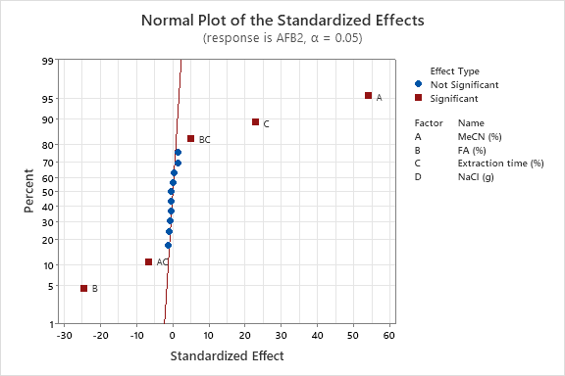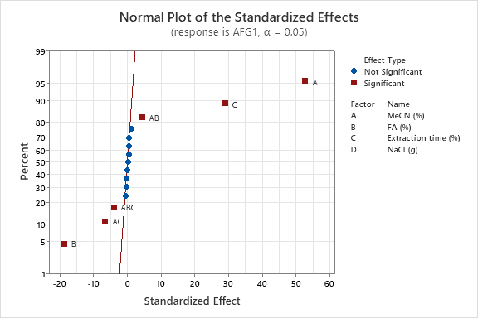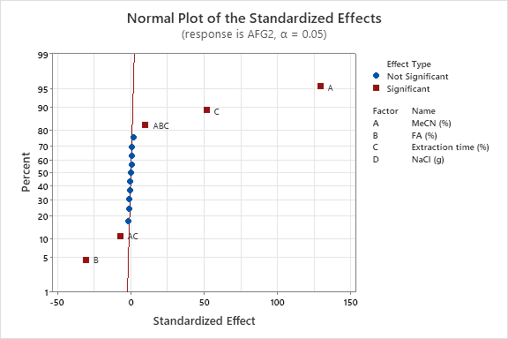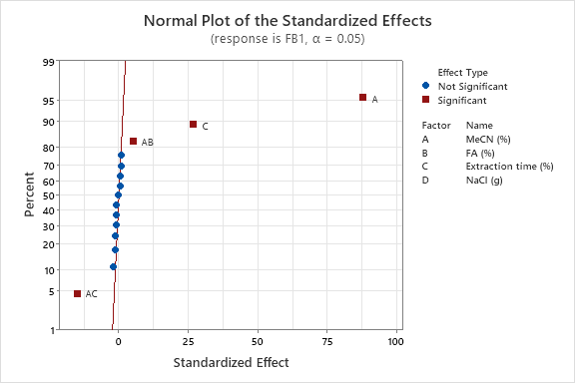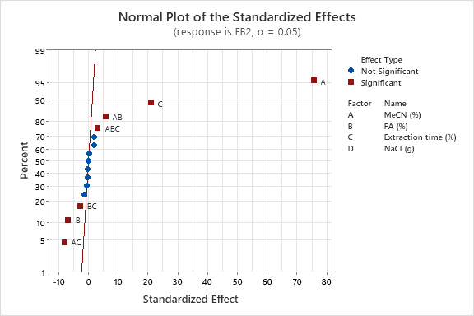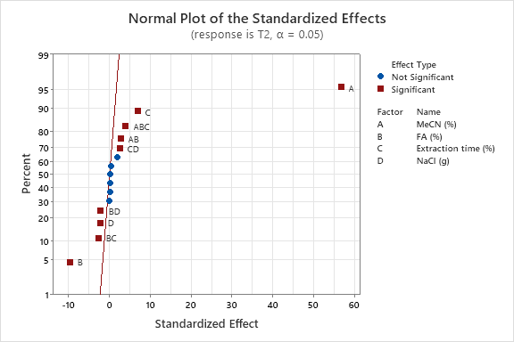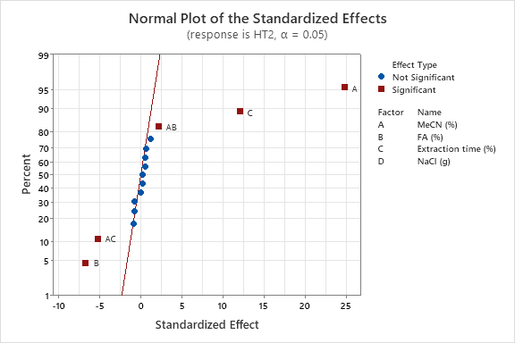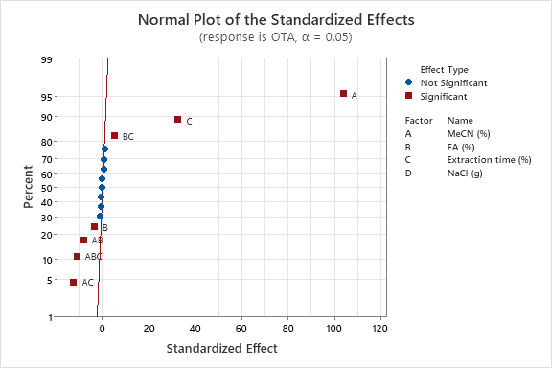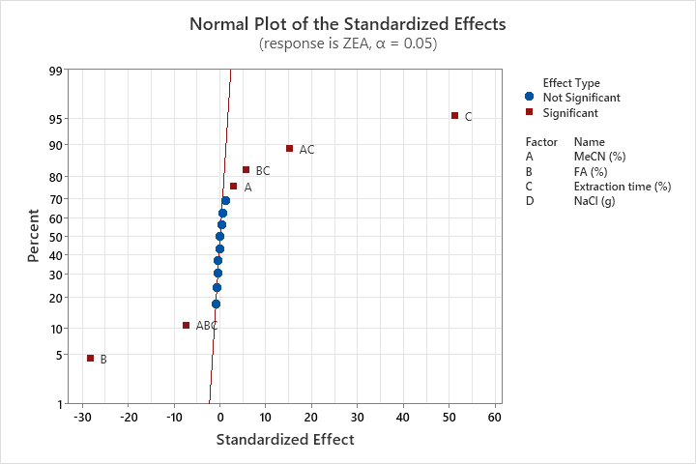
Fig. S3: Normal probability plot of standardized effects for AFB2, AFG1, AFG2, FB1, FB2, T2, HT2, OTA and ZEA
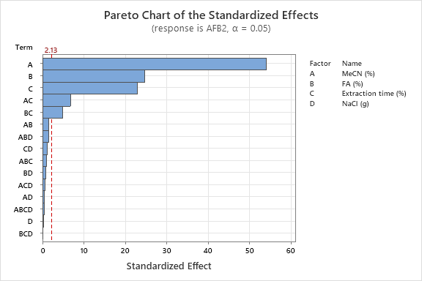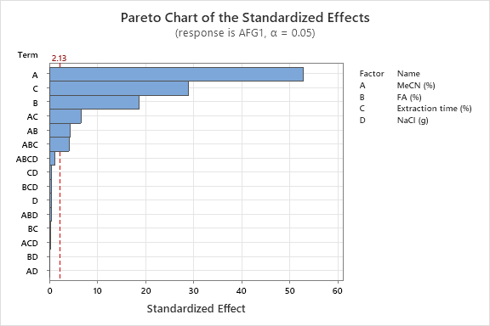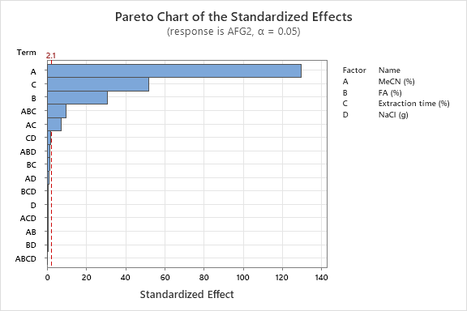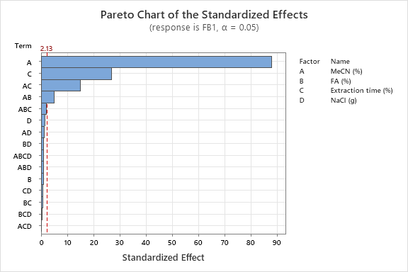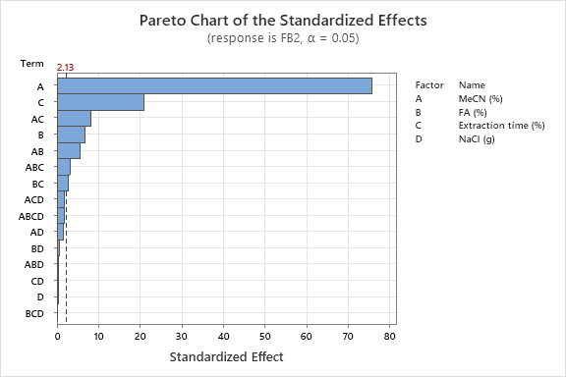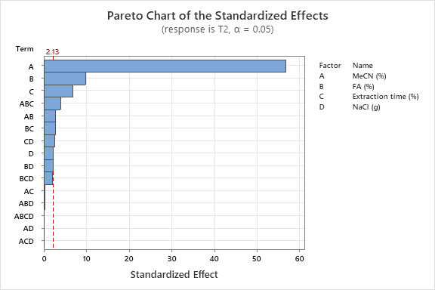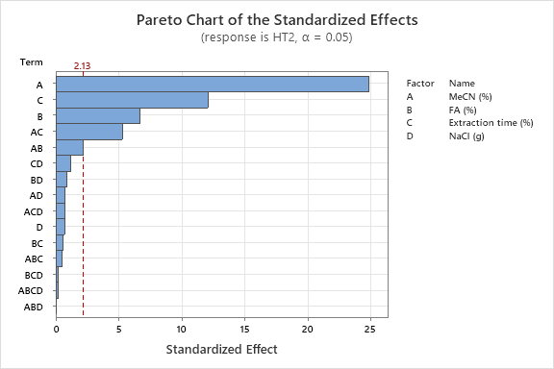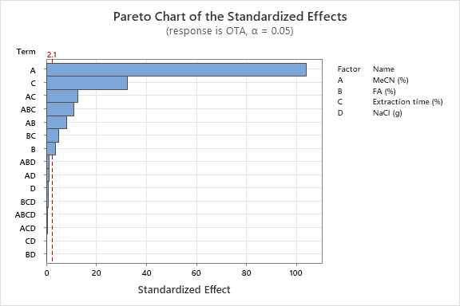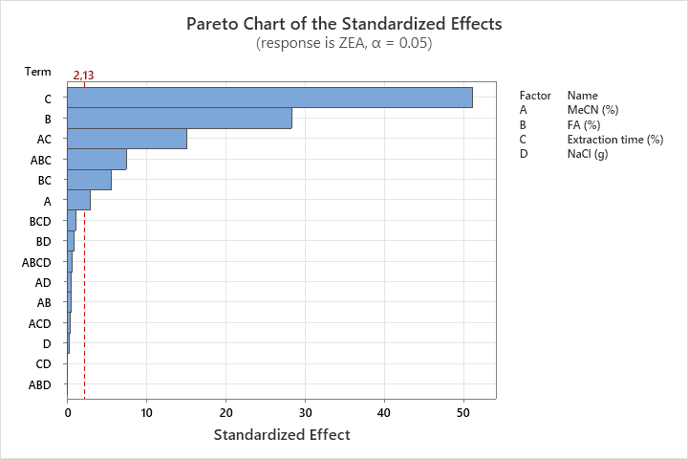
Fig. S4: Pareto charts of standardized effects for AFB2, AFG1, AFG2, FB1, FB2, T2, HT2, OTA and ZEA
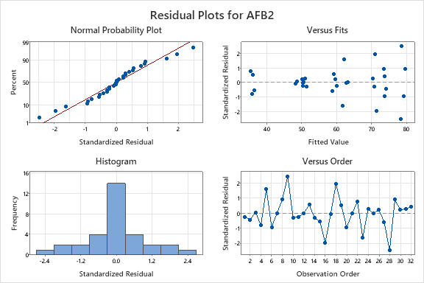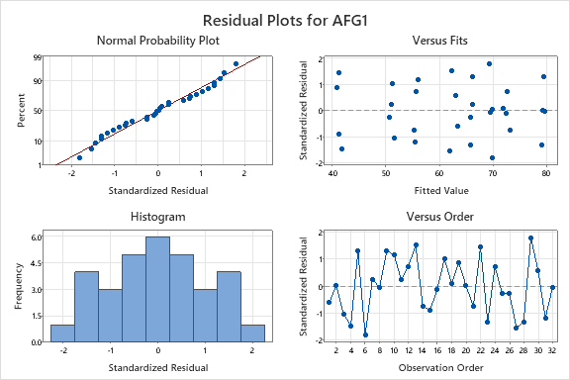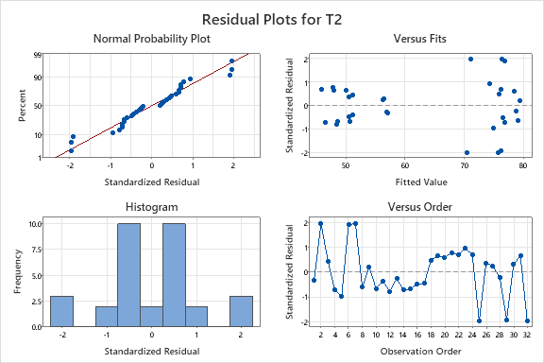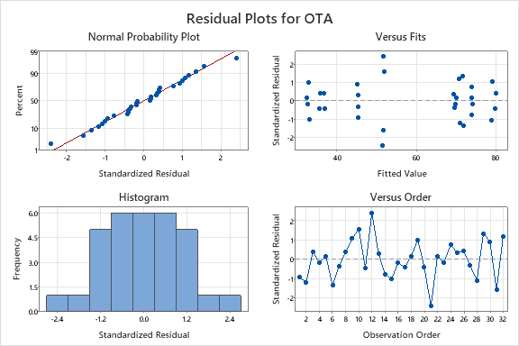
Fig. S5: Residual plots for AFB2, AFG1, T2 and OTA

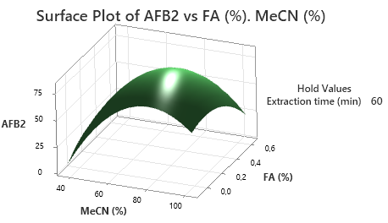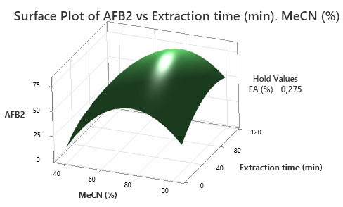
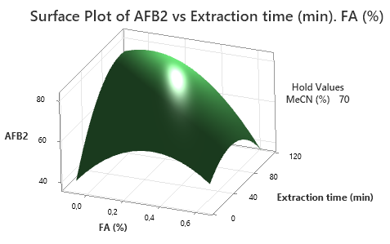
Fig. S6: Surface plots for AFB₂

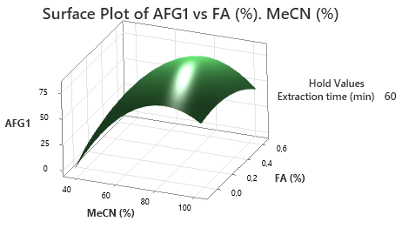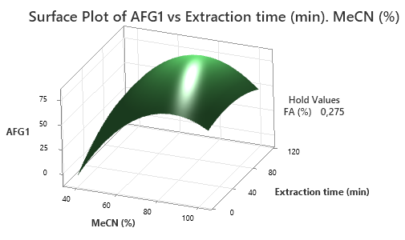
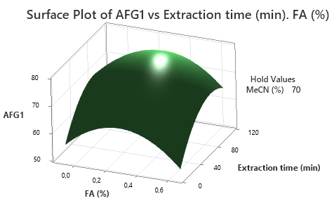
Fig. S7: Surface plots for AFG₁

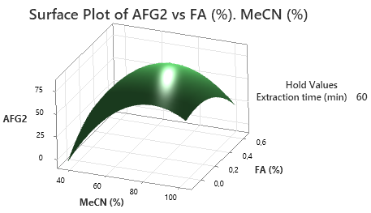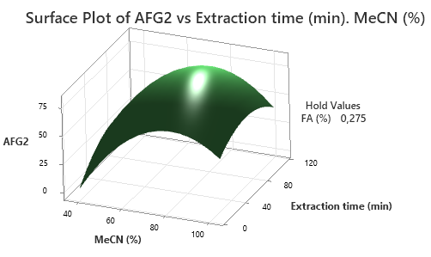
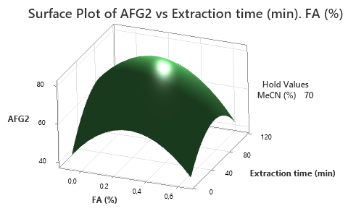
Fig. S8: Surface plots for AFG₂

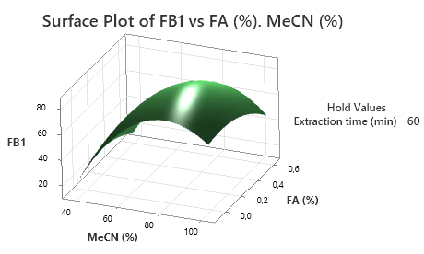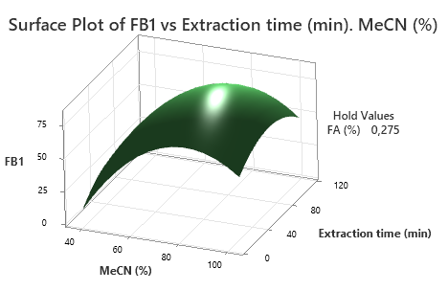
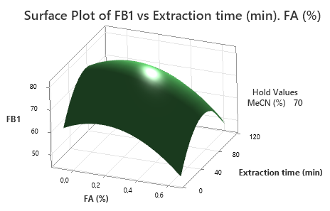
Fig. S9: Surface plots for FB₁

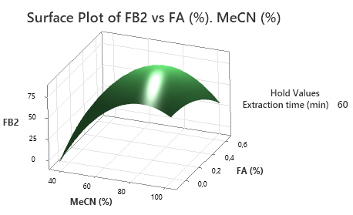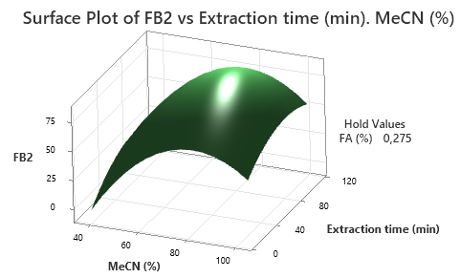
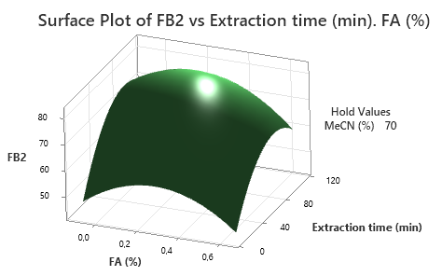
Fig. S10: Surface plots for FB₂

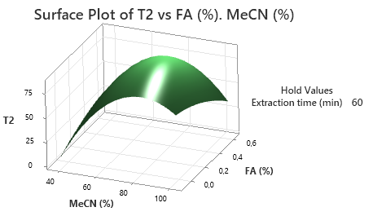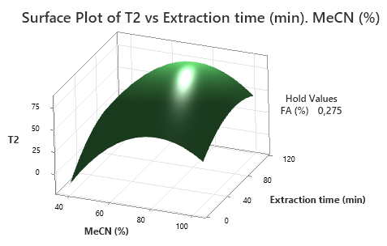
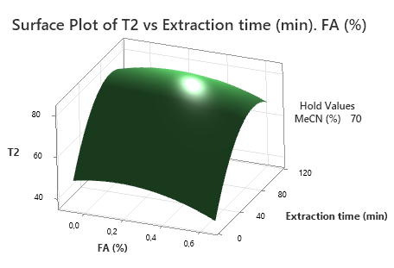
Fig. S11: Surface plots for T2-toxin

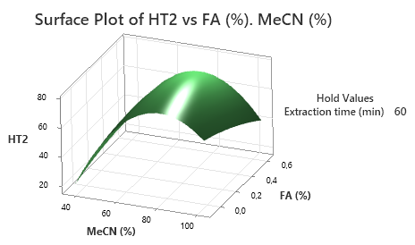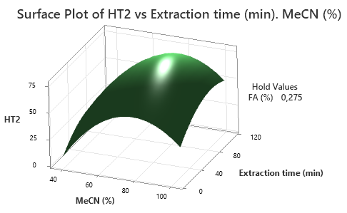
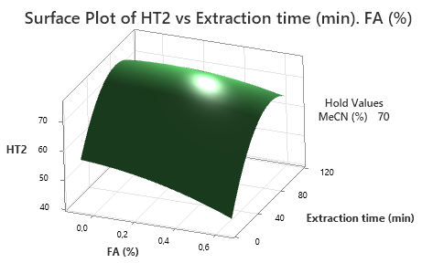
Fig. S12: Surface plots for HT2-toxin

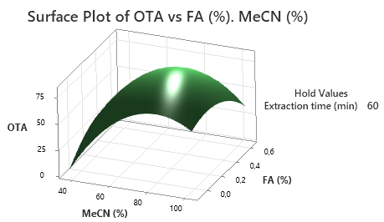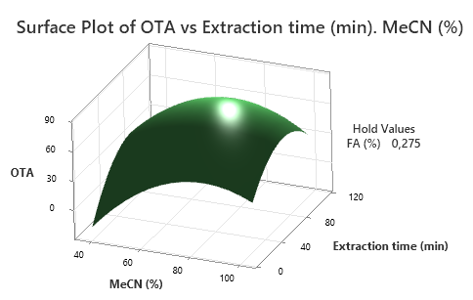
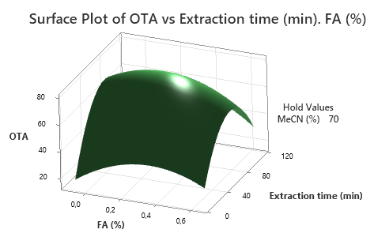
Fig. S13: Surface plots for OTA

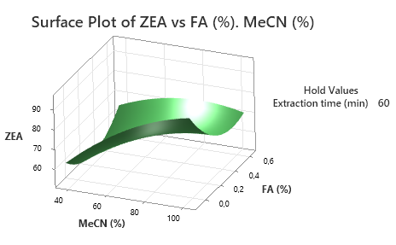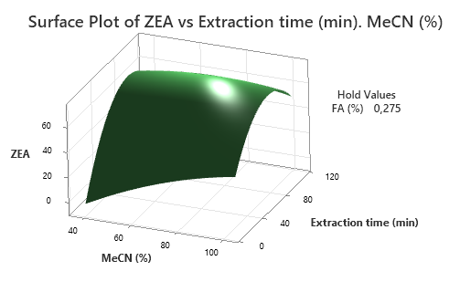
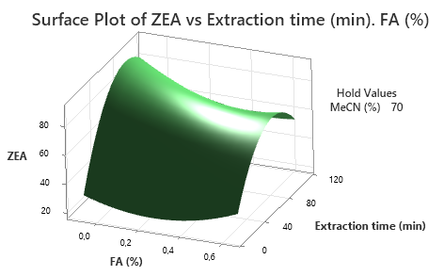
Fig. S14: Surface plots for ZEA

