Supporting Information

Ultrabroadband Visible to Mid-wave Infrared PbS/HgTe Colloidal Quantum Dot Imagers

Yimei Tan^{1,3#}, Cheng Bi^{1,3#}, Ge Mu^{1,2*}, Pengfei Zhao¹, Menglu Chen^{1,4}, Yanfei Liu³, Qun Hao^{1,4*}, Xin Tang^{1,4*}

1. School of Optics and Photonics, Beijing Institute of Technology, Beijing 100081, China
2. Faculty of Materials and Manufacturing, Beijing University of Technology, Beijing 100124, China
3. Zhongxinrecheng Science and Technology Co., Ltd., Beijing 101102, China
4. Yangtze Delta Region Academy of Beijing Institute of Technology, Jiaxing, 314019, China
# These authors contributed equally to this work.
* Corresponding author. xintang@bit.edu.cn (X. T.), 7520210145@bit.edu.cn (G. M.), qhao@bit.edu.cn (Q.H.)

Section 1. Visible to Mid-wave Infrared Ultrabroadband Photodetectors

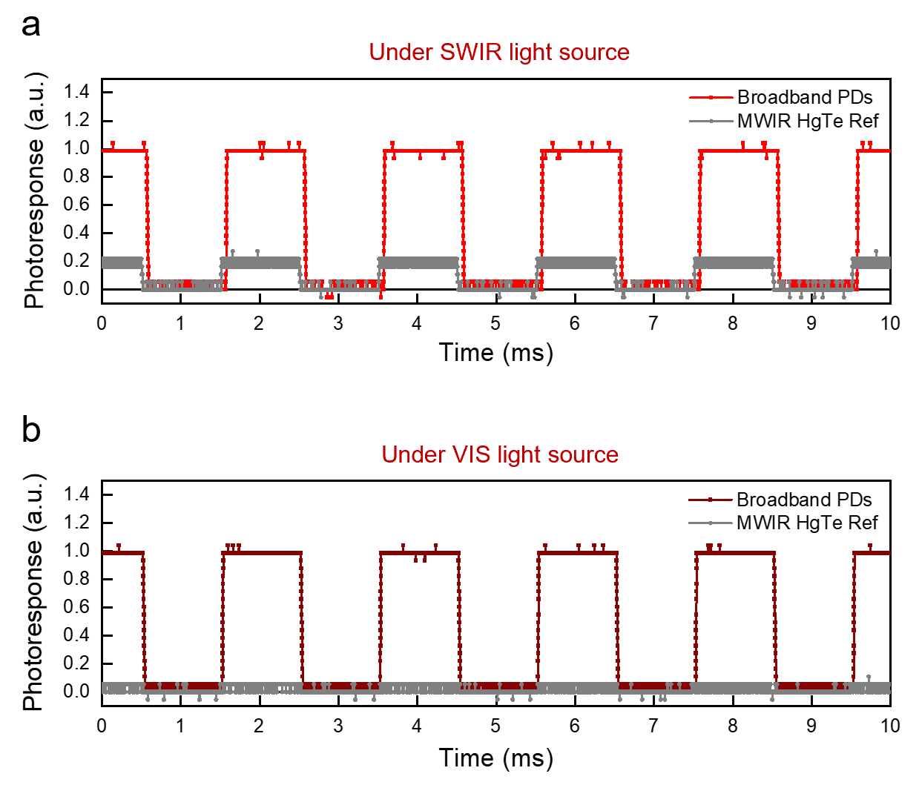
Figure S1. The photoresponse of broadband PbS/HgTe CQDs photodetectors and reference MWIR HgTe CQDs photodetectors under (a) SWIR and (b) visible light sources.

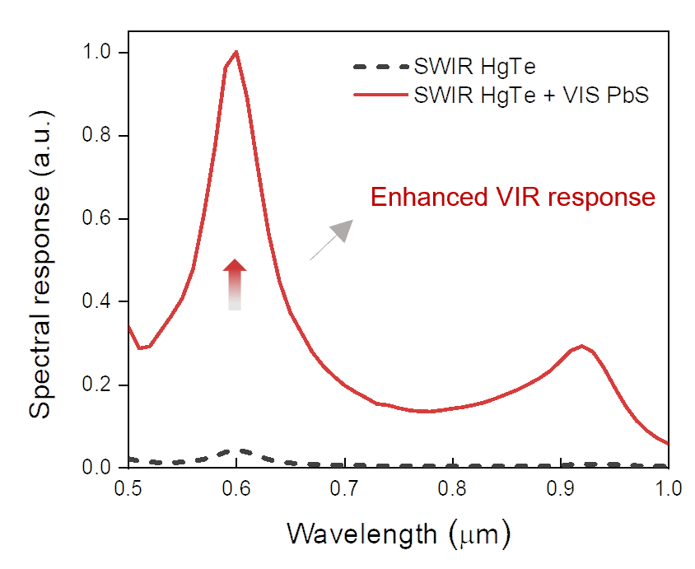
Figure S2. Spectral response of SWIR HgTe CQDs-based photodetectors without and with VIS PbS CQDs layers.
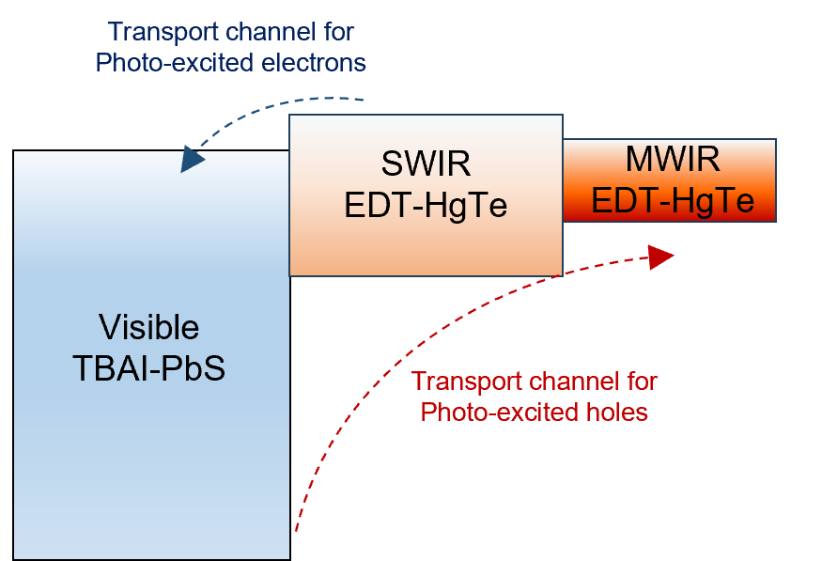
Figure S3. Band diagram of broadband PbS/HgTe CQDs photodetectors.

Section 2. Ultrabroadband Photodetectors Performance Characterization.

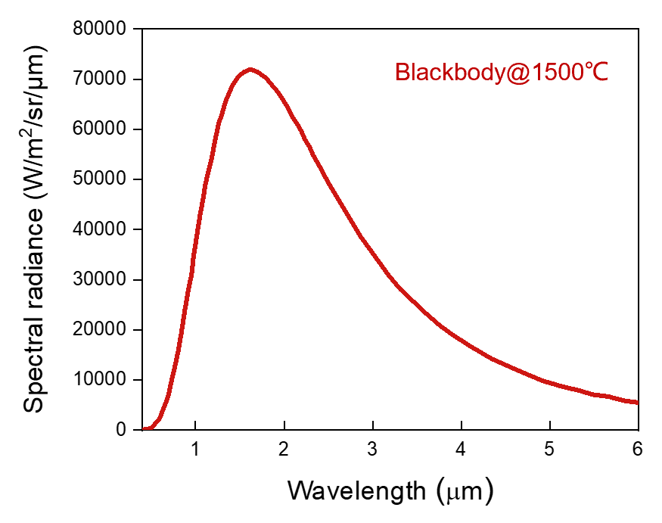
Figure S4. The spectral radiance versus wavelength curves of high-temperature blackbody @ 1500℃.

Responsivity (ℜ, units of A W⁻¹) of photodetectors:
$R=\frac{I_{ph}}{P}$ (S1)
where I_{ph} is the photocurrent and P is the input optical power.

Detectivity (D*, units of Jones) of photodetectors:
$D^{*}=\frac{\sqrt{A⋅Δf}}{I_{n}}R$ (S2)
where A is the sensing area, Δf is the bandwidth, I_{n} is the noise spectral density, and ℜ is the responsivity.

Section 3. Ultrabroadband FPA Imagers Pixel Design and Performance Characterization.

A pixel electrode is placed in the center of each pixel and a common ground electrode is placed around it. A bias voltage is applied between the pixel electrode and the ground electrode. The layout of ROICs is presented in Figure S5. The function and typical setting of pins are shown in Table S1.
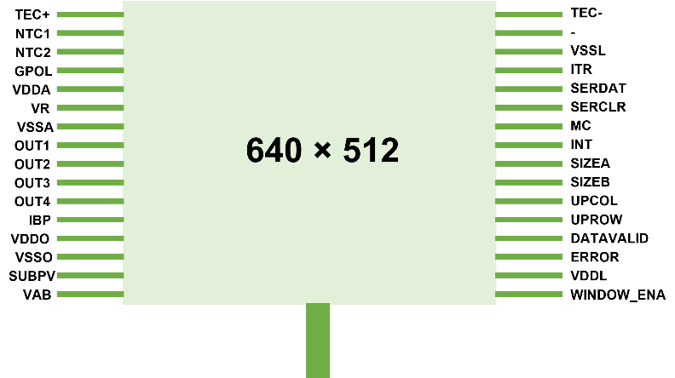
Figure S5. The layout of ROICs.
Table S1. The function and typical setting of pins.
Name | I/O | Define | Type
TEC+ | I | Positive electrode of refrigeration chip | Analog
TEC- | I | Negative electrode of the refrigeration chip | Analog
NTC1 | I | Temperature sensing resistor pins1 | Analog
NTC2 | I | Temperature sensing resistor pins2 | Analog
GPOL | I | Bias control | Analog
VDDA | I | Analog Power | Power
VSSA | I | Analog Ground | Ground
VDDO | I | Output Power | Power
VSSO | I | Output Ground | Ground
VR | I | Reset Power | Analog
VDETCOM | I | Common terminal bias | Power
IBP | O | Detector bias adjustment | Analog
OUT1/2/3/4 | O | Output | Analog
DATAVALID | O | Readout synchronization | Digital
ERROR | O | Error singal | Digital
MC | I | Clock | Digital
INT | I | Integration time | Digital
SIZEA | I | Window control | Digital
SIZEB | I | Window control | Digital
UPCOL | I | Image rotation | Digital
UPROW | I | Image rotation | Digital
ITR | I | Exposure readout mode selection | Digital
SERDAT | I | Window coordinate input interface | Digital
SERCLR | I | Serial register reset | Digital
WINDOW_ENA | I | Arbitrary window enablement | Digital
VAB | I | Overflow protection bias voltage | Analog
VDDL | I | Digital Power | Power
VSSL | I | Digital Ground | Ground

The FPA circuit architectures are presented in Figure S6. Each pixel is integrated and stored by directly injecting a detector response current. After the detector integration is completed, the signal of each pixel is output row-by-row.
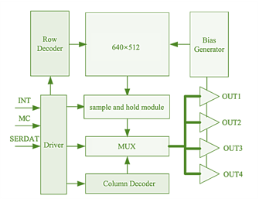
Figure S6. The schematic diagram of FPA circuit architectures.

Responsivity of a pixel for FPA imager:
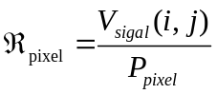 (S3)
where V_{signal} (i, j) is the signal voltage of i^{th} row and j^{th} column, P_{pixel} is the optical power incident on each pixel.
Average responsivity for FPA imager:
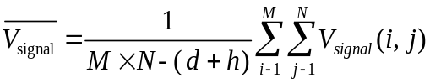 (S4)
where M is the total number of pixels in a row, N is the total number of pixels in a column, d is the number of dead pixels, h is the number of over heat pixels, V_{signal} (i, j) is the signal voltage of i^{th} row and j^{th} column.
Detectivity for FPA imager:
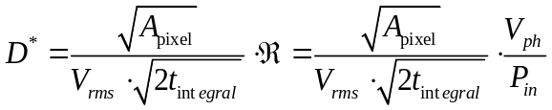 (S5)
where A_{pixel} is the effective size of a pixel, V_{rms} is the noise voltage, t_{integral} is the integration time for each pixel, and ℜ is the responsivity.

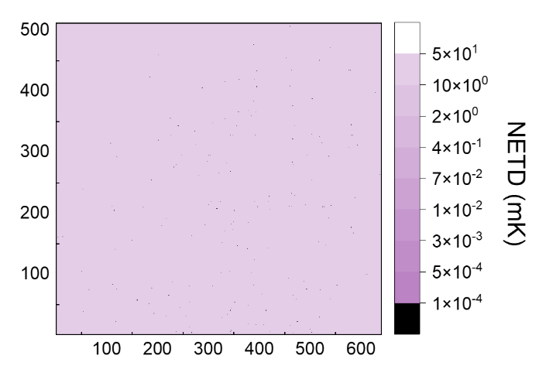
Figure S7. The NETD mapping of the ultrabroadband FPA imager.

