Supplementary Information for
Cross-shore parallel channel systems formed by the dominance of alongshore tidal currents
Zeng Zhou^{1,2}, Yizhang Wei², Liang Geng^{1,4*}, Ying Zhang², Yuxian Gu², Alvise Finotello³, Zheng Gong¹, Andrea D’Alpaos³, Fan Xu^{4*}, Changkuan Zhang², Giovanni Coco⁵

¹The National Key Laboratory of Water Disaster Prevention, Hohai University, Nanjing, China
²Jiangsu Key Laboratory of Coast Ocean Resources Development and Environment Security, Hohai University, Nanjing, China.
³Department of Geosciences, University of Padova, Padova, Italy.
⁴State Key Laboratory of Estuarine and Coastal Research, East China Normal University, Shanghai, China.
⁵Faculty of Science, University of Auckland, Private Bag 92019, Auckland, New Zealand.
* Corresponding authors: gengliang1991@hhu.edu.cn and fxu@sklec.ecnu.edu.cn.

Supplementary section 1: Overview of investigated parallel channel systems

Table S1.1. Site characteristics of the selected locations for parallel channel analysis
Site | Latitude, longitude  (decimal degrees) | Parallel channel pattern | Averaged intersecting angle $α$(°) | Averaged overall angle $β$(°) | Tidal currents | Type | Date of remote sensing image  (dd/mm/yy)
Chongming Island, China | 31°42'N, 121°38'E | Perpendicular | 91.6 | 85 | Alongshore^{r1} | Estuary | 04/10/2021
Warbah Island, Kuwait | 30°1'N, 48°4'E | Perpendicular | 87 | 89.1 | Alongshore^{r2} | Estuary | 27/10/2020
Tillingham Tidal Flats, UK | 51°40'N, 0°56'E | Non-perpendicular | 78.25 | 84.1 | Alongshore | Open coast | 10/04/2020
Hooge Plates, Netherlands | 51°23'N, 3°39'E | Perpendicular | 83.5 | 92.7 | Alongshore^{r3} | Estuary | 07/03/2020
Bath Tidal Flats  Western Scheldt, Netherlands | 51°22'N, 4°14'E | Perpendicular | 83.4 | 83.2 | Alongshore^{r3} | Estuary | 20/09/2019
Ems-Dollard, Netherlands | 53°21'N, 6°54'E | Non-perpendicular | 97 | 106.3 | Alongshore^{r4} | Lagoon | 21/05/2018
San Francisco Bay, USA | 37°27'N, 122°1'W | Perpendicular | 98 | 93.5 | Alongshore^{r5} | Lagoon | 28/09/2021
Meda River Delta, Australia | 17°2'S, 123°54'E | Perpendicular | 79.1 | 82.3 | Alongshore^{r6} | Lagoon | 30/01/2020
Jiangsu Coast, China | 32°59'N, 120°55'E | Non-perpendicular | 104.8 | 105 | Alongshore | Open coast | 2006
Orne Estuary, France | 49°16'N, 0°14'W | Perpendicular | 92 | 92.8 | Alongshore | Estuary | 29/05/2020
Inhassunge Tidal Flats, Mozambique | 18°10'S, 36°50'E | Non-perpendicular | 71 | 65.8 | Alongshore | Lagoon | 21/11/2018
Iranian Bay,  Iran | 30°11'N, 49°11'E | Perpendicular | 71.8 | 79.5 | Alongshore^{r2} | Estuary | 12/01/2021
Shoalwater Bay, Australia | 22°28'S, 150°33'E | Non-perpendicular | 41.3 | 78.5 | Alongshore | Open coast | 17/08/2021
Bahmanshir River Mouth, Iran | 30°1'N, 48°41'E | Non-perpendicular | 61.3 | 61.2 | Alongshore^{r2} | Estuary | 12/12/2018
Taeryong River Delta, North Korea | 39°35'N, 125°13'E | Non-perpendicular | 51 | 65.8 | Alongshore | Estuary | 29/09/2021
Rio Cabelo da Valha, Brazil | 1°43'S, 44°46'W | Non-perpendicular | 67.8 | 100.3 | Alongshore | Estuary | 30/06/2020
Thengar Island, Bangladesh | 22°32'N, 91°30'E | Non-perpendicular | 71.9 | 79.2 | Alongshore | Estuary | 24/04/2021
Colorado River Delta, Mexico | 31°47'N, 114°48'W | Non-perpendicular | 87.4 | 63.9 | Alongshore | Estuary | 11/03/2022
Bahia Blanca, Argentina | 38°48'S, 62°18'E | Non-perpendicular | 67.3 | 108.2 | Alongshore | Lagoon | 13/05/2019
Rio Cacine Channel, Guinea | 11°9'N, 15°3'W | Non-perpendicular | 68 | 72.4 | Alongshore | Lagoon | 25/11/2016
Broome Tidal Flats, Australia | 17°59'S, 122°21'E | Non-perpendicular | 102.7 | 74 | Alongshore | Open coast | 30/09/2021

^{r1}Ou, Yang and Cangzi, Liu. (2002). Analysis on sediment transport patterns and sediment sources of north branch of Changjiang estuary. Journal of Hydraulic Engineering, 02, 79-84; Bowen, You., et al. (2018). Sediment Characteristics and Transport Trend in North Branch and Offshore Area of Yangtze Estuary in the Last 30 Years. Resources and Environment in the Yangtze Basin, 27(10), 2328-2338. ^{r2}Baby, S. (2011). Information research on coastal morphological environment of Kuwait, organizations, role and coastal legislations. Emirates Journal for Engineering Research, 16(2), 7-24; Al-Ghadban, A. N. (1990). Holocene sediments in a shallow bay, southern coast of Kuwait, Arabian Gulf. Marine Geology, 92(3-4), 237-254. ^{r3}Bolle, A., et al. (2010). The influence of changes in tidal asymmetry on residual sediment transport in the Western Scheldt. Continental Shelf Research, 30(8), 871-882; Stark, J., et al. (2017). Impact of intertidal area characteristics on estuarine tidal hydrodynamics: A modelling study for the Scheldt Estuary. Estuarine, Coastal and Shelf Science, 198, 138-155. ^{r4}Ridderinkhof, H., et al. (2000). Temporal variations in concentration and transport of suspended sediments in a channel–flat system in the Ems-Dollard estuary. Continental Shelf Research, 20(12-13), 1479-1493. ^{r5}Barnard, P. L., et al. (2013). Integration of bed characteristics, geochemical tracers, current measurements, and numerical modeling for assessing the provenance of beach sand in the San Francisco Bay Coastal System. Marine Geology, 345, 181-206. ^{r6}Zigic, S., et al. (2009). A numerical modelling study for the proposed increase in Barramundi production, Cone Bay, Western Australia. Proceedings of the 11th Estuarine and Coastal Modelling Conference, 10(41121), 388.

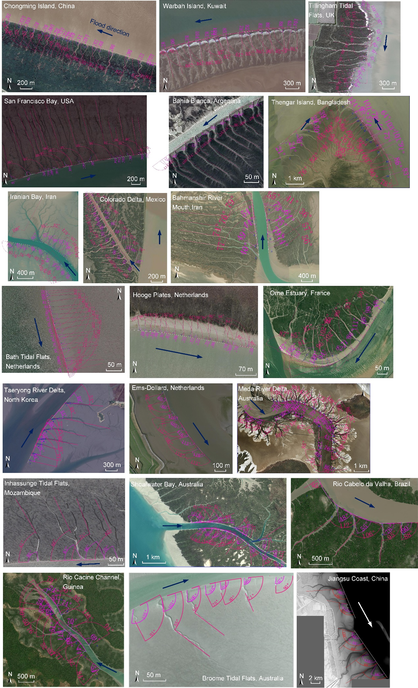
Figure S1.1. Overview of 21 systems analysed for channel angles. Tidal channel angle is measured as the angle between the parallel branch and the shoreline at the low water level, consistent with the flood flow direction, as shown by the purple numbers in the figure.

Supplementary section 2: Background information on the reference site in southeastern China (Chongming Island and Jiangsu Coast)

Table. S2.1. Background information on reference field sites
 | Chongming Island | Jiangsu Coast
 | Perpendicular PCs | Non-perpendicular PCs
Hydrodynamics
Mean tidal range (cm) | 307^{r1} | 368^{r2}
Sediment: value (Year)
Grain size d50 (μm) | 104 (2012) ^{r3} | 81 (2003) ^{r4}
Sand content (%) | 57%-71% (2016) ^{r3} | 83%-98% (2003) ^{r4}
Clay content (%) | 28%-43% (2016) ^{r3} | 2%-17% (2003) ^{r4}
Slope (mm⁻¹): value (Year)
Channel area | 0.0006 (2019) | 0.0004 (2022)
Subtidal area | 0.002 (2019) | 0.0008 (2022)
^{r1}Fangfang, Zhao., et a. (2013). Mechanism of water and suspended sediment transport from neap tide to spring tide in North Branch of Changjiang Estuary. Journal of Sediment Research, 04, 55-62. ^{r2}Zheng, Gong., et a. (2017). Mechanisms underlying the dynamic evolution of an open-coast tidal flat-creek system: Ⅱ: influence of tidal range. Advances in water science, 28(02), 231-239. ^{r3}Hong, Yang., et al. (2012). Grain-size characteristics of the inter-tidal flat sediments of Shanghai nonresident islands. Journal of Shanghai Ocean University, 21(02), 257-264. ^{r4}Zhanhai, Li., et al. (2006). Suspended sediment concentration profiles and grain size distribution patterns over the Dafeng tidal flat. Journal of Sediment Research, 01, 62-70.

Supplementary section 3: Model parameters and scenarios of numerical experiments

Table. S3.1. Hydro-morphodynamic model equations
Hydro-morphodynamic processes
Nr. | Governing equation | Short description
1 | $\frac{∂η}{∂t}+\frac{∂hu}{∂x}+\frac{∂hv}{∂y}=0$  $\frac{∂u}{∂t}+u\frac{∂u}{∂x}+v\frac{∂u}{∂y}=fv-g\frac{∂η}{∂x}+v\left(\frac{∂^{2}u}{∂x^{2}}+\frac{∂^{2}u}{∂y^{2}}\right)-g\frac{v\sqrt{u^{2}+v^{2}}}{C^{2}h}$  $\frac{∂v}{∂t}+u\frac{∂v}{∂x}+v\frac{∂v}{∂y}=-fu-g\frac{∂η}{∂y}+v\left(\frac{∂^{2}v}{∂x^{2}}+\frac{∂^{2}v}{∂y^{2}}\right)-g\frac{v\sqrt{u^{2}+v^{2}}}{C^{2}h}$ | shallow water  equations
2 | $\frac{∂(ch)}{∂t}+\frac{∂(uch)}{∂x}=Q_{mud,e}-Q_{mud,d}$  $Q_{mud,e}=\left\{\begin{aligned}M_{e}\left(\frac{τ_{max}}{τ_{cr,e}}\right)-1, if τ_{max}>τ_{cr,e} \\ 0, if τ_{max}≤τ_{cr,e}\end{aligned}\right.$  $Q_{mud,d}=\left\{\begin{aligned}w_{s}c\left(1-\frac{τ_{max}}{τ_{cr,d}}\right), if τ_{max}<τ_{cr,d} \\ 0, if τ_{max}≥τ_{cr,d}\end{aligned}\right.$  $S_{sand}=A_{s}u{\left[{(u^{2}+\frac{0.018}{C_{dc}}U_{rms}^{2})}^{1/2}-u_{cr}\right]}^{2.4}$ | Sediment transport formulations
3 | $\left(1-ε\right)\frac{∂z}{∂t}+\frac{∂S_{x}}{∂x}+\frac{∂S_{y}}{∂y}=0$ | Bed level update

Table. S3.2. Hydro-morphodynamic model parameters
Symbol | Parameter | Unit | Value | Ref.
$t$ | hydrodynamic time step | min | 0.5
$g$ | the gravitational constant | kg/s² | 9.81 | (Zhou et al., 2014)
$v$ | the horizontal eddy viscosity coefficient | m²/s | 1 | (Zhou et al., 2014)
$M_{e}$ | the erosion parameter | kg/m²/s | $5×{10}^{-5}$ | (Zhou et al., 2016)
$w_{s}$ | the settling velocity | m/s | $5×{10}^{-4}$ | (Zhou et al., 2016)
$τ_{cr,e}$ | the critical shear stress for erosion | Pa | 0.2 | (Zhou et al., 2016)
$C_{dc}$ | non-dimensional drag coefficient due to current alone  $C_{dc}={\left[0.4/(ln⁡h/z_{r}-1)\right]}^{2}$ | - |  | (Soulsby R, 1997)
$z_{r}$ | the bed roughness length | m | 0.006 | (Soulsby R, 1997)
$ε$ | bed porosity | - | 0.4 | (van der Wegen et al., 2008)
$f_{mor}$ | morphological acceleration factor | - | 25

Figure. S3.1. Simplified model domain of Chongming tidal flats (a and b), representing the intertidal zone with sharp transition; model domain (c and d) representing the schematic Jiangsu coast, with gentle slope changes in the intertidal zone.

Supplementary section 4: Analysis of parallel channel characteristics

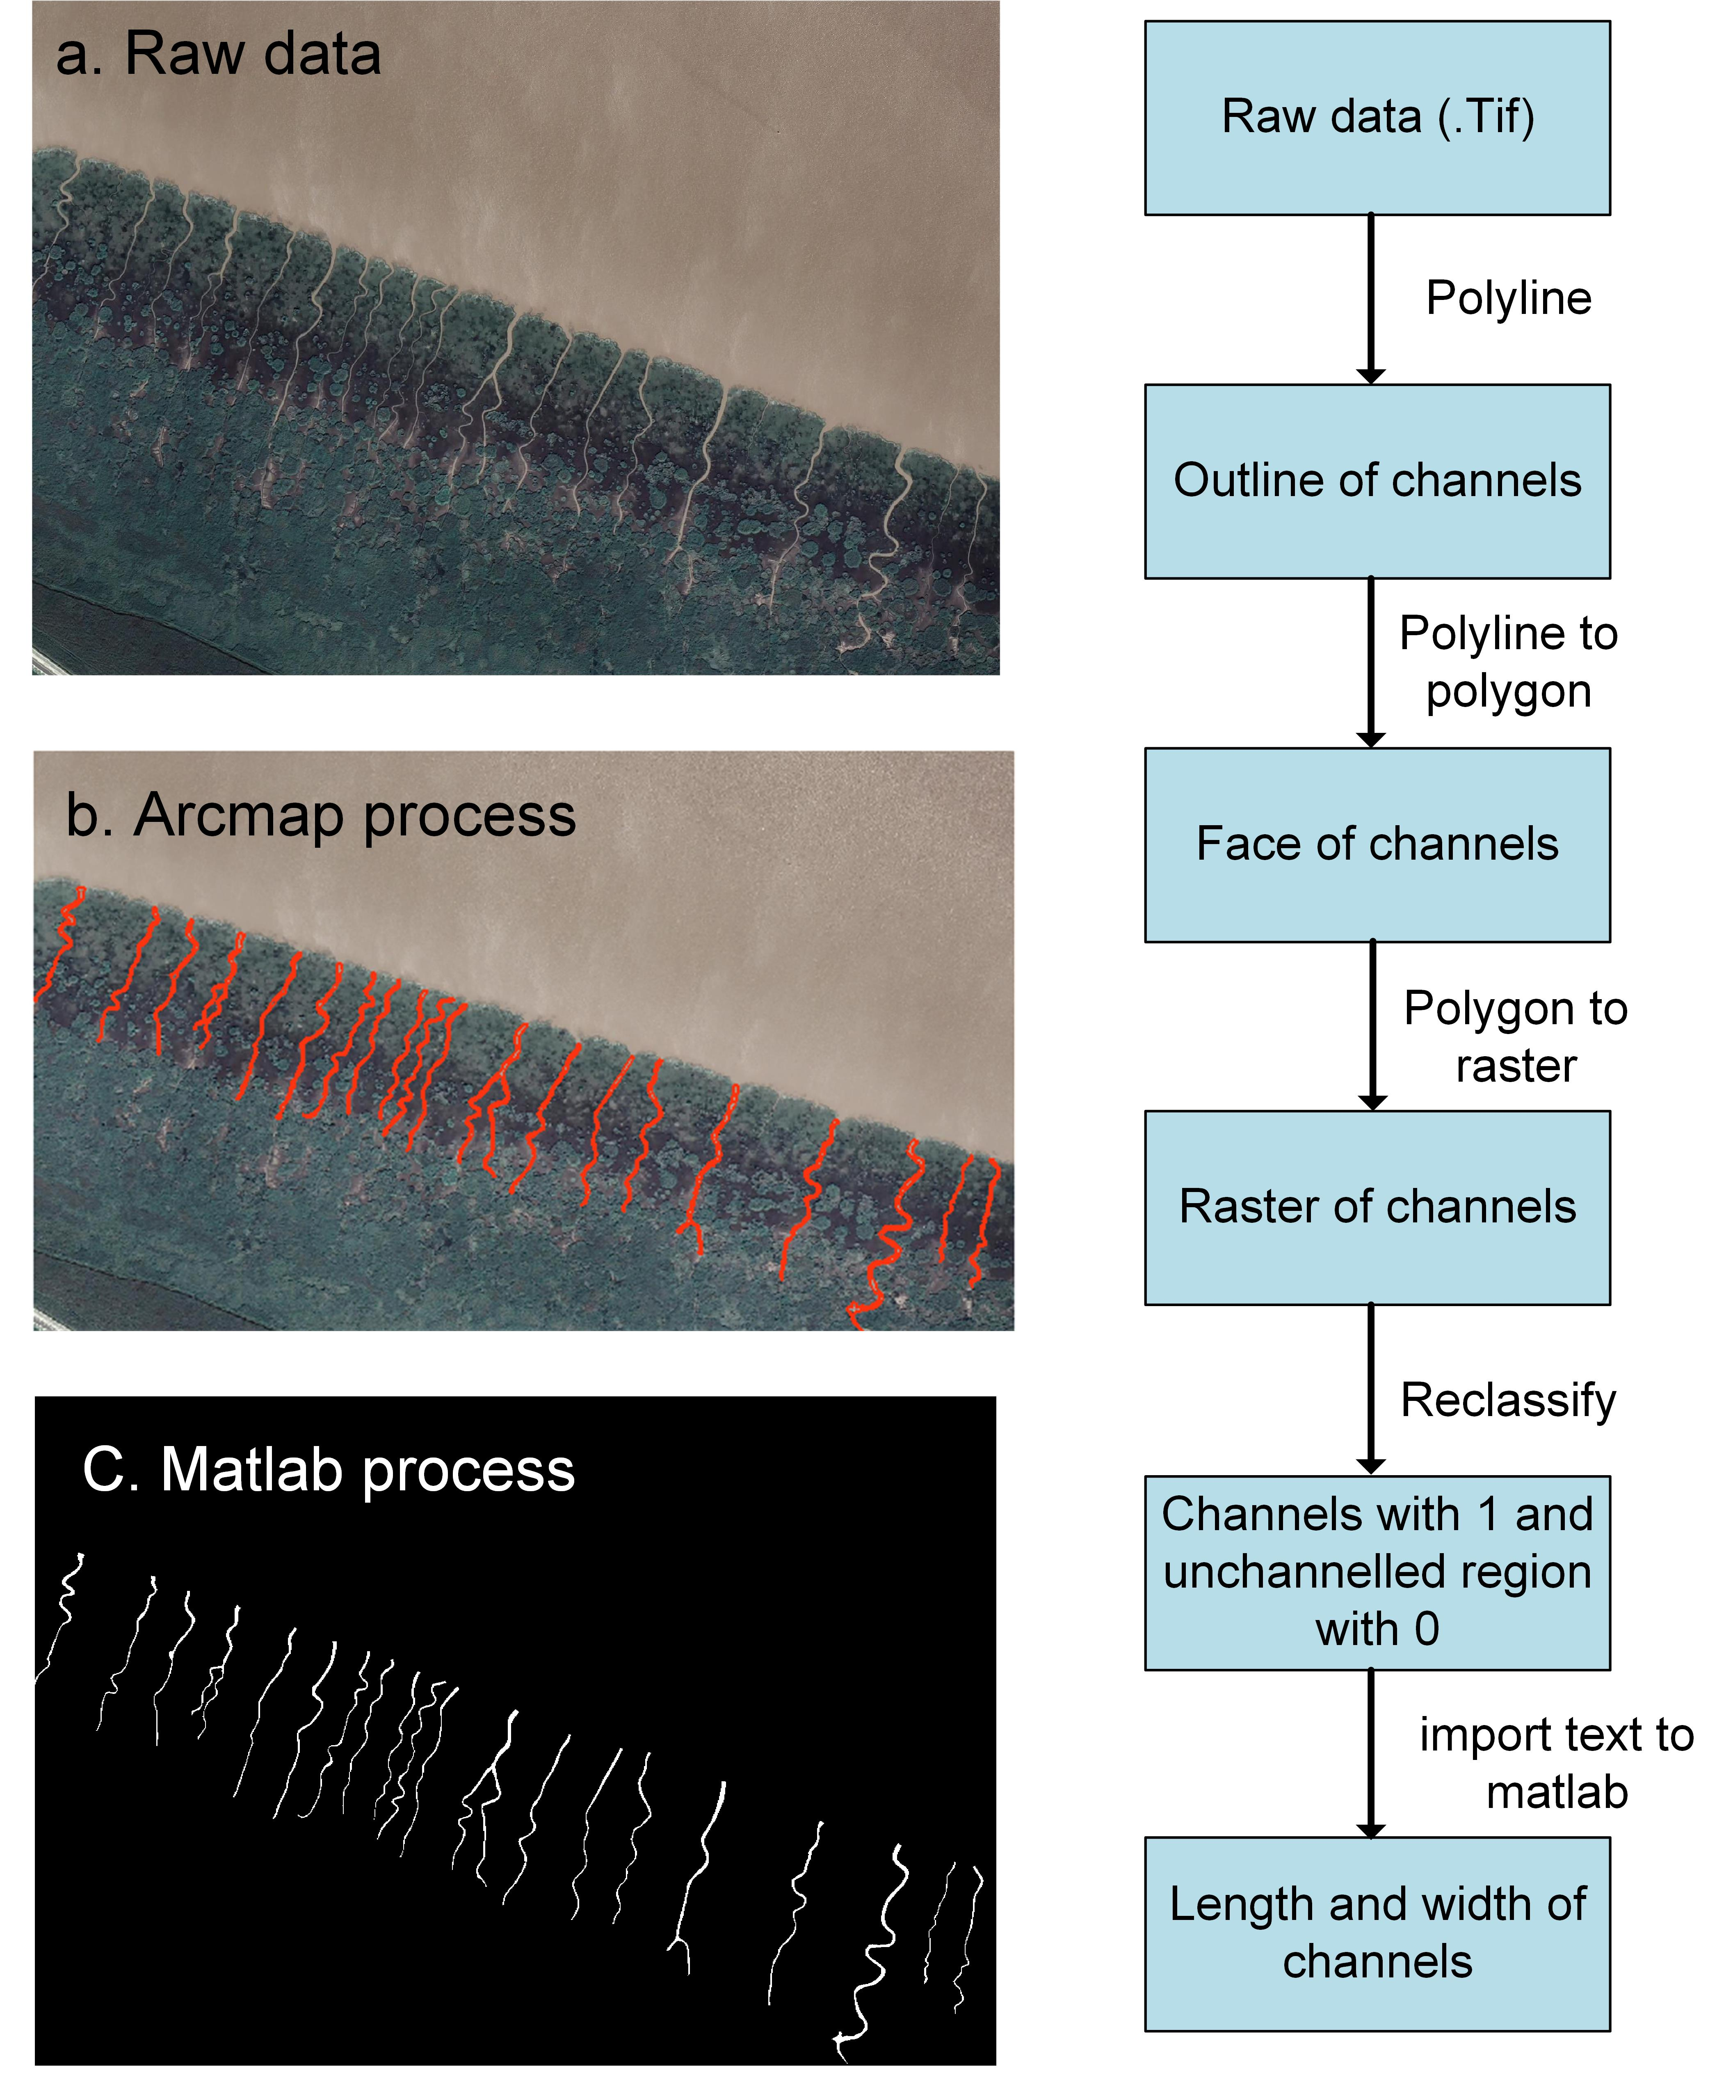
Figure. S4.1. Channel extraction: First, The raw data of different areas is from Google Earth. Then, raw data was import in Arcmap. After polyline, polyline-to-polygon, polygon-to-raster, reclassification，the two classes is channels and unchannelled region. The resulting text was covered with value (channels with 1 and unchannelled region with 0). The length and width of channels were calculated in Matlab with the text.

Table. S4.1. Offshore tidal range, width of parent channel, and mean morphological parameters of parallel channels in selected locations.
 | Tidal range (m) | Parent channel width (m) | Mean channel width (m) | Mean channel spacing (m) | Mean channel length (m)
Orne Estuary, France | 7.1 | 324.3 | 4.3 | 58.6 | 232.6
Chongming Island, China | 3 | 3355.0 | 5.3 | 117.4 | 513.0
Western Scheldt, Netherlands | 4 | 1706.5 | 1.1 | 14.9 | 140.4
Hooge Plates, Netherlands | 4.2 | 1565.5 | 1.1 | 20.2 | 63.5
Warbah Island, Kuwait | 4 | 1460.5 | 5.5 | 176.6 | 609.0
Tillingham Marsh, UK | 4.6 | (connected to the open sea) | 8.4 | 183.3 | 523.0
San Francisco Bay, USA | 2.9 | 315.5 | 2.9 | 53.6 | 463.9
Ems-Dollard, Netherlands | 2.9 | 270.1 | 3.3 | 109.0 | 174.8
Inhassunge Tidal Flats, Mozambique | 3.7 | 245.0 | 4.1 | 112.1 | 260.3
Shoalwater Bay, Australia | 6.9 | 266.1 | 10.8 | 329.9 | 1277.4
Meda River Delta, Australia | 8.6 | 644.2 | 26.7 | 338.2 | 1115.7
Jiangsu Coast, China | 5 | (connected to the open sea) | 238.45 | 3347.24 | 8081.11
Colorado River Delta, Mexico | 6.9 | 29.5 | 8.5 | 98.5 | 499.4
Thengar Island, Bangladesh | 3.9 | 3482.5 | 16.9 | 374.1 | 2840.4
Iranian Bay,  Iran | 4.2 | 153.6 | 7.8 | 132.2 | 388.6
Bahia Blanca, Argentina | 2.5 | 26.7 | 3.0 | 16.4 | 125.9
Bahmanshir River Mouth, Iran | 4 | 365.0 | 14.2 | 220.1 | 1646.5
Rio Cabelo da Valha, Brazil | 4.5 | 666.3 | 23.5 | 606.1 | 1136.6
Taeryong River Delta, North Korea | 7.5 | 1044.0 | 24.7 | 315.7 | 1280.3
Rio Cacine Channel, Guinea | 4.5 | 191.8 | 15.2 | 439.3 | 890.6
Broome Tidal Flats, Australia | 8.5 | 55.0 | 3.0 | 42.6 | 103.0

Figure. S4.2. The mean channel width and mean channel length of the 20 selected areas are plotted as a function of offshore tidal range.

The information of tidal range is inquired from ArcGIS map viewer: https://www.arcgis.com/apps/mapviewer/index.html?layers=d5354dea41b14f0689860bf4b2cf5e8a. Because of the lack of in-situ data, we can only find the offshore tidal range, which may be far away from the selected study areas. Therefore, the tidal range doesn’t show a good relationship with the morphological parameters.

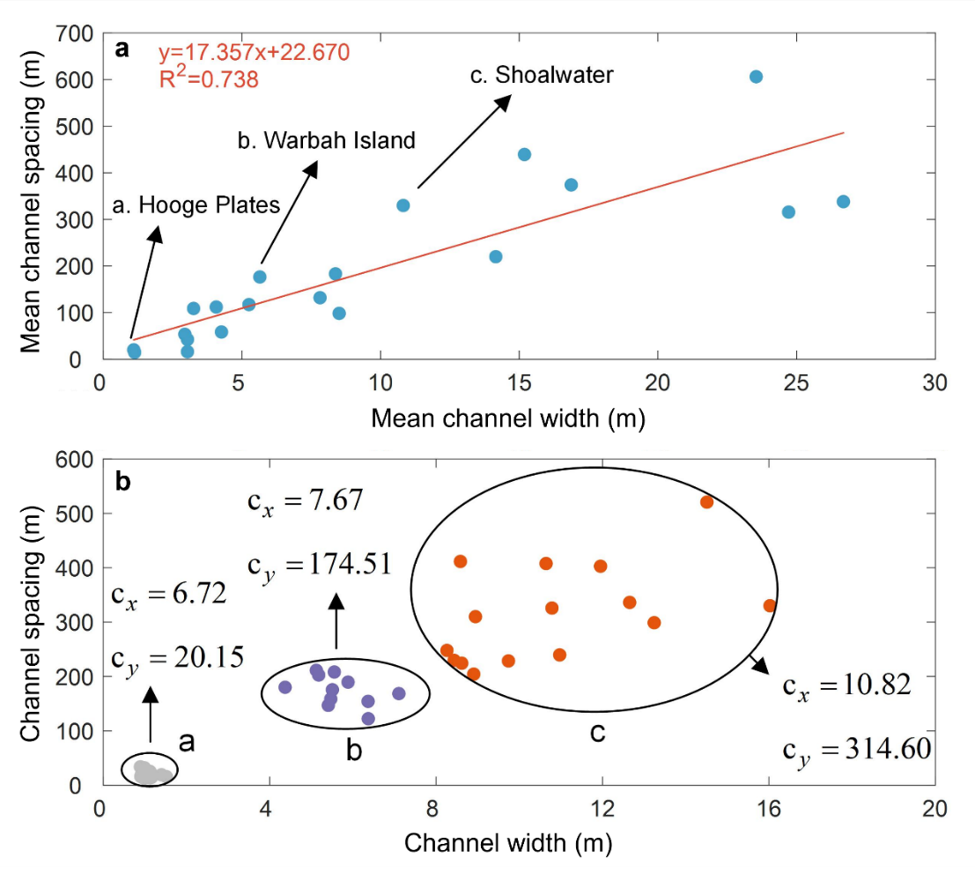
Figure. S4.3. (a) The mean channel spacings of the 20 selected areas are plotted as a function of mean channel width. (b) The channel spacings of 3 areas (Hooge Plates, Netherlands, Warbah Island, Kuwait, and Shoalwater Bay, Australia) are plotted as a function of channel width.

Figure. S4.4. The mean channel length of the 20 selected areas are plotted as a function of mean channel width.

Note that Fig. S4.2 - S4.4 do not include the situation of Jiangsu Coast, China, because the channel system in Jiangsu Coast is too large compared with other systems.
The mean channel spacing and mean channel width approximately follow a linear relation (Fig. S4.3 a). In Fig. S4.3 b, $c_{x}$ and $c_{y}$ are the dispersion coefficient of channel width and channel spacing, respectively. It shows that larger tidal channel systems also have greater degree of variation.

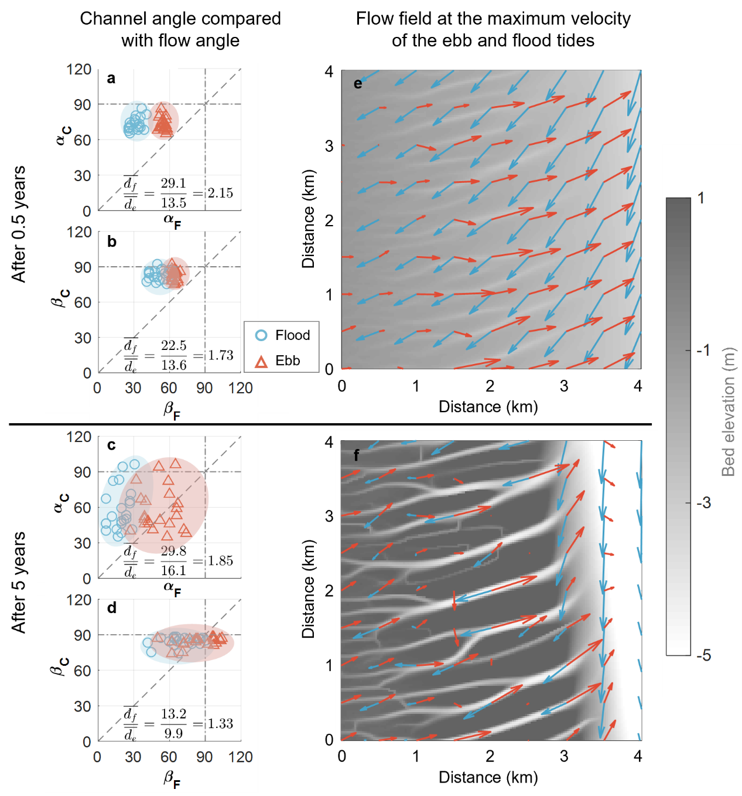
Figure. S4.5. Comparison between channel angle and flow direction during flood and ebb phases at the initial (a-b) and after 5 years (c-d). The corresponding flow field at the maximum velocity of the ebb and flood tides (e-f).

The simulation was conducted on an initial bed surface where the upper platform has a slope of 0.08% and the transition point between the upper platform and the lower bank has an elevation of -3m. In Fig. S4.5 a-d, $α_{C}$ and $β_{C}$ are the connecting channel angles and overall channel angles, respectively. $α_{F}$ and $β_{F}$ are the flow angles measured at the roots and at the middle of the channel branches.
Fig. S4.5 shows that the flood flow angle is smaller than ebb flow angle, and the ebb flow is close to 90°. It indicates that the flood currents provide a stronger contribution on generating channel branches with small angles, while the direction of ebb currents is heavily influenced by gravity, resulting in a more perpendicular trend with the shorelines.

Supplementary section 5: Numerical solution of Poisson equation

Poisson equation (Di Silvio et al, 2010):
$$\frac{∂^{2}η}{{∂x}^{2}}+\frac{∂^{2}η}{{∂y}^{2}}=f\left(x\right)=\frac{λa_{0}2π}{{h\left(x\right)}^{2}T}$$
where, $η（x,y）$ represents the fluctuation intensity of the free water surface relative to the mean water level. $a_{0}$ is the tidal amplitude, $T$ is the tidal period, $λ$ is a constant, and $h\left(x\right)$ is the average water depth (which does not vary with the (y) direction).
With the boundary condition:
$${\left.η\right|}_{y=2000}=0 {\left.\frac{∂η}{∂y}\right|}_{y=0}=0 {\left.\frac{∂η}{∂x}\right|}_{x=0, x=800}=0$$
Here we simulated two cases with different bed surfaces (Fig. S5.1). In the two cases, the upper boundary is an open boundary, while the other three boundaries are closed boundaries. As the water flows into the basin from the upper boundary, there are abrupt changes in the flow direction in the case with sudden changes in bed slope. In cases where the bed slope is uniform, the changes of flow direction are also gradual.
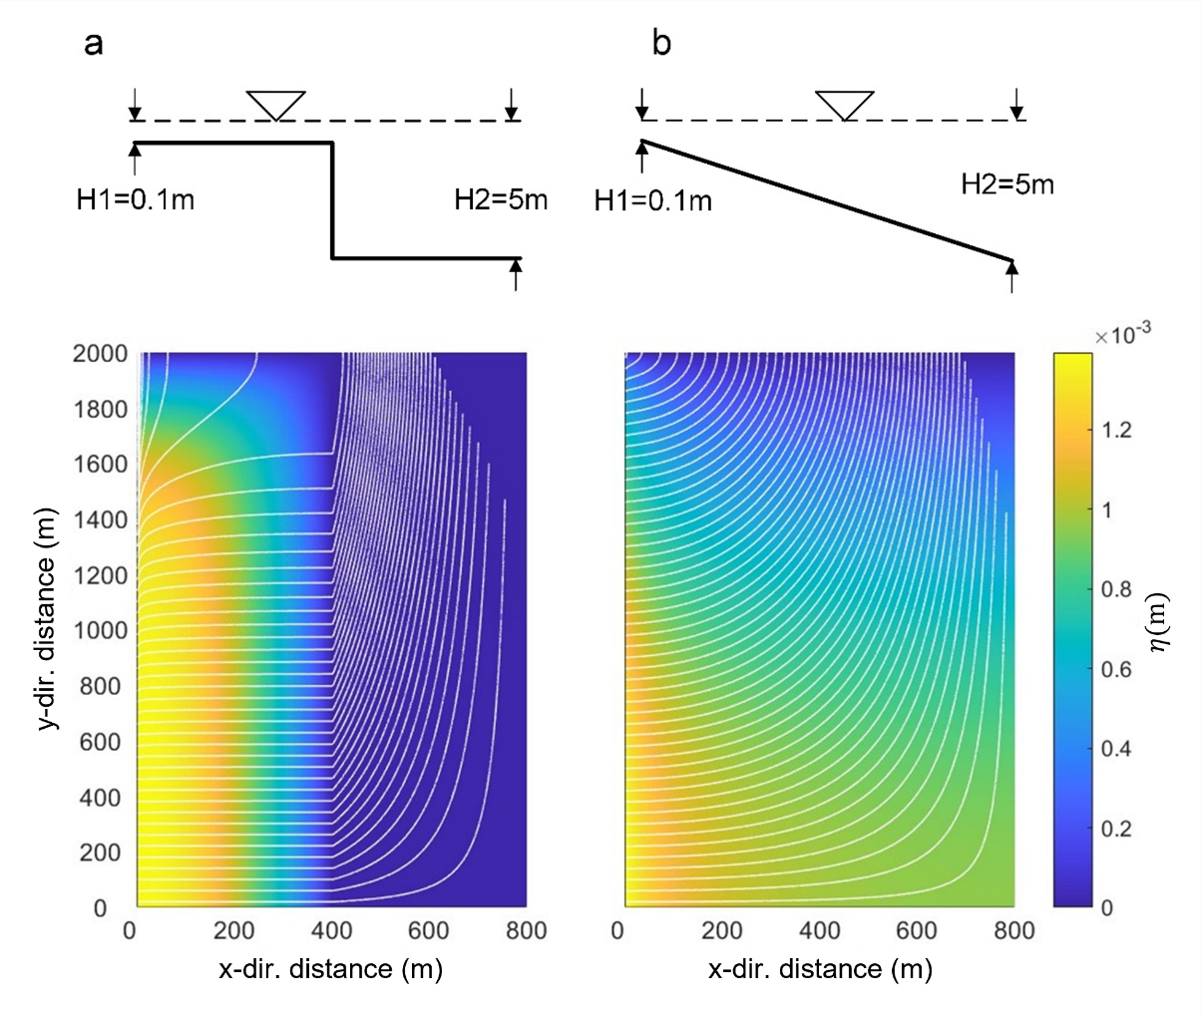
Figure. S5.1. Comparison of flow lines between cases with abruptly-changing slope and uniform slope

- Di Silvio, G., Dall’Angelo, C., Bonaldo, D., & Fasolato, G. (2010). Long-term model of planimetric and bathymetric evolution of a tidal lagoon. Continental Shelf Research, 30(8), 894-903.

