Identification and Risk Assessment of Distinct Prognostic Subtypes in Sepsis Patients Requiring Invasive Mechanical Ventilation Using Machine Learning and Deep Learning Models

Jialong Chen,MD, Jing Lin,MD, Jianing Wen,PhD, Jianzhen Weng,PhD, Yang Ju,PhD，Yanming Li,PhD

Supplemental Digital Content

Supplemental Tables 2
eTable 1. Characteristics of surviving and deceased patients 2
eTable 2. Model evaluation results on MIMIC-IV Test Set and eICU database 5
Supplemental Figure 6
e Figure1 Schematic illustration of the study design. 6
e Figure2 Variables and their missing percentages 7
e Figure 3 The top 15 of variables and importance for the random forest method 8
e Figure 4 The top 15 of variables and importance for the backward screening method 9
eFigure 5 Hyperparameter optimization history using RandomizedSearchCV 6

Supplementary Tables
e Table 1. Characteristics of surviving and deceased patients
MIMIC-IV database |  |  |  | eICU database
 | Survival patients(N=10,023) | Deceased patients(N=2907) | P value | Survival patients(N=1,196) | Deceased patients(N=241) | P value
Demographic
Ethnicity(%) | 6819(68%) | 1702(58.5%) | <0.001 | 945(79.01%) | 186(77.2%) | 0.781
 | 771(7.7%) | 253(8.7%) |  | 115(9.62%) | 24(0.10%)
 | 2433(24.3%) | 952(32.7%) |  | 136(11.37%) | 31(12.86%)
Age(year) | 65±15 | 68±15 | 0.031 | 61±16 | 63±17 | 0.249
Male(%) | 6246(62.32%) | 1201(41.31%) | <0.001 | 712(59.53%) | 126(52.28%) | <0.01
Comorbidity
Hypertension(%) | 4791(47.8%) | 1075(37%) | <0.001 | 650(54.35%) | 112(46.47%) | 0.03
Myocardial infarction(%) | 1941(19.4%) | 646(22.2%) | <0.001 | 0(0%) | 0(0%) | NA
Congestive heart failure(%) | 2986(29.8%) | 1070(36.8%) | <0.001 | 0(0%) | 0(0%) | NA
Cerebrovascular disease(%) | 1288(12.9%) | 551(19%) | <0.001 | 112(9.36%) | 27(11.20%) | 0.45
Chronic pulmonary disease(%) | 2760(27.5%) | 870(29.9%) | 0.012 | 408(34.11%) | 81(33.61%) | 0.94
Diabetes(%) | 3223(32.2%) | 914(31.4%) | 0.467 | 406(33.95%) | 68(28.22%) | 0.10
Renal disease(%) | 1981(19.8%) | 799(27.5%) | <0.001 | 217(18.14%) | 50(20.75%) | 0.390
Malignant cancer(%) | 1001(10%) | 536(18.4%) | <0.001 | 151(12.63%) | 43(17.84%) | 0.040
Liver disease(%) | 1369(13.7%) | 833(28.7%) | <0.001 | 17(1.42%) | 8(3.32%) | 0.07
Metastatic solid tumor(%) | 324(3.2%) | 274(9.4%) | <0.001 | 0(0%) | 0(0%) | NA
Aids(%) | 65(0.6%) | 24(0.8%) | 0.309 | 0(0%) | 0(0%) | NA
Laboratory tests
White blood cell(K/uL) | 12.825±6.985 | 15.111±15.272 | <0.001 | 15.06±8.3 | 14.67±8.52 | 0.509
Hemoglobin(g/dL) | 10.684±1.825 | 10.286±2.074 | <0.001 | 10.95±2.29 | 10.17±2.1 | <0.001
Platelet(K/uL) | 196.899±99.515 | 187.91±114.498 | <0.001 | 219.93±120.53 | 173.78±109.92 | <0.001
Alt(IU/L) | 143.234±419.831 | 243.223±658.921 | <0.001 | 107.33±341.78 | 138.64±339.58 | 0.194
Ast(IU/L) | 233.989±666.793 | 497.332±1378.667 | <0.001 | 182.09±693.59 | 268.31±795.68 | 0.086
Creatinine(mg/dL) | 1.411±1.317 | 1.963±1.529 | <0.001 | 1.77±1.51 | 2.01±1.77 | 0.029
Bun(mg/dL) | 25.779±19.018 | 38.449±26.025 | <0.001 | 32.85±24.12 | 35.82±23.26 | 0.080
Lactate(ng/mL) | 2.247±1.293 | 3.985±3.341 | <0.001 | 2.43±1.92 | 3.3±2.68 | <0.001
Glucose(mg/dL) | 142.166±50.937 | 163.375±73.636 | <0.001 | 156.71±75.41 | 152.91±64.26 | 0.465
Ph | 7.279±0.1 | 7.204±0.147 | <0.001 | 7.34±0.09 | 7.33±0.09 | 0.025
Pco2(mmHg) | 52.7±15.3 | 55.4±19.5 | <0.001 | 41.99±12.2 | 41.14±11.75 | 0.319
Fio2(%) | 57.163±13.593 | 60.774±17.379 | <0.001 | 59.32±26.25 | 63.55±21.55 | 0.019
Oxygenation index | 249.452±99.803 | 209.925±110.118 | <0.001 | 165.73±98.14 | 124.27±77.46 | <0.001
Vital sign
Heart rate(bpm) | 85.92±14.15 | 92.06±17.44 | <0.001 | 89.31±12.62 | 93.41±13.68 | <0.001
Systolic blood pressure(mmHg) | 114.404±12.464 | 109.492±14.59 | <0.001 | 121.55±13.76 | 113.95±13.33 | <0.001
Diastolic blood pressure(mmHg) | 59.718±8.725 | 58.743±9.883 | <0.001 | 64.24±8.98 | 58.56±9.84 | <0.001
Mean arterial pressure(mmHg) | 75.86±8.34 | 73.59±9.89 | <0.001 | 80.21±10.17 | 74.3±10.24 | <0.001
Respiratory rate(insp/min) | 19.05±3.48 | 21.74±4.35 | <0.001 | 20.99±3.58 | 22.44±4.69 | <0.001
Temperature(℃) | 36.959±0.559 | 36.738±0.922 | <0.001 | 37.04±0.48 | 36.93±0.65 | 0.012
Spo2(%) | 97.524±1.743 | 96.04±4.277 | <0.001 | 96.86±1.68 | 96.16±2 | <0.001
Vasoactive agent
Epinephrine infusion rate(mcg/kg/min) | 0.01±0.03 | 0.03±0.12 | <0.001 | 0.09±2.32 | 0±0 | 0.526
Norepinephrine infusion rate(mcg/kg/min) | 0.05±0.18 | 0.16±0.5 | <0.001 | 0.03±0.11 | 0.07±0.17 | <0.001
Dobutamine infusion rate(mcg/kg/min) | 0.07±0.64 | 0.28±1.46 | <0.001 | 0±0 | 0±0 | NA
Dopamine infusion rate(mcg/kg/min) | 0.32±4.5 | 1.04±3.59 | <0.001 | 0.2±1.72 | 0.12±1.04 | 0.494
Phenylephrine infusion rate(mcg/kg/min) | 0.45±2.27 | 0.81±2.06 | <0.001 | 0±0 | 0±0 | NA
Vasopressin infusion rate(units/hour) | 0.25±1.4 | 0.88±2.05 | <0.001 | 0.02±0.12 | 0.04±0.14 | 0.024
Milrinone infusion rate(mcg/kg/min) | 0.01±0.25 | 0.01±0.12 | 0.439 | 0±0 | 0±0 | NA
Septic shock(%) | 4095(40.9%) | 2057(70.8%) | <0.001 | 205(17.14%) | 82(32.02%) | <0.001
GCS | 12.7±3.7 | 12.2±4.1 | <0.001 | 3.9±0.5 | 4±0.2 | <0.001
SOFA | 5±2.5 | 7±2.5 | <0.001 | 7±2 | 7±2 | 0.109
Length of hospitalization(day) | 11±7 | 8.3±7.6 | <0.001 | 17.79±24.95 | 10.52±8.35 | <0.001
SOFA：Sequential Organ Failure Assessment,GCS:Glasgow Coma Scale

eTable 2. Model evaluation results on MIMIC-IV Test Set and eICU database
MIMIC-IV test set(N=2,584) |  |  |  |  |  | eICU database(N=1,437)
Model | Sensitivity | Specificity | Accuracy | F1 score | Precision | Sensitivity | Specificity | Accuracy | F1 score | Precision
CNN | 0.32 | 0.97 | 0.82 | 0.45 | 0.75 | 0.11 | 0.99 | 0.85 | 0.20 | 0.82
ANN | 0.30 | 0.97 | 0.82 | 0.43 | 0.76 | 0.09 | 1.00 | 0.85 | 0.16 | 0.95
RF | 0.37 | 0.96 | 0.83 | 0.49 | 0.71 | 0.61 | 1.00 | 0.93 | 0.76 | 1.00
ADA | 0.38 | 0.97 | 0.84 | 0.51 | 0.78 | 0.40 | 0.99 | 0.89 | 0.55 | 0.91
CAT | 0.44 | 0.96 | 0.84 | 0.56 | 0.76 | 0.53 | 1.00 | 0.92 | 0.69 | 0.98
LGBM | 0.44 | 0.96 | 0.84 | 0.56 | 0.75 | 0.51 | 0.99 | 0.91 | 0.65 | 0.92
CNN: Convolutional Neural Network; ANN:Artificial Neural Network;RF:Random Forest; AdaBoost: Adaptive Boosting; CatBoost: Categorical Boosting; LGBM: Light Gradient Boosting Machine; AUC:area under the receiver operating characteristic curve

Supplemental Figures
e Figure1 Schematic illustration of the study design.

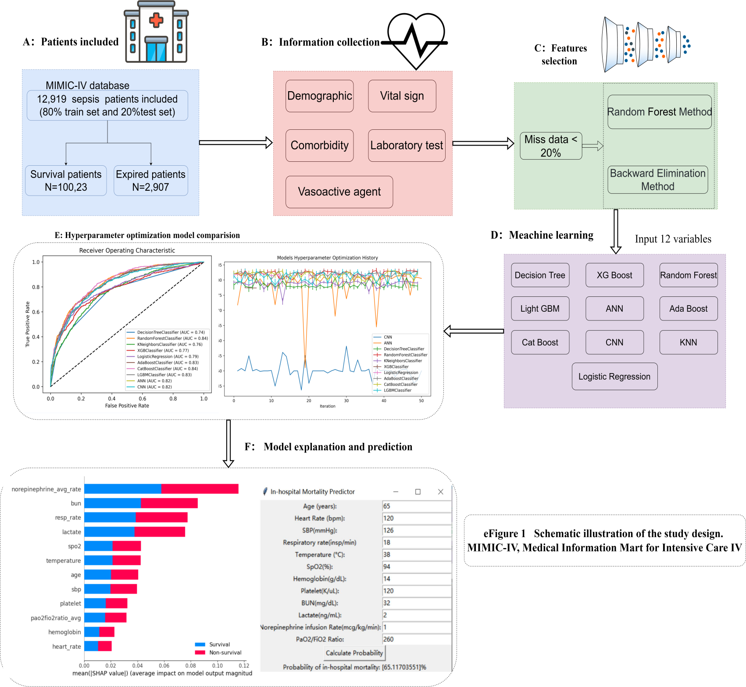

e Figure2 Variables and their missing percentages

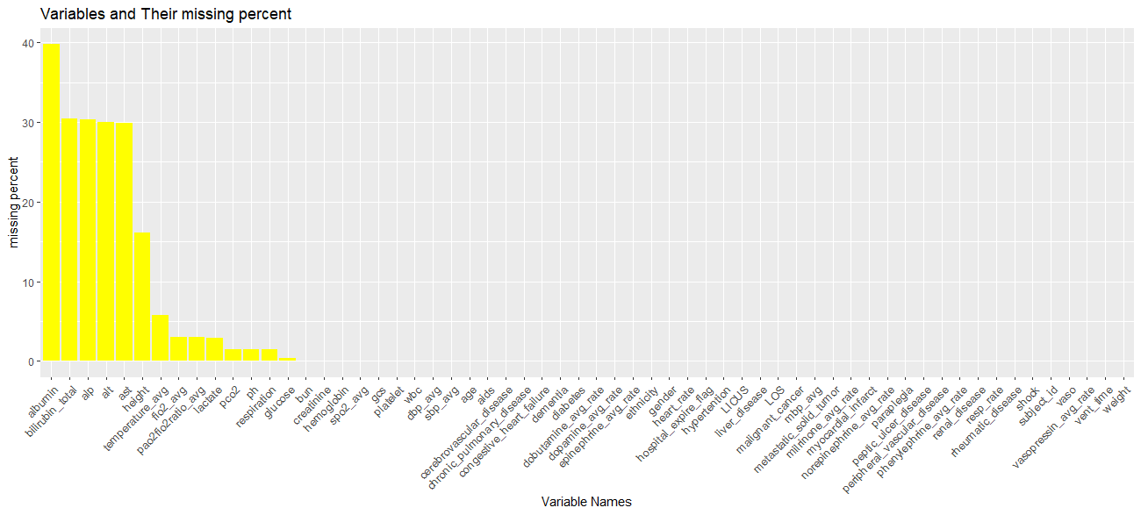

e Figure 3 The top 15 of variables and importance for the random forest method

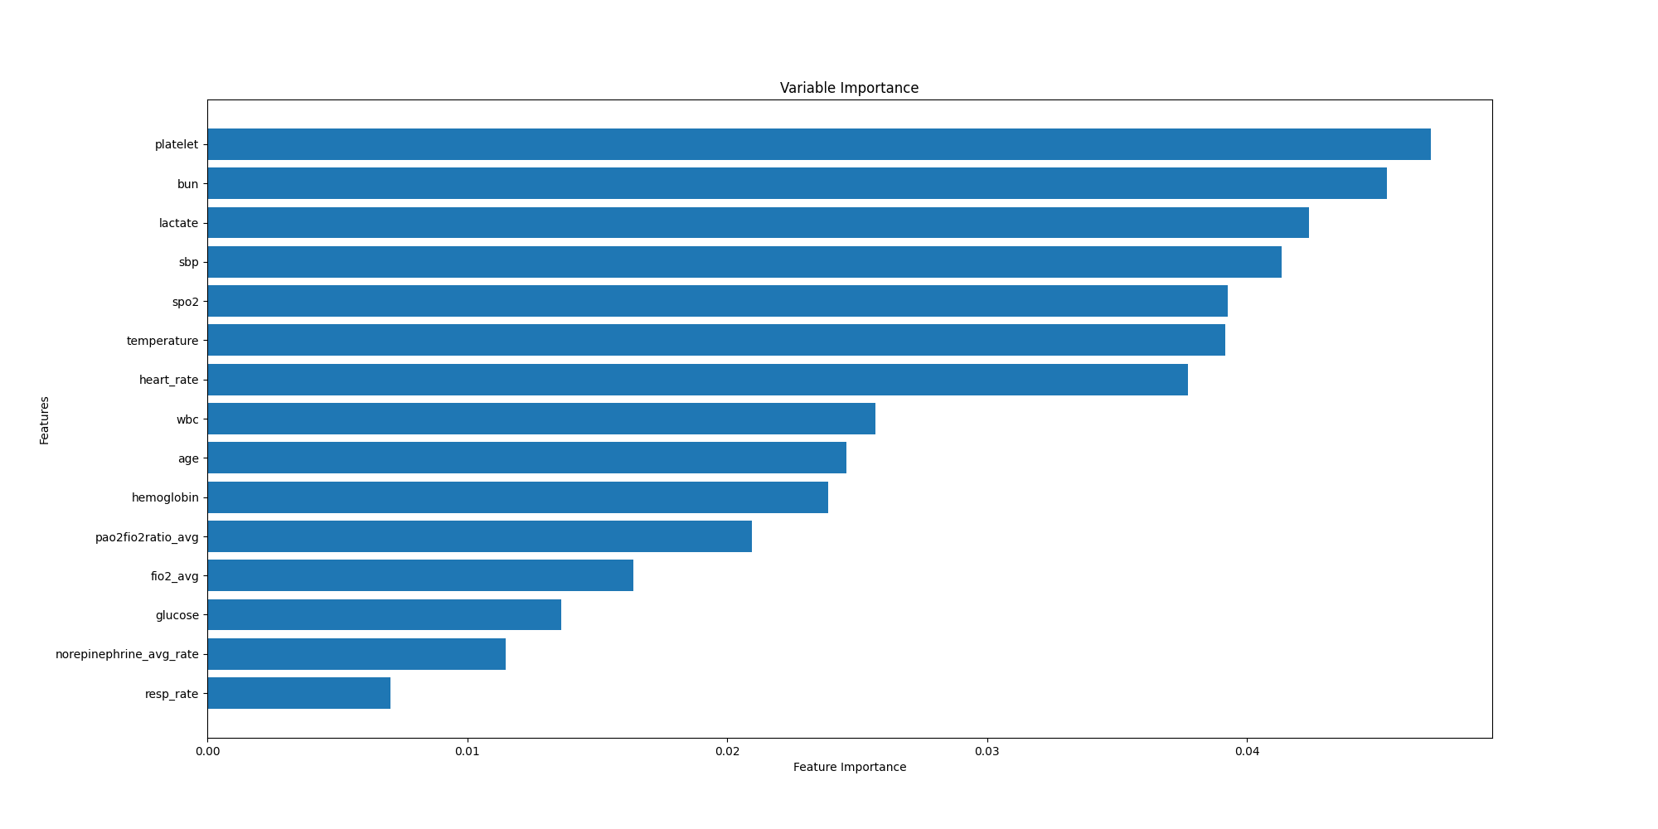

e Figure 4 The top 15 of variables and importance for the backward screening method
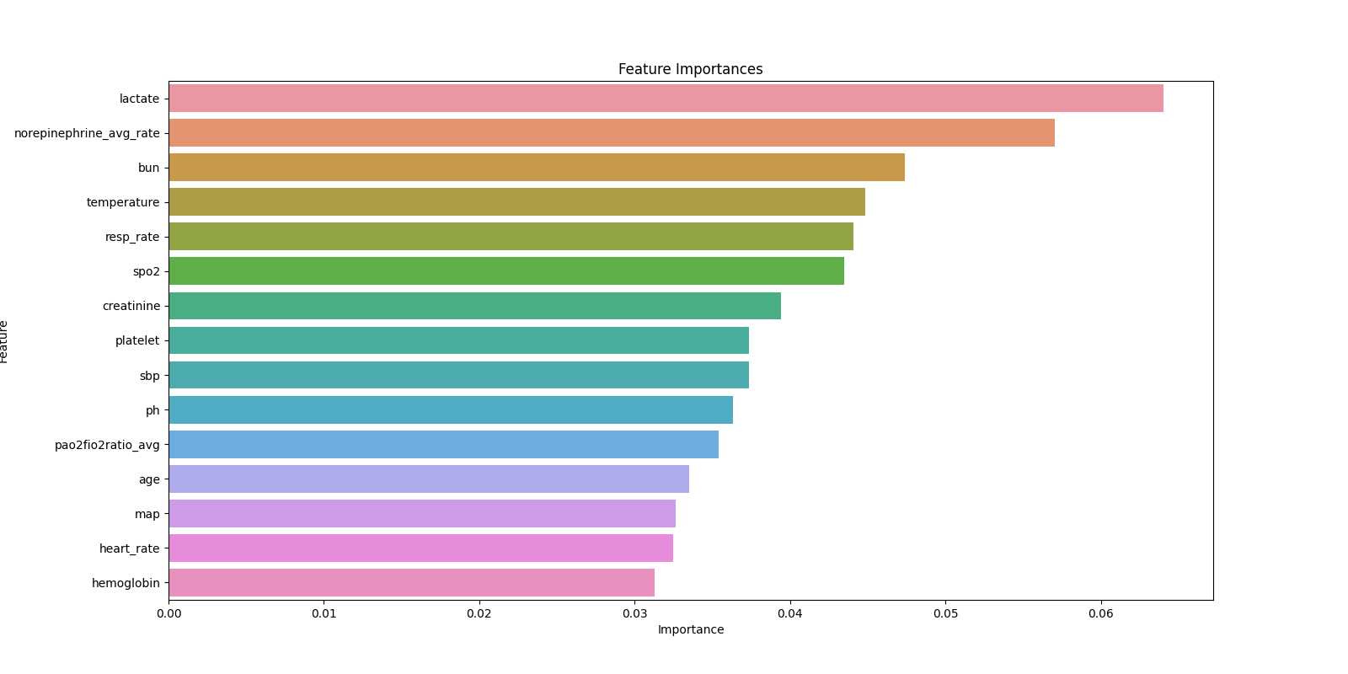

e Figure 5 Hyperparameter optimization history using RandomizedSearchCV

