Article title: Whole exome sequencing and polygenic assessment of a Swedish cohort with severe developmental language disorder
Journal Name: Human Genetics
Document: Supplementary material
Authors
Ashraf Yahia^{1,2}, Danyang Li^{1,2,3}, Sanna Lejerkrans^{1,2}, Shyam Rajagopalan^{1,2,4}, Nelli Kalnak^{1,5} and Kristiina Tammimies^{1,2}
Affiliations
¹Center of Neurodevelopmental Disorders (KIND), Centre for Psychiatry Research, Department of Women's and Children's Health, Karolinska Institutet
²Astrid Lindgren Children's Hospital, Karolinska University Hospital, Region Stockholm, Stockholm, Sweden
³Social, Genetic and Developmental Psychiatry Centre, King's College London, London, the United Kingdom
⁴Institute of Bioinformatics and Applied Biotechnology, Bengaluru, India
⁵Department of Speech-Language Pathology, Helsingborg Hospital, Helsingborg, Sweden

Correspondence: Dr. Kristiina Tammimies (kristiina.tammimies@ki.se).

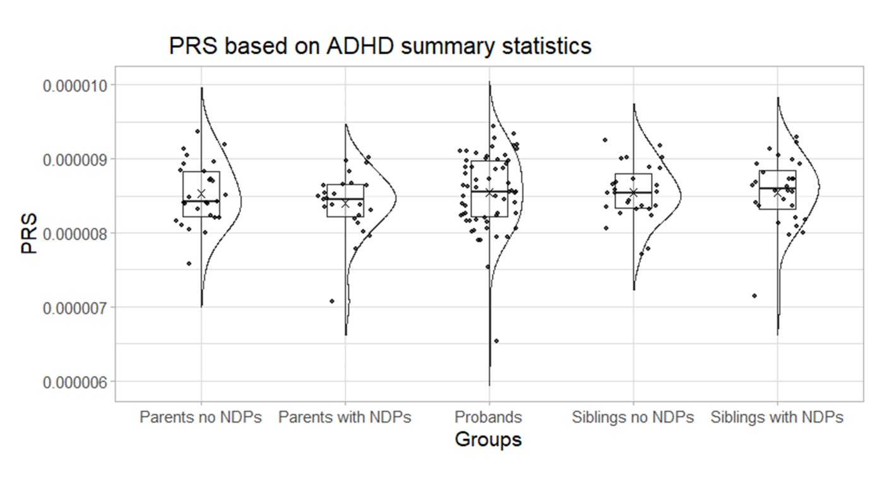
Figure S1. PRS based on ADHD summary statistics. Demontis et al., 2023, was used as a base data source to calculate PRS. No significant difference was noted between the different groups. ADHD, Attention-deficit hyperactivity disorder; PRS, Polygenic Risk Score; NDPs, neurodevelopmental phenotypes.
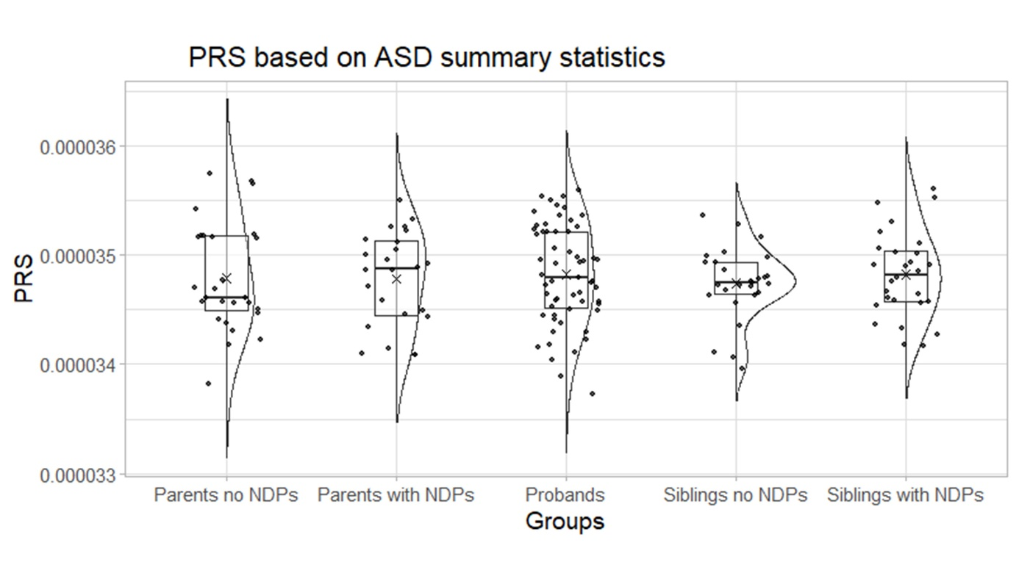
Figure S2. PRS based on ASD summary statistics. Grove et al., 2019, was used as a base data source to calculate PRS. No significant difference was noted between the different groups. ASD, Autism spectrum disorder; PRS, Polygenic Risk Score; NDPs, neurodevelopmental phenotypes.
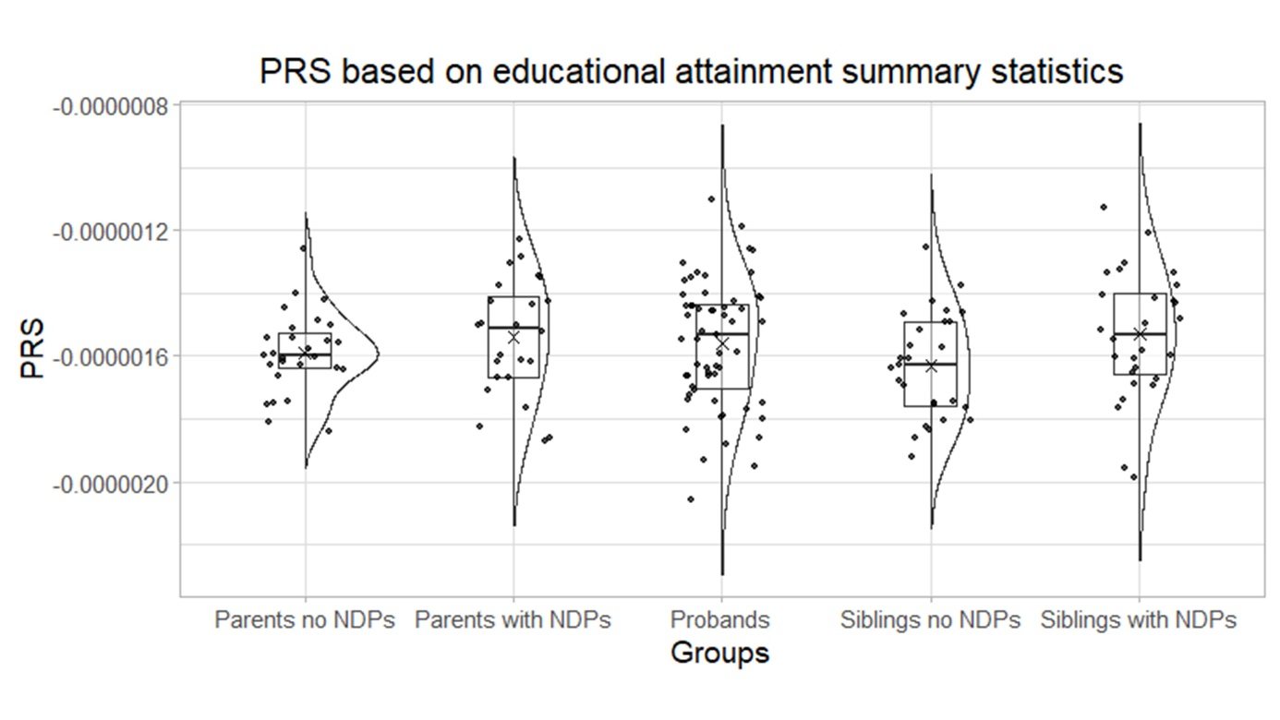
Figure S3. PRS based on educational attainment summary statistics. Okbay et al., 2022, was used as a base data source to calculate PRS. No significant difference was noted between the different groups. PRS, Polygenic Risk Score; NDPs, neurodevelopmental phenotypes.

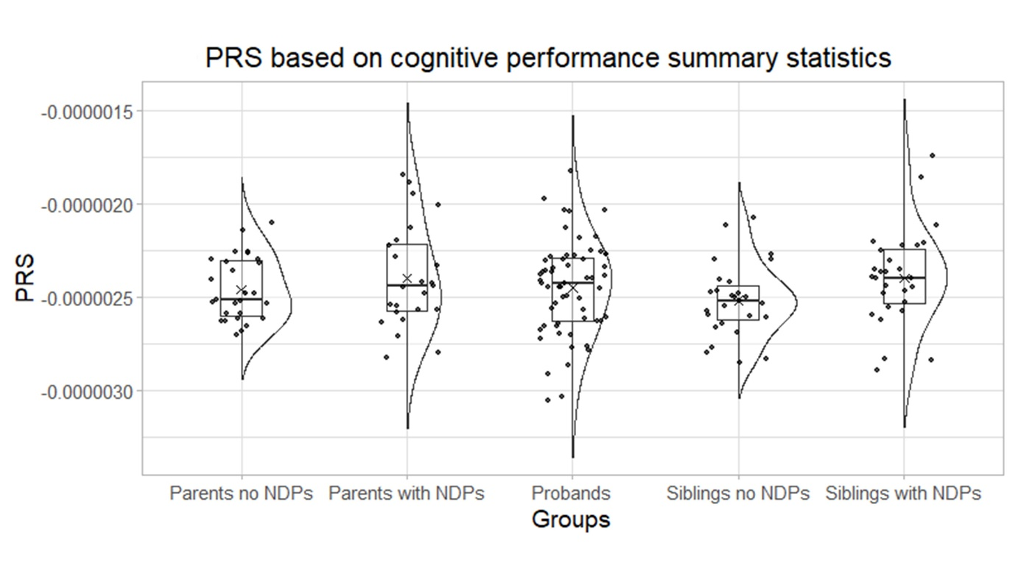
Figure S4. PRS based on cognitive performance summary statistics. Lee et al., 2018, was used as a base data source to calculate PRS. No significant difference was noted between the different groups. PRS, Polygenic Risk Score; NDPs, neurodevelopmental phenotypes.

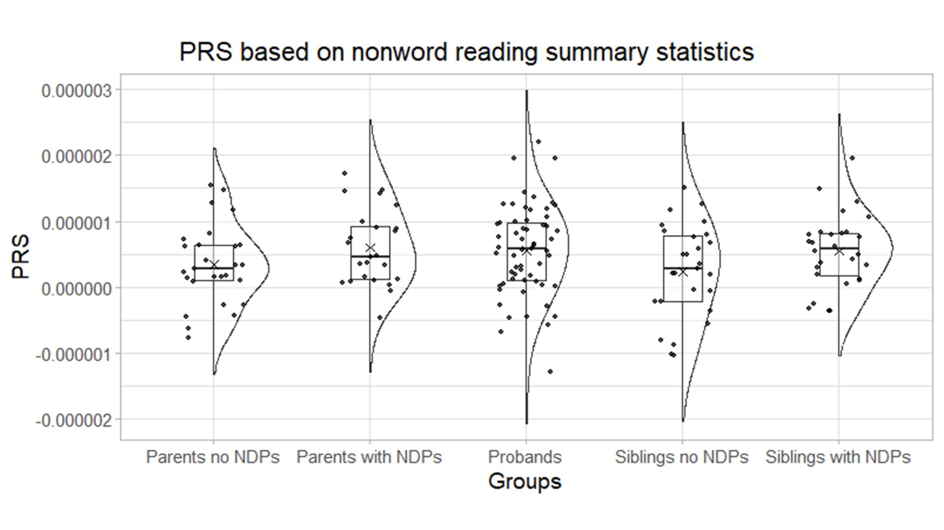
Figure S5. PRS based on nonword reading summary statistics. Eising et al., 2022, was used as a base data source to calculate PRS. No significant difference was noted between the different groups. PRS, Polygenic Risk Score; NDPs, neurodevelopmental phenotypes.

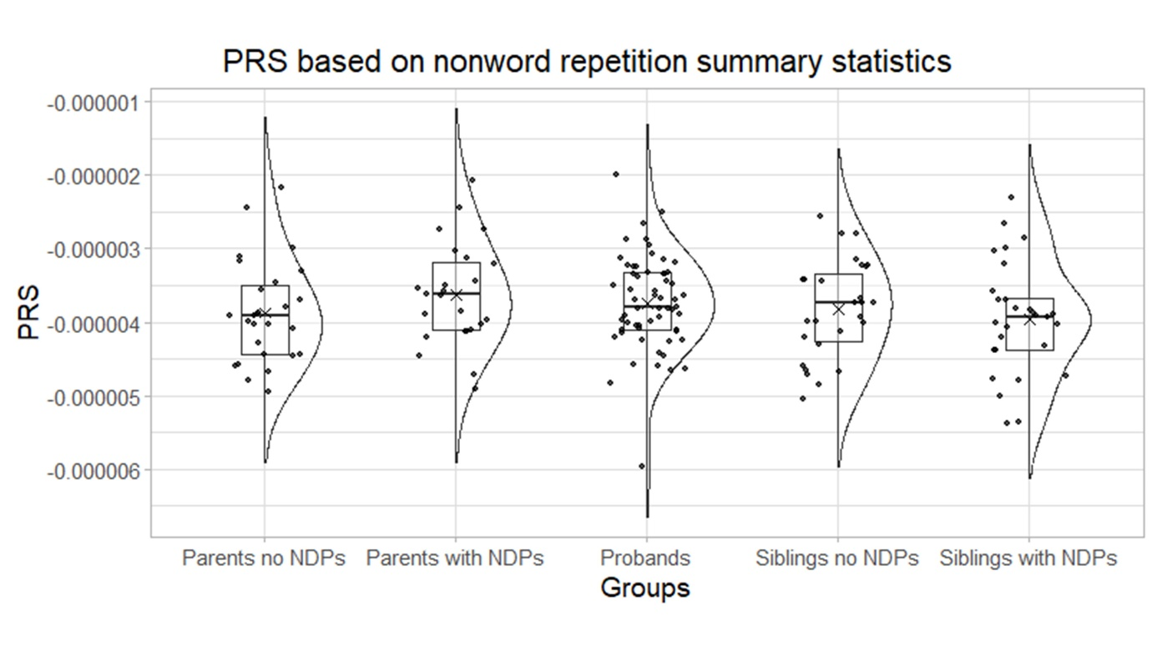
Figure S6. PRS based on nonword repetition summary statistics. Eising et al., 2022, was used as a base data source to calculate PRS. No significant difference was noted between the different groups. PRS, Polygenic Risk Score; NDPs, neurodevelopmental phenotypes.

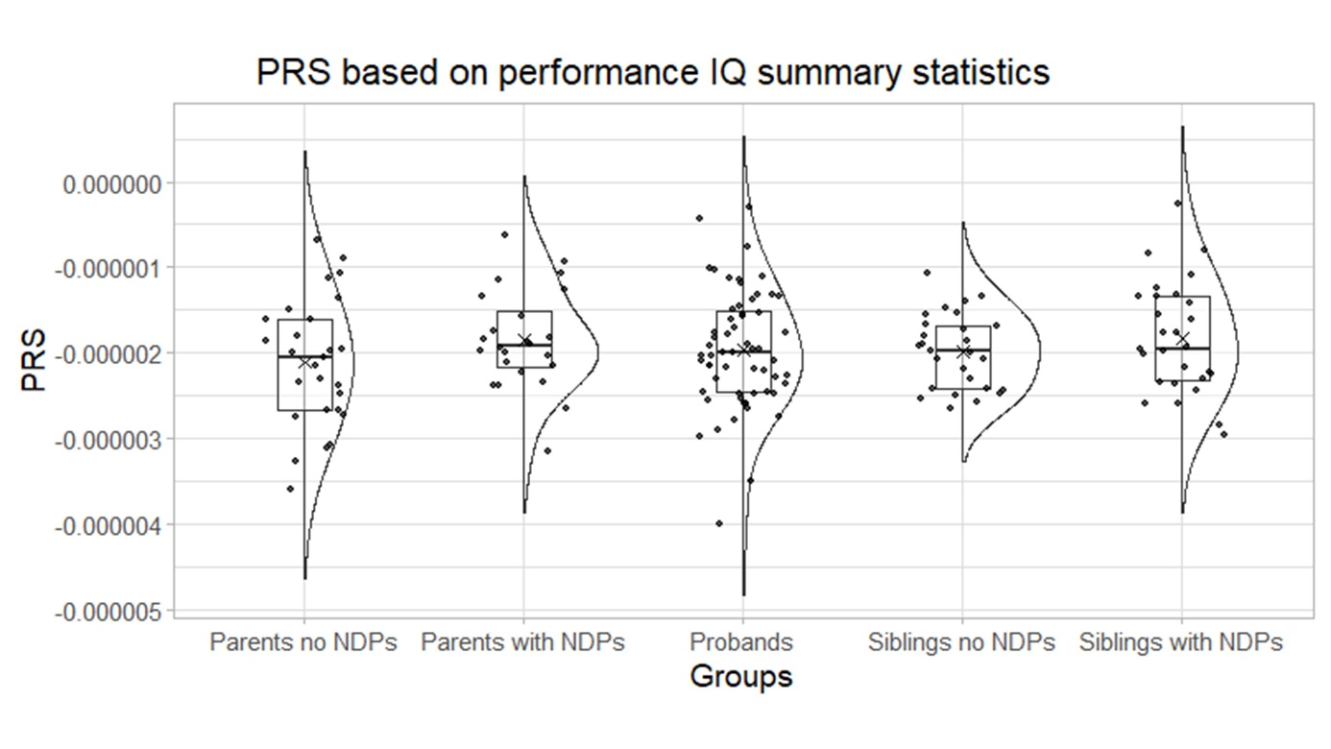
Figure S7. PRS based on performance IQ summary statistics. Eising et al., 2022, was used as a base data source to calculate PRS. No significant difference was noted between the different groups. PRS, Polygenic Risk Score; NDPs, neurodevelopmental phenotypes.

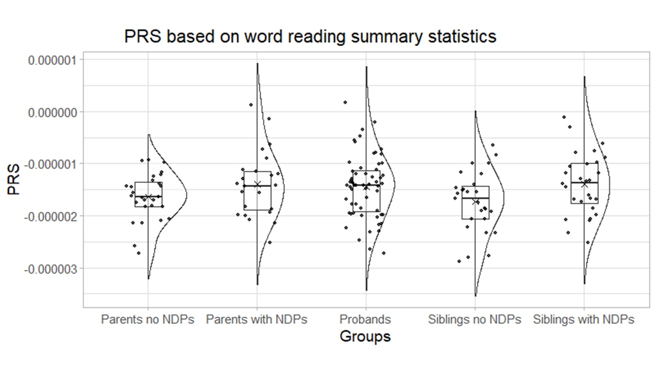
Figure S8. PRS based on word reading summary statistics. Eising et al., 2022, was used as a base data source to calculate PRS. No significant difference was noted between the different groups. PRS, Polygenic Risk Score; NDPs, neurodevelopmental phenotypes.

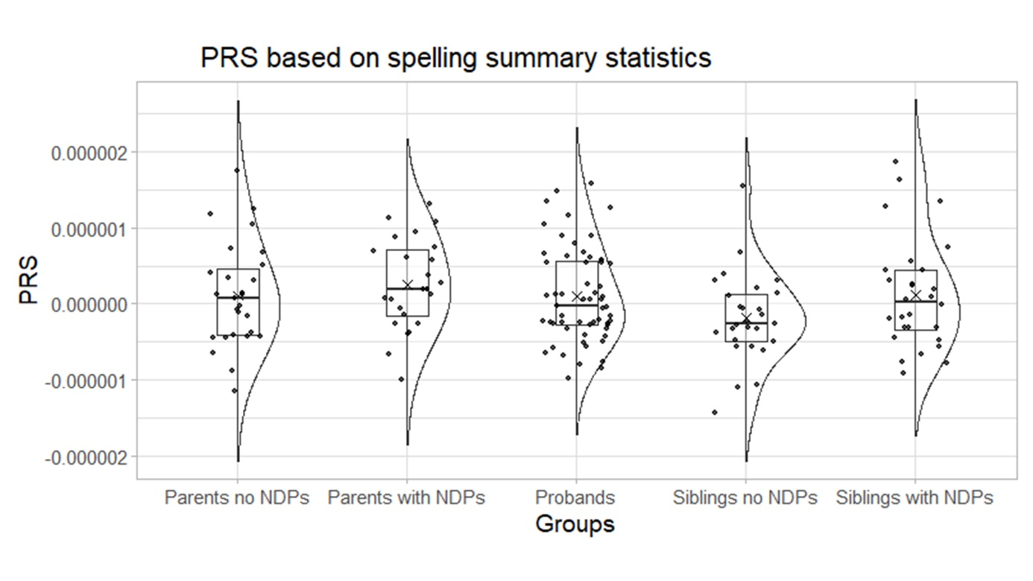
Figure S9. PRS based on spelling summary statistics. Eising et al., 2022, was used as a base data source to calculate PRS. No significant difference was noted between the different groups. PRS, Polygenic Risk Score; NDPs, neurodevelopmental phenotypes.

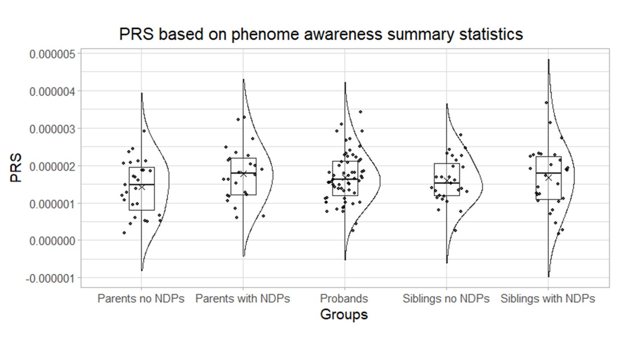
Figure S10. PRS based on phenome awareness summary statistics. Eising et al., 2022, was used as a base data source to calculate PRS. No significant difference was noted between the different groups. PRS, Polygenic Risk Score; NDPs, neurodevelopmental phenotypes.
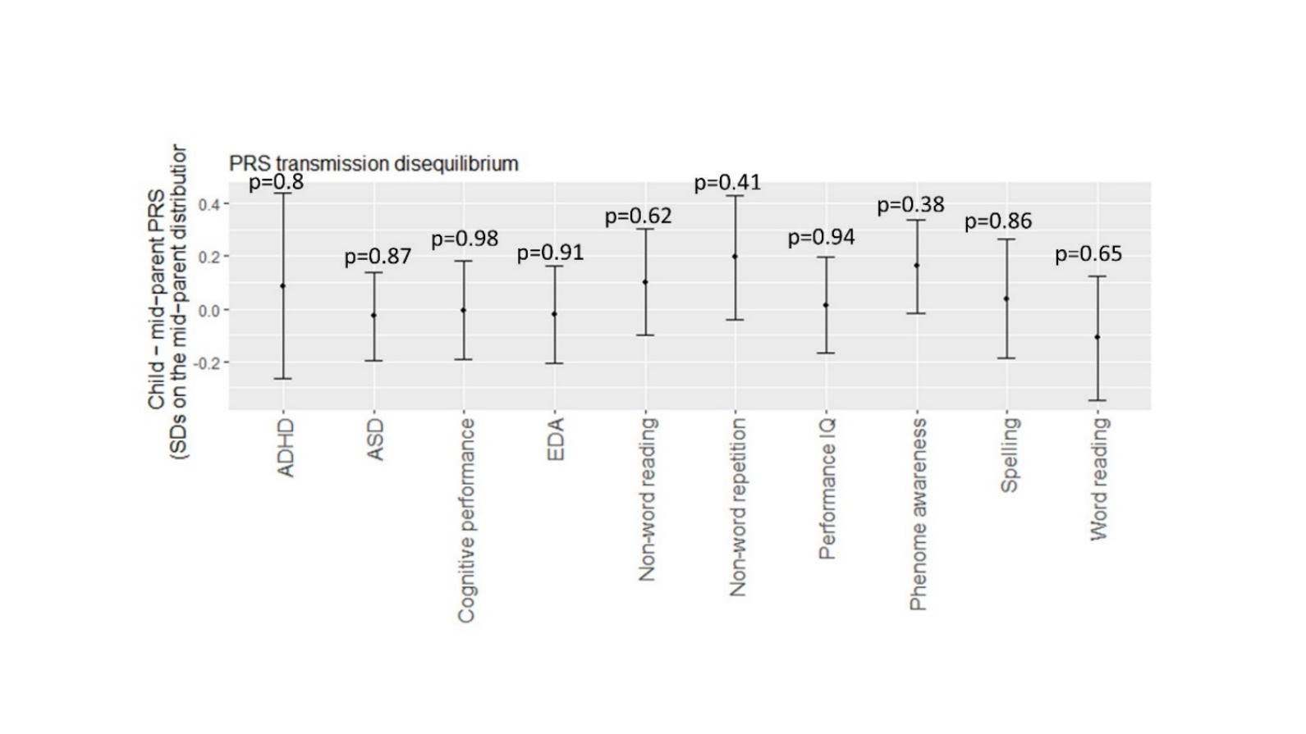
Figure S11. Parents to probands PRS transmission disequilibrium test. PRS transmission disequilibrium was tested in 30 patients from 20 families using ptdt tool generated by Weiner et al., 2017. Transmission disequilibrium is shown in terms of standard deviation on the mid-parent distribution ± 1.96 standard error (95% confidence intervals). P values indicate the probability that the mean of the pTDT deviation distribution is 0 (two-sided, one-sample t test). No statistically significant over-inheritance of the assessed PRS was noted. ADHD, Attention-deficit hyperactivity disorder; ASD, Autism spectrum disorder; EDA, educational attainment; PRS, polygenic risk score; SDs, standard deviations.

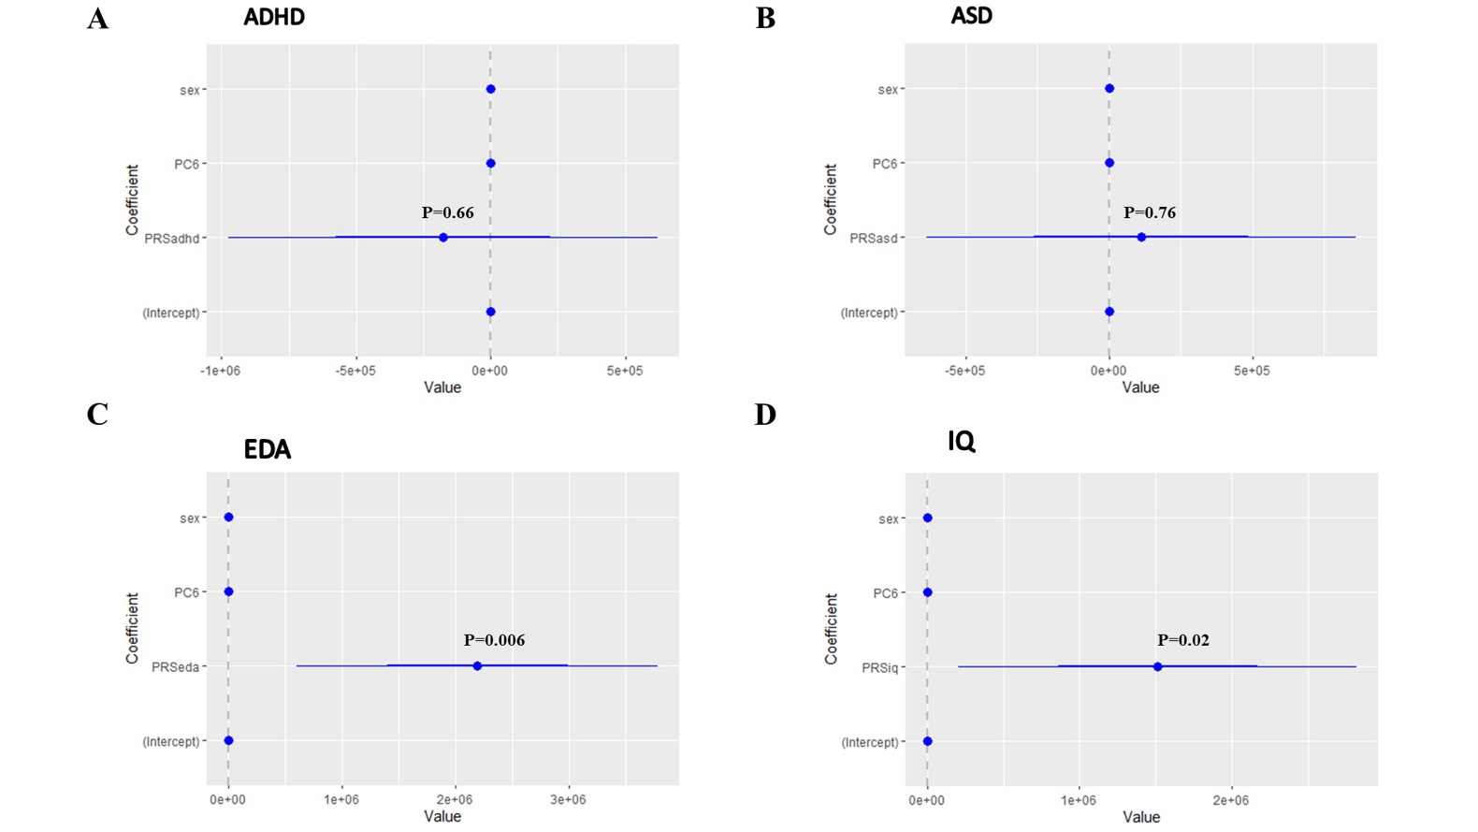
Figure S12. Generalized estimating equations (GEE) model to test the association between DLD (or other neurodevelopmental phenotypes) and polygenic scores for attention-deficit hyperactivity disorder (A), autism spectrum disorder (B), educational attainment (C), and cognitive performance (D) adjusted for family structure, sex, and PC6. Educational attainment and IQ polygenic risk scores showed a statistically significant but negligible association. No other statistically significant associations were detected. ADHD, attention-deficit hyperactivity disorder; ASD, autism spectrum disorder; EDA, educational attainment; PRS, polygenic risk scores; PC6, the first six principal component analysis.

Table S1. Statistical analysis of the performance of the probands with a likely monogenic diagnosis vs those without a monogenic diagnosis on Raven’s colored progressive matrices (CPM9), non-word repetition task (NWR), and test of word-reading efficiency (TOWRE) tests. CPM9, NWR, and TOWRE were expressed in standard deviation units (z-scores). NWR z-scores were calculated based on whole-word accuracy (binary outcome of either a positive or negative response; NWR_binary), numbers of syllabi (NWR_length), and percent of correct consonants (NWR_PCC). TOWRE z-scores were based on number of words (TOWRE_words) the number of non-words (TOWRE_nonwords). Unpaired student t-test detected a statistically significant difference in the percent of correct consonants during non-word reading (NWR_PCC) between the two groups.
CPM9 | Description
CPM9 | Group | Number | Mean | Standard deviation
CPM9 | Group 1: Genomic/monogenic condition | 16 | 96.87 | 14
CPM9 | Group 2: No high-impact genetic findings | 45 | 100.22 | 14.5
CPM9 | Student t-test
CPM9 | t-value | 0.80
CPM9 | Degrees of freedom | 59
CPM9 | Two-tailed p-value | 0.43
CPM9 | Standard error of the difference | 4.19
NWR_binary | Description
NWR_binary | Group | Number | Mean | Standard deviation
NWR_binary | Group 1: Genomic/monogenic condition | 16 | -8.72 | 5.2
NWR_binary | Group 2: No high-impact genetic findings | 45 | -8.52 | 5.5
NWR_binary | Student t-test
NWR_binary | t-value | 0.13
NWR_binary | Degrees of freedom | 59
NWR_binary | Two-tailed p-value | 0.89
NWR_binary | Standard error of the difference | 1.58
NWR_length | Description
NWR_length | Group | Number | Mean | Standard deviation
NWR_length | Group 1: Genomic/monogenic condition | 16 | -7.8 | 9.92
NWR_length | Group 2: No high-impact genetic findings | 45 | -4.74 | 6.09
NWR_length | Student t-test
NWR_length | t-value | 1.45
NWR_length | Degrees of freedom | 59
NWR_length | Two-tailed p-value | 0.15
NWR_length | Standard error of the difference | 2.11
NWR_PCC | Description
NWR_PCC | Group | Number | Mean | Standard deviation
NWR_PCC | Group 1: Genomic/monogenic condition | 16 | -5.81 | 2.82
NWR_PCC | Group 2: No high-impact genetic findings | 45 | -3.69 | 2.64
NWR_PCC | Student t-test
NWR_PCC | t-value | 2.71
NWR_PCC | Degrees of freedom | 59
NWR_PCC | Two-tailed p-value | 0.009
NWR_PCC | Standard error of the difference | 0.78
TOWRE_words | Description
TOWRE_words | Group | Number | Mean | Standard deviation
TOWRE_words | Group 1: Genomic/monogenic condition | 16 | -2.01 | 1.17
TOWRE_words | Group 2: No high-impact genetic findings | 45 | -1.77 | 1.36
TOWRE_words | Student t-test
TOWRE_words | t-value | 0.64
TOWRE_words | Degrees of freedom | 59
TOWRE_words | Two-tailed p-value | 0.53
TOWRE_words | Standard error of the difference | 0.38
TOWRE_nonwords | Description
TOWRE_nonwords | Group | Number | Mean | Standard deviation
TOWRE_nonwords | Group 1: Genomic/monogenic condition | 16 | -2.22 | 0.89
TOWRE_nonwords | Group 2: No high-impact genetic findings | 45 | -1.88 | 1.35
TOWRE_nonwords | Student t-test
TOWRE_nonwords | t-value | 0.91
TOWRE_nonwords | Degrees of freedom | 59
TOWRE_nonwords | Two-tailed p-value | 0.37
TOWRE_nonwords | Standard error of the difference | 0.37

Table S2. Associations between six language-related clinical measures and their cognate polygenic risk scores using linear regression. Age, sex, the presence of a mongenic diagnosis, and PC6 were added as covariables. The used clinical measures were CPM9, NWR, and TOWRE and were expressed in standard deviation units (z-scores). NWR z-scores were calculated based on whole-word accuracy (binary outcome of either a positive or negative response; NWR_binary), numbers of syllabi (NWR_length), and percent of correct consonants (NWR_PCC). TOWRE z-scores were based on number of words (TOWRE_words).
Linear regression model |  | Estimate | Std. Error | t value | Pr(>|t|)
CPM9 vs cognitive performance PRS | Intercept | 289.65 | 164.71 | 1.76 | 0.08
CPM9 vs cognitive performance PRS | Cognitive performance PRS | 47001.60 | 44085.33 | 1.07 | 0.29
CPM9 vs cognitive performance PRS | Age | -1.30 | 1.81 | -0.72 | 0.47
CPM9 vs cognitive performance PRS | Sex | 3.90 | 4.44 | 0.88 | 0.38
CPM9 vs cognitive performance PRS | Monogenic | -3.55 | 4.48 | -0.79 | 0.43
CPM9 vs cognitive performance PRS | PC6 | 7.23 | 26.54 | 0.27 | 0.79
CPM9 vs performance IQ PRS | Intercept | 113.45 | 18.35 | 6.18 | 9.29E-08
CPM9 vs performance IQ PRS | Performance IQ PRS | 2311.01 | 12986.92 | 0.18 | 0.86
CPM9 vs performance IQ PRS | Age | -1.87 | 1.76 | -1.06 | 0.29
CPM9 vs performance IQ PRS | Sex | 3.88 | 4.48 | 0.87 | 0.39
CPM9 vs performance IQ PRS | Monogenic | -3.12 | 4.52 | -0.69 | 0.49
CPM9 vs performance IQ PRS | PC6 | 9.49 | 27.08 | 0.35 | 0.73
NWR_binary vs non-wordrepetition PRS | Intercept | -33.33 | 8.02 | 4.15 | -0.00012
NWR_binary vs non-wordrepetition PRS | Non-word repetition PRS | -2869.80 | 8499.95 | -0.34 | 0.74
NWR_binary vs non-wordrepetition PRS | Age | 3.03 | 0.54 | 5.60 | 7.76E-07
NWR_binary vs non-wordrepetition PRS | Sex | -1.25 | 1.38 | -0.90 | 0.37
NWR_binary vs non-wordrepetition PRS | Monogenic | -2.04 | 1.38 | -1.48 | 0.15
NWR_binary vs non-wordrepetition PRS | PC6 | -4.55 | 8.22 | -0.55 | 0.58
NWR_length vs non-wordrepetition PRS | Intercept | 11.70 | 13.50 | 0.86 | 0.39
NWR_length vs non-wordrepetition PRS | Non-word repetition PRS | -18900.00 | 14300.00 | -1.33 | 0.19
NWR_length vs non-wordrepetition PRS | Age | -0.24 | 0.91 | -0.26 | 0.80
NWR_length vs non-wordrepetition PRS | Sex | -2.85 | 2.32 | -1.23 | 0.23
NWR_length vs non-wordrepetition PRS | Monogenic | -2.28 | 2.32 | -0.98 | 0.33
NWR_length vs non-wordrepetition PRS | PC6 | -5.51 | 13.80 | -0.40 | 0.69
NWR_PCC vs non-wordrepetition PRS | Intercept | 3.22 | 4.88 | 0.66 | 0.51
NWR_PCC vs non-wordrepetition PRS | Non-word repetition PRS | -4260.00 | 5170.00 | -0.82 | 0.41
NWR_PCC vs non-wordrepetition PRS | Age | -0.48 | 0.33 | -1.47 | 0.15
NWR_PCC vs non-wordrepetition PRS | Sex | 0.33 | 0.84 | 0.39 | 0.70
NWR_PCC vs non-wordrepetition PRS | Monogenic | -1.46 | 0.84 | -1.74 | 0.09
NWR_PCC vs non-wordrepetition PRS | PC6 | 4.86 | 5.00 | 0.97 | 0.34
TOWRE_words vs wordreading PRS | Intercept | -3.09 | 1.85 | -1.67 | 0.10
TOWRE_words vs wordreading PRS | Word reading PRS | -3120.00 | 3540.00 | -0.88 | 0.38
TOWRE_words vs wordreading PRS | Age | 0.26 | 0.16 | 1.62 | 0.11
TOWRE_words vs wordreading PRS | Sex | -0.07 | 0.42 | -0.17 | 0.87
TOWRE_words vs wordreading PRS | Monogenic | -0.31 | 0.42 | -0.73 | 0.47
TOWRE_words vs wordreading PRS | PC6 | 0.22 | 2.49 | 0.09 | 0.93
NWR, non-word repetition task; CPM9, Raven’s colored progressive matrices; TOWRE, test of word-reading efficiency.

References
Demontis, D., Walters, G. B., Athanasiadis, G., Walters, R., Therrien, K., Nielsen, T. T., Farajzadeh, L., Voloudakis, G., Bendl, J., Zeng, B., Zhang, W., Grove, J., Als, T. D., Duan, J., Satterstrom, F. K., Bybjerg-Grauholm, J., Bækved-Hansen, M., Gudmundsson, O. O., Magnusson, S. H., … Børglum, A. D. (2023). Genome-wide analyses of ADHD identify 27 risk loci, refine the genetic architecture and implicate several cognitive domains. Nature Genetics 2023 55:2, 55(2), 198–208. https://doi.org/10.1038/s41588-022-01285-8
Eising, E., Mirza-Schreiber, N., de Zeeuw, E. L., Wang, C. A., Truong, D. T., Allegrini, A. G., Shapland, C. Y., Zhu, G., Wigg, K. G., Gerritse, M. L., Molz, B., Alagoz, G., Gialluisi, A., Abbondanza, F., Rimfeld, K., van Donkelaar, M., Liao, Z., Jansen, P. R., Andlauer, T. F. M., … Fisher, S. E. (2022). Genome-wide analyses of individual differences in quantitatively assessed reading- and language-related skills in up to 34,000 people. Proceedings of the National Academy of Sciences of the United States of America, 119(35), e2202764119. https://doi.org/10.1073/PNAS.2202764119/SUPPL_FILE/PNAS.2202764119.SD15.XLSX
Grove, J., Ripke, S., Als, T. D., Mattheisen, M., Walters, R. K., Won, H., Pallesen, J., Agerbo, E., Andreassen, O. A., Anney, R., Awashti, S., Belliveau, R., Bettella, F., Buxbaum, J. D., Bybjerg-Grauholm, J., Bækvad-Hansen, M., Cerrato, F., Chambert, K., Christensen, J. H., … Børglum, A. D. (2019). Identification of common genetic risk variants for autism spectrum disorder. Nature Genetics, 51(3), 431. https://doi.org/10.1038/S41588-019-0344-8
Lee, J. J., Wedow, R., Okbay, A., Kong, E., Maghzian, O., Zacher, M., Nguyen-Viet, T. A., Bowers, P., Sidorenko, J., Karlsson Linnér, R., Fontana, M. A., Kundu, T., Lee, C., Li, H., Li, R., Royer, R., Timshel, P. N., Walters, R. K., Willoughby, E. A., … Turley, P. (2018). Gene discovery and polygenic prediction from a genome-wide association study of educational attainment in 1.1 million individuals. Nature Genetics, 50(8), 1112–1121. https://doi.org/10.1038/S41588-018-0147-3
Okbay, A., Wu, Y., Wang, N., Jayashankar, H., Bennett, M., Nehzati, S. M., Sidorenko, J., Kweon, H., Goldman, G., Gjorgjieva, T., Jiang, Y., Hicks, B., Tian, C., Hinds, D. A., Ahlskog, R., Magnusson, P. K. E., Oskarsson, S., Hayward, C., Campbell, A., … Young, A. I. (2022). Polygenic prediction of educational attainment within and between families from genome-wide association analyses in 3 million individuals. Nature Genetics 2022 54:4, 54(4), 437–449. https://doi.org/10.1038/s41588-022-01016-z
Weiner, D. J., Wigdor, E. M., Ripke, S., Walters, R. K., Kosmicki, J. A., Grove, J., Samocha, K. E., Goldstein, J. I., Okbay, A., Bybjerg-Grauholm, J., Werge, T., Hougaard, D. M., Taylor, J., Skuse, D., Devlin, B., Anney, R., Sanders, S. J., Bishop, S., Mortensen, P. B., … Arking, D. E. (2017). Polygenic transmission disequilibrium confirms that common and rare variation act additively to create risk for autism spectrum disorders. Nature Genetics, 49(7), 978. https://doi.org/10.1038/NG.3863

