Table s.1 Effect of exogenous Ce on the biomass under Cu stress
Treatment | Root length(cm) | Shoot length(cm) | Root weight（g\plant） | Shoot weight（g\plant) | Leaf weight（g\plant） | Shoot dry weight（g\plant） | Shoot dry weight（g\plant） | Leaf dry weight（g\plant）
CK | 5.37±1.04ab | 22.412±4.41a | 0.497±0.46a | 2.921±1.28a | 0.103±0.68a | 0.29±0.10a | 0.205±0.10b | 0.205±0.11a
Cu200 | 3.12±0.76d | 16.66±0.61d | 0.182±0.10d | 1.624±0.65d | 0.032±0.33c | 0.172±0.01d | 0.189±0.17d | 0.189±0.14c
Cu200+Ce20 | 3.39±1.16c | 19.931±4.12b | 0.307±0.23b | 2.599±1.54b | 0.078±0.50b | 0.453±0.06b | 0.137±0.40a | 0.137±0.04b
Ce20 | 6.98±2.44a | 17.64±1.04c | 0.282±0.01c | 1.852±0.41c | 0.056±0.23d | 0.233±0.02c | 0.102±0.10c | 0.102±0.04d
Note：Different lowercase letters in the same column show the significant difference among different treatments at the level of 0. 05. The same below.

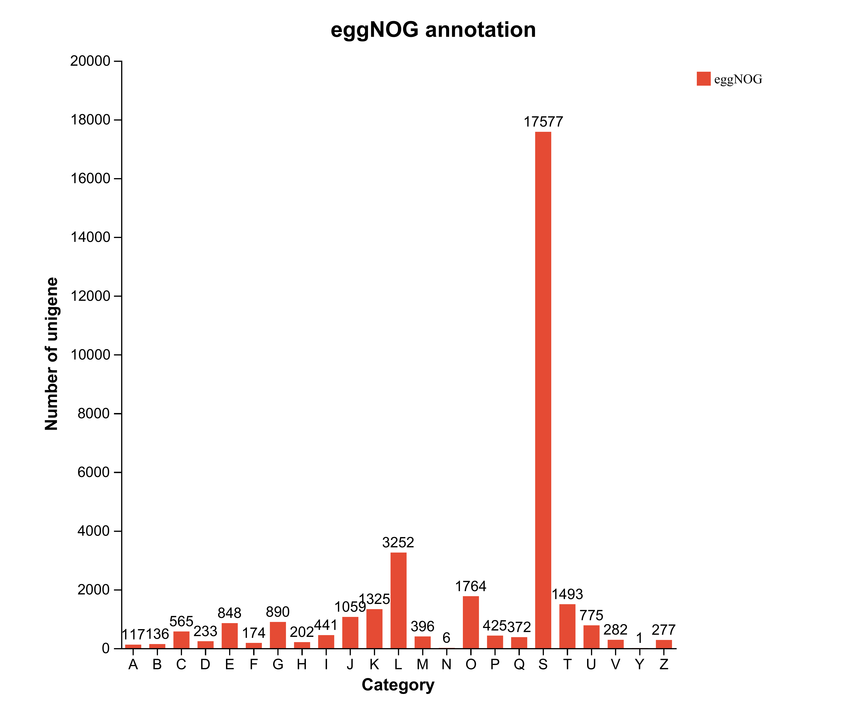
Fig.s.1 COG function classification of Unigenes. (Note. A.RNA processing and modification. B.Chromatin structure and dynamics. C. Energy production and conversion. D. Cell cycle control, cell division, chromosome partitioning. E. Amino acid transport and metabolism. F. Nucleotide transport and metabolism. G. Carbohydrate transport and metabolism. H. Coenzyme transport and metabolism. I. Lipid transport and metabolism. I. Translation, ribosomal structure and biogenesis. K. Transcription. L. Replication, recombination and repair. M. Cell wall/membrane/envelope biogenesis. N. Cell motility. O. Posttranslational modification, protein turnover, chaperones. P. Inorganic ion transport and metabolism. Q. Secondary metabolites biosynthesis, transport and catabolism. S. Function unknown. T. Signal transduction mechanisms. U. Intracellular trafficking, secretion, and vesicular transport. V. Defense mechanisms. Y. Nuclear structure. Z. Cytoskeleton

Table s.2 Statistical Table of Sequencing Data
Sample | Raw reads |  | Raw bases |  | Clean reads | Clean bases |  | Error rate (%) |  | Q20(%) | Q30(%) |  |  | GC content (%)
CK1 | 48227876 |  | 7282409276 |  | 47462128 | 6557779677 |  | 0.0259 |  | 97.79 | 93.56 |  | 45.58
CK2 | 47276640 |  | 7138772640 |  | 46669422 | 6809119717 |  | 0.0262 |  | 97.63 | 93.11 |  | 46.13
CK3 | 42861706 |  | 6472117606 |  | 42224054 | 6217352263 |  | 0.0263 |  | 97.58 | 92.91 |  | 46.36
Cu4 | 46435352 |  | 7011738152 |  | 45577560 | 6743607209 |  | 0.026 |  | 97.71 | 93.23 |  | 45.74
Cu5 | 49404256 |  | 7460042656 |  | 48806208 | 7139431061 |  | 0.0258 |  | 97.76 | 93.4 |  | 46.31
Cu6 | 47623772 |  | 7191189572 |  | 46900142 | 6924362046 |  | 0.0264 |  | 97.57 | 92.85 |  | 45.69
Cu+Ce7 | 47036600 |  | 7102526600 |  | 46335788 | 6812753860 |  | 0.0258 |  | 97.8 | 93.44 |  | 45.1
Cu+Ce8 | 45906442 |  | 6931872742 |  | 45134054 | 6679803299 |  | 0.0261 |  | 97.67 | 93.08 |  | 44.41
Cu+Ce9 | 43912390 |  | 6630770890 |  | 42973284 | 6262124418 |  | 0.0264 |  | 97.55 | 92.91 |  | 45.64
Ce10 | 43607184 |  | 6584684784 |  | 43070728 | 6175091405 |  | 0.0259 |  | 97.76 | 93.36 |  | 45.54
Ce11 | 43733626 |  | 6603777526 |  | 42816748 | 6197954680 |  | 0.026 |  | 97.7 | 93.26 |  | 45.81
Ce12 | 60362376 |  | 9114718776 |  | 58880308 | 8587408289 |  | 0.0261 |  | 97.65 | 93.15 |  | 46.21
Table s.3 Statistics of gene function annotation of expression genes
Database |  | Exp-Unigene  (percent) |  | Exp-Transcript  (percent) |  |  | All-Unigene  (percent) |  | All-Transcript  (percent)
GO |  | 38363(0.3146) |  | 77925(0.411) |  |  | 38545(0.3133) |  | 78339(0.4099)
KEGG |  | 11718(0.0961) |  | 30563(0.1612) |  |  | 11741(0.0954) |  | 30717(0.1607)
COG |  | 30320(0.2486) |  | 68959(0.3637) |  |  | 30408(0.2472) |  | 69275(0.3625)
NR |  | 60809(0.4987) |  | 114850(0.6057) |  |  | 61133(0.4969) |  | 115475(0.6043)
Total |  | 121942(1) |  | 189614(1) |  |  | 123025(1) |  | 191096(1)

Table s.4 Transcription factor analysis of Cu vs Cu+Ce
Gene_id | Description | Family | E-value | Score
TRINITY_DN5573_c0_g1 | Helix-loop-helix DNA-binding domain | bHLH | 3.10E-06 | 27.2
TRINITY_DN9070_c0_g1 | B3 DNA binding domain | B3_superfamily | 1.40E-35 | 121.3
TRINITY_DN3268_c0_g1 | GRAS domain family | GRAS | 5.20E-90 | 302.2
TRINITY_DN67777_c0_g1 | HSF-type DNA-binding | HSF | 9.80E-23 | 80.7
TRINITY_DN32429_c0_g1 | HSF-type DNA-binding | HSF | 1.90E-32 | 111.8
TRINITY_DN21298_c0_g1 | HSF-type DNA-binding | HSF | 6.00E-23 | 81.4
TRINITY_DN24408_c0_g1 | Myb-like DNA-binding domain | MYB_superfamily | 1.10E-33 | 115.2
TRINITY_DN5126_c0_g1 | AP2 domain | AP2/ERF | 1.40E-14 | 54.2
TRINITY_DN29935_c0_g1 | AP2 domain | AP2/ERF | 1.00E-14 | 54.7
TRINITY_DN93551_c0_g1 | AP2 domain | AP2/ERF | 8.60E-08 | 32.5
TRINITY_DN4888_c0_g1 | WRKY DNA -binding domain | WRKY | 1.30E-26 | 92.8
TRINITY_DN9847_c0_g2 | WRKY DNA -binding domain | WRKY | 3.20E-30 | 104.3
TRINITY_DN2471_c0_g1 | Zinc finger C-x8-C-x5-C-x3-H type (and similar) | C3H | 8.50E-07 | 28.9
TRINITY_DN58681_c0_g1 | Zinc finger C-x8-C-x5-C-x3-H type (and similar) | C3H | 7.80E-08 | 32.2
TRINITY_DN395_c0_g2 | BES1/BZR1 plant transcription factor, N-terminal | BES1 | 1.70E-46 | 158.5
TRINITY_DN12751_c0_g1 | Homeodomain | LBD (AS2/LOB) | 1.00E-17 | 63.8
TRINITY_DN8012_c0_g1 | TCP family transcription factor | TCP | 1.30E-28 | 100.6
TRINITY_DN6711_c0_g1 | TCP family transcription factor | TCP | 9.00E-27 | 94.7
TRINITY_DN21705_c0_g1 | No apical meristem (NAM) protein | NAC | 3.70E-51 | 173
TRINITY_DN942_c2_g1 | GAGA binding protein-like family | BBR-BPC | 1.90E-35 | 123.8

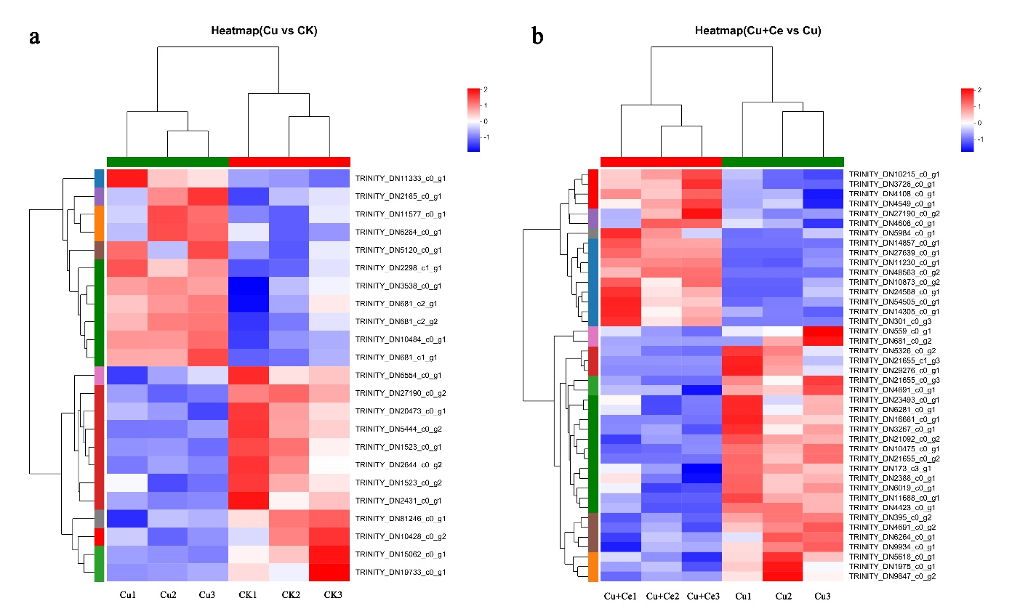
Fig.s.2 The pattern analysis of DEGs, a is CK vs. Cu, b is Cu vs. Cu+Ce.

