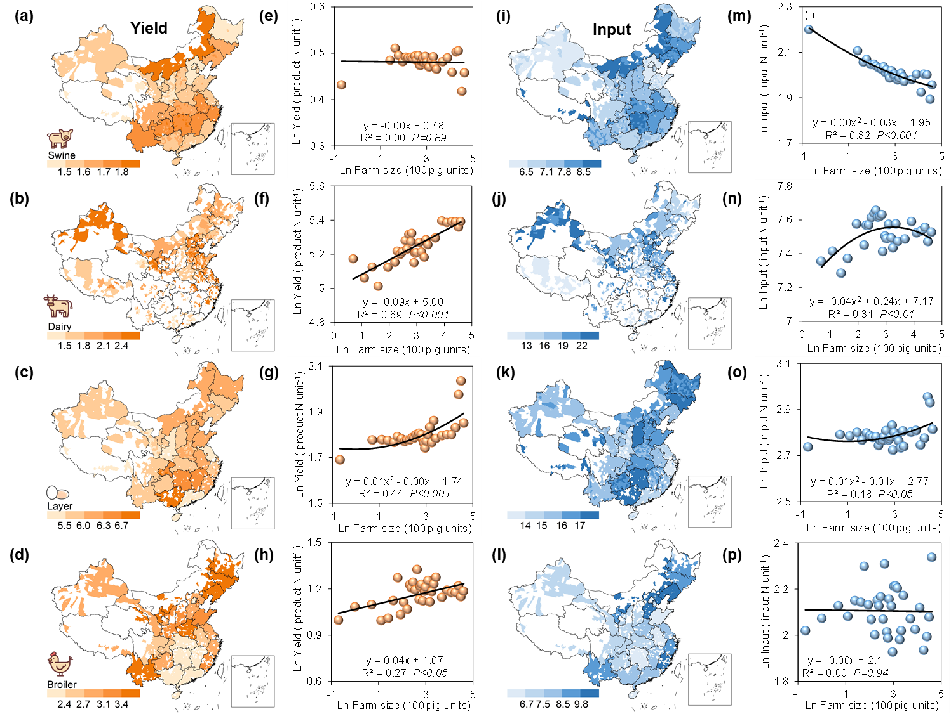
Extended data Fig. 1| Livestock yield N and feed N input in all livestock production systems. (a-d), livestock yield N for pig, dairy cattle, layer and broiler chicken production systems, respectively, kg product N head⁻¹. (e-h), the relationship between livestock yield N and farm size for all livestock. (i-l), unit feed N input for all livestock, kg feed N head⁻¹. (m-p), the relationship between unit feed N input and farm size for all livestock.

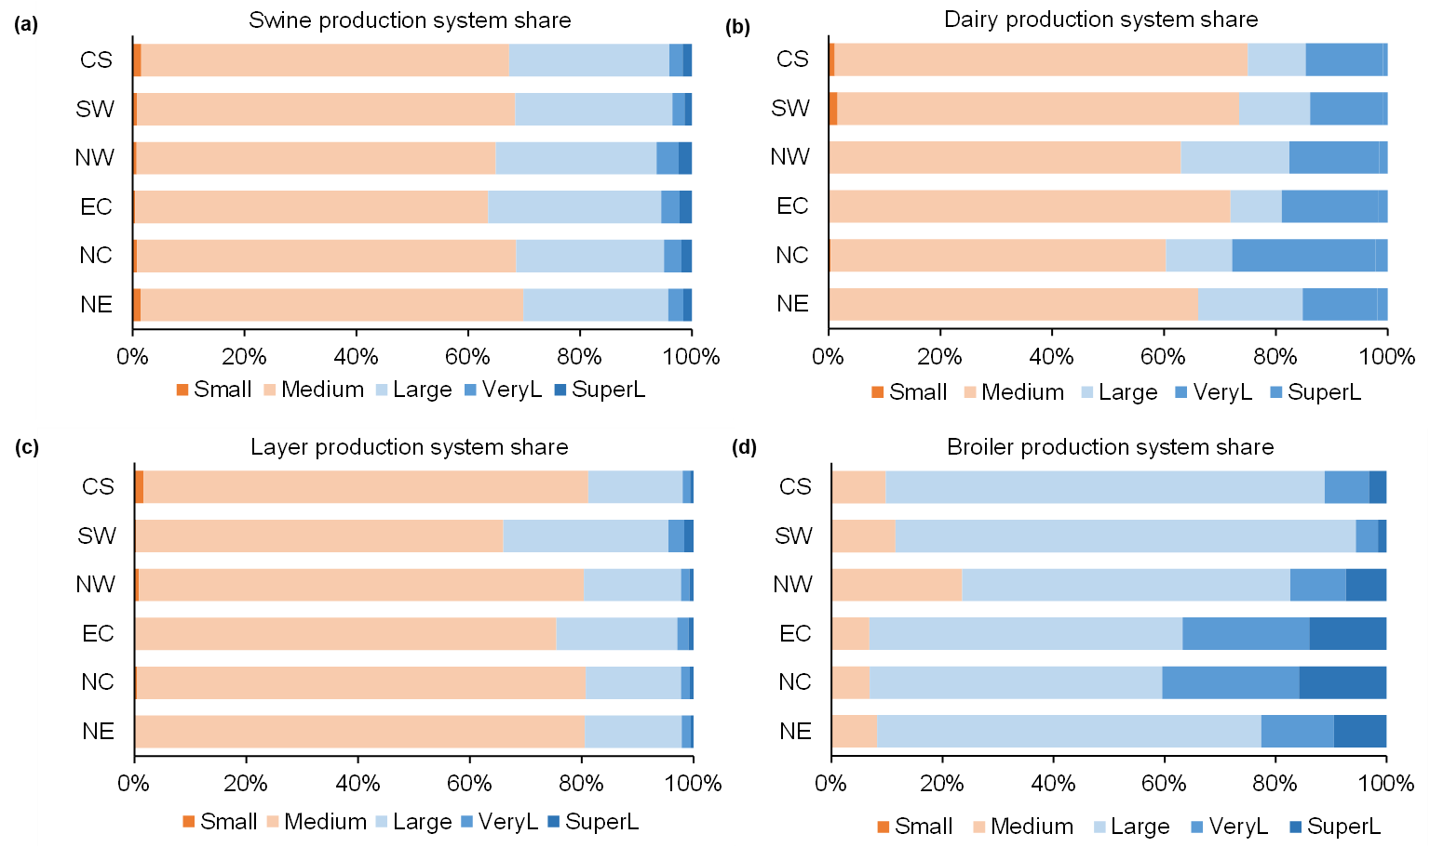
Extended data Fig. 2 | Shares of different livestock farm size by region for four livestock species. The farm size classifications by animal type are detailed in the Table S1, and the abbreviations of all agriculture regions were shown in Table S7.

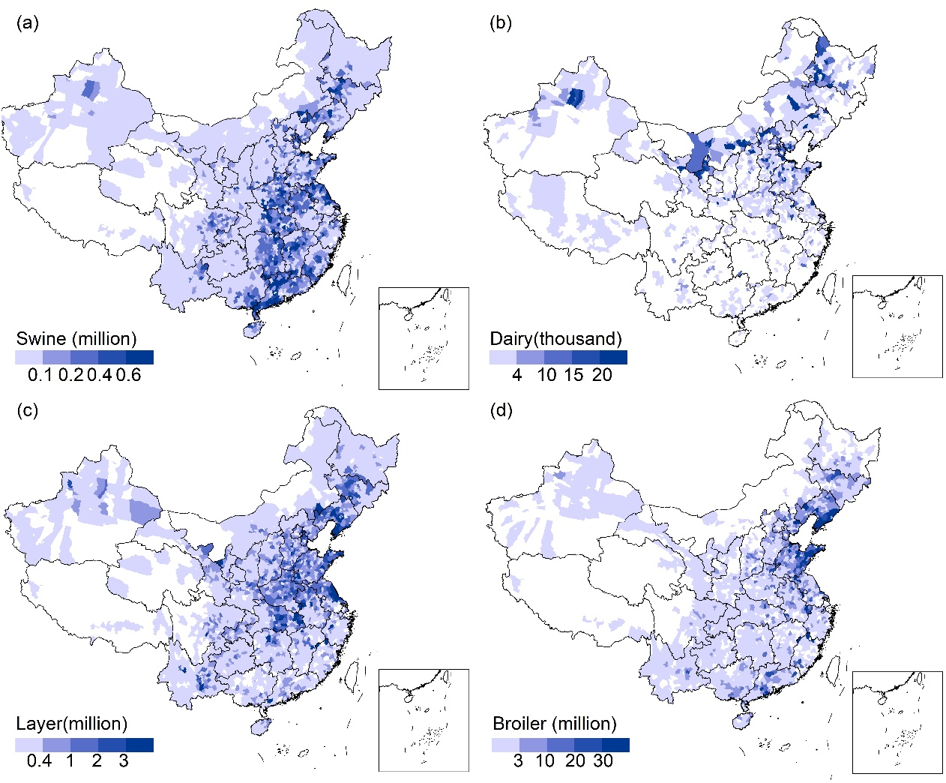
Extended data Fig. 3 | Spatial distribution of livestock population in 2017 in China. a, pig, b, dairy, c, layer chicken, d, broiler chicken.

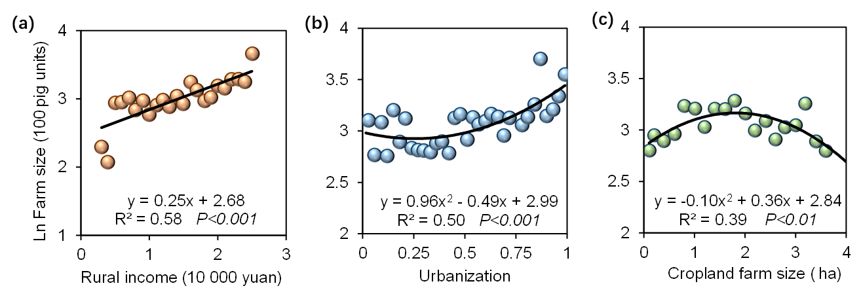
Extended data Fig. 4 | Relationship between rural income (a), urbanization (b), cropland farm size (c) and livestock farm size, respectively.

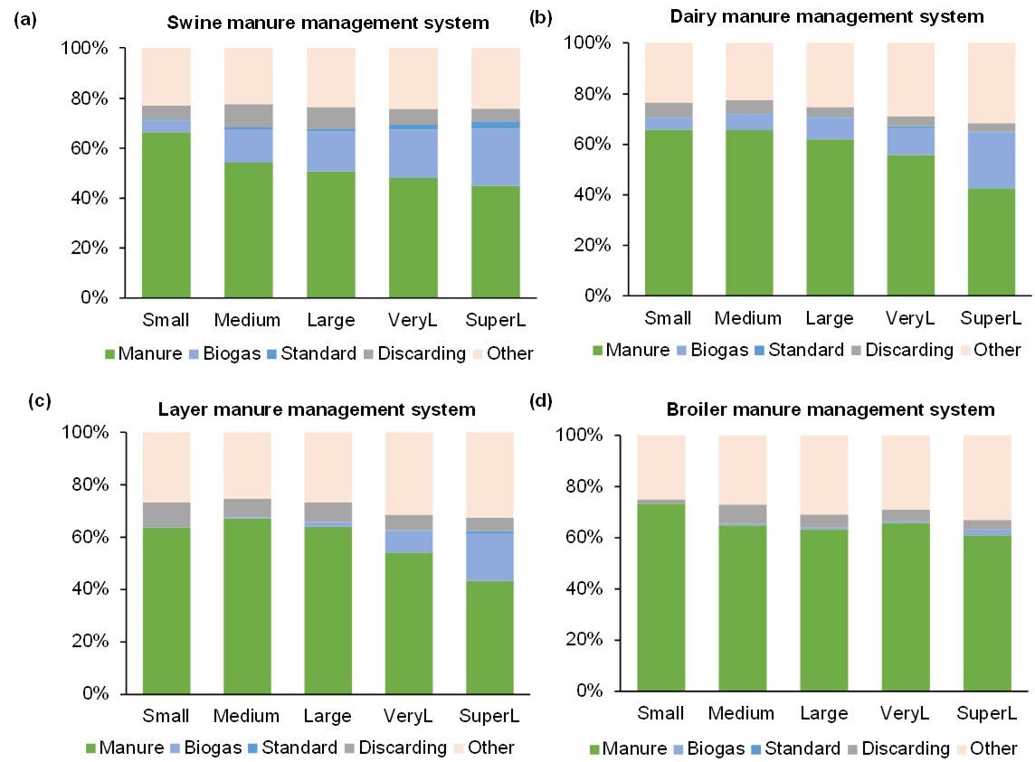
Extended data Fig. 5 |Manure management systems for all different farm sizes in pig (a), dairy (b), layer (c), and broiler (d) production systems, respectively.

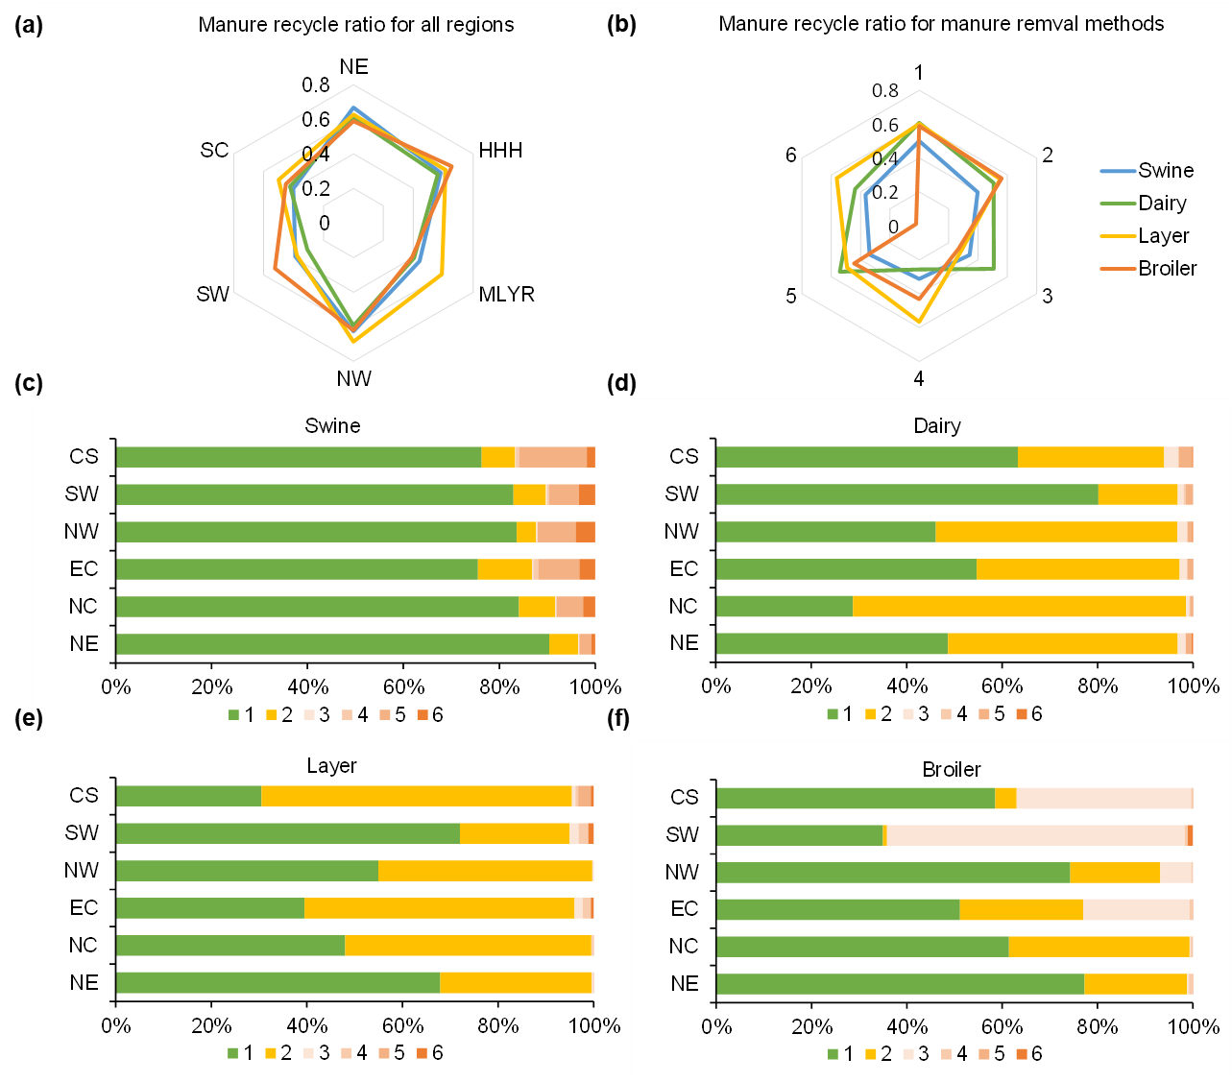
Extended data Fig. 6 |Manure recycling ratio and manure removal methods in all regions. 1, manual dry manure removal; 2, mechanical dry manure removal; 3, bedding materials; 4, raised bed farming; 5, water-flushed manure; 6, blistered manure. Central and Southern China Region (CS) Southwest Region (SW), Northwest Region (NW), Eastern China Region (EC), Northern China region (NC), Northeast Region (NE).

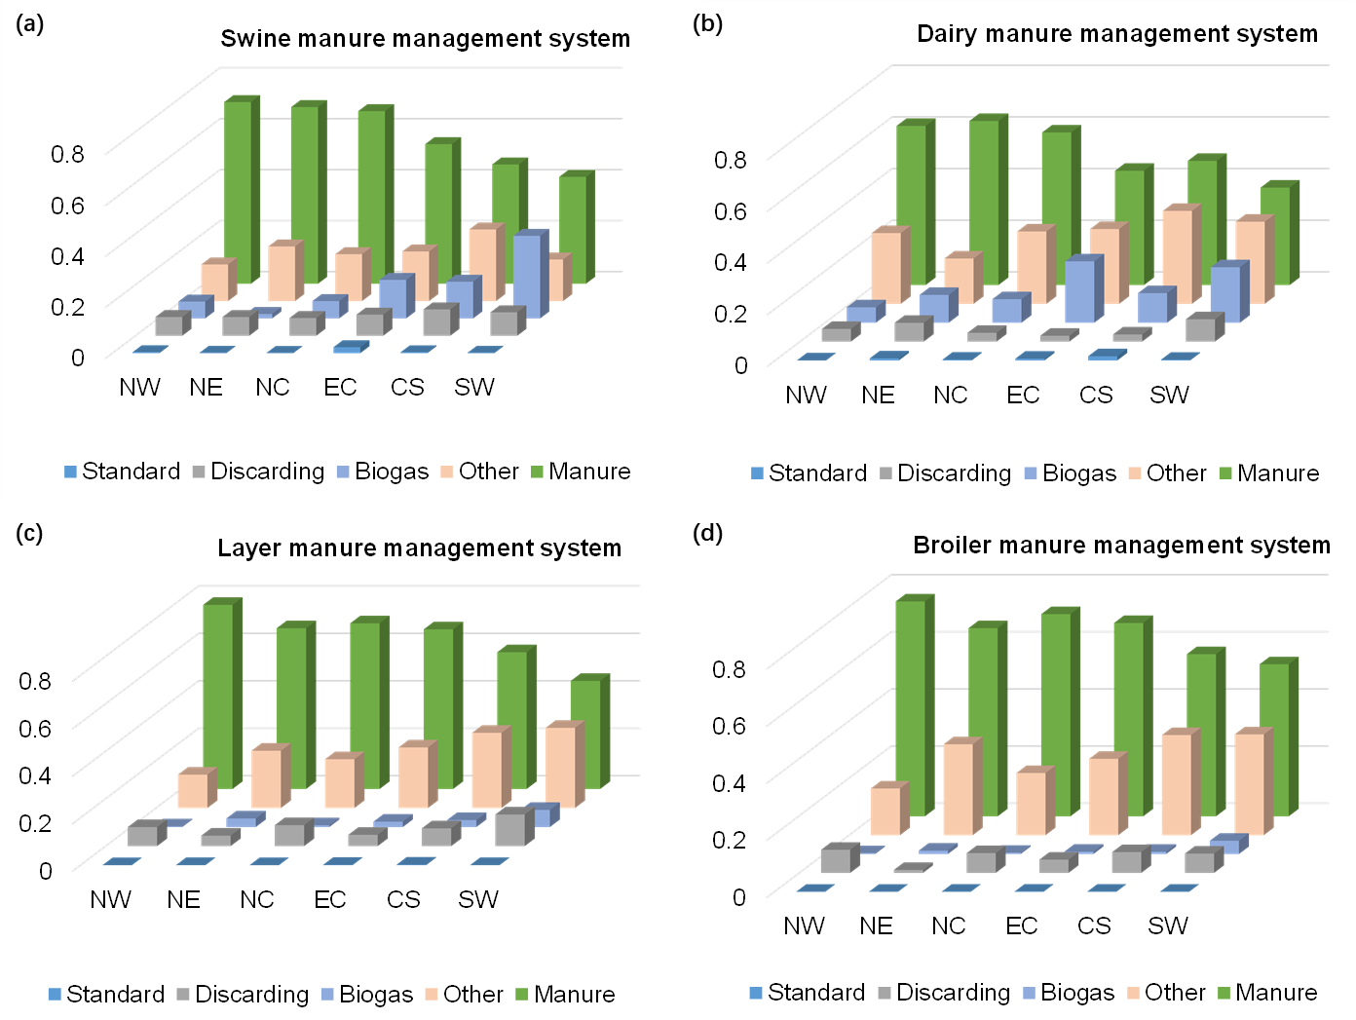
Extended data Fig. 7 | Manure management systems in all different regions for pig (a), dairy (b), layer (c), and broiler (d) production systems, respectively.
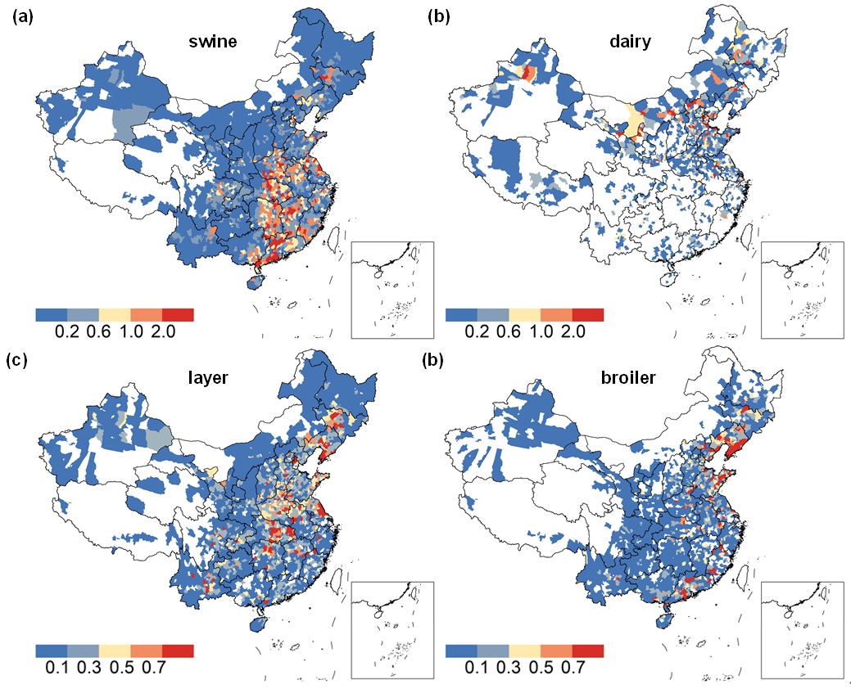
Extended data Fig. 8 | Total N losses for four livestock production systems. Pig (a), dairy (b), layer (c), and broiler (d) production systems, respectively, in Gg N.
Extended data Fig. 9 | N losses in all regions. The abbreviations of all provinces were listed in Table S7.

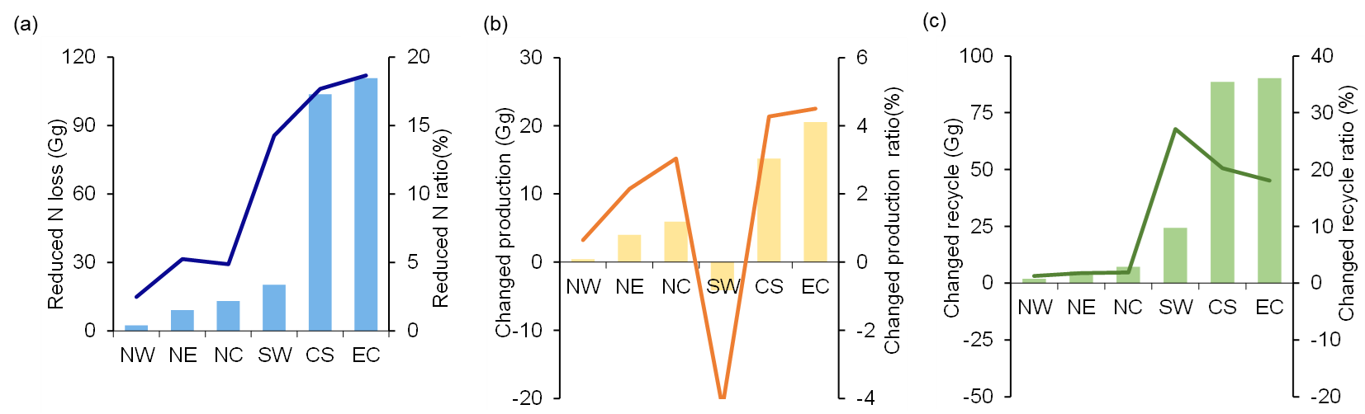
Extended data Fig. 10 | Changes in N losses, production N and manure recycled N under OPT scenario.

